Chapter 2: Introduction to Relational Model

Overview
The Relational Model is the most widely used data model, where data is organized into tables (relations) consisting of rows (tuples) and columns (attributes).

1. Structure of Relational Databases

Basic Terminology
Term | Also Called | Description
Relation | Table | A collection of related data
Tuple | Row / Record | A single data entry in a relation
Attribute | Column / Field | A property or characteristic
Domain | - | Set of allowed values for an attribute

Example: Instructor Relation
ID | name | dept_name | salary
10101 | Srinivasan | Comp. Sci. | 65000
12121 | Wu | Finance | 90000
22222 | Einstein | Physics | 95000
45565 | Katz | Comp. Sci. | 75000

Key Properties of Relations
- Tuples are unordered - Order of rows is irrelevant
- Attribute values are atomic - Indivisible (no composite/multi-valued)
- NULL values - Special value indicating “unknown”

2. Database Schema vs Instance
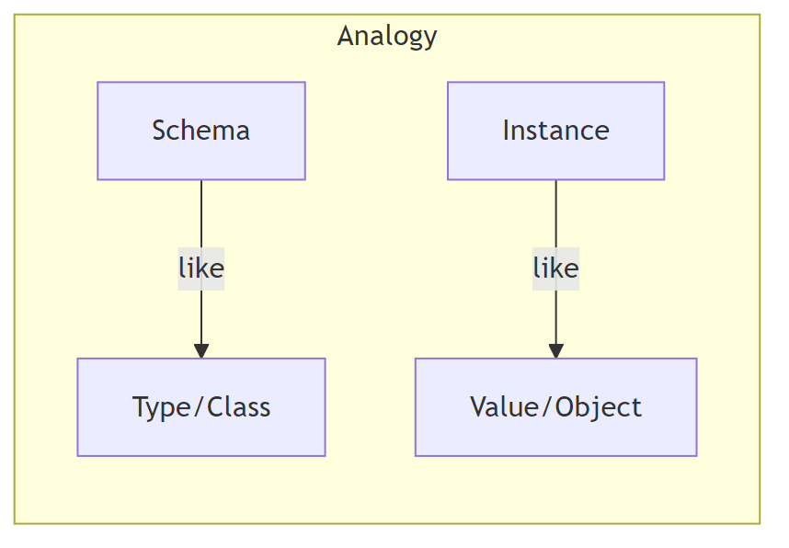
Diagram
Concept | Description | Example
Schema | Logical structure (design) | instructor(ID, name, dept_name, salary)
Instance | Actual data at a point in time | The table with current rows

3. Keys

Types of Keys
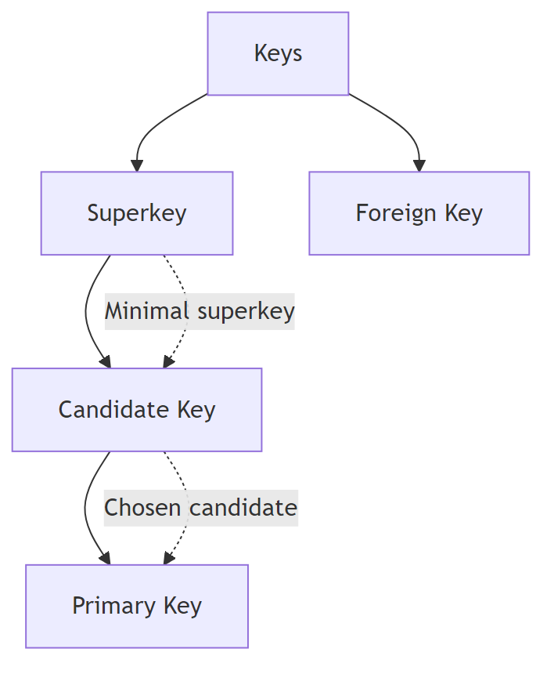
Diagram
Key Type | Definition | Example
Superkey | Set of attributes that uniquely identifies a tuple | {ID}, {ID, name}
Candidate Key | Minimal superkey (no proper subset is a superkey) | {ID}
Primary Key | Chosen candidate key for the relation | ID (underlined)
Foreign Key | Attribute referencing primary key of another relation | dept_name in instructor

Foreign Key Constraint
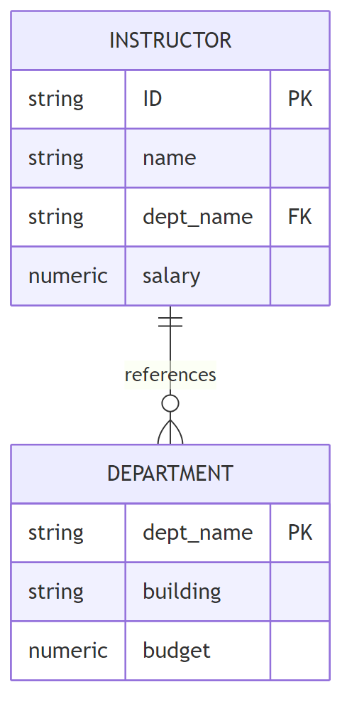
Diagram
Rule: Values in the referencing relation must exist in the referenced relation.

4. Schema Diagram - University Database
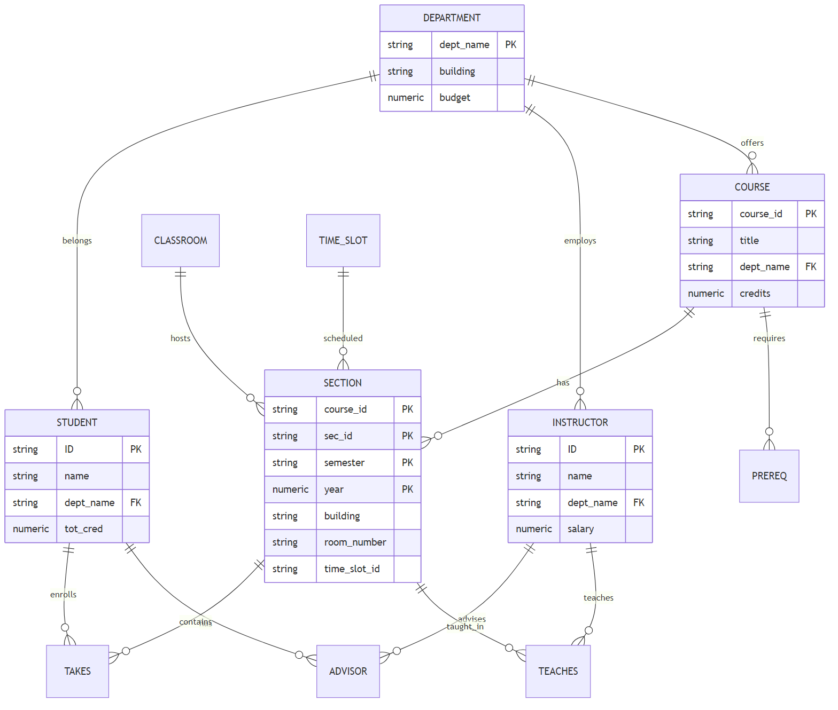
Diagram

5. Relational Query Languages

Classification
Type | Description | Example
Procedural | Specifies what data and how to get it | Relational Algebra
Declarative | Specifies only what data is needed | SQL, Tuple/Domain Calculus

Pure Languages (Equivalent in Power)
- Relational Algebra - Procedural
- Tuple Relational Calculus - Declarative
- Domain Relational Calculus - Declarative

6. Relational Algebra Operations

Six Fundamental Operations
Operation | Symbol | Type | Description
Select | σ (sigma) | Unary | Filter rows by condition
Project | Π (pi) | Unary | Select specific columns
Union | ∪ | Binary | Combine tuples from two relations
Set Difference | − | Binary | Tuples in r but not in s
Cartesian Product | × | Binary | All combinations of tuples
Rename | ρ (rho) | Unary | Rename relation or attributes

Additional Operations
Operation | Symbol | Description
Set Intersection | ∩ | Tuples in both relations
Join | ⋈ | Combine related tuples
Assignment | ← | Store intermediate results

7. Select Operation (σ)
Purpose: Select tuples that satisfy a predicate.
Notation: σ_p(r) where p is the selection predicate

Comparison Operators
=, ≠, >, ≥, <, ≤

Logical Connectives
- ∧ (AND)
- ∨ (OR)
- ¬ (NOT)

Examples
σ_dept_name="Physics"(instructor)
Result: All instructors in Physics department
σ_dept_name="Physics" ∧ salary>90000(instructor)
Result: Physics instructors with salary > 90,000
ID | name | dept_name | salary
22222 | Einstein | Physics | 95000

8. Project Operation (Π)
Purpose: Return relation with only specified attributes (columns).
Notation: Π_A1,A2,...,Ak(r)

Example
Π_ID,name,salary(instructor)
Before (instructor): | ID | name | dept_name | salary | |—-|——|———–|——–| | 22222 | Einstein | Physics | 95000 | | 12121 | Wu | Finance | 90000 |
After: | ID | name | salary | |—-|——|——–| | 22222 | Einstein | 95000 | | 12121 | Wu | 90000 |
Note: Duplicate rows are automatically removed (relations are sets).

9. Composition of Operations
Operations can be combined into expressions:
Π_name(σ_dept_name="Physics"(instructor))
Interpretation: Find names of all Physics instructors
Diagram

10. Cartesian Product (×)
Purpose: Combine every tuple from r with every tuple from s.
Notation: r × s
If r has n tuples and s has m tuples, result has n × m tuples.

Example
instructor × teaches
- Produces all possible combinations
- Common attributes are prefixed: instructor.ID, teaches.ID

11. Join Operation (⋈)
Purpose: Combine Cartesian product with selection on related attributes.
Definition:
r ⋈_θ s = σ_θ(r × s)

Example
instructor ⋈_instructor.ID=teaches.ID teaches
Equivalent to:
σ_instructor.ID=teaches.ID(instructor × teaches)

12. Set Operations

Union (∪)
Combines tuples from both relations (removes duplicates)
Π_course_id(σ_semester="Fall" ∧ year=2017(section))
∪
Π_course_id(σ_semester="Spring" ∧ year=2018(section))

Set Intersection (∩)
Returns tuples present in both relations
Π_course_id(σ_semester="Fall" ∧ year=2017(section))
∩
Π_course_id(σ_semester="Spring" ∧ year=2018(section))

Set Difference (−)
Returns tuples in r but not in s
Π_course_id(σ_semester="Fall" ∧ year=2017(section))
−
Π_course_id(σ_semester="Spring" ∧ year=2018(section))

Requirements for Set Operations
- Same arity (number of attributes)
- Compatible attribute domains

13. Assignment (←) and Rename (ρ)

Assignment Operation
Store intermediate results in temporary variables:
Physics ← σ_dept_name="Physics"(instructor)
Music ← σ_dept_name="Music"(instructor)
Physics ∪ Music

Rename Operation
Give names to results or rename attributes:
ρ_x(E) -- rename result to x
ρ_x(A1,A2,...)(E) -- rename result and attributes

14. Aggregate Functions
Function | Description
avg | Average value
min | Minimum value
max | Maximum value
sum | Sum of values
count | Number of values

Examples
Average salary of all instructors:
γ_avg(salary)(instructor)
Average salary by department (GROUP BY):
dept_name γ_avg(salary)(instructor)
dept_name | avg_salary
Biology | 72000
Comp. Sci. | 77333
Finance | 85000
Physics | 91000

15. Equivalent Queries
Multiple relational algebra expressions can produce the same result.

Example 1: Different Select Orderings
Query 1:
σ_dept_name="Physics" ∧ salary>90000(instructor)
Query 2:
σ_dept_name="Physics"(σ_salary>90000(instructor))
Both are equivalent (same result on any database).

Example 2: Selection Before vs After Join
Query 1:
σ_dept_name="Physics"(instructor ⋈ teaches)
Query 2:
(σ_dept_name="Physics"(instructor)) ⋈ teaches
Query 2 is typically more efficient (filters before join).

Summary Table: Relational Algebra Operations
Operation | Symbol | Input | Output | Purpose
Select | σ | 1 relation | Subset of tuples | Filter rows
Project | Π | 1 relation | Subset of attributes | Choose columns
Union | ∪ | 2 relations | Combined tuples | OR logic
Difference | − | 2 relations | Tuples in r not in s | Exclusion
Intersection | ∩ | 2 relations | Common tuples | AND logic
Cartesian Product | × | 2 relations | All combinations | Combine all
Join | ⋈ | 2 relations | Related tuples | Combine related
Rename | ρ | 1 relation | Same with new name | Aliasing
Assignment | ← | Expression | Temporary variable | Store result

Key Takeaways
- Relational model organizes data into tables with rows and columns
- Keys ensure uniqueness and establish relationships between tables
- Relational algebra provides a procedural query language with six fundamental operations
- Operations can be composed to form complex queries
- Equivalent queries produce the same result but may have different performance
- Aggregate functions enable computations over groups of tuples

