Chapter 7: Normalization

Overview
Normalization is the process of organizing database schemas to reduce redundancy and dependency. This chapter covers functional dependencies, normal forms (1NF, 2NF, 3NF, BCNF, 4NF), and decomposition algorithms.

Features of Good Relational Design

Problems with Bad Design
Problem | Description | Example
Redundancy | Information repeated multiple times | Department info repeated for each instructor
Update Anomalies | Inconsistency when updating | Changing building name requires multiple updates
Insertion Anomalies | Cannot add data without other data | Cannot add department without instructor
Deletion Anomalies | Losing data unintentionally | Deleting last instructor loses department info

Example of Bad Design
in_dep(ID, name, salary, dept_name, building, budget)
ID | name | salary | dept_name | building | budget
101 | Wu | 90000 | Finance | Painter | 120000
102 | Einstein | 95000 | Physics | Watson | 70000
103 | Gold | 87000 | Physics | Watson | 70000
Problems: Physics department info (building, budget) is repeated.

Decomposition
Decomposition splits a relation into smaller relations to eliminate redundancy.
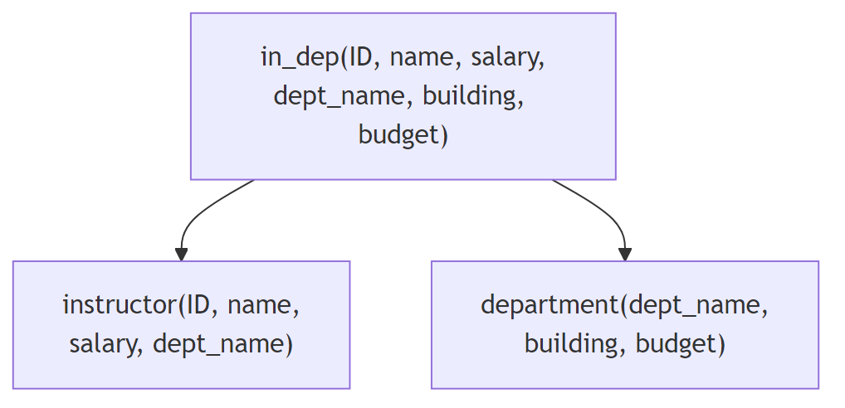
Diagram

Lossless vs. Lossy Decomposition
Type | Definition | Result
Lossless | Can reconstruct original relation | R₁ ⋈ R₂ = R
Lossy | Cannot reconstruct (spurious tuples) | R₁ ⋈ R₂ ⊃ R

Condition for Lossless Decomposition
A decomposition of R into R₁ and R₂ is lossless if at least one holds: - R₁ ∩ R₂ → R₁ (common attributes determine R₁) - R₁ ∩ R₂ → R₂ (common attributes determine R₂)
Example: R = (A, B, C), F = {A → B, B → C}
Lossless: R₁ = (A, B), R₂ = (B, C)
R₁ ∩ R₂ = {B}, and B → BC ✓
Lossy: R₁ = (A, B), R₂ = (A, C) when only A → B holds

Functional Dependencies

Definition
A functional dependency α → β holds on R if for any two tuples t₁ and t₂:
t₁[α] = t₂[α] ⟹ t₁[β] = t₂[β]
“If two tuples agree on α, they must agree on β”

Examples
Dependency | Meaning
ID → name | ID determines name
dept_name → building | Department determines building
course_id, sec_id, semester, year → building | Section determines building

Trivial Functional Dependencies
A FD is trivial if β ⊆ α (always satisfied).
Example | Trivial?
ID, name → ID | Yes (ID ⊆ {ID, name})
name → name | Yes
ID → name | No

Keys and Functional Dependencies
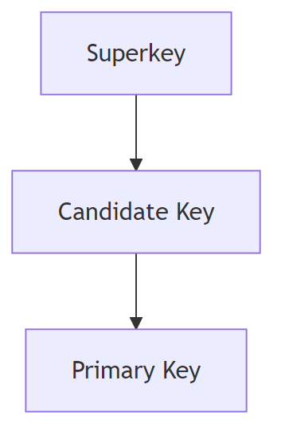
Diagram
Term | Definition
Superkey | K → R (determines all attributes)
Candidate Key | Minimal superkey (no proper subset is superkey)
Primary Key | Chosen candidate key

Example
R = (A, B, C, G, H, I)
F = {A → B, A → C, CG → H, CG → I, B → H}
Is AG a candidate key?
1. (AG)⁺ = ABCGHI = R ✓ (AG is superkey)
2. (A)⁺ = ABCH ≠ R ✓ (A alone not superkey)
3. (G)⁺ = G ≠ R ✓ (G alone not superkey)
∴ AG is a candidate key

Closure of Functional Dependencies (F⁺)
The closure F⁺ is the set of all FDs logically implied by F.

Armstrong’s Axioms
Axiom | Rule | Example
Reflexivity | If β ⊆ α, then α → β | AB → A
Augmentation | If α → β, then αγ → βγ | A → B implies AC → BC
Transitivity | If α → β and β → γ, then α → γ | A → B, B → C implies A → C

Additional Rules (Derived)
Rule | Statement
Union | If α → β and α → γ, then α → βγ
Decomposition | If α → βγ, then α → β and α → γ
Pseudotransitivity | If α → β and γβ → δ, then αγ → δ

Attribute Closure (α⁺)
The attribute closure α⁺ is the set of all attributes functionally determined by α.

Algorithm
result := α
while (changes to result) do
for each β → γ in F do
if β ⊆ result then
result := result ∪ γ

Example
R = (A, B, C, G, H, I)
F = {A → B, A → C, CG → H, CG → I, B → H}
Compute (AG)⁺:
1. result = AG
2. result = ABCG (A → B, A → C)
3. result = ABCGH (CG → H)
4. result = ABCGHI (CG → I)
(AG)⁺ = ABCGHI

Uses of Attribute Closure
Use | How
Test if α is superkey | Check if α⁺ = R
Test if α → β holds | Check if β ⊆ α⁺
Compute F⁺ | For each α ⊆ R, output α → S for each S ⊆ α⁺

Canonical Cover (Fᶜ)
A canonical cover Fᶜ is a minimal set of FDs equivalent to F: - No extraneous attributes - Each left side is unique - F⁺ = Fᶜ⁺

Extraneous Attributes
Location | Test
A extraneous in α of α → β | Check if (α - A)⁺ includes β
A extraneous in β of α → β | Check if α⁺ (under F’) includes A, where F’ = (F - {α → β}) ∪ {α → (β - A)}

Computing Canonical Cover
repeat
1. Use union rule: α → β₁, α → β₂ becomes α → β₁β₂
2. Find and remove extraneous attributes
until Fᶜ doesn't change

Example
F = {A → BC, B → C, A → B, AB → C}
Step 1: Combine A → BC and A → B → A → BC
Result: {A → BC, B → C, AB → C}
Step 2: A is extraneous in AB → C (since B → C exists)
Result: {A → BC, B → C}
Step 3: C is extraneous in A → BC (A → B and B → C implies A → C)
Result: {A → B, B → C}
Canonical Cover: Fᶜ = {A → B, B → C}

Normal Forms
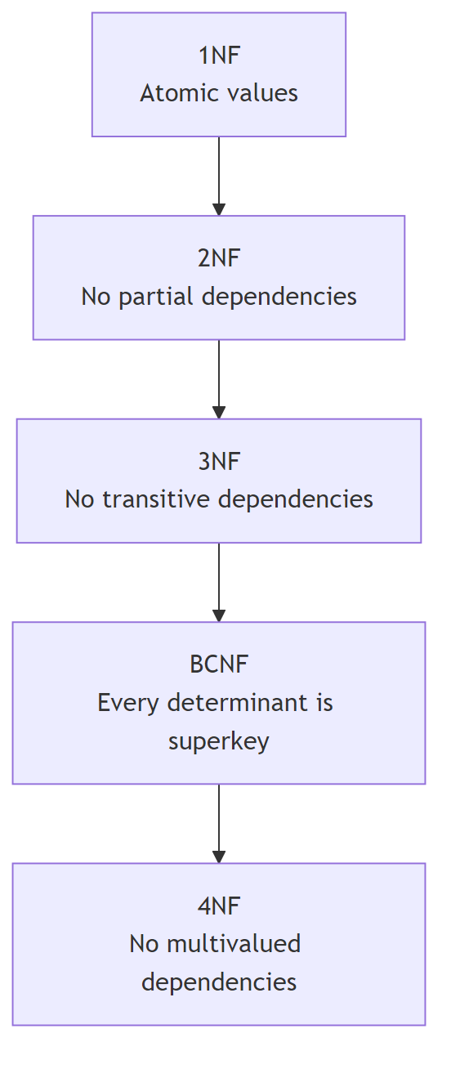
Diagram

Normal Forms Comparison
Normal Form | Requirement | Issues Addressed
1NF | All attributes are atomic | Non-atomic values
2NF | 1NF + no partial dependencies | Partial key dependencies
3NF | 2NF + no transitive dependencies | Some redundancy, but dependency preserving
BCNF | Every non-trivial FD has superkey on left | All FD-based redundancy
4NF | BCNF + no non-trivial MVDs | Multivalued dependency redundancy

First Normal Form (1NF)
A relation is in 1NF if all attribute domains are atomic (indivisible).
Non-Atomic | Problem
Set of values | {phone1, phone2}
Composite attributes | name = (first, last)
Encoded values | CS101 → extracting “CS”

Boyce-Codd Normal Form (BCNF)
A relation R is in BCNF if for every non-trivial FD α → β: - α is a superkey for R

BCNF Test
For each α → β in F:
Compute α⁺
If α⁺ ≠ R, then R is not in BCNF

BCNF Decomposition Algorithm
result := {R}
while (there is Rᵢ in result not in BCNF) do
Let α → β be a FD violating BCNF on Rᵢ
Replace Rᵢ with:
(α ∪ β) -- new relation with FD
(Rᵢ - (β - α)) -- remaining attributes

BCNF Decomposition Example
class(course_id, title, dept_name, credits, sec_id,
semester, year, building, room_number, capacity, time_slot_id)
FDs:
- course_id → title, dept_name, credits
- building, room_number → capacity
- course_id, sec_id, semester, year → building, room_number, time_slot_id
Candidate Key: {course_id, sec_id, semester, year}
Decomposition:
1. course_id → title, dept_name, credits violates BCNF
Split into:
- course(course_id, title, dept_name, credits)
- class-1(course_id, sec_id, semester, year, building,
room_number, capacity, time_slot_id)
2. building, room_number → capacity violates BCNF in class-1
Split into:
- classroom(building, room_number, capacity)
- section(course_id, sec_id, semester, year, building,
room_number, time_slot_id)
Final: course, classroom, section (all in BCNF)

Third Normal Form (3NF)
A relation R is in 3NF if for every non-trivial FD α → β, at least one holds: - α is a superkey for R, OR - Each attribute A in (β - α) is contained in a candidate key

3NF vs BCNF
Property | BCNF | 3NF
Redundancy | None | Some possible
Lossless decomposition | Always | Always
Dependency preservation | Not always | Always

3NF Example
dept_advisor(s_ID, i_ID, dept_name)
F = {i_ID → dept_name, s_ID, dept_name → i_ID}
Candidate Keys: {s_ID, dept_name}, {s_ID, i_ID}
Check: i_ID → dept_name
- i_ID is not a superkey ✗
- dept_name is in candidate key {s_ID, dept_name} ✓
∴ R is in 3NF (but not BCNF)

3NF Decomposition Algorithm
Compute canonical cover Fᶜ
for each α → β in Fᶜ do
if no Rⱼ contains αβ then
Create Rᵢ := αβ
if no Rⱼ contains a candidate key for R then
Add a relation with any candidate key
Remove redundant relations (subsets of others)

3NF Decomposition Example
R = (customer_id, employee_id, branch_name, type)
F = {customer_id, employee_id → branch_name, type
employee_id → branch_name
customer_id, branch_name → employee_id}
Canonical Cover:
Fᶜ = {customer_id, employee_id → type
employee_id → branch_name
customer_id, branch_name → employee_id}
3NF Decomposition:
1. (customer_id, employee_id, type)
2. (employee_id, branch_name)
3. (customer_id, branch_name, employee_id)
Remove (employee_id, branch_name) as subset of (3)
Final:
- (customer_id, employee_id, type)
- (customer_id, branch_name, employee_id)

Dependency Preservation
A decomposition is dependency preserving if all FDs can be checked on individual relations (without joins).

Test for Dependency Preservation
For each α → β in F:
result := α
repeat
for each Rᵢ in decomposition:
t := (result ∩ Rᵢ)⁺ ∩ Rᵢ
result := result ∪ t
until result doesn't change
If β ⊆ result, then α → β is preserved

Example
R = (A, B, C), F = {A → B, B → C}
Decomposition 1: R₁ = (A, B), R₂ = (B, C)
- A → B: checkable in R₁ ✓
- B → C: checkable in R₂ ✓
∴ Dependency preserving
Decomposition 2: R₁ = (A, B), R₂ = (A, C)
- A → B: checkable in R₁ ✓
- B → C: cannot check without join ✗
∴ NOT dependency preserving

Multivalued Dependencies (MVDs)

Definition
α →→ β holds if for tuples with same α value, the β values are independent of other attributes.
If t₁[α] = t₂[α], then there exist t₃, t₄ such that:
- t₃[α] = t₄[α] = t₁[α] = t₂[α]
- t₃[β] = t₁[β], t₃[R - α - β] = t₂[R - α - β]
- t₄[β] = t₂[β], t₄[R - α - β] = t₁[R - α - β]

MVD Example
inst_info(ID, child_name, phone_number)
ID | child_name | phone_number
99999 | David | 512-555-1234
99999 | David | 512-555-4321
99999 | William | 512-555-1234
99999 | William | 512-555-4321
MVDs: ID →→ child_name, ID →→ phone_number
Problem: Adding a phone requires adding tuples for ALL children.

Relationship: FD implies MVD
If α → β, then α →→ β (every FD is also an MVD).

Fourth Normal Form (4NF)
A relation R is in 4NF if for every non-trivial MVD α →→ β: - α is a superkey for R

4NF Decomposition Algorithm
result := {R}
while (there is Rᵢ not in 4NF) do
Let α →→ β be an MVD violating 4NF
Replace Rᵢ with:
(α, β)
(Rᵢ - β)

4NF Example
inst_info(ID, child_name, phone_number)
MVDs: ID →→ child_name, ID →→ phone_number
ID is not a superkey (no FDs)
Decompose into:
- inst_child(ID, child_name)
- inst_phone(ID, phone_number)
Both are in 4NF.

Normal Forms Hierarchy
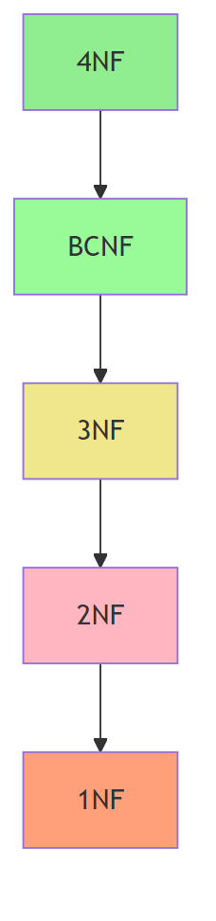
Diagram
If in… | Then also in…
4NF | BCNF, 3NF, 2NF, 1NF
BCNF | 3NF, 2NF, 1NF
3NF | 2NF, 1NF
2NF | 1NF

Design Goals Summary

Ideal Goals
- BCNF (eliminate all redundancy from FDs)
- Lossless decomposition (can reconstruct original)
- Dependency preservation (can check FDs efficiently)

Trade-offs
If BCNF not dependency preserving | Options
Accept BCNF | Lose easy FD checking
Accept 3NF | Keep some redundancy

Denormalization
Sometimes denormalization is used for performance:
Approach | Pros | Cons
Denormalized tables | Faster reads | Update anomalies, redundancy
Materialized views | Faster reads, auto-maintained | Storage overhead

Overall Design Process
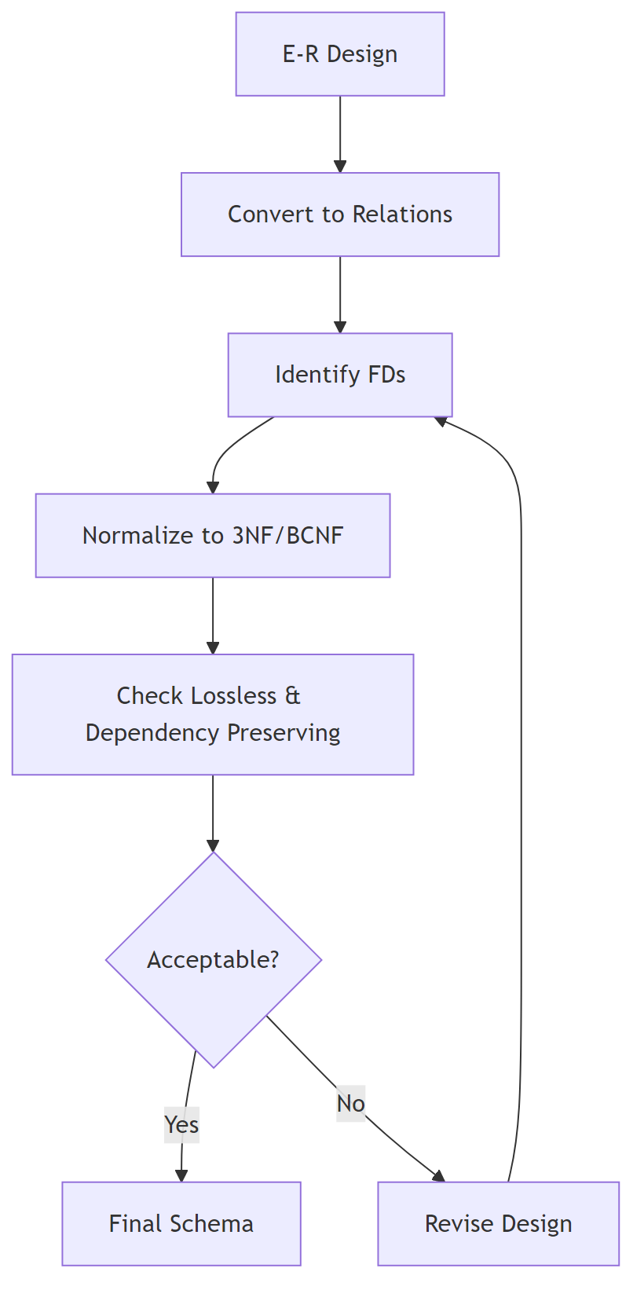
Diagram

Key Formulas and Tests
Test | Formula/Method
α is superkey | α⁺ = R
α → β holds | β ⊆ α⁺
Lossless decomposition | R₁ ∩ R₂ → R₁ or R₁ ∩ R₂ → R₂
BCNF | ∀ non-trivial α → β: α is superkey
3NF | ∀ non-trivial α → β: α is superkey OR β in candidate key
4NF | ∀ non-trivial α →→ β: α is superkey

Quick Reference: Decomposition
Normal Form | Algorithm | Guarantees
BCNF | Split on violating FD | Lossless
3NF | Canonical cover → relations | Lossless + Dependency preserving
4NF | Split on violating MVD | Lossless

