q

W1 PRACTICE
PART 2 – MANIPULATION

 Before this practice
- You need to have completed: PART 1- EXPLORATION

 Learning objectives
- Apply type inference for variable declarations.
- Handle nullable and non-nullable variables.
- Differentiate between final and const.
- Manipulate strings, lists, and maps.
- Use loops and conditions to control flow.
- Define and call functions with positional and named arguments, understand arrow syntax



 Are you lost?
Read the following documentation to be ready for this practice:
- Variables
- Null Safety
- Built-in types
- Lists
- Loops
- Conditions
- Functions

REVIEW PART-1
In group of 3 or 4, review the self-learning work.
- After discussing with your peer, update your answers if you need
- Some groups will present their outcome to the classroom

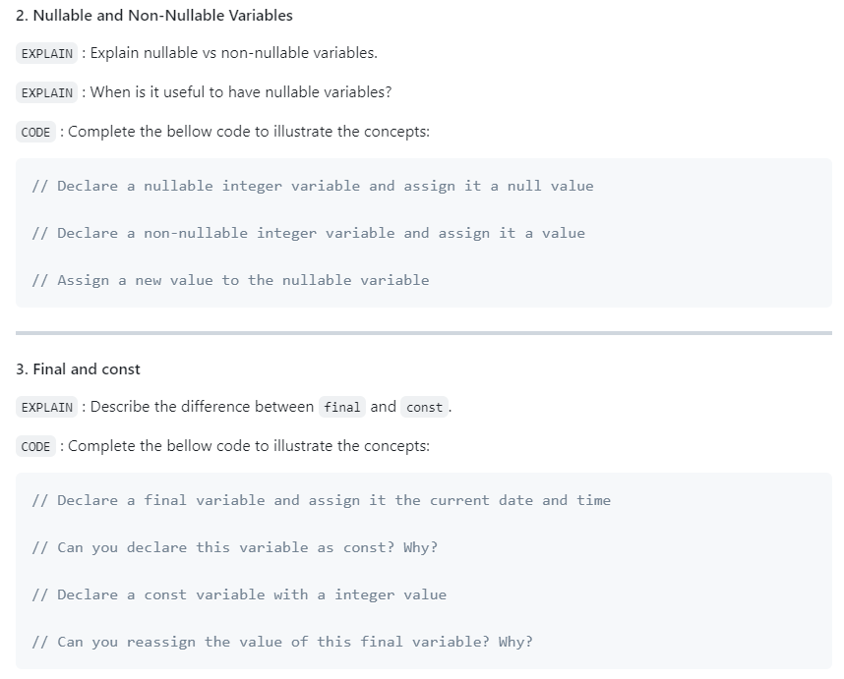
Review, and update your answer regarding your work

EX 1 – Manipulate Types
Are you clear about strings, integer, list, map, set, objects in Dart?
Examine the given data structures and write the inferred Dart type for each one (see example)

Notes
- First find by yourself the type
- If you need, double check your answer with VSCode.

Data | Dart Type
const studentGrades = {  'Sokan': [90, 85, 88],  'Sokea': [70, 80, 75],  'Hay': [95, 92, 89],  }; | Map<String, List<int>> studentGrades = {  'Sokan': [90, 85, 75],  'Sokea': [70, 80, 75],  'Hay': [95, 92, 89],  };
const pizzaPrices = {  'margherita': 5.5,  'pepperoni': 7.5,  'vegetarian': 6.5,  }; | Map<String, double> pizzaPrices = {  "margherita": 5.5,  "pepperoni":7.5,  "vegetarian":6.5,  };
const books = [  {'title': '1984', 'author': 'George Orwell'},  {'title': 'Brave New World', 'author': 'Aldous Huxley'},  {'title': 'Fahrenheit 451', 'author': 'Ray Bradbury'},  ]; | List<Map<String, String>> books = [  {'title': '1984', 'author': 'George Orwell'},  {'title': 'Brave New World', 'author': 'Aldous Huxley'},  {'title': 'Fahrenheit 451', 'author': 'Ray Bradbury'},  ];
const company = {  'HR': {'employees': 5, 'budget': 20000},  'IT': {'employees': 10, 'budget': 50000},  'Marketing': {'employees': 7, 'budget': 30000},  }; | Map<String, Map< String, int>> company = {  'HR': {'employees': 5, 'budget': 20000},  'IT': {'employees': 10, 'budget': 50000},  'Marketing': {'employees': 7, 'budget': 30000},  };
const coordinates = [  [1, 2],  [3, 4],  [5, 6],  ]; | List<List<int>> coordinates = [  [1, 2],  [3, 4],  [5, 6],  ];
const productDetails = {  'id': 101,  'name': 'Laptop',  'price': 999.99,  'inStock': true,  }; | Map<String, Object> productDetails = {  'id': 101,  'name': 'Laptop',  'price': 999.99,  'inStock': true,  };
const operations = [  (int a, int b) => a + b,  (int a, int b) => a - b,  (int a, int b) => a * b,  ]; | List<int Function(int, int)> operations = [  (int a, int b) => a + b,  (int a, int b) => a - b,  (int a, int b) => a * b,  ];
const distances = {3.1, 5.5, 10.2, 7.8}; | Set<double> distance = {3.1, 5.5, 10.2, 7.8};
const university = {  'departments': [  {  'name': 'Computer Science',  'students': [  {'name': 'Alice', 'age': 22},  {'name': 'Bob', 'age': 24},  ]  },  {  'name': 'Mathematics',  'students': [  {'name': 'Charlie', 'age': 21},  {'name': 'Dave', 'age': 23},  ]  }  ]  }; | Map<String, List<Map<String, Object>>> university = {  'departments': [  {  'name': 'Computer Science',  'students': [  {'name': 'Alice', 'age': 20},  {'name': 'Bob', 'age': 24},  ]  },  {  'name': 'Mathematics',  'students': [  {'name': 'Charlie', 'age': 21},  {'name': 'Dave', 'age': 23},  ]  }  ]  };

EX 2 – Manipulate final and const
In this exercise, you need to decide which variable can be declared as const or final.

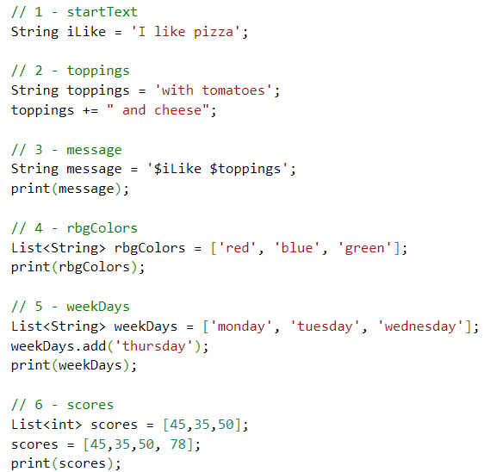

Guess which variables can be declared as const, final or var, and explain your choices.
Notes
- Read here to understand the concepts.
- Prefer const over final over var.

 | VAR, FINAL, CONST? | WHY
iLike | CONST | Because this variable never changes
toppings | VAR | Because this variable can change but in still keep as the String type
message | FINAL | Because this variable can ADD MORE STRING now change the string
rbgColors | CONST | Because this variable can’t changes the element colors
weekDays | FINAL | Because this variable is initial afterword (at compile time)
score | FINAL | Because this can’t change

EX 3 – Filter a list

Instructions
- You are given a list of integers representing the scores of students in an exam.
- A score of 50 or higher is considered passing.
- Write a Dart program that filters and returns a list of students and the number of students who passed the exam.

Constraints
- You must use the where function with a proper anonymous function to filter the original list
- More information here

Examples
INPUT
[45, 78, 62, 49, 85, 33, 90, 50]

OUTPUT
[78, 62, 85, 90, 50]
5 students passed

Code:
void main(){
List<int> scores = [45, 78, 62, 49, 85, 33, 90, 50];
print(scores.where((scorePass) => scorePass >= 50).toList());
}

EX 4 – Manipulate maps
Given the following map of pizza prices:

const pizzaPrices = {
'margherita': 5.5,
'pepperoni': 7.5,
'vegetarian': 6.5,
};

Write a program to calculate the total for a given order.
print(pizzaPrices.values.toList().reduce((a, b) => a + b)); // it can error when the map of pizza is nothing
print(pizzaPrices.values.toList().fold<double>(0.0, (a, b) => a + b)); // it set to 0.0 when the map of pizz is nothing

For example, given the following order:
const orders = ['margherita', 'pepperoni'];

void main(){
const pizzaPrices = {
'margherita': 5.5,
'pepperoni': 7.5,
'vegetarian': 6.5,
};
const orders = ["margherita", "pepperoni", "1"]; // ordered

final checkPizza = orders.where((pizzaOrdered) => ! pizzaPrices.containsKey(pizzaOrdered)).toList(); // store pizza that not in the menu as a list
if(checkPizza.isNotEmpty){
print('$checkPizza pizza is not on the menu'); // print the pizza that not in the menu
}else{
final total = orders.map((pizzaOrdered) => pizzaPrices[pizzaOrdered] ?? 0.0).fold<double>( 0.0, (sumTotalItems, prices) => sumTotalItems + prices); //create a new list as map from orders and check it in the pizzaPrices if it null using 0.0 if not using .fold method to calculate the total value and store in the total.

print('Total: \$${total.toStringAsFixed(0)}');
}
}

The program should print:
Total: $13

If a pizza is not on the menu, the program should print:
pineapple pizza is not on the menu



HOMEWORK 1 – Write a robot simulator

A robot factory's test facility needs a program to verify robot movements.
The robots have three possible movements:
- turn right
- turn left
- advance

Robots are placed on a hypothetical infinite grid, facing a particular direction (NORTH, EAST, SOUTH, OR WEST) at a set of {X, Y} coordinates, e.g., {3,8}, with coordinates increasing to the north and east.

The robot then receives a number of instructions, at which point the testing facility verifies the robot's new position, and in which direction it is pointing.

As example
- the string "RAALAL" means:
- Turn right
- Advance twice
- Turn left
- Advance once
- Turn left yet again

- Say a robot starts at {7, 3} facing north.
- Then running this stream of instructions should leave it at {9, 4} facing west.

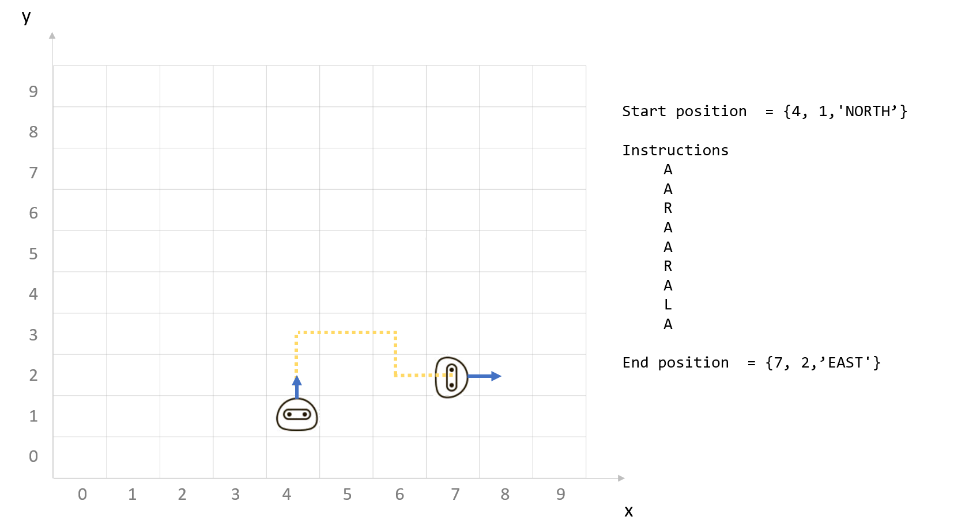

Note
- You are free to decide how to structure your data in Dart language
- Try to use as much as possible functions to separate your logic

Code:
enum Direction { north, east, south, west } // to access each element use .name, .index, .values
void main() {
// Initial position {7, 3} and facing north
int x = 7;
int y = 3;
Direction direction = Direction.north;
// Example instruction sequence
const instructions = "RAALAL";

// Process the instructions and get the final position and direction
for (int i = 0; i < instructions.length; i++ ){
String movement = instructions[i];

if(movement == "R"){
direction = Direction.values[(direction.index +1) % 4];
}else if(movement == "L"){
direction = Direction.values[(direction.index +3) % 4];
}else if (movement == "A") {
if(direction == Direction.north) y++;
else if( direction == Direction.east) x++;
else if (direction == Direction.west) x--;
else if ( direction == Direction.south) y--;
// the below comment is in advance way generate by AI review by me (still not clear)
// final movements = {
// Direction.north: (0, 1),
// Direction.east: (1, 0),
// Direction.south: (0, -1),
// Direction.west: (-1, 0),
// };
// final (dx, dy) = movements[direction]!;
// x += dx;
// y += dy;
}else print("Invalid Instruction");
}

// Print the final position and direction
print("Final position: $x, $y");
print("Facing: $direction.name");
}

HOMEWORK 2 – Matching Brackets

Instructions
Given a string containing brackets [], braces {}, parentheses (), or any combination thereof, verify that any and all pairs are matched and nested correctly. Any other characters should be ignored.

Examples
INPUT | OUTPUT
{what is (42)}? | Balanced
[text} | Not balanced
{[[(a)b]c]d} | Balanced

Code:

String eleminateMatchSymbols(String symbols){ // using recursive
final eleminated = symbols.replaceAll("()", "").replaceAll("[]", "").replaceAll("{}", "");
return (eleminated == symbols) ? symbols : eleminateMatchSymbols(eleminated); // if eleminated == symbols calling the function again and again until it not equal
}
void main (){
// const input = "{what is (42)}?";
const input = "[text}";
// const input = "{[[(ab)]c]d}";
const validSymbols = [
"{", "(", "[", "}", ")", "]"
];
// var stackOpens = input.split("").where((comparedSymbol) => validSymbols.contains(comparedSymbol)).join(); // for simple way but still need to call the function recursive
final checkSymboles = eleminateMatchSymbols(input.split("").where((comparedSymbol) => validSymbols.contains(comparedSymbol)).join()); // in advance way
print(checkSymboles.isEmpty ? "balanced" : "not Balanced");
}

