**Lab 09.**

**Task #1 – Tresure Hunt**

Joonyoung)



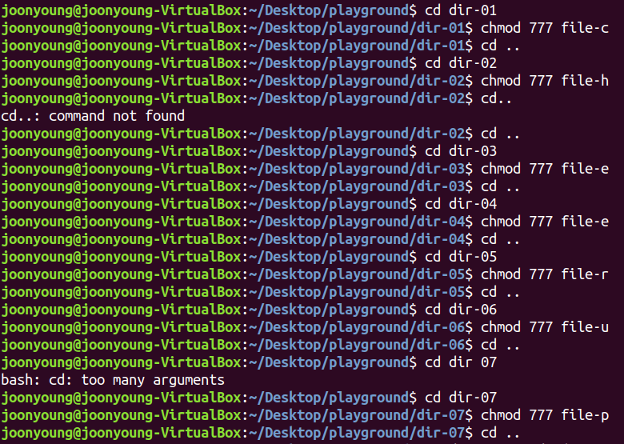

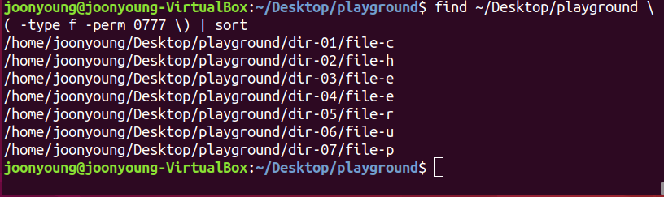

Jin a)

**Task #2**

submit the URL to your remote repository

**https://github.com/ChoiJoonyoung/OSS_09_Post.git**