**\*TOP SECRET\***

**iPear X PROTOTYPE**

**DO NOT DISCLOSE TO ANYONE IN ANY FORM**

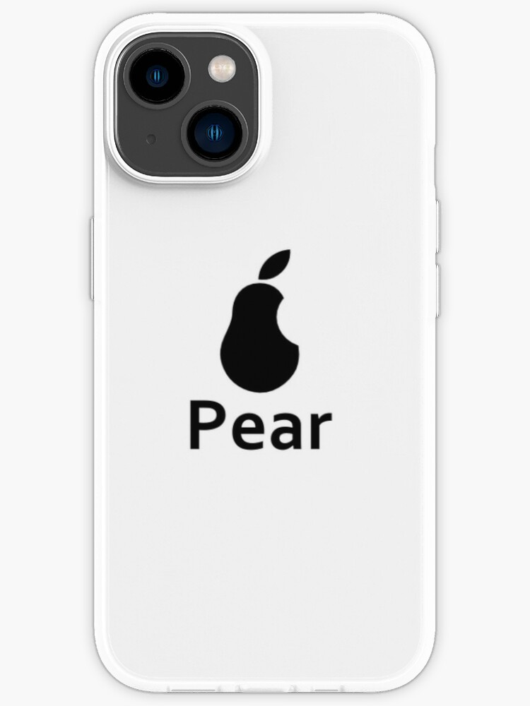

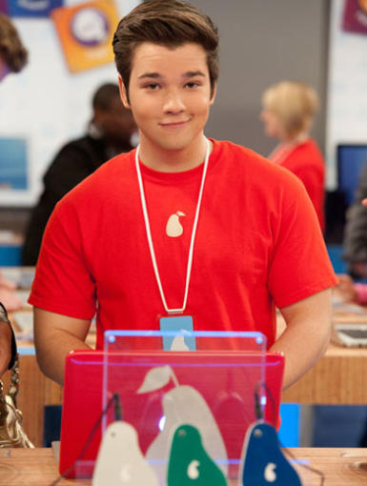

Bruh