From the original paper: The “Narratives” fMRI dataset for evaluating models of naturalistic language comprehension
“Pie Man”
The “Pie Man” dataset was collected between October, 2011 and March, 2013, and comprised 82 participants (ages 18–45 years, mean age 22.5 ± 4.3 years, 45 reported female). The “Pie Man” story was told by Jim O’Grady and recorded live at The Moth, a non-profit storytelling event, in New York City in 2008 (freely available at https://themoth.org/stories/pie-man). The “Pie Man” audio stimulus was 450 seconds (7.5 minutes) long and began with 13 seconds of neutral introductory music followed by 2 seconds of silence, such that the story itself started at 0:15 and ended at 7:17, for a duration 422 seconds, with 13 seconds of silence at the end of the scan. The stimulus was started simultaneously with the acquisition of the first functional MRI volume, and the scans comprise 300 TRs, matching the duration of the stimulus. The transcript for the “Pie Man” story stimulus contains 957 words; 3 words (0.3%) were not successfully localized by the forced-alignment algorithm, and 19 words (2.0%) were not found in the vocabulary (e.g. proper names). The “Pie Man” data were in some cases collected in conjunction with temporally scrambled versions of the “Pie Man” stimulus, as well the “Tunnel Under the World” and “Lucy” datasets among others, and share subjects with these datasets (as specified in the participants.tsv file). The current release only includes data collected for the intact story stimulus (rather than the temporally scrambled versions of the stimulus). The following subjects received the “Pie Man” stimulus on two separate occasions (specified by run-1 or run-2 in the BIDS file naming convention): sub-001, sub-002, sub-003, sub-004, sub-005, sub-006, sub-008, sub-010, sub-011, sub-012, sub-013, sub-014, sub-015, sub-016. We recommend excluding subjects sub-001 (both run-1 and run-2), sub-013 (run-2), sub-014 (run-2), sub-021, sub-022, sub-038, sub-056, sub-068, and sub-069 (as specified in the scan_exclude.json file in the code/ directory) based on criteria explained in the “Intersubject correlation” section of “Data validation.” Subsets of the “Pie Man” data have been previously reported in numerous publications109,115,119,190,191,192,193,194,195,196,197,198, and additional datasets not shared here have been collected using the “Pie Man” auditory story stimulus199,200,201,202. In the filename convention (and figures), “Pie Man” is labeled using the task alias pieman.

In this whole analysis pipeline, we constructed stimulus representations for encoding modeling using the Pie Man narrative transcript and GPT-2 XL. First, token-level contextual embeddings were extracted and aggregated into word-level representations, followed by dimensionality reduction using PCA (50 dimensions) across all model layers. These word embeddings were then temporally aligned to the fMRI sampling rate by aggregating features within each TR, producing TR-level linguistic representations. To account for the delayed hemodynamic response, multiple temporal lags (1–8 TRs) were applied, yielding a lag-expanded feature matrix. Using relaxed coverage filtering, 259 valid TRs were retained, resulting in a final design matrix (pieman_Xlagged_flat.npy) that serves as the complete LLMs feature space for subsequent encoding model training.

Step 1 — Word-Level Alignment and Contextual Embedding Preparation
We used the Pie Man auditory narrative from the dataset (Nastase et al., 2021), which provides naturalistic story stimuli together with temporally aligned linguistic annotations. The dataset includes multiple components designed to facilitate language–brain alignment analyses, including:
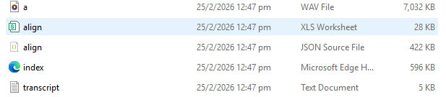
The align.csv file contains forced-alignment outputs linking each spoken word to precise onset and offset timestamps within the audio stream. These timestamps define the temporal correspondence between linguistic content and the continuous stimulus timeline. The Pie Man stimulus lasts 450 seconds and contains 957 spoken words. Forced alignment successfully localized nearly all tokens.

In Step 1, our goal was to construct a unified word-level table linking linguistic content, temporal annotations, and language-model tokenization. Using the forced-alignment transcript (align.csv) as the primary temporal reference, we performed the following preprocessing steps.
First, we parsed the alignment file to extract, for each word: the lexical form, onset time (seconds),
offset time (seconds), and word duration.

Next, the transcript was tokenized using the GPT-2 XL tokenizer. Because GPT-2 employs byte-pair encoding (BPE), individual words may correspond to one or multiple subword tokens. We therefore mapped each aligned word to its corresponding token indices while preserving the original temporal boundaries defined by the forced alignment. To ensure compatibility with contextual embedding extraction, we verified that every aligned word was associated with at least one tokenizer output token. Words not localized by forced alignment were retained but flagged for diagnostic inspection.
audio time → word → token indices

A CSV file (pieman_word_table.csv) was generated containing one row per aligned word (N = 957). Each row includes: word identity, onset and offset timestamps, duration, token span indices, token count per word.

The Fig.1 shows the distribution of word durations derived from forced alignment.
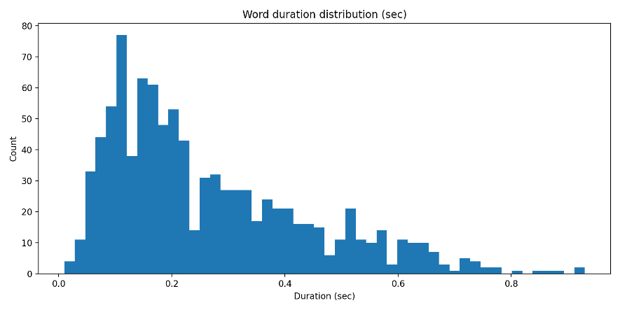
Fig.1

Fig. 2 shows the number of GPT-2 tokens associated with each word. Because GPT-2 uses sub-word segmentation, multi-token mappings are possible, particularly for rare or morphologically complex words.
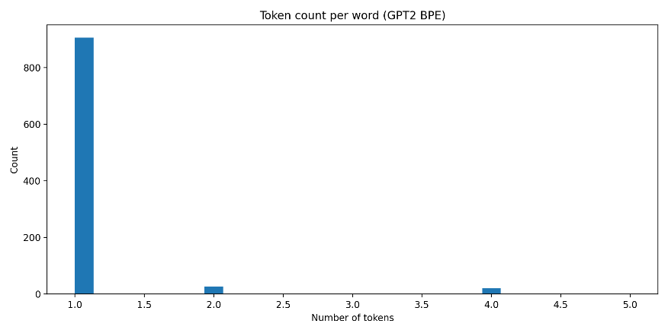
Fig.2

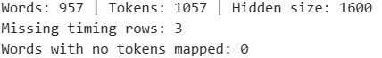
According to out results, the dataset contained 957 words and 1,057 tokenizer tokens, indicating modest sub-word fragmentation consistent with GPT-2 tokenization processing. Only 3 words lacked reliable timing information, and all aligned words were successfully mapped to at least one token, demonstrating complete coverage of linguistic content.
Step1 converts raw narrative stimuli into a structured representation linking acoustic time, lexical units, and model input token indices. This representation enables later extraction of contextual embeddings, temporal aggregation into repetition-time bins, and construction of lagged encoding design matrices.

Notice! In Step1, embeddings extracted at this stage were limited to the final hidden layer of GPT-2 XL and served only as a diagnostic validation of the alignment pipeline. Therefore, in Step 2 we extended the procedure to extract contextual embeddings from all layers of GPT-2 XL and constructed a reduced-dimensional representation suitable for time-resolved encoding analyses.
Step 2 — Extraction of Layer-wise Contextual Embeddings from GPT-2 XL:
To construct stimulus representations suitable for encoding analyses, we extracted contextual embeddings from the pretrained GPT-2 XL language model (Radford et al., 2019). Using the temporally aligned transcript in Step 1, the full narrative text was processed sequentially through the GPT-2 tokenizer. Because transformer models operate under a fixed context window, embeddings were extracted using a sliding-window procedure to preserve contextual continuity across the entire story while avoiding truncation artifacts.
For each token position, hidden states were collected from: 𝐿 = 49 representational levels (embedding layer + 48 transformer layers):
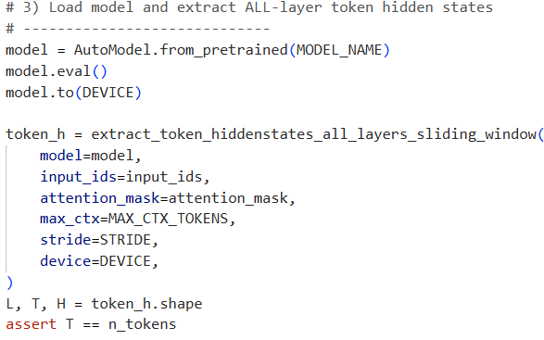
Each tensor in hidden_states corresponds to contextual representations at a specific layer:
(layer, token, hidden_dimension)
the hidden dimensionality equals 1600 for GPT-2 XL

Next, we tried to proceed word-level aggregation, since forced alignment proceeded at the word level while GPT-2 produces token-level representations, token embeddings belonging to the same word were averaged to obtain a single contextual embedding per word. This aggregation preserves contextual information while ensuring temporal compatibility with alignment timestamps:
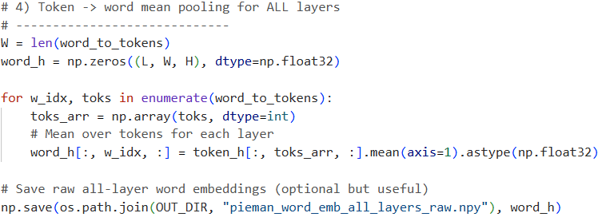

This procedure produced a tensor of shape:
(words × layers × hidden_size)
= (957 × 49 × 1600)

Next, we tried to reduce the dimensionality, high-dimensional Transformer representations are highly redundant and may lead to unstable regression estimates. Following previous studies (Bhattacharjee et al., 2025), we reduced embedding dimensionality using PCA applied independently to each layer.
Specifically, for each layer, PCA was fitted across words:
(words × layers × PCA_dim)
= (957 × 49 × 50)

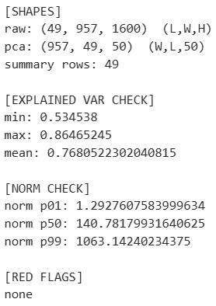
We evaluated dimensionality reduction using cumulative explained variance ratios across layers. The retained components explained between 53% and 86% of variance depending on layer depth (mean ≈ 76.8%), indicating effective compression without substantial information loss.

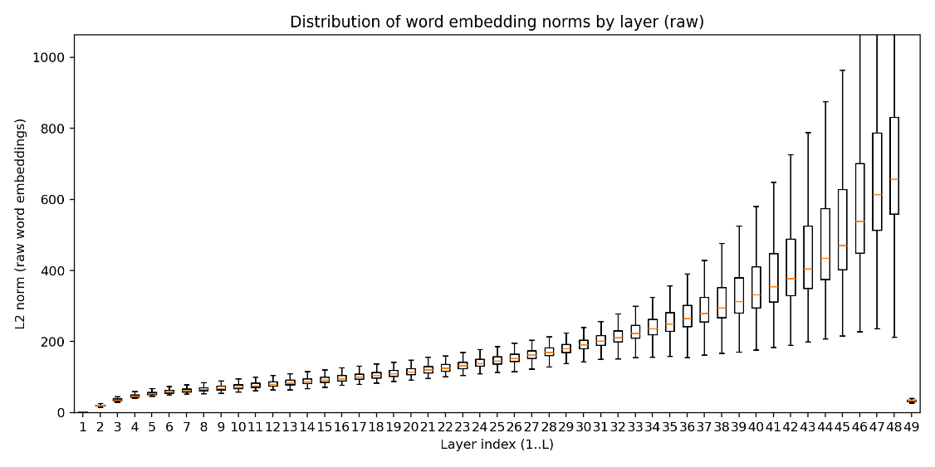
Fig3
Fig3 shows embedding norms increased monotonically with layer depth. Early layers exhibited relatively small magnitudes with limited variance, whereas deeper transformer layers showed progressively larger norms. The increased trend in embedding norms across layers points that the extracted representations capture the hierarchical progression from lexical processing to deeper contextual processing.

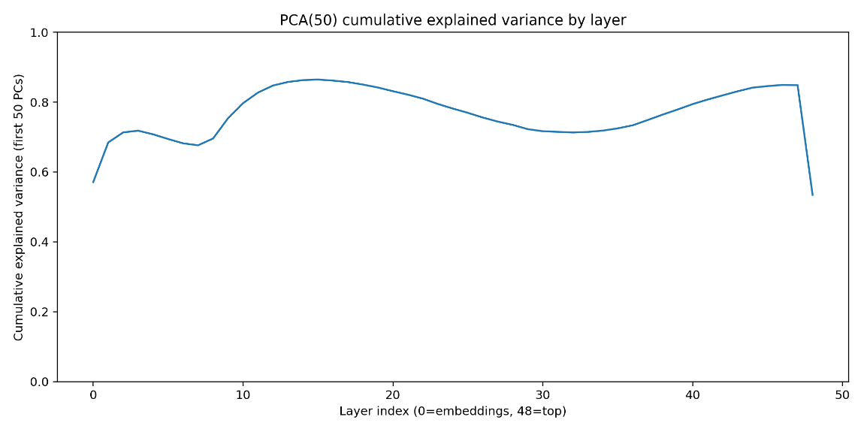
Fig.4
Fig.4 shows effectiveness of dimensionality reduction by computing cumulative explained variance ratios for the first 50 principal components independently within each layer. About 9 to 22, 33-47 layers exhibited the highest explained variance, suggesting that deeper representations are more structurally organized. In contrast, early embedding layers (1-8) required more components to capture equivalent variance, reflecting higher variability associated with lexical representations.
Step 2 converts temporally aligned linguistic input into a hierarchy of contextual representations, which produced the full stimulus feature space used to model neural responses.

Step 3 — TR-level aggregation of language-model features
fMRI data are sampled at the repetition time (TR), whereas linguistic annotations and language-model representations are defined at temporal resolution (word onsets/offsets). To make stimulus representations commensurate with neuroimaging data, we aggregated word-level GPT-2 XL representations into TR-aligned features. This step generated a discrete time series X(t) where each time point corresponds to one fMRI volume and contains a compact representation of the linguistic content occurring within that TR window.
For the Pie Man stimulus, the scan duration is 450 seconds and comprises 300 TRs at TR = 1.5 s, matching the full stimulus timeline

We first defined TR bins spanning the full experiment. We then assigned each word to TR bins based on the temporal overlap between the word’s forced-alignment interval and each TR bin.
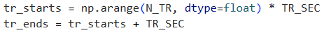
Because words can straddle TR boundaries, we used duration-weighted overlap rather than hard assignment:
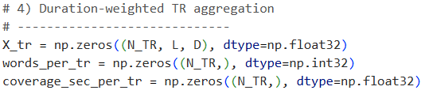
Next, word-level features were then aggregated into a TR-level feature vector as a weighted mean across all words overlapping that bin:
This procedure was applied independently for every GPT-2 XL layer and every retained PCA component, producing a TR-level tensor of shape (N TR, L, D) where L=49 layers and D=50 PCA dimensions.

The final results contains:
TR-level feature tensor
containing X(t) with shape (300, 49, 50)

TR summary table
, for each TR: TR start/end time (sec), number of contributing words,
total linguistic coverage within the TR (seconds).

containing one row per TR × layer pair with the 50 PCA features plus metadata.

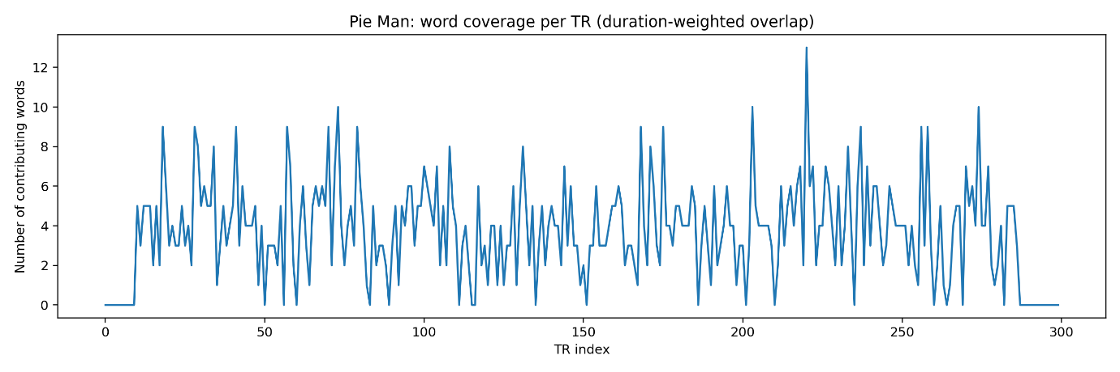
Fig.5
Fig.5 shows the number of words contributing to each TR. This time course serves as a direct proxy for linguistic density and confirms that: the initial TRs contain minimal or no words (consistent with introductory music). The main story segment exhibits sustained word coverage with natural variability, and the final TRs return to near-zero coverage (consistent with end-of-scan silence). These patterns indicate that forced-alignment timings and TR binning are coherent.

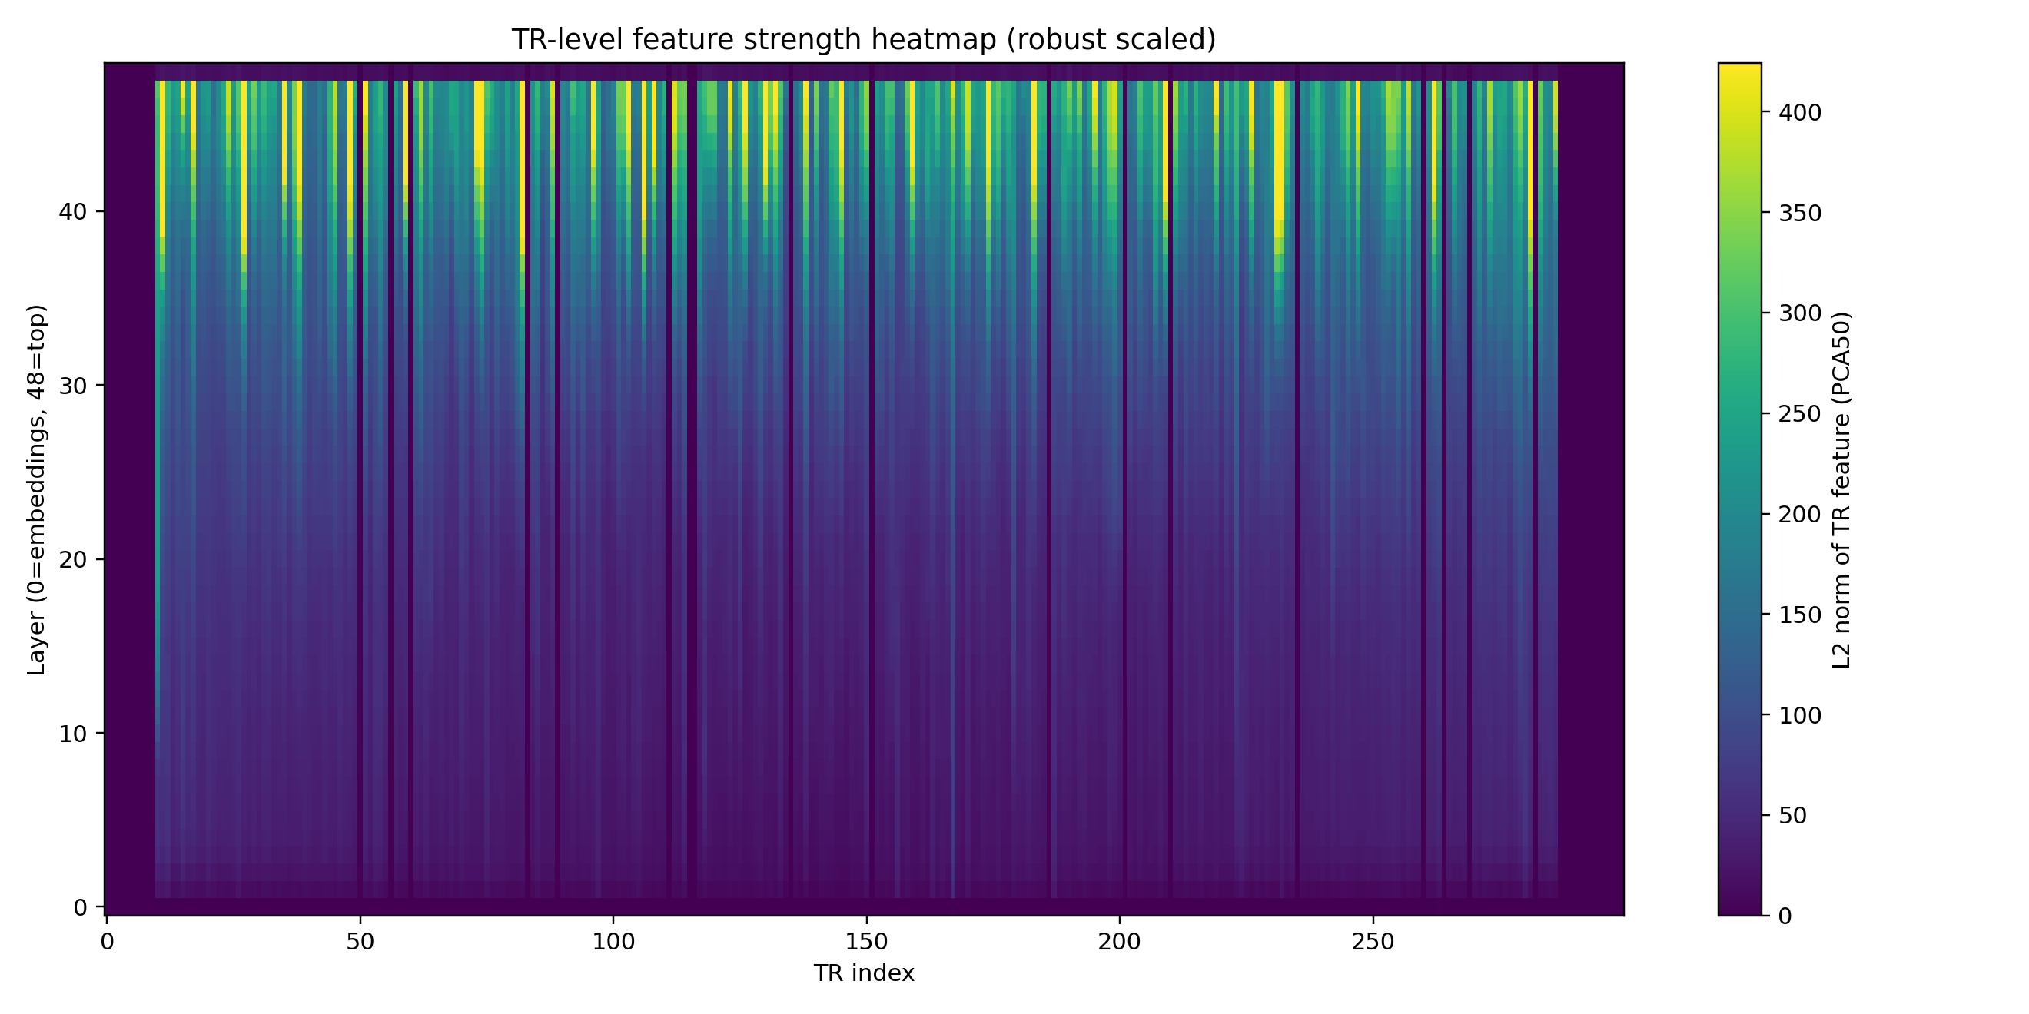
Fig.6
Fig.6 shows the computational results about the L2 norm of the PCA feature vector for each TR and layer. The figure shows higher feature magnitudes in deeper transformer layers, consistent with the layer-wise norm structure observed at the word level.25/2/2026

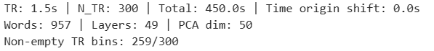
In Pie Man analysis, a substantial fraction of TRs contained non-zero linguistic coverage (TR bins: 259/300), while the remaining TRs corresponded primarily to introductory or trailing silent segments and occasional sparse bins.
The outputs of Step 3 constitute the canonical TR-aligned stimulus features X(t) used for subsequent hemodynamic delay modeling and construction of encoding design matrices.

Step 4 — Construction of Lagged Encoding Design Matrices
Although TR-level linguistic features provide temporal alignment between language representations and stimulus time, neural data measured with fMRI reflect delayed and temporally blurred hemodynamic activity rather than instantaneous processing. Thus, encoding models should incorporate temporal offsets between stimulus features and neural signals.
In order to try to solve this delay, we constructed lagged stimulus representations, allowing each fMRI time point to depend on linguistic features occurring several seconds earlier. This approach corresponds to a finite impulse response (FIR) formulation widely used in naturalistic encoding analyses.
For the Pie Man dataset (TR = 1.5 s), we modeled delays spanning:
1–8 TRs (1.5–12s),
which covering the typical temporal extent of the hemodynamic response function (HRF).

For each target TR 𝑡, we constructed a lagged feature tensor: Xlag​(t)=[X(t−1),X(t−2),…,X(t−8)]. Each sample therefore contains linguistic information from the preceding temporal window rather than the current TR alone. This produces a 4D representation:
(NTR​, Nlags​, L, D)
Nlags = 8, L = 49 GPT-2 layers, D = 50 PCA components.

The lagged tensor was constructed directly from the TR-level feature array:
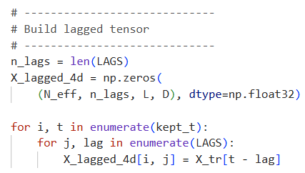

The resulting tensor was additionally reshaped into a flattened design matrix suitable for regression-based encoding models:
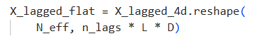

BUT! Here is the question!
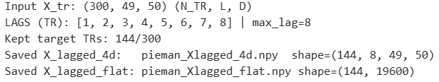
Our Initial construction required all lagged TRs to contain linguistic coverage, which substantially reduced usable samples (Kept target TRs: 144/300). Because silent intervals naturally occur in continuous speech and do not invalidate encoding analyses, we adopted a relaxed filtering criterion in which only target TRs were required to contain linguistic input.
The final selection rule was:
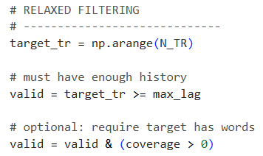
Lagged TRs with zero linguistic overlap were retained and represented as zero-valued feature vectors, preserving temporal continuity while maximizing statistical power.

Thus, we finally got the following files:
Structured lagged tensor (TR × lag × layer × PCA)
Temporal indices and preprocessing metadata
Most importantly, the lagged tensor was reshaped into this regression-ready design matrix: with dimensions: 259×19600. And 259 TR samples × (8 lags × 49 layers × 50 PCA features)

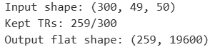
The NEW filtering retained 259 of 300 TRs, removing only boundary segments lacking linguistic content while preserving the continuous narrative timeline.

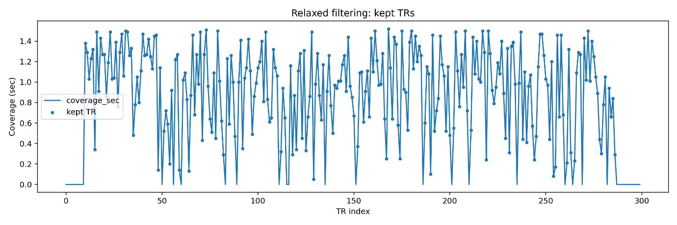
Fig. 7
Fig.7 visualizes temporal coverage of linguistic input across TRs. The blue curve represents word coverage duration (seconds) within each TR. Blue markers indicate TRs retained after relaxed filtering. Coverage varies continuously across the narrative, reflecting natural speech pacing.
Most TRs contain substantial linguistic information (>0.5 s overlap). Only boundary regions (beginning/end silence) lack coverage. Relaxed filtering preserves nearly the full narrative temporal structure while excluding empty bins.

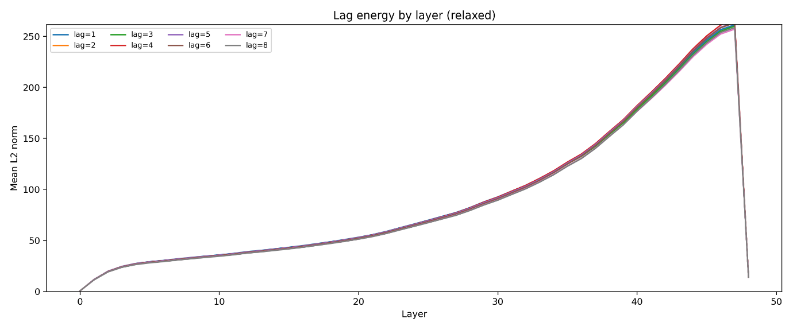
Fig.8
Fig. 8 summarizes feature magnitude across GPT-2 XL layers after temporal lag expansion. Y-axis: mean L2 norm of lagged PCA features. Multiple curves correspond to temporal delays (lags 1–8 TRs). We can see that feature energy grows steadily into higher layers, indicating progressively richer contextual representations. All lag lines nearly overlap, showing that temporal shifting does not distort representation scale, lagged features are numerically stable.

The most important file in this pipeline is:

This file contains the final stimulus design matrix used for all subsequent encoding analyses.
It has: (1) the complete GPT-2 XL hierarchical representation; (2) temporally aligned to the stimulus, (3) dimensionally reduced, (4) transformed into an HRF-aware feature space.
pieman_Xlagged_flat.npy is the input 𝑋 for every encoding model trained in later stages of the study.

