Implementation of an End-to-End SOC Monitoring and Incident Response Lab Using Wazuh and MISP

1.Wazuh File Integrity Monitoring (FIM)
Windows Endpoint Setup and Testing Report

1. Purpose
The purpose of this lab is to monitor a selected folder on a Windows endpoint using Wazuh File Integrity Monitoring. When a file is created, changed, or deleted inside the folder, the Windows Wazuh Agent sends the event to the Ubuntu Wazuh Manager. The alert then appears on the Wazuh Dashboard.

2. Lab Architecture
Windows Endpoint  Wazuh Agent  C:\SOC-Lab\Monitored | Ubuntu Server  Wazuh Manager  Indexer  Dashboard | SOC Analyst  Dashboard Review  Investigation  Evidence Collection
File activity → Wazuh Agent → Wazuh analysis → FIM alert

3. Requirements
- Wazuh Manager, Indexer, and Dashboard must be running on Ubuntu.
- The Wazuh Agent must be installed and active on the Windows endpoint.
- You must have sudo access on the Ubuntu server.
- Windows PowerShell must be opened as Administrator.
- This report uses Agent ID 001 as an example. Replace it with your own Agent ID.

4. Step 1: Check Wazuh Services and Agent Status
Run the following commands in the Ubuntu Terminal or a MobaXterm SSH session. Check that all three Wazuh services are running.
sudo systemctl status wazuh-manager --no-pager
sudo systemctl status wazuh-indexer --no-pager
sudo systemctl status wazuh-dashboard --no-pager

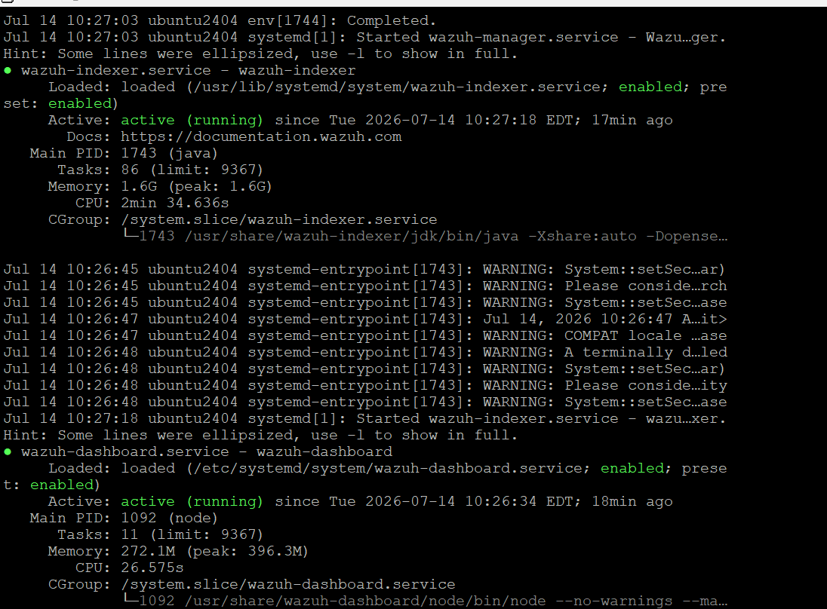

Now check the Windows agent ID and status:
sudo /var/ossec/bin/agent_control -l

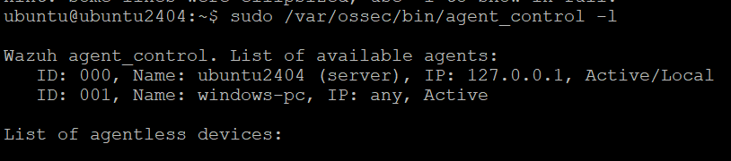

5. Step 2: Create a Windows Agent Group
Create a group named windows-soc for centralized configuration. This allows you to manage the Windows agent FIM settings from the Ubuntu Wazuh Manager.
sudo /var/ossec/bin/agent_groups -a -g windows-soc
sudo /var/ossec/bin/agent_groups -l

6. Step 3: Add the Windows Agent to the Group
In the following command, replace 001 with your Windows agent ID.
sudo /var/ossec/bin/agent_groups -a -i 001 -g windows-soc
sudo /var/ossec/bin/agent_groups -s -i 001

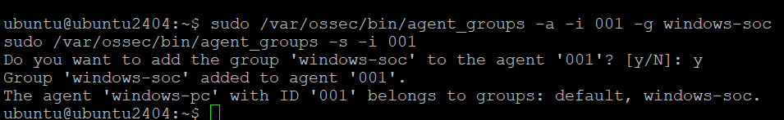

7. Step 4: Create Monitored and Quarantine Folders on Windows
Open Windows PowerShell as Administrator and run the following commands. The monitored folder must exist before real-time FIM monitoring starts.
New-Item -ItemType Directory -Force "C:\SOC-Lab\Monitored"
New-Item -ItemType Directory -Force "C:\SOC-Lab\Quarantine"
Get-ChildItem "C:\SOC-Lab"

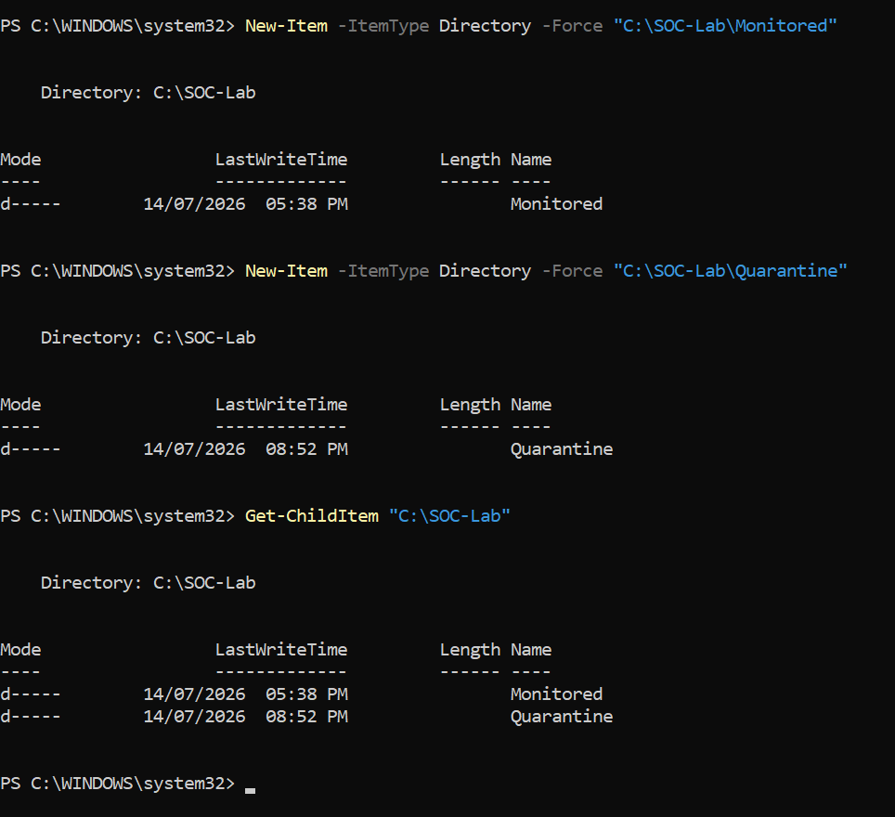

8. Step 5: Create the Centralized FIM Configuration
Create a temporary agent.conf file on the Ubuntu Wazuh Server. A temporary file helps prevent an incomplete XML configuration from being sent to the agent.
sudo touch /var/ossec/etc/shared/windows-soc/agent.conf.tmp
sudo chown wazuh:wazuh /var/ossec/etc/shared/windows-soc/agent.conf.tmp
sudo chmod 660 /var/ossec/etc/shared/windows-soc/agent.conf.tmp
sudo nano /var/ossec/etc/shared/windows-soc/agent.conf.tmp

Paste the following XML configuration into the Nano editor:

<agent_config os="Windows">
<syscheck>
<disabled>no</disabled>
<directories check_all="yes"
report_changes="yes"
realtime="yes">C:\SOC-Lab\Monitored</directories>
</syscheck>
</agent_config>
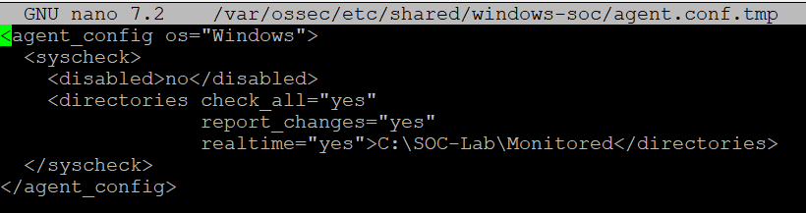
To save: Press Ctrl + O, press Enter, then press Ctrl + X.

9. Step 6: Validate and Activate the Configuration
First, validate the XML configuration. Do not activate it if an error appears.
sudo /var/ossec/bin/verify-agent-conf -f /var/ossec/etc/shared/windows-soc/agent.conf.tmp

After successful validation, rename the temporary file to agent.conf:
sudo mv /var/ossec/etc/shared/windows-soc/agent.conf.tmp \
/var/ossec/etc/shared/windows-soc/agent.conf

The Wazuh Manager automatically detects the new shared configuration and sends it to the agents in the group. You may restart the manager to speed up the update:
sudo systemctl restart wazuh-manager

10. Step 7: Check Configuration Synchronization
Use the following command to check whether the agent received the shared configuration:
sudo /var/ossec/bin/agent_groups -S -i 001

11. Step 8: Check the Windows Agent Service
Open Windows PowerShell as Administrator and check that the service is running. Restarting the service before the test helps ensure that the new configuration is loaded.
Get-Service wazuh
Restart-Service -Name wazuh
Get-Service wazuh

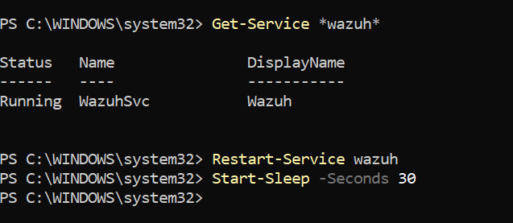

12. Step 9: Test FIM Detection
Now create, modify, and delete the same file to generate three FIM events. Wait 5 seconds after each action.

12.1 File Creation Test
Set-Content -Path "C:\SOC-Lab\Monitored\demo.txt" `
-Value "Wazuh FIM Test"
Start-Sleep -Seconds 5

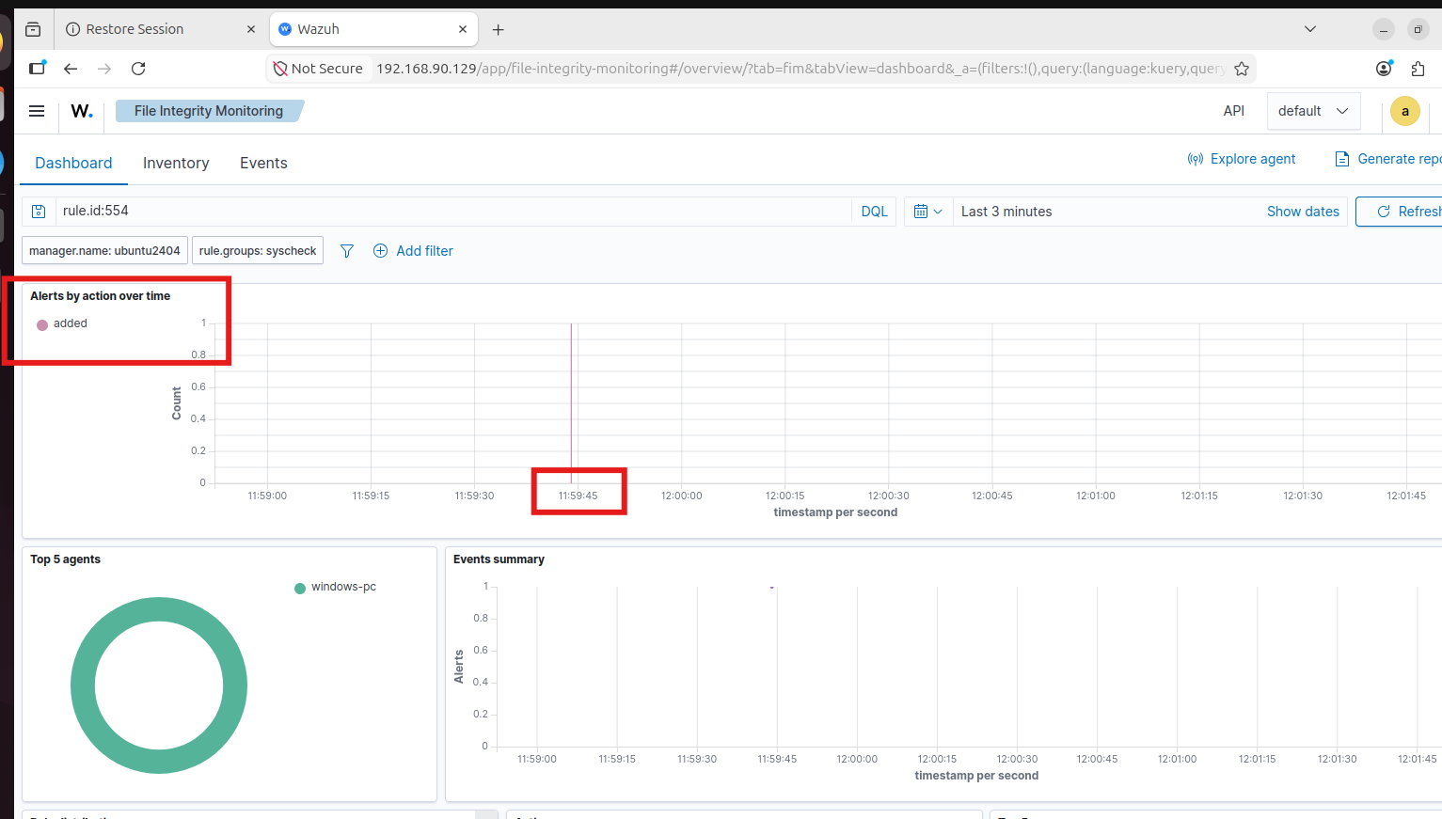

12.2 File Modification Test
Add-Content -Path "C:\SOC-Lab\Monitored\demo.txt" `
-Value "File Modified"
Start-Sleep -Seconds 5
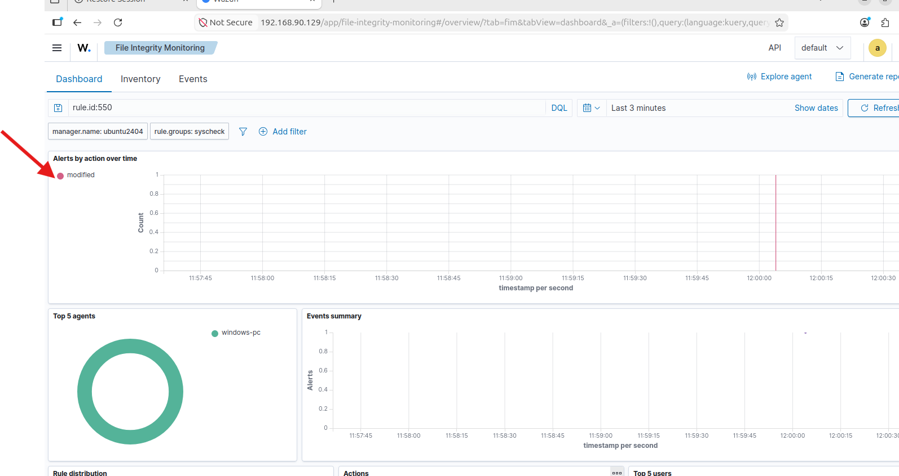

12.3 File Deletion Test
Remove-Item "C:\SOC-Lab\Monitored\demo.txt"
Start-Sleep -Seconds 5
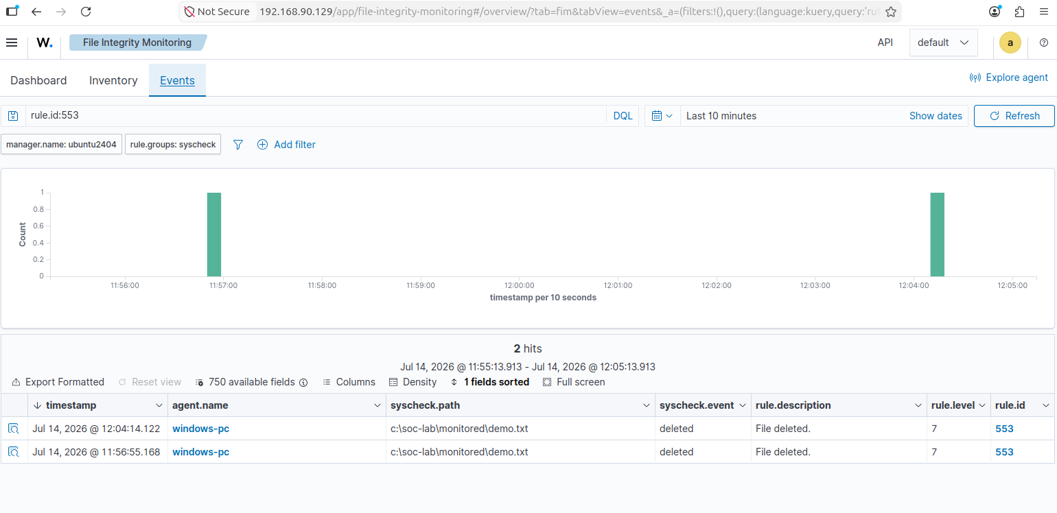

13. Step 10: View FIM Alerts on the Wazuh Dashboard
Log in to the Wazuh Dashboard and open the File Integrity Monitoring module. The menu path may be slightly different depending on the Wazuh version. Usually, the Events view is available under Endpoint Security or File Integrity Monitoring.
- Set the dashboard time range to Last 24 hours or another suitable range.
- Open the Events view in File Integrity Monitoring.
- Filter the events using Rule IDs 550, 553, and 554.
rule.id: is one of 550,553,554

Typical rule mapping:
Rule ID | Event | Expected Description
554 | File added | File added to the system
550 | File modified | Integrity checksum changed
553 | File deleted | File deleted from the system

For rule.id 553
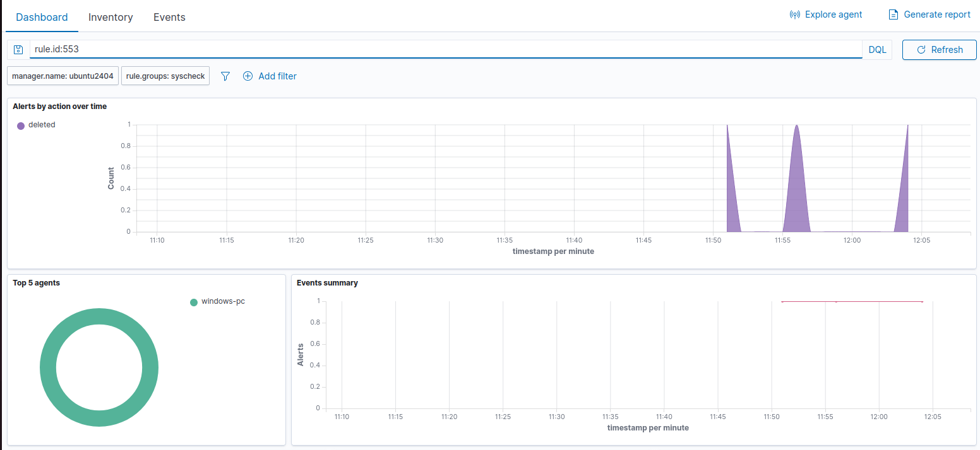
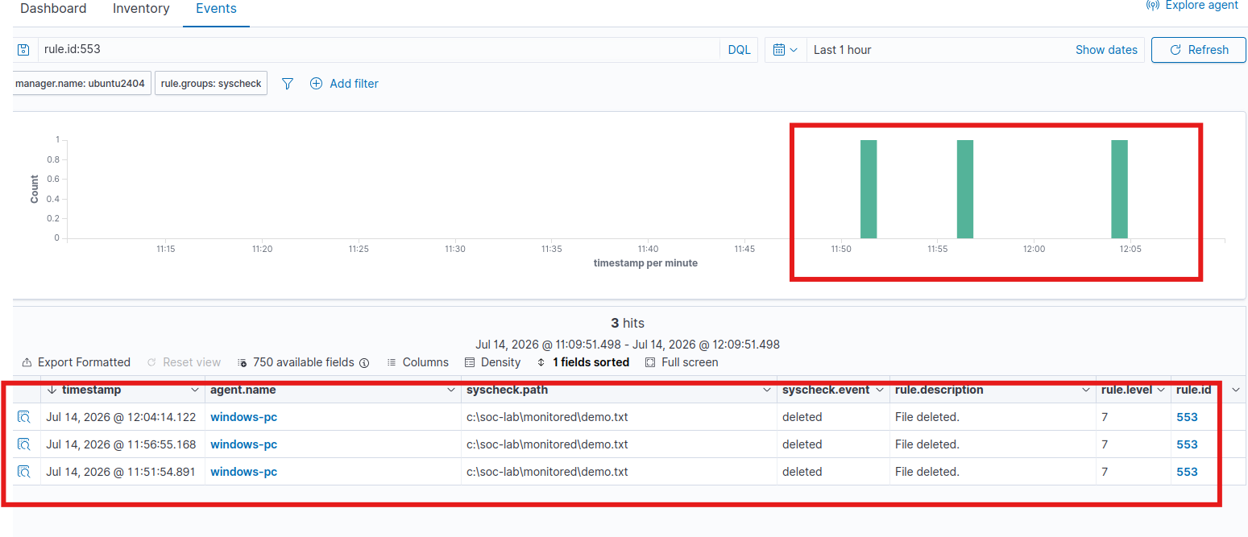

14. Review the Alert Details
Open any FIM alert and use the following fields as evidence:
Field | Meaning
agent.name | The Windows endpoint that sent the event
rule.id | The FIM rule that was triggered
syscheck.path | The file or path that changed
syscheck.event | The event type: added, modified, or deleted
syscheck.sha256_after | The file hash after the change, if available
timestamp | The time of the event
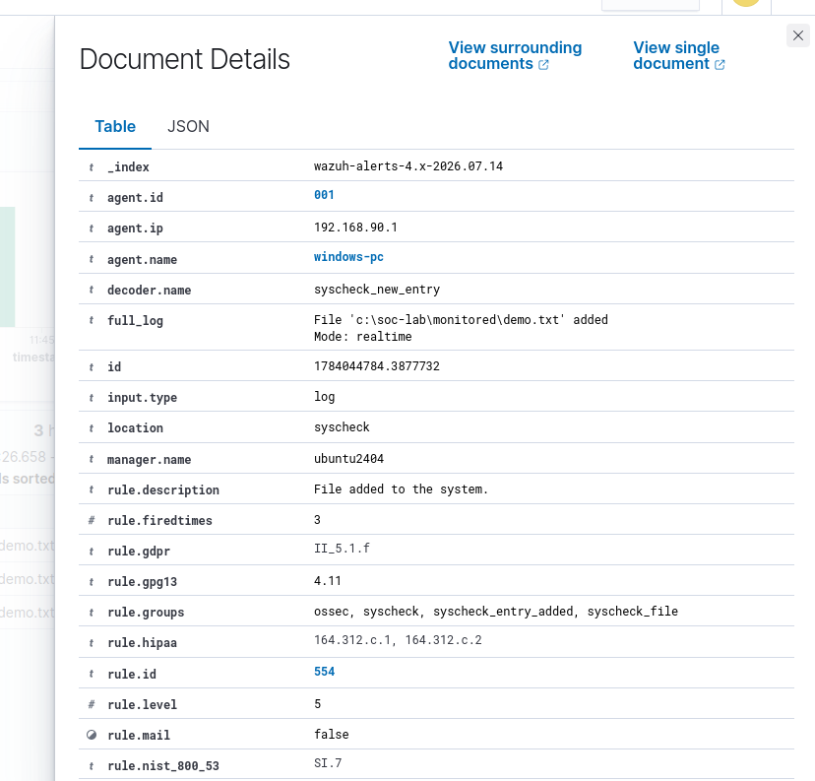

15. Observation and Result
Test | Observed Rule ID | Result
File creation | 554 | Pass
File modification | 550 | Pass
File deletion | 553 | Pass
Agent synchronization | Synchronized | Pass
Final observation: After a file was created, modified, and deleted in the monitored Windows directory, the Wazuh Agent collected the events and the related FIM alerts appeared on the Ubuntu Wazuh Server Dashboard.

16. Troubleshooting
Problem | Possible Cause | Solution
Agent is not synchronized | The Agent ID is wrong or the configuration has not been distributed yet | Check the Agent ID, wait 30 seconds, and restart wazuh-manager if needed.
verify-agent-conf error | An XML tag or quotation mark is incorrect | Open agent.conf.tmp again, correct the XML, and validate it again.
FIM alerts do not appear | The Monitored folder did not exist before the configuration was applied | Create the folder and restart the Windows Wazuh Agent.
Events do not appear on the Dashboard | The time range or filter is incorrect | Select Last 24 hours and filter by Rules 550, 553, and 554.
The Windows service does not restart | PowerShell is not running as Administrator | Open PowerShell as Administrator and run the command again.
A network folder is not being monitored | Windows FIM requires a local path | Use a local folder on the C: drive. Do not use a UNC path or mapped drive.

2.Security Configuration Assessment (SCA)
Wazuh Security Configuration Assessment checks whether the Windows endpoint follows recommended security settings. In this lab, the system was assessed using the CIS Microsoft Windows 11 Enterprise Benchmark v3.0.0.
The assessment completed 482 security checks. The results were:
- Passed: 124
- Failed: 349
- Not applicable: 9
- Compliance score: 26%
A failed check does not mean that the computer is hacked. It means that the security setting does not meet the recommended CIS security standard. For example, weak password policies, disabled audit settings, or insecure system configurations may produce failed results.
SCA helps the SOC analyst identify security weaknesses before an attack occurs. Each failed check includes information that can be used to improve and harden the endpoint.

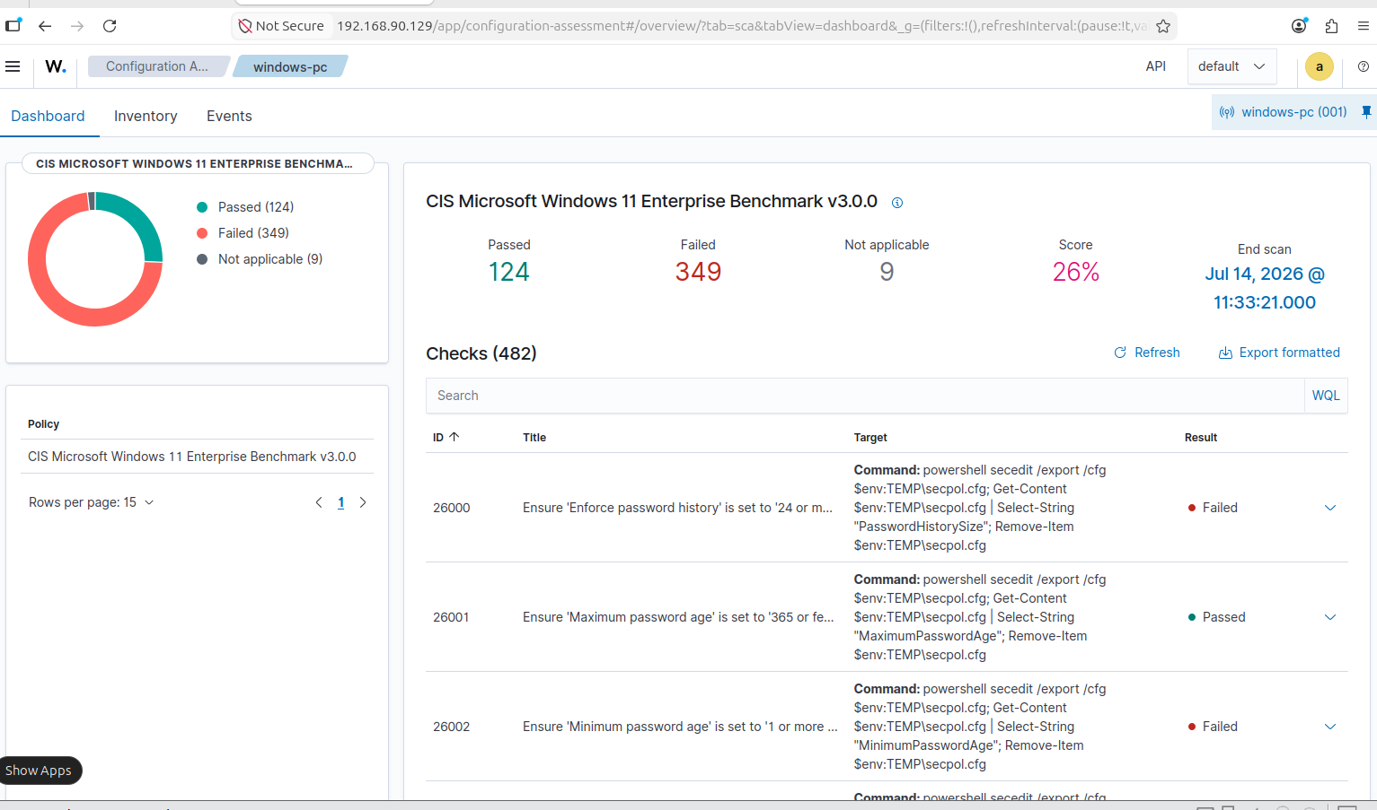
Figure: Windows 11 Security Configuration Assessment result showing passed, failed, not applicable checks, and the overall compliance score.

Final Observation
The SCA scan was completed successfully. The result shows that the Windows endpoint requires further security hardening because the current compliance score is 26%.

3.Response Status

Manual Incident Response
A manual response can be performed by moving a suspicious file from the monitored folder to the quarantine folder.

Open Windows PowerShell as Administrator and run:
Get-ChildItem "C:\SOC-Lab\Monitored"
Move-Item "C:\SOC-Lab\Monitored\suspicious-demo.txt" `
"C:\SOC-Lab\Quarantine\suspicious-demo.txt"
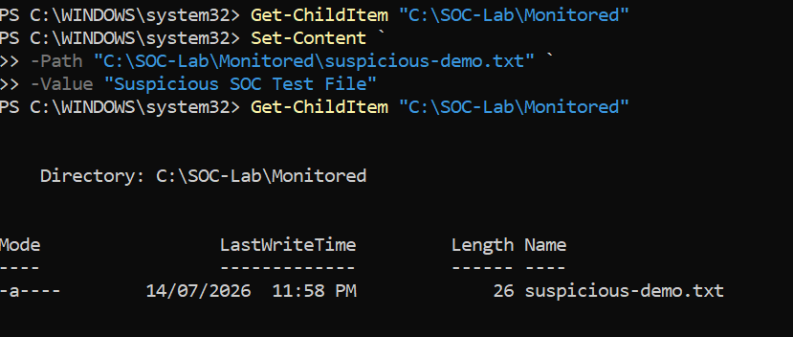
Verify the quarantined file:
Get-ChildItem "C:\SOC-Lab\Quarantine"
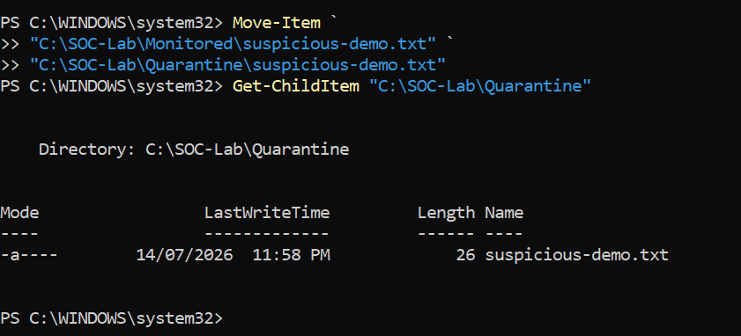

This process removes the suspicious file from the monitored location and isolates it inside the quarantine folder.

4. Vulnerability Detection
Vulnerability Detection should be checked from the Wazuh Dashboard.
Navigation path:
Vulnerability Detection
→ Inventory or Events
The dashboard may display:
- CVE number
- Vulnerability severity
- Affected software
- Installed software version
- Recommended update or remediation
This feature helps the SOC analyst identify outdated or vulnerable software installed on the Windows endpoint.
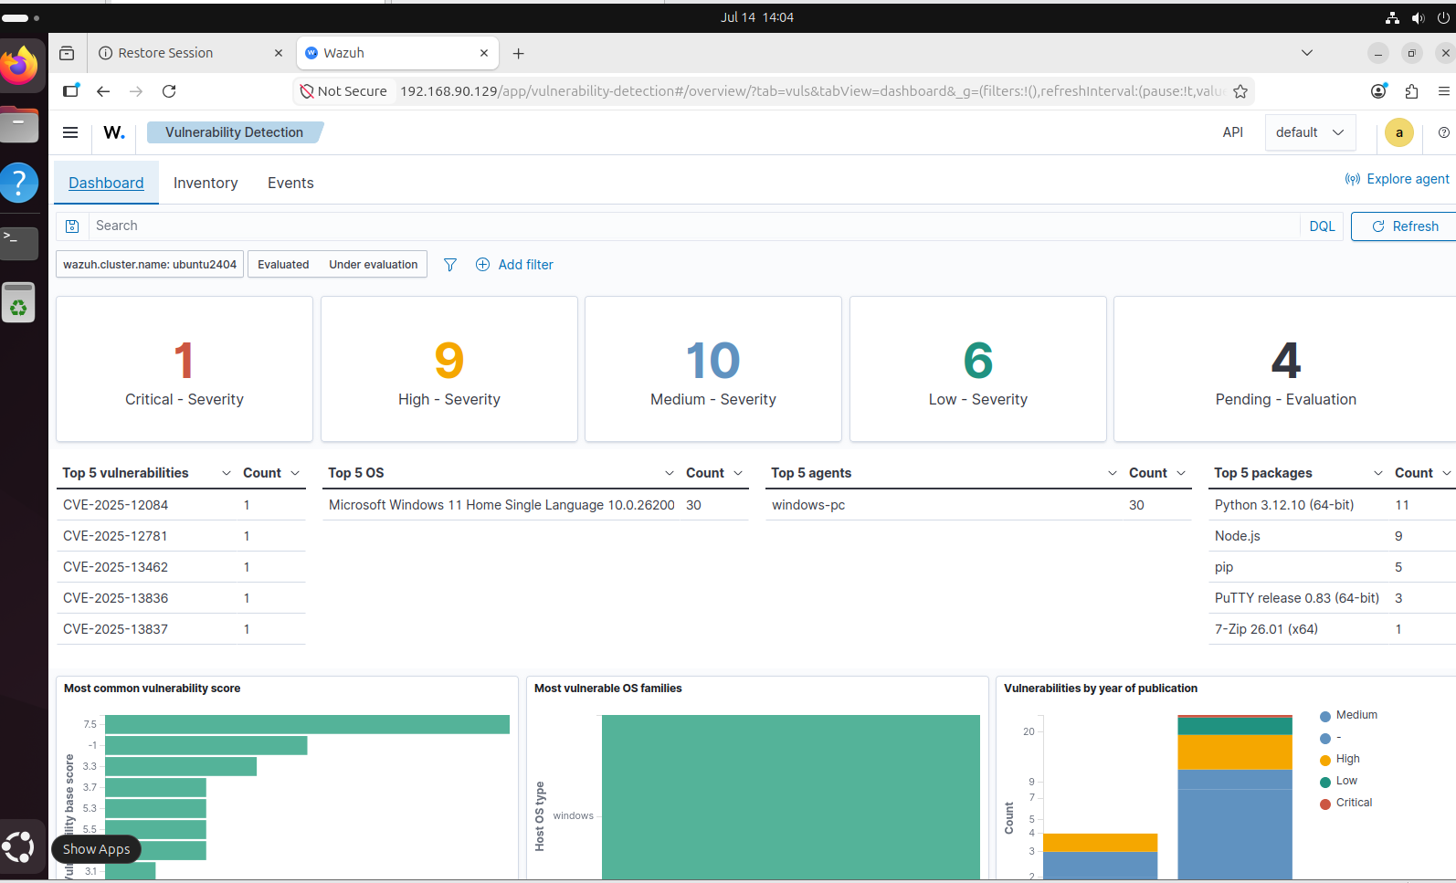
Figure: Vulnerability Detection result showing CVE, severity, and affected software.

5. MISP Threat Intelligence Platform Setup
MISP was installed on a separate Ubuntu virtual machine to keep the threat intelligence platform independent from the Wazuh server. Both virtual machines were connected to the same VMware network so that Wazuh could query the MISP REST API.
5.1 Lab Architecture
Windows Endpoint (Wazuh Agent)
|
v
Ubuntu VM 1: Wazuh Manager and Dashboard (192.168.90.129)
| HTTPS REST API
v
Ubuntu VM 2: MISP Server (192.168.90.130)
5.2 Create the MISP Virtual Machine
- Create a second Ubuntu 24.04 virtual machine in VMware.
- Use the same network mode as the Wazuh VM, such as NAT or Bridged.
- Recommended lab resources: 4 CPU cores, 8 GB RAM, and at least 50 GB storage.
- Install Ubuntu and enable SSH if remote terminal access is required.
sudo apt update
sudo apt upgrade -y
sudo apt install -y git curl ca-certificates openssh-server
sudo systemctl enable --now ssh
hostname -I
5.3 Install Docker Engine and Compose
sudo install -m 0755 -d /etc/apt/keyrings
sudo curl -fsSL https://download.docker.com/linux/ubuntu/gpg -o /etc/apt/keyrings/docker.asc
sudo chmod a+r /etc/apt/keyrings/docker.asc
echo "deb [arch=$(dpkg --print-architecture) signed-by=/etc/apt/keyrings/docker.asc] https://download.docker.com/linux/ubuntu $(. /etc/os-release && echo ${UBUNTU_CODENAME:-$VERSION_CODENAME}) stable" | sudo tee /etc/apt/sources.list.d/docker.list > /dev/null
sudo apt update
sudo apt install -y docker-ce docker-ce-cli containerd.io docker-buildx-plugin docker-compose-plugin
sudo systemctl enable --now docker
sudo docker --version
sudo docker compose version

5.4 Download and Start MISP
cd ~
git clone https://github.com/MISP/misp-docker.git
cd misp-docker
cp template.env .env
nano .env
The following values were configured in the .env file. The actual password is not included in this report.
ADMIN_EMAIL=admin@soclab.local
ADMIN_ORG=SOC-LAB
ADMIN_PASSWORD=[REDACTED]
BASE_URL=https://192.168.90.130
TZ=Asia/Dhaka
After saving the configuration, the MISP container images were downloaded and started:
sudo docker compose pull
sudo docker compose up -d
sudo docker compose ps
Successful status requires the database, Redis, MISP modules, and MISP core containers to be running. The MISP web interface is then opened from a browser at:
https://192.168.90.130
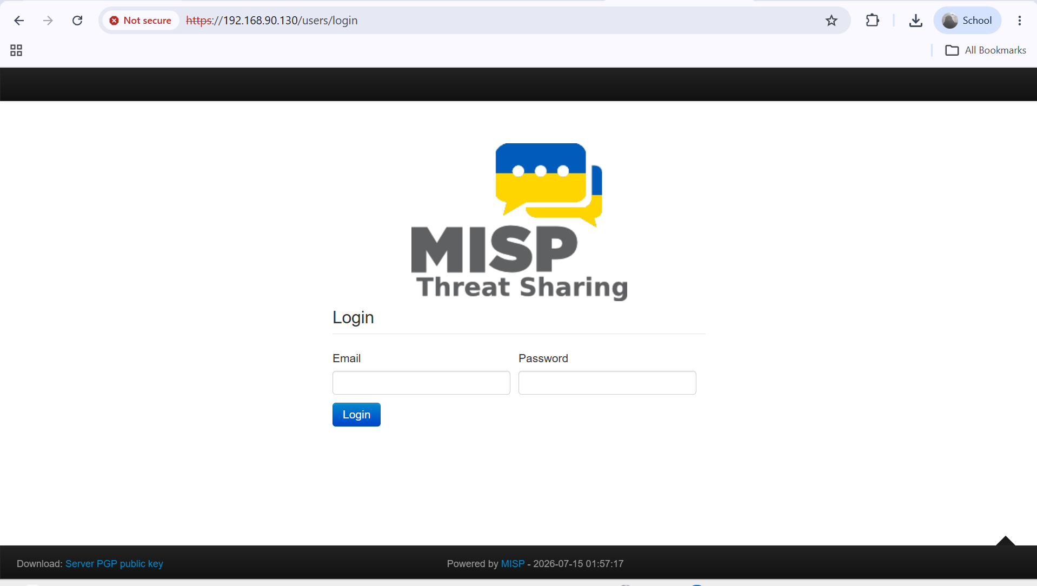
Figure: MISP login page available through HTTPS on the MISP virtual machine.
5.5 Create and Publish a Test IOC
A harmless text file was created on the Windows endpoint and its SHA256 hash was calculated. This hash was used as a controlled test IOC in MISP.
Set-Content -Path "C:\SOC-Lab\test-misp.txt" -Value "SOC MISP TEST FILE" -NoNewline
(Get-FileHash "C:\SOC-Lab\test-misp.txt" -Algorithm SHA256).Hash.ToLower()
In MISP, a new event named SOC Lab Suspicious File IOC was created. The SHA256 value was added as an attribute with the following settings:
- Category: Payload delivery
- Type: sha256
- For IDS: Yes
- Distribution: Inherit event
- Comment: Harmless file hash for Wazuh SOC lab
- Event status: Published
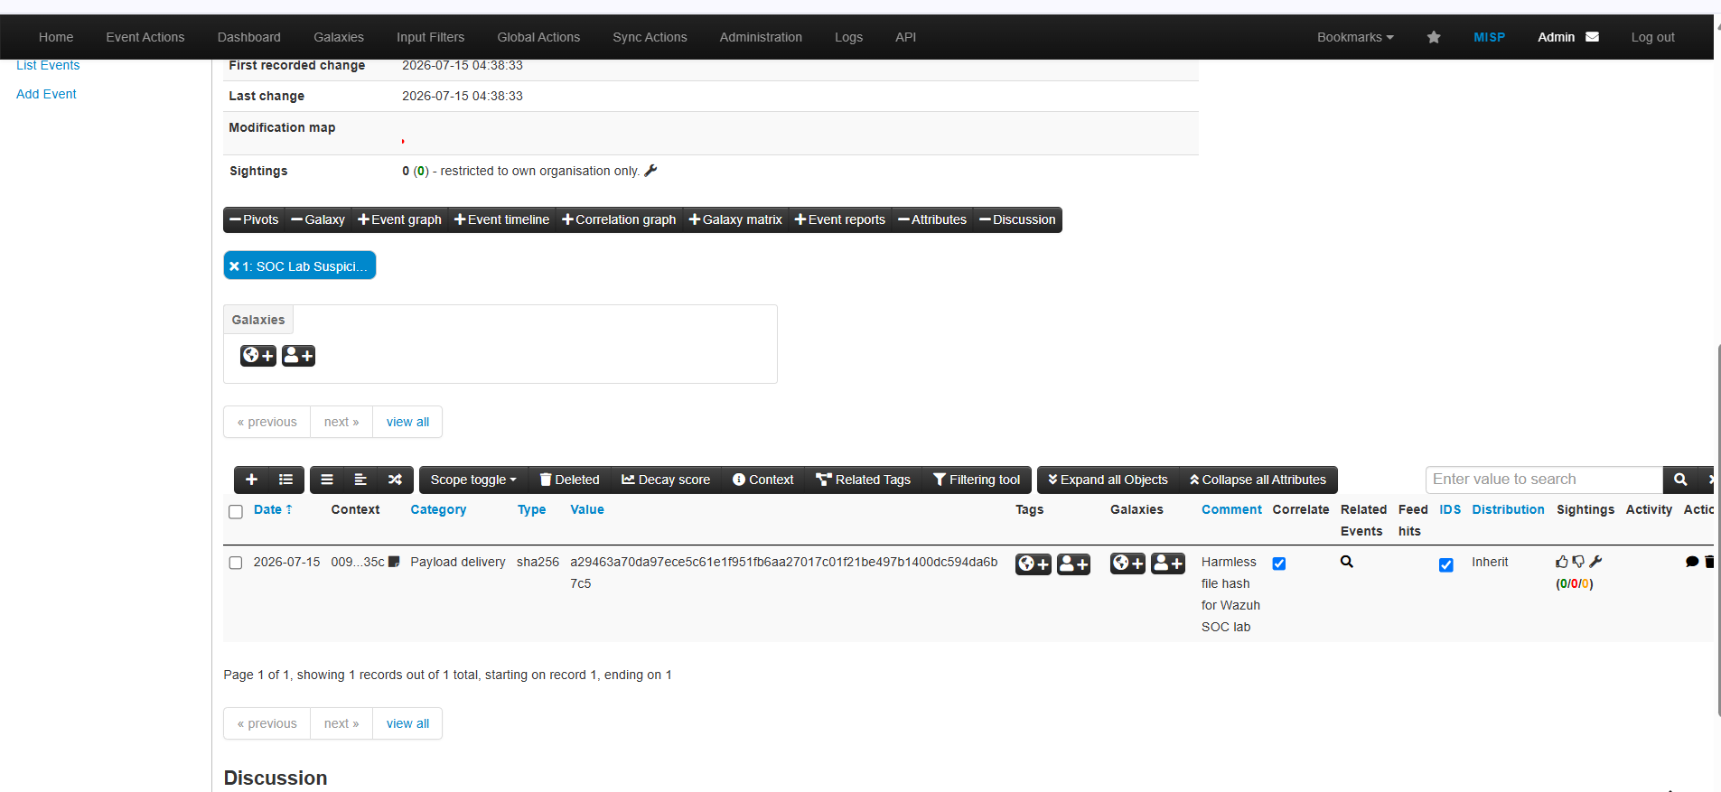
Figure: Published MISP event containing the SHA256 IOC with the IDS flag enabled.

6. Wazuh and MISP Integration
The Wazuh manager was configured to send new-file FIM alerts to a custom MISP integration script. The script extracts MD5, SHA1, and SHA256 hashes from the Wazuh alert and searches for a matching attribute in MISP.
6.1 Create a Restricted MISP API Key
A dedicated read-only authentication key was created in MISP for the Wazuh integration. The key was restricted to the Wazuh server IP address 192.168.90.129/32. API keys are sensitive and must not be included in screenshots, reports, or GitHub repositories.
6.2 Install the Wazuh MISP Integration Files
Run the following commands on the Wazuh Ubuntu VM:
sudo apt update
sudo apt install -y git
cd /tmp
git clone https://github.com/MISP/wazuh-integration.git
cd wazuh-integration
sudo cp scripts/custom-misp_file_hashes.py /var/ossec/integrations/
sudo cp rules/misp_file_hashes.xml /var/ossec/etc/rules/
sudo chown root:wazuh /var/ossec/integrations/custom-misp_file_hashes.py
sudo chmod 750 /var/ossec/integrations/custom-misp_file_hashes.py
sudo chown root:wazuh /var/ossec/etc/rules/misp_file_hashes.xml
sudo chmod 640 /var/ossec/etc/rules/misp_file_hashes.xml
6.3 Configure Wazuh Integrator
Back up and open the Wazuh configuration file:
sudo cp /var/ossec/etc/ossec.conf /var/ossec/etc/ossec.conf.backup-before-misp
sudo nano /var/ossec/etc/ossec.conf
The following block was added before the final </ossec_config> tag. The real API key was used locally but is redacted below:
<integration>
<name>custom-misp_file_hashes.py</name>
<hook_url>https://192.168.90.130</hook_url>
<api_key>[REDACTED_MISP_API_KEY]</api_key>
<group>syscheck</group>
<rule_id>554</rule_id>
<alert_format>json</alert_format>
<options>{
"timeout": 10,
"retries": 3,
"debug": true,
"push_sightings": false
}</options>
</integration>
6.4 Lab Certificate Handling
The MISP Docker deployment used a self-signed HTTPS certificate. For this isolated lab only, certificate verification was disabled in the two requests.post() calls of custom-misp_file_hashes.py by adding verify=False. In production, the correct solution is to install a trusted certificate or add the MISP certificate authority to the Wazuh server trust store.
response = requests.post(
...,
timeout=timeout,
verify=False,
)
6.5 Validate and Restart Wazuh
sudo /var/ossec/framework/python/bin/python3 -m py_compile /var/ossec/integrations/custom-misp_file_hashes.py
sudo /var/ossec/bin/wazuh-analysisd -t
sudo systemctl restart wazuh-manager
sudo systemctl status wazuh-manager --no-pager
sudo grep -a -i "integrat" /var/ossec/logs/ossec.log | tail -30
The expected manager log includes: Enabling integration for: custom-misp_file_hashes.py.

7. Final Threat Intelligence Correlation Test
7.1 Trigger the FIM Event
The test file whose hash was stored in MISP was copied into the FIM monitored folder on Windows:
Remove-Item "C:\SOC-Lab\Monitored\test-misp.txt" -Force -ErrorAction SilentlyContinue
Start-Sleep -Seconds 5
Copy-Item "C:\SOC-Lab\test-misp.txt" "C:\SOC-Lab\Monitored\test-misp.txt"
Start-Sleep -Seconds 20
7.2 Verify the Integration Log
sudo tail -n 50 /var/ossec/logs/integrations.log
A successful lookup returns found: 1 and includes the matching SHA256 value, MISP event UUID, and event permalink. This confirms that the Wazuh integration queried MISP and found the IOC.
7.3 Verify the Wazuh High-Severity Alert
In the Wazuh Dashboard, open Threat Hunting, select Events, set the time range to Last 24 hours, and search for:
rule.id:100802
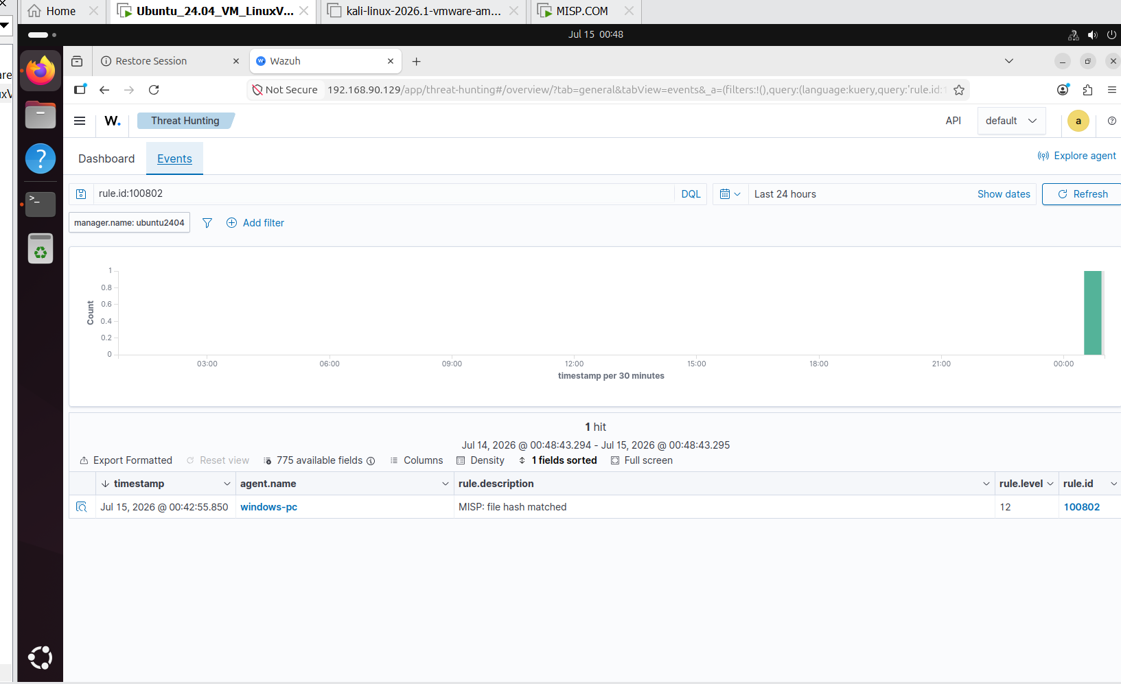
Figure: Successful MISP file-hash match displayed in Wazuh with Rule ID 100802 and alert level 12.

7.4 Result
Component | Status
Windows Wazuh Agent | Completed
File Integrity Monitoring | Completed
Security Configuration Assessment | Completed
Vulnerability Detection Review | Completed
MISP Docker Deployment | Completed
MISP SHA256 IOC Event | Published and IDS enabled
Wazuh-MISP API Integration | Completed
Threat Intelligence Correlation | Matched, Rule 100802, Level 12
Manual Quarantine | Completed
Final Conclusion
This project implemented a complete SOC monitoring workflow using a Windows endpoint, Wazuh, and MISP. Wazuh FIM detected file creation, modification, and deletion. SCA and Vulnerability Detection provided security posture information. A test SHA256 IOC was published in MISP, and the Wazuh integration successfully matched the file hash and generated a high-severity Level 12 alert. The workflow demonstrates endpoint visibility, detection, threat intelligence enrichment, investigation, and manual containment in a controlled lab environment.

