Implementation of an End-to-End SOC Monitoring and Incident Response Lab Using Wazuh and MISP

1.Wazuh File Integrity Monitoring (FIM)
Windows Endpoint Setup and Testing Report

1. Purpose
The purpose of this lab is to monitor a selected folder on a Windows endpoint using Wazuh File Integrity Monitoring. When a file is created, changed, or deleted inside the folder, the Windows Wazuh Agent sends the event to the Ubuntu Wazuh Manager. The alert then appears on the Wazuh Dashboard.

2. Lab Architecture
Windows Endpoint  Wazuh Agent  C:\SOC-Lab\Monitored | Ubuntu Server  Wazuh Manager  Indexer  Dashboard | SOC Analyst  Dashboard Review  Investigation  Evidence Collection
File activity → Wazuh Agent → Wazuh analysis → FIM alert

3. Requirements
- Wazuh Manager, Indexer, and Dashboard must be running on Ubuntu.
- The Wazuh Agent must be installed and active on the Windows endpoint.
- You must have sudo access on the Ubuntu server.
- Windows PowerShell must be opened as Administrator.
- This report uses Agent ID 001 as an example. Replace it with your own Agent ID.

4. Step 1: Check Wazuh Services and Agent Status
Run the following commands in the Ubuntu Terminal or a MobaXterm SSH session. Check that all three Wazuh services are running.
sudo systemctl status wazuh-manager --no-pager
sudo systemctl status wazuh-indexer --no-pager
sudo systemctl status wazuh-dashboard --no-pager

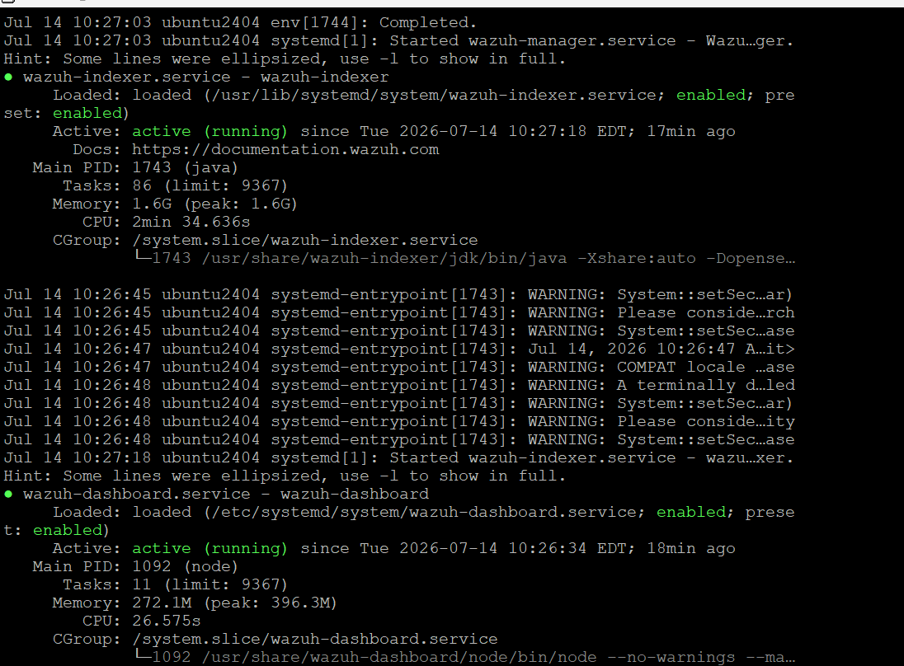

Now check the Windows agent ID and status:
sudo /var/ossec/bin/agent_control -l

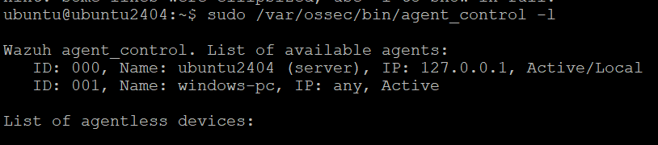

5. Step 2: Create a Windows Agent Group
Create a group named windows-soc for centralized configuration. This allows you to manage the Windows agent FIM settings from the Ubuntu Wazuh Manager.
sudo /var/ossec/bin/agent_groups -a -g windows-soc
sudo /var/ossec/bin/agent_groups -l

6. Step 3: Add the Windows Agent to the Group
In the following command, replace 001 with your Windows agent ID.
sudo /var/ossec/bin/agent_groups -a -i 001 -g windows-soc
sudo /var/ossec/bin/agent_groups -s -i 001

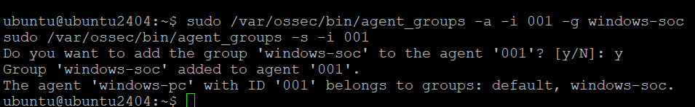

7. Step 4: Create Monitored and Quarantine Folders on Windows
Open Windows PowerShell as Administrator and run the following commands. The monitored folder must exist before real-time FIM monitoring starts.
New-Item -ItemType Directory -Force "C:\SOC-Lab\Monitored"
New-Item -ItemType Directory -Force "C:\SOC-Lab\Quarantine"
Get-ChildItem "C:\SOC-Lab"

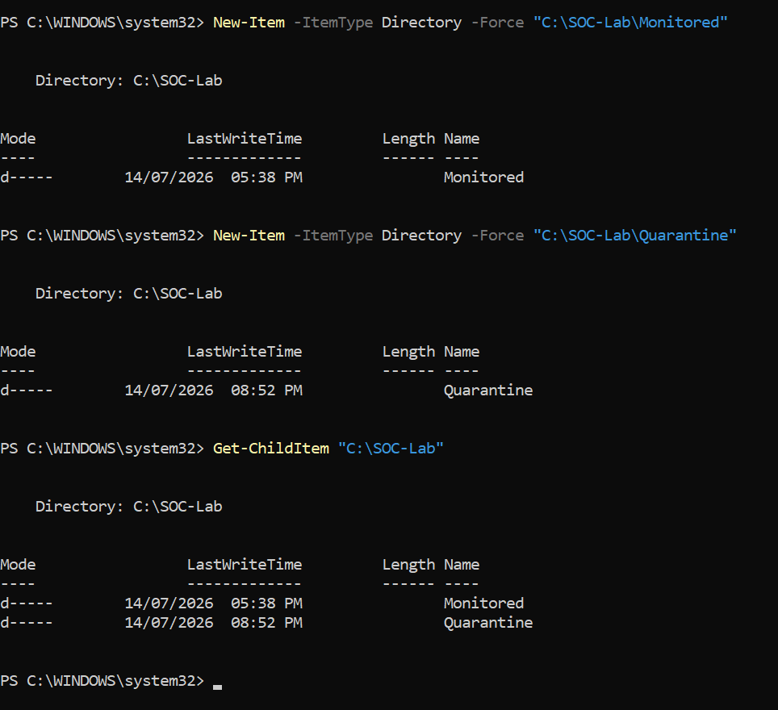

8. Step 5: Create the Centralized FIM Configuration
Create a temporary agent.conf file on the Ubuntu Wazuh Server. A temporary file helps prevent an incomplete XML configuration from being sent to the agent.
sudo touch /var/ossec/etc/shared/windows-soc/agent.conf.tmp
sudo chown wazuh:wazuh /var/ossec/etc/shared/windows-soc/agent.conf.tmp
sudo chmod 660 /var/ossec/etc/shared/windows-soc/agent.conf.tmp
sudo nano /var/ossec/etc/shared/windows-soc/agent.conf.tmp

Paste the following XML configuration into the Nano editor:

<agent_config os="Windows">
<syscheck>
<disabled>no</disabled>
<directories check_all="yes"
report_changes="yes"
realtime="yes">C:\SOC-Lab\Monitored</directories>
</syscheck>
</agent_config>
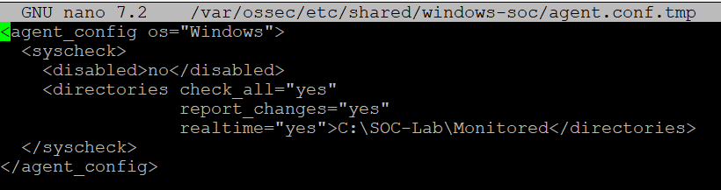
To save: Press Ctrl + O, press Enter, then press Ctrl + X.

9. Step 6: Validate and Activate the Configuration
First, validate the XML configuration. Do not activate it if an error appears.
sudo /var/ossec/bin/verify-agent-conf -f /var/ossec/etc/shared/windows-soc/agent.conf.tmp

After successful validation, rename the temporary file to agent.conf:
sudo mv /var/ossec/etc/shared/windows-soc/agent.conf.tmp \
/var/ossec/etc/shared/windows-soc/agent.conf

The Wazuh Manager automatically detects the new shared configuration and sends it to the agents in the group. You may restart the manager to speed up the update:
sudo systemctl restart wazuh-manager

10. Step 7: Check Configuration Synchronization
Use the following command to check whether the agent received the shared configuration:
sudo /var/ossec/bin/agent_groups -S -i 001

11. Step 8: Check the Windows Agent Service
Open Windows PowerShell as Administrator and check that the service is running. Restarting the service before the test helps ensure that the new configuration is loaded.
Get-Service wazuh
Restart-Service -Name wazuh
Get-Service wazuh

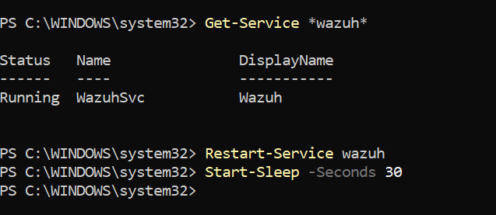

12. Step 9: Test FIM Detection
Now create, modify, and delete the same file to generate three FIM events. Wait 5 seconds after each action.

12.1 File Creation Test
Set-Content -Path "C:\SOC-Lab\Monitored\demo.txt" `
-Value "Wazuh FIM Test"
Start-Sleep -Seconds 5

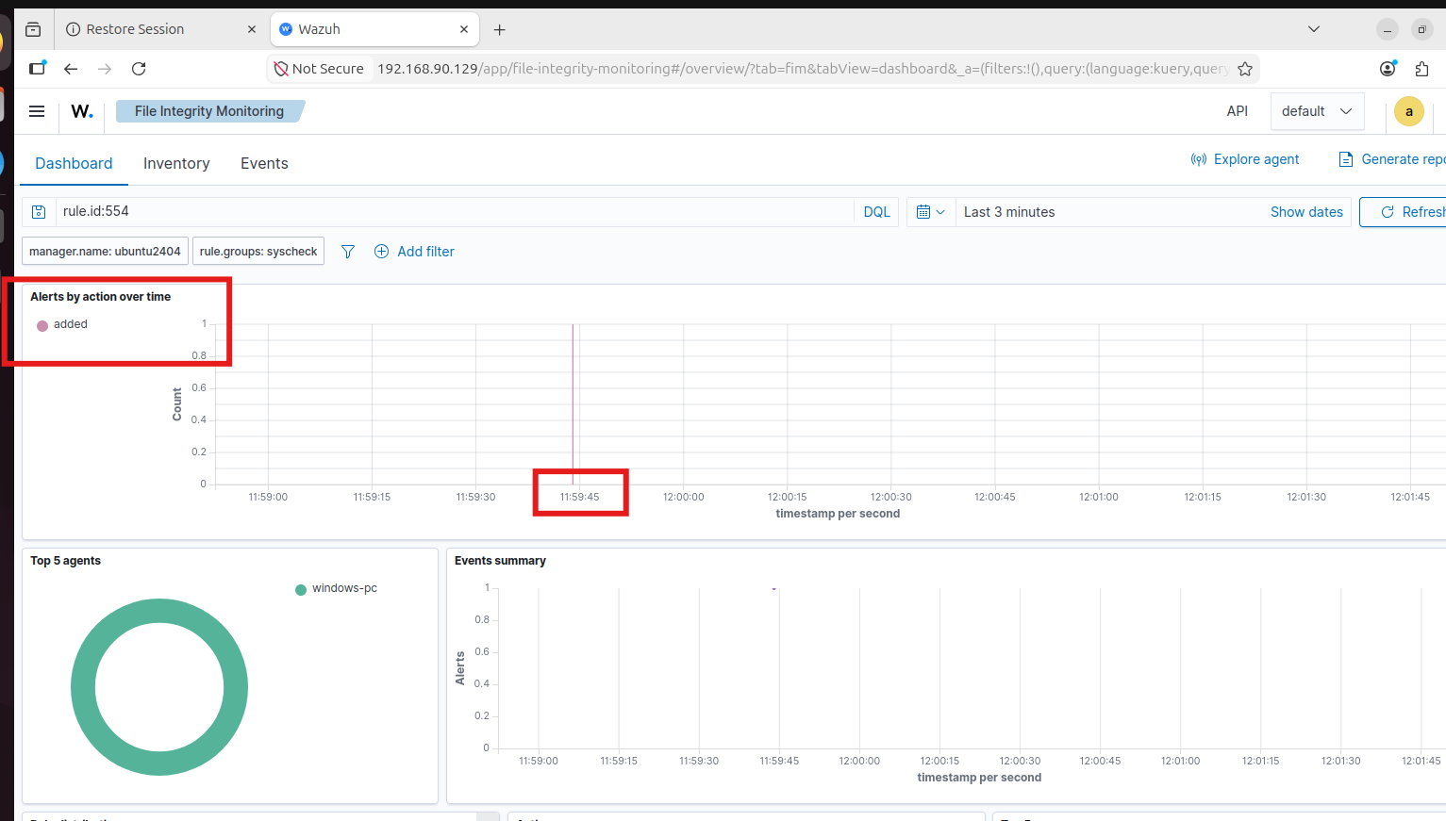

12.2 File Modification Test
Add-Content -Path "C:\SOC-Lab\Monitored\demo.txt" `
-Value "File Modified"
Start-Sleep -Seconds 5
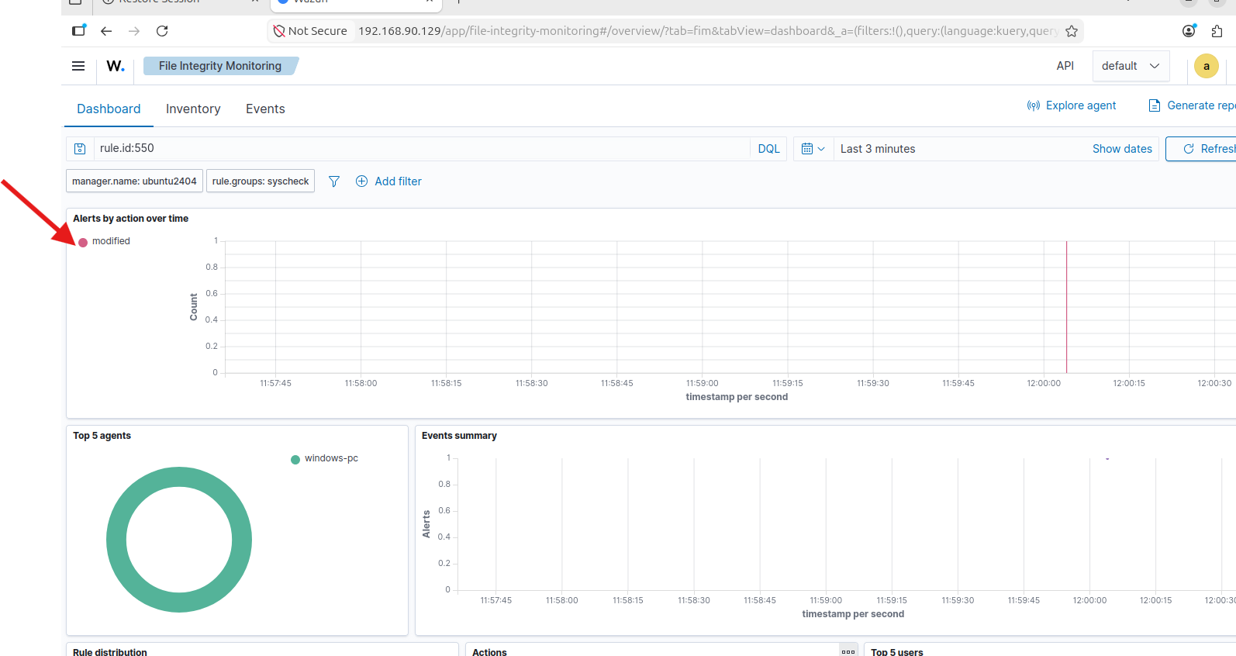

12.3 File Deletion Test
Remove-Item "C:\SOC-Lab\Monitored\demo.txt"
Start-Sleep -Seconds 5
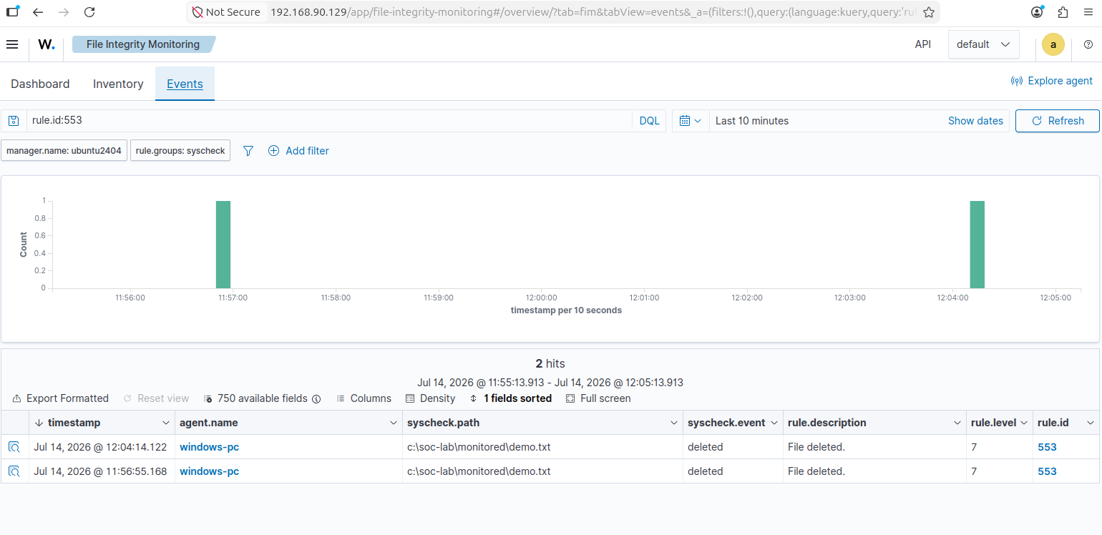

13. Step 10: View FIM Alerts on the Wazuh Dashboard
Log in to the Wazuh Dashboard and open the File Integrity Monitoring module. The menu path may be slightly different depending on the Wazuh version. Usually, the Events view is available under Endpoint Security or File Integrity Monitoring.
- Set the dashboard time range to Last 24 hours or another suitable range.
- Open the Events view in File Integrity Monitoring.
- Filter the events using Rule IDs 550, 553, and 554.
rule.id: is one of 550,553,554

Typical rule mapping:
Rule ID | Event | Expected Description
554 | File added | File added to the system
550 | File modified | Integrity checksum changed
553 | File deleted | File deleted from the system

For rule.id 553
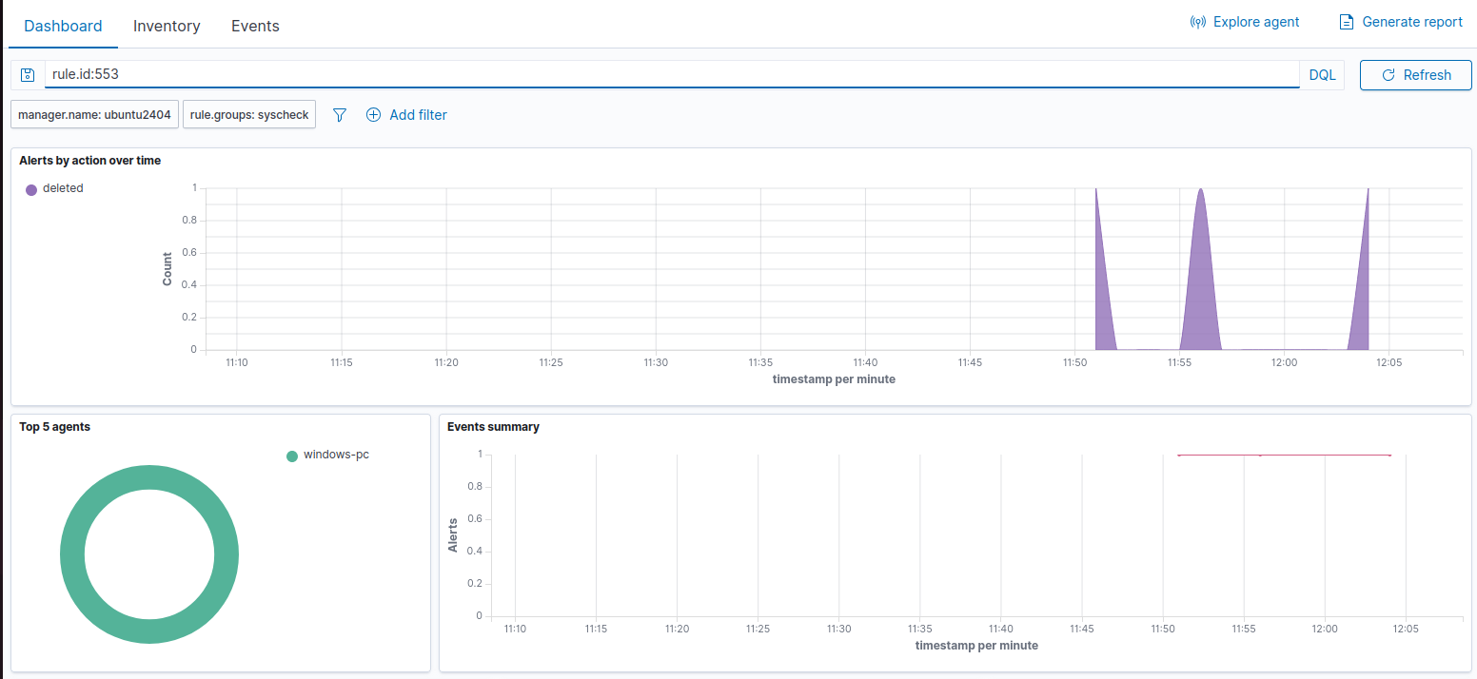
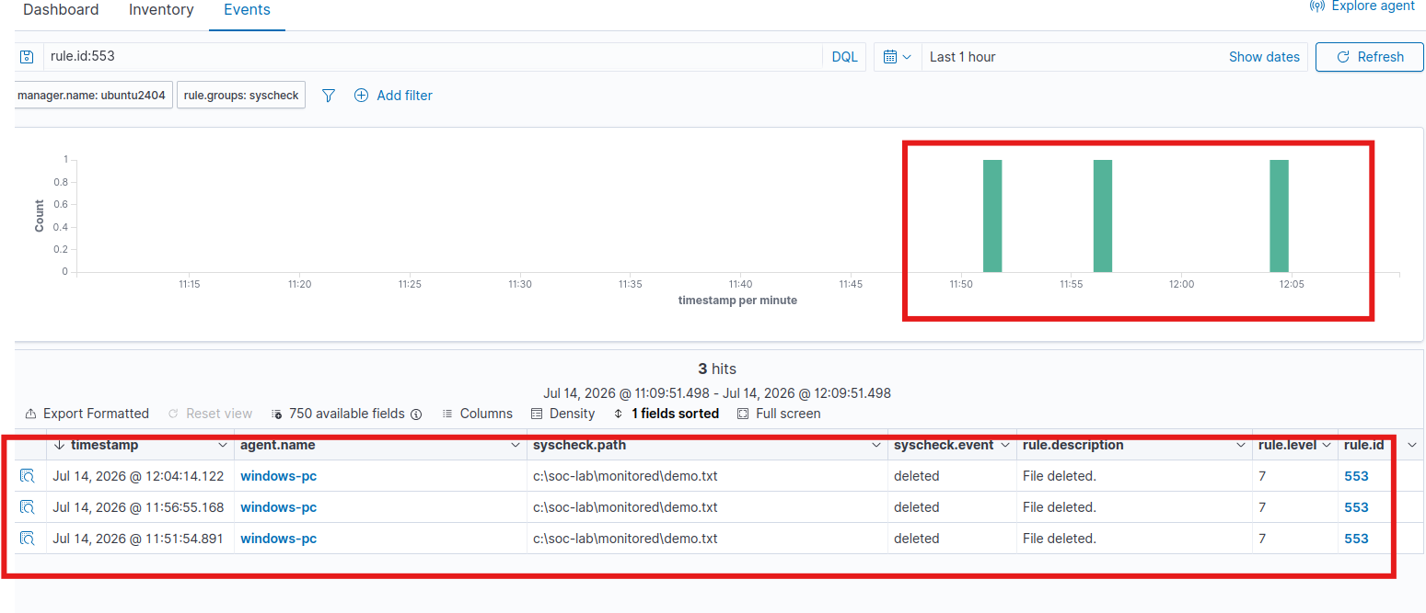

14. Review the Alert Details
Open any FIM alert and use the following fields as evidence:
Field | Meaning
agent.name | The Windows endpoint that sent the event
rule.id | The FIM rule that was triggered
syscheck.path | The file or path that changed
syscheck.event | The event type: added, modified, or deleted
syscheck.sha256_after | The file hash after the change, if available
timestamp | The time of the event
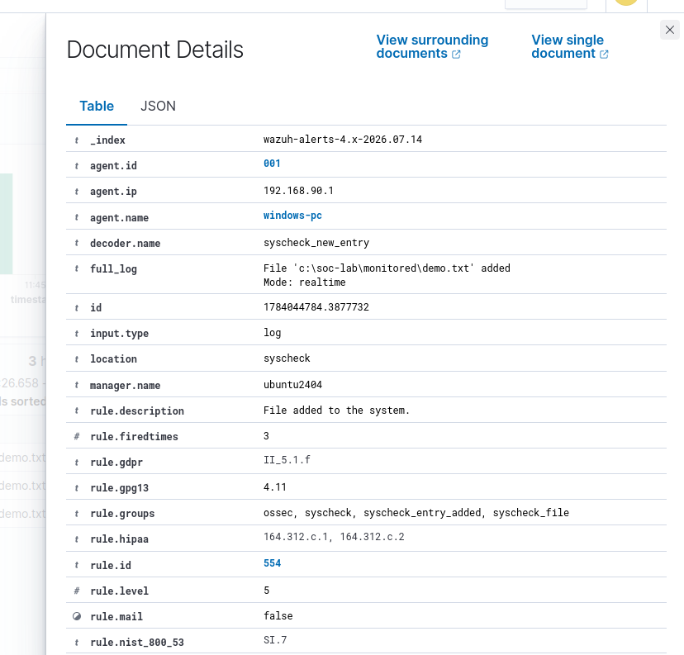

15. Observation and Result
Test | Observed Rule ID | Result
File creation | 554 | Pass
File modification | 550 | Pass
File deletion | 553 | Pass
Agent synchronization | Synchronized | Pass
Final observation: After a file was created, modified, and deleted in the monitored Windows directory, the Wazuh Agent collected the events and the related FIM alerts appeared on the Ubuntu Wazuh Server Dashboard.

16. Troubleshooting
Problem | Possible Cause | Solution
Agent is not synchronized | The Agent ID is wrong or the configuration has not been distributed yet | Check the Agent ID, wait 30 seconds, and restart wazuh-manager if needed.
verify-agent-conf error | An XML tag or quotation mark is incorrect | Open agent.conf.tmp again, correct the XML, and validate it again.
FIM alerts do not appear | The Monitored folder did not exist before the configuration was applied | Create the folder and restart the Windows Wazuh Agent.
Events do not appear on the Dashboard | The time range or filter is incorrect | Select Last 24 hours and filter by Rules 550, 553, and 554.
The Windows service does not restart | PowerShell is not running as Administrator | Open PowerShell as Administrator and run the command again.
A network folder is not being monitored | Windows FIM requires a local path | Use a local folder on the C: drive. Do not use a UNC path or mapped drive.

Security Configuration Assessment (SCA)
Wazuh Security Configuration Assessment checks whether the Windows endpoint follows recommended security settings. In this lab, the system was assessed using the CIS Microsoft Windows 11 Enterprise Benchmark v3.0.0.
The assessment completed 482 security checks. The results were:
- Passed: 124
- Failed: 349
- Not applicable: 9
- Compliance score: 26%
A failed check does not mean that the computer is hacked. It means that the security setting does not meet the recommended CIS security standard. For example, weak password policies, disabled audit settings, or insecure system configurations may produce failed results.
SCA helps the SOC analyst identify security weaknesses before an attack occurs. Each failed check includes information that can be used to improve and harden the endpoint.

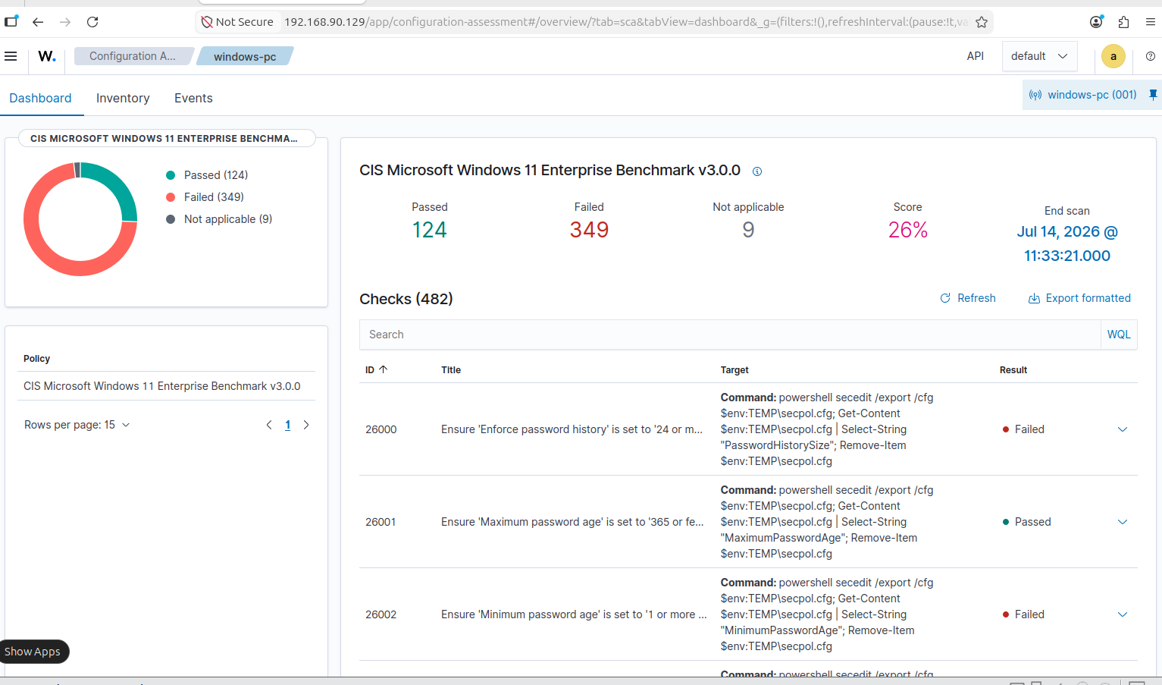
Figure: Windows 11 Security Configuration Assessment result showing passed, failed, not applicable checks, and the overall compliance score.

Final Observation
The SCA scan was completed successfully. The result shows that the Windows endpoint requires further security hardening because the current compliance score is 26%.

