**CS 482 Machine Learning**

**TEST 1 – MAKE-UP**

**One Hour Test**

Your Name: ___________________________

INSTRUCTIONS:

Answer the following questions on a different piece of paper and take pictures of the solution and upload it.

This is an open notes, open textbook, open slides exam. You can use a regular calculator. No consultation with internet resources such as google or contact with another individual is allowed during the exam.

Show work for full credit

1. The different types of machine learning problems. Determine whether the tasks described below involve supervised learning or unsupervised learning. For supervised learning problems, identify them as regression, classification, or probabilistic classification.
2. Predict the risk of an accident at an intersection, given features such as the time of day and weather.  
   Supervised Regression
3. Identify cars, bicyclists, and pedestrians in video taken by an autonomous vehicle’s cameras.  
   Supervised Classification
4. Determine the probability that there is a stop sign in an image.  
   Supervised Probabilistic Classification
5. Generate new road scenarios (generate streets, place stop signs and intersections) for testing autonomous vehicles in a simulation  
   Unsupervised

2. In this problem we are given the location of each object and the type of object (triangle, circle or square) along with an identifying name (e.g., T1, C1, S1). The data is tabulated below. The goal is to classify the object centered at the point (2, -1) as a triangle, circle or rectangle using k nearest neighbors (KNN).

Shape ID & Location

Triangles: T1: (-3,-2) T2: (3,3) T3: (0,3)

Circles: C1: (3,2) C2: (-2,-1)

Squares: S1: (7,4) S2: (4,5) S3: (3,0)

(a) Fill in the table below which gives the Euclidean distance from the point (2,-1) to each of the points in the data set. Leave your answer in terms of the square root. Recall that to find the Euclidean distance between two points (x1; y1) and (x2; y2) we use the formula below.



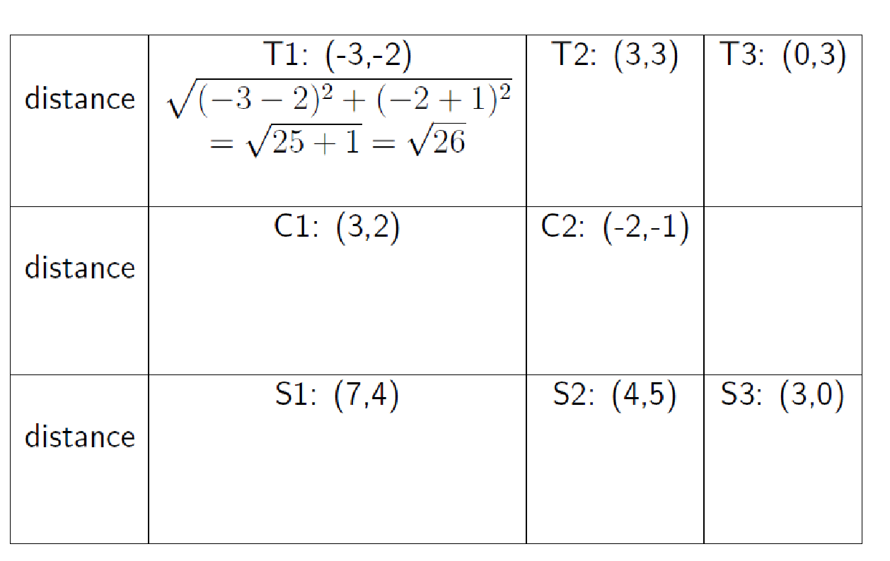

(b) Use your table to classify the object located at (2,-1) using its single nearest neighbor. Justify your answer.

(c) Use your table to classify uniquely the object located at (2,-1) using KNN with k = 3. Justify your answer. If not possible to classify uniquely, indicate why.

(d) Use your table to classify uniquely the object located at (2,-1) using KNN with k = 5. Justify your answer. If not possible to classify uniquely, indicate why.

(e) Use your table to classify uniquely the object located at (2,-1) using KNN with k = 6. Justify your answer. If not possible to classify uniquely, indicate why.

1. Given the following training data with 2 predictors x1 an x2 and sample size of 3 for linear regression,

Training data = and the target y, y =

1. Find the parameters of the linear model where y = β0 + β1 x1 + β2 x2

B_0

B_1

B_2

1. Find R2 for the model developed in a) for the test set ([4 5],6) and ([6,7], 8)
2. Given the following table

Observed

Predicted College-Educated No College Education

College-Educated *7 3*

No College Eduation *6 5*

Compute Accuracy, Recall, Precision and Specificity and f-statistic