CS-482 MACHINE LEARNING
HOMEWORK QUESTIONS
CHAPTER 2

- Compute Minkowski distance (p=2) between data at row 5 and row 6 for the following data set using only those predictors whose values are numbers. (not categorical data). The row index begins at 1.

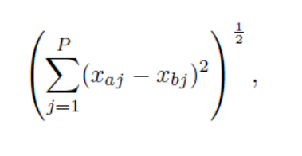

$${\left(\sum_{j=1}^{P}{{\left(x_{aj}-x_{bj}\right)}^{2}}\right)}^{\frac{1}{2}}=\sqrt{{\left(44-39\right)}^{2}+{\left(0-1\right)}^{2}+{\left(2-2\right)}^{2}}$$
$$=\sqrt{26}$$

- In this problem we have circles of three different colors and we want to classify a new circle (indicated in black) as one of these colors. The red, blue and green circles are illustrated below along with an unknown circle which we want to classify.

- Classify the unknown circle as red, green or blue using a single nearest neighbor. Justify your answer by drawing circle(s) about the unknown point. Explain.
Green is the nearest neighbor
- If possible, classify uniquely the unknown circle as red, green or blue using KNN with k = 2. Justify your answer by drawing circle(s) about the unknown point. If you are unable to uniquely classify it, explain why.

- If possible, classify uniquely the unknown circle as red, green or blue using KNN with k = 3. Justify answer by drawing circle(s) about the unknown point. If you are unable to uniquely classify it, explain why.

- In this problem we are given the location of each object and the type of object (triangle, circle or square) along with an identifying name (e.g., T1, C1, S1). The data is tabulated below. The goal is to classify the object centered at the point (2, -1) as a triangle, circle or rectangle using k nearest neighbors (KNN).

Shape ID & Location
Triangles: T1: (-3,-2) T2: (3,3) T3: (0,3)
Circles: C1: (3,2) C2: (-2,-1)
Squares: S1: (7,4) S2: (4,5) S3: (3,0)

(a) Fill in the table below which gives the Euclidean distance from the point (2,-1) to each of the points in the data set. Leave your answer in terms of the square root. Recall that to find the Euclidean distance between two points (x₁; y₁) and (x₂; y₂) we use the formula below.

- Consider K-NN using Euclidean distance on the following data set (each point belongs to one of two classes: + and◦).
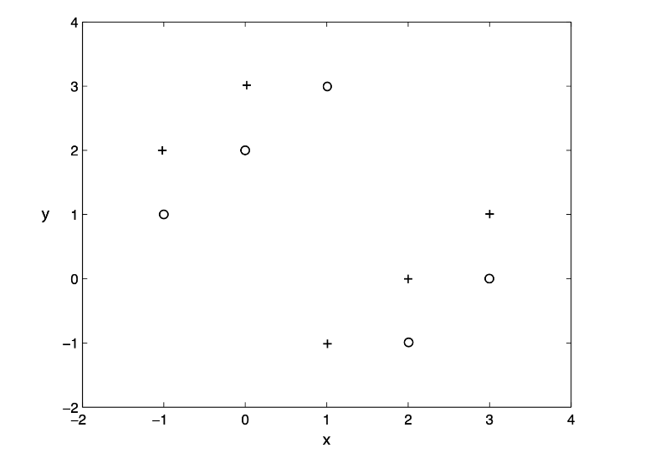
a) What is the leave one out cross validation error when using 1-NN?
b) Which of the following values of k leads to the minimum leave-one-out cross validation error: 3, 5 or 9? What is the error for that k? (If there is a tie, please elaborate)

- Consider k-fold cross-validation. Let’s consider the tradeoffs of larger or smaller k (the number of folds). Please select one of the multiple choice options. With a higher number of folds, the estimated error will be, on average
- Higher b) Lower c) Same d) Can’t tell
Explain the reason for your choice

- In a KNN classification problem, assume that the distance measure is not explicitly specified to you. Instead, you are given a “black box” where you input a set of instances P₁, P₂, .. P_{n} and a new example Q, and the black box outputs the nearest neighbor of Q, say P_{i} and its corresponding class label C_{i}. Is it possible to construct a k-NN classification algorithm (w.r.t the unknown distance metrics) based on this black box alone? If so, how and if not, why not?

