Table of Contents
Table of Contents i
List of Figures iii
List of Tables v
1. Multiple Linear Regression Model to Predict `Outstate` 1
1.1. Fitting the Multiple Linear Regression Model 1
1.2. Interpretation of Model Results 3
1.2.1. Significance of the Model 4
1.2.2. Significance of the Coefficient of `Apps` ($β1$) 4
1.2.3. Significance of the Coefficient of `Accept` ($β2$) 5
1.2.4. Significance of the Coefficient of `Enroll` ($β3$) 5
1.2.5. Significance of the Coefficient of `Top10perc` ($β4$) 6
1.2.6. Significance of the Coefficient of `Top25perc` ($β5$) 6
1.3. Diagnostic Plots 7
1.3.1. Residuals vs. Fitted Plot 8
1.3.2. $QQ$ Plot of Residuals 8
1.3.3. Scale-Location Plot 9
1.3.4. Residuals vs. Leverage Plot 9
1.3.5. Studentised Residual Plot 9
1.4. Issues Identified with the Fit 10
1.5. Suggested Transformations to Improve the Model 11
1.5.1. Log Transformation of the Response Variable `Outstate` 11
1.5.2. Square Root Transformation of Some Predictors 13
2. Best Subset Selection for Optimal Predictors 17
2.1. Best Subset Selection Procedure 17
2.2. Models Obtained and Evaluation Metrics 18
2.2.1. Adjusted R-squared 18
2.2.2. Mallows’ $Cp$ 19
2.2.3. Bayesian Information Criterion (BIC) 19
2.3. Interpretation of Best Models 20
3. Evaluation of Polynomial Regression Models for Predicting `Top10perc` 21
3.1. Fitting Polynomial Regression Models with Different Cross-Validation Approaches 21
3.2. Results of Cross-Validation Analysis 23
3.2.1. Holdout Method 23
3.2.2. Leave-One-Out Cross-Validation (LOOCV) 24
3.2.3. $k$-Fold Cross-Validation 24

List of Figures
Figure 1.1: R code for fitting a multiple linear regression model using the “College” dataset from the “ISLR2” library 2
Figure 1.2: Summary of the multiple linear regression model 3
Figure 1.3: R code for generating diagnostic plots and a studentised residual plot for the multiple linear regression model 7
Figure 1.4: Some diagnostic plots for the multiple linear regression model. Top left: Residuals vs. Fitted plot; Top right: $QQ$ plot; Bottom left: Scale-Location plot; Bottom right: Residuals vs. Leverage plot 7
Figure 1.5: Studentised residual plot for the multiple linear regression model 8
Figure 1.6: R code for fitting the log-transformed multiple linear regression model 11
Figure 1.7: Summary of the log-transformed multiple linear regression model 11
Figure 1.8: Some diagnostic plots for the log-transformed multiple linear regression model. Top left: Residuals vs. Fitted plot; Top right: $QQ$ plot; Bottom left: Scale-Location plot; Bottom right: Residuals vs. Leverage plot 12
Figure 1.9: Studentised residual plot for the log-transformed multiple linear regression model 13
Figure 1.10: R code for fitting the square root-transformed multiple linear regression model 14
Figure 1.11: Summary of the square root-transformed multiple linear regression model 14
Figure 1.12: Some diagnostic plots for the square root-transformed multiple linear regression model. Top left: Residuals vs. Fitted plot; Top right: $QQ$ plot; Bottom left: Scale-Location plot; Bottom right: Residuals vs. Leverage plot 15
Figure 1.13: Studentised residual plot for the square root-transformed multiple linear regression model 16
Figure 2.1: R code for performing best subset selection 17
Figure 2.2: Summary of the best subset selection 17
Figure 2.3: Model selection criteria for subset regression applied to the “College” dataset. Left: Adjusted R-squared; Middle: $C_{p}$; Right: BIC 18
Figure 2.4: The best model based on Adjusted R-squared 19
Figure 2.5: The best model based on $C_{p}$ 19
Figure 2.6: The best model based on BIC 20
Figure 3.1: R code for fitting polynomial regression models with Holdout Method, LOOCV, and $k$-Fold Cross-Validation 22
Figure 3.2: R code for creating and printing data frames of MSE results from different cross-validation approaches 23
Figure 3.3: MSE results of Holdout Method for different polynomial degrees 24
Figure 3.4: MSE results of LOOCV for different polynomial degrees 24
Figure 3.5: MSE results of $k$-Fold Cross-Validation for different polynomial degrees 25

List of Tables
Table 1.1: Description of the variables from the “College” dataset 1

Multiple Linear Regression Model to Predict `Outstate`

Fitting the Multiple Linear Regression Model
The dataset used in this assignment is the “College” dataset from the “ISLR2” library in R, which contains various statistics for numerous colleges in the United States. The dataset is organised as a data frame with 777 observations (rows) and 18 variables (columns). Notably, the dataset has no null values in any of its variables. The variables and their description are detailed in Table 1.1 below.

Table 1.1: Description of the variables from the “College” dataset
No. | Variable | Description | Type
1. | Private | A factor with levels `No` and `Yes` indicating whether the college is private or public. | Qualitative
2. | Apps | Number of applications received. | Quantitative
3. | Accept | Number of applications accepted. | Quantitative
4. | Enroll | Number of new students enrolled. | Quantitative
5. | Top10perc | Percentage of new students from the top 10% of their high school class. | Quantitative
6. | Top25perc | Percentage of new students from the top 25% of their high school class. | Quantitative
7. | F.Undergrad | Number of full-time undergraduates. | Quantitative
8. | P.Undergrad | Number of part-time undergraduates. | Quantitative
9. | Outstate | The tuition fees charged to students who are not residents of the state where the college is located. | Quantitative
10. | Room.Board | Room and board costs. | Quantitative
11. | Books | Estimated book costs. | Quantitative
12. | Personal | Estimated personal spending. | Quantitative
13. | PhD | Percentage of faculty with Ph.D.’s. | Quantitative
14. | Terminal | Percentage of faculty with terminal degrees. | Quantitative
15. | S.F.Ratio | Student/faculty ratio. | Quantitative
16. | perc.alumni | Percentage of alumni who donate. | Quantitative
17. | Expend | Instructional expenditure per student. | Quantitative
18. | Grad.Rate | Graduation rate. | Quantitative

For the first part of this assignment, only six (6) variables will be used: `Apps`, `Accept`, `Enroll`, `Top10perc`, and `Top25perc` as predictors, and `Outstate` as the response variable. All these variables are quantitative. In a multiple linear regression model with five (5) predictors and one (1) response variable, the formula can be written as:

$$\hat{y}={\hat{β}}_{0}+{\hat{β}}_{1}x_{1}+{\hat{β}}_{2}x_{2}+{\hat{β}}_{3}x_{3}+{\hat{β}}_{4}x_{4}+{\hat{β}}_{5}x_{5}$$

where:
- $\hat{y}$ is the response variable `Outstate`,
- ${\hat{β}}_{0}$ is the intercept,
- ${\hat{β}}_{1}, {\hat{β}}_{2}, {\hat{β}}_{3}, {\hat{β}}_{4}, {\hat{β}}_{5}$ are the coefficients for each predictor,
- $x_{1}, x_{2}, x_{3}, x_{4}, x_{5}$ are the predictors `Apps`, `Accept`, `Enroll`, `Top10perc`, and `Top25perc`, respectively.

Figure 1.1 displays the R code used to fit a multiple linear regression model for predicting `Outstate` using the predictors `Apps`, `Accept`, `Enroll`, `Top10perc`, and `Top25perc`.

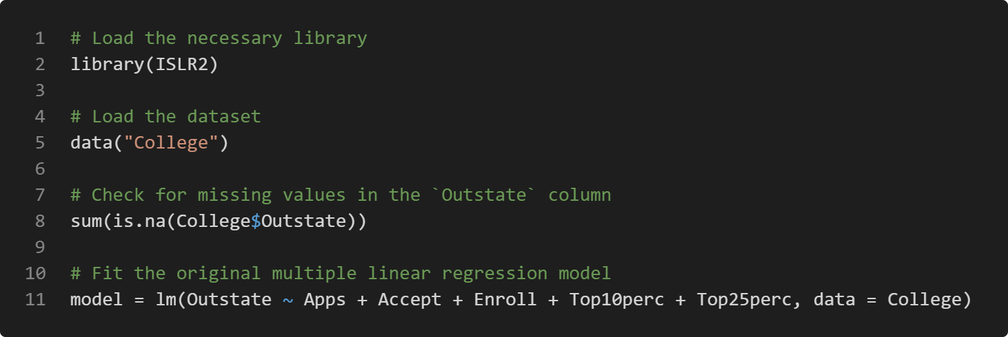
Figure 1.1: R code for fitting a multiple linear regression model using the “College” dataset from the “ISLR2” library

Interpretation of Model Results
Figure 1.2 presents the summary output of the fitted multiple linear regression model, highlighting the statistical significance and impact of each predictor on `Outstate` in the “College” dataset.

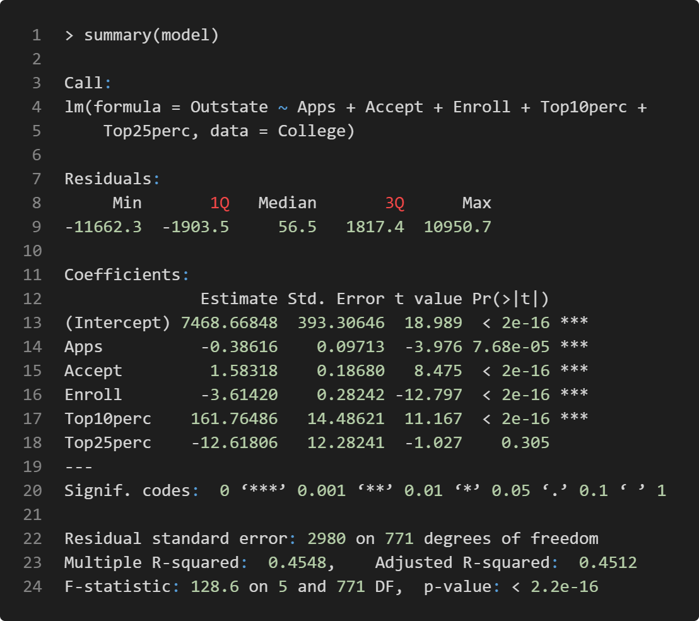
Figure 1.2: Summary of the multiple linear regression model

As depicted in Figure 1.2, the fitted multiple linear regression model can be written in the following formula:

$$\hat{y}=7468.66848-0.38616x_{1}+1.58318x_{2}-3.61420x_{3}+161.76486x_{4}-12.61806x_{5}$$

where:
- $\hat{y}$ is the response variable `Outstate`,
- $x_{1}, x_{2}, x_{3}, x_{4}, x_{5}$ are the predictors `Apps`, `Accept`, `Enroll`, `Top10perc`, and `Top25perc`, respectively.

Significance of the Model
According to Figure 1.2 (line 24), the overall $F$-statistic for the model is $128.6$ with a $p$-value of less than $2.2×{10}^{-16}$. The hypothesis being tested is:

$$H_{0}:β_{1}=β_{2}=β_{3}=β_{4}=β_{5}=0$$
$$H_{1}:At least one β_{i}≠0$$

At a $5\%$ significance level $(α=0.05)$, the $p$-value of the model is smaller than $α$. Therefore, the null hypothesis is rejected at the 5% level. This indicates that the model is statistically significant, meaning that at least one of the predictors is significantly related to the response variable `Outstate`.

In addition, the Residual Standard Error (RSE) is $2980$. The Multiple R-squared value is $0.4548$, suggesting that approximately $45.48\%$ of the variability in the response variable `Outstate` can be explained by the model.

Next, the significance of each predictor will be evaluated.

Significance of the Coefficient of `Apps` (${\hat{β}}_{1}$)
As shown in Figure 1.2 (line 14), the coefficient of `Apps` (${\hat{β}}_{1}$) is $-0.38616$ with a $p$-value of $7.68×{10}^{-5}$. The hypothesis being tested is:

$$H_{0}: β_{1}=0$$
$$H_{1}: β_{1}≠0$$

At a $5\%$ significance level $(α=0.05)$, the $p$-value for the coefficient of `Apps` (${\hat{β}}_{1}$) is smaller than $α$. Therefore, the null hypothesis is rejected at the 5% level. This indicates a statistically significant negative relationship between the predictor `Apps` and the response variable `Outstate`.

Significance of the Coefficient of `Accept` (${\hat{β}}_{2}$)
Based on Figure 1.2 (line 15), the coefficient of `Accept` (${\hat{β}}_{2}$) is $1.58318$ with a $p$-value of less than $2×{10}^{-16}$. The hypothesis being tested is:

$$H_{0}: β_{2}=0$$
$$H_{1}: β_{2}≠0$$

At a $5\%$ significance level $(α=0.05)$, the $p$-value for the coefficient of `Accept` (${\hat{β}}_{2}$) is smaller than $α$. Therefore, the null hypothesis is rejected at the 5% level. This indicates a statistically significant positive relationship between the predictor `Accept` and the response variable `Outstate`.

Significance of the Coefficient of `Enroll` (${\hat{β}}_{3}$)
Referring to Figure 1.2 (line 16), the coefficient of `Enroll` (${\hat{β}}_{3}$) is $-3.61420$ with a $p$-value of less than $2×{10}^{-16}$. The hypothesis being tested is:

$$H_{0}: β_{3}=0$$
$$H_{1}: β_{3}≠0$$

At a $5\%$ significance level $(α=0.05)$, the $p$-value for the coefficient of `Enroll` (${\hat{β}}_{3}$) is smaller than $α$. Therefore, the null hypothesis is rejected at the 5% level. This indicates a statistically significant negative relationship between the predictor `Enroll` and the response variable `Outstate`.

Significance of the Coefficient of `Top10perc` (${\hat{β}}_{4}$)
As indicated by Figure 1.2 (line 17), the coefficient of `Top10perc` (${\hat{β}}_{4}$) is $161.76486$ with a $p$-value of less than $2×{10}^{-16}$. The hypothesis being tested is:

$$H_{0}: β_{4}=0$$
$$H_{1}: β_{4}≠0$$

At a $5\%$ significance level $(α=0.05)$, the $p$-value for the coefficient of `Top10perc` (${\hat{β}}_{4}$) is smaller than $α$. Therefore, the null hypothesis is rejected at the 5% level. This indicates a statistically significant positive relationship between the predictor `Top10perc` and the response variable `Outstate`.

Significance of the Coefficient of `Top25perc` (${\hat{β}}_{5}$)
Figure 1.2 (line 18) reveals that the coefficient of `Top25perc` (${\hat{β}}_{5}$) is $-12.61806$ with a $p$-value of $0.305$. The hypothesis being tested is:

$$H_{0}: β_{5}=0$$
$$H_{1}: β_{5}≠0$$

At a $5\%$ significance level $(α=0.05)$, the $p$-value for the coefficient of `Top25perc` (${\hat{β}}_{5}$) is larger than $α$. Therefore, the null hypothesis fails to be rejected at the 5% level. This indicates that there is no statistically significant relationship between the predictor `Top25perc` and the response variable `Outstate`.

In summary, the overall model is statistically significant, with several predictors showing strong statistical significance in explaining the variability in the response variable `Outstate`. Four out of five predictors (`Apps`, `Accept`, `Enroll`, and `Top10perc`) are statistically significant, whereas `Top25perc` is not.

Diagnostic Plots
To further assess the model’s adequacy, it is essential to examine the diagnostic plots. These plots can help identify issues such as non-linearity, heteroscedasticity, and influential observations. Figure 1.3 shows the R code for generating diagnostic plots and a residual plot for the multiple linear regression model. Figure 1.4 displays some diagnostic plots for the multiple linear regression model. There include the Residuals vs. Fitted plot, the $QQ$ plot, the Scale-Location plot, and the Residuals vs. Leverage plot. Figure 1.5 presents the studentised residual plot.

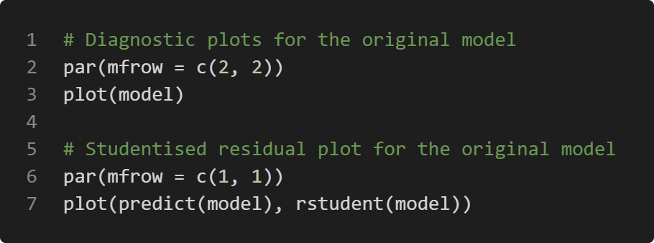
Figure 1.3: R code for generating diagnostic plots and a studentised residual plot for the multiple linear regression model

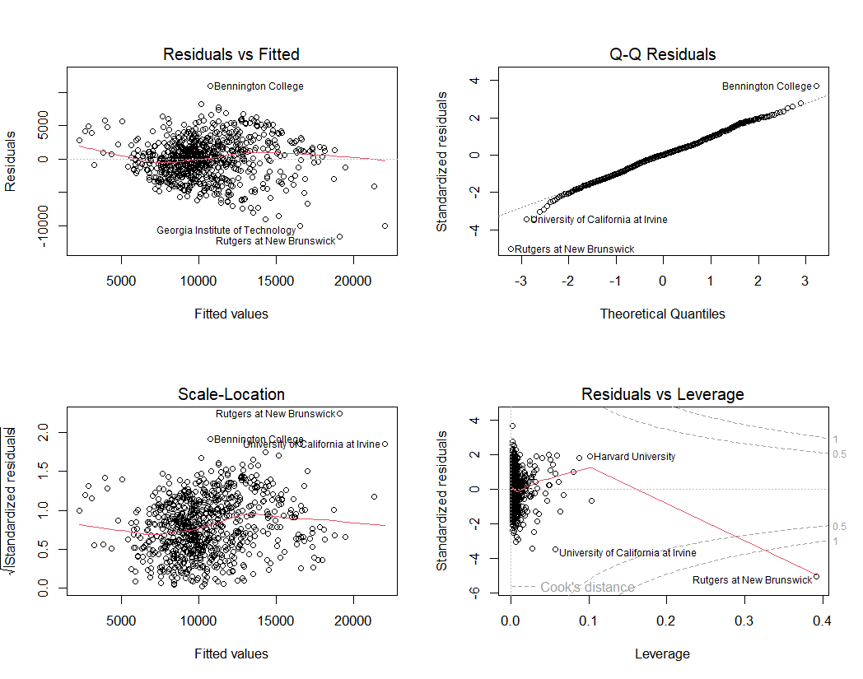
Figure 1.4: Some diagnostic plots for the multiple linear regression model. Top left: Residuals vs. Fitted plot; Top right: $QQ$ plot; Bottom left: Scale-Location plot; Bottom right: Residuals vs. Leverage plot
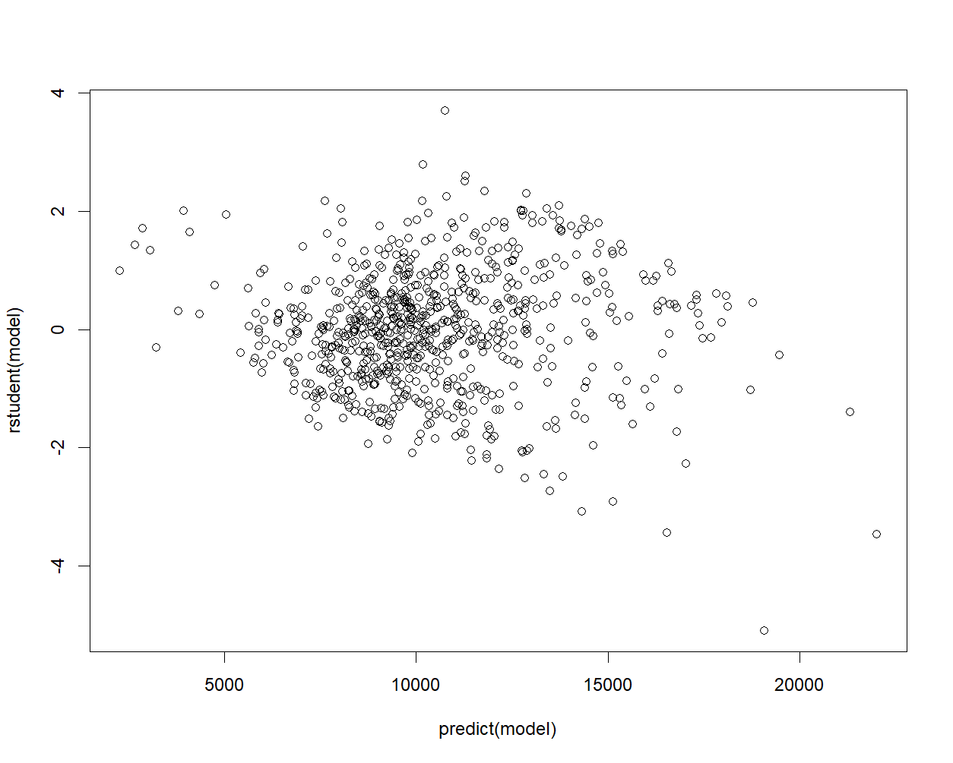
Figure 1.5: Studentised residual plot for the multiple linear regression model

Residuals vs. Fitted Plot
The Residuals vs. Fitted plot is used to check the linearity assumption. If the red line is approximately horizontal and there is no clear pattern in the residuals, the linearity assumption is likely satisfied. Ideally, the residuals should be randomly scattered around the horizontal line (residual $= 0$), indicating a good fit.

In Figure 1.4, the Residuals vs. Fitted plot reveals a slight pattern, with the residuals showing some curvature. This suggests the presence of non-linear relationships that the model has not captured. Additionally, some outliers are visible, particularly Bennington College, Georgia Institute of Technology, and Rutgers at New Brunswick.

$QQ$ Plot of Residuals
The $QQ$ plot checks the normality of the residuals and assesses whether they follow a normal distribution. The residuals should lie approximately along the 45-degree reference line if they are normally distributed.

According to the $QQ$ plot in Figure 1.4, the residuals generally follow the reference line, indicating that they are approximately normally distributed. However, there are deviations at both tails, especially the upper tail. Bennington College, University of California at Irvine, and Rutgers at New Brunswick are identified as potential outliers.

Scale-Location Plot
The Scale-Location plot examines the homoscedasticity (constant variance) of the residuals. A horizontal red line with equally spread points indicates homoscedasticity. Ideally, the points should be randomly dispersed without any clear pattern.

Referring to the Scale-Location plot in Figure 1.4, the red line is not perfectly horizontal and shows a slight downward trend, indicating some heteroscedasticity. The spread of residuals varies somewhat across the range of fitted values. This suggests that the assumption of constant variance might be violated to some degree.

Residuals vs. Leverage Plot
The Residuals vs. Leverage plot identifies influential data points that might unduly affect the model. Points outside Cook’s distance lines are considered influential.

In Figure 1.4, the Residuals vs. Leverage plot shows that most observations have low leverage. However, a few observations, such as Harvard University and University of California at Irvine, exhibit high leverage or large residuals. Moreover, Rutgers at New Brunswick is outside the Cook’s distance lines, indicating it might be an influential point.

Studentised Residual Plot
As seen in the studentised residual plot in Figure 1.5, there are possible outliers, indicated by data points with values greater than $3$ and less than $-3$.

Issues Identified with the Fit
The diagnostic plots shown earlier in Figure 1.4 and Figure 1.5 reveal several issues with the model fit that require attention. Firstly, the Residuals vs. Fitted plot indicates evidence of non-linearity in the relationship between predictors and the response variable, as shown by the slight curved pattern. This suggests that the current linear model may not fully capture the complexity of the underlying relationships.

The $QQ$ plot indicates a departure from normality in the residuals, particularly at the tails of the distribution. This non-normality can affect the validity of statistical tests and confidence intervals derived from the model, potentially leading to incorrect inferences.

Heteroscedasticity is another concern, visible in the Scale-Location plot. The uneven spread of residuals across fitted values violates the assumption of constant variance, which can lead to unreliable standard errors and confidence intervals.

The Residuals vs. Leverage plot also highlights points with high leverage, particularly Rutgers at New Brunswick, which can have a strong influence on the regression line.

Several data points stand out as potential outliers or highly influential observations, including Bennington College, Georgia Institute of Technology, Rutgers at New Brunswick, University of California at Irvine, and Harvard University. These points may be disproportionately affecting the model’s estimates and could be skewing the results.

Suggested Transformations to Improve the Model

Log Transformation of the Response Variable `Outstate`
To address the identified issues, applying a logarithmic transformation to the response variable `Outstate` can improve the model. This transformation can help stabilise the variance, linearise the relationship, and address heteroscedasticity, making the relationship between the predictors and the response variable more linear. Figure 1.6 shows the R code for fitting the log-transformed multiple linear regression model, while Figure 1.7 displays the summary of the model.

Figure 1.6: R code for fitting the log-transformed multiple linear regression model

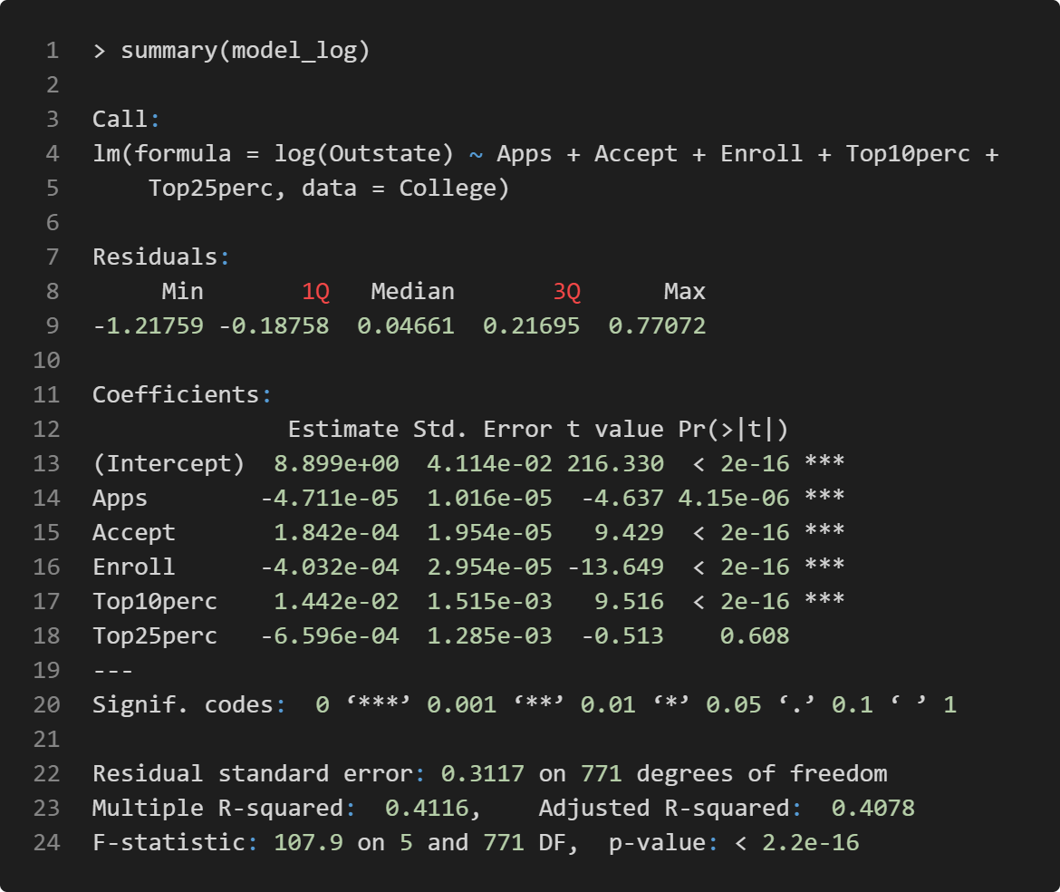
Figure 1.7: Summary of the log-transformed multiple linear regression model
According to Figure 1.7 (line 24), the overall $F$-statistic for the model is $107.9$ with a $p$-value of less than $2.2×{10}^{-16}$, indicating that the model is still statistically significant. The significance of individual predictors is largely unchanged, with the same predictors being significant or non-significant as in the original model. The RSE has decreased from $2980$ in the original model to $0.3117$ (line 22), which is expected due to the log transformation of the response variable `Outstate`. However, the Multiple R-squared value has slightly decreased from $0.4548$ in the original model to $0.4116$ (line 23) in the log-transformed model, suggesting that the log transformation does not improve the overall explanatory power of the model.

Next, Figure 1.8 and Figure 1.9 display some of the diagnostic plots for the log-transformed multiple linear regression model.

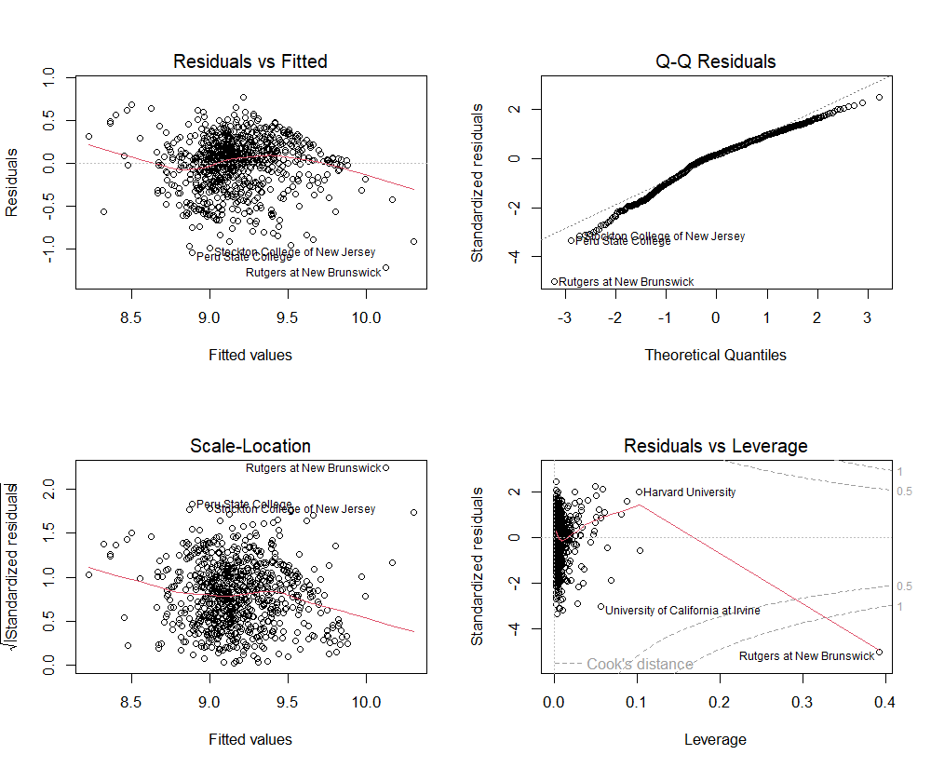
Figure 1.8: Some diagnostic plots for the log-transformed multiple linear regression model. Top left: Residuals vs. Fitted plot; Top right: $QQ$ plot; Bottom left: Scale-Location plot; Bottom right: Residuals vs. Leverage plot
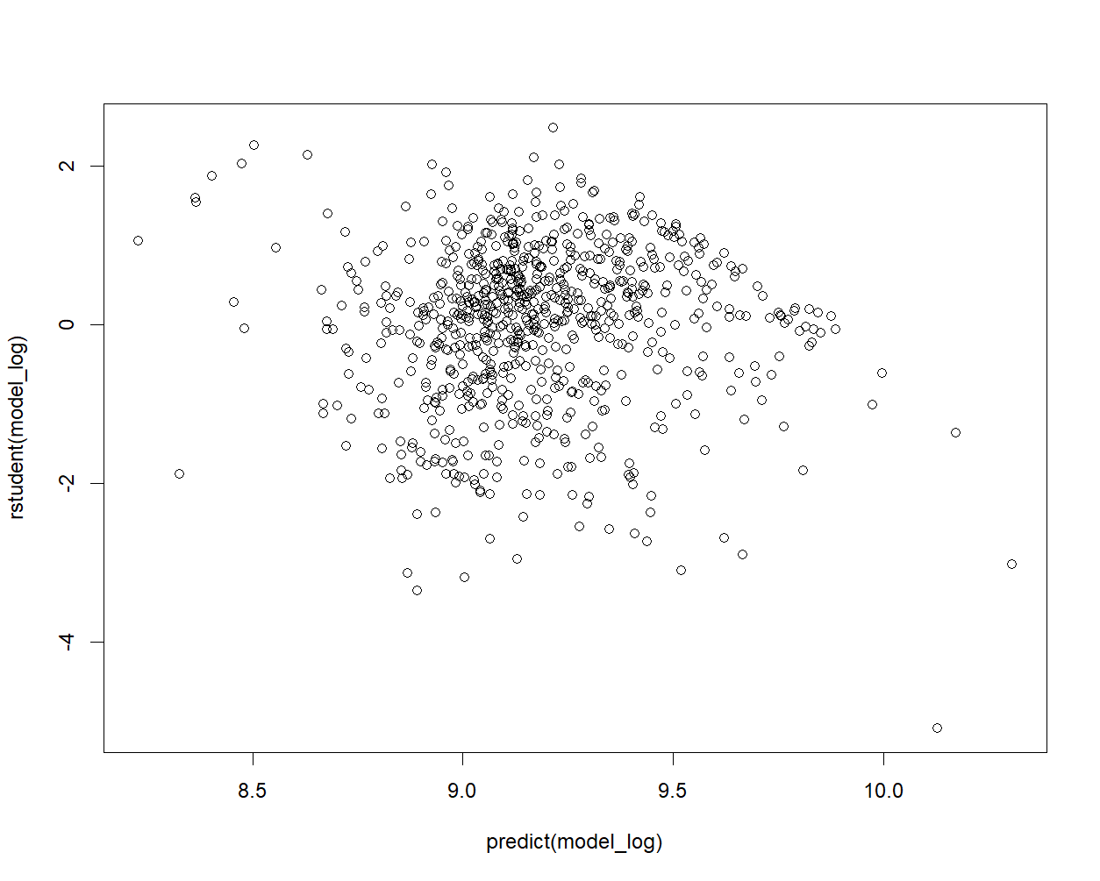
Figure 1.9: Studentised residual plot for the log-transformed multiple linear regression model

Based on the diagnostic plots in Figure 1.8 and Figure 1.9, the log transformation of the response variable `Outstate` has improved the consistency of residual spread across fitted values. The residuals are closer to a normal distribution, particularly in the middle range. The range of residuals is now smaller and more manageable. Nevertheless, some non-linear patterns are still visible in the Residuals vs. Fitted plot. There is still some variation in residual spread, although it is much improved. While less extreme, outliers are still present in the studentised residual plot.

Square Root Transformation of Some Predictors
Another useful transformation is applying a square root transformation to some predictors. This transformation can also help linearise their relationship with the response variable `Outstate` and potentially reduce the impact of outliers in these predictors. Figure 1.10 shows the R code for fitting the multiple linear regression model with the square root transformation of the predictors `Apps`, `Accept`, and `Enroll`, while Figure 1.11 displays the summary of the model.

Figure 1.10: R code for fitting the square root-transformed multiple linear regression model

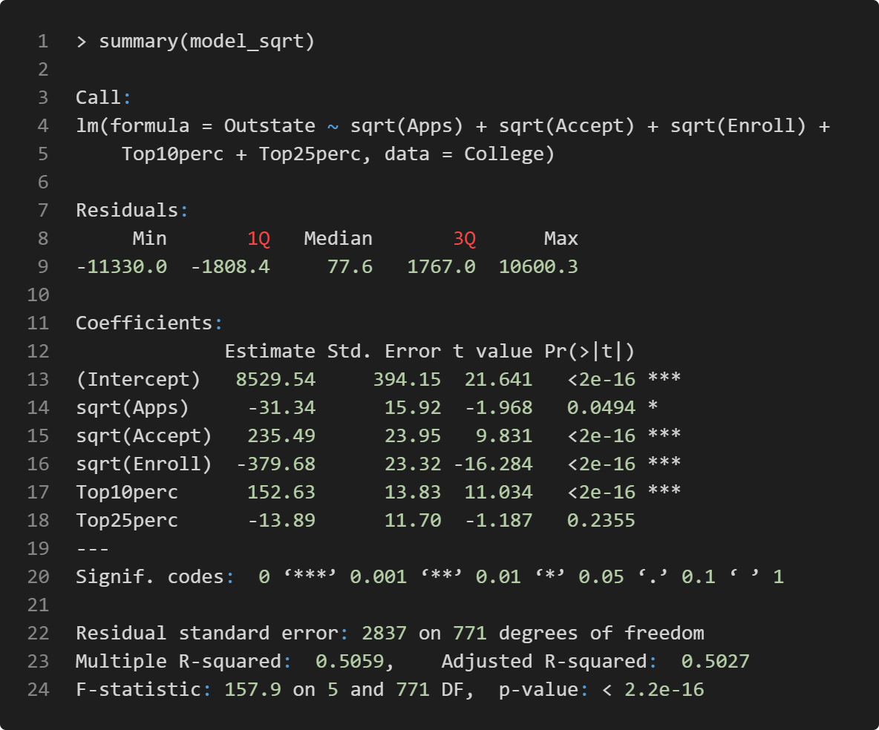
Figure 1.11: Summary of the square root-transformed multiple linear regression model

According to Figure 1.11 (line 24), the overall $F$-statistic for the model is $157.9$ with a $p$-value of less than $2.2×{10}^{-16}$, indicating that the model is still statistically significant. The significance of individual predictors is unchanged, with the same predictors being significant or non-significant as in the original model. The RSE has decreased from $2980$ in the original model to $2837$ (line 22), indicating a slight improvement in the model’s precision. The Multiple R-squared value has increased from $0.4548$ in the original model to $0.5059$ (line 23) in the square root-transformed model, suggesting that the square root transformation has improved the overall explanatory power of the model.

Next, Figure 1.12 and Figure 1.13 display some of the diagnostic plots for the multiple linear regression model with square root transformation of the predictors `Apps`, `Accept`, and `Enroll`.

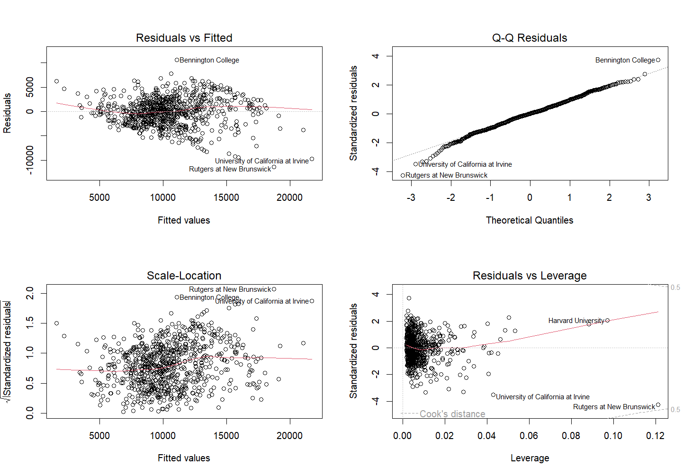
Figure 1.12: Some diagnostic plots for the square root-transformed multiple linear regression model. Top left: Residuals vs. Fitted plot; Top right: $QQ$ plot; Bottom left: Scale-Location plot; Bottom right: Residuals vs. Leverage plot

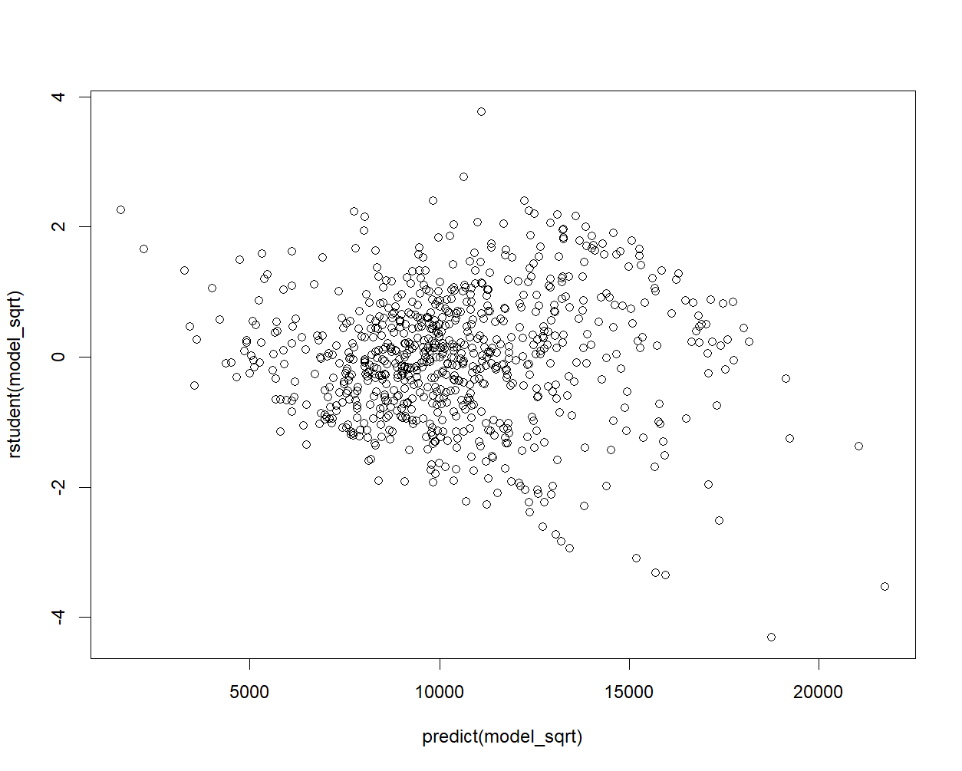
Figure 1.13: Studentised residual plot for the square root-transformed multiple linear regression model

Based on the diagnostic plots in Figure 1.12 and Figure 1.13, a more random scatter points is observed from the Residuals vs. Fitted plot. The $QQ$ plot demonstrates improved normality of residuals, especially in the mid-range, although some deviations persist at the tails. Additionally, some outliers and high-leverage points are still present.

Best Subset Selection for Optimal Predictors

Best Subset Selection Procedure
To perform the best subset selection, all predictors will be utilised to identify the optimal predictors for modelling the response variable `Outstate`. Figure 2.1 shows the R code used to perform best subset selection using all predictors, using the `leaps` library. Figure 2.2 presents the summary output of the best subset selection, providing a clear picture of how predictors are selected across different model sizes.

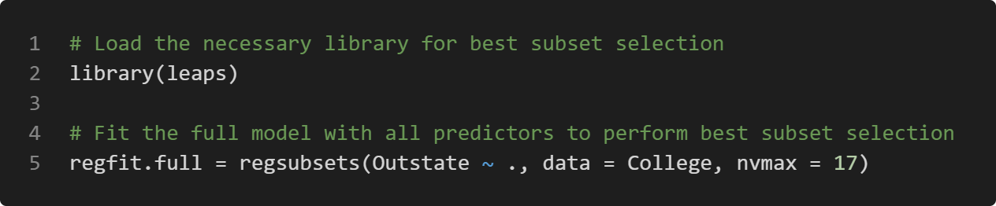
Figure 2.1: R code for performing best subset selection

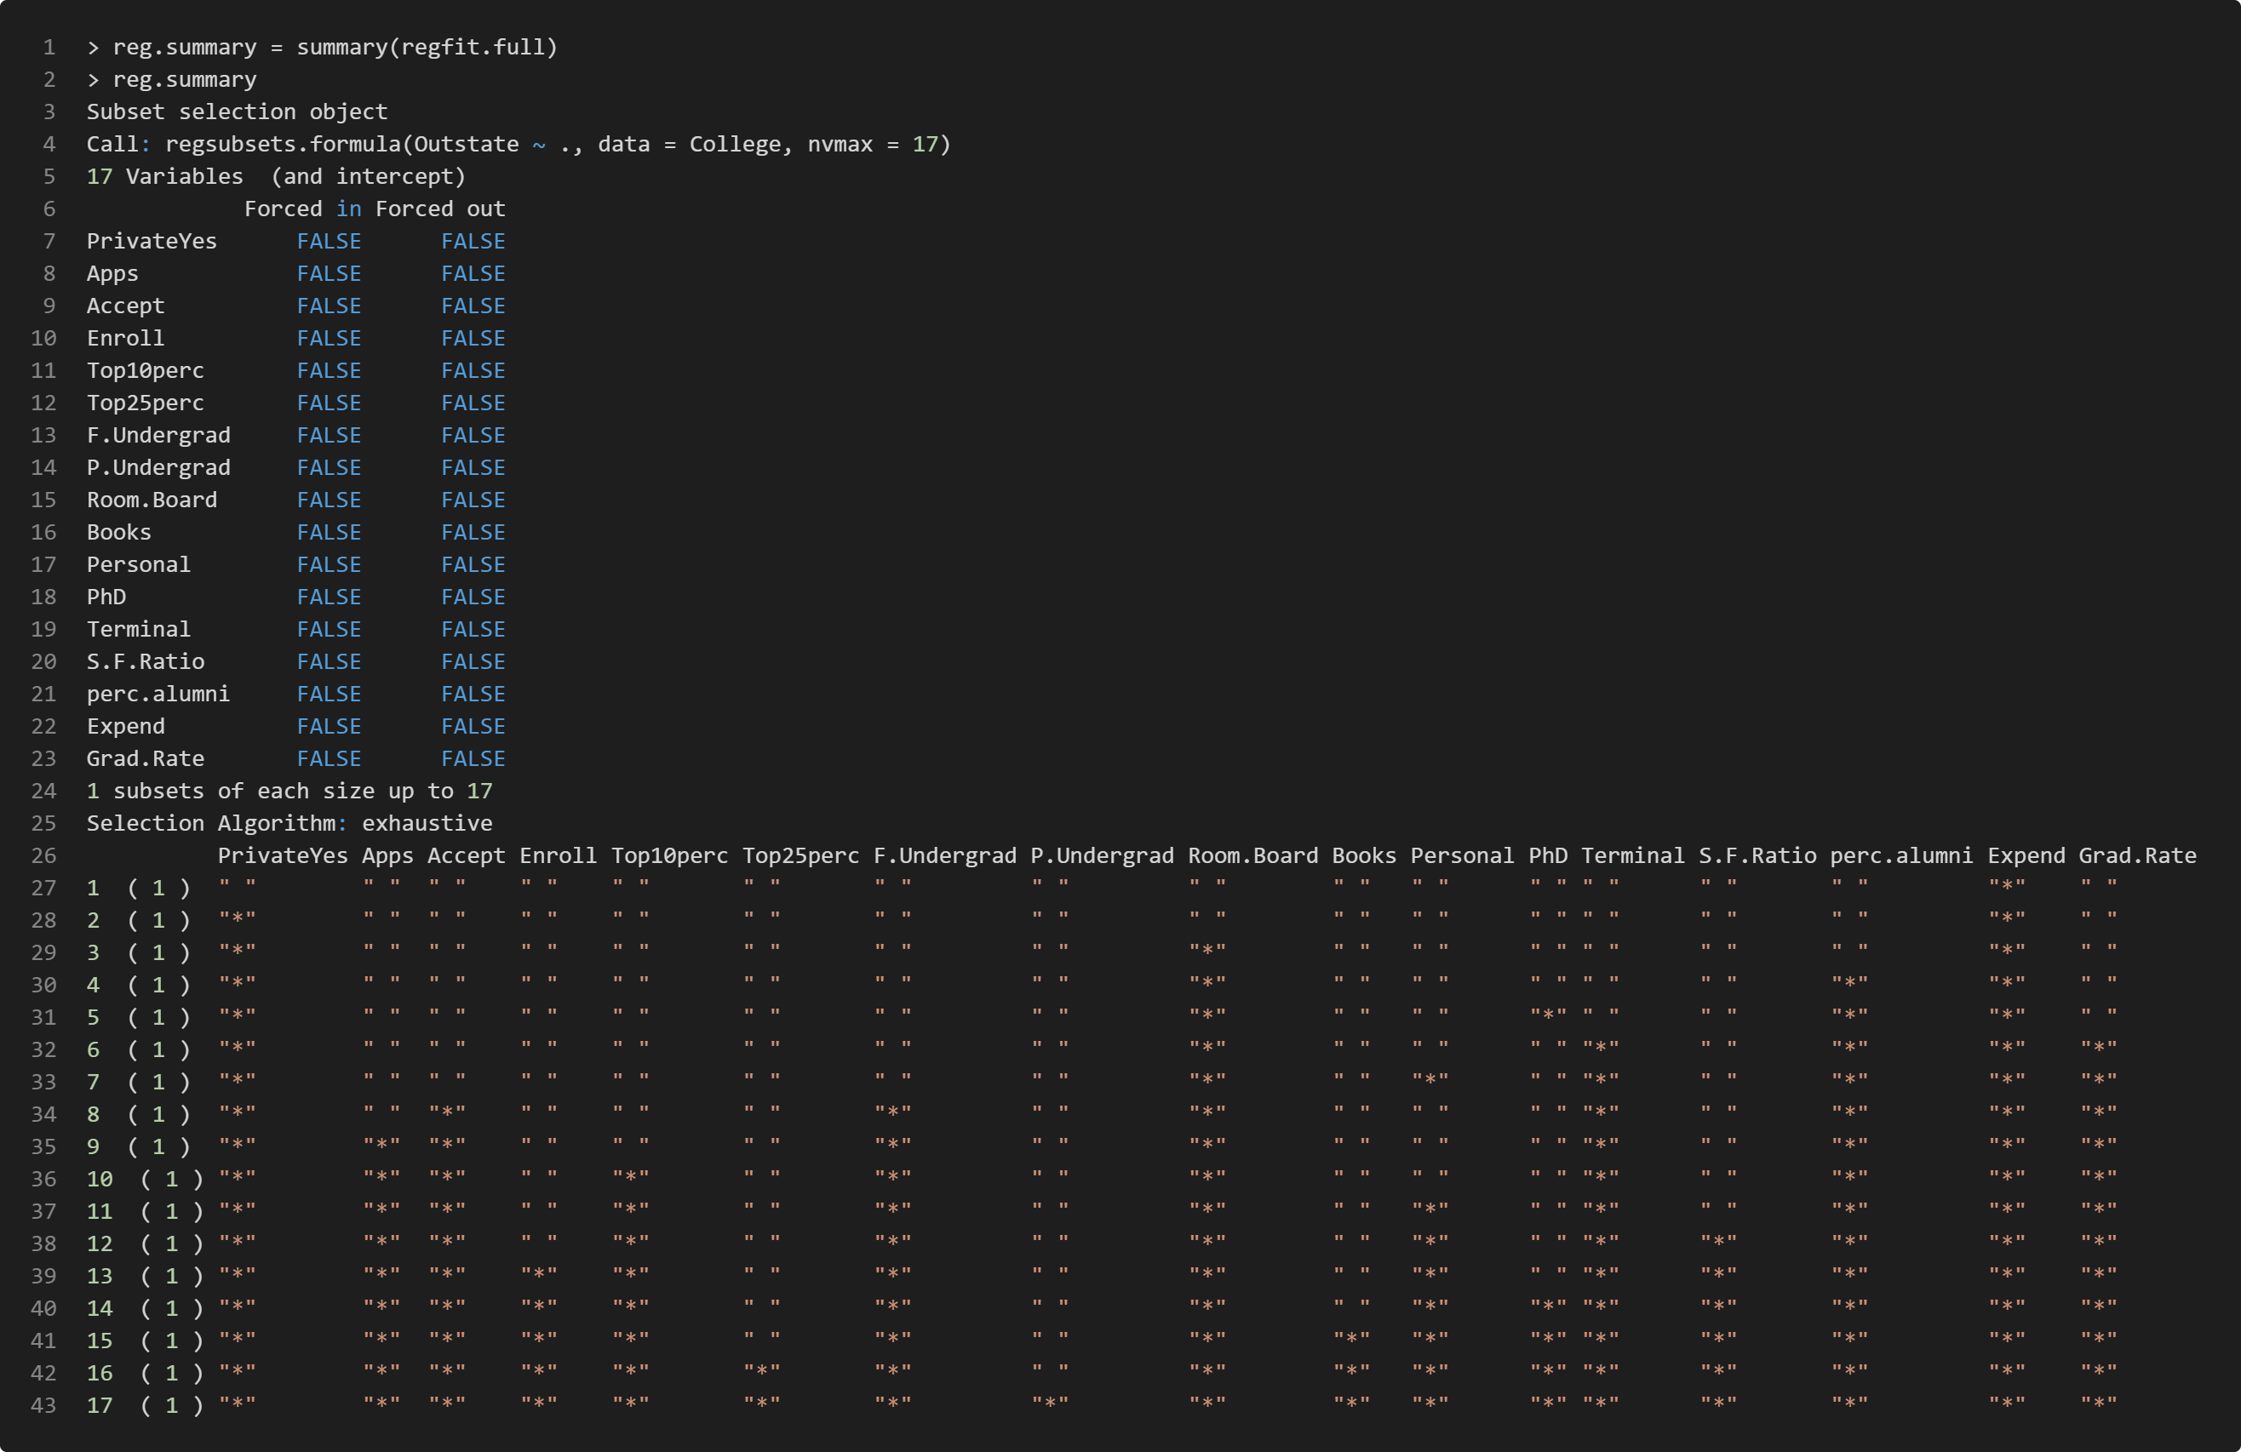
Figure 2.2: Summary of the best subset selection

Models Obtained and Evaluation Metrics
To determine the optimal model size, evaluation metrics such as Adjusted R-squared, Mallows’ $C_{p}$, and Bayesian Information Criterion (BIC) will be utilised. Figure 2.3 shows a plot of the number of predictors against each of these evaluation metrics. According to the plot, the Adjusted R-squared value increases sharply with the addition of predictors initially, then begins to level off. This suggests that while adding predictors initially enhances the model’s explanatory power, the benefits become marginal beyond a certain point. In contrast, the $C_{p}$ value generally decreases as the number of predictors increases. The BIC value decreases sharply at first, but then shows a slight increase with the addition of more predictors.

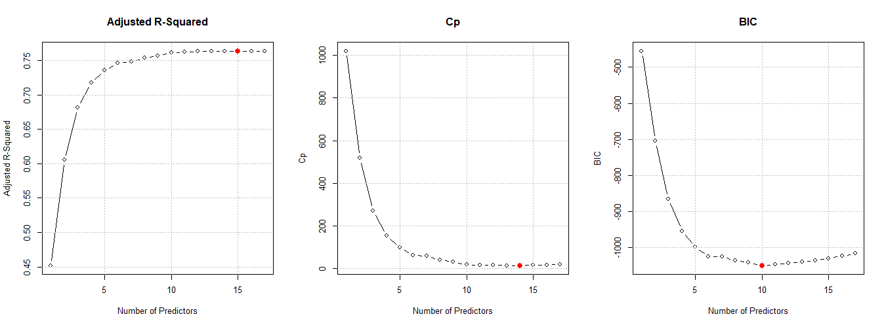
Figure 2.3: Model selection criteria for subset regression applied to the “College” dataset. Left: Adjusted R-squared; Middle: $C_{p}$; Right: BIC

Adjusted R-squared
The model with the highest Adjusted R-Squared value is preferred as it indicates a higher proportion of variance explained by the model, adjusted for the number of predictors. Figure 2.4 shows the best model based on the highest Adjusted R-squared value. This model includes 15 out of 17 possible predictors, excluding only `P.Undergrad` and `Top25perc`.

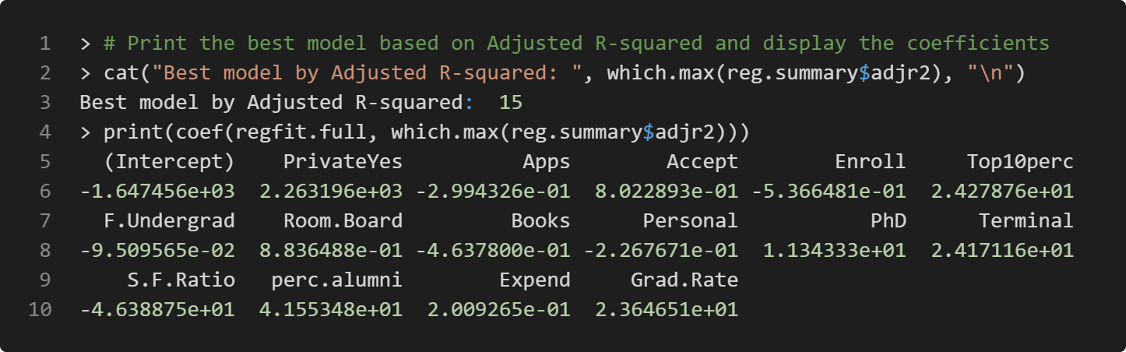
Figure 2.4: The best model based on Adjusted R-squared

Mallows’ $C_{p}$
The model with the lowest $C_{p}$ value is considered the best, indicating the most appropriate trade-off between goodness-of-fit and model complexity. Figure 2.5 shows the best model based on the lowest $C_{p}$ value. This model includes 14 out of 17 possible predictors, closely resembling the Adjusted R-squared model, but excluding the predictor `Books`.

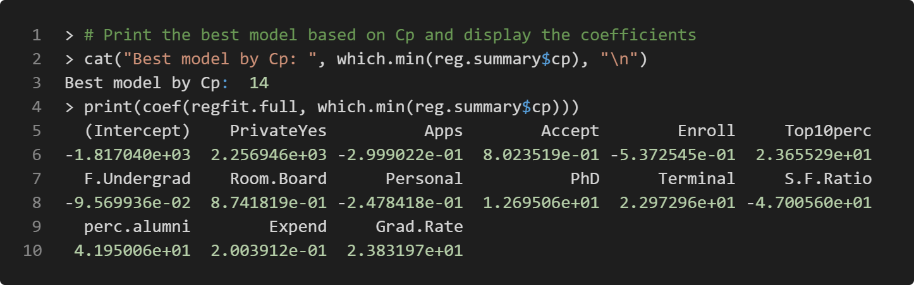
Figure 2.5: The best model based on $C_{p}$

Bayesian Information Criterion (BIC)
The model with the lowest BIC value is preferred, as BIC imposes a larger penalty for model complexity compared to Adjusted R-squared and $C_{p}$, thus favouring more parsimonious models. Figure 2.6 shows the best model based on the lowest BIC value. This model includes only 10 predictors, the fewest among all three metrics.

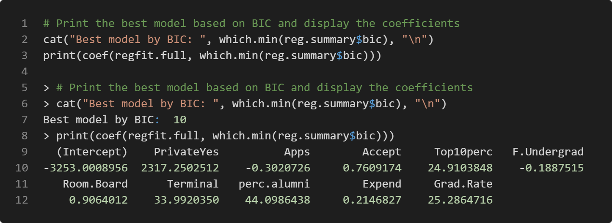
Figure 2.6: The best model based on BIC

Interpretation of Best Models
In summary, all three models include the predictors `PrivateYes`, `Apps`, `Accept`, `Top10perc`, `F.Undergrad`, `Room.Board`, `Terminal`, `perc.alumni`, `Expend`, and `Grad.Rate`. These variables are likely the most important predictors of the response variable `Outstate`. The optimal number of predictors should range between 10 and 15, as indicated by the BIC metric (suggesting a minimum of 10 predictors) and the Adjusted R-squared metric (suggesting a maximum of 15 predictors).

Evaluation of Polynomial Regression Models for Predicting `Top10perc`
This section of the assignment involves using the predictor `Apps` to evaluate the predictive performance of polynomial regression models in predicting the response variable `Top10perc` across different polynomial degrees. Various cross-validation techniques, including Holdout Method, Leave-One-Out Cross-Validation (LOOCV), and $k$-Fold Cross-Validation, will be employed to assess the models’ performance. The Mean Squared Error (MSE) will be calculated for each model using the three cross-validation approaches. The performance of each polynomial model will be evaluated based on the MSE, and the results will be summarised and compared to identify the polynomial degree that offers the best predictive performance.

Fitting Polynomial Regression Models with Different Cross-Validation Approaches
Figure 3.1 presents the R code for fitting polynomial regression models using the Holdout Method, LOOCV, and $k$-Fold Cross-Validation. On line 2, a seed value of $1$ is set to ensure reproducibility of the results. A function named `calculate_mse` is then created on line 5, which takes five arguments: `data`, `response`, `predictor`, `method`, and `k`.

On line 10, a numeric vector `mse_values` is initialised to store the MSE values for each polynomial degree from $1$ to $10$. In the Holdout Method, beginning on line 13, the dataset is split into training ($70\%$) and testing ($30\%$) sets. For each polynomial degree from $1$ to $10$, a polynomial regression model is fitted on the training set (lines 20-22). The model’s predictions are then made on the test set, and the MSE is calculated by comparing the predicted values to the actual values in the test set (lines 25-28).

For both LOOCV and $k$-Fold Cross-Validation, starting on line 33, the function loops through each polynomial degree, fitting a polynomial regression model on the entire dataset. For LOOCV, the MSE is computed using the `cv.glm` function (lines 39). The function `cv.glm` returns an object that includes the element `delta`, where `delta[1]` represents the estimated cross-validation error (MSE in this case). For $k$-Fold Cross-Validation, the dataset is divided into $k$ folds (with $k$ set to $10$ in this analysis), and the `cv.glm` function is also used to compute the MSE for each fold (line 44). On line 50, the function returns a vector of MSE values corresponding to each polynomial degree for the specified cross-validation approach.

Finally, the `calculate_mse` function is applied to the “College” dataset on lines 54-56 to predict the response variable `Top10perc` using `Apps` as the predictor. The function is executed three times, each with a different cross-validation approach: Holdout Method, LOOCV, and $k$-Fold Cross-Validation.

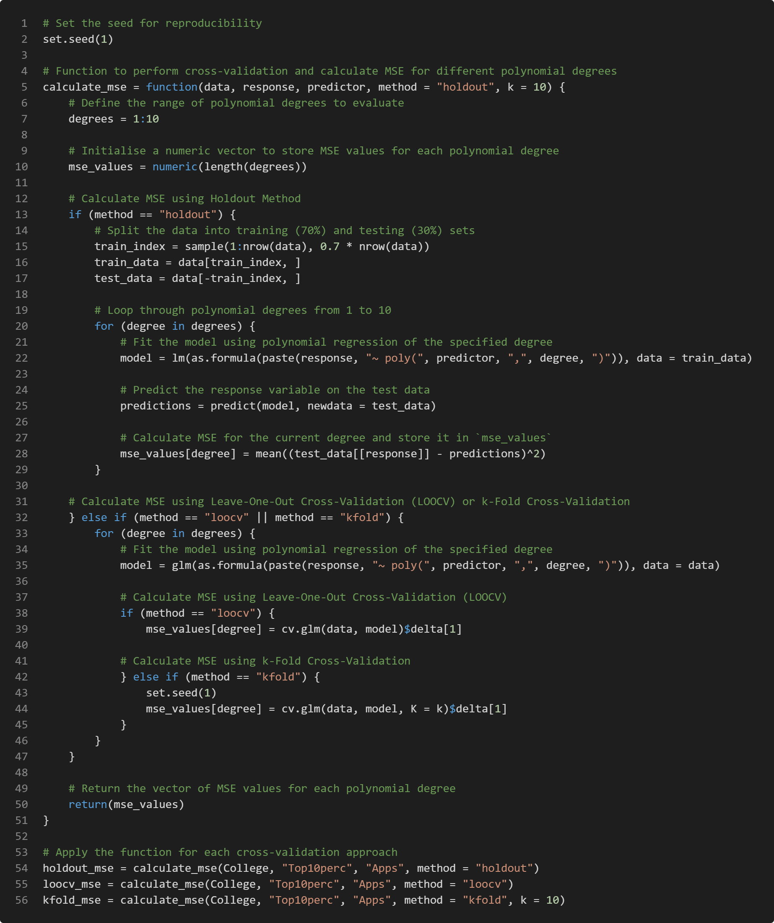
Figure 3.1: R code for fitting polynomial regression models with Holdout Method, LOOCV, and $k$-Fold Cross-Validation

Results of Cross-Validation Analysis
Figure 3.2 shows the R code for creating and printing the data frames of MSE results from different cross-validation approaches: Holdout Method, LOOCV, and $k$-Fold Cross-Validation.

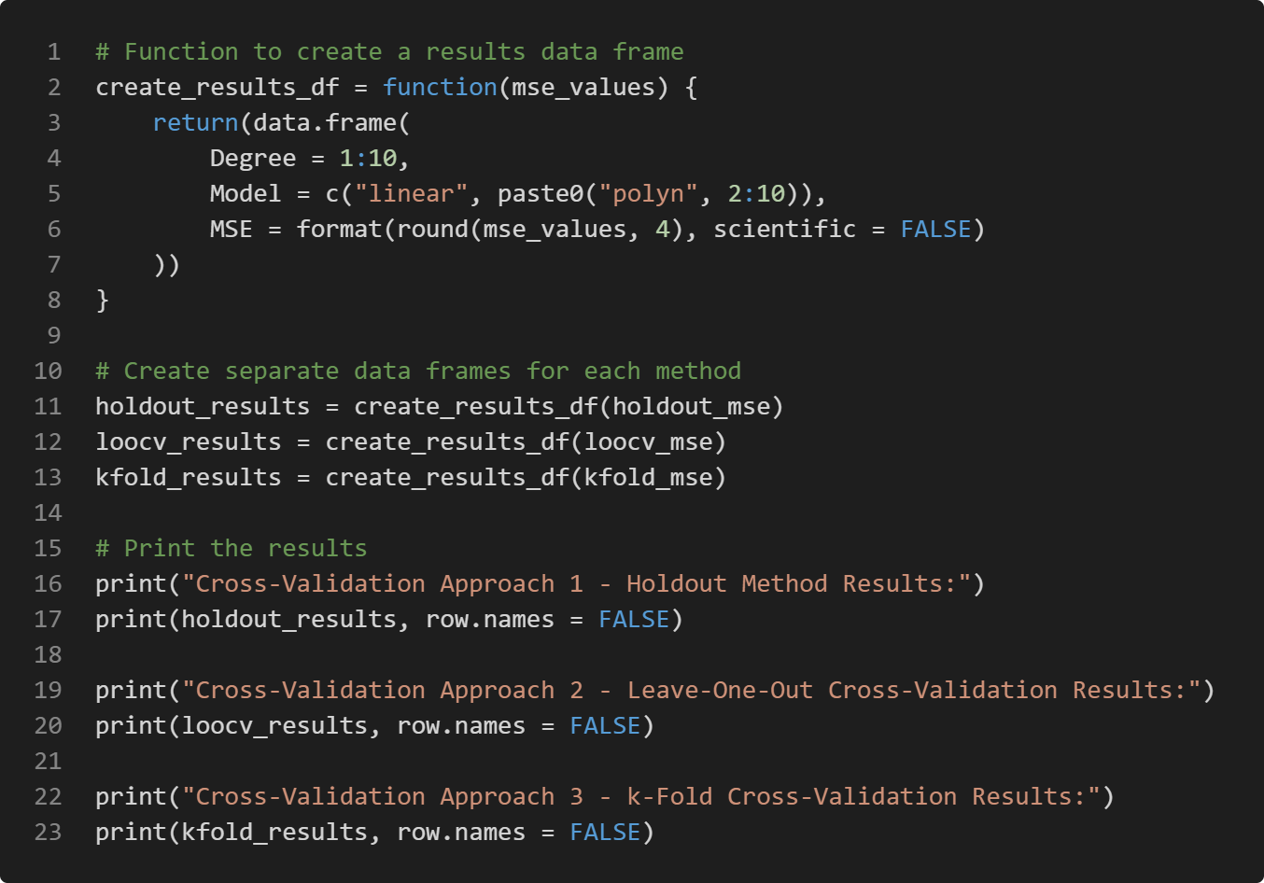
Figure 3.2: R code for creating and printing data frames of MSE results from different cross-validation approaches

Holdout Method
Figure 3.3 presents the MSE results for different polynomial degrees using the Holdout Method. The MSE values fluctuate slightly across different polynomial degrees, with no clear trend of improvement or deterioration as the degree increases. The differences in MSE values between models are relatively small. Although the lowest MSE value ($263.6213$) is achieved with a $7^{th}$-degree polynomial, high-degree polynomials are generally not preferred due to their complexity. Therefore, for a better balance between performance and simplicity, a $1^{st}$-degree (linear) polynomial is preferred in this case due to its relatively low MSE value ($268.6026$).

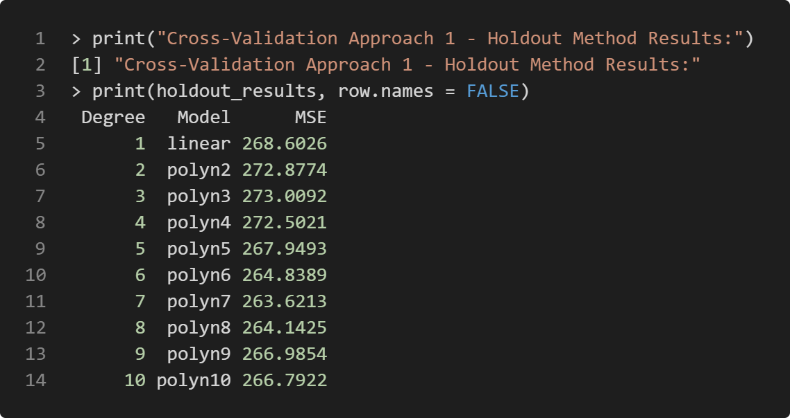
Figure 3.3: MSE results of Holdout Method for different polynomial degrees

Leave-One-Out Cross-Validation (LOOCV)
Figure 3.4 shows the MSE results for different polynomial degrees using LOOCV. The MSE values remain relatively stable for degrees $1$ to $3$ but increase dramatically for higher degrees. This sharp increase in MSE value for degrees $4$ and above indicates severe overfitting. The lowest MSE value ($270.7443$) is achieved with a $2^{nd}$-degree (quadratic) polynomial.

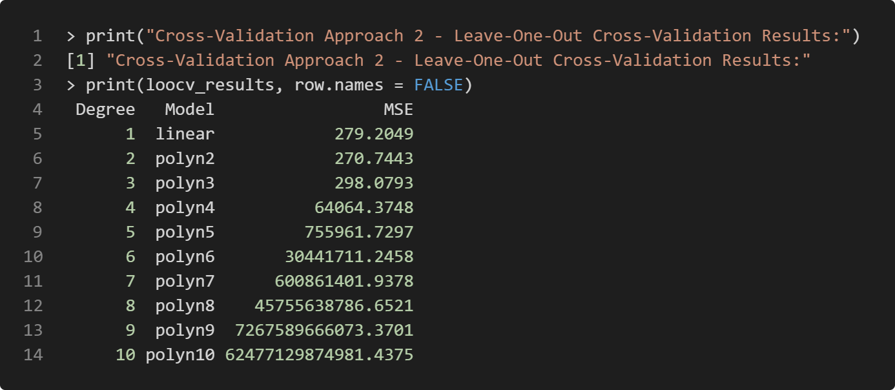
Figure 3.4: MSE results of LOOCV for different polynomial degrees

$k$-Fold Cross-Validation
Figure 3.5 displays the MSE results for different polynomial degrees using $k$-fold Cross-Validation. The results are very similar to those obtained with LOOCV. There is a similar pattern of a dramatic increase in MSE values for higher-degree polynomials. The lowest MSE value ($270.4458$) is also achieved with a $2^{nd}$-degree polynomial.

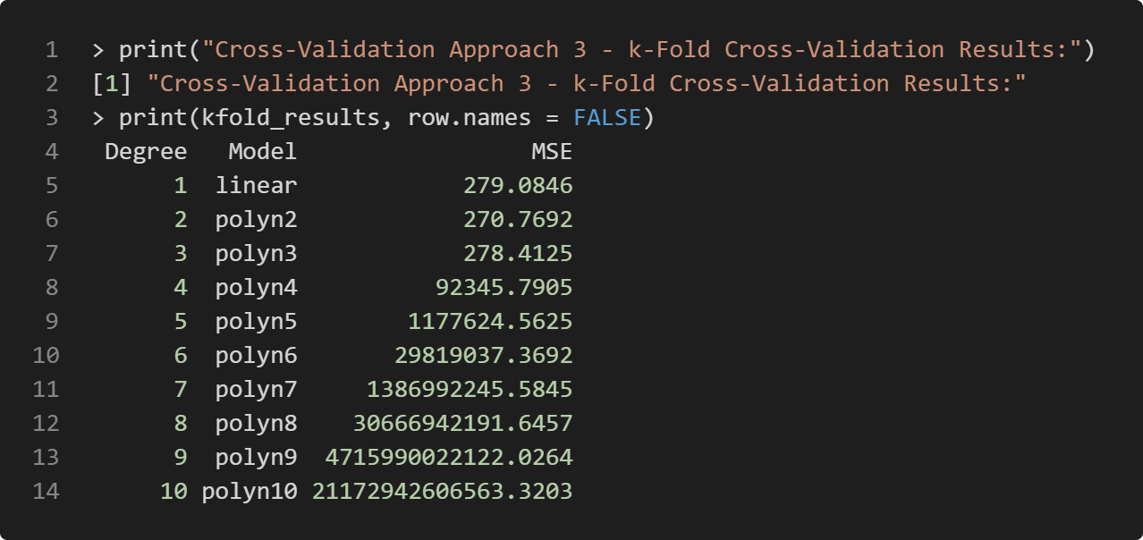
Figure 3.5: MSE results of $k$-Fold Cross-Validation for different polynomial degrees

In summary, the cross-validation analysis suggests that a quadratic ($2^{nd}$ degree) polynomial regression model of response variable `Top10perc` on the predictor `Apps` provides the best balance between model complexity and predictive performance. Higher-degree polynomials ($4$ and above) show clear signs of overfitting and should be avoided. The consistency between LOOCV and $k$-Fold Cross Validation results provides strong evidence for these conclusions.

