Page: - Review.aspx

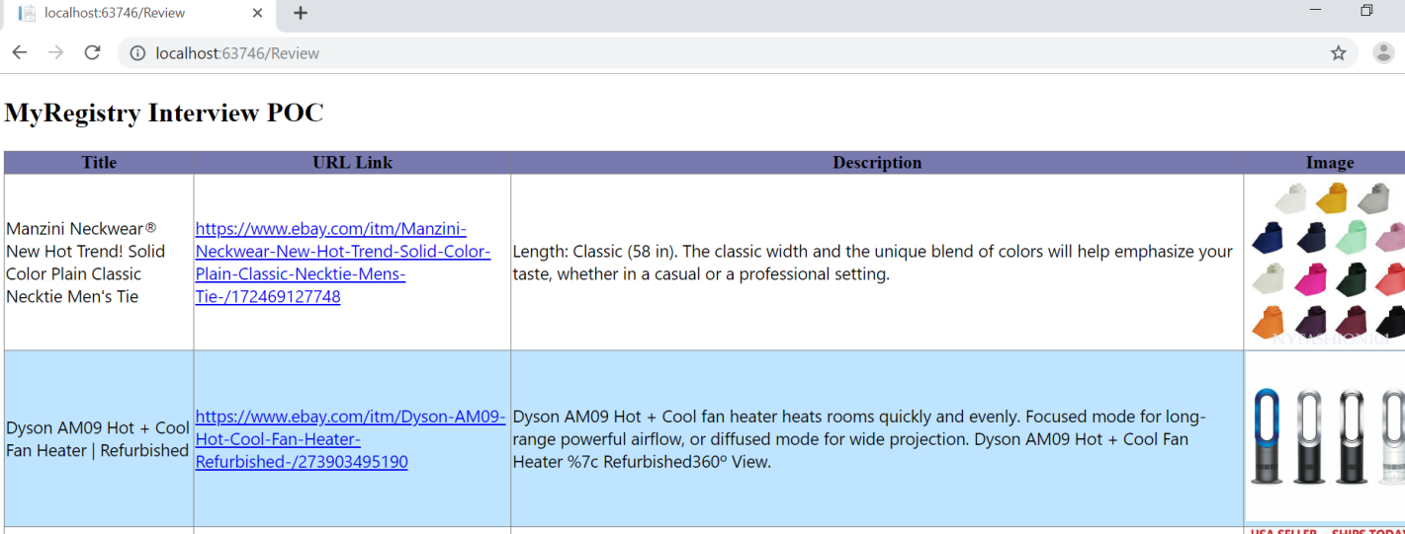

Project : ReadRSSPOC

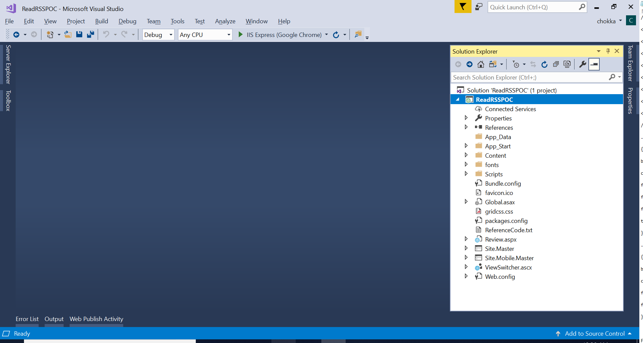

Chokka’s Stackoverflow Account : <https://stackoverflow.com/users/620720/goofyui>