Program Tutor:

Adrian Hargreaves



ASSIGNMENT 1

Business Intelligence and Big Data

Dalvir Singh – 21801212

Vrajesh Choksi - 21801861

Contents

**Executive Summary:** 2

SQL VIEW: 3

vInventoryByType: 3

Figure1.1: vInventoryByType 3

SQL Code: 3

vAcceptedByCountry: 4

Figure1.2: vAcceptedByCountry: 4

SQL CODE: 4

vRejectedProductsByType: 5

Figure1.3: vRejectedProductsByType: 5

SQL Code: 5

**SQL STORE PROCEDURE:** 7

spMaxInventoryByType : 7

Code: 7

spAcceptedByCountry: 8

Code: 8

spAvgRejected: 9

Code: 9

**Interactive Dashboard:** 10

# **Executive Summary:**

In this assignment we have developed a reporting service dashboard to visualise data which is extracted from a SQL Server database. There are various combination of views and stored procedures according to many specifications, it contains number of widgets including tables, gauges and a map which can be change dynamically in with respect to data input. We have three different views for different data purpose which is **vInventoryByType, vAcceptedByCountry and vRejectedProductsByType.** Also we have three stored procedures which is **spMaxInventoryByType, spAcceptedByCountry and spAvgRejected,** this stored procedures going to use the three views to display the data. At last we have a report that shows all the codes used to create the dashboard and a screenshot of our dashboard showing that it works fine even when we change input parameter.

# SQL VIEW:

## vInventoryByType:

This view is used to provide details of products by its name type then subtype name with inventory level as well as date of inventory. It used to control inventory database for essential to the efficiency and profitability in retail business. It gives a brief idea with an accurate stock details for each product with an up to date picture of product. It also helps to see the most purchased product throughout the whole stock with respect to date.

## Figure1.1: vInventoryByType

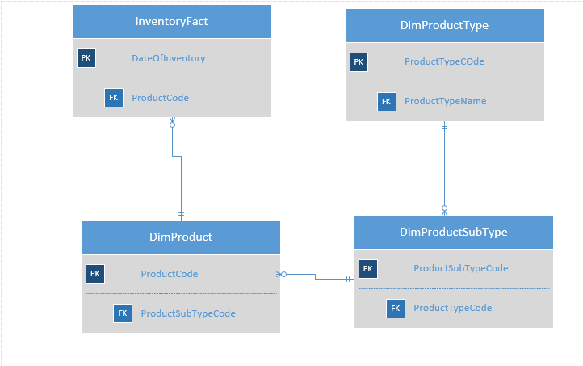

### SQL Code:

CREATE VIEW vInventoryByType

AS

SELECT

DimProductType.ProductTypeName,

DimProductSubtype.ProductSubtypeName,

CONVERT(VARCHAR, DateOfInventory, 103) AS [DateOfInventory],

InventoryFact.InventoryLevel

FROM InventoryFact

INNER JOIN DimProduct

ON InventoryFact.ProductCode = DimProduct.ProductCode

INNER JOIN DimProductSubType

ON DimProduct.ProductSubTypeCode = DimProductSubType.ProductSubTypeCode

INNER JOIN DimPRoductType

ON DimProductSubType.PRoductTypeCode = DimProductType.ProductTypeCode

## vAcceptedByCountry:

Thisview used to provide details of manufactured product which is accepted by various countries, with respect to date of manufacture as well as region where the product was manufactured.

## Figure1.2: vAcceptedByCountry:

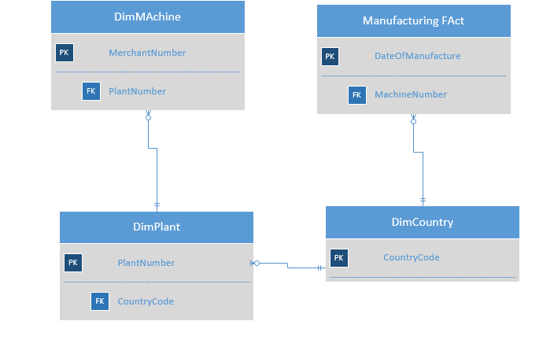

### SQL CODE:

ALTER VIEW vAcceptedByCountry

AS

SELECT DimPlant.CountryCode,

DimCountry.CountryName,

DimPlant.PlantName,

CONVERT (VARCHAR, DateOfManufacture,103) [DateOfManufacture],

ManufacturingFact.AcceptedProducts

FROM DimCountry

INNER JOIN DimPlant

ON DimPlant.CountryCode = DimCountry.CountryCode

INNER JOIN DimMachine

ON DimPlant.PlantNumber = DimMachine.PlantNumber

INNER JOIN ManufacturingFact

ON ManufacturingFact.MachineNumber = DimMachine.MachineNumber

select* from vAcceptedByCountry

## vRejectedProductsByType:

This view used to provide details of the accepted product and rejected product during the time of manufactured with respect to the percentage of the rejected products.

## Figure1.3: vRejectedProductsByType:

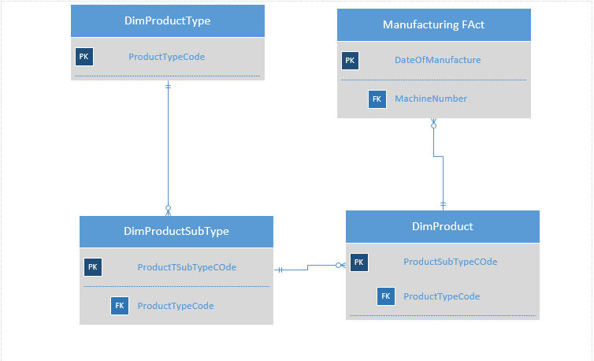

### SQL Code:

ALTER VIEW vRejectedProductsByType

AS

SELECT DimProductType.ProductTypeName,

DimProductSubtype.ProductSubtypeName,

CONVERT(DEC(5,4), 100.0 * ManufacturingFact.RejectedProducts/ (ManufacturingFact.AcceptedProducts + ManufacturingFact.RejectedProducts))

AS 'Percent Rejected',

ManufacturingFact.AcceptedProducts + ManufacturingFact.RejectedProducts

AS 'Total Manufactured',

CONVERT(VARCHAR, DateOfManufacture, 103)

AS [DateOfManufacture]

FROM DimProductType

INNER JOIN DimProductSubtype

ON DimProductType.ProductTypeCode = DimProductSubtype.ProductTypeCode

INNER JOIN DimProduct

ON DimProductSubtype.ProductSubtypeCode = DimProduct.ProductSubtypeCode

INNER JOIN ManufacturingFact

ON ManufacturingFact.ProductCode = DimProduct.ProductCode

select*from vRejectedProductsByType

# **SQL STORE PROCEDURE:**

## spMaxInventoryByType :

This store procedure view will be using the vInventoryByType. It will show the most astounding stock level an incentive inside every item subtype, recorded during the period of the year provided by the info parameters. Each column returned by the strategy will list the item type name, the item subtype name and the most elevated stock level worth recorded out of all items inside that item subtype, during the predefined announcing period.

## Code:

CREATE PROC spMaxInventoryByType

@year INT=1, @month INT=1

AS

SELECT ProductTypeName, ProductSubtypeName, MAX(InventoryLevel) AS 'Max Inventory'

FROM vInventoryByType

WHERE YEAR(DateOfInventory) = @year AND MONTH (DateOfInventory) = @month

GROUP BY ProductTypeName, ProductSubtypeName

ORDER BY ProductTypeName

EXEC spMaxInventoryByType @year ='2009', @month ='04'

## spAcceptedByCountry:

The stored procedure will use the view called **vAcceptedByCountry**. It will show the all-out number of acknowledged items produced at a plant during the long stretch of the year provided by the info parameters. Each line returned by the methodology will list the nation code, nation name, plant name and the all-out number of acknowledged items produced at that plant, during the predefined announcing period.

## Code:

CREATE PROC spAcceptedByCountry

@year INT=1, @month INT=1

AS

SELECT CountryCode, CountryName,

REPLACE(PlantName,'Maximum Miniatures -','') AS [PlantName],

SUM(AcceptedProducts) AS 'Maximum Accepted'

FROM vAcceptedByCountry

WHERE YEAR(DateOfManufacture) = @year AND MONTH (DateOfManufacture) = @month

GROUP BY CountryCode, PlantName, CountryName

ORDER BY CountryCode

EXEC spAcceptedByCountry @year ='2009', @month ='04'

## spAvgRejected:

The stored procedure will use the view called **vRejectedProductsByType**. It will show the all-out number of items made and the level of those items dismissed inside every item subtype, during the long stretch of the year provided by the info parameters. Each column returned by the strategy will list the item type name, item subtype name and the all-out number of items fabricated and the level of those items dismissed inside that item subtype, during the predefined detailing period.

## Code:

CREATE PROC spAvgRejected

@year INT, @month INT

AS

SELECT ProductTypeName, ProductSubtypeName,

AVG([Percent Rejected]) AS 'AvgPercentRejected',

SUM([TotalProducts]) AS 'TotalManufactured'

FROM vRejectedProductsByType

WHERE YEAR(DateOfManufacture) = @year AND MONTH(DateOfManufacture) = @month

GROUP BY ProductTypeName, ProductSubtypeName

ORDER BY ProductTypeName

EXEC spAvgRejected @year ='2009', @month ='04'

# **Interactive Dashboard:**

