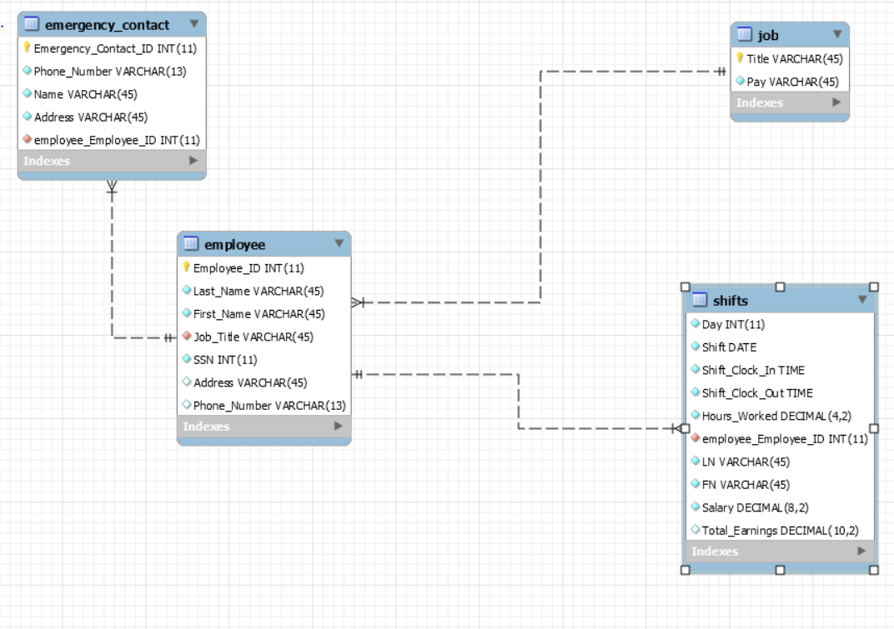

1. Job:
   1. Columns: Title and pay
   2. Data types: VARCHAR
   3. Possible Nulls: All columns Required
   4. Primary key(s): Title
   5. Foreign Key(s): None
   6. Foreign Key Reference: N/A
2. Employee:
   1. Columns: Employee ID, Last Name, First Name, Job Title, SSN, Address, Phone Number
   2. Data types: INT and VARCHAR
   3. Possible Nulls: Address and Phone Number
   4. Primary key(s): Employee ID
   5. Foreign Key(s): Job_Title
   6. Foreign Key Reference: Job(Title)>Employee(Job Title)
3. Job:
   1. Columns: Title and pay
   2. Data types: VARCHAR
   3. Possible Nulls: All columns Required
   4. Primary key(s): Title
   5. Foreign Key(s): None
   6. Foreign Key Reference: N/A
4. Emergency Contact:
   1. Columns: Emergency Contact ID, Phone Number, Name, Address, and (Employee ID)
   2. Data types: INT and VARCHAR
   3. Possible Nulls: All columns Required
   4. Primary key(s): Emergency Contact ID
   5. Foreign Key(s): (Employee ID)
   6. Foreign Key Reference: Employee(Employee ID) ->Emergency Contact(Employee Id)
5. Shifts:
   1. Columns: Day of the Shift, The Shift Date, Clock In Times, Clock Out Times, Last Name, First Name, Salary(wage I know), and Total Earnings.
   2. Data types: INT, Date, Time, Decimal, and VARCHAR
   3. Possible Nulls: Total Earnings
   4. Primary key(s): None
   5. Foreign Key(s): Employee Id
   6. Foreign Key Reference: Employee(Employee Id)->Shifts(Employee Id)