
Artificial Intelligence 2025, Homework 2
Cholponai Manapova, 2229146


Artificial Intelligence and Robotics

Table of Contents
- Introduction………………………………………………….…………2
- Problem Formulation……………………………………….…………..3
- A* Search Approach …………………………….………….………….3
- CSP Approach ……………………………………………...………….4
- Experimental Setup……………………………………………………..5
- Experimental Results…………………………………………………....5
- Discussion and Conclusion …………………………………….………6
- Instructions to run and references……………………………...……….7

Here GitHub code: click me

Final Report: Solving the n-Queens Problem using A* and CSP

1. Introduction
The n-Queens problem is a classical combinatorial search problem in artificial intelligence. The goal is to place n queens on an n × n chessboard such that no two queens attack each other. This means that no two queens can share the same row, column, or diagonal.
This problem is widely used as a benchmark for evaluating search algorithms and constraint-based approaches because it has a clear formulation, a large search space, and well-known theoretical properties.
The objective of this project is to compare two different approaches to solving the n-Queens problem:
- A* search algorithm
- Constraint Satisfaction Problem (CSP) approach using OR-Tools
The comparison focuses on execution time and scalability as the size of the board increases.
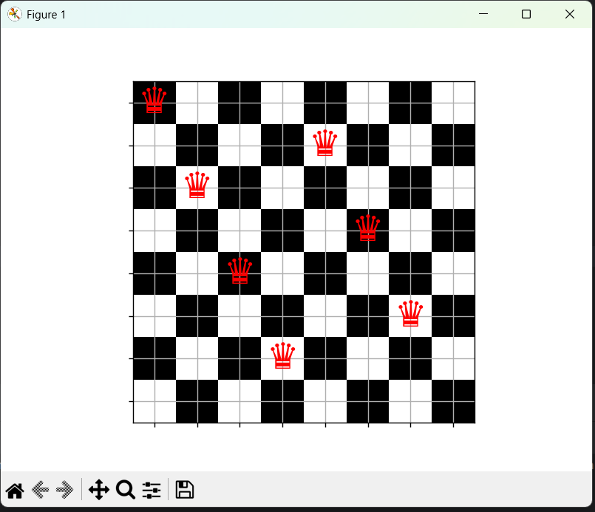
The n-Queens problem is not only a theoretical puzzle but also represents a class of real-world problems involving resource allocation, scheduling, and constraint reasoning. Similar formulations appear in timetabling, register allocation in compilers, and placement problems in engineering.
Because of its simple formulation and complex combinatorial structure, the problem is commonly used as a benchmark for evaluating artificial intelligence techniques such as state-space search, heuristics, and constraint satisfaction methods. This makes it particularly suitable for comparing general-purpose search algorithms like A* with specialized solvers designed for constraint-based problems.

2. Problem Formulation
The n-Queens problem can be formulated as follows:
- Variables:
One variable for each column of the chessboard, representing the row index of the queen placed in that column.
- Domain:
Each variable can take values from 0 to n−1, corresponding to possible row positions.
- Constraints:
  - No two queens can be placed in the same row.
  - No two queens can be placed on the same diagonal.
A solution is a complete assignment of all variables that satisfies all constraints.
The theoretical worst-case complexity of the n-Queens problem remains exponential due to the size of the search space, which is O(n!). Although pruning and heuristic guidance significantly reduce the number of explored states in practice, the problem remains computationally challenging for large values of n. This justifies the need for more specialized techniques such as constraint propagation, as used in CSP solvers.

3. A* Search Approach

State Representation
A state is represented as a tuple of integers. The index of the tuple corresponds to the column, and the value corresponds to the row position of the queen in that column. For example, the state (1, 3, 0) represents three queens placed in columns 0, 1, and 2.

Successor Function
Successors are generated by placing a queen in the next column in any row that does not violate existing constraints. This means that only safe placements are considered, which significantly prunes the search space.

Heuristic Function
The heuristic function used is:
h(state) = n − len(state)
This represents the number of queens still to be placed. The heuristic is admissible because it never overestimates the remaining cost to reach a complete solution.

Goal Test
A state is a goal if its length equals n, meaning that all queens have been successfully placed without conflicts.

Visualization
Additionally, a visualization module was implemented to demonstrate how the solution is incrementally constructed on the chessboard. This visualization was used only for demonstration purposes and was not involved in performance experiments.

4. CSP Approach
The n-Queens problem can naturally be formulated as a Constraint Satisfaction Problem. In this project, the Google OR-Tools CP-SAT solver was used.

Variables
Each queen is represented as an integer variable with a domain from 0 to n−1.

Constraints
The following constraints are applied:
- All queens must be in different rows.
- For every pair of queens, diagonal conflicts are forbidden using absolute difference constraints.

Solver
We utilized the Google OR-Tools CP-SAT solver, which internally combines constraint programming techniques with SAT-based reasoning and efficient backtracking strategies. This allows the solver to prune the search space very effectively and scale well to larger problem instances.
The n-Queens problem is particularly well-suited to the CSP paradigm because the problem is naturally expressed in terms of variables and constraints rather than paths or actions. Each queen corresponds to a variable, and all problem rules are directly encoded as constraints. This allows CSP solvers to exploit powerful techniques such as constraint propagation and domain filtering, which are not available in classical search algorithms.

5. Experimental Setup
All experiments were executed on a personal computer with the following configuration:
- Operating System: Windows 11
- Processor: Intel Core i7
- Memory: 24 GB RAM
- Python version: Python 3.11
Each experiment was executed once, since the results were deterministic for the tested configurations.
The algorithms were tested on increasing values of n:
4, 6, 8, 10, 12, 14, 16
The following metrics were recorded:
- Execution time (seconds)
- Number of expanded nodes (for A*)

6. Experimental Results
n | Algorithm | Time (seconds) | Nodes Expanded
4 | A* | 0.0000 | 9
4 | CSP | 0.0196 | –
6 | A* | 0.0001 | 32
6 | CSP | 0.0142 | –
8 | A* | 0.0003 | 114
8 | CSP | 0.0139 | –
10 | A* | 0.0003 | 103
10 | CSP | 0.0299 | –
12 | A* | 0.0010 | 262
12 | CSP | 0.0433 | –
14 | A* | 0.0093 | 1900
14 | CSP | 0.0504 | –
16 | A* | 0.0633 | 10053
16 | CSP | 0.0691 | –

Visualization Module
A visualization module was implemented to provide an intuitive understanding of how solutions are constructed. The module displays a graphical chessboard and incrementally shows the placement of queens during the solving process.
This visualization was designed purely for educational and demonstrational purposes. It was not used during the performance evaluation to avoid influencing timing measurements. Such a visual component can be useful when explaining algorithmic behavior, especially in educational contexts.

7. Discussion
The experimental results confirm the theoretical expectations. The A* algorithm performs very well on small instances, but the number of expanded nodes generally increases as n grows, reflecting the exponential nature of the search space. Although constraint-based pruning significantly improves its performance, A* still becomes more expensive for larger boards.
The CSP approach based on OR-Tools demonstrates much more stable performance and scales better with increasing problem size. This behavior is explained by the use of advanced techniques such as constraint propagation, domain reduction, and efficient backtracking implemented in the CP-SAT solver.

Limitations
The A* implementation heavily relies on constraint-based pruning in successor generation. Without this pruning, the approach would not scale to larger instances. Additionally, experiments were conducted on a limited range of n due to practical runtime constraints.

Conclusion
This project compared two different approaches to solving the n-Queens problem: A* search and CSP using OR-Tools. The results show that while A* can be effective for small to medium problem sizes, specialized CSP solvers provide better scalability and more consistent performance.
The experiments highlight the importance of selecting an appropriate algorithm depending on the structure of the problem. For constraint-heavy problems such as n-Queens, CSP solvers are generally more suitable than general-purpose search algorithms.
Several extensions could be explored in future work. More advanced heuristics could be designed for the A* algorithm, such as heuristics based on conflict estimation. Additional experiments could be performed with larger values of n and multiple runs to obtain averaged performance results. Furthermore, other approaches such as local search (e.g., Min-Conflicts) could be included in the comparison.

8. Instructions to Run
The project is organized into modular packages. To reproduce the results:
- Install dependencies: pip install -r requirements.txt
- Run experiments: python experiments.run_experiments.py
- View individual solutions: python main.py

References
- Favorito, M., & Fuggitti, F. Artificial Intelligence Course Slides: Chapter 4 - Classical Search. Sapienza University of Rome.
- Google OR-Tools Documentation. The CP-SAT Solver.
- Python heap library documentation

