

REMIS V2
Rental Management Information System

BACKEND IMPLEMENTATION REPORT

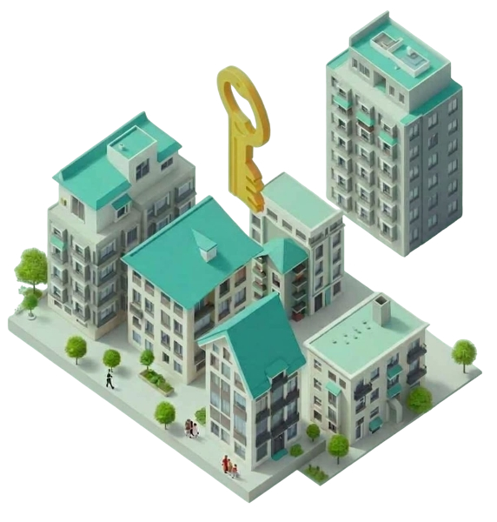

Framework: Laravel 12 | PHP 8.2+
Database: MySQL 8 (XAMPP / Windows)
Report Date: June 2026
Version: 2.0 (commit 2d39813)

Table of Contents
1. Project Overview
2. Technology Stack
3. Backend Architecture
4. Directory Structure
5. Database Design
6. Models and Relationships
7. Database Migrations
8. Authentication and Authorization
9. Middleware
10. Routing
11. Controllers
12. Service Layer
13. Mail System
14. External API Integrations
15. PDF Report Generation
16. Artisan Console Commands
17. Configuration Files
18. Testing
19. Security Implementation
20. Performance Considerations
21. Deployment Notes
22. Component Interaction Summary

1. Project Overview
REMIS V2 (Rental Management Information System) is a full-stack web application built on Laravel 12 for the Tanzanian rental property market. It provides landlords with a unified platform to manage properties, units, tenants, leases, and rent payments — deeply integrated with Tanzanian financial and regulatory infrastructure including NMB Bank, BRIQ SMS, and the Tanzania Revenue Authority (TRA).

Core Capabilities
Domain | Capability
Property Management | Single-unit and multi-unit (multi-floor) property registration with image upload
Tenant Management | Tenant onboarding, identity fields (TIN/NIDA/gender/nationality), invitations
Lease Lifecycle | Create, assign tenant, terminate with reason, renew, download as PDF
Rent Payments | NMB Bank SPG: generate control numbers, send via email/SMS, poll status
Notifications | SMTP email (Gmail-ready) + BRIQ bulk SMS (Tanzania)
TIN Verification | Real-time AJAX lookup against Tanzania Revenue Authority API
PDF Reports | Rent payments, tenants, overdue payments, property inventory
Admin Panel | System settings, audit logs, database backups, user management
Session Security | Lock screen, rate-limited unlock, force-password-change for new tenants
Multi-role Access | Landlord, Tenant, and Admin — each with isolated dashboard and permissions

Development Timeline
Phase | Period | Scope
Phase 1 – Foundation | January 2024 | Users, Properties, Leases, Payments, Maintenance, Auth
Phase 2 – Multi-Unit Support | April–May 2026 | Units table, floor layouts, lease lifecycle, identity fields
Phase 3 – Security & Admin | May 2026 | Admin panel, audit logs, backups, session lock, role:admin
Phase 4 – Payment & Profiles | May–Jun 2026 | NMB SPG integration, user profiles, preferences JSON

2. Technology Stack
REMIS V2 is built on the Laravel 12 framework using PHP 8.2+. The full dependency list is managed by Composer and defined in composer.json.

2.1 Production Dependencies
Package | Version | Purpose
laravel/framework | ^12.0 | MVC framework — routing, ORM, auth, mail, cache, HTTP client
php | ^8.2 | Runtime — named args, enums, readonly props, fibers
barryvdh/laravel-dompdf | ^3.1 | PDF generation from Blade templates (A4 lease & report PDFs)
laravel/tinker | ^2.9 | REPL for debugging and quick model inspection in development

2.2 Development Dependencies
Package | Version | Purpose
phpunit/phpunit | ^11.0 | Unit and feature test runner
fakerphp/faker | ^1.23 | Fake data generation for factories/seeders
laravel/pint | ^1.13 | PSR-12 code style enforcement
mockery/mockery | ^1.6 | Mock objects for unit tests
nunomaduro/collision | ^8.0 | Pretty CLI error reporting during test runs

2.3 Infrastructure Components
Layer | Technology | Notes
Web Server | Apache 2.4 (XAMPP) | mod_rewrite enabled; AllowOverride All on document root
Database | MySQL 8.0 | InnoDB engine; foreign key constraints ON; charset utf8mb4
PHP Runtime | PHP 8.2.12 | Extensions: pdo_mysql, mbstring, openssl, fileinfo, gd, curl, zip
Session Store | File-based (default) | SESSION_DRIVER=file; configurable to Redis or DB
Cache | File-based (default) | Used by NmbPaymentService for 14-min token caching
Mail | SMTP / Log driver | Development: log driver. Production: Gmail SMTP (port 587/TLS)
Frontend Build | Vite + Tailwind CSS | Managed separately; Blade templates served from resources/views
SMS Gateway | BRIQ (Tanzania) | REST API at karibu.briq.tz; Tanzanian E.164 number normalization
Payment GW | NMB Bank SPG (Zalongwa) | REST API at nmb.spg.co.tz; Bearer token auth; 14-min TTL
TIN Verify | TRA API (Tanzania) | Tanzania Revenue Authority; dev-mode mock available

3. Backend Architecture
REMIS follows the standard Laravel MVC architecture augmented with a dedicated Service Layer for business logic that spans multiple models. The application uses session-based (stateful) authentication rather than a separate REST API, meaning all routes — including AJAX endpoints — are protected by the same middleware pipeline.

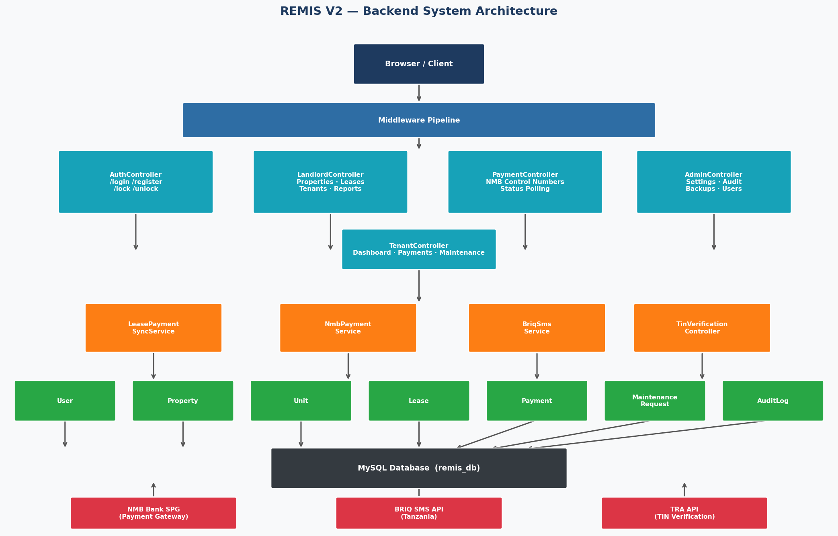
Figure 1 – REMIS V2 Backend System Architecture

3.1 Design Patterns
Pattern | Where Applied | Benefit
MVC | All routes → controllers → views | Clear separation of concerns
Service Objects | LeasePaymentSyncService, NmbPaymentService, BriqSmsService | Complex domain logic isolated from controllers
Eloquent Active Record | All 9 models (User, Property, Unit, Lease…) | Readable query API, relationship graph
Mailable Classes | 4 mail classes (Invitation, ControlNumber, Termination, Warning) | Testable, reusable email objects
Middleware Pipeline | auth → role:X → locked → force.password.change | Stackable request interceptors
Named Routes | landlord.payments.index, tenant.dashboard… | Decoupled URL generation, safe refactoring
Repository-like Scoping | All queries scoped to Auth::id() via where('landlord_id'…) | Automatic tenant/landlord data isolation

3.2 Request Lifecycle
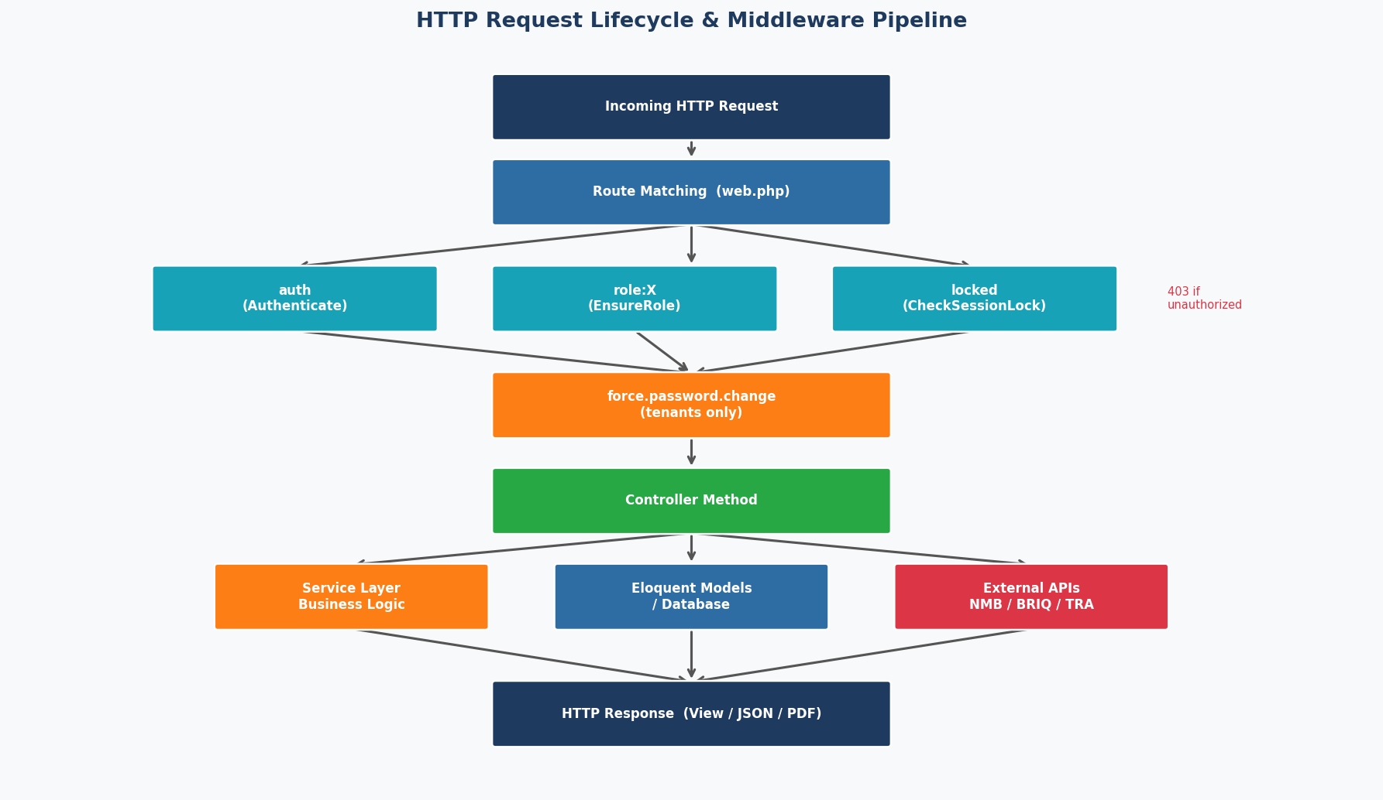
Figure 2 – HTTP Request Lifecycle and Middleware Pipeline
Every HTTP request passes through Laravel's Kernel, which applies the 'web' middleware group (sessions, CSRF verification, cookie handling) before reaching route-specific middleware. Authentication is checked first; if the user is unauthenticated they are redirected to the landing page. The EnsureRole middleware then verifies the user's role matches the route group. The CheckSessionLock middleware fires for remembered sessions, redirecting to the lock screen. Finally, ForcePasswordChange applies only to tenant routes where the flag is set.

4. Directory Structure
The project follows the standard Laravel directory layout with a few custom additions. The most important backend-specific directories are described below.
RemisV2/
├── app/
│ ├── Console/Commands/ # CLI: GenerateLeasePdf, GenerateReportPdf
│ ├── Http/
│ │ ├── Controllers/ # 7 controllers (one per domain)
│ │ └── Middleware/ # EnsureRole, ForcePasswordChange, CheckSessionLock
│ ├── Mail/ # 4 Mailable classes
│ ├── Models/ # 9 Eloquent models
│ ├── Providers/ # AppServiceProvider, AuthServiceProvider
│ └── Services/ # LeasePaymentSyncService, NmbPaymentService, BriqSmsService
├── bootstrap/app.php # Middleware alias registration
├── config/
│ ├── auth.php # Guard / provider / password-reset config
│ ├── database.php # MySQL connection
│ ├── mail.php # SMTP config
│ └── services.php # NMB / BRIQ / TRA credentials map
├── database/
│ ├── migrations/ # 28 migration files (4 phases)
│ └── seeders/ # SystemSettings seeder (8 default keys)
├── routes/web.php # All 60+ named routes
├── resources/views/ # Blade templates (frontend)
├── tests/
│ ├── Feature/BriqSmsServiceTest.php
│ └── Unit/LeasePaymentSyncServiceTest.php
├── composer.json # PHP dependencies
└── .env.example # Environment variable template

Directory / File | Purpose
app/Http/Controllers/ | One controller per domain. No fat controllers — complex logic delegated to Services.
app/Http/Middleware/ | 3 custom middleware: role guard, session lock, force-password-change.
app/Models/ | 9 Eloquent models covering all business entities.
app/Services/ | 3 service classes encapsulating NMB payment, SMS, and lease sync logic.
app/Mail/ | 4 Mailable classes for transactional email (invitation, control number, notices).
app/Console/Commands/ | 2 Artisan commands for server-side PDF generation.
database/migrations/ | 28 migration files evolving the schema from 2024 to 2026.
routes/web.php | All application routes — no api.php (AJAX endpoints use web session auth).
config/services.php | Central registry for all third-party API credentials.

5. Database Design
The database uses MySQL 8 with InnoDB engine, enforcing foreign key constraints for referential integrity. The schema evolved across 28 migrations organized in 4 development phases. The central entities are users, properties, units, leases, and payments.

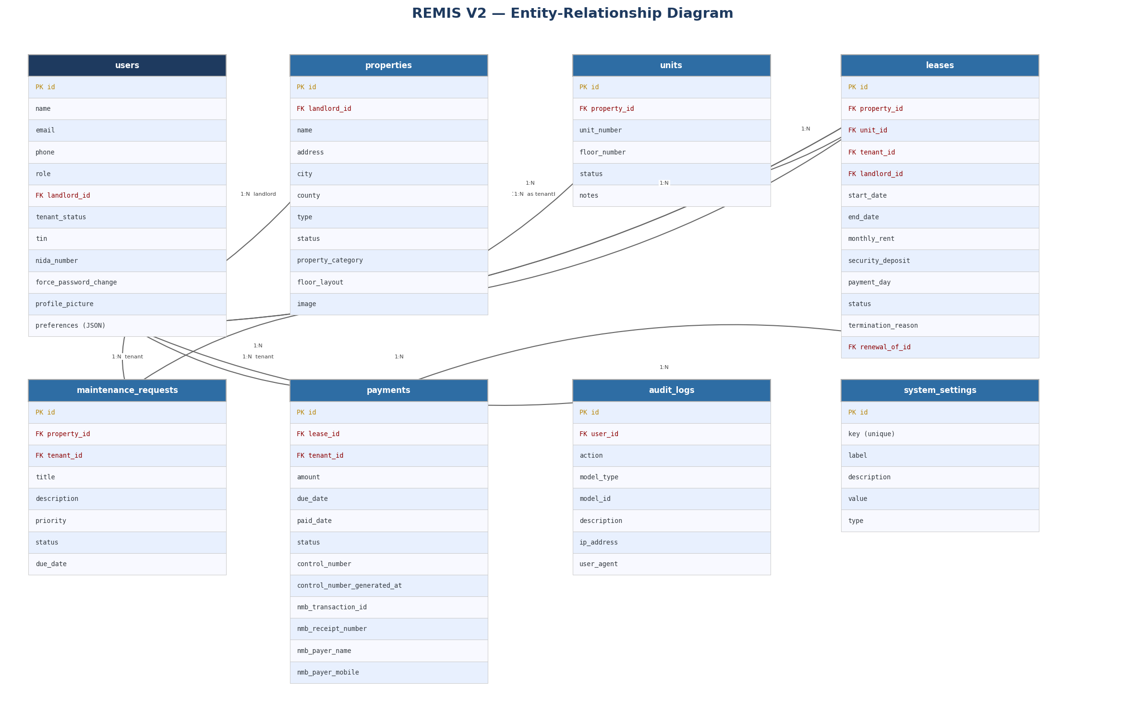
Figure 3 – Entity-Relationship Diagram (all tables and foreign keys)

5.1 Table Summary
Table | Primary Role | Key Foreign Keys
users | Stores all roles in one table (landlord/tenant/admin) | landlord_id → users.id (self-ref)
properties | Physical property records per landlord | landlord_id → users.id
units | Individual rentable units within properties | property_id → properties.id
leases | Tenant-unit contracts with full lifecycle tracking | property_id, unit_id, tenant_id, landlord_id, renewal_of_id
payments | Rent payment records including NMB transaction data | lease_id, tenant_id
maintenance_requests | Tenant-submitted maintenance tickets | property_id, tenant_id
audit_logs | Admin action trail with IP and user agent | user_id → users.id
system_settings | Admin-configurable key-value application settings | —
backups | Database backup metadata records | created_by → users.id
sessions | Laravel session storage (file or DB) | user_id → users.id
password_reset_tokens | Tenant invitation and password reset tokens | email → users.email

5.2 Key Design Decisions

Unified Users Table
All three roles (landlord, tenant, admin) are stored in a single users table differentiated by the 'role' column. This simplifies authentication — one guard, one provider — while role-specific fields (tin, nida_number for tenants; profile_picture, preferences for all) are nullable on rows where they don't apply.

Self-Referential landlord_id on Users
When a landlord creates a tenant account, the tenant row records the landlord's ID in the landlord_id column. This creates a direct ownership link, allowing queries like user.createdTenants() without joining through the leases table.

Units Table Introduced in Phase 2
The original schema linked leases directly to properties (1:1 for single-unit). Phase 2 introduced the units table to support multi-unit buildings with individual floor/unit-number tracking. unit_id on leases is nullable to preserve backward compatibility with legacy single-unit lease records.

JSON preferences Column
User preferences (notification settings, UI options) are stored in a JSON column cast to a PHP array by Eloquent. This avoids a separate user_preferences table and allows extending settings without additional migrations.

NMB Payment Fields on payments Table
Rather than a separate nmb_transactions table, all NMB gateway data (control_number, nmb_transaction_id, nmb_receipt_number, nmb_payer_name, nmb_payer_mobile, nmb_paid_at) is stored directly on the payments row. This keeps the payment record self-contained for reporting.

6. Models and Relationships
All business entities are represented as Eloquent models in app/Models/. Each model defines its fillable fields, casts, relationships, and any domain helper methods.

6.1 User Model (app/Models/User.php)
The User model extends Authenticatable, giving it Laravel's built-in auth capabilities (remember tokens, password reset). It serves all three roles.
class User extends Authenticatable
{
protected $fillable = [
'name', 'email', 'phone', 'role', 'password', 'landlord_id',
'tenant_status', 'tin', 'nida_number', 'gender', 'nationality',
'force_password_change', 'default_password_hint', 'invitation_status',
'profile_picture', 'preferences',
];
protected function casts(): array
{
return [
'password' => 'hashed', // auto-bcrypt on assignment
'preferences' => 'array', // JSON column ↔ PHP array
];
}
public function isLandlord(): bool { return $this->role === 'landlord'; }
public function isTenant(): bool { return $this->role === 'tenant'; }
public function isAdmin(): bool { return $this->role === 'admin'; }
// Self-referential: landlords own tenants they created
public function createdTenants() { return $this->hasMany(User::class, 'landlord_id'); }
public function createdByLandlord(){ return $this->belongsTo(User::class, 'landlord_id'); }
public function properties() { return $this->hasMany(Property::class, 'landlord_id'); }
public function leasesAsLandlord() { return $this->hasMany(Lease::class, 'landlord_id'); }
public function leasesAsTenant() { return $this->hasMany(Lease::class, 'tenant_id'); }
public function payments() { return $this->hasMany(Payment::class, 'tenant_id'); }
}

6.2 Property Model (app/Models/Property.php)
class Property extends Model
{
protected $fillable = [
'landlord_id', 'name', 'address', 'city', 'county', 'total_area',
'type', 'bedrooms', 'bathrooms', 'status', 'description',
'property_category', // 'single' | 'multi'
'number_of_units', 'floor_layout', 'image',
];
public function units() { return $this->hasMany(Unit::class); }
public function leases() { return $this->hasMany(Lease::class); }
public function activeLease() { return $this->hasOne(Lease::class)
->where('status','active'); }
public function isMultiUnit(): bool { return $this->property_category === 'multi'; }
public function occupiedUnitsCount() { return $this->units()->where('status','occupied')->count(); }
public function vacantUnitsCount() { return $this->units()->where('status','vacant')->count(); }
}

6.3 Lease Model (app/Models/Lease.php)
The Lease is the central entity binding a tenant, a unit, and a landlord. It tracks the full contract lifecycle including renewals via a self-referential renewal_of_id foreign key.
class Lease extends Model
{
protected $fillable = [
'property_id', 'unit_id', 'tenant_id', 'landlord_id',
'start_date', 'end_date', 'monthly_rent', 'security_deposit',
'payment_day', 'payment_frequency', 'status',
'termination_reason', 'termination_notes', 'terminated_at',
'renewal_of_id', // Self-FK — points to the lease being renewed
'lease_terms',
];
protected function casts(): array
{
return ['start_date' => 'date', 'end_date' => 'date'];
}
public function renewedFrom() { return $this->belongsTo(Lease::class, 'renewal_of_id'); }
public function renewals() { return $this->hasMany(Lease::class, 'renewal_of_id'); }
public function isActive(): bool { return $this->status === 'active'; }
public function isTerminated(): bool { return $this->status === 'terminated'; }
public function daysUntilExpiry(): int
{
return (int) now()->startOfDay()->diffInDays($this->end_date, false);
}
}

6.4 Payment Model (app/Models/Payment.php)
Payment records are auto-generated by the LeasePaymentSyncService. NMB transaction data is stored directly on the payment row when payment is confirmed.
class Payment extends Model
{
protected $fillable = [
'lease_id', 'tenant_id', 'amount', 'due_date', 'paid_date',
'status', 'reference', 'notes',
// NMB fields (populated after gateway interaction):
'control_number', 'control_number_generated_at',
'control_number_sent_at', 'control_number_sent_via',
'nmb_transaction_id', 'nmb_receipt_number',
'nmb_payer_name', 'nmb_payer_mobile', 'nmb_paid_at',
];
protected function casts(): array
{
return [
'due_date' => 'date',
'paid_date' => 'date',
'control_number_generated_at' => 'datetime',
'nmb_paid_at' => 'datetime',
];
}
}

6.5 AuditLog Model (app/Models/AuditLog.php)
All admin actions are recorded using a static helper method, capturing user, action type, related model, IP address, and user agent.
class AuditLog extends Model
{
protected $fillable = [
'user_id', 'action', 'model_type', 'model_id',
'description', 'ip_address', 'user_agent',
];
public static function log(string $action, string $description,
?string $modelType = null, ?int $modelId = null): void
{
static::create([
'user_id' => Auth::id(),
'action' => $action,
'model_type' => $modelType,
'model_id' => $modelId,
'description' => $description,
'ip_address' => request()->ip(),
'user_agent' => request()->userAgent(),
]);
}
}

6.6 Model Relationship Map
Model | Has Many | Belongs To
User (landlord) | Property, Lease (as landlord), User (created tenants) | —
User (tenant) | Lease (as tenant), Payment, MaintenanceRequest | User (landlord via landlord_id)
Property | Unit, Lease, MaintenanceRequest | User (landlord)
Unit | Lease | Property
Lease | Payment, Lease (renewals) | Property, Unit, User×2, Lease (renewedFrom)
Payment | — | Lease, User (tenant)
MaintenanceRequest | — | Property, User (tenant)
AuditLog | — | User

7. Database Migrations
Database schema changes are managed via 28 Laravel migration files grouped into four development phases. Running php artisan migrate applies them in chronological order, building the full schema from scratch.

Phase 1 — Foundation (January 2024)
Migration | What It Creates / Changes
0001_01_01_000000_create_users_table | users, password_reset_tokens, sessions, cache tables
2024_01_01_000010_create_properties_table | properties with landlord_id FK
2024_01_01_000011_add_county_area_to_properties | Adds county, total_area columns
2024_01_01_000020_create_leases_table | leases with property/tenant/landlord FKs
2024_01_01_000021_add_payment_fields_to_leases | payment_day, payment_frequency, lease_expiry_reminder_days
2024_01_01_000030_create_payments_table | payments with lease/tenant FKs, status, reference
2024_01_01_000040_create_maintenance_requests_table | maintenance_requests with priority/status
2024_01_01_000041_update_maintenance_requests_table | Adds viewable_by column

Phase 2 — Multi-Unit Support (April–May 2026)
Migration | Change
2026_04_25_make_tenant_id_nullable_on_leases | tenant_id becomes nullable (lease can exist before tenant assigned)
2026_04_27_add_landlord_id_to_users_table | Self-referential FK for landlord→tenant ownership
2026_05_07_000001_add_property_category_to_properties | property_category, number_of_units, image columns
2026_05_07_000002_create_units_table | New units table (unit_number, floor_number, status, notes)
2026_05_07_000003_add_unit_id_and_terms_to_leases | unit_id FK on leases, lease_terms text field
2026_05_07_100001_add_tenant_status_to_users | tenant_status column (active/inactive)
2026_05_07_100002_add_lifecycle_fields_to_leases | termination_reason, termination_notes, terminated_at, renewal_of_id
2026_05_07_200001_add_identity_fields_to_users | tin, nida_number, gender, nationality (Tanzania compliance)
2026_05_12_add_floor_fields | floor_layout on properties, floor_number on units

Phase 3 — Security & Admin (May 2026)
Migration | Change
2026_05_11_000001_add_force_password_change | force_password_change bool, default_password_hint string
2026_05_11_000002_add_invitation_status | invitation_status on users (pending/invited/accepted)
2026_05_12_add_performance_indexes | Composite indexes on payments and leases for query optimization
2026_05_29_000001_add_admin_role | Extends role enum to include 'admin'
2026_05_29_000002_create_audit_logs_table | audit_logs with indexed (action, created_at) and (model_type, model_id)
2026_05_29_000003_create_system_settings_table | system_settings key-value table, pre-seeded with 8 defaults
2026_05_29_000004_create_backups_table | backups metadata table with created_by FK

Phase 4 — User Profiles & NMB Payments (May–June 2026)
Migration | Change
2026_05_31_add_profile_settings_to_users | profile_picture path, preferences JSON column
2026_06_02_add_nmb_fields_to_payments_table | All NMB gateway fields: control_number, nmb_transaction_id, nmb_receipt_number, nmb_payer_* , nmb_paid_at

8. Authentication and Authorization
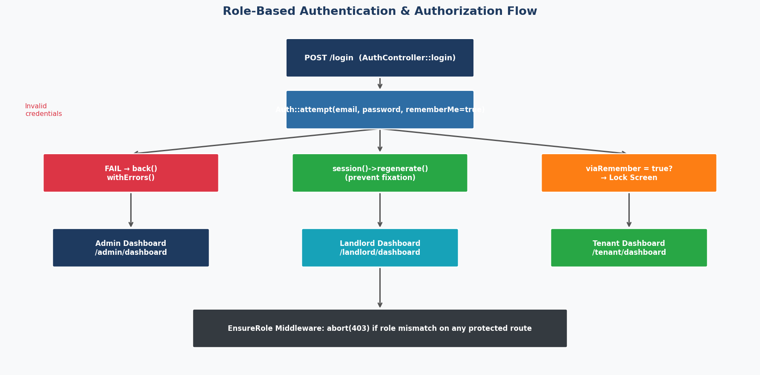
Figure 4 – Role-Based Authentication and Authorization Flow

8.1 Login Flow (AuthController::login)
Authentication uses Laravel's Auth::attempt() with remember-me always enabled. On success, the session is regenerated to prevent session fixation attacks. The user is then redirected to their role-specific dashboard.
public function login(Request $request)
{
$validator = Validator::make($request->all(), [
'email' => ['required', 'email'],
'password' => ['required'],
]);
if ($validator->fails()) {
return back()->withErrors($validator)
->with('open_modal', 'login');
}
if (Auth::attempt($request->only('email', 'password'), true)) {
$request->session()->regenerate(); // prevent session fixation
return $this->redirectByRole(); // → correct dashboard by role
}
return back()->withErrors([
'email' => 'These credentials do not match our records.',
]);
}
private function redirectByRole()
{
$user = Auth::user();
if ($user->isAdmin()) return redirect()->route('admin.dashboard');
if ($user->isLandlord()) return redirect()->route('landlord.dashboard');
return redirect()->route('tenant.dashboard');
}

8.2 Registration (AuthController::register)
Registration enforces strong validation rules with user-friendly custom messages. Password strength is enforced using Laravel's Password rule object.
$validator = Validator::make($request->all(), [
'name' => ['required', 'string', 'max:100',
'regex:/^[\pL\s\-\']+$/u'], // letters, spaces, hyphens
'email' => ['required', 'email:rfc', 'max:150', 'unique:users,email'],
'phone' => ['nullable', 'regex:/^\+?[0-9\s\-]{7,20}$/'],
'role' => ['required', 'in:landlord,tenant'],
'password' => ['required', 'confirmed',
Password::min(8)->mixedCase()->numbers()->symbols()],
]);

8.3 Session Lock Screen (AuthController::showLock / unlock)
When a user has a persistent session and reopens the browser, Auth::viaRemember() returns true and they are redirected to /lock before accessing any page. The unlock form requires their password and is rate-limited to 5 attempts with a 60-second decay window.
public function unlock(Request $request)
{
$throttleKey = 'session-unlock:' . Auth::id();
if (RateLimiter::tooManyAttempts($throttleKey, 5)) {
$seconds = RateLimiter::availableIn($throttleKey);
return back()->withErrors([
'password' => "Too many failed attempts. Try again in {$seconds} seconds.",
]);
}
if (!Hash::check($request->password, Auth::user()->password)) {
RateLimiter::hit($throttleKey, 60); // 60-second decay
$remaining = 5 - RateLimiter::attempts($throttleKey);
return back()->withErrors([
'password' => "Incorrect password. {$remaining} attempts remaining.",
]);
}
RateLimiter::clear($throttleKey);
session()->forget('auth.locked');
$request->session()->regenerate();
return $this->redirectByRole();
}

Figure 5 – Sign-In Page with Lock Screen Support

8.4 Force Password Change
When a landlord creates a tenant account and sends an invitation, the tenant's force_password_change flag is set to true. The ForcePasswordChange middleware intercepts every tenant route and redirects to /tenant/change-password until the tenant sets a new password.
// ForcePasswordChange middleware
if ($user && $user->force_password_change) {
if (! $request->routeIs('tenant.password.change',
'tenant.password.update', 'logout')) {
return redirect()->route('tenant.password.change')
->with('warning', 'You must set a new password before continuing.');
}
}
// TenantController::changePasswordUpdate
Auth::user()->update([
'password' => Hash::make($validated['password']),
'force_password_change' => false,
]);

8.5 Payment-Level Authorization
Within PaymentController, every action verifies the requesting landlord owns the property associated with the payment, preventing one landlord from accessing another's payments.
private function authorizePayment(Payment $payment): void
{
$propertyIds = Property::where('landlord_id', Auth::id())->pluck('id');
$allowed = $payment->lease
? $propertyIds->contains($payment->lease->property_id)
: false;
abort_if(! $allowed, 403); // → HTTP 403 Forbidden
}

9. Middleware
Three custom middleware classes protect routes and enforce business rules. All three are registered as aliases in bootstrap/app.php and applied to route groups in routes/web.php.
Alias | Class | Applied To | What It Does
role | EnsureRole | landlord/tenant/admin route groups | abort(403) if user.role != required role
locked | CheckSessionLock | landlord/tenant/admin route groups | Redirects to /lock for remembered or locked sessions
force.password.change | ForcePasswordChange | tenant route group only | Redirects to /tenant/change-password while flag is true

9.1 EnsureRole (app/Http/Middleware/EnsureRole.php)
class EnsureRole
{
public function handle(Request $request, Closure $next, string $role): mixed
{
if (! Auth::check() || Auth::user()->role !== $role) {
abort(403, 'Unauthorized.');
}
return $next($request);
}
}
// Registered in bootstrap/app.php:
$middleware->alias(['role' => EnsureRole::class]);
// Applied to route groups in routes/web.php:
Route::middleware(['auth', 'role:landlord', 'locked'])->prefix('landlord')->group(...);
Route::middleware(['auth', 'role:tenant', 'force.password.change', 'locked'])->prefix('tenant')->group(...);
Route::middleware(['auth', 'role:admin', 'locked'])->prefix('admin')->group(...);

9.2 CheckSessionLock (app/Http/Middleware/CheckSessionLock.php)
When Auth::viaRemember() returns true (browser was reopened with a remembered session), or session('auth.locked') is set, the user is redirected to /lock. This gives a second-factor check before accessing any protected page.

9.3 ForcePasswordChange (app/Http/Middleware/ForcePasswordChange.php)
class ForcePasswordChange
{
public function handle(Request $request, Closure $next): mixed
{
$user = Auth::user();
if ($user && $user->force_password_change) {
// Only allow the change-password page and logout through
if (! $request->routeIs('tenant.password.change',
'tenant.password.update', 'logout')) {
return redirect()->route('tenant.password.change')
->with('warning', 'You must set a new password before continuing.');
}
}
return $next($request);
}
}

10. Routing
All 60+ routes are defined in routes/web.php. There is no api.php file — AJAX endpoints (TIN verification, payment status polling) return JSON from within the web routes file, sharing the same session-based authentication. All routes use named route keys for clean URL generation in Blade templates.

10.1 Route Groups Summary
Group | Prefix | Middleware | Route Count
Public | / | (none) | 6
Auth Lock | / | auth | 2 (GET/POST /lock)
Landlord | /landlord | auth, role:landlord, locked | ~28
Admin | /admin | auth, role:admin, locked | ~10
Tenant | /tenant | auth, role:tenant, force.password.change, locked | ~12

10.2 Key Route Definitions
// ── Landlord: Unit-based lease workflow (new) ──────────────────────────
Route::get('/properties/{property}/units/{unit}/leases/create',
[LandlordController::class, 'unitLeaseCreate'])
->name('properties.units.leases.create');
Route::post('/properties/{property}/units/{unit}/leases',
[LandlordController::class, 'unitLeaseStore'])
->name('properties.units.leases.store');
Route::post('/properties/{property}/units/{unit}/leases/{lease}/assign-tenant',
[LandlordController::class, 'unitLeaseAssignTenant'])
->name('properties.units.leases.assign-tenant');
// ── NMB Payment routes ──────────────────────────────────────────────────
Route::post('/payments/{payment}/generate',
[PaymentController::class, 'generateControlNumber'])
->name('payments.generate');
Route::post('/payments/{payment}/send',
[PaymentController::class, 'sendControlNumber'])
->name('payments.send');
Route::get('/payments/{payment}/status', // AJAX JSON response
[PaymentController::class, 'checkStatus'])
->name('payments.status');
// ── TIN Verification (AJAX, must be before /{user} wildcard) ───────────
Route::post('/tenants/verify-tin',
[TinVerificationController::class, 'verify'])
->name('tenants.verify-tin');

10.3 Route Naming Convention
All routes follow the pattern {role}.{resource}.{action} — for example landlord.payments.generate, tenant.settings.profile. This convention ensures Blade templates and controllers can generate correct URLs with route('landlord.payments.generate', $payment) regardless of future URL changes.

11. Controllers
Controllers in app/Http/Controllers/ handle all HTTP request/response cycles. Complex domain logic is delegated to Services, keeping controllers lean.
Controller | Routes Served | Key Responsibilities
AuthController | /login, /register, /lock, /logout | Login, registration with strong validation, session lock/unlock, logout
LandlordController | /landlord/* | Largest controller (~600+ lines): properties, leases, tenants, reports, settings
TenantController | /tenant/* | Tenant dashboard, payment checkout, force-password-change, maintenance, settings
AdminController | /admin/* | System settings, audit logs, backups, user role management
PaymentController | /landlord/payments/* | NMB control number generation, send email/SMS, status polling, batch poll
TinVerificationController | /landlord/tenants/verify-tin | AJAX proxy to TRA API with dev-mode mock fallback
PasswordSetupController | /create-password/{token} | Tenant invitation password setup (uses password reset tokens)

11.1 LandlordController — Property Creation
The storeProperty() method handles three distinct workflows determined by the property_category and floor_layout fields submitted from the form.
// Single-unit property: auto-create one Unit
if ($request->property_category === 'single') {
$unit = Unit::create([
'property_id' => $property->id,
'unit_number' => 'Unit 1',
'status' => 'vacant',
]);
}
// Multi-unit, single floor: auto-generate "Unit 1", "Unit 2", ...
if ($request->floor_layout === 'single_floor') {
for ($i = 1; $i <= $request->number_of_units; $i++) {
Unit::create(['property_id' => $property->id,
'unit_number' => "Unit {$i}", 'status' => 'vacant']);
}
}
// Multi-unit, multi-floor: read JSON floor_config from form
// floor_config = [{"floor":"Ground","count":4}, {"floor":"Floor 1","count":6}]
foreach ($floorConfig as $floor) {
$letter = chr(65 + $floorIndex); // A, B, C, ...
for ($u = 1; $u <= $floor['count']; $u++) {
Unit::create(['property_id' => $property->id,
'unit_number' => "{$letter}{$u}", // A1, A2, B1, ...
'floor_number' => $floor['floor'],
'status' => 'vacant']);
}
}

11.2 LandlordController — Dashboard Metrics
public function dashboard()
{
$landlordId = Auth::id();
// Sync all lease payments before computing dashboard metrics
app(LeasePaymentSyncService::class)->syncLandlord($landlordId);
$properties = Property::where('landlord_id', $landlordId)
->with('units','leases.payments')->get();
$activeLeases = Lease::where('landlord_id', $landlordId)
->where('status','active')->get();
$monthlyRevenue = $activeLeases->sum('monthly_rent');
$overdueAmount = Payment::whereIn('lease_id', $activeLeases->pluck('id'))
->where('status','overdue')->sum('amount');
$collectionRate = ...; // paid / (paid+overdue) * 100
$sixMonthChartData = ...; // monthly sum of payments for last 6 months
return view('landlord.dashboard', compact(...));
}

11.3 PaymentController — Index (Most Complex Method)
The index() method is the most complex in the codebase. It syncs all payments, computes 4 stat counters, applies a filter, paginates 25 tenants per page, then pre-computes per-tenant flags in a single additional query to avoid N+1 database hits in the Blade template.
// 1. Sync all payments for this landlord
app(LeasePaymentSyncService::class)->syncLandlord($landlord->id);
// 2. Build base query of all tenants linked to this landlord
$base = User::where('role','tenant')
->where(function($q) use ($propertyIds, $landlord) {
$q->whereHas('leasesAsTenant', fn($q2) => $q2->whereIn('property_id',$propertyIds))
->orWhere('landlord_id', $landlord->id);
});
// 3. Compute stats (total, pending, overdue, upcoming next-7-days)
$stats = ['total'=>$base->count(), 'pending'=>..., 'overdue'=>..., 'upcoming'=>...];
// 4. Apply selected filter (all/pending/overdue/upcoming/paid/previous)
switch ($filter) { ... }
// 5. Paginate + eager-load leases
$tenants = $query->with(['leasesAsTenant'=>...])->paginate(25);
// 6. Load most-relevant payment per tenant in ONE query, group by tenant
$paymentMap = Payment::whereIn('tenant_id', $tenants->pluck('id'))
->orderByRaw("FIELD(status,'overdue','pending','paid')")
->get()->groupBy('tenant_id');
// 7. Pre-compute flags in PHP (avoids N+1 in Blade)
foreach ($tenants as $tenant) {
$payment = $paymentMap->get($tenant->id)?->first();
$rowData[$tenant->id] = [
'payment' => $payment,
'can_generate' => $sync->canGenerateControlNumber($payment),
'active_control' => $sync->activeControlNumber($payment),
];
}

11.4 AdminController — Settings & Audit Logs
// Settings update — handles unchecked booleans (not sent by browser forms)
public function settingsUpdate(Request $request)
{
$booleanKeys = ['maintenance_mode', 'allow_tenant_registration'];
foreach ($request->except(['_token','_method']) as $key => $value) {
$val = in_array($key, $booleanKeys)
? ($request->boolean($key) ? '1' : '0')
: $value;
SystemSetting::set($key, $val); // updateOrCreate on system_settings
}
AuditLog::log('settings_updated', 'Admin updated system settings');
return back()->with('success', 'Settings saved.');
}
// Audit logs — paginated with filters
public function auditLogsIndex(Request $request)
{
$query = AuditLog::with('user')->latest();
if ($request->filled('action')) $query->where('action', $request->action);
if ($request->filled('user_id')) $query->where('user_id', $request->user_id);
if ($request->filled('from')) $query->whereDate('created_at','>=',$request->from);
if ($request->filled('to')) $query->whereDate('created_at','<=',$request->to);
$logs = $query->paginate(50)->withQueryString();
return view('admin.audit-logs.index', compact('logs'));
}

12. Service Layer
Three service classes in app/Services/ encapsulate domain logic that is too complex for controllers and spans multiple models or external systems.

12.1 LeasePaymentSyncService
This service is the engine of the payment system. It is called at the start of every payment-related page load to ensure Payment records are up-to-date with the current date and lease status.
// syncLandlord — entry point; processes 100 leases at a time
public function syncLandlord(int $landlordId): void
{
Lease::where('landlord_id', $landlordId)
->with('payments')
->chunkById(100, function (Collection $leases) {
$leases->each(fn (Lease $lease) => $this->syncLease($lease));
});
}
// syncLease — creates or updates a single Payment for the current billing cycle
public function syncLease(Lease $lease): ?Payment
{
$this->syncPaymentStatuses($lease->payments);
if (! $this->leaseCanReceivePayment($lease)) {
return null; // no tenant, or lease inactive/expired
}
$dueDate = $this->currentDueDate($lease);
$status = $dueDate->isPast() && ! $dueDate->isToday() ? 'overdue' : 'pending';
$payment = $lease->payments->whereIn('status',['pending','overdue'])->first();
if (! $payment) {
return Payment::create([
'lease_id' => $lease->id,
'tenant_id' => $lease->tenant_id,
'amount' => $lease->monthly_rent,
'due_date' => $dueDate->toDateString(),
'status' => $status,
'notes' => 'Generated from lease rent terms.',
]);
}
// Update but DON'T move due_date if a control number is already active
$updates = ['tenant_id'=>$lease->tenant_id, 'amount'=>$lease->monthly_rent, 'status'=>$status];
if (empty($payment->control_number)) {
$updates['due_date'] = $dueDate->toDateString();
}
if ($this->hasChanged($payment, $updates)) {
$payment->update($updates);
}
return $payment->refresh();
}
// currentDueDate — calculates the correct due date for the current month
private function currentDueDate(Lease $lease): Carbon
{
$today = now()->startOfDay();
$day = $lease->payment_day ?: $lease->start_date->day;
$dueDate = $today->copy()->day(min($day, $today->daysInMonth));
if ($dueDate->lt($lease->start_date)) $dueDate = $lease->start_date->copy();
if ($dueDate->gt($lease->end_date)) $dueDate = $lease->end_date->copy();
return $dueDate;
}

12.2 NmbPaymentService
Handles all communication with NMB Bank's Zalongwa SPG (Service Payment Gateway). Bearer tokens are cached for 14 minutes. The postWithAuth() helper automatically detects a 401 response, clears the cache, and retries once with a fresh token.
// Token management with 14-minute cache
public function getToken(bool $forceRefresh = false): array
{
if (! $forceRefresh && Cache::has('nmb_spg_token')) {
return ['token' => Cache::get('nmb_spg_token')];
}
$response = Http::post($this->baseUrl . '/api/v1/login', [
'client_usr' => $this->clientUsr,
'client_key' => $this->clientKey,
]);
$token = $response->json('token');
Cache::put('nmb_spg_token', $token, now()->addMinutes(14));
return ['token' => $token];
}
// Control number payload
$payload = [
'systemName' => 'REMIS',
'systemCode' => 'SP1001',
'payerID' => 'TENANT-' . $tenant->id,
'firstName' => $firstName,
'lastName' => $lastName,
'email' => $tenant->email,
'payerMobile' => $this->normalizeMobile($tenant->phone),
'currency' => 'TZS',
'amount' => (float) $payment->amount,
'amountType' => 'EXACT',
'paymentType' => 'RENT',
'paymentDesc' => 'RENT payment - PropertyName / UnitNumber',
];
// POST /api/v1/generatectlno => { "status":"success", "reference_number":"1234567890" }
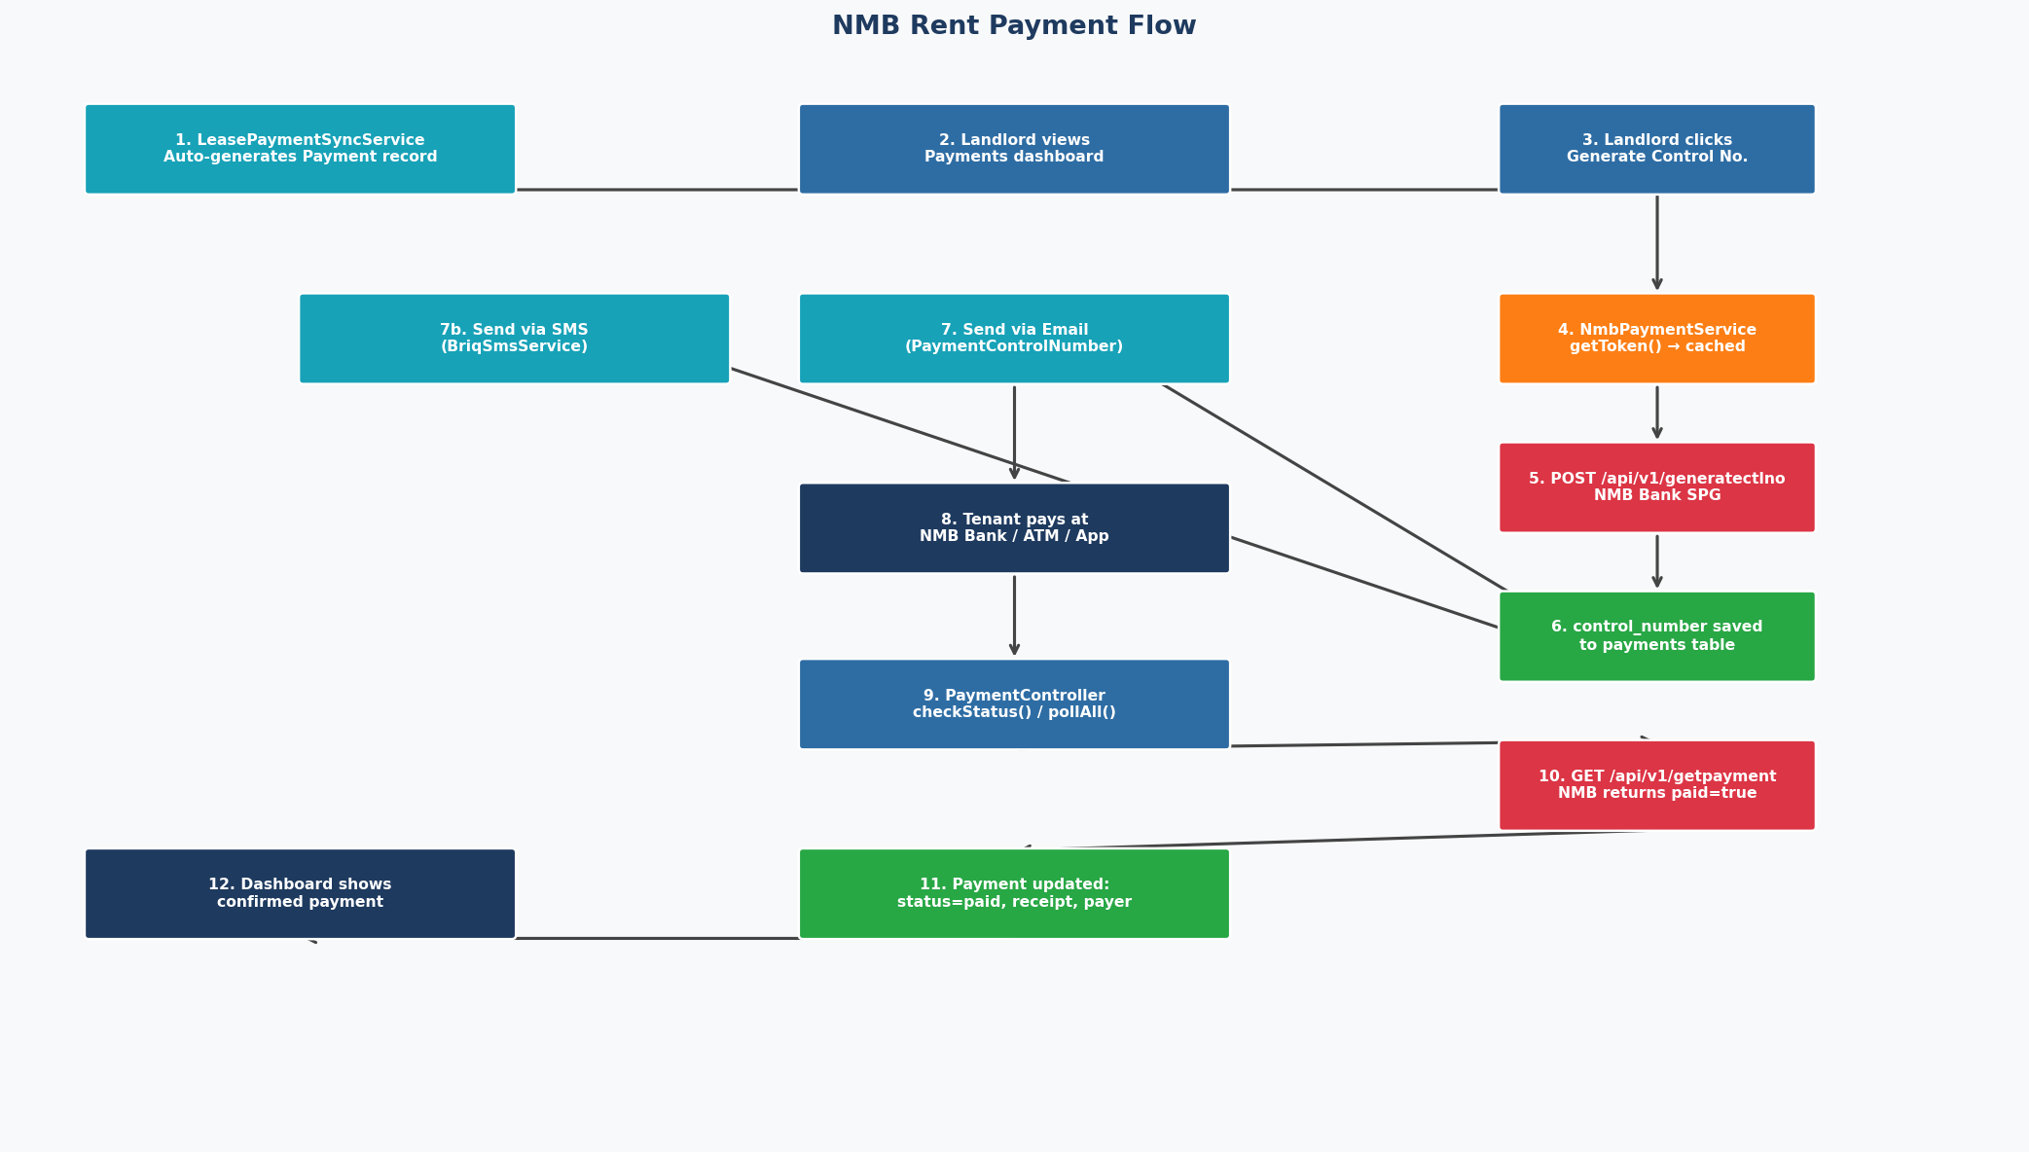
Figure 6 – NMB Rent Payment Flow (end-to-end)

12.3 BriqSmsService
Sends SMS messages via BRIQ's REST API (Tanzania). The service normalizes all input phone numbers to E.164 format, accepting four common Tanzanian formats.
// Accepted formats all normalised to +255XXXXXXXXX:
// 07XXXXXXXX (10 digits, leading zero)
// 7XXXXXXXX (9 digits, no prefix)
// 2557XXXXXXXX (12 digits, country code only)
// +2557XXXXXXXX (full E.164)
private function normalizePhone(string $phone): array
{
$digits = preg_replace('/\D/', '', $phone);
if (strlen($digits) === 9)
$subscriber = $digits;
elseif (strlen($digits) === 10 && str_starts_with($digits,'0'))
$subscriber = substr($digits, 1);
elseif (strlen($digits) === 12 && str_starts_with($digits,'255'))
$subscriber = substr($digits, 3);
else
return ['valid'=>false, 'error'=>'Invalid Tanzanian mobile number.'];
// Must start with 6 or 7 (Tanzanian mobile prefixes)
if (!preg_match('/^[67]\d{8}$/', $subscriber))
return ['valid'=>false, 'error'=>'Not a valid Tanzanian mobile number.'];
return ['valid'=>true, 'number'=>'+255'.$subscriber];
}
// SMS payload sent to BRIQ API
Http::withHeaders(['X-API-Key' => $this->apiKey])->post($endpoint, [
'content' => $message,
'recipients' => [$normalizedNumber], // without the '+' prefix
'sender_id' => 'REMIS',
]);

13. Mail System
Transactional emails are sent via Laravel's Mail facade using dedicated Mailable classes in app/Mail/. Each class constructs an HTML email from a Blade template in resources/views/mail/. The development environment uses the log driver (emails written to storage/logs/laravel.log); production uses SMTP via Gmail.
Mailable Class | Subject | Triggered By | Template
TenantInvitation | Your REMIS Account is Ready | Landlord clicks Invite Tenant | mail/tenant-invitation.blade.php
PaymentControlNumber | Your Rent Payment Control Number | Landlord sends control number (email) | mail/payment-control-number.blade.php
LeaseTerminationNotice | Your Lease Has Been Terminated | Landlord sends termination notice | mail/lease-termination.blade.php
TenantWarningNotice | Official Warning Notice Regarding Your Lease | Landlord sends warning notice | mail/tenant-warning-notice.blade.php

13.1 Tenant Invitation Flow
When a landlord invites a tenant, a signed URL is generated using Laravel's password broker. The tenant receives an email with a 'Set Password' button that links to /create-password/{token}?email=..., valid for 7 days (10,080 minutes).
// LandlordController::tenantInvite
$token = app('auth.password.broker')->createToken($tenant);
$setupUrl = route('password.setup.show', ['token' => $token, 'email' => $tenant->email]);
Mail::to($tenant->email)->send(
new TenantInvitation($tenant, $plainPasswordHint, $setupUrl)
);
$tenant->update(['invitation_status' => 'invited',
'force_password_change' => true]);
// PasswordSetupController::store (tenant clicks link)
$user = User::where('email', $request->email)->firstOrFail();
app('auth.password.broker')->reset([...], function($user, $password) {
$user->update(['password' => Hash::make($password),
'force_password_change' => false]);
});

13.2 Mail Configuration (.env)
# Development
MAIL_MAILER=log # writes to storage/logs/laravel.log
# Production
MAIL_MAILER=smtp
MAIL_HOST=smtp.gmail.com
MAIL_PORT=587
MAIL_ENCRYPTION=tls
MAIL_USERNAME=your@gmail.com
MAIL_PASSWORD=app-specific-password
MAIL_FROM_ADDRESS=noreply@remis.tz
MAIL_FROM_NAME="REMIS Rental System"

14. External API Integrations
REMIS integrates with three Tanzanian external services: NMB Bank's payment gateway, BRIQ's SMS provider, and the Tanzania Revenue Authority's TIN lookup API.

14.1 NMB Bank SPG (Zalongwa Payment Gateway)
API Endpoint | Method | Purpose
/api/v1/login | POST | Authenticate: obtain 15-min Bearer token (cached 14 min)
/api/v1/generatectlno | POST | Generate a control number for a payment (live)
/api/v1/generatedemoctlno | POST | Generate a demo control number (testing/staging)
/api/v1/getpayment | POST | Poll payment status: returns paid=true when tenant has paid
/api/v1/getdemopayment | POST | Poll demo payment status
/api/v1/verification | POST | Verify a control number is valid and active
# Required environment variables
NMB_SPG_URL=https://nmb.spg.co.tz
NMB_SPG_USER=client_email@example.com
NMB_SPG_KEY=client_password
NMB_SYSTEM_NAME=REMIS
NMB_SYSTEM_CODE=SP1001
NMB_SPG_TIMEOUT=20
NMB_CA_BUNDLE=/path/to/ca-bundle.crt # optional custom SSL cert

The service implements automatic token refresh on 401 responses. If the cached token is rejected, Cache::forget() is called and the request retried once with a freshly obtained token before returning an error to the caller.

14.2 BRIQ SMS (Tanzania Bulk SMS)
BRIQ_API_KEY=your_api_key
BRIQ_BASE_URL=https://karibu.briq.tz
BRIQ_SENDER_ID=REMIS
BRIQ_BEARER_TOKEN= # optional secondary auth
Used to deliver rent payment control numbers to tenants via SMS. The service normalizes Tanzanian mobile numbers, validates them (must start with 06x or 07x), and never logs the API key — only sanitized recipient numbers are written to logs.

14.3 Tanzania Revenue Authority — TIN Verification
TRA_API_BASE_URL=https://api.tra.go.tz
TRA_API_KEY=your_api_key
TRA_API_TIMEOUT=15
TRA_DEV_MODE=true # returns realistic mock data in development
The TinVerificationController provides an AJAX endpoint that the tenant creation form calls when a TIN is entered. In dev_mode=true, realistic mock data is returned instantly without hitting the live TRA API. In production, it queries the real TRA endpoint and returns normalized fields (taxpayer_id, taxpayer_name, has_vat, vrn).
// AJAX request from tenant form
POST /landlord/tenants/verify-tin { tin: "100-123-456" }
// Response (production)
{
"success": true,
"taxpayer_id": "100-123-456",
"taxpayer_name": "JOHN DOE LIMITED",
"has_vat": false,
"vrn": null
}

15. PDF Report Generation
PDF documents are generated using the barryvdh/laravel-dompdf package v3.1, which renders Blade templates to A4 PDF files. Two types of PDFs are produced: individual lease documents and batch management reports.
Report / Document | Route | Contents
Lease PDF | GET /landlord/leases/{id}/download | Tenant/landlord details, property, dates, rent, security deposit, terms, signatures section
Rent Payments Report | GET /landlord/reports/pdf/rent-payments | All payment records with status, due date, paid date, amount
Tenant Inventory | GET /landlord/reports/pdf/tenants | All tenants with contact info, TIN, NIDA, current lease status
Overdue Payments | GET /landlord/reports/pdf/overdue | Tenants with overdue balances, amounts, days overdue
Property Inventory | GET /landlord/reports/pdf/properties | All properties with unit counts, occupancy rate, monthly revenue
// Pattern used in all report methods
public function reportRentPaymentsPdf()
{
$payments = Payment::whereHas('lease',
fn($q) => $q->where('landlord_id', Auth::id()))
->with(['tenant', 'lease.property'])
->orderBy('due_date','desc')
->get();
$pdf = Pdf::loadView('landlord.reports.pdf.rent-payments',
compact('payments'));
$pdf->setPaper('A4', 'portrait');
return $pdf->stream('rent-payments-' . now()->format('Y-m-d') . '.pdf');
}

16. Artisan Console Commands
Two custom Artisan commands in app/Console/Commands/ support server-side PDF generation outside of the HTTP request cycle.
Command Signature | Purpose | Usage Example
remis:generate-pdf {leaseId} {outputPath} | Generate a single lease as a PDF file to disk | php artisan remis:generate-pdf 42 /tmp/lease-42.pdf
remis:generate-report-pdf {type} {landlordId} {outputPath} | Generate a batch management report PDF (types: rent-payments, tenants, overdue, properties) | php artisan remis:generate-report-pdf overdue 7 /tmp/overdue.pdf
These commands use GD image processing to embed property images in PDFs. They are useful for scheduled report generation (e.g., monthly rent summaries dispatched via email as attachments) without needing an HTTP session.

17. Configuration Files
Laravel configuration files in config/ map environment variables from .env to structured PHP arrays consumed by the application. All sensitive credentials remain in .env and are never committed to version control.

17.1 config/auth.php
'guards' => [
'web' => ['driver' => 'session', 'provider' => 'users'],
],
'providers' => [
'users' => ['driver' => 'eloquent', 'model' => App\Models\User::class],
],
'passwords' => [
'users' => [
'provider' => 'users',
'table' => 'password_reset_tokens',
'expire' => 10080, // 7 days — tenant invitation tokens
'throttle' => 60, // 60-second resend throttle
],
],

17.2 config/services.php (Third-party API credentials)
return [
'tra' => [
'base_url' => env('TRA_API_BASE_URL'),
'api_key' => env('TRA_API_KEY'),
'timeout' => env('TRA_API_TIMEOUT', 15),
'dev_mode' => env('TRA_DEV_MODE', true),
],
'briq' => [
'api_key' => env('BRIQ_API_KEY'),
'base_url' => env('BRIQ_BASE_URL', 'https://karibu.briq.tz'),
'sender_id' => env('BRIQ_SENDER_ID', 'REMIS'),
'bearer_token' => env('BRIQ_BEARER_TOKEN'),
],
'nmb' => [
'base_url' => env('NMB_SPG_URL', 'https://nmb.spg.co.tz'),
'client_usr' => env('NMB_SPG_USER'),
'client_key' => env('NMB_SPG_KEY'),
'system_name' => env('NMB_SYSTEM_NAME', 'REMIS'),
'system_code' => env('NMB_SYSTEM_CODE', 'SP1001'),
'timeout' => env('NMB_SPG_TIMEOUT', 20),
'ca_bundle' => env('NMB_CA_BUNDLE'),
],
];

17.3 .env.example (Key Variables)
Variable | Default/Example | Description
APP_NAME | REMIS | Application name shown in emails and UI
APP_ENV | local | Environment: local / staging / production
APP_DEBUG | true | Set false in production to hide stack traces
DB_DATABASE | remis_db | MySQL database name
SESSION_DRIVER | file | Session storage: file / database / redis
MAIL_MAILER | log | log (dev) or smtp (production)
TRA_DEV_MODE | true | false in production to use live TRA API
NMB_SPG_URL | https://nmb.spg.co.tz | NMB bank payment gateway base URL
NMB_SYSTEM_CODE | SP1001 | Merchant system code assigned by NMB
BRIQ_SENDER_ID | REMIS | SMS sender ID shown on tenant's phone

18. Testing
The test suite uses PHPUnit 11 and covers the two most critical backend components: the SMS service (which must correctly normalize Tanzanian phone numbers and handle API errors) and the lease payment sync service (which must compute correct payment statuses and control number validity).
Test File | Type | Test Cases | Coverage Area
tests/Feature/BriqSmsServiceTest.php | Feature | 9 | SMS API, phone normalization, error handling, payload structure
tests/Unit/LeasePaymentSyncServiceTest.php | Unit | 8 | Payment status logic, control number expiry, lease eligibility

18.1 BriqSmsServiceTest — Test Cases
Test Case | Assertion
it requires api key to be configured | Returns error when BRIQ_API_KEY is empty
it normalizes 07XXXXXXXX format | 0712345678 -> +255712345678
it normalizes 9-digit format | 712345678 -> +255712345678
it normalizes 255XXXXXXXXX format | 255712345678 -> +255712345678
it rejects numbers starting with 08 | Returns valid=false, error message
it rejects non-Tanzanian numbers | Returns valid=false for invalid lengths
it sends correct payload to BRIQ endpoint | Asserts content, recipients[], sender_id fields
it returns success on HTTP 200 | Returns ['success' => true, 'data' => ...]
it returns error on HTTP 4xx | Returns ['success' => false, 'error' => ...]

18.2 LeasePaymentSyncServiceTest — Test Cases
Test Case | Assertion
pending stays pending if due date is today | status remains 'pending' when due_date == today
payment becomes overdue when due date passes | status flips to 'overdue' when due_date < today
paid payment is never changed | status always 'paid' regardless of due_date/lease
payment on inactive lease becomes overdue | lease.status != 'active' forces 'overdue'
control number is active within 7 days | activeControlNumber() true if generated < 7 days ago
control number expires after 7 days | activeControlNumber() false if generated > 7 days ago
cannot generate when active control exists | canGenerateControlNumber() false if activeControlNumber()
can generate when previous has expired | canGenerateControlNumber() true after 7-day expiry

18.3 Running Tests
# Run all tests
php artisan test
# Run with coverage (requires Xdebug or PCOV)
php artisan test --coverage
# Run only SMS tests
php artisan test --filter BriqSmsService
# Run only sync service tests
php artisan test --filter LeasePaymentSync
# Using Composer script (clears config cache first)
composer test

19. Security Implementation
Security is implemented at multiple layers: input validation, authentication hardening, route authorization, object-level authorization, and secure handling of API credentials.

19.1 Authentication Security
Threat | Mitigation | Implementation
Brute-force login | Rate limiting | RateLimiter::tooManyAttempts() — 5 unlock attempts, 60s decay
Session fixation | Session regeneration | session()->regenerate() called on every successful login
CSRF attacks | CSRF token middleware | VerifyCsrfToken on all POST/PUT/DELETE routes via web middleware group
Password exposure | Bcrypt hashing | 'password' => 'hashed' cast auto-hashes on assignment
Stale browser sessions | Lock screen | CheckSessionLock redirects viaRemember() sessions to /lock
Weak passwords | Strong password policy | Password::min(8)->mixedCase()->numbers()->symbols() at registration
Unauthorized cross-role access | Role middleware | abort(403) in EnsureRole if role doesn't match route group

19.2 Object-Level Authorization
Beyond role checks, the application verifies ownership of individual records. PaymentController::authorizePayment() confirms the landlord owns the property linked to the payment. TenantController scopes all queries to Auth::user()->id. LandlordController uses where('landlord_id', Auth::id()) on every query.

19.3 API Credential Security
API | Security Measures
NMB SPG | Credentials in .env only; token cached server-side (never sent to browser); only error status codes logged (no credentials)
BRIQ SMS | API key in .env only; only sanitized recipient numbers (no keys) written to logs
TRA API | Bearer token in .env only; dev_mode=true in development prevents live API calls
General | SSL/TLS enforced on all outbound HTTP calls; custom CA bundle path supported via NMB_CA_BUNDLE

19.4 Input Validation
All user input is validated at the controller level using Laravel's Validator. Key rules in use:
Field | Validation Rules
name | required | string | max:100 | regex:letters/spaces/hyphens/apostrophes only
email | required | email:rfc | max:150 | unique:users,email
phone | nullable | regex:/+?[0-9 -]{7,20}/
password | required | confirmed | min:8 | mixedCase | numbers | symbols
role | required | in:landlord,tenant (registration only)
tin | AJAX-validated against TRA API before form submission

20. Performance Considerations

20.1 Database Indexes
Performance indexes were added in migration 2026_05_12_083721. These cover the most frequent query patterns in the application.
Table | Index Columns | Query Pattern Served
payments | (lease_id, status) | Filter payments for a lease by status (pending/overdue)
payments | (tenant_id, status) | Load tenant's payment history by status
payments | (due_date, status) | Upcoming/overdue date range queries on payments dashboard
leases | (landlord_id, status) | Landlord dashboard: all active leases
leases | (property_id, status) | Property detail: find active lease for a unit
leases | (tenant_id, status) | Tenant portal: find active lease for the logged-in tenant
audit_logs | (action, created_at) | Admin audit log filtering by action type and date range
audit_logs | (model_type, model_id) | Look up all audit events for a specific record

20.2 N+1 Query Prevention
Eloquent's eager loading (->with([...])) is used throughout all controllers. The most complex case is the Payment index — after paginating 25 tenants, a single additional query loads all relevant payments grouped by tenant_id in PHP, avoiding per-row database calls in the Blade template.
// All 25 tenants' payments loaded in ONE query
$paymentMap = Payment::whereIn('tenant_id', $tenants->pluck('id'))
->with(['lease.property', 'lease.unit'])
->orderByRaw("FIELD(status,'overdue','pending','paid')")
->get()
->groupBy('tenant_id'); // PHP grouping, no extra DB round-trips
// Flags computed in PHP loop, not in Blade (avoids N+1)
foreach ($tenants as $tenant) {
$payment = $paymentMap->get($tenant->id)?->first();
$rowData[$tenant->id] = [
'can_generate' => $sync->canGenerateControlNumber($payment),
'active_control' => $sync->activeControlNumber($payment),
];
}

20.3 Chunked Batch Processing
LeasePaymentSyncService::syncLandlord() uses chunkById(100) to process leases in batches of 100, preventing memory exhaustion for landlords with large portfolios. Each chunk is processed and then garbage collected before the next is loaded.

20.4 API Token Caching
NMB bearer tokens are cached for 14 minutes (tokens expire at 15 minutes) using Laravel's Cache facade. The dashboard page for a landlord with 50 tenants triggers zero NMB API calls for token acquisition on warm cache hits.

20.5 Pagination
The Payments index paginates at 25 tenants per page using Laravel's paginate(25) with withQueryString() to preserve filter parameters across pages. Audit logs are paginated at 50 records per page.

21. Deployment Notes

21.1 Local Development (XAMPP)
Requirement | Specification
XAMPP | Apache 2.4 + MySQL 8 + PHP 8.2 (Windows)
PHP Extensions | pdo_mysql, mbstring, openssl, fileinfo, gd, curl, zip (all included in XAMPP)
mod_rewrite | Must be enabled in httpd.conf; AllowOverride All on htdocs/RemisV2
Document Root | Set VirtualHost to c:/xampp/htdocs/RemisV2/public
Permissions | storage/ and bootstrap/cache/ must be writable by Apache

21.2 Setup Script
# One-command setup (runs composer install + migrate + npm build)
composer run setup
# Equivalent to:
composer install
php artisan key:generate
php artisan migrate --force
npm install --ignore-scripts
npm run build

21.3 Development Server
# Start all services concurrently (PHP server + queue + Vite HMR)
composer run dev
# Equivalent to running these in parallel:
php artisan serve # PHP dev server on :8000
php artisan queue:listen # Queue worker
npm run dev # Vite HMR for frontend assets

21.4 Production Checklist
Step | Command / Setting
Set environment | APP_ENV=production APP_DEBUG=false in .env
Enable live TRA API | TRA_DEV_MODE=false
Enable live NMB API | NMB_SPG_URL=https://nmb.spg.co.tz (production URL)
Enable SMTP mail | MAIL_MAILER=smtp MAIL_HOST=smtp.gmail.com
Cache configuration | php artisan config:cache
Cache routes | php artisan route:cache
Cache views | php artisan view:cache
Run optimizer | php artisan optimize
Set storage permissions | chmod -R 775 storage bootstrap/cache
Symlink storage | php artisan storage:link

22. Component Interaction Summary
The diagram below traces the complete flow of the most complex backend operation — a landlord generating a rent control number and sending it to a tenant via SMS. This single user action touches every layer of the backend.

Figure 7 – Complete NMB Payment Flow Across All Backend Layers

22.1 Step-by-Step Interaction Trace
Step | Component | Action
1 | Browser | POST /landlord/payments/{id}/generate (CSRF token included)
2 | Route (web.php) | Matches route landlord.payments.generate, applies middleware stack
3 | Middleware: auth | Verifies session is authenticated; redirects to / if not
4 | Middleware: role:landlord | Checks user.role == 'landlord'; abort(403) if not
5 | Middleware: locked | Checks !viaRemember() and !locked; redirects to /lock if needed
6 | PaymentController::generateControlNumber | authorizePayment() confirms landlord owns property
7 | LeasePaymentSyncService::syncPaymentStatuses | Recalculates payment status (may flip pending to overdue)
8 | LeasePaymentSyncService::canGenerateControlNumber | Validates: not paid, lease active, no active control number
9 | NmbPaymentService::getToken | Returns cached token or calls NMB /api/v1/login
10 | NmbPaymentService::generateControlNumber | POST /api/v1/generatectlno to NMB Bank SPG
11 | NMB Bank SPG | Returns { status:'success', reference_number:'1234567890' }
12 | Payment::update | Saves control_number and control_number_generated_at to DB
13 | Browser (redirect) | Flash success: 'Control number generated: 1234567890'
14 | Landlord clicks Send via SMS | POST /landlord/payments/{id}/send channel=sms
15 | PaymentController::sendControlNumber | Validates active control, loads tenant and lease
16 | BriqSmsService::send | Normalizes tenant phone to E.164, POSTs to BRIQ API
17 | BRIQ API | Delivers SMS to tenant's Tanzanian mobile number
18 | Payment::update | Records control_number_sent_at and control_number_sent_via='sms'
19 | Tenant pays via NMB | Tenant visits NMB branch/ATM/app, enters control number
20 | PaymentController::pollAll (AJAX) | Calls NMB /api/v1/getpayment for each pending payment
21 | NMB Bank SPG | Returns paid=true with transaction reference, receipt, payer details
22 | Payment::update | status='paid', nmb_transaction_id, nmb_receipt_number, nmb_paid_at saved
23 | Dashboard | Payment shows as confirmed; landlord sees receipt and payer name

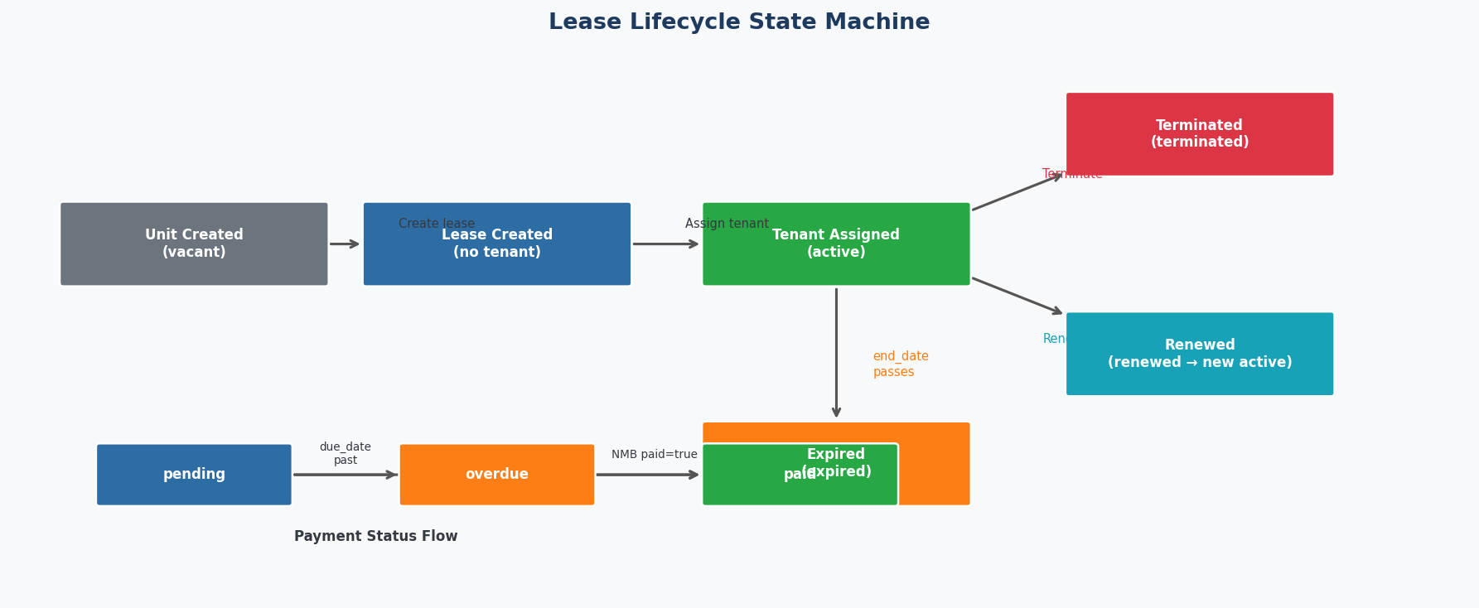
Figure 8 – Lease Lifecycle State Machine and Payment Status Flow

22.2 Final Architecture Summary
REMIS V2 demonstrates a cohesive, layered backend where each concern is handled by the right component:
- Routes (web.php) — URL-to-controller mapping and middleware grouping
- Middleware — cross-cutting concerns (auth, role, session lock, force-password)
- Controllers — HTTP request/response handling, input validation, delegation
- Service Layer — complex domain logic (payment sync, NMB, SMS, TIN)
- Models — data structure, relationships, casts, domain helper methods
- Migrations — version-controlled schema evolution across 4 phases
- Mail classes — decoupled, testable transactional email objects
- Config / .env — environment-specific credentials and feature flags

Conclusion
The REMIS V2 backend is a production-ready Laravel 12 application purpose-built for the Tanzanian rental property market. It was developed in four phases from January 2024 to June 2026, evolving from a basic property management system to a comprehensive platform with deep integrations into Tanzania's financial and regulatory infrastructure.

The architecture prioritizes data isolation (each landlord sees only their own data), security (rate-limiting, session locking, object-level authorization), and maintainability (service objects for complex logic, named routes for refactoring safety, and descriptive migration naming for schema traceability).

The NMB Bank SPG integration enables a complete digital rent collection workflow: control number generation, multi-channel delivery (email or SMS), and real-time payment confirmation polling — all with automatic token management and graceful error handling.

With 28 database migrations, 9 Eloquent models, 7 controllers, 3 service classes, 4 mail classes, 3 middleware, and 60+ named routes, REMIS V2 represents a complete, well-structured backend implementation that can be maintained and extended by any Laravel developer familiar with the framework.

Appendix — Application Screenshots

Figure A1 – REMIS Landing Page


Figure A2 – Sign-In / Lock Screen


Figure A3 – Complete System Architecture Diagram


Figure A4 – Full Database Entity-Relationship Diagram


Figure A5 – HTTP Request Lifecycle & Middleware Pipeline

