DEVPULSE
Project Description
A unified workspace for IT diagnostics, website assurance, network planning, API inspection, and developer focus.
Release | Version 1
Platform | .NET 9 Blazor Server
Audience | Technical and nontechnical presentation audiences
Status | Presentation and deployment package

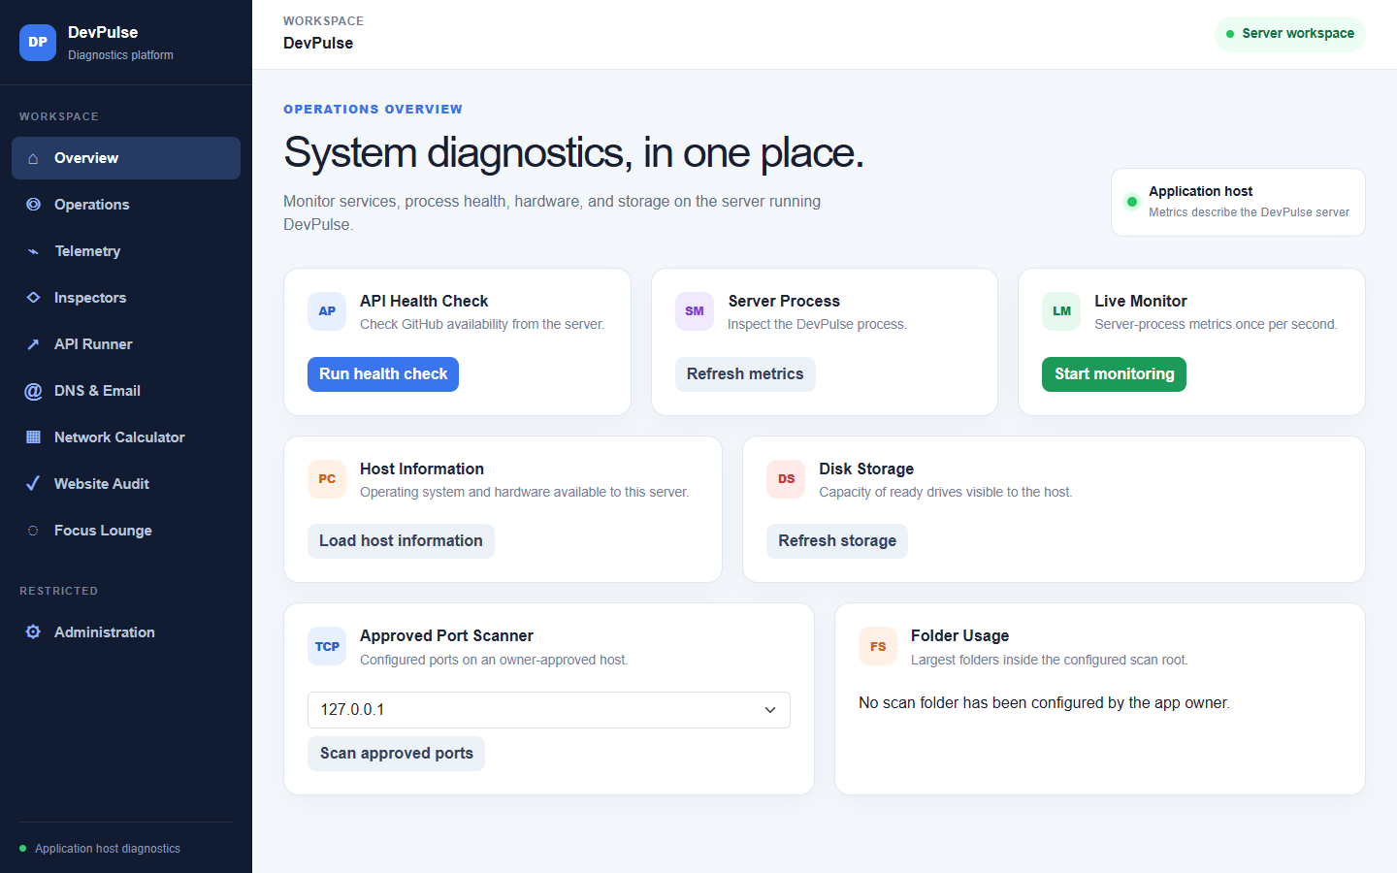
DevPulse Version 1 workspace

OVERVIEW

Executive summary
DevPulse Version 1 is a .NET 9 Blazor Server application that brings common IT and developer checks into one controlled web workspace.

The problem
Developers and small operations teams often move between operating-system utilities, network calculators, command-line probes, API clients, website-audit tools, credential-sensitive dashboards, and music applications. That switching makes demonstrations harder and evidence more fragmented.

The response
DevPulse combines those workflows without pretending to be an enterprise monitoring replacement. It emphasizes bounded execution, clear ownership, visible safety limits, locally understandable results, and a user interface that can be presented to both technical and nontechnical audiences.
Version 1 value proposition
One web workspace can observe its host, test approved services, inspect local data, plan networks, audit owned websites, exercise APIs, and support focused work.

Release outcome
- A coherent navigation model across diagnostics, assurance, planning, inspection, and focus tools.
- A server-side safety model for outbound requests and administrative actions.
- A Docker deployment contract for Render or another container host.
- Automated regression, build, formatting, and published HTTP smoke evidence.

AUDIENCE

Users and core workflows
DevPulse is designed for learning, demonstration, small-team operations, and personal development environments.
User | Need | DevPulse workflow
Developer | Check an API or website while coding | API Runner, Website Audit, telemetry, Focus Lounge
IT student | Learn subnets and diagnostic behavior | Network Calculator, ping, DNS, TLS, TCP scans
Small-team operator | See host and service condition | Overview, Operations, telemetry, alerts
Presenter or reviewer | Show evidence and system boundaries | Dashboard, audit results, release status, administration export
Music-enabled user | Stay focused without losing the active Spotify device | Focus Lounge, Spotify Connect, optional browser playback

Typical end-to-end scenario
1. Confirm application and host status on Overview.
2. Calculate the target subnet without manual binary arithmetic.
3. Run approved connectivity checks from the DevPulse host.
4. Audit an owned website and review browser, header, and accessibility evidence.
5. Exercise a public API collection with bounded assertions.
6. Use Focus Lounge while Spotify continues on the selected phone or computer.

PRODUCT

Version 1 capability map
The product is organized around five verbs that are easy to explain during a presentation.
Pillar | Modules | Representative outputs
Observe | Overview, Telemetry, Administration | Host metrics, storage, processes, request traces, incidents
Test | Operations, Website Audit, API Runner, DNS & Email | Latency, status, TLS, crawl results, assertions, DNS policy
Inspect | JSON, JWT, SHA-256, encrypted files | Trees, decoded claims, hashes, reversible encrypted packages
Plan | Network Calculator | IPv4/IPv6 ranges, VLSM, routes, bandwidth, MTU and MSS
Focus | Focus Lounge and Spotify | Timers, breathing, ambience, notes, library and playback controls

Notable feature depth
- Website auditing includes crawl limits, headers, JSON checks, optional browser evidence, accessibility, screenshots, visual baselines, and scheduled uptime.
- Spotify includes current playback, active-device following, search, Liked Songs, albums, playlists, queue, shuffle, repeat, transfer, and opt-in browser audio.
- Networking includes both active checks and offline calculations, with explicit restrictions for private and reserved targets.

DESIGN

Architecture and execution model
Blazor Server keeps application logic and credentials on the server while the browser receives an interactive UI over a live circuit.
Layer | Responsibility
Browser | Renders Razor components, captures user actions, maintains local focus notes, and hosts optional Spotify browser audio
Blazor application | Coordinates pages, authentication, validation, diagnostics, and near-real-time UI updates
Application services | Perform system, storage, network, website, DNS, API, Spotify, telemetry, and administration work
Local data directory | Stores encrypted Spotify sessions, data-protection keys, telemetry history, and selected baselines
Approved external services | Public websites, APIs, DNS, Spotify, alert destinations, and optional OTLP collector
Critical interpretation
Every host diagnostic describes the machine running DevPulse. A Render deployment reports its container storage, processes, network path, and reachability. It cannot inspect a visitor's computer without a future authenticated remote agent.

Deployment flow
Local source -> .NET 9 publish -> Docker image -> HTTPS hosting service
-> persistent /app/data

Technology stack
- ASP.NET Core and Blazor Server on net9.0.
- OpenTelemetry instrumentation with optional OTLP export.
- Node.js and Chromium for optional browser audits.
- Docker multi-stage image running as a non-root user.

SECURITY

Safety and trust model
Diagnostics are useful only when the application prevents them from becoming an unrestricted proxy, scanner, credential sink, or destructive control surface.
Boundary | Version 1 control
Outbound targets | Public-target validation, pinned addresses, exact owner allowlists, redirect blocking
Request volume | Timeout, response-size, request-count, concurrency, port, and crawl caps
Credentials | User Secrets or environment variables; masked transient API authorization values
Spotify sessions | Encrypted server-side tokens, opaque browser cookie, seven-day maximum session
Administration | Separate administrator cookie, antiforgery protection, rate limiting, audit history
Process termination | Disabled by default and requires explicit owner enablement
Production routes | Diagnostic surfaces can return 404 when Diagnostics is disabled
Deployment recommendation
Public deployments should put diagnostic pages behind authenticated access or a private gateway. Spotify authentication is separate and does not grant administrator rights.

Data minimization
- Uploaded inspector files are processed in memory rather than retained as user content.
- API collections exist only in the active Blazor circuit.
- Query strings and authorization data are excluded or redacted from telemetry and exports.

EVIDENCE

Website and API assurance
DevPulse turns a public site or API that the user owns into a repeatable demonstration target.
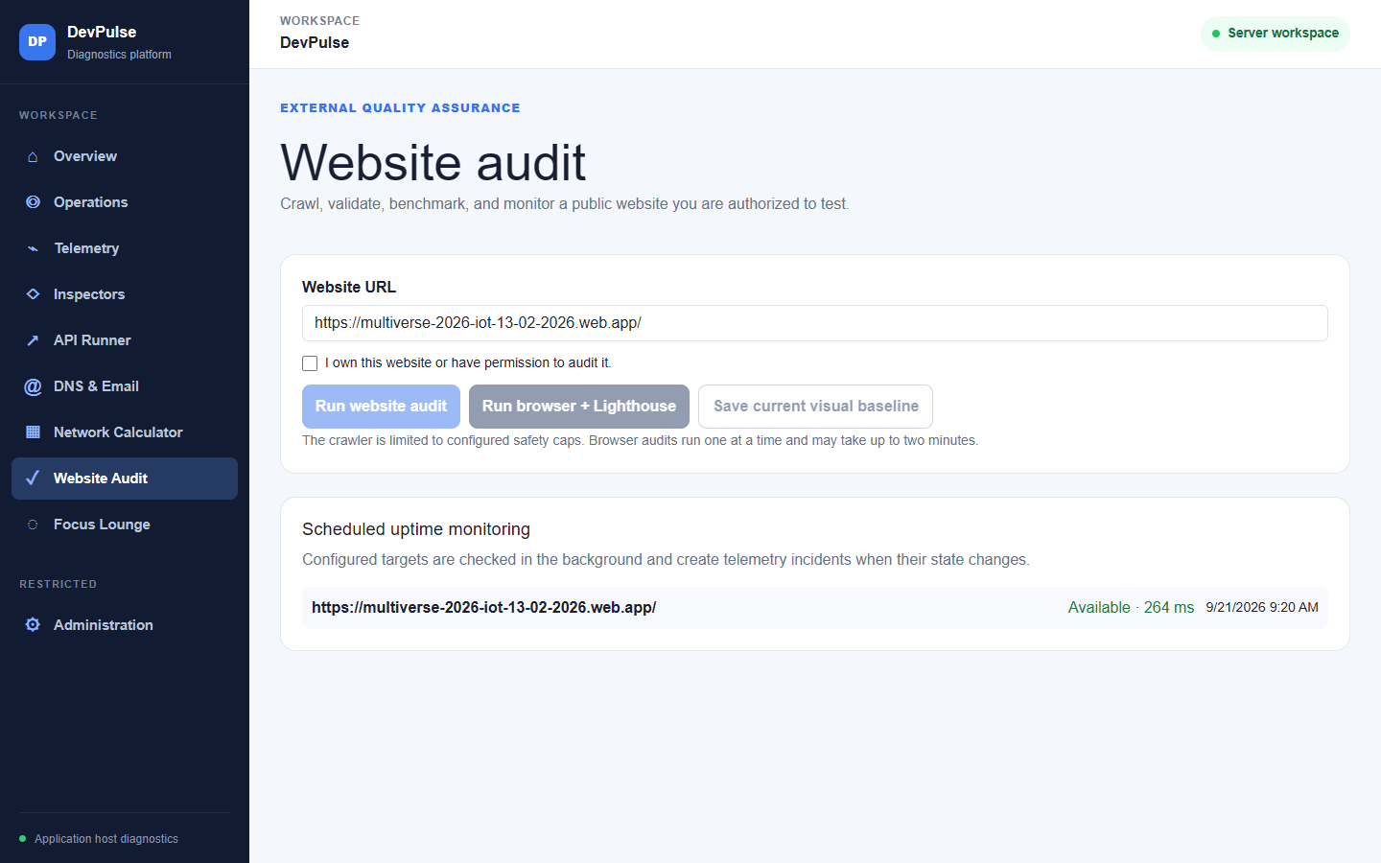
Website Audit combines bounded server checks with optional browser evidence.

Website Audit outputs
- HTTP status, redirects, timing, headers, metadata, resources, and crawl findings.
- Optional browser run with screenshot, accessibility evidence, performance signals, and visual comparison.
- Scheduled availability checks that create telemetry incidents when state changes.

API and DNS outputs
- Up to ten temporary API requests with methods, headers, bodies, and assertions.
- Public DNS inspection for address, mail, SPF, DMARC, DKIM, and CAA records.
- Strict write-method and private-address boundaries to preserve owner intent.

EXPERIENCE

Developer wellness and Spotify
Focus Lounge keeps restorative tools and music control beside technical work without forcing playback into the browser.
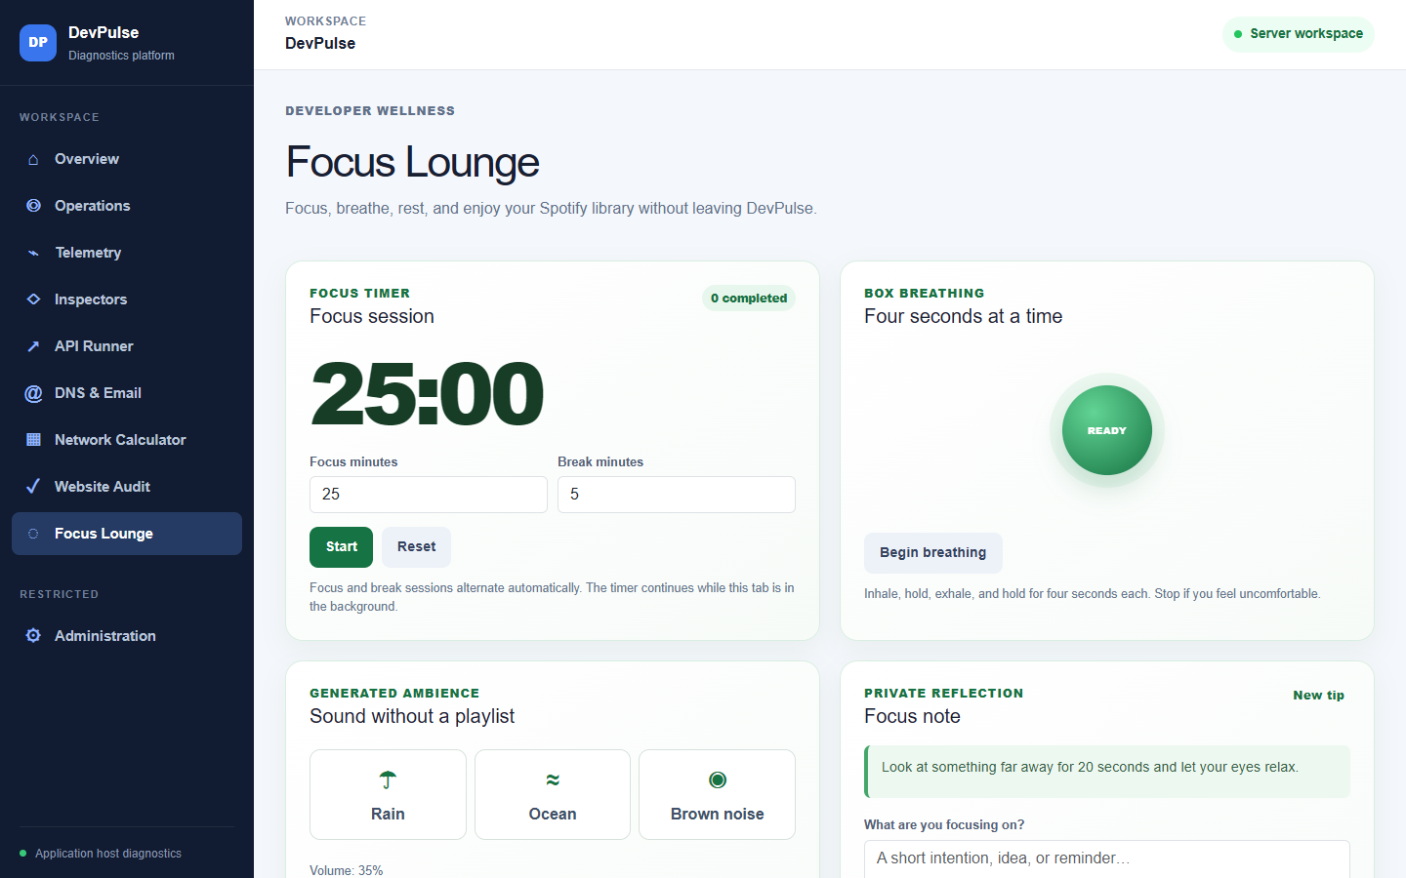
Focus Lounge combines a timer, breathing, generated ambience, reflection, and Spotify.
Experience | Behavior
Focus timer | Alternates focused work and break periods while the tab remains open
Box breathing | Guides four equal phases and can be stopped at any time
Generated ambience | Produces rain, ocean, and brown-noise sound without an external playlist
Private reflection | Keeps the note in browser-local storage
Spotify Connect | Follows the active desktop, phone, speaker, or browser device
Browser playback | Requires Premium and explicit activation by the user

VERIFICATION

Quality and release evidence
Version 1 was validated at service, integration, formatting, publishing, and user-interface levels.
Check | Result | Coverage
Automated regression executable | 79 / 79 passed | Spotify parsing and sessions, cryptography, safety rules, audit behavior, telemetry, APIs, DNS
Release build | 0 warnings, 0 errors | Complete net9.0 solution build
Formatting | Verified | Repository source formatting
Published HTTP smoke suite | Passed | Routes, static assets, diagnostics gate, OAuth/PKCE, scopes, token endpoint, proxy handling, logout
Visual review | Passed | Desktop navigation and presentation-critical pages
Release statement
The software package is technically ready for a controlled presentation and deployment. Public promotion still depends on securing diagnostic routes and resolving the current Google Safe Browsing or Search Console warning.

Demonstration evidence
- Overview provides immediate system context.
- Network Calculator produces deterministic examples without contacting a target.
- Website Audit demonstrates permission-aware external assurance.
- Focus Lounge provides a clear, nontechnical closing experience.

HONESTY

Known limitations and release notes
These boundaries should be stated during a presentation so that expectations match what Version 1 actually does.
Limitation | Practical meaning
Server-side visibility | Hosted metrics and storage belong to the Render container, not the visitor
Private network reachability | A hosted container cannot normally reach a home or campus LAN
Spotify near-real-time polling | External device changes reconcile periodically because there is no playback webhook
Spotify account constraints | Premium is required for playback controls and browser audio; development apps may restrict users
Database health depth | Version 1 performs TCP acceptance or unauthenticated Redis PING, not SQL query analysis
Single-instance storage | Local encrypted sessions and journals are not shared across replicas
Public reputation review | The current public hostname must clear browser reputation review before broad sharing
Why these limits are useful
They keep Version 1 understandable and safer while establishing clear work for a future remote agent, shared storage, database monitoring, and role-based access.

NEXT STEPS

Presentation route and Version 2
A short live path shows the product clearly without depending on every external integration.

Suggested live demonstration
1. Overview: explain host identity and the difference between local and hosted metrics.
2. Network Calculator: calculate 192.168.10.25/24 and point out the usable range.
3. Website Audit: run or show cached evidence for a website you own.
4. API Runner: perform one public GET request and explain write-method allowlists.
5. Focus Lounge: start the timer, demonstrate breathing, and show Spotify device continuity.

Version 2 candidates
Candidate | Value
SQL Server health and performance monitor | Adds query latency, connection, wait, storage, and backup visibility
IT asset inventory and IP address management | Tracks devices, owners, addresses, subnets, and lifecycle
Authenticated remote monitoring agent | Collects workstation or server metrics beyond the hosted container
Incident response and backup verification | Adds runbooks, evidence, recovery checks, and notification workflows
Role-based access control | Separates viewers, operators, auditors, and administrators
Version 1 conclusion
DevPulse Version 1 establishes the product language, navigation, safety model, deployment contract, and quality baseline needed for these additions.

