HOME！！！

 Logo

Chloe.Co (店名)

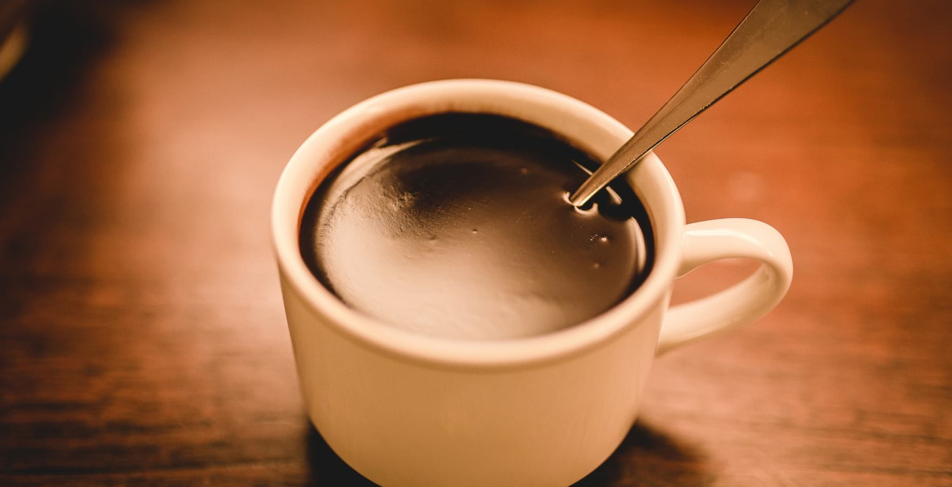

* Elite Coffee Brands

Coffee Shop is the place where you can get flavorful coffee strains from global elite brands and roasters at very affordable price. Lorem ipsum dolor sit amet elit. Non, explicabo et sit amet.

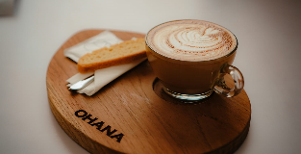

* Hot and Tasty Coffee

Coffee Shop is the place where you can get flavorful coffee strains from global elite brands and roasters at very affordable price. Lorem ipsum dolor sit amet elit. Non, explicabo et sit amet.

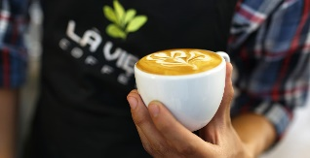

* Dedicated Coffee Fans

Coffee Shop is the place where you can get flavorful coffee strains from global elite brands and roasters at very affordable price. Lorem ipsum dolor sit amet elit. Non, explicabo et sit amet.

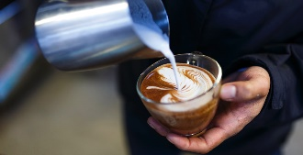

* Celebrate Coffee Brands

Coffee Shop is the place where you can get flavorful coffee strains from global elite brands and roasters at very affordable price. Lorem ipsum dolor sit amet elit. Non, explicabo et sit amet.

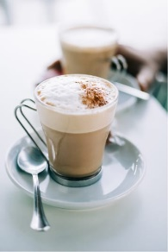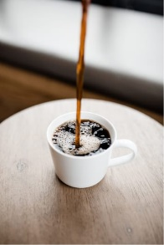

Who we are.

We make the delicious coffee for the coffee lovers. We are a team of dedicated coffee fans who celebrate exceptional coffee brands and roasters. Lorem ipsum feugiat.

Our Products

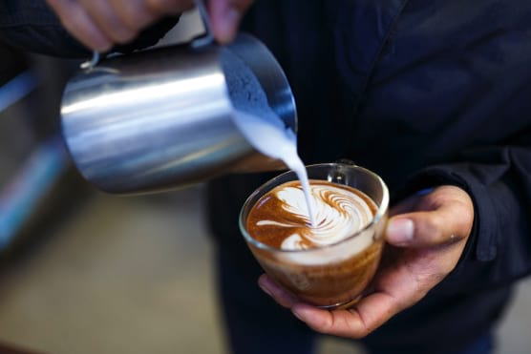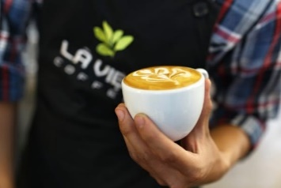

* Espresso Americano

Consectetur elit, sed do eiusmod tempor sed et dolor init.

* Cappuccino coffee

Consectetur elit, sed do eiusmod tempor sed et dolor init.

* Cold brew coffee

Consectetur elit, sed do eiusmod tempor sed et dolor init.

Our Services

We make the delicious coffee for the coffee lovers. We are a team of dedicated coffee fans who celebrate exceptional coffee brands and roasters. Lorem ipsum viverra feugiat. Pellen tesque libero ut justo, in ligula. Semper at.

We make the delicious coffee for the coffee lovers. We are a team of dedicated coffee fans who celebrate exceptional coffee brands and roasters, ipsum dolor.

* Types of Coffee

Vivamus a ligula quam. Ut blandit eu leo non. Duis sed dolor amet ipsum sit et init laore leo et.

* Bean Varieties

Vivamus a ligula quam. Ut blandit eu leo non. Duis sed dolor amet ipsum sit et init laore leo et.

* Coffee & Pastry

Vivamus a ligula quam. Ut blandit eu leo non. Duis sed dolor amet ipsum sit et init laore leo et.

* Coffe to go

Vivamus a ligula quam. Ut blandit eu leo non. Duis sed dolor amet ipsum sit et init laore leo et.

Customers Review



* Dennis Wilson

Lorem ipsum dolor sit amet int consectetur adipisicing elit. Velita beatae laudantium Quas minima sunt natus tempore, maiores aliquid modi felis vitae facere aperiam sequi optio lacinia id ipsum non velit, culpa, voluptate rem ullam dolore nisi est quasi, doloribus tempora.



* Tommy Sakura

Lorem ipsum dolor sit amet int consectetur adipisicing elit. Velita beatae laudantium Quas minima sunt natus tempore, maiores aliquid modi felis vitae facere aperiam sequi optio lacinia id ipsum non velit, culpa, voluptate rem ullam dolore nisi est quasi, doloribus tempora.

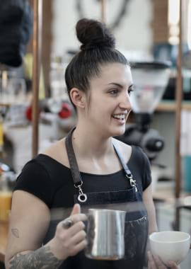

* Roy Linderson

Lorem ipsum dolor sit amet int consectetur adipisicing elit. Velita beatae laudantium Quas minima sunt natus tempore, maiores aliquid modi felis vitae facere aperiam sequi optio lacinia id ipsum non velit, culpa, voluptate rem ullam dolore nisi est quasi, doloribus tempora.



* Mike Thyson

Lorem ipsum dolor sit amet int consectetur adipisicing elit. Velita beatae laudantium Quas minima sunt natus tempore, maiores aliquid modi felis vitae facere aperiam sequi optio lacinia id ipsum non velit, culpa, voluptate rem ullam dolore nisi est quasi, doloribus tempora.

About！！！



About Us

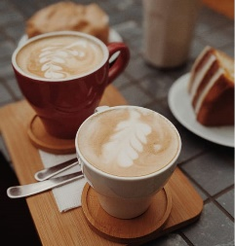

What we're all about

We have 25+ years of experience. "Our only Aim, Happy Customers. At the end of the day, it all comes down to coffee. But to get there it takes a dedicated, knowledgeable team with a sustainable approach. We make the delicious coffee for the coffee lovers. We are a team of dedicated coffee fans who celebrate exceptional coffee brands. We provide a variety of services both to our new and regular customers. All your favourites, delivered straight to you.

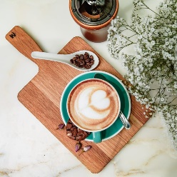

We provide a variety of services both to our new and regular customers.

Lorem ipsum dolor sit, amet consectetur adipisicing elit. Facilis, aliquid non? Suscipit numquam obcaecati necessitatibus voluptas. Molestias, sint atque aliquid magnam magni, fuga iste fugit iusto maiores vero soluta voluptates?

Our Coffee!!!

* Espresso 

-Short & Intense $19.50

Donec malesuada ex sit amet pretium sid ornare. Nulla congue scelerisque tellus, utpretium. Mauris suscipit nisi ut ipsum egestas, et velit convallis. Phasellus rhoncus tempus.

* Americano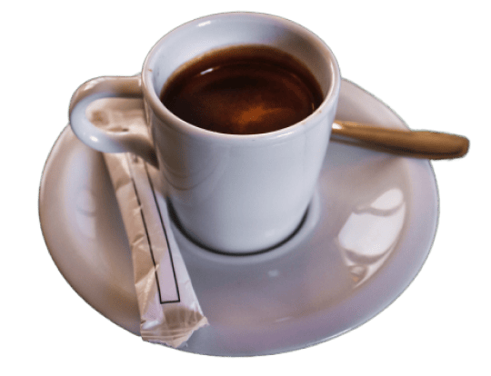

-Simple and smooth - $17.50

Donec malesuada ex sit amet pretium sid ornare. Nulla congue scelerisque tellus, utpretium. Mauris suscipit nisi ut ipsum egestas, et velit convallis. Phasellus rhoncus tempus.

* Latte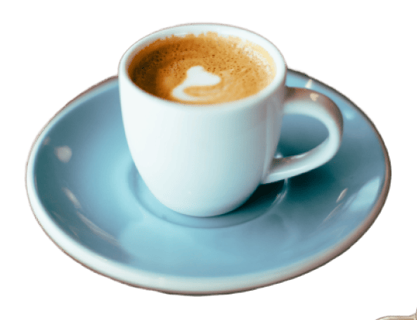

-Mild & Milky - $11.90

Donec malesuada ex sit amet pretium sid ornare. Nulla congue scelerisque tellus, utpretium. Mauris suscipit nisi ut ipsum egestas, et velit convallis. Phasellus rhoncus tempus.

* Cappuccino

-Famously frothy - $9.00

Donec malesuada ex sit amet pretium sid ornare. Nulla congue scelerisque tellus, utpretium. Mauris s

uscipit nisi ut ipsum egestas, et velit convallis. Phasellus rhoncus tempus.

All your favourites, delivered straight to you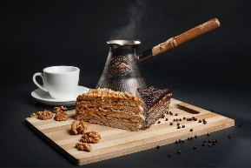

Lorem ipsum dolor sit, amet consectetur adipisicing elit. Facilis, aliquid non? Suscipit numquam obcaecati necessitatibus voluptas. Molestias, sint atque aliquid magnam magni, fuga iste fugit iusto maiores vero soluta voluptates?

Start your Order

Contact!!!



Contact Us

* Address info

Coffee bean, 343 cafe coffee lane, #2214 cravel street, NY.

* Opening hours

Monday-Friday: 9am-6pm

Saturday: 10am - 4pm

* Contact info

+1(21) 234 4567

[Chloe@gmail.com](mailto:Chloe@gmail.com)

我也要这个

Your Name

Your Gmail Address

Your Message

Submit