eat() : void

sleep() : void

fly() : void

climb() : void

play() : void

breed : string

color : string

size : string

classification : string

Bird

Example Methods

Example States

breed : string

color: string

size : string

type : string

eat() : void

sleep() : void

sit() : void

run() : void

work() : void

play() : void

Dog

Example Methods

Example States

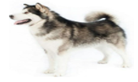

Example States

Example Methods

Boat

type : string

color : string

brand : string

ford() : void

sail(): void

fetch(): void

float(): void

Example Methods

Example States

travel() : void

ride(): void

brake() : void

fetch() : void

type : string

color : string

size : string

engineCapacity : int

Motorcycle

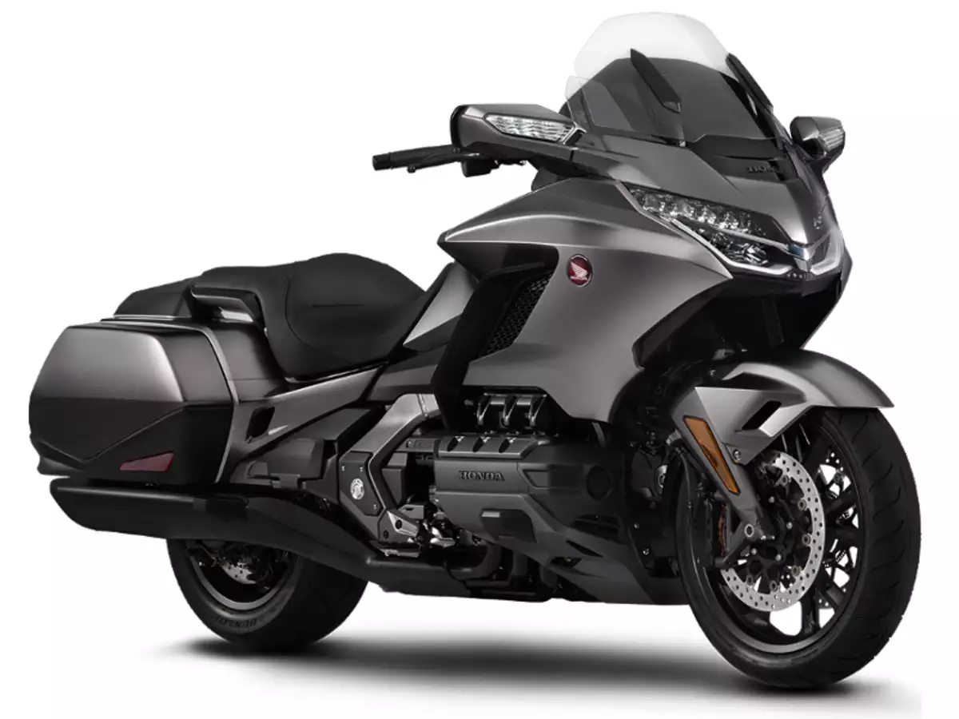

eat() : void

sleep() : void

sit() : void

run() : void

play() : void

climb() : void

breed: string

color: string

size: string

coat: string

Cat

Example Methods

Example States

