Cat

Properties:

Breed

Color

Size

Coat

Behaviour:

Eat()

Sleep()

Sit()

Run()

Play()

Climb()

Breed: Birman

Color: White

Size: Small

Coat: Medium

Breed: Chartreux

Color: Shade of blue

Size: Medium

Coat: Medium

Breed: Bombay

Color: Black

Size: Medium

Coat: Short

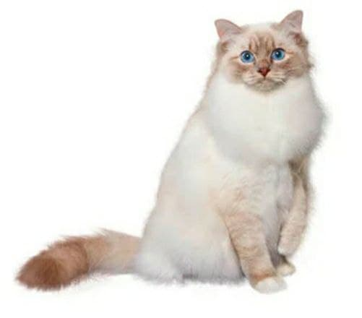

Properties:

Breed

Color

Size

Classification

Bird

Behaviour:

Eat()

Sleep()

Fly()

Climb()

Play()

Breed: Mealy Amazon

Color: Green

Size: Big

Classification: Parrots

Breed: Golden Eagle

Color: Dark brown

Size: Big

Classification: Eagle

:

Breed: Northern Cardinal

Color: Red & brown

Size: Medium

Classification: Songbirds

Motorcycle

Properties:

Type

Color

Size

Engine capacity

Behaviour:

Travel()

Ride()

Brake()

Fetch()

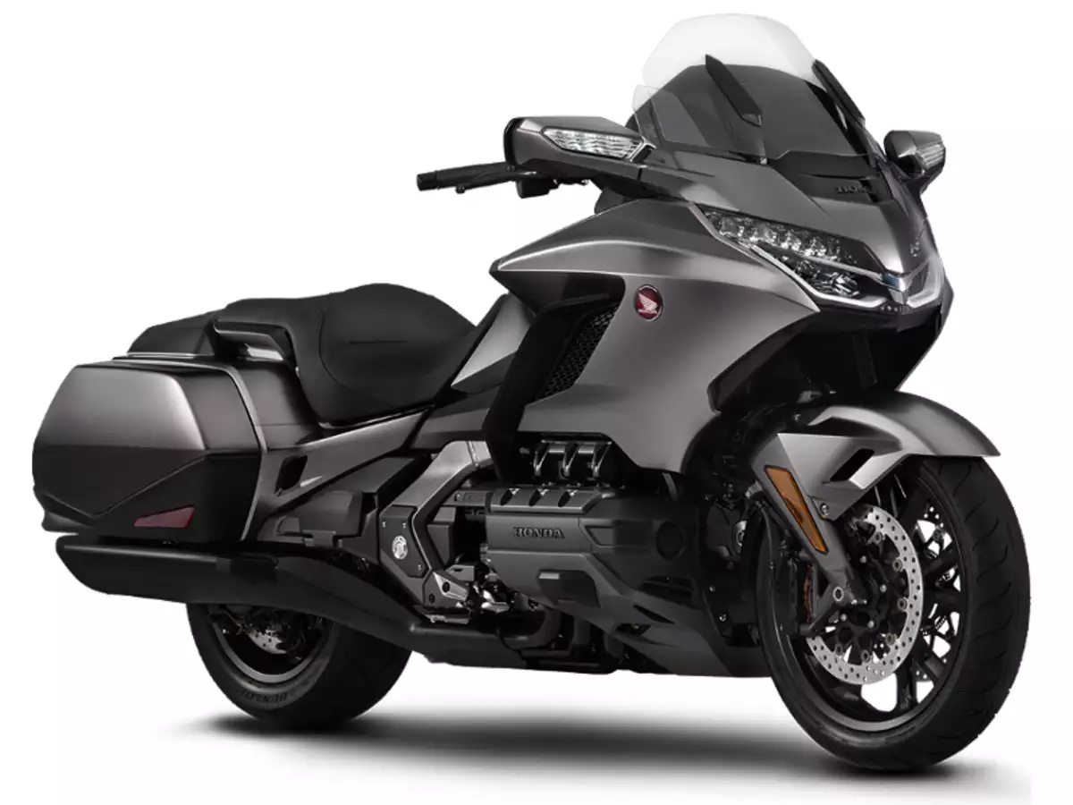

Type: Suzuki GSX-R600

Color: Black or White

Classification: Sport Bike

Engine capacity: 599cc

Type: Gold Wing

Color: Grey and black

Classification: Touring

Engine capacity: 1833cc

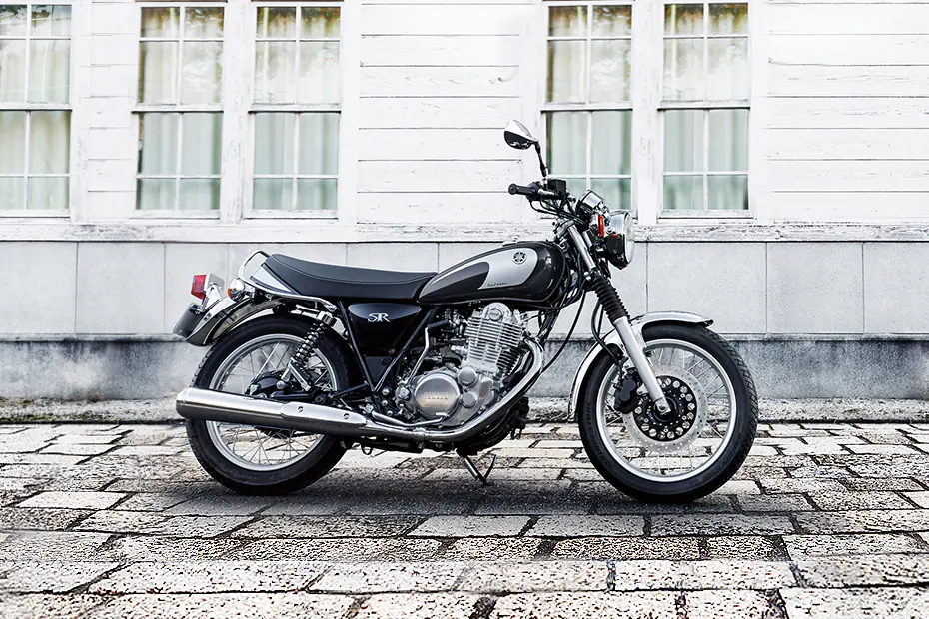

Type: Yamaha SR400

Color: Black

Classification: Standard

Engine capacity: 399cc

Properties:

Type

Color

Brand

Boat

Behaviour:

Ford()

Sail()

Fetch()

Float()

Type: Trawler boats

Size: Medium

Brand: Beneteau

Type: House Boats

Size: Big

Brand: Farea

Type: Dinghy Boats

Size: Small

Brand: Newport Vessels

Dog

Properties:

Breed

Color

Size

Type

Behaviour:

Eat()

Sleep()

Sit()

Run()

Work()

Play()

Breed: Affenpinscher

Color: Black

Size: Small

Type: Toy dogs

Breed: Alaskan Malamute

Color: Grey

Size: Medium

Type: Working dogs

Breed: Anatolian Shepherd Dog

Color: White

Size: Big

Type: Pastoral dogs