# **Features with final app screenshots**

Groupay mainly manages expense sharing among group mates. The features of this application can be separated as five parts: user module, friend module, group module, event module and finance module.

## 1 User module

**1.1 User Register feature**

When a new user comes to this application, he has to register at first by clicking the hyperlink “New User, Click here” in the main page as Figure 1.1.a. The application will direct user to the register page as Figure 1.1.b. After setting user email, user name and password and clicking the Register button, it will validate input data. A pop up window will show up if information is validated by application, which also means that your data has been stored in database.

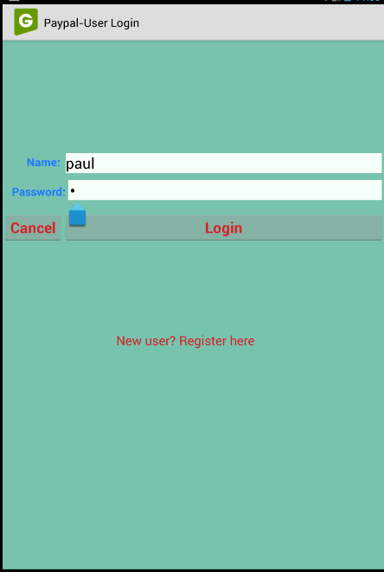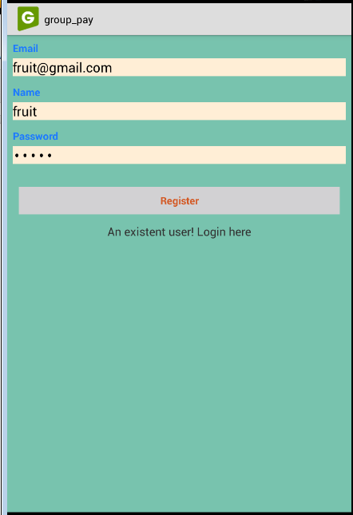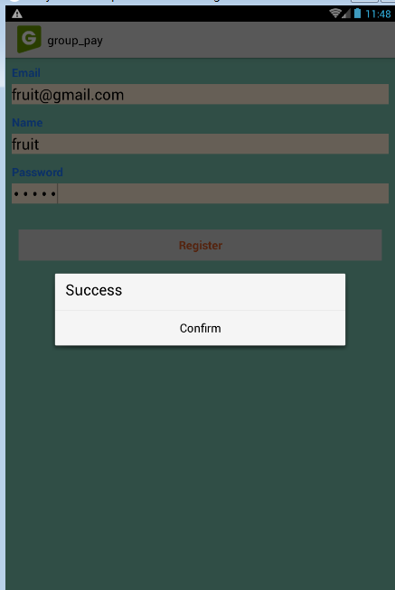

(Figure 1.1.a) (Figure 1.1.b) (Figure 1.1.c)

**1.2 User Login feature**

User who has registered the application has access to login the Groupay. From the Login page(Figure 1.1.a), if input information is validated, it will jump to the main page automatically. However, if it fails at validating user information, an error message will pop up .

## 2 Friend module

2.1 Add Friend Feature

At main page, friend list shows up as default as Figure 2.1.a. Here user can invite new friend by entering another friend’s nickname and clicking Add button. A pop up notice will show up if the operation goes successfully with “Add Friend Success” as Figure 2.1.b. After confirming this pop window, the new friend will display in the friend list if click Refresh button top right as Figure 2.1.c.

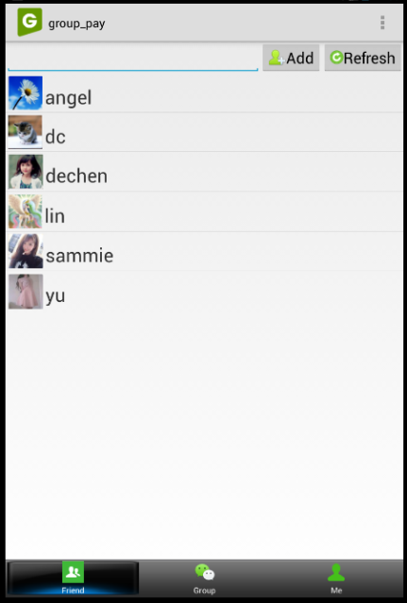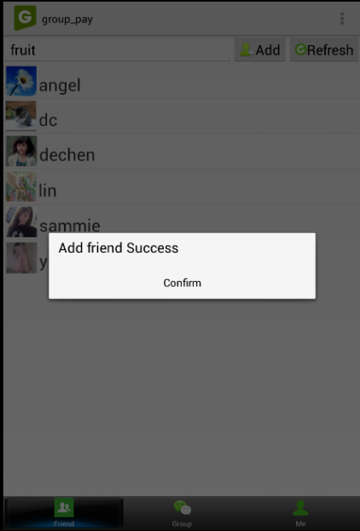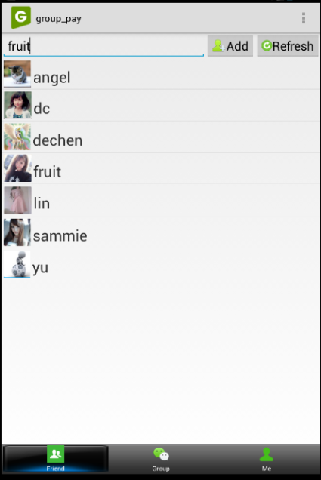

(Figure 2.1.a) (Figure 2.1.b) (Figure 2.1.c)

## 3 group module

Group module mainly concentrates its features at the second tab in the bottom bar. Displaying a list of groups is a default page in group module as Figure 3.1.a

**3.1 Create Group Feature**

At the main page of group module, user can create a new group by clicking top left Create button. A new page will be directed. After setting up all group information in the create group page, a context window with “Successful!” texts will show up if click create button as Figure 3.1.b. If everything goes well here, it will jump to the default main page automatically with a new group in a list of groups as Figure 3.1.c.

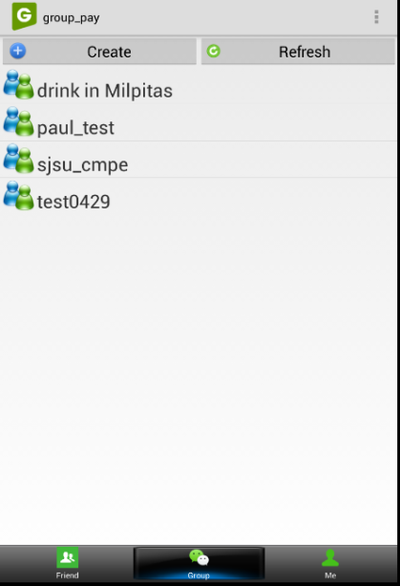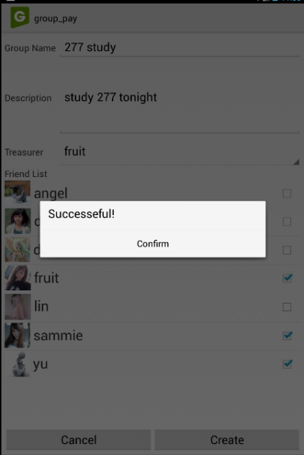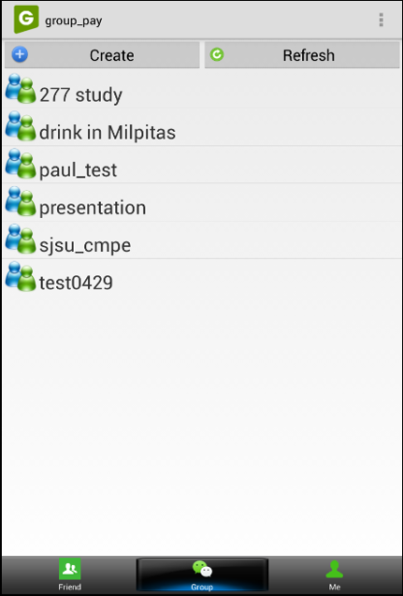

(Figure 3.1.a) (Figure 3.1.b) (Figure 3.1.c)

**3.2 Group Description Feature**

In the group list, user can view every group description by clicking the group name. Abundant details relate to the selected group will show up in a concise way as Figure 3.2.a, including group name, group leader, fund leader and several impressive features which we will introduce later, like Group Funding, Group Event.

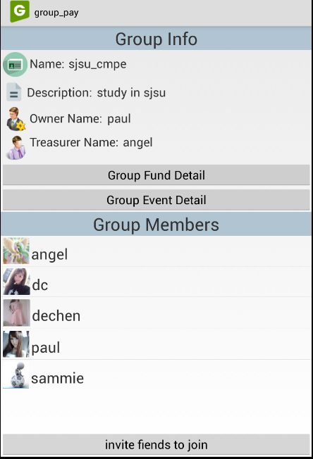

(Figure 3.2.a)

**3.3 Group Invitation Feature**

From the group description page, user can find the “invite friends to join” button at the bottom. Once click this button, user will be guided to the invite friends page as Figure 3.3.a. At this page, user can choose multiple friends by confirming related checkbox. Application will notify user if invitations are sent out successfully.

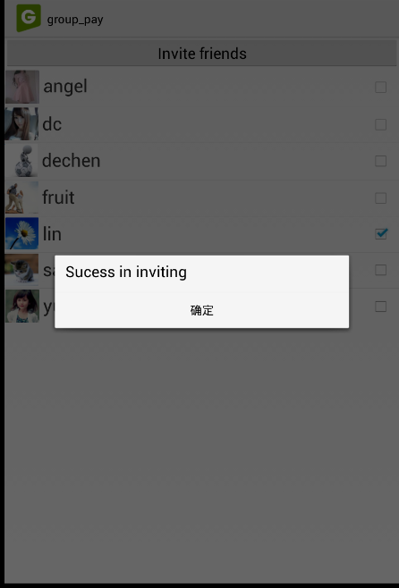

(Figure 3.3.a)

## 4 ME module

**4.1 Deposit Funds Feature**

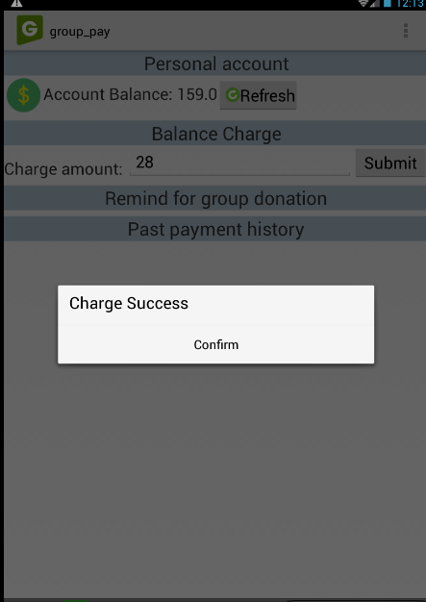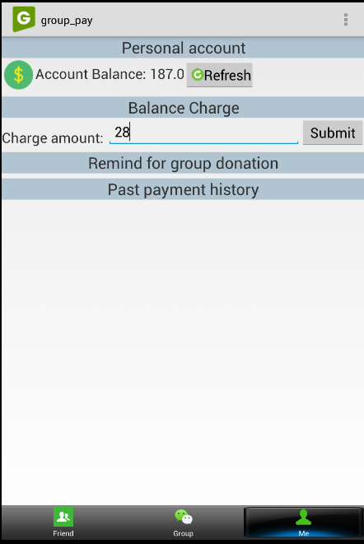

(Figure 1.a) (Figure 1.b)

Let’s move to the third tab “Me” at the bottom of main page(Figure 1.1.a), where user can deposit his own money for future donating or submitting operations. From this page, user can enter how much money he would like to deposit in the text field and click submit button. After refreshing the page, Account balance will get updated with latest value.

## 5 finance module in group

**5.1 Donate to Group Feature**

From the group description page(Figure 3.2.a), user can check group funds by clicking “Group Fund Detail” button in the middle. If user click the button, application will direct user to a group fund info page as Figure 5.1.a. Enter how much you would like to donate and click submit button. If the donation is equal or less than your own deposit, your operation will success with a pop up notice as Figure 5.1.b. The same as before, group fund account will get updated with latest value while refreshing the page as Figure 5.1.c.

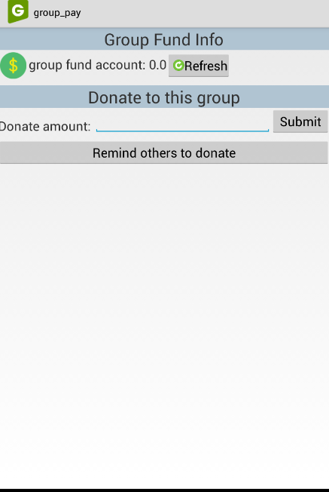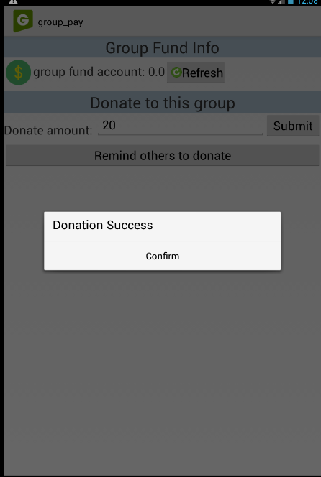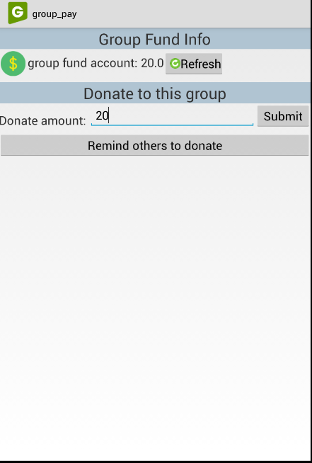

(Figure 5.1.a) (Figure 5.1.b) (Figure 5.1.c)

**5.2. Donation Notification Feature**

As we can see in Figure 5.1.a, there is “Remind others to donate” button in the page. Only group leader has access to operate this feature that notify groups members to do donation. Otherwise, it will tell you a permission denied message as Figure 5.2.a.

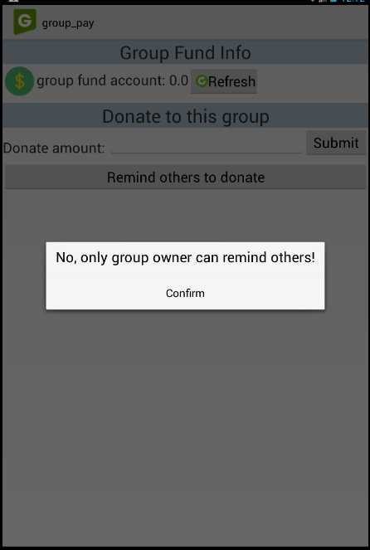

(Figure 5.2.a)

## 6 event module

**6.1 Post Event Feature**

From the group description page(Figure 3.2.a), user can check events by clicking “Group Event Detail” button in the middle under ”Group Fund Detail”.

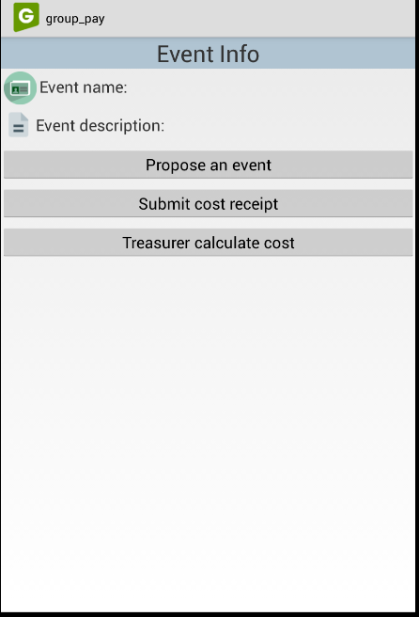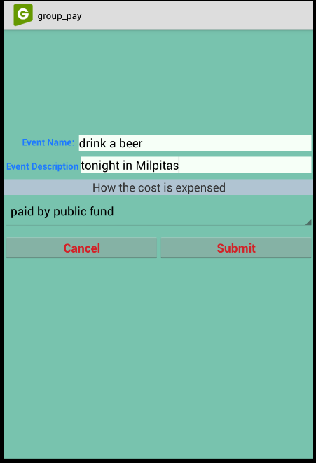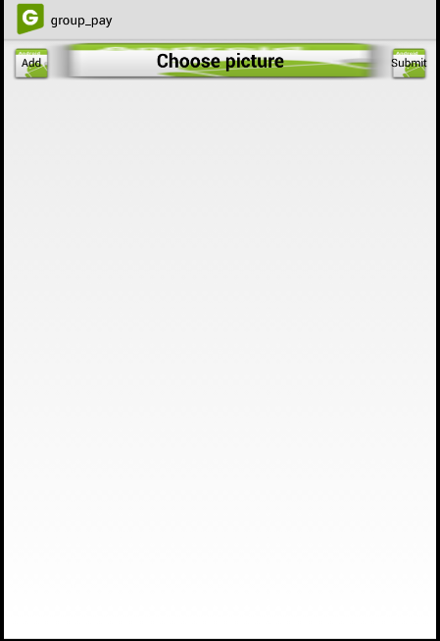

(Figure 6.1.a) (Figure 6.1.b) (Figure 6.1.c)

If user click the “Group Event Detail” button, application will direct user to a event info page as Figure 6.1.a. Here, user can check all events he would have from the top area. What’s more user can use below buttons to propose an event (Figure 6.1.b), submit receipt(Figure 6.1.c).