Udoo Neo Motion sensor

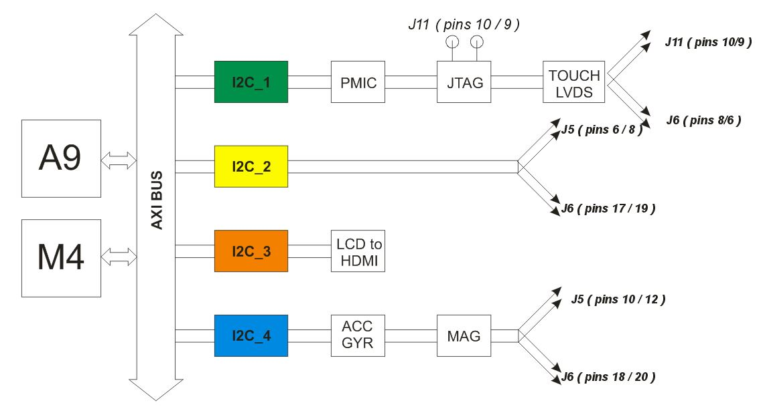 UDOO Neo is equipped with 9-axis motion sensors: accelerometer, magnetometer and gyroscope. Accelerometer and magnetometer are embedded on the same Freescale chip, that is FXOS8700CQ, the gyroscope is a single FXAS21002C chip. They communicate with i.MX 6SoloX over I2C bus number 4. They can be accessed by M4 core and also by A9 core. They can be used in ping mode, asking the values to the sensors, or in interrupt mode.

* Accelerometer and Magnetometer: FXOS8700CQ
* 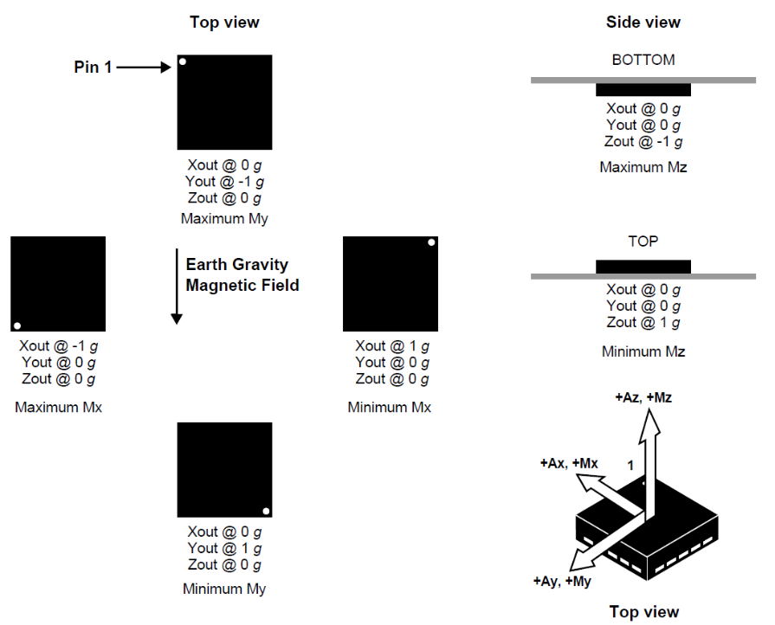FXOS8700CQ is a small, low-power, 3-axis, linear accelerometer and 3-axis, magnetometer combined into a single package. The device features an I2C with 14-bit accelerometer and 16-bit magnetometer ADC resolution along with smart-embedded functions.
* FXOS8700CQ has dynamically selectable acceleration full scale ranges of ±2g / ±4g /±8g and a fixed magnetic measurement range of ±1200μT. Output data rates (ODR) from 1.563 Hz to 800 Hz are selectable by the user for each sensor. Interleaved magnetic and acceleration data is available at ODR rates of up to 400 Hz. FXOS8700CQ is guaranteed to operate over the extended temperature range of -40 °C to +85 °C.
* I2C address: 0x1E
* To read accelerometer and magnetometer filed data:
* Configure I2C protocol between Udoo Neo and FXOS8700CQ
* Use I2C Write data to register function to initialize operation mode for FXOS8700CQ. There are many registers but we just focus on some registers to get the sensor value.

|  |  |  |
| --- | --- | --- |
| Register | Address | Value |
| FXOS8700CQ_CTRL_REG1 | 0x2A | 0x1D* |
| FXOS8700CQ_CTRL_REG2 | 0x2B |  |
| FXOS8700CQ_F_SETUP_REG | 0x09 | 0x01 |
| FXOS8700CQ_M_CTRL_REG1 | 0x5B | 0x9F |
| FXOS8700CQ_M_CTRL_REG2 | 0x5C | 0x20 |
| FXOS8700CQ_XYZ_DATA_CFG_REG | 0x0E | 0x00 |

* Note: Before configure operation mode for sensor, we must put it to standby mode first (by set bit 0 of CTRL_REG1 to 0). After configuration, we put sensor to active mode again to read sensor value (by set bit 0 of CTRL_REG1 to 1).

* Use I2C Read data from register function to get accelerometer and magnetometer value from FXOS8700CQ

|  |  |
| --- | --- |
| Register | Address |
| FXOS8700CQ_WHO_AM_I_REG | 0x0D |
| FXOS8700CQ_OUT_X_MSB_REG | 0x01  …  0x06 |
| FXOS8700CQ_OUT_X_LSB_REG |
| FXOS8700CQ_OUT_Y_MSB_REG |
| FXOS8700CQ_OUT_Y_LSB_REG |
| FXOS8700CQ_OUT_Z_MSB_REG |
| FXOS8700CQ_OUT_Z_LSB_REG |
| FXOS8700CQ_MOUT_X_MSB_REG | 0x33  …  0x38 |
| FXOS8700CQ_MOUT_X_LSB_REG |
| FXOS8700CQ_MOUT_y_MSB_REG |
| FXOS8700CQ_MOUT_y_LSB_REG |
| FXOS8700CQ_MOUT_z_MSB_REG |
| FXOS8700CQ_MOUT_z_LSB_REG |

* Gyroscope: FXAS21002C
* 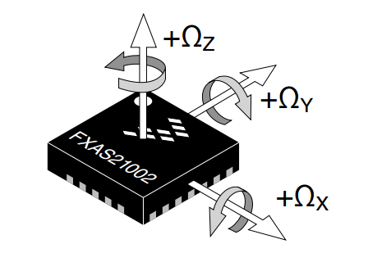3-Axis Digital Angular Rate Gyroscope FXAS21002C is a small, low-power, yaw, pitch, and roll angular rate gyroscope with 16 bit ADC resolution. The full-scale range is adjustable from ±250°/s to ±2000°/s. It features I2C interface. FXAS21002C is capable of measuring angular rates up to ±2000°/s, with output data rates (ODR) from 12.5 to 800 Hz.
* An integrated Low-Pass Filter (LPF) allows the host application to limit the digital signal bandwidth. The device may be configured to generate an interrupt when a user-programmable angular rate threshold is crossed on any one of the enabled axes. FXAS21002C is guaranteed to operate over the extended temperature range of –40 °C to +85 °C
* I2C address: 0x20
* To read gyroscope field data:
* Configure I2C protocol between Udoo Neo and FXAS21002C
* Use I2C Write data to register function to initialize operation mode for FXAS21002C. There are many registers but we just focus on some registers to get the sensor value.

|  |  |  |
| --- | --- | --- |
| Register | Address | Value |
| FXAS21002C_CTRL_REG1 |  | 0x40* |
| FXAS21002C_CTRL_REG0 |  | 0x1F |
| FXAS21002C_CTRL_REG2 |  | 0x0C |

* Note: Before configure operation mode for sensor, we must put it to standby mode first (by set bit 0 of CTRL_REG1 to 0). After configuration, we put sensor to active mode again to read sensor value (by set bit 0 of CTRL_REG1 to 1).

* Use I2C Read data from register function to get accelerometer and magnetometer value from FXAS21002C

|  |  |
| --- | --- |
| Register | Address |
| FXAS21002C_WHO_AM_I_REG | 0x0C |
| FXAS21002C_OUT_X_MSB_REG | 0x01  …  0x06 |
| FXAS21002C_OUT_X_LSB_REG |
| FXAS21002C_OUT_Y_MSB_REG |
| FXAS21002C_OUT_Y_LSB_REG |
| FXAS21002C_OUT_Z_MSB_REG |
| FXAS21002C_OUT_Z_LSB_REG |

Power Supply for Udoo Neo: 9V DC

Module Buzzer

Button Interrupt