

Policy
Policy for Association
FSC-POL-01-004 V3-0

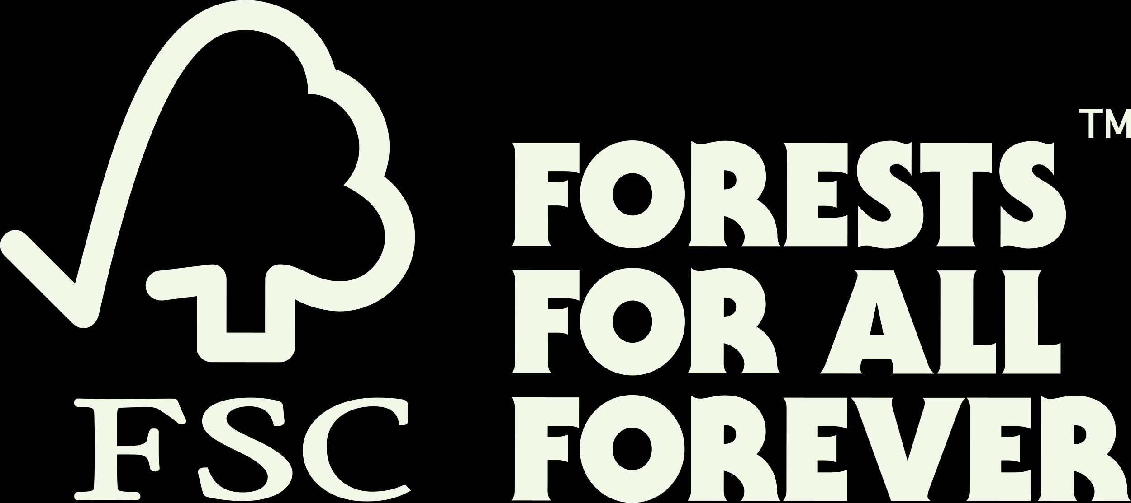

Title: | Policy for Association
Dates: | Approval date: 26 August 2022
Contact for comments: | FSC Global Development – Dispute Management  Adenauerallee 134  53113 Bonn  Germany  Phone: +49 -(0)228 -36766 -0  Fax: +49 -(0)228 -36766 -65  Email: dispute.resolution@fsc.org
Version control
Publication date: | 4 October 2022
Effective date: | 1 January 2023
Version | Description | Date
V1-0 | The FSC Board of Directors approved the essential elements of Policy for Association in July 2009 – the six unacceptable activities in which organizations wishing to associate* with FSC could not be directly or indirectly involved in (see Part I) – but recognized that further work was needed to describe the policy implementation process in more detail. | 02/07/2009
V2-0 | The FSC Board of Directors approved the policy implementation details (see Part II) in September 2011. | 01/09/2011
V3-0 | This version introduces definitions of control* and corporate group* to redefine the scope of application as well as requirements for disclosure for risk-based screenings. It aligns policy with an existing interpretation concerning research in genetic engineering and the latest thinking in FSC’s position on conversion. | 01/01/2023

® 2022 Forest Stewardship Council, A.C. All Rights Reserved
FSC® F000100
You may not distribute, modify, transmit, reuse, reproduce, re-post or use the copyrighted materials from this document for public or commercial purposes, without the express written consent of the publisher. You are hereby authorized to view, download, print and distribute individual pages from this document subject for informational purposes only.

CONTENTS
Introduction 4
Objective 4
Scope 4
References 5
Part I: Policy elements 6
Part II: Policy implementation 6
Annex 1: Corporate group 8
Annex 2: Engagement in unacceptable activities 9
Annex 3: Terms and definitions 10
Verbal forms for the expression of provisions 12

Introduction
Forests sustain life on earth and must be protected. That's why FSC exists: to provide a sustainable forest management solution that is trusted by NGOs, consumers, and businesses alike to protect healthy and resilient forests, for all, forever. We bring together experts form the environmental, economic and social spheres to promote the responsible management of the world’s forests. The Policy for Association is an expression of the values shared by individuals and organizations associated* with FSC. It defines six unacceptable activities that associated* individuals and organizations and their corporate group* commit to avoid in both certified and non-certified operations.
The Policy for Association serves as a risk management tool for FSC, protecting the credibility and reputation of the FSC brand and organizations associated* with it. It applies to entire corporate groups* even if only a limited part of a group has an active relationship with FSC. The policy extends the reach of FSC core values to also those organizations in the corporate group* that are not themselves active within the certification system. This scope of the policy is a means to avoid any confusion or use of FSC’s name in relation to activities that violate FSC’s core principles and that could compromise FSC’s ability to deliver on its mission. The policy also allows for requiring improvements and remedy as well as the termination of all contractual ties with an individual or organization found to be in violation of the policy.
Policy implementation
To protect FSC’s reputation and to remedy harm caused by unacceptable activities, FSC will assess multiple options, from mediation to investigation, sanctions and conditions-setting, to improve the performance of individuals and organizations associated* with FSC. The measures and consequences depend on the gravity of the violation. Stakeholders should engage in all reasonable efforts to address concerns before presenting a Policy for Association complaint.
Allegations* of violations of the Policy for Association against associated* individuals and organizations are accepted and evaluated by FSC upon presentation of substantial information* that the associated* individual or organization or its corporate group* has violated the policy.
To implement the Policy for Association, two procedural documents are used:
- An individual or organization seeking to associate* with FSC must undergo a screening process and disclose information, in accordance with FSC-PRO-10-004 Disclosure Requirements for Association with FSC.
- If a potential violation of this policy is brought to the attention of FSC, then FSC-PRO-01-009 Processing FSC Policy for Association Complaints is applied.

Objective
The objective of the Policy for Association is to outline and define unacceptable activities that severely impact forests and people on-the-ground and that pose reputational risks if associated* with FSC. The policy defines consequences of engaging in them for organizations and individuals that are or seek to be associated* with FSC. The policy determines which organizations and individuals can or cannot be associated* with FSC.

Scope
The Policy for Association applies to all associated* individuals, organizations, and their corporate groups* and to those seeking association* with FSC.

The policy states six unacceptable activities (see Part I: Policy elements) that associated* individuals, organizations and their corporate groups* must commit to avoid and defines the consequences of a violation to this policy (see Part II: Policy implementation).
This policy applies to situations where the unacceptable activity is occurring or has occurred. Intent to engage in an unacceptable activity is not sufficient grounds to trigger an investigation or complaint. However, intent to engage in an unacceptable activity may trigger other, proactive measures by FSC, including information-gathering and monitoring, to help ensure that the unacceptable activity does not occur in the future.
In the spirit of the FSC system, disputes should always be addressed at the lowest level possible, and stakeholders are encouraged to follow this principle. Complaints related to a violation of the Policy for Association that overlap with an organization’s conformance with its certification requirements should therefore first be addressed with the respective certification body through its established complaints procedure.
The timeframe for how far back a violation is considered relevant is handled on a case-by-case basis, unless specified in this policy, using conditions such as, but not limited to: i) whether there is lingering harm; ii) the scale and impact of the harm done; iii) the level of action already taken to remedy past harm; iv) whether there is demonstrable systemic change to prevent the re-occurrence of the unacceptable activity.
This policy version 3-0 will be applicable from its effective date. The previous version 2-0 of the policy remains effective for violations that occurred before the effective date of the version 3-0.

References
The following referenced documents are essential for the application of this document. For undated references, the latest edition of the referenced document (including any amendments) applies.

FSC-PRO-01-009 | Processing FSC Policy for Association Complaints
FSC-PRO-10-004 | Disclosure Requirements for Association with FSC
FSC-PRO-01-004 | FSC Remedy Framework
FSC-STD-01-002 | FSC Glossary of Terms
 | FSC Statutes

Part I: Policy elements
- FSC aims to associate* with individuals and organizations aligned with the FSC mission and values and will not allow an association* if the individual, organization or its corporate group* is or has been engaged in the following unacceptable activities:
- Illegal harvesting or illegal trade* in forest products*
- Violation of customary* or human rights* within the forestry or forest products sector*
- Violation of workers’ rights* and principles defined in the International Labour Organization (ILO) Declaration on Fundamental Principles and Rights at Work within the forestry or forest products sector*
- Destruction of High Conservation Values* (HCVs) in forests or High Conservation Value areas*
- Conversion of natural forest cover*
- Use of genetically modified* organisms in forestry operations for any other purposes than research.
NOTE: See Annex 1 for criteria defining a corporate group* and Annex 2 for further considerations on circumstances where an associated* individual or organization has engaged in an unacceptable activity.

Part II: Policy implementation
- Due diligence and disclosure
  - An associated* individual or organization shall ensure that they and their corporate group* have policies and procedures in place to avoid any engagement in relevant unacceptable activities stipulated in Part I. Existence of such policies is not verified by FSC prior to association*. In case of complaint, a lack of sufficient due diligence* to avoid risk of violation of the Policy for Association will be taken into consideration.
  - FSC will only enter into, or maintain, an association* with an individual or organization that conforms to the disclosure requirements of FSC-PRO-10-004 Disclosure Requirements for Association with FSC.

- Evaluating allegations
  - Any stakeholder can submit a complaint if there is substantial information* that an associated* individual or organization or its corporate group* is suspected of a violation of this policy. Complaints are processed according to FSC-PRO-01-009 Processing FSC Policy for Association Complaints.

- Consequences of a violation of this policy
  - An associated* individual or organization found to be in violation of this policy will, together with its corporate group*, face one of two consequences, as further elaborated in FSC-PRO-01-009:
- Maintaining association* with time-bound conditions that must be met to remain associated* with FSC. The associated* individual or organization must agree to meet these conditions. Failure to implement them within the agreed timelines will be grounds for disassociation*.
- Disassociation* from FSC, with main pre-conditions to be fulfilled before considering a process for ending disassociation*.
NOTE: See FSC-PRO-01-009 Processing FSC Policy for Association Complaints for a list of the factors considered in determining the consequences of a violation, as well as the types of conditions that must be met for maintaining association* or ending disassociation*. See also the FSC Statutes for the process for destitution of a member.
  - An organization or individual applying for association* that has been found to be in violation of this policy, shall not be granted association* with FSC.

5. Ending disassociation and applying for association after confirmed violation
5.1 A disassociated* or rejected individual or organization interested in associating* with FSC shall enter into a remedy process.
5.2 Individual or organization-specific requirements shall be developed by an independent third-party based on general requirements defined in FSC-PRO-01-004 FSC Remedy Framework. The requirements constitute a plan of how to remedy, correct and prevent reoccurrence of previously identified violations. They may also consider activities that were not included in the original complaint if they might be in violation of the Policy for Association and are considered necessary to include for trust-building reasons. See FSC Remedy Framework and FSC-PRO-01-009 Processing FSC Policy for Association Complaints for more information on the process.
5.3 Upon fulfilling the defined conditions, and FSC ending the disassociation*, the individual or organization may apply to associate* with FSC as a member and/or an FSC license agreement holder.

Annex 1: Corporate group
The Policy for Association applies to associated* individuals and organizations and to the corporate group* they belong to.

Table 1: Definition and factors used to determine corporate group*
Definition of corporate group*: | Factors that are used to determine whether a company is part of a broader corporate group* include:
The totality of legal entities to which an associated* organization is affiliated in a corporate relationship in which either party controls* the performance of the other (e.g. parent or sister company, subsidiary, joint venture, etc.).  Control* in this regard means the possession of power to direct, restrict, regulate, govern, or administer the performance of the other company through authority, rights, contract, or other means.  NOTE: Control* may exist irrespective of the percentage share of ownership; however, it is deemed to exist (unless evidence points to the contrary) when an organization or individual owns more than 50 percent share interest in another legal entity. | - Formality of relationship: Is there formal ownership, such as through an investment holding structure?  - Declared as a group: Has the group publicly declared the companies are linked?  - Family control: Are the companies owned or run and controlled by members of the same family?  - Financial control: Are there contractual or other financial arrangements that indicate one party controls* the performance of another?  - Management control: Is there extensive overlap in officials between companies?  - Operational control: Are landholdings under a group’s operational control*?  - Beneficial ownership: Is ultimate ownership hidden in offshore companies or by use of nominees?  - Shared resources: Do companies share a registered address, land or other physical assets, or provision of company functions or services?

NOTE: The definition and factors used for determining corporate group* and control*, will be applied and evaluated on a case-by-case basis.

Example of managerial control* within a corporate group*

Company A holds multiple FSC certificates, and Company B does not have any FSC certificates. The owner of Company A sits on the board of Company B with voting power of 20%. The owner of Company A sets the performance benchmarks for the management of Company B. If Company B is found to have been engaged in an unacceptable activity, then an investigation would be triggered to determine whether Company A had managerial control* over the actions of Company B and whether they would be considered to be part of the same corporate group*. If yes, the unacceptable activities of Company B constitute a violation of the Policy for Association.

Annex 2: Engagement in unacceptable activities
An associated* individual or organization and its corporate group* are in violation of the Policy for Association if they are or have been engaged in any of the unacceptable activities defined in clause 1 of Policy elements. They are considered engaged in unacceptable activities if they have control* over these activities. The unacceptable activities could have been performed by themselves, or by another organization they have control* over.
Thus, an individual or organization and its corporate group* can be in violation of the Policy for Association also through commercial relationships. This is determined by existence of control* over the unacceptable activities. For example, the unacceptable activities of a supplier constitute a violation of the Policy for Association only if the associated* individual or organization and its corporate group* had control* over the actions of its supplier.

Example of control* in a commercial relationship
Company A has an FSC chain of custody certificate and buys timber from Company B, which is not FSC certified. Company B is a supplier to Company A, and both are separate corporate entities. Company A, however, is the sole buyer of Company B’s products and the sales contract between the companies gives Company A the right to veto Company B’s management plan. If Company B were found to be engaged in an unacceptable activity, then a Policy for Association evaluation would be triggered to determine whether Company A had control* over the actions of Company B. If yes, the unacceptable activities of Company B constitute a violation of the Policy for Association.

Annex 3: Terms and definitions
For the purposes of this international document, the terms and definitions given in FSC-STD-01-002 FSC Glossary of Terms and the following apply:
Allegation: A statement of belief that some wrong or harm has occurred.
Association (associated, associate, associated organization): An association with FSC is formally established through any of the following contractual relationships: FSC membership agreement; FSC certificate holder license agreement; FSC certification body license agreement; FSC partnership agreement.
Control: The possession of power to direct, restrict, regulate, govern, or administer the performance of the other company through authority, rights, contract, or other means.
Conversion of natural forest cover: A lasting change of natural forest cover* induced by human activity*. This covers gradual forest degradation* as well as rapid forest transformation.
- Induced by human activity: In contrast to drastic changes caused by natural calamities like hurricanes or volcanic eruptions. It also applies in cases of naturally ignited fires where human activities (e.g., draining of peatlands) have significantly increased the risk of fire.
- Lasting change of natural forest* cover: Permanent or long-term change of natural forest* cover. Temporary changes of forest cover or structure (e.g., harvesting followed by regeneration in accordance with the FSC normative framework) is not considered conversion of natural forest cover*.
NOTE: For the purposes of this policy, the establishment of ancillary infrastructure necessary to implement the objectives of responsible forest management (e.g., forest roads, skid trails, log landings, fire protection, etc.) is not considered conversion.
NOTE: The provisions for minimal conversion apply also in the context of association*.
Corporate group: The totality of legal entities to which an associated* organization is affiliated in a corporate relationship in which either party controls* the performance of the other (e.g., parent or sister company, subsidiary, joint venture, etc.). See also Annex 1.
Customary rights: Rights which result from a long series of habitual or customary actions, constantly repeated, which have, by such repetition and by uninterrupted acquiescence, acquired the force of a law within a geographical or sociological unit. (Source: FSC-STD-01-001 V5-2).
Degradation: Changes within a natural forest* or High Conservation Value area* that significantly and negatively affect its species composition, structure and/or function, and reduces the ecosystem’s capacity to supply products, support biodiversity and/or deliver ecosystem services.
Destruction of High Conservation Values: Lasting change of any of the High Conservation Values*. This may be characterized by significant loss of species diversity*, habitat diversity, structural complexity, ecosystem functionality or livelihoods and cultural values. Temporary changes that do not negatively and permanently impact the values (e.g., harvesting followed by regeneration in accordance with Principle 9) are not considered a lasting change.
Explanatory notes:
For the purposes of this policy, it is not expected that the associated* individual or organization or its corporate group* will systematically conduct HCV* assessments to determine the existence of HCVs* and the threats to them. Rather, it is expected that they make use of available tools and have mitigation strategies in place for situations where potential risk to HCVs* exist. For tools, see for example FSC Risk Assessment Platform, HCV Guide for Forest Managers (FSC-GUI-30-009) and FSC Guidelines for the Implementation of the Right to Free, Prior and Informed Consent (FPIC) (FSC-GUI-30-003).
Disassociation (disassociated): The termination of all existing contractual relationships (member and license) between FSC and the associated* individual, organization and corporate group*. Disassociation also prevents entry into any new contractual relationships with FSC.
Due diligence: A risk management process implemented by an organization to identify, prevent, mitigate, and account for how it addresses environmental and social risks and impacts in its operations, supply chains and investments.
Forest product: Forest-based organic materials and products produced within a forest matrix, including wood and non-timber forest products. (Source: Adapted from definition of forest based in FSC-STD-40-004 V3-1).
Forest products sector: Includes all entities that trade or manufacture products from forest-based organic materials, including timber and non-timber forest products*. (Source: Adapted from definition of forest based in FSC-STD-40-004 V3-1).
Genetically modified (organism): An organism in which the genetic material has been altered in a way that does not occur naturally by mating and/or natural recombination. This policy is specific to organisms that are trees. (Based on FSC-POL-30-602). (Source: FSC-STD-01-001 V5-2).
High Conservation Value areas: Zones and physical spaces which possess and/or are needed for the existence and maintenance of identified High Conservation Values*. (Source: FSC-STD-60-004 V2-0).
High Conservation Values (HCVs): As defined in FSC-STD-01-001 V5-2 FSC Principles and Criteria for Forest Stewardship, including HCV1 species diversity, HCV2 landscape level ecosystems and mosaics, HCV3 ecosystems and habitats, HCV4 critical ecosystem services, HCV5 community needs and HCV6 cultural values.
Human rights: Human rights are rights that every human being has by virtue of his or her human dignity and are the sum of individual and collective rights laid down in State constitutions and international law. Human rights are manifold. Human rights include, at a minimum, rights expressed in the International Bill of Human Rights (consisting of the Universal Declaration of Human Rights and the main instruments through which it has been codified: the International Covenant on Civil and Political Rights and the International Covenant on Economic, Social and Cultural Rights), the United Nations Declaration on the Rights of Indigenous Peoples, the ILO Indigenous and Tribal Peoples Convention No. 169 and the principles concerning fundamental rights set out in the International Labour Organization’s Declaration on Fundamental Principles and Rights at Work. Depending on the circumstances, organizations may need to consider additional standards and instruments.
Illegal harvesting and/or illegal trade in forest products: Harvesting of timber and non-timber forest products* in violation of any and all laws applicable in that location or jurisdiction including, but not limited to, laws related to the acquisition of harvesting rights from the rightful owner, the harvesting methods used, and the payment of all relevant fees and royalties. The term ‘illegal trade’ refers to both ‘illegal trade in forest products’ and ‘legal trade in illegal forest products’ and includes for example fraud, bribery and purchase or resale of illegally harvested timber’. (Source: Adapted from FSC-STD-40-005 V3-1).
Natural forest: A forest area with many of the principal characteristics and key elements of native ecosystems, such as complexity, structure and biological diversity, including soil characteristics, flora and fauna, in which all or almost all the trees are native species, not classified as plantations.
Natural forest includes the following categories:
- Forest affected by harvesting or other disturbances, in which trees are being or have been regenerated by a combination of natural and artificial regeneration with species typical of natural forests in that site, and where many of the above-ground and below-ground characteristics of the natural forest are still present. In boreal and north temperate forests which are naturally composed of only one or few tree species, a combination of natural and artificial regeneration to regenerate forest of the same native species, with most of the principal characteristics and key elements of native ecosystems of that site, is not by itself considered as conversion to plantations.
- Natural forests which are maintained by traditional silvicultural practices including natural or assisted natural regeneration.
- Well-developed secondary or colonizing forest of native species which has regenerated in non-forest areas.
- The definition of natural forest may include areas described as wooded ecosystems, woodland and savanna.
Natural forest does not include land that is not dominated by trees, was previously not forest, and that does not yet contain many of the characteristics and elements of native ecosystems. Young regeneration may be considered as natural forest after some years of ecological progression.
Significant loss of species diversity: Loss of species is considered significant where rare species and threatened species or other locally important, keystone and/or flagship species are lost, whether in terms of numbers of individuals or in terms of number of species. This refers to both displacement and extinction.
Substantial information: Credible information provided by third parties and/or gathered through independent research obtained from reliable/renowned sources which constitutes a solid piece of evidence to be considered in an investigation. Substantial information may include any of the following forms so long as the evidence meets the criteria required in this definition: scientific reports, technical analysis, certification reports, corroborated news articles, official reports and/ or announcements by governmental authorities, legal analysis, Geographic Information System information (boundary coordinates, satellite change mapping), videos or footage, images, independent interviews, affidavits and declarations, meeting minutes, and corporate/organizational information.
Workers’ rights: Rights defined in International Labour Organization (ILO) Declaration of Fundamental Principles and Rights at Work and ILO Core Conventions. The fundamental principles and rights at work include freedom of association and the effective recognition of the right to collective bargaining; the elimination of all forms of forced or compulsory labour; the effective abolition of child labour; and the elimination of discrimination in respect of employment and occupation. These fundamental rights and their implementation have been further examined for example in the ILO Tripartite Declaration of Principles Concerning Multinational Enterprises and Social Policy and for verification purposes in FSC Core Labour Requirements.

Verbal forms for the expression of provisions
[Adapted from ISO/IEC Directives Part 2: Rules for the structure and drafting of International Standards]
“shall”: indicates requirements strictly to be followed in order to conform to the document.
“should”: indicates that among several possibilities one is recommended as particularly suitable, without mentioning or excluding others, or that a certain course of action is preferred but not necessarily required.
“may”: indicates a course of action permissible within the limits of the document.
“can”: is used for statements of possibility and capability, whether material, physical or causal.

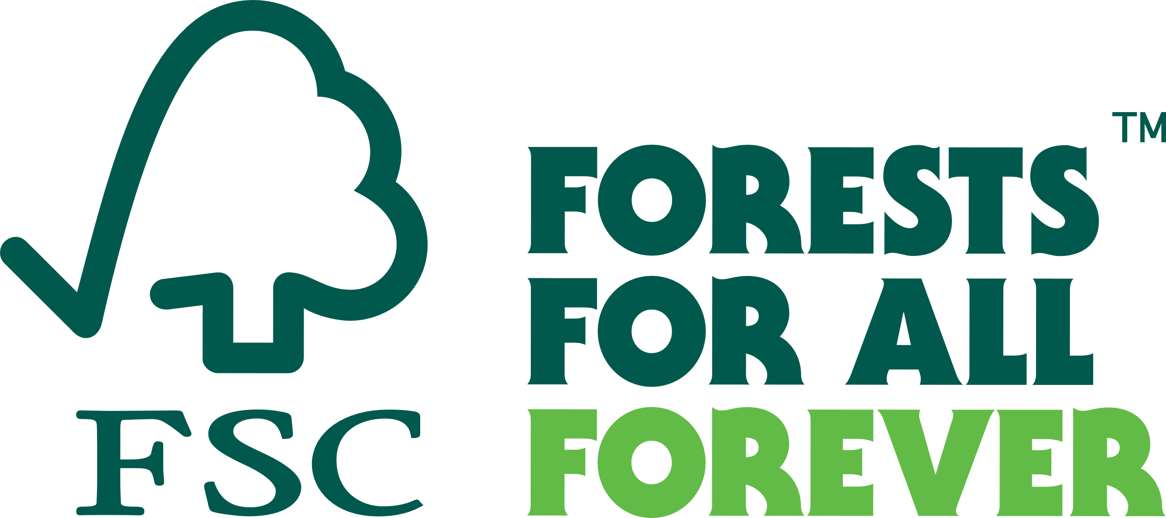

FSC Global Development – Dispute Management
Adenauerallee 134
53113 Bonn
Germany

Phone: +49 -(0)228 -36766 -0
Fax: +49 -(0)228 -36766 -65
Email: dispute.resolution@fsc.org

Research, as defined by INT-POL-01-004-01, is understood as activities that a) have a clear investigative purpose (i.e., test a hypothesis), b) are carried out on a limited scale and with defined timelines that are compatible to the scope of research, and c) are conducted following all related legal requirements, including safeguards, and permits.
Definition and factors adapted from the definition of “Corporate Group” by Accountability Framework Initiative (2022)

