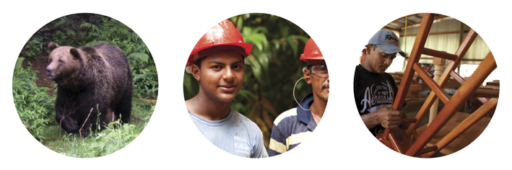

FSC Pesticides Policy

FSC-POL-30-001 V3-0 EN

Title: | FSC Pesticides Policy
Document reference code: | FSC-POL-30-001 V3-0 EN
Approval body: | FSC Board of Directors
Contact for comments: | FSC International Center  Performance and Standards Unit  Adenauerallee 134,  53113 Bonn  Germany

+49-(0)228-36766-0

+49-(0)228-36766-30

psu@fsc.org
© 2019 Forest Stewardship Council, A.C. All rights reserved.
FSC® F000100

No part of this work covered by the publisher’s copyright may be reproduced or copied in any form or by any means (graphic, electronic or mechanical, including photocopying, recording, recording taping, or information retrieval systems) without the written permission of the publisher.

Printed copies are uncontrolled and for reference only. Please refer to the electronic copy on the FSC website (ic.fsc.org) to ensure you are referring to the latest version.

The Forest Stewardship Council® (FSC) is an independent, not for profit, non-government organization established to promote environmentally appropriate, socially beneficial, and economically viable management of the world's forests.

FSC’s vision is that the world’s forests meet the social, ecological, and economic rights and needs of the present generation without compromising those of future generations.
CONTENTS

Introduction

A Objective

B Scope

C Effective and validity date

D References

E Terms and definitions

F Version history

Part I - Policy elements

Part II - Implementing the Policy

Annexes

Annex 1. Criteria, Indicators and Thresholds for identifying highly hazardous pesticides (HHPs)

Annex 2. Minimum list of hazards, elements and variables to consider in the assessment of environmental and social risks

Annex 3. Procedure for the exceptional use of FSC prohibited HHPs

Annex 4. Procedure to implement policy requirements for ESRA framework at national level

Introduction

In line with the objectives of the 2015-2020 FSC Global Strategic Plan and stakeholder feedback, the FSC Pesticides Policy has been revised to incorporate a risk-based approach that considers not only the hazard of the active ingredient but also under what circumstances chemical pesticides could be used.

FSC requires certified Organizations to use integrated pest management (IPM) to avoid, or aim to eliminate, the use of chemical pesticides in management units (MU), and minimize risks to human health and the environment while maintaining economically viable management.

However, in certain circumstances, after having identified and determined likely impacts of a pest, weed or disease and having considered all available pest management strategies, the use of chemical pesticides may be identified as the most suitable control. The FSC Pesticides Policy regulates the use of chemical pesticides in these situations. (See Figure 1. Relation between the FSC Pesticides Policy and Integrated Pest Management).

The first version of this Policy was approved in 2002 to facilitate the implementation of the FSC-STD-01-001 V4-0 FSC Principles and Criteria. The Policy was developed using a hazard approach to identify chemical pesticides that, due to their high toxicity, were prohibited unless a temporary derogation was granted for their use.

The revised Pesticides Policy is based on the following main considerations:

- First, highly hazardous pesticides (HHPs) are identified and categorized as prohibited, highly restricted or restricted according to their hazard;
- Second, where integrated pest management (IPM) identifies the need to use a permitted chemical pesticide as a measure of last resort, an environmental and social risk assessment (ESRA) is conducted at different levels to identify the nature and degree of risk together with the measures for mitigation, and the monitoring requirements.
- The Policy highlights the importace of repairing and compensating for any damage to environmental values and human health and of monitoring both the use of pesticides and the impact of the Policy itself.

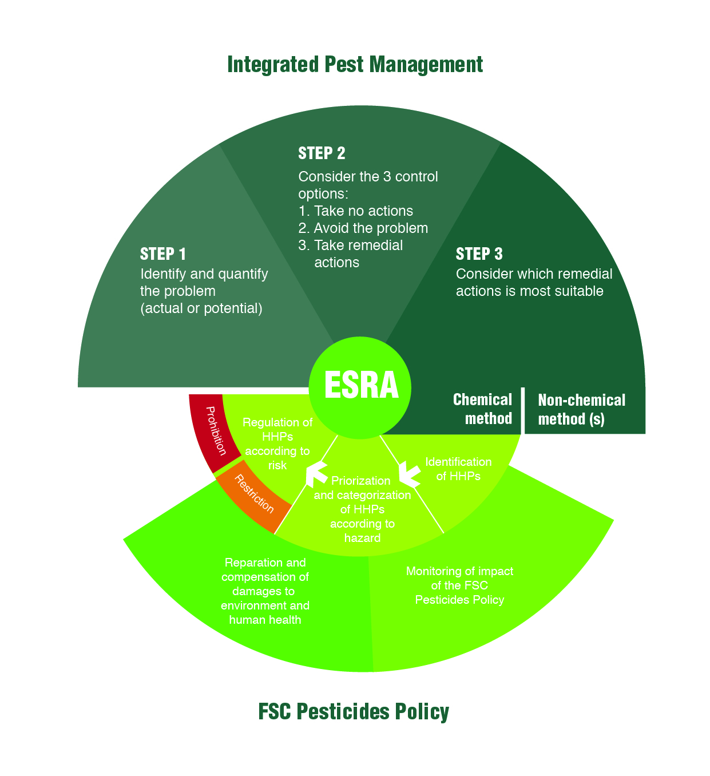

A Objective
Figure 1. Relation between the FSC Pesticides Policy and Integrated Pest Management.

The FSC Pesticides Policy lays out FSC’s position for managing the use of chemical pesticides in FSC-certified management units in consistency with Criterion 10.7 of FSC-STD-01-001 V5-2 FSC Principles and Criteria, which requires, inter alia, the use of integrated pest management.

The short-term objectives of the FSC Pesticides Policy are to:
- Promote best practices to minimize associated risks to human health and the environment when using chemical pesticides;
- Reduce the overall volume and number of chemical pesticides in use; and
- Eliminate the use of the most hazardous chemical pesticides.

The long-term aim of this Policy is to eliminate the use of chemical pesticides in the management unit.

B Scope

This Policy applies to FSC certified Organizations, Standard Development Groups and Certification Bodies and for the use of chemical pesticides within the management unit for the protection of vegetation, human health, livestock and native species, including, but not limited to, FSC-certified nurseries and other facilities.
Definition of management unit (MU) in FSC-STD-01-001 V5-2 FSC Principles and Criteria:
A spatial area or areas submitted for FSC certification with clearly defined boundaries managed to a set of explicit long-term management objectives which are expressed in a management plan. This area or areas include(s) all facilities and area(s):

- Within or adjacent to this spatial area or areas under legal title or management control of, or operated by or on behalf of The Organization, for the purpose of contributing to the management objectives; and

- Outside, and not adjacent to this spatial area or areas and operated by or on behalf of The Organization, solely for the purpose of contributing to the management objectives.
This Policy does not apply to:
- Third party nurseries;
- Area excised from the management unit;
- Biological control;
- Chemical pesticides used for other purposes than pest control in the management unit (e.g., as fertilizer);
- Impurities in fertilizer; and
- The use of chemical pesticides once the forest products have left the management unit.

C Effective and validity date
Approval date 13 March 2019
Publication date 1 May 2019
Effective date 1 August 2019
Period of validity Until replaced or withdrawn

The full implementation of the FSC Pesticides Policy requires the development of International Generic Indicators (IGIs) and their incorporation to national contexts.
There will be an interim period starting from the effective date of the Policy and lasting until the IGI are incorporated to national standards. The length of the interim period may vary between different countries, depending on the timeline for the development and approval of national indicators.
During the interim period:
- FSC-PRO-30-001 V1-0 EN Pesticides Derogation Procedure will be phased out and no new derogations applications will be processed.
- Existing approved derogations and their conditions will remain valid until their expiry date or until national HHP indicators become effective and replace the derogations.
If the expiry date of an existing approved derogations is before the end of the one-year transition period of the Policy document (as per FSC-PRO-01-001 V3-1 Development and revision of FSC normative documents), it will be extended until the end of this period.
- After the one year transition period of the Policy document, FSC prohibited HHPs shall not be used outside emergency situations or governmental orders.
- If an Organization identifies the need to use a FSC prohibited HHPs (in an emergency situation or by governmental order), a FSC highly restricted HHP, a FSC restricted HHP or other chemical pesticide and does not have a valid derogation for its use, they shall:
  - conduct an environmental and social risk assessment (ESRA) in accordance with this Policy.
  - incorporate to their ESRA the conditions from the more recent derogation approved in the country for that chemical pesticide, if there is one.
  - incorporate to the ESRA, the requirements from the most recent published draft of the IGI.

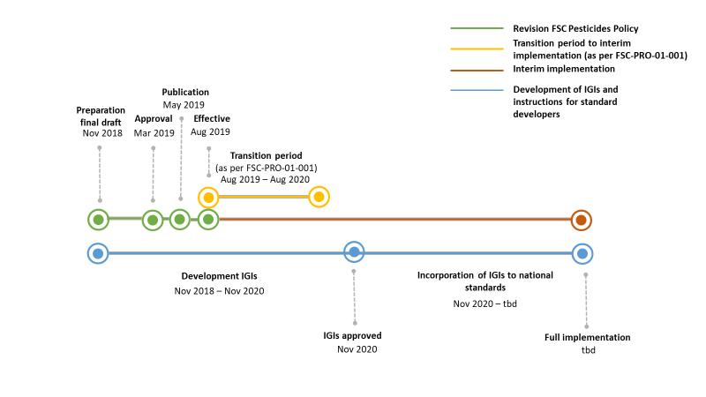
Figure 2. Transition process to revised FSC Pesticides Policy.

D References
The following referenced documents are relevant for the application of this Policy document. For undated references, the latest edition of the referenced document (including any amendments) applies.
FSC-STD-01-001 FSC Principles and Criteria.
FSC-STD-01-002 FSC Glossary of Terms.
FSC-STD-60-004 International Generic Indicators (IGI).

FSC normative documents superseded and replaced by this Policy:
FSC-STD-30-001 V1-0 EN Indicators and Thresholds for the identification of 'highly hazardous' pesticides (HHP).
FSC-STD-30-001a EN FSC List of 'highly hazardous' pesticides.
FSC-PRO-30-001 V1-0 EN Pesticides Derogation Procedure.
FSC-PRO-30-001a EN List of approved derogations for the use of "highly hazardous" pesticides.

E Terms and definitions
For the purposes of this Policy, the terms and definitions provided in FSC-STD-01-002 FSC Glossary of Terms, FSC-STD-01-001 V5-2 FSC Principles and Criteria for Forests Stewardship, FSC-STD-60-004 V2-0 FSC International Generic Indicators, and the following apply:

Active ingredient: part of the product that provides the pesticidal action (Source: FAO International Code of Conduct on Pesticide Management).

Biological control agents: organisms used to eliminate or regulate the population of other organisms (Source: Based on FSC-STD-01-001 V4-0 and World Conservation Union [IUCN]. Glossary definitions as provided on IUCN website).

Biopesticides: certain types of pesticides derived from such natural materials as animals, plants, bacteria, and certain minerals. (Source: United States Environmental Protection Agency)

Chemical pesticide: synthetically produced pesticide.

Emergency: a situation that requires immediate action to control the sudden invasion or infestation of a pest, which threatens either long-term stability of the ecosystem, human well-being or economic viability.

Events that happen cyclically and scenarios which are predicted through planning, monitoring or the application of an integrated pest management system cannot be considered an emergency.

For the purpose of the FSC Pesticides Policy, emergency situations require immediate action and cannot feasibly be controlled by a less hazardous alternative.

Environmental and social risk assessment (ESRA): a process to predict, assess and review the likely or actual environmental and social effects of a well-defined action, evaluate alternatives, and design appropriate mitigation, management and monitoring measures. In the context of the FSC Pesticides Policy, it relates to chemical pesticide use.

Facilities: infrastructure installations, including, but not limited to offices, workers' housing and warehouses. In the context of this Policy, there are differences between how ESRA is implemented in nurseries as compared to other type of facilities.

Fair compensation: remuneration that is proportionate to the magnitude and type of services rendered by another party or of the harm that is attributable to the first party (Source: FSC-STD-60-004 V1-0 EN International Generic Indicators)

Governmental order: the use of a specific chemical pesticide is ordered or carried out by governmental authorities independent of the Organization.

Highly hazardous pesticide (HHP): chemical pesticides that are acknowledged to present particularly high levels of acute or chronic hazards to health and environment according to internationally accepted classification systems, or are listed in relevant binding international agreements or conventions, or contain dioxins, or heavy metals.

In addition, pesticides that appear to cause severe or irreversible harm to health or the environment under conditions of use in a country may be considered to be and treated as highly hazardous (Source: Based on FAO International Code of Conduct on Pesticide Management).

FSC distinguishes between FSC prohibited HHPs, FSC highly restricted HHPs and
FSC restricted HHPs:
- FSC prohibited HHPs: chemical pesticides that: a) are listed or recommended for listing under Annex A (elimination) of the Stockholm Convention on Persistent Organic Pollutants or Annex III of the Rotterdam Convention on the Prior Informed Consent Procedure, or listed under the Montreal Protocol on Substances that Deplete the Ozone Layer, or b) are acutely toxic and that can induce cancer (carcinogenic and likely to be carcinogenic), or c) contain dioxins or d) contain heavy metals).

- FSC highly restricted HHPs: chemical pesticide presenting two or three out of the following hazards: acute toxicity, chronic toxicity and environmental toxicity.

- FSC restricted HHPs: chemical pesticide presenting one out of three of the following hazards: acute toxicity, chronic toxicity and environmental toxicity.

Integrated pest management (IPM): careful consideration of all available pest control techniques and subsequent integration of appropriate measures that discourage the development of pest populations, encourage beneficial populations and keep pesticides and other interventions to levels that are economically justified and reduce or minimize risks to human and animal health and/or the environment. IPM emphasizes the growth of a healthy forest with the least possible disruption to ecosystems and encourages natural pest control mechanisms (Source: Based on FAO International Code of Conduct on Pesticide Management).

The Organization: the person or entity holding or applying for certification and therefore responsible for demonstrating compliance with the requirements upon which FSC certification is based (Source: FSC-STD-01-001 V5-2 Principles and Criteria for Forest Stewardship).

Pest: any species, strain or biotype of plant, animal or pathogenic agent injurious to plants and plant products, materials or environments and includes vectors of parasites or pathogens of human and animal disease and animals causing public health nuisance (Source: FAO International Code of Conduct on Pesticide Management).

Pesticide: any substance, or mixture of substances of chemical or biological ingredients intended for repelling, destroying or controlling any pest, or regulating plant growth (Source: FAO International Code of Conduct on Pesticide Management).
This definition includes insecticides, rodenticides, acaricides, molluscicides, larvaecides, nematicides, fungicides and herbicides.

Repair: process of assisting the recovery of environmental values and human health.

Risk: the probability of an unacceptable negative impact arising from any activity in the management unit combined with its seriousness in terms of consequences (Source: FSC-STD-01-001 V5-2 Principles and Criteria for Forest Stewardship).

In the context of pesticide use, risk is the probability and severity of an adverse health or environmental effect occurring as a function of a hazard and the likelihood and the extent of exposure to a pesticide (Source: FAO International Code of Conduct on Pesticide Management).

Silviculture: the art and science of controlling the establishment, growth, composition, health and quality of forests and woodlands to meet the targeted diverse needs and values of landowners and society on a sustainable basis (Source: Nieuwenhuis, M. 2000. Terminology of Forest Management. IUFRO World Series Vol. 9. IUFRO 4.04.07 SilvaPlan and SilvaVoc).

Stakeholder: see definitions for ‘affected stakeholder’ and ‘interested stakeholder’:
- Affected stakeholder: any person, group of persons or entity that is or is likely to be subject to the effects of the activities of a Management Unit. Examples include but are not restricted to (for example in the case of downstream landowners), persons, groups of persons or entities located in the neighbourhood of the Management Unit.
The following are examples of affected stakeholders: local communities, Indigenous Peoples, workers, forest dwellers, neighbours, downstream landowners, local processors, local businesses, tenure and use rights holders, including landowners, organizations authorized or known to act on behalf of affected stakeholders, for example social and environmental NGOs, labor unions, etc. (Source: FSC-STD-01-001 V5-2 Principles and Criteria for Forest Stewardship).

- Interested stakeholders: any person, group of persons, or entity that has shown an interest, or is known to have an interest, in the activities of a Management Unit. The following are examples of interested stakeholders: conservation organizations, for example environmental NGOs; labour (rights) organizations, for example labour unions; human rights organizations, for example social NGOs; local development projects; local governments; national government departments functioning in the region; FSC National Offices; experts on particular issues, for example High Conservation Values. (Source: FSC-STD-01-001 V5-2 Principles and Criteria for Forest Stewardship).

Verbal forms for the expression of provisions
[Adapted from ISO/IEC Directives Part 2: Rules for the structure and drafting of International Standards]
“shall”: indicates requirements strictly to be followed in order to conform to the document.
“should”: indicates that among several possibilities one is recommended as particularly suitable, without mentioning or excluding others, or that a certain course of action is preferred but not necessarily required.
“may”: indicates a course of action permissible within the limits of the document.
“can”: is used for statements of possibility and capability, whether material, physical or causal.

F Version history

FSC-POL-30-601 Chemical Pesticides in Certified Forests: Interpretation of the FSC Principles & Criteria: Initial version. Approved by the FSC Board Pesticides Committee in July 2002.
FSC-POL-30-001 EN Pesticides Policy (2005) Approved in December 2005 at the 40th meeting of FSC Board of Directors.

FSC-POL-30-001 V3-0 EN Pesticides Policy Approved in March 2019 at the 80th meeting of the FSC Board of Directors.

Part I –Policy elements

FSC approach to the use of chemical pesticides
FSC-STD-01-001 V5-2 FSC Principles and Criteria, Criterion 10.7:
‘The Organization shall use integrated pest management and silviculture systems which avoid, or aim at eliminating, the use of chemical pesticides. The Organization shall not use any chemical pesticides prohibited by FSC policy. When pesticides are used, The Organization shall prevent, mitigate, and/or repair damage to environmental values and human health.’

  - FSC-STD-01-001 V5-2 FSC Principles and Criteria Criterion 10.7 requires the use of integrated pest management and silviculture systems which avoid, or aim to eliminate, the use of chemical pesticides.

  - FSC recognizes that in certain circumstances, and after having considered other available pest management strategies and practices, the use of chemical pesticides may be the only feasible way of controlling a pest, weed or disease problem.

  - The steps to reduce and eliminate the use of chemical pesticides, and to minimize associated risks to human health and the environment, are to:

- Identify highly hazardous pesticides (HHPs) according to their short and long-term toxicity characteristics.

- Prioritize these characteristics and categorize the HHPs into three hazard-based lists: Prohibited HHPs, Highly Restricted HHPs and Restricted HHPs.
- Regulate the use of HHPs in each list according to the risk they pose to human health and the environment.
- Repair and compensate for damage to environmental values and human health caused by inadequate development or implementation of environmental and social risk assessment.
- Monitor the use of pesticides and the impact of the FSC Pesticides Policy.
Risk = toxicity x exposure to humans and the environment

While toxicity is a fixed property of the active ingredient that is globally consistent, exposure is local and depends on how the pesticide is used.
Therefore risk can be reduced by minimizing exposure.
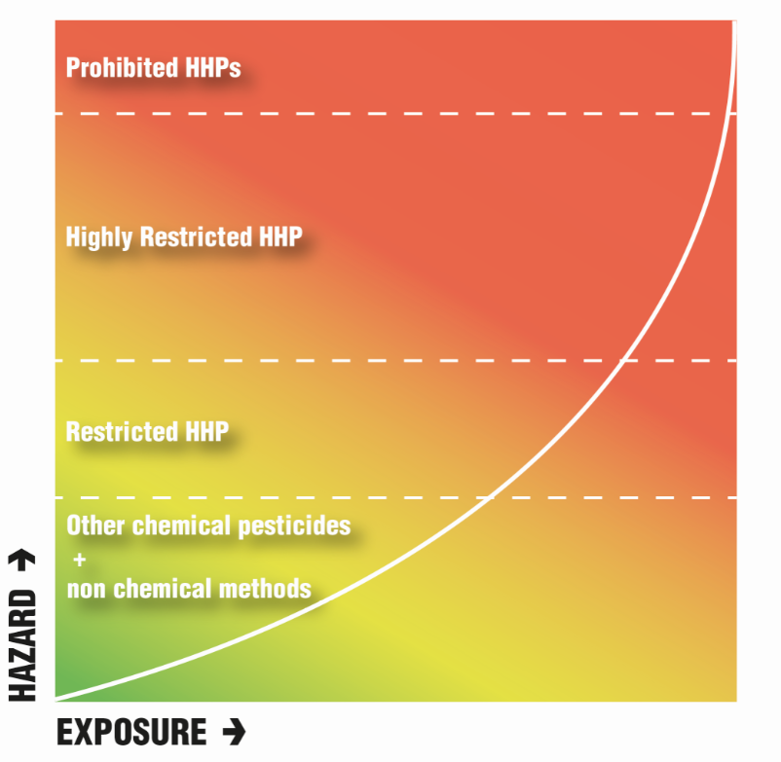

Part II – Implementing the Policy
Figure 3. Risk is a function of toxicity and exposure, and as it increases, The Organization shall intensify the activities undertaken to mitigate it.

Identification of HHPs

  - FSC identifies HHPs according to the following internationally recognized hazard criteria. Associated indicators and thresholds are listed in Annex 1.

- Relevant international agreements or conventions: legally binding international instruments put in place by the United Nations to lead to gradual decrease of the presence and trade of hazardous chemicals in the signatory Parties. This Policy considers:
- Stockholm Convention on Persistent Organic Pollutants.
- Rotterdam Convention on the Prior Informed Consent Procedure.
- Montreal Protocol on Substances that Deplete the Ozone Layer.

- Acute toxicity to mammals and birds: a substance causes harmful or lethal effects following oral, dermal or inhalation exposure in a short space of time.
Criterion b) represents the hazard group acute toxicity.
- Carcinogenicity: the ability of a substance to induce cancer or increase its incidence in humans.
- Mutagenicity: the ability of a substance to induce an increased occurrence of mutations in cells and/or organisms.
- Developmental and reproductive toxicity: the ability of a substance to cause adverse effects on unborn children and induce adverse effects on sexual function and fertility in adults.
- Endocrine disruptors: substances that interfere at very low concentrations with hormones and hormonal balance.
Criteria c) to f) represent the hazard group chronic toxicity, which contains substances that cause harmful effects over an extended period, usually following repeated or continuous exposure to very low doses.
- Aquatic toxicity: the effect of a substance to organisms – vertebrates, invertebrates and plants – living in the water.
- Persistence in soil or water: the ability of a substance to resist environmental degradation and accumulate in soil, sediment and aquatic environments.
- Soil sorption potential: a characteristic based on the combination of the persistence and the water solubility of a chemical substance, and its soil sorption coefficient (Koc), which measures the mobility of a substance in soil.
- Bioaccumulation: the increase in the concentration of a substance in a biological organism over time, as the organism absorbs the toxic substance at a rate greater than that at which the substance is eliminated from its body.
- Biomagnification: the increase of the concentration of a substance in the tissues of organisms as it travels up the food chain.
Criteria g) to k) represent the hazard group environmental toxicity, which contains substances that have harmful effects on the environment, threatening ecosystems and/or accumulating in water and soil.
- Dioxins (residues or emissions): persistent organic pollutants (POPs), that are highly toxic and can cause reproductive and developmental problems, damage the immune system, interfere with hormones and cause cancer, and
- Heavy metals (arsenic, cadmium, lead, and mercury): systemic toxicants known to induce multiple organ damage, even at lower levels of exposure.
  - The HHPs identified by FSC according to the criteria above and the associated indicators and thresholds are listed in the addendum to this Policy.

  - FSC will update the HHP lists considering the set of criteria, indicators and thresholds in Annex 1 at least every 3 years.

  - FSC shall annually review whether changes have occurred to the relevant international agreements or conventions (criterion 1 in Annex 1), or recommendations for listing new chemical pesticides have been made.
A chemical pesticide is recommended to be listed, when:
- the Persistent Organic Pollutants (POP) Review Committee has proposed to list it under Annex A (elimination) of the Stockholm Convention. (http://chm.pops.int/TheConvention/ThePOPs/ChemicalsProposedforListing/tabid/2510/Default.aspx)
- the Rotterdam Convention Chemical Review Committee has recommended to list it in Annex III of the Rotterdam Convention and submitted a Decision Guidance Document (DGD) to the Conference of the Parties (http://www.pic.int/TheConvention/Chemicals/RecommendedtoCOP/tabid/1185/language/en-US/Default.aspx)

  - If changes have occurred or new recommendations have been made, FSC shall update the FSC lists of HHP and re-categorize listed HHPs accordingly.

  - The implementation of the updated FSC lists of HHPs will follow the timeframes described in the table below.

Types of updates | Frequency | Process
Incorporate changes made to the relevant international agreements or conventions (criterion 1 in Annex 1).  This update may lead to a reclassification of HHPs but does not add new HHPs to the FSC HHP lists. | Every year | If changes have occurred, the HHP lists will be updated and effective immediately after publication.
Incorporate recommendations for listing new chemical pesticides in the relevant annexes of the Stockholm or Rotterdam conventions.  This update may lead to a reclassification of HHPs but does not add new HHPs to the FSC HHP lists. | Every year | If recommendations for listing new chemical pesticides have been made, the HHP lists will be updated.  Before it becomes effective, the FSC Board of Directors may agree on a plan for implementation (including timeframes) considering implications and potential impacts on forest operations.
Incorporate changes in the identification and classification of HHPs according to the criteria, indicators and thresholds in Annex 1.  This update may lead to the incorporation of new HHPs, exclusion of HHP or reclassification of HHPs. | At least every 3 years | If changes have occurred, the HHP lists will be updated and submitted to the FSC Board of Directors for decision making.
Review and if required revise the FSC Pesticides Policy, including the criteria, indicators and thresholds to identify HHPs and the FSC lists of HHPs.  This update may lead to the incorporation of new HHPs or exclusion or reclassification of HHPs. | Every 5 years | The review, revision and implementation of the updated FSC lists of HHPs will follow the timeframes described in FSC-PRO-01-001 V3-1 Development and revision of FSC normative documents.
Table 1. Types, frequency and process for updating FSC lists of highly hazardous pesticides

Prioritization of criteria and categorization of HHPs

  - FSC classifies HHPs into three categories based on prioritized hazard groups and criteria, as follows:

- FSC prohibited HHPs are chemical pesticides that:
- are listed or recommended for listing under Annex A (elimination) of the Stockholm Convention on Persistent Organic Pollutants or Annex III of the Rotterdam Convention on the Prior Informed Consent Procedure or listed under the Montreal Protocol on Substances that Deplete the Ozone Layer.
- are acutely toxic and can induce cancer (carcinogenic and likely to be carcinogenic); or,
- contain dioxins; or,
- contain heavy metals.

- FSC highly restricted HHPs: chemical pesticides that fall into two or three of the following hazard groups:
- acute toxicity.
- chronic toxicity.
- environmental toxicity.

- FSC restricted HHPs: chemical pesticides that fall into one of the following hazard groups:
- acute toxicity.
- chronic toxicity.
- environmental toxicity.

  - Chemical pesticides not included in the categories above, including biopesticides, are not considered highly hazardous by FSC.

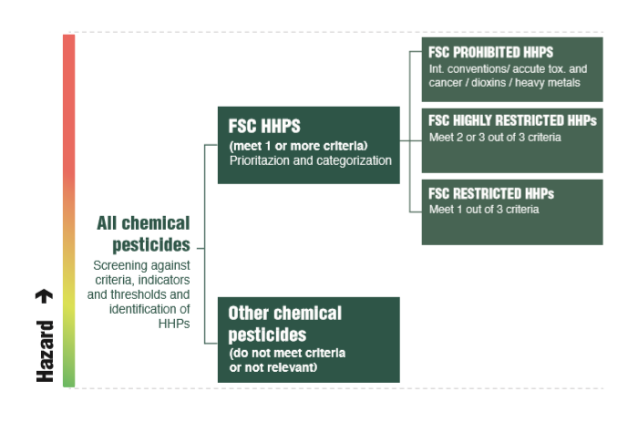
Figure 4. Classification of chemical pesticides

Figure 3. Classification of chemical pesticides and categorization of HHPs.

Regulation for the use of HHPs

General principles

  - The prioritization of criteria and categorization of HHPs results in the prohibition or restriction of their use according to the risk they pose to human health and the environment, with risk being a function of the toxicity, which is a global constant, and the local exposure.

  - In certain instances, a more hazardous alternative may present lower social and environmental risks than a less hazardous option.

  - An environmental and social risk assessment (ESRA) shall be undertaken by different stakeholders at international, national and management unit levels to identify:
- Lower risk alternatives,
- Conditions for chemical pesticide use; and
- Adequate mitigation and monitoring measures.

(See Table 2. Environmental and social risk assessment framework).

  - As risk increases, the efforts undertaken to reduce and mitigate the risk shall also increase.

  - Under the same conditions of effectiveness and risk, the less hazardous pest management alternative available shall be selected.

  - FSC considers the risk associated with using FSC prohibited HHPs to be unacceptable due to their high toxicity, even at low exposure.

  - The fact that a chemical pesticide is not included in the FSC lists of HHPs, does not mean that it is safe. Before using a chemical pesticide not listed in the FSC lists of HHPs, the Organization shall undertake environmental and social risk assessment (ESRA) as per Clause 4.12.2 and 4.12.6 below.

ESRA framework: role of FSC International

  - FSC will develop International Generic Indicators (IGI) for the use and risk management of HHPs for each hazard group in Annex 1.

  - The IGI shall consider:
- the exposure elements and variables described in Annex 2.
- research into less hazardous alternatives.
- engagement with interested and/or affected stakeholders.
- training requirements (FSC-STD-01-001 FSC Principles and Criteria V5-2, Criteria 2.5 and 4.3).
- monitoring requirements (FSC-STD-01-001 FSC Principles and Criteria V5-2, Criterion 8.2).
- use of personal protective equipment (FSC-STD-01-001 Principles and Criteria V5-2, Criterion 2.3).

ESRA framework: role of Standard Developers

  - Standard Developers (Standard Development Groups registered by FSC or certification bodies) shall incorporate the IGIs to the national context and develop locally relevant thresholds or conditions for the use of the relevant FSC Highly Restricted HHPs and FSC Restricted HHPs.

  - Standard Developers shall engage with stakeholders in this process as per FSC-STD-60-006 Process Requirements for the Development and Maintenance of National Forest Stewardship Standards and FSC-PRO-60-007 Structure, Content and Development of Interim National Standards.

ESRA framework: role of Organizations

  - The Organization shall:

- Give preference, as a matter of principle, to:
- non-chemical methods over chemical pesticides,
- chemical pesticides not listed in the FSC lists of HHPs over those listed in the FSC lists of HHPs, and
- FSC restricted HHPs over FSC highly restricted HHPs.

- Undertake a comparative ESRA according to scale, intensity and risk (SIR) as part of its integrated pest management to identify the lowest risk option to control a pest, weed or disease, the conditions for its use and the generic mitigation and monitoring measures to minimize the risks.

- Consider in their ESRA the minimum list of types of hazards, exposure elements and exposure variables described in Annex 2.

- Select the option that demonstrates least social and environmental damages, more effectiveness and equal or greater social and environmental benefits.

- Conform with the applicable international and national indicators and thresholds for the use of HHPs.

- Before applying any chemical pesticide, incorporate the results of their ESRA to site operational plans, to identify site-specific risks and adapt the generic mitigation and monitoring measures previously identified in the IPM ESRA (Clause 4.12.2).

- Make the ESRAs and incorporation to the operational plans available to affected stakeholders upon request.

- Consult the online FSC database for information exchange on alternatives and monitoring procedures.

- Have programmes in place, according to SIR, to research, identify and test alternatives to replace FSC highly restricted HHPs and restricted HHPs with less hazardous alternatives. Programmes shall have clear actions, timelines, targets and resources allocated.

- Engage with stakeholders in conformance with the requirements in the applicable National Forest Stewardship Standard or Interim National Standard when conducting ESRA.

- Not use any FSC Prohibited HHPs except in the case of an emergency situation or by governmental order. (See Annex 3. Procedure for use of FSC prohibited HHPs in case of emergency situations or governmental orders).

- Inform third-party processing plants located in the spatial area of the MU and third-party nursery suppliers of the list of FSC prohibited chemical pesticides, encouraging them to avoid these pesticides in their processes and in the production of seedlings and other materials entering the management unit.

- Request the list of FSC prohibited chemical pesticides used by processing plants and nurseries suppliers described in clause 4.12.12.

  - The Organization may:

- Collaborate with other Organizations with similar pest problems and forest conditions to conduct ESRA.

- Collaborate with research institutions and other Organizations on research programs for the identification of less hazardous alternatives.

TASKS | RESPONSIBLE ENTITY | TYPE OF PESTICIDES ASSESSED | PURPOSE | FREQUENCY | ENGAGEMENT REQUIREMENTS
International level
Identification and categorization of HHPs.  Provide minimum requirements for ESRA.  Development IGI for use and risk management of HHPs. | FSC | Hazard groups of highly hazardous pesticides (HHPs). | Provide a control framework to ensure consistency in the development of national indicators by SDGs.  Provide indicators for countries with no SDG. | Five-year review and revision cycle according to FSC-PRO-01-001 V3-1 EN Development and revision of FSC normative documents. | According to FSC-PRO-01-001 V3-1 EN Development and revision of FSC normative documents.
National level
Countries with SDG  Identify HR and R HHPs used or likely to be used in the country.  Conduct an overall risk assessment to identify and assess their risks.  Based on the risk assessment, determine whether or not a HR or R may be used in the country.  Develop National Indicators for the use and risk management of allowed HR and R using IGI as a starting point (except for those used in facilities different from nurseries or for research purposes).  SDGs may complete ESRA template to assist certificate holders, in particular smallholders, to conduct ESRA. | Standard Development Groups (SDGs) | Highly Restricted (HR) HHPs  and  Restricted (R)  HHPs  Highly Restricted (HR) HHPs  and  Restricted (R)  HHPs | Confirm list of HR and R HHPs allowed for use in the country.  Establish conditions for their use.  Assist CHs ESRA if the ESRA template is used. | Revise as new information becomes available, or otherwise review and revise consistent with FSC-STD-60-006 (V1-2) EN Process requirements for the development and maintenance of National Forest Stewardship Standards. | FSC-STD-60-006 (V1-2) EN Process requirements for the development and maintenance of National Forest Stewardship Standards.
Countries with no SDG  Adopt IGI or  Adopt National Indicators from country with similar forests and pesticide use, upon approval of FSC. | Certification Bodies (CBs) |  | Incorporate conditions for use and risk management of relevant HR and R. | Review and revise consistent with FSC-PRO-60-007 V1-1 EN Structure, content and development of interim national standards | FSC-PRO-60-007 V1-1 EN Structure, content and development of interim national standards
Management unit level
Conduct risk assessment as part of the  integrated pest management (IPM) system according to SIR (including those used in facilities or for research purposes).  CHs may use the ESRA template to complete ESRA at the MU level, or demonstrate that ESRA requirements have been followed if other company systems are in place to meet the requirements (without completing the template). Under similar conditions, ESRA may be transferable between certificate holders at national level.  Conform with the applicable international and national indicators and thresholds for the use of HHPs. | Certificate holders (CH) | All chemical pesticides | Identify the lowest risk option to control a pest, weed or disease problem.  Identify additional or specific mitigation measures required to control MU/site specific risks.  Assist SDG ESRA if the ESRA template is used. | Review and revise, if needed, in five-year certificate cycle. | According to the requirements for stakeholder engagement in the relevant national standard.
Site level
Incorporate ESRA results to operational plans or prescriptions.  Implement mitigation measures. | Certificate holders (CH) | All chemical pesticides | Control risks when using a chemical pesticide. | Linked to the duration of the operation. | According to the requirements for stakeholder engagement in the relevant national standard.
Table 2. Environmental and social risk assessment framework

Repairing damages to environmental values and human health from the use of chemical pesticides

  - The Organization shall:

    - Prioritize risk prevention and mitigation over damage repair and compensation.

    - Repair damages according to their magnitude, in consistency with Criterion 6.3 of FSC-STD-01-001 FSC Principles and Criteria V5-2, regarding environmental damage and Criterion 2.6 regarding occupational injuries.

    - Provide fair compensation when reparation is not possible; and

    - Develop mechanisms for resolving grievances and for providing fair compensation to workers and local communities, consistent with Criterion 2.6 and Criterion 4.6 of FSC-STD-01-001 FSC Principles and Criteria V5-2.

Monitoring of the use of chemical pesticides and the impact of the FSC Pesticides Policy.

6.1 The Organization shall maintain records of chemical pesticide usage, including:
- Trade name,
- Active ingredient,
- Quantity of active ingredient used,
- Period of use,
- Number and frequency of applications,
- Location and area of use and
- Reason for use.

  - FSC will monitor, evaluate and regularly report on the impact of the FSC Pesticides Policy, in particular on the trends in the number, amount and frequency of HHPs used per area unit and in the injuries and accidents rates related to chemical pesticide use.

Annex 1. Criteria, Indicators and Thresholds for identifying highly hazardous pesticides (HHPs)

- Criteria to determine the hazard of chemical pesticides.
FSC has selected the following criteria to determine the hazard rating of chemical pesticides:
Hazard group | Number | Criteria
Relevant International Agreements or conventions | 1 | Relevant International Agreements or conventions
Acute toxicity | 2 | Acute toxicity to mammals and birds
Chronic toxicity | 3 | Carcinogenicity
 | 4 | Mutagenicity to mammals
 | 5 | Developmental and reproductive toxicity
 | 6 | Endocrine disrupting chemical (EDC)
Environmental toxicity | 7 | Acute toxicity to aquatic organisms
 | 8 | Persistence in soil or water and soil sorption potential and bio-magnification and bio-accumulation
Dioxins | 9 | Dioxins (residues or emissions)
Heavy metals | 10 | Heavy metals
Table 3. Hazard groups and criteria for the identification of highly hazardous pesticide.

These internationally recognized criteria, as well as the associated indicators and thresholds are based on:

- Use of Chemical Pesticides in Certified Forests: clarification of FSC Criteria 6.6, 6.7 and 10.7 (S. Radosevich, M. Lappé & B. Addlestone (2000) FSC-US).
- Review of the Forest Stewardship Council’s Pesticide Indicators and Thresholds (2005) by Pesticides Action Network (PAN) UK.
- The results of the revision processes conducted by a panel of experts in 2007 and 2013.

The global criteria selected to identify highly hazard pesticides were initially established by the World Health Organization (WHO) and Food and Agriculture Organization of the United Nations (FAO) in 2007 and included: acute toxicity, chronic health hazards (carcinogenicity according to the Global Harmonized System of Classification and Labelling of Chemical (GHS) evaluation, reproductive and mutagenic effects) as well as high incidence of severe or irreversible adverse effects on human health or the environment.

To make them workable, PAN further developed these criteria, and added the following indicators: fatal if inhaled, carcinogenic and probably carcinogenic according to International Agency for Research on Cancer (IARC) / US Environmental Protection Agency (EPA) and endocrine disrupting chemicals.

FSC has added firstly two additional criteria: dioxins and heavy metals and secondly, the indicator: acute toxicity for rats and birds.

The indicators and thresholds selected by FSC are benchmarked by the best science available and by international authorities, including the World Health Organization (WHO), US Environmental Protection Agency (EPA) and the Globally Harmonized System (GHS) followed by extensive consultation with social, environmental and economic stakeholders.

Criteria, indicators and thresholds for the identification of FSC highly hazardous pesticides (HHPs)
Hazard Group | Criteria | Indicators and thresholds for the identification of FSC highly hazardous pesticides (HHPs) | Sources of information
RELEVANT INTERNATIONAL  AGREEMENTS OR CONVENTIONS | Criterion 1. Relevant International Agreements or conventions | - A pesticide is considered ‘highly hazardous’ if it is:  - Banned by international agreement under the Persistent Organic Pollutants (POP) convention (Stockholm Convention), or  - Listed in Annex III of the Rotterdam Convention on the Prior Informed Consent (PIC) Procedure for Certain Hazardous Chemicals and Pesticides in International Trade, or  - Listed as ozone depleting substance under the Montreal Protocol on Substances that Deplete the Ozone Layer. | - Stockholm Convention on Persistent Organic Pollutants (POPs) at http://www.pops.int  - Rotterdam Convention on the Prior Informed Consent (PIC) Procedure for Certain Hazardous Chemicals and Pesticides in International Trade  at http://www.pic.int  - Montreal Protocol on Substances that Deplete the Ozone Layer at http://ozone.unep.org/
ACUTE TOXICITY | Criterion 2. Acute toxicity to mammals and birds | - A pesticide is considered ‘highly hazardous’ if it contains any active ingredient that is:  - ‘Extremely hazardous’ (Class Ia) or ‘Highly hazardous’ (Class Ib), according to World Health Organization (WHO) Recommended Classification of Pesticides by Hazard, or  - Acutely toxic for rats and birds: acute oral LD50 for rats/birds ≤ 200 mg/kg body weight (or most sensitive mammal/bird), or  - ‘Fatal if inhaled’ (H330) according to the Globally Harmonized System of Classification and Labelling of Chemicals as classified by national/ international authorities. | - WHO & IPCS: The WHO recommended classification of pesticides by hazard and guidelines to classification. International Programme on Chemical Safety (IPCS) & World Health Organization (WHO). Geneva.  - The FOOTPRINT Pesticide Properties DataBase: http://sitem.herts.ac.uk/aeru/footprint/index2.htm  - The Pesticide Manual British Crop Protection Council (BCPC): https://www.bcpc.org/  - Regulation (EC) No 1272/2008 of The European Parliament and of the Council of 16 December 2008 on classification, labelling and packaging of substances and mixtures, amending and repealing Directives 67/548/EEC and 1999/45/EC, and amending Regulation (EC) No 1907/2006 and its amendments and other national legislation implementing the GHS

Hazard Group | Criteria | Indicators and thresholds for the identification of FSC highly hazardous pesticides (HHPs) | Sources of information
CHRONIC TOXICITY | Criterion 3. Carcinogenicity | - A pesticide is considered ‘highly hazardous’ if it contains any active ingredient that is in any of the following categories by classification systems:  - Group 1: ‘The agent (mixture) is carcinogenic to humans’ or Group 2A: ‘The agent (mixture) is probably carcinogenic to humans’, according to the International Agency for Research on Cancer (IARC), or  - Group A (Carcinogenic to Humans) (1986 Guidelines) or Group B (Probably Carcinogenic to Humans) (1986 Guidelines) or Known/Likely human carcinogen (1996 Guidelines) or Carcinogenic to humans (1999 and 2005 Guidelines-current) or Likely to be carcinogenic to humans (1999 and 2005 Guidelines - current), according to the US Environmental Protection Agency (EPA) Carcinogenicity Classification, or  - Category IA (Known to have carcinogenic potential for humans) or category IB (Presumed to have carcinogenic potential for humans), as classified by national/ international authorities according to classification for carcinogens of the Global Harmonized System of Classification and Labelling of Chemicals (GHS). | - US EPA: Chemicals Evaluated for Carcinogenic Potential. Office of Pesticide Programs, U.S. Environmental Protection Agency (US EPA).  - IARC: Agents reviews by the IARC Monographs. Volumes 1-102 International Agency for Research on Cancer (IARC), Lyon, France  - Regulation (EC) No 1272/2008 of The European Parliament and of the Council of 16 December 2008 on classification, labelling and packaging of substances and mixtures, amending and repealing Directives 67/548/EEC and 1999/45/EC, and amending Regulation (EC) No 1907/2006 and its amendments and other national legislation implementing the GHS.
CHRONIC TOXICITY | Criterion 4. Mutagenicity to mammals | - A pesticide is considered ‘highly hazardous’ if it contains any active ingredient that is in any of the following categories:  - Category IA (Substances known to induce heritable mutations in germ cells of humans) or Category IB (Substances which should be regarded as if they induce heritable mutations in the germ cells of humans), as classified by national/ international authorities according to the classification for mutagenicity of the Global Harmonized System of Classification and Labelling of Chemical (GHS). | - Regulation (EC) No 1272/2008 of the European Parliament and of the Council of 16 December 2008 on classification, labelling and packaging of substances and mixtures, amending and repealing Directives 67/548/EEC and 1999/45/EC, and amending Regulation (EC) No 1907/2006 and its amendments and other national legislation implementing the GHS.
 | Criterion 5. Developmental and reproductive toxicity | 5.1 A pesticide is considered ‘highly hazardous’ if it contains any active ingredient that is in any of the following categories:  - Category IA (Known human reproductive toxicant) or Category IB (Presumed human reproductive toxicant), as classified by national/ international authorities according to the classification for reproductive toxicants of the Global Harmonized System of Classification and Labelling of Chemical (GHS). | - Regulation (EC) No 1272/2008 of the European Parliament and of the Council of 16 December 2008 on classification, labelling substances and mixtures, amending and repealing Directives 67/548/EEC and 1999/45/EC, and amending Regulation (EC) No 1907/2006 and its amendments and other national legislation implementing the GHS.
CHRONIC TOXICITY | Criterion 6. Endocrine disrupting chemical (EDC) | 6.1 A pesticide is considered ‘highly hazardous’ if it contains any active ingredient that is classified as:  - Category 1 (Substances for which endocrine activity have been documented in at least one study of a living organism) according to the EU list of potential endocrine disruptors, or  Category 2 (Suspected human carcinogens) of the classification for carcinogens of the GHS⁶ AND Category 2 (Suspected human reproductive toxicant) of the classification for reproductive toxicants of the Global Harmonized System of Classification and Labelling of Chemical (GHS). | - EC (2000): Towards the establishment of a priority list of substances for further evaluation of their role in endocrine disruption – preparation of a candidate list of substances as a basis for priority setting, European Commission, Delft.  - EC (2004): Commission Staff Working Document SEC (2004) 1372 on implementation of the Community Strategy for Endocrine Disrupters – a range of substances suspected of interfering with the hormone systems of humans and wildlife (COM (1999) 706), European Commission, Brussels.  - EC (2007): Commission staff working document on the implementation of the "Community Strategy for Endocrine Disrupters" – a range of substances suspected of interfering with the hormone systems of humans and wildlife (COM (1999) 706), (COM (2001) 262) and (SEC (2004) 1372), SEC(2007).  - Regulation (EC) No 1272/2008 of the European Parliament and of the Council of 16 December 2008 on classification, labelling and packaging of substances and mixtures, amending and repealing Directives 67/548/EEC and 1999/45/EC, and amending Regulation (EC) No 1907/2006 and its amendments and other national legislation implementing the GHS.
ENVIRONMENTAL TOXICITY | Criterion 7. Acute toxicity to aquatic organisms | 7.1. A pesticide is considered ‘highly hazardous’ if it contains any active ingredient that:  - has aquatic toxicity LC50/EC50 < 50 μg/l, using Daphnia as the test organism or other invertebrate or vertebrate aquatic organisms that show greater sensitivity than Daphnia. Acute test duration up to 96 hours. | - The FOOTPRINT Pesticide Properties DataBase:  http://sitem.herts.ac.uk/aeru/footprint/index2.htm  - The Pesticide Manual British Crop Protection Council (BCPC):  https://www.bcpc.org/
 | Criterion 8. Persistence in soil or water and low sorption potential  and  Bio- magnification, bio-accumulation | 8.1 A pesticide is considered ‘highly hazardous’ if it contains any active ingredient that is considered:  - Persistent (DT50> 90 days), combined with  - Low soil sorption coefficient (Koc < 300ml/g),  and/or,  - High water solubility (> 30mg/l)  and  8.2. it has the potential to accumulate in animal/human tissue:  - Bio-concentration factor (BCF) for the active ingredient is ≥ 1000, or  - Octanol-water partition coefficient (KOW) for the active ingredient is > 1000 i.e. logP (KOW) > 3  Note: BCF data shall supersede the logP (KOW) data. | - The FOOTPRINT Pesticide Properties DataBase:  http://sitem.herts.ac.uk/aeru/footprint/index2.htm  - The Pesticide Manual British Crop Protection Council (BCPC):  https://www.bcpc.org/
DIOXINS | Criterion 9. Dioxins (residues or emissions) | 9.1 A pesticide is considered ‘highly hazardous’ if:  - it is contaminated with any dioxins at a level of 10 part per trillion (corresponding to 10 ng/kg) or greater of tetrachlorodibenzo-pdioxin (TCDD) equivalent (TEQ), or it produces such an amount of dioxin(s) when burned. | - Stockholm Convention and national monitoring data
HEAVY METALS | Criterion 10. Heavy metals | 10.1 A pesticide is considered ‘highly hazardous’ if it contains any of the following heavy metals as active ingredient, inert or known impurity:  - lead (Pb), or  - cadmium (Cd), or  - arsenic (As), or  - mercury (Hg) | - The Pesticide Manual British Crop Protection Council (BCPC):  https://www.bcpc.org/
Table 4. Criteria, indicators and thresholds for the identification of FSC highly hazardous pesticides (HHPs).

Annex 2. Minimum list of hazards, elements and variables to consider in the assessment of environmental and social risks.

This annex provides:
- the minimum types of hazards, exposure elements and exposure variables to be considered by FSC, Standard Development Groups registered by FSC and Organizations to identify and assess the risks of chemical pesticide use.
- a guidance template to assist Standard Development Groups and Organizations conducting ESRA.

a) Minimum requirements for ESRA

Hazard identification

The first step in the risk assessment is to identify the type and nature of adverse effects associated with chemical pesticide use. Once the hazards are identified, proper measures can be taken to eliminate them.
To identify and assess the risks of using a chemical pesticide, the following hazards shall be considered at a minimum:

Hazard group | Types of hazard
Acute toxicity | Toxic by contact or ingestion
 | Toxic by inhalation
Chronic toxicity | Carcinogenicity
 | Mutagenicity to mammals
 | Developmental and reproductive toxicity
 | Endocrine disruption
Environmental toxicity | Acute toxicity to aquatic organisms
 | Persistence in soil and water
 | Biomagnification and bioaccumulation
Table 5. Groups and types of hazards

- Exposure Characterization

The second step in the risk assessment is to conduct the exposure characterization to analyse how different values are affected by chemical pesticide use.
The exposure characterization considers:
- Environmental and social values that can be affected by exposure to chemical pesticides; and
- Exposure variables that influence the level of exposure.

  - Exposure elements

Exposure elements are types of values that may be negatively affected by chemical pesticide use.

At a minimum the following environmental values, with specific components in brackets, shall be considered to identify and assess the risks of chemical pesticide use:
- Soil (erosion, degradation, biota, carbon storage).
- Water (ground water, surface waters, water supplies).
- Atmosphere (air quality, greenhouse gasses).
- Non-target species (vegetation, wildlife, bees and other pollinators, pets).
- Non-timber forest products (as FSC-STD-01-001 V5-2 FSC Principles and Criteria, criterion 5.1).
- High Conservation Values (particularly HCV 1-4)
- Landscape (aesthetics, cumulative impacts)
- Ecosystem services (water, soil, carbon sequestration, tourism).
At a minimum the following social values, with specific components in brackets, shall be considered to identify and assess the risks of chemical pesticide use.
These social values should be considered with regards to workers, including migrant and seasonal workers, workers’ families, neighbours, local communities, Indigenous Peoples and visitors to the forest.
- High Conservation Values (especially HCV 5-6)
- Health (fertility, reproductive health, respiratory health, dermatologic, neurological and gastrointestinal problems, cancer and hormonal imbalance);
- Welfare;
- Food and water;
- Social infrastructure; (schools and hospitals, recreational infrastructure, infrastructure adjacent to the management unit),
- Economic viability (agriculture, livestock, tourism); and
- Rights (legal and customary).

  - Local exposure variables

The conditions of chemical pesticide use affect the level of exposure. To reduce the risk of chemical pesticide use, the following variables, at a minimum, shall be considered:
- Formulation (type and components).
- Mixture of active ingredients (composition and mixing process).
- Concentration of the active ingredient(s).
- Dose of the active ingredient(s).
- Frequency and interval of application.
- Scale of treatment area.
- Method of application (e.g., spot, foliar, spray, aerial, broadcast)
- Application system and equipment (e.g., knapsack sprayer, helicopter, drone, plane)
- Number of previous applications.
- Metabolites of the active ingredient.
- Capacity and skills of workers (license to handle pesticides, training, ability to read and understand labels and instructions).
- Personal protective equipment.
- Emergency related equipment (e.g., first aid, spill kits).
- Site conditions (e.g., soil type, topography of the area).
- Predicted weather and climatic conditions (e.g., wind speed and direction, temperature, humidity).
- Spray drift.
- Waste management systems.
- Information available to neighbours about pesticide application (e.g., risks associated with pesticide use, re-entry period after application).
b) Guidance template for completing Environmental and Social Risk Assessment

Standard Development Groups shall conduct overall risk assessments to identify risks of using certain HHPs and to develop indicators for the use and risk management.

Organizations shall complete the ESRA at the management unit level to identify the lowest risk option to control a pest, weed or disease problem.

This template has been designed as a tool to support the ESRA. While an ESRA shall be completed to include the elements listed in this Annex, use of this template is not mandatory.

The template outlines the risk factors to be identified and mitigated:
- Hazard – the type of hazard the chemical pesticide presents (e.g. toxicity by contact or ingestion, carcinogenicity),
- Exposure elements – the environmental and social values that may be affected by the chemical pesticide (e.g. water quality, human health) and
- Exposure variables – the characteristics of the chemical pesticide application (e.g. concentration, application method),
- In addition, a description of the associated risks and the mitigation strategies to minimize them shall be included.

Additional hazards, exposure elements and/or exposure variables may be identified to reflect the operational, environmental and social circumstances within which the chemical pesticide is being applied.

ESRA Instructions

When completing the ESRA at the site level it is important to consider for each chemical pesticide:
- The scale of the operation: What area is being treated?
- The intensity of the operation: Is the entire area being treated? Are other areas nearby also being treated?
- The hazard represented: How toxic is the chemical pesticide to non-target values? Are high-risk values likely to be affected given the application method used?
- Local conditions: This includes environmental, social and regulatory aspects. How does the environment of the area to be treated affect the choice of chemical pesticide(s) and/or application methods? Are there people living nearby and/or do they use the area to be treated for recreation, for NTFPs collection purposes? How do regulatory requirements affect the choice of chemical pesticide(s) and/or application methods?

ESRA template

This template may be used by SDGs and Organizations in their Environmental and Social Risk Assessment (ESRA), and by certification bodies as a check list to assess conformance with the minimum requirements for ESRA.

Date
Country
Proposed chemical pesticide |  | Purpose of use  (protection of vegetation, logs, human health, livestock, native species, seeds or seedlings, weed control, others)

Identification and assessment of risk – function of toxicity and exposure- and mitigation strategies to minimize it
Exposure Elements | Minimum list of values | Hazard groups and types of hazards |  |  |  |  |  |  |  |  | Description of why/why not a risk | Mitigation strategies defined to minimize risk
 |  | Acute toxicity |  | Chronic toxicity |  |  |  | Environmental toxicity
 |  | Toxic by contact or ingestion | Toxic by inhalation | Carcinogenicity | Mutagenicity to mammals | Developmental and reproductive toxicity | Endocrine disruption | Acute toxicity to aquatic organisms | Persistence in soil and water | Biomagnification -bioaccumulation
Environ-mental | Soil (erosion, degradation, biota, carbon storage)
 | Water (ground water, surface waters, water supplies)
 | Atmosphere (air quality, greenhouse gasses)
 | Non-target species (vegetation, wildlife, bees and other pollinators, pets)
 | Non-timber forest products (as FSC-STD-01-001 V5-2 FSC Principles and Criteria, criterion 5.1)
 | High Conservation Values (particularly HCV 1-4)
 | Landscape (aesthetics, cumulative impacts)
 | Ecosystem services (water, soil, carbon sequestration, tourism)
Social | High Conservation Values (especially HCV 5-6)
 | Health (fertility, reproductive health, respiratory health, dermatologic, neurological and gastrointestinal problems, cancer and hormonal imbalance)
 | Welfare
 | Food and water
 | Social infrastructure; (schools and hospitals, recreational infrastructure, infrastructure adjacent to the management unit)
 | Economic viability (agriculture, livestock, tourism)
 | Rights (legal and customary)
 | Others

Exposure variables
The following minimum list of exposure variables shall be considered when describing the mitigation strategies in the table above:
- Formulation (type and components).
- Mixture of active ingredients (composition and mixing process).
- Concentration of the active ingredient(s).
- Dose of the active ingredient(s).
- Frequency and interval of application.
- Scale of treatment area.
- Method of application (e.g., spot, foliar, spray, aerial, broadcast)
- Application system and equipment (e.g., knapsack sprayer, helicopter, drone, plane)
- Number of previous applications.
- Metabolites of the active ingredient.
- Capacity and skills of workers (license to handle pesticides, training, ability to read and understand labels and instructions).
- Personal protective equipment
- Emergency related equipment (e.g., first aid, spill kits)
- Site conditions (e.g., soil type, topography of the area)
- Predicted weather and climatic conditions (e.g., wind speed and direction, temperature, humidity).
- Spray drift.
- Waste management systems
- Information available to neighbours about pesticides application (e.g., risks associated with pesticide use, re-entry period after application).

Annex 3. Procedure for the exceptional use of FSC prohibited HHPs

This procedure describes the requirements for the use of FSC prohibited Highly Hazardous Pesticides (HHP) in emergency situations or by government orders, consistent with section 4.12.11 It also defines the respective roles of Organizations and Certification Bodies.
4.12.11 The Organization shall not use any FSC prohibited HHPs except in the case of an emergency situation or by governmental order.

- Prior to using a FSC prohibited HHP, the Organization shall provide a written notification to the certification body that includes:
  - The intent to use a FSC prohibited HHP
  - A rationale for its use.

- Within thirty (30) days of starting the use, the Organization shall submit a report to the certification body providing:
  - A rationale for the need to use the FSC prohibited HHP,
  - A site specific environmental and social risk assessment (ESRA) consistent with Clause 4.12,
  - Control measures for identified risks,
  - Training and monitoring in place to prevent, minimize and mitigate impacts and
  - A description of the review processes of c) and d).

- The Organization shall conform with the International Generic Indicators (IGI) applicable to the hazard(s) that the FSC prohibited HHP presents.

- The Organization shall conform with the requirements of the applicable national standard related to training, monitoring, use of personal protective equipment, research and engagement with interested and/or affected stakeholders.

- In emergency situations, a comparative ESRA shall be completed and demonstrate that the pest or disease problem cannot feasibly be controlled by a less hazardous alternative.

- Certification bodies supported by independent pesticides technical experts shall assess conformance with the requirements for emergency or governmental orders.

- Non-compliance with these requirements for FSC prohibited HHPs shall result in a major non-conformity and the corresponding corrective action request, including measures for repairing damages to environment or human health.

- If the certification body finds intentional non-conformance with these requirements for the use of prohibited HHPs, the certificate shall be suspended, which in accordance to FSC-STD-20-001 (V4-0) General Requirements for FSC Accredited Certification Bodies may lead to the withdrawal of the certificate.

- The certification body shall include in the public summary reports annual records of the use of FSC prohibited HHPs in emergency situations or by governmental orders.

Annex 4. Procedure to implement policy requirements for ESRA framework at national level

This procedure describes how Standards Developers shall use Annex 2 to establish the conditions for the use highly restricted and restricted HHPs at national level.

This procedure applies in countries with and without Standard Development Groups.

ESRA in countries with Standard Development Groups (SDGs)

- For each restricted and highly restricted HHPs used or likely to be used in the country (except for those used in facilities or for research purposes), SDGs shall conduct an overall environmental and social risk assessment considering Annex 2 to identify and assess key environmental and social risks.

- Based on the risk characterization in the assessment, SDGs shall determine whether or not the HHP may be used at the national level.

- For each highly restricted and restricted HHP permitted for use, SDGs shall develop indicators and locally relevant thresholds for its use at the national level.

- As a starting point, SDGs shall consider the international generic indicators, to be developed by FSC.

- The indicators shall consider the scale, intensity and risk (SIR) of the Organization and of pesticide use. As the risk to social and environmental values increases, so too shall the frequency and intensity of stakeholder engagement, monitoring, research activities and mitigation measures.

- To conduct the assessment and develop indicators, SDGs shall consider:
  - Information in chemical labels,
  - Material safety data sheets (MSDS),
  - Existing national or regional level risk assessments undertaken by regulatory agencies, and
  - Conditions for derogations approved in the country when applicable.

- The national indicators shall:
- When possible, define circumstances where a highly restricted HHPs may be used instead of a restricted HHP.
- Be submitted to FSC for decision making in accordance with FSC-STD-60-006 Process Requirements for the Development and Maintenance of National Forest Stewardship Standards.

ESRA in countries without Standard Development Groups (SDGs)

- Certification bodies shall adopt the International Generic Indicators (IGI) for the use of chemical pesticides.

- Upon approval by FSC, national indicators and locally relevant thresholds for the use and risk management of highly restricted and restricted pesticides from a country with similar pest problems and forest conditions, shall be used.

European Union
The mitigation strategies will be developed considering at least the minimum list of exposure variables below

