

Procedure
Disclosure Requirements for Association with FSC
FSC-PRO-10-004 V2-0

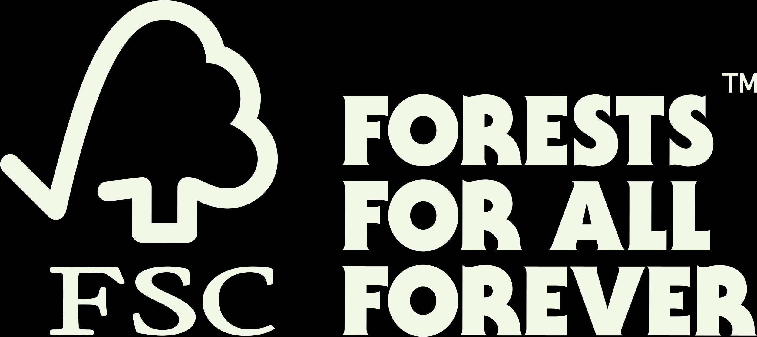

Title: | Disclosure Requirements for Association with FSC
Dates: | Approval date: 26 August 2022
Contact for comments: | FSC Global Development – Dispute Management  Adenauerallee 134  53113 Bonn  Germany  Phone: +49 -(0)228 -36766 -0  Fax: +49 -(0)228 -36766 -65  Email: dispute.resolution@fsc.org

Version control
Publication date: | 4 October 2022
Effective date: | 1 July 2023
Version | Description | Date
V1-0 | Initial version, an internal operating procedure based on an associated* organization’s self-declaration. | 01/01/2015
V2-0 | The first public version of the procedure. It includes requirement to declare commitment to the Policy for Association and to disclose background information for further screening by FSC and outlines a high-level process for screening of the information. | 01/07/2023

® 2022 Forest Stewardship Council, A.C. All Rights Reserved
FSC® F000100
You may not distribute, modify, transmit, reuse, reproduce, re-post or use the copyrighted materials from this document for public or commercial purposes, without the express written consent of the publisher. You are hereby authorized to view, download, print and distribute individual pages from this document subject for informational purposes only.

CONTENTS
Introduction 4
Objective 4
Scope 4
References 5
1. Applicant background disclosure 6
2. Notification 6
3. Review 6
4. Action and consequences based on disclosure process 6
Annex 1: Disclosure questions for association with FSC 7
Annex 2: Outline of screening process 8
Annex 3: Terms and definitions 9
Verbal forms for the expression of provisions 9

Introduction
FSC-POL-01-004 Policy for Association is an expression of the values shared by individuals and organizations associated* with FSC. It defines six unacceptable activities that associated* individuals and organizations and their corporate group* commit to avoid in both certified and non-certified operations.
This document describes the process used by FSC to screen individuals and organizations applying for association* with FSC for conformance with the Policy for Association. The intention of the procedure is to reduce the risk of establishing or maintaining association* with an organization in violation of the Policy for Association and its corporate group*.
The risk management approach taken in this procedure aims to balance the need for proactive implementation of Policy for Association while recognizing that it cannot place undue burden on or create a disincentive for individuals and organizations committed to the values of FSC through association*. It therefore places a strong emphasis on these disclosure requirements. The screening process will be rapid and highly automated. A detailed extended assessment will be made only if clear indication of high risk for engagement in unacceptable activities defined in the Policy for Association is identified.
Conformance with the Policy for Association is overseen by FSC, unlike for example forest management, chain of custody, and controlled wood certification that is based on contractual agreements between the organization and the certification body. FSC therefore implements this Disclosure Procedure. If a certification body finds evidence or observes actions that point to a possible violation of Policy for Association, the certification body is responsible for informing both the organization and FSC of such information.

Objective
The objective of this procedure is to reduce the risk to FSC of establishing or maintaining an association* with an individual or organization and its corporate group* in violation of the Policy for Association by providing a screening mechanism for conformity with Policy for Association.

Scope
This procedure is implemented by FSC and is applied to both applicant FSC members (for FSC International membership) and applicant certificate holders.
This procedure focuses on screening the risk that an individual, organization, or its corporate group* has been engaged in any of the six unacceptable activities defined in Policy for Association through their operations. The procedure supplements the assessment process for forest management, chain of custody, and controlled wood certification.
The procedure will be implemented in a multi-step approach: In the first phase, as of the effective date, it shall apply to individuals and organizations applying for FSC certification or FSC membership. In a subsequent stage, and after a formal review of its effectiveness it is envisaged that the scope will be extended to organizations when applying for re-certification (for certificate holders) and membership renewal (for members). When such a decision is taken, the scope section will be revised accordingly.

References
The following references are relevant for the application of this document. For references without a version number, the latest version of the referenced document (including any amendments) applies.

FSC-POL-01-004 | Policy for Association
FSC-PRO-01-009 | Processing FSC Policy for Association Complaints

Applicant background disclosure
  - The applicant shall complete a background questionnaire and a declaration of commitment to Policy for Association as part of their application process.
  - As part of the background questionnaire, the applicant shall disclose information related to their organization and their corporate group*. Examples of required information is listed in Annex 1.
  - Upon completion of the background questionnaire, the applicant may pursue FSC certification and/or membership, unless immediate risk to violation of Policy for Association has been identified.

Notification

  - FSC shall make the names of all applicants publicly available on the FSC webpage on a monthly basis.
  - If a stakeholder provides substantial information* that an applicant or associated* individual or organization is in violation of Policy for Association, then FSC-PRO-01-009 Processing FSC Policy for Association Complaints shall be followed.

Review
  - FSC may review the background information provided (see 1.1.), using a combination of risk profiling services tools such as Controlled Wood National Risk Assessments and others.
  - The criteria to trigger an extended review could include but is not limited to following:
- Connection to a disassociated* organization as part of the corporate group*.
- Previous legal findings confirming engagement with any of the unacceptable activities defined in the Policy for Association.
- Operating in high-risk areas or high-risk sectors (based on existing risk identification tools) when risk mitigation measures are not clear.
- Track record of previously unsuccessful applications of association* with FSC.
- Unclear, incomplete, or inaccurate information provided.
NOTE: The specific risk criteria will be developed in another process establishing the detailed process and tools to support disclosure and screening.

Action and consequences based on disclosure process

  - Failure to disclose all required information may be grounds for the initiation of an evaluation in accordance with FSC-PRO-01-009 Processing FSC Policy for Association Complaints.
  - If the screening produces substantial information* that the individual or organization may be in violation of the Policy for Association, then the procedure FSC-PRO-01-009 Processing FSC Policy for Association Complaints shall be initiated, and the association* decision delayed until the process has been completed.
  - The individual or organization shall be given the opportunity to withdraw the application if they do not want to move forward with the evaluation.

Annex 1: Disclosure questions for association with FSC
Below are examples of information FSC would ask organizations to provide. The questions are used for screening by FSC based on risk management systems. Not all questions may be relevant for or asked from all applicants.
    - Current status and type of association*
    - Type of association* applied for
    - Size of the corporate group*
    - Corporate structure of the corporate group*
    - Countries of forest and forest products sector operations of the corporate group*
    - Sectors of operations of the corporate group*
    - Affiliation or other corporate relationship with any currently disassociated* organization
    - Previous decisions on disassociation* or blocks from the FSC system and their status
    - Previous applications for association* or membership that was not granted
    - Current or past legal proceedings confirming engagement with any of the unacceptable activities defined in Policy for Association from last 5 years
    - Types of due diligence systems used (if any)
    - Other
Some questions might trigger additional questions for further clarification or skipping other questions to move directly to end if further information is not required.

Annex 2: Outline of screening process

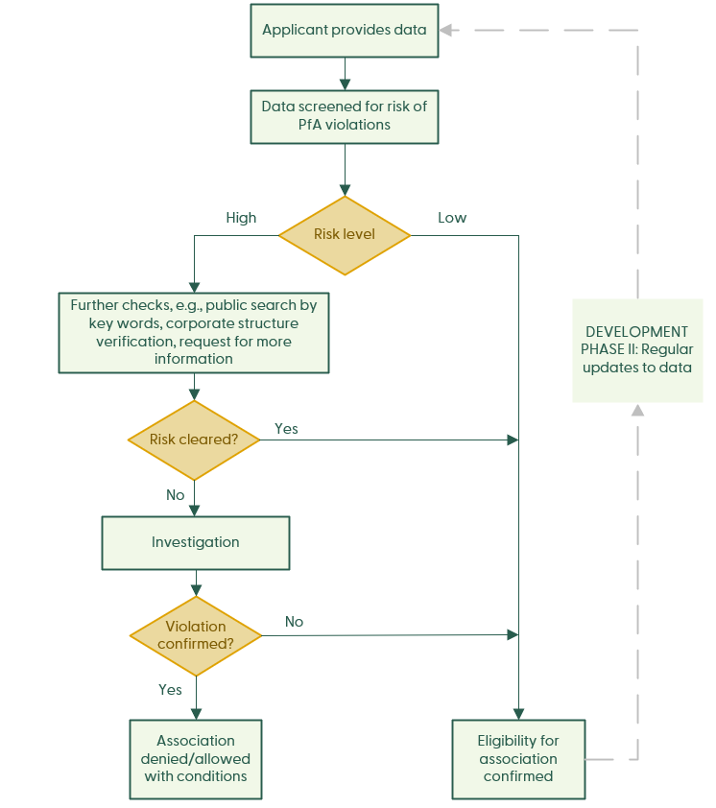

Annex 3: Terms and definitions
For the purposes of this procedure, the terms and definitions given in FSC-POL-01-004 Policy for Association, FSC-STD-01-002 FSC Glossary of Terms and the following apply:
Association (associated, associate, associated organization): An association with FSC is formally established through any of the following contractual relationships: FSC membership agreement; FSC certificate holder license agreement; FSC certification body license agreement; FSC partnership agreement.
Corporate group: The totality of legal entities to which an associated* organization is affiliated in a corporate relationship in which either party controls the performance of the other (e.g. parent or sister company, subsidiary, holding company, joint venture, etc.) as described in FSC-POL-01-004 Policy for Association.
Disassociation (disassociated): The termination of all existing contractual relationships (member and license) between FSC and the associated* individual, organization and corporate group*. Disassociation also prevents entry into any new contractual relationships with FSC.
Substantial information: Credible information provided by third parties and/or gathered through independent research obtained from reliable/renowned sources which constitutes a solid piece of evidence to be considered in an investigation. Substantial information may include any of the following forms so long as the evidence meets the criteria required in this definition: scientific reports, technical analysis, certification reports, corroborated news articles, official reports and/ or announcements by governmental authorities, legal analysis, Geographic Information System information (boundary coordinates, satellite change mapping), videos or footage, images, independent interviews, affidavits and declarations, meeting minutes, and corporate/organizational information.

Verbal forms for the expression of provisions
[Adapted from ISO/IEC Directives Part 2: Rules for the structure and drafting of International Standards]
“shall”: indicates requirements strictly to be followed in order to conform to the document.
“should”: indicates that among several possibilities one is recommended as particularly suitable, without mentioning or excluding others, or that a certain course of action is preferred but not necessarily required.
“may”: indicates a course of action permissible within the limits of the document.
“can”: is used for statements of possibility and capability, whether material, physical or causal.



FSC Global Development – Dispute Management
Adenauerallee 134
53113 Bonn
Germany

Phone: +49 -(0)228 -36766 -0
Fax: +49 -(0)228 -36766 -65
Email: dispute.resolution@fsc.org

