







Procedure

FSC-PRO-30-011 V1-0

Published: 17 May 2022
Page 1 of 21 Continuous Improvement Procedure
FSC-PRO-30-011 V1-0

Title: | Continuous Improvement Procedure
Dates: | Approval date: | 15 March 2022
Contact for comments: | FSC International – Performance and Standards Unit Adenauerallee 134
 | 53113 Bonn
 | Germany
 | Phone: +49 -(0)228 -36766 -0
 | Fax: +49 -(0)228 -36766 -65
 | Email : psu@fsc.org



Publication date: | 17 May 2022
Effective date: | 17 August 2022

® 2022 Forest Stewardship Council, A.C. All Rights Reserved FSC® F000100
You may not distribute, modify, transmit, reuse, reproduce, re-post or use the copyrighted materials from this document for public or commercial purposes, without the express written consent of the publisher. You are hereby authorized to view, download, print and distribute individual pages from this document subject for informational purposes only.


FSC seeks to improve access to, and uptake of, the FSC system by communities and owners of small forests. The FSC system consists of common Principles and Criteria (P&C) for the certification of all management units globally, regardless of their size, ownership, socioeconomic conditions, or types of forest systems.

Despite the application of the concepts of scale, intensity, and risk (SIR) and small or low intensity managed forest (SLIMF) in the FSC normative framework, for small-scale and community forests, particularly in tropical countries, conformity with FSC requirements is still a big challenge and involves a large investment compared to the economic benefit that FSC certification may offer to them.

To overcome some of these challenges, FSC has developed this Continuous Improvement Procedure (CIP). The development of the CIP responds to an FSC members mandate from motion 46 passed on the General Assembly held in 2017 in Vancouver, Canada, and it aims to contribute to the FSC goals described in the FSC Global Strategy (2021-2026).

The CIP follows a risk-based approach, which allows for a stepwise approach to certification for SLIMF and community forests based on an international assessment of risk (the categorization of Core Criteria (CC) and Continuous Improvement Criteria (CIC) and low-risk designation to certain criteria) and local considerations (active and inactive forest management units). It is also arguably outcome-oriented, as it focuses on delivering on the most impactful criteria in the context of small-scale and community forests, while leading to full conformance with the P&C.

Figure 1: Continuous Improvement concept.
The CIP concept distinguishes between Core Criteria (CC) and Continuous Improvement Criteria (CIC) that shall be conformed with in different points in time. The CIP user shall meet the CC and have an Action Plan to obtain FSC certification at the initial stage of the process. To maintain certification, the CIC shall be met in accordance with the path established in the Action Plan during the first certification cycle comprised of 5 years or, in case of group members, during the first 5 years of the group membership.

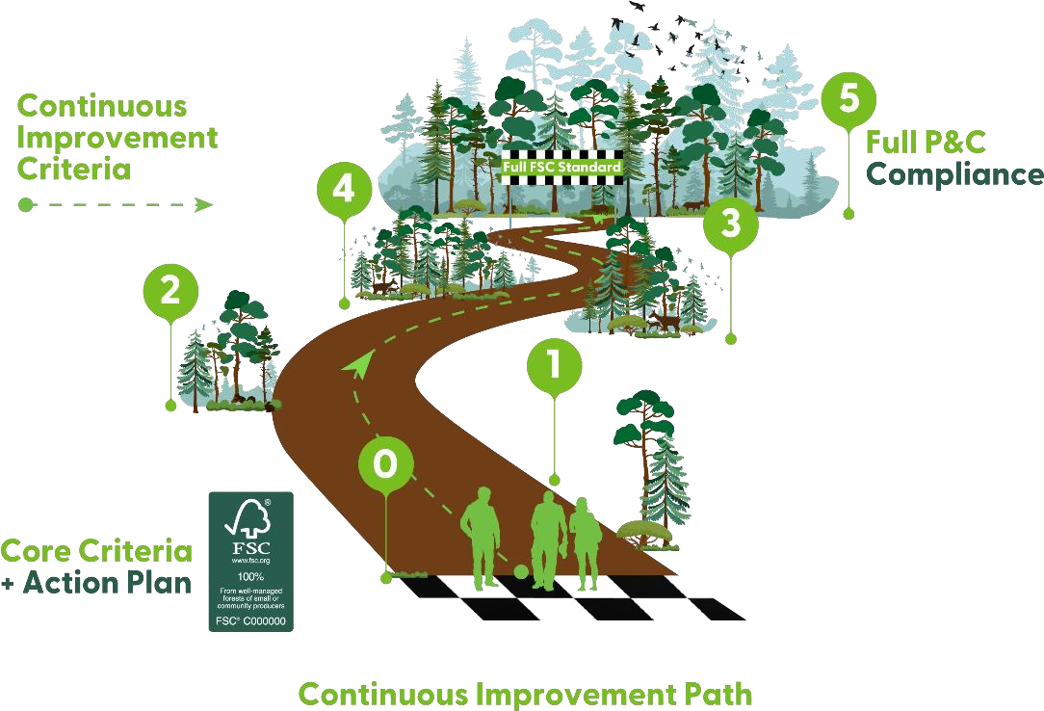



A Objective 5

B Scope 5

C Effective and validity date 5

D References 5

E Terms and definitions 6

PART I: Requirements for Continuous Improvement Procedure (CIP) users 10
- Application to use the CIP 10
- Initial Conformity Self-Check 10
- Action Plan development 10
- Action Plan Implementation 13
- Self-Monitoring 14
- Applying the Continuous Improvement concept in forest management groups 16

PART II: Requirements for certification bodies 18
- General requirements 18
- Application 18
- Main evaluation 18
- Surveillance evaluation 18
- Non-conformities 19
- Auditing of CIP users in a forest management group 19

Annexes 20
- Annex 1: Initial Conformity Self-Check format (available in excel) 20
- Annex 2: Action Plan format (available in excel) 20
- Annex 3: Specifications for Local Experts 20



The objective of this procedure is to provide a flexible way for The Organization managing small or low intensity managed forest (SLIMF) or community forests, within or outside a group, to access FSC forest management certification, by conforming to the applicable FSC standard progressively throughout the first certification cycle comprised of five (5) years or, in case of group members, the first 5 years of the group membership.


This procedure is for use throughout the first certification cycle comprised of five (5) years or, in case of group members, the first 5 years of the group membership by:
  - Part I: The Organization managing SLIMF or community forests, within or outside a group.
  - Part II: FSC-accredited certification bodies (CB)
All aspects of this procedure from section A onward are considered normative, including the scope, effective and validity dates, references, terms and definitions, notes, tables, and annexes, unless otherwise stated. The content of the information boxes is NOT normative.

Approval date: 15 March 2022
Publication date: 17 May 2022
Effective date: 17 August 2022
Period of validity: Until replaced or withdrawn.


The following referenced documents are relevant for the application of this document. For undated references, the latest edition of the referenced document (including any amendments) applies.
FSC-STD-01-001 FSC Principles and Criteria for Forest Stewardship FSC-STD-01-002 FSC Glossary of Terms
FSC-STD-01-003 SLIMF Eligibility Criteria
FSC-STD-20-007 Forest Management Evaluations
FSC-STD-20-001 General requirements for FSC accredited certification bodies FSC-STD-30-005 Forest Management Groups Standard
FSC-PRO-60-010 Incorporating a risk-based approach in National Forest Stewardship Standards

FSC normative documents replaced by this version of the procedure
FSC-POL-10-003 Modular Approaches for Forest Certification



For the purposes of this procedure, the terms and definitions provided in FSC-STD-01-002 FSC Glossary of Terms, and the following apply:
Action Plan: A written document that specifies the time by when the different criteria from the applicable FSC standard will be implemented by the CIP user during the first certification cycle comprised of five (5) years or, in case of group members, during the first 5 years of the group membership.
Action Plan Cycle: Five (5) year timeframe for Action Plan implementation.
Active management unit: A management unit in which site-disturbing activities are planned to take place prior to the next evaluation to be conducted by the certification body. Source: Adapted from FSC- STD-30-005 V2-0.
Audit team: Is made up of one or more auditors, one of whom is appointed to be the audit team leader. In case of CIP user evaluations, the team is integrated by a local expert. When necessary, audit teams are also supported by technical experts, and/or further personnel (e.g., interpreter), who assist auditors but do not themselves act as auditors. Source: Adapted from FSC-STD-01-002
Applicable FSC standard: In the context of this procedure, this term is used to refer to the approved forest stewardship standard(s) of a country or region. These can be Interim National/Regional Standard(s) or National/Regional Forest Stewardship Standard(s)¹. Adapted from FSC-STD-30-005 V2-0.
Certification cycle: The period of validity of FSC certification (usually five years).
CIP user: The Organization managing SLIMF or community forests (within or outside a group) obtaining FSC forest management certification through the application of the CIP.
Community forest: In the context of this procedure a management unit that conforms with the following tenure AND management criteria:
Tenure: The legal right to manage the forest management unit (e.g., title, long-term lease, concession) is held at the communal level, AND i) the community members must be either Indigenous Peoples or Traditional Peoples, OR ii) the forest management unit meets the SLIMF eligibility criteria.
Management: The forest management unit is managed actively by a community through a concerted effort (e.g., under a communal forest management plan) OR the community authorizes management of the forest by others (e.g., resource manager, contractors, forest products company).
If the community authorizes management of the forest by others, i. and either ii. or iii. of the following must be met:
- The community’s own representative institution has legal responsibility for the harvesting operations, AND
- The community performs the harvesting operations OR
- The community’s own representative institution is responsible and has the control over the forest management decisions and follows and monitors the operations.
NOTE: The community forest can be either located in a communal forest and/or on individually assigned plots, as long as the right to use the forest is communally held (e.g., this is the case for Mexican ejidos, Brazilian sustainable development reserves). Source: Adapted from FSC-STD-01-002.

1 See FSC-PRO-60-007 Structure, Content and Development of Interim National Standards for the definition of “Interim National Standard”, “Interim Regional Standard” and “National Forest Stewardship Standard”.

Continuous Improvement Criteria (CIC): Criteria from the FSC Principles and Criteria (P&C) whose conformity is required according to the Action Plan within the first certification cycle or, in case of group members, the first 5 years of the group membership. Conformity with CIC designated as low-risk is not required to be demonstrated in case of inactive management units.
Continuous Improvement Procedure (CIP): FSC procedure that allows its users to achieve FSC forest management certification based on conformity to only a subset of the requirements of the applicable FSC standard, offering flexible steps towards full conformity with all the remaining requirements within the first certification cycle or, in case of group members, the first 5 years of the group membership.
Core Criteria (CC): Criteria from the FSC P&C whose conformity is indispensable in the initial stage of CIP application. Conformity with the CC shall be demonstrated during the main evaluation to obtain FSC forest management certification. Conformity with CC designated as low-risk is not required to be demonstrated in case of inactive management units.
Inactive management unit: A management unit in which no site-disturbing activities are planned to take place prior to the next evaluation to be conducted by the CB.
Initial Conformity Self-Check: A self-assessment of the initial situation (baseline) and the level of conformity with the indicators of the applicable FSC standard performed by The Organization. The initial conformity self-check is voluntary but highly recommended.
Indigenous Peoples: People and groups of people that can be identified or characterized as:
    - The key characteristic or criterion is self-identification as Indigenous Peoples at the individual level and acceptance by the community as their member.
    - Historical continuity with pre-colonial and/or pre-settler societies.
    - Strong link to territories and surrounding natural resources.
    - Distinct social, economic, or political systems.
    - Distinct language, culture, and beliefs.
    - Form non-dominant groups of society.
    - Resolve to maintain and reproduce their ancestral environments and systems as distinctive peoples and communities.
(Source: Adapted from United Nations Permanent Forum on Indigenous Issues, Factsheet ‘Who are Indigenous Peoples’ October 2007; United Nations Development Group, ‘Guidelines on Indigenous Peoples’ Issues’ United Nations 2009, United Nations Declaration on the Rights of Indigenous Peoples, 13 September 2007) Source: FSC-STD-01-001 V5-2.
Local expert: A person with proven knowledge and practical experiences of the specific local context, culture, language and living conditions of Indigenous or Traditional Peoples or smallholders who supports the audit team but does not act as auditor. This person participates in on-site and hybrid audits and their role is to collect information and evidence on behalf of the auditor and to contribute to the use of culturally adapted audit techniques and appropriate communication between, and the learning process of, the audit team and the auditee. The local expert may inform and advise the CIP user about content required to conform with the applicable FSC standard but is not allowed to provide consultancy and directly support activities to conform with the FSC standard requirements.
Self-Monitoring: A monitoring of the Action Plan implementation to conform with the applicable FSC standard conducted by the CIP user. In case of forest management groups, it can be conducted by the group entity.
Site-disturbing activities: Forest management activities with a risk of adversely impacting any value of the forest, including economic, environmental and/or social values. Source: FSC-STD-30-005 V2-0.

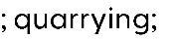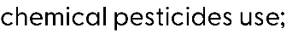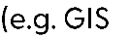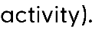

→

→

→
→
→
→
→
→
→
→

→
→

→

→
→
→
→

SLIMF (Small or low intensity managed forest): A forest management unit which meets specific FSC requirements related to size and/or intensity. Source: FSC-STD-20-012 V1-1.
Traditional Peoples: Traditional Peoples are social groups or peoples who do not self-identify as Indigenous and who affirm rights to their lands, forests and other resources based on long established custom or traditional occupation and use (Source: Forest Peoples Program (Marcus Colchester, 7 October 2009). Source: FSC-STD 01-001 V5-2.

NOTE:
Part I describes the requirements for The Organization that qualify as CIP user to obtain FSC forest management certification. This part is only applicable in the first certification cycle. In the case of group certifications, the CIP is applicable during all certification cycles, but within the group, it can only be used by each management unit during the first 5 years of the group membership. After the first 5 years, management units that have been applying the CIP must have conformed with all requirements of the applicable FSC standard.
Part II contains the additional requirements to FSC-STD-20-007 Forest Management Evaluations that certification bodies must conform with when evaluating organizations that are applying this procedure. Subsequently, these requirements will be incorporated into FSC-STD 20-007 Forest Management Evaluations.

Any part of the process to obtain FSC forest management certification that is not explicitly mentioned in this procedure will follow the regular process for FSC forest management certification.




  - The Organization shall request the use of this procedure during its application for FSC forest management certification to a certification body (CB).
  - The request to apply the CIP are subject to approval by the CB.

NOTE: The FSC-STD-01-003 SLIMF Eligibility Criteria is currently under revision and defining both SLIMF and community forest. When both definitions are approved and effective, they will become valid for defining CIP users. Certificate holders using the CIP who may then no longer be covered by the new definition may continue to use the CIP during their first certification cycle.






  - The CIP user should carry out an initial conformity self-check to analyse their situation (baseline) and level of conformity with the indicators of the applicable FSC standard.
  - The initial conformity self-check should be carried out by following the corresponding template in Annex 1.
  - If the CIP user wants the results of the initial conformity self-check to be used by the CB for the preparation of the main evaluation, the results shall be sent to the CB at least thirty (30) days prior to the main evaluation.

NOTE: Although voluntary, it is strongly recommended to carry out an initial conformity self-check, as it can serve to gain a detailed understanding of the requirements of the FSC standard and to prepare for the certification process, as well as contribute to the development of the mandatory Action Plan. In addition, the Self-Check Report could fasten the work of the CB and thus could reduce the evaluations costs.
NOTE: The Conformity Self-Check Template is an example drawn up based on the FSC Principles and Criteria (P&C), but for greater accuracy of the assessment it must be adapted to the applicable FSC standard. Also, any other template can be used.




  - The CIP user shall develop an Action Plan by taking into consideration the criteria classification as prescribed in Table 1 where the applicable FSC standard is based on the P&C V5, or as prescribed in Table 2 where the applicable FSC standard is based on the P&C V4.

Table 1: Categorization of criteria of the FSC P&C V5 (FSC-STD-01-001 V5-2)

Principle | Core Criteria | Continuous Improvement Criteria | Low-risk Criteria
1 | 2, 3, 5, 6, 7, 8 | 1, 4
2 | 1, 3, 4, 6 | 1, 5 | 3
3 | 1, 2, 3, 4 | 5, 6
4 | 1, 2, 6 | 3, 4, 5, 7, 8
5 | 2 | 1, 3, 4, 5
6 | 1, 2, 3, 4, 5, 7, 9, 10 | 6, 8 | 2, 3, 5
7 | 1 | 2, 3, 4, 5, 6
8 | 5 | 1, 2, 3, 4
9 | 1 | 2, 3, 4 | 1, 2, 3, 4
10 | 1, 2, 3, 4, 5, 7, 8, 10, 11 | 6, 9, 12 | 1, 2, 3, 4, 5, 7, 8, 10, 11
TOTAL | 38 | 32 | 17

Table 2: Categorization of criteria of the FSC P& C V4 (FSC-STD-01-001 V4-0)

Principle | Core Criteria | Continuous Improvement Criteria | Low-risk Criteria
1 | 1, 2, 3, 4, 6 | 5
2 | 1, 2, 3
3 | 1, 2 | 3, 4
4 | 2, 3, 5 | 1, 4 | 2
5 | 3, 6 | 1, 2, 4, 5 | 3
6 | 1, 2, 4, 5, 6, 8, 9, 10 | 3, 7 | 1, 4, 5, 6, 8, 9
7 |  | 1, 2, 3, 4
8 | 3 | 1, 2, 4, 5
9 | 1 | 2, 3, 4 | 1, 2, 3, 4
10 | 1, 2, 3, 4, 5, 6, 7, 8, 9 |  | 1, 2, 3, 4, 5, 6, 7, 8
TOTAL | 34 | 22 | 20

  - The CIP user shall develop the Action Plan by following the corresponding template in Annex 2.
NOTE: In case of groups, the group entity is responsible for developing one or more Action Plan(s) and monitoring the Action Plan implementation of the CIP users in its group.

  - In the Action Plan the CIP user:
    - Shall specify what constitutes active and inactive management units in its context, with justification;
    - Shall specify, as much as possible, when site-disturbing activities will be carried out during the action plan cycle;
    - May suggest the non-applicability of criteria to its management unit;
    - Shall specify in which year which criteria of the applicable FSC standard shall be implemented, by applying the following rules:
Core Criteria (CC)
      - If the management unit is planned to be active during any of the first three (3) years of the action plan cycle, conformity with all CC shall be demonstrated in the main evaluation.
      - If the management unit is planned to be inactive throughout the first three (3) years of the action plan cycle, conformity with the CC designated as low-risk is not required to be demonstrated in the main evaluation.
Continuous Improvement Criteria (CIC)
      - 50% of the CIC shall be implemented from year one (1) to year three (3) of the action plan cycle; the remaining 50% of the CIC shall be implemented in year four (4) and five
(5) of the action plan cycle.
      - In inactive management units, conformity with the CIC designated as low risk is not required to be demonstrated.
  - The CIP user shall share the Action Plan with the CB at least thirty (30) days before the main evaluation.
  - The Action Plan is subject to approval by the CB during the main evaluation.

NOTE: Once certification has been achieved, the CIP user has full access to the labels, trademarks, and marketing options as any other organization that has achieved FSC forest management certification.

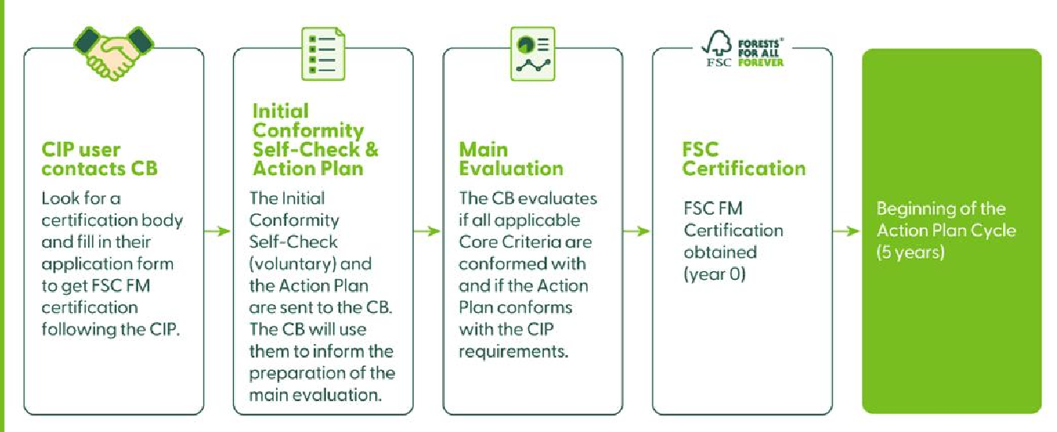


  - The CIP user shall conform with all CC and CIC according to the timeline established in the approved Action Plan.
  - If the CIP user for any reason is unable to implement all planned criteria for a given year, the Action Plan shall be adapted and the delay together with a justification shall be communicated as early as possible to the CB.
  - If the CIP user is to undertake site-disturbing activities not considered in the initial planning, the CB shall be informed of the changes as early as possible; the Action Plan shall be adapted in the way that the CIP user conforms with the low-risk criteria prior to conducting site-disturbing activities.
  - All changes to the Action Plan are subject to approval by the CB.

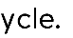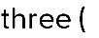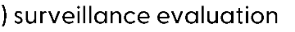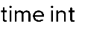





  - The CIP user shall implement a self-monitoring in year one (1), two (2) and four (4) of the action plan cycle and prepare a report including the following information:
    - Information on the implementation of the Action Plan during the previous twelve (12) months; evidence of conformity with the criteria set out in the Action Plan.
    - Information and evidence on actions taken to address any non-conformities.
    - Information on whether there are stakeholder complaints and whether they have been addressed according to the mechanism for resolving grievances established by the CIP user (according to Criteria 1.6., 2.6. and 4.6. of the FSC P&C) and the status of the complaint’s resolution process.
    - Whether any site-disturbing activities are planned in the coming twelve (12) months that were not included in the Action Plan.
  - The CIP user shall send the Self-Monitoring Report together with supporting evidence to the CB on a date agreed with the CB.

NOTE: In case of groups, the self-monitoring can be carried out by the group entity or by the group member.

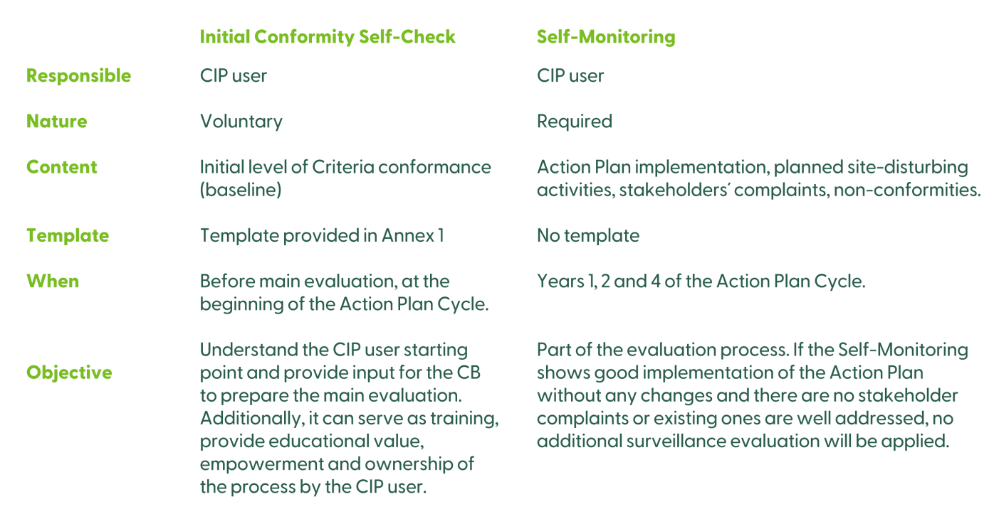



  - The group entity shall establish specific rules in its management system to ensure conformance with this procedure.
  - Before adding a new member to the group, the group entity shall evaluate each applicant wishing to apply the CIP to ensure that there are no major non-conformities with the applicable CC of the applicable FSC standard and that the applicant is committed to implementing the Action Plan.
  - In cases where not all members of the group apply this procedure, in order to differentiate those who use the CIP from those who do not, one or more subgroups shall be established with the members who apply this procedure.
  - The group entity shall define how new members who apply the CIP can be incorporated in the group, using the following options:
    - New management units can only be added to the group when a new certification cycle begins, and all new members will start at the year zero (0) of the action plan cycle;
OR
    - New management units can join the group at any year of the certification cycle. In this case one or both of the following options can be implemented:
      - The group entity shall form a subgroup and all its members start in year zero (0) of the action plan cycle.
      - New management units can join a group or subgroup at a year different than year zero
(0) of the action plan cycle. In this case the group entity shall verify that the applicant conforms with all requirements corresponding to the year of action plan cycle in which the applicant will join the group or subgroup.
  - The group entity shall develop an Action Plan in accordance with Section 3 of this procedure.
    - As far as possible all group members using the CIP should follow the same Action Plan.
    - When the group entity considers it essential to have different Action Plans for different group members, the same Action Plan shall be followed by all subgroup members.
  - The group entity shall keep a register of the subgroups, their members and the action plan versions used by each subgroup
  - The group entity shall have sufficient capacity and resources to manage the implementation of this procedure and the option chosen.
NOTE: It is recommended that a group does not form more than one subgroup during a certification cycle, as this may increase the cost and complexity of the evaluations.
  - The group entity shall include the annual monitoring of the Action Plan implementation of its CIP users in their internal monitoring system.
  - The group entity shall define and document whether self-monitoring is the responsibility of the group entity or of the group members.
  - In any case, the group entity shall ensure the Self-Monitoring Report of its members applying the CIP in accordance with Section 5 of this procedure.





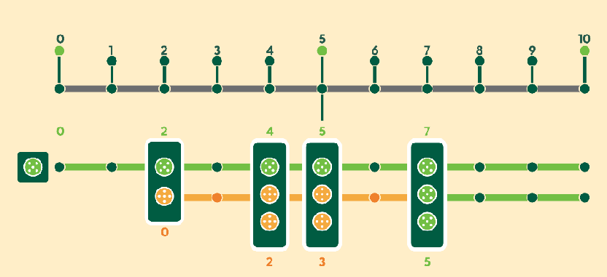






















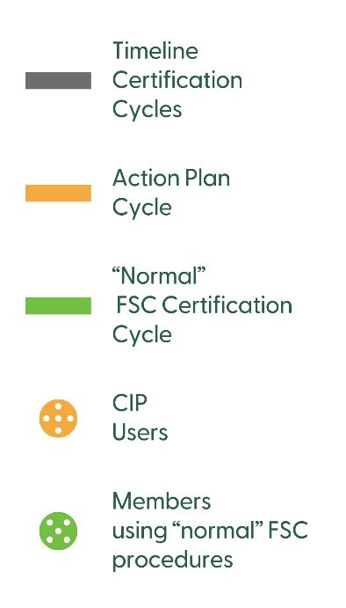
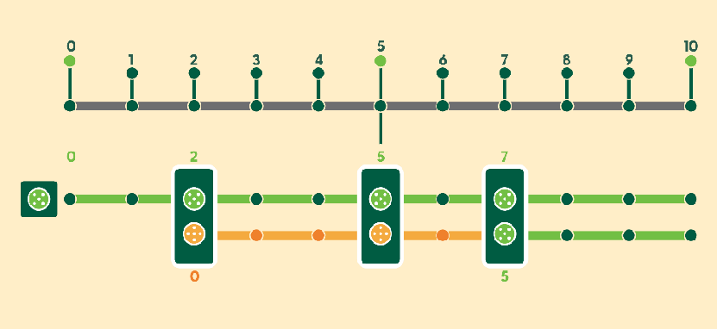




In addition to the requirements in FSC-STD-20-001 General requirements for FSC accredited certification bodies and FSC-STD-20-007 Forest Management Evaluations, the CB shall conform with the following general requirements when evaluating an organization for conformity to this procedure:
  - The audit team shall include a local expert in all on-site and hybrid evaluations.
  - The local expert shall conform with the requirements for local experts as outlined in Annex 3.
  - The local expert may perform interviews, gather information and other specified tasks unaccompanied on behalf of the audit team leader.
  - The CB shall make use of Information and Communication Technology (ICT) as much as possible to minimize costly site inspections.



  - When the CIP user has been supported by a third person (consultant, NGO, etc.) for the conformity with a requirement from the applicable FSC standard and if the CIP user agrees, the CB should address this third person during the evaluation of such requirement.
8.1. CBs shall proactively offer the option to be evaluated as a CIP user to all Organizations managing SLIMF or community forests when applying for FSC forest management certification.

  - The CB should use the following sources of information (not excluding others) to prepare for the main evaluation, if available:
    - Initial Conformity Self-Check results;
    - Action Plan, including criteria/indicator applicability check and the list of site-disturbing activities identified for the management unit.
  - During the main evaluation, the CB shall evaluate:
    - Whether the CIP user conforms with all CC of the applicable FSC standard;
NOTE: When no site-disturbing activities are planned before the surveillance evaluation in year three (3), conformity with the CC designated as low-risk are not required to be evaluated.
    - The Action Plan for conformity with the requirements of Section 3 of this procedure; and
    - Site-disturbing activities identified by the CIP user for accurate classification in line with the FSC definition of site-disturbing activities.
  - In year three (3) of the certification cycle, a surveillance evaluation shall be conducted on-site.
  - During the surveillance evaluation the CB shall verify that the CIP user:
    - Conforms with the CIC allocated to the first three (3) years of the Action Plan, and
    - Conforms with CC designated as low risk when site-disturbing activities are planned before the re-evaluation.
  - The CB shall conduct additional surveillance evaluation in years one (1), two (2) or four (4) in the following situations:
    - Site-disturbing activities that were not initially planned in the Action Plan have been announced by the CIP user for the following year.

    - The CIP user has not been implementing the Action Plan and the CB has not been properly informed to agree to an adaptation of the plan.
    - Presence of stakeholder complaints with a risk of escalation, and the CIP user is not implementing the mechanism for resolving grievances to address the complaints.
    - The self-monitoring results have not been delivered by the CIP user as agreed.
    - The self-monitoring results raise concerns regarding the performance of the CIP user.
  - Any additional surveillance evaluation shall be conducted as a hybrid or remote assessment unless justified by a specific risk where the CB deems it necessary to obtain objective on-site evidence to verify conformance.
  - When the CB conducts additional surveillance evaluations the CB shall verify that the CIP user:
    - Conforms with the CIC allocated up to the respective year in the Action Plan.
    - Conforms with criteria designated as low-risk when site-disturbing activities are planned to be conducted during the next 12-month.

Figure 2: Evaluation techniques and frequency for CIP users.
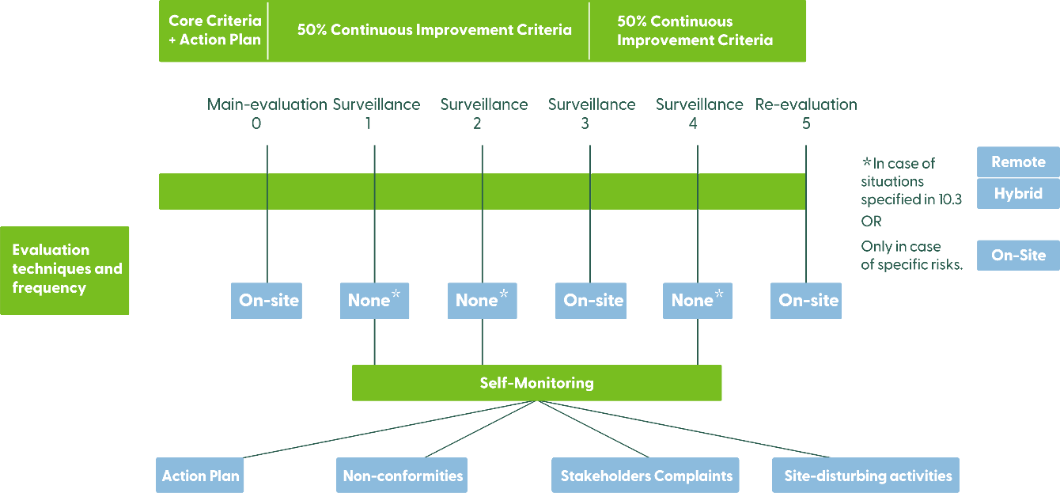




Minor non-conformities shall be fully corrected within two (2) years.




CIP users in a group shall be audited during the main, surveillance and re-evaluation of the group according to this procedure and against the requirements according to their Action Plan.


























- Prior and proven knowledge and practical experiences of the specific local context, culture
and living conditions and on governance and territorial interrelationship of Indigenous Peoples, traditional communities, or smallholders whose management unit will be evaluated.
- Knowledge of the local language is desirable but not mandatory.
- Experience in forest management, FSC requirements and FSC audits is desirable but not mandatory.
- Being able to work independently.
- Having access to the required technology.
- Having sufficient technical skills to use the required technology including capabilities to share documents and participate in meetings online.





FSC International – Performance and Standards Unit
Adenauerallee 134
53113 Bonn Germany

Phone: +49 -(0)228 -36766 -0
Fax: +49 -(0)228 -36766 -65
Email : psu@fsc.org
Page 21 of 21 Continuous Improvement Procedure
FSC-PRO-30-011 V1-0

