

Standard
SLIMF and Community Forest Eligibility Criteria
FSC-STD-01-003 V2-0 EN

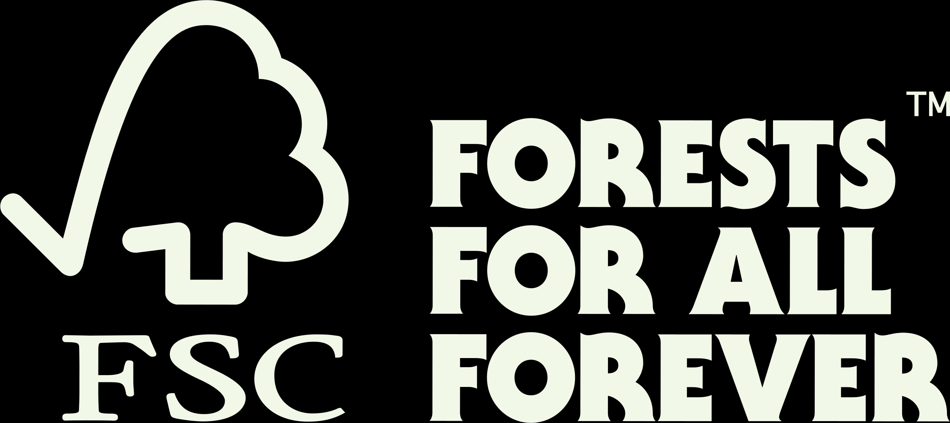

Title: | SLIMF and Community Forest Eligibility Criteria
Dates: | Approval date: 21 March 2023
Timeframes: | Transition end date: 01 July 2025  Period of validity: until replaced or withdrawn
Contact for comments: | FSC International Center – Performance and Standards Unit  Adenauerallee 134  53113 Bonn  Germany  Phone: +49 -(0)228 -36766 -0  Fax: +49 -(0)228 -36766 -65  Email: communityfamilyforests@fsc.org

Version control
Publication date: | 21 April 2023
Effective date: | 1 January 2024
Version | Description | Date
V1-0 | Approved at the 34th meeting of the FSC Board of Directors.  This standard has been developed to provide consistent definitions of 'small' and 'low intensity' managed forests for the purpose of implementing streamlined certification procedures. | 15.09.2004
V2-0 | This version has been developed to provide the definitions for a community forest in addition to ‘small’ and ‘low intensity’ managed forests at the international level as well as options for national level adaptations for consistent application across the FSC system. | 21.03.2023

® 2023 Forest Stewardship Council, A.C. All Rights Reserved
FSC® F000100
You may not distribute, modify, transmit, reuse, reproduce, re-post or use the copyrighted materials from this document for public or commercial purposes, without the express written consent of the publisher. You are hereby authorized to view, download, print and distribute individual pages from this document subject for informational purposes only.

Introduction
FSC has always strived to address the needs of all its forest stewards by fostering responsible forest management in their various geographies and socio-economic settings.
The SLIMF Eligibility Criteria V1-0, launched in 2004, have offered small scale and low intensity managed operations the opportunity to benefit from streamlined certification procedures to save costs and avoid disproportionate burdens.
The concept of SLIMF (small or low intensity managed forest) became so popular that it was increasingly applied outside of its original scope, such as for setting differentiated national indicators in Forest Stewardship Standards. This resulted in a largely unregulated use of the SLIMF concept.
A review conducted by FSC in 2021 revealed the following opportunities for revision:
- Changing the scope to allow the application of the SLIMF concept across the whole FSC system in a regulated way.
- Introducing a local adaptation process for allowing flexibility at regional or national level.
- Introducing the new concept of a ‘community forest’, to address a wider range of user groups that could benefit from streamlined applications.
All these points have been addressed in this version of the standard.
The revision was also guided by the FSC Global Strategy goal 1.2, with the intended outcomes of ensuring high integrity and credibility, and of balancing global consistency with local adaptability. The changes enable more equitable access to FSC requirements for all user groups, provide clarity in the relevant requirements and ensure better adaptability to given geographical and socio-economic conditions.

Contents
Introduction 3
A. Objective 5
B. Scope 5
C. References 5
D. Terms and definitions 5
PART I - SLIMF and Community Forest Eligibility Criteria 6
PART II - Regional or National Adaptation 7

Objective
The objective of this standard is to provide the universal international concepts of ‘small or low intensity managed forest’ (SLIMF) and ‘community forest’ for consistent application across the FSC system (Part I).
This standard also provides the process for the option of regional or national adaptation of these concepts by standard developers (Part II).

Scope
This standard is for use by:
• FSC International, when applying these concepts in institutional or normative documents.
• Standard developers, when applying or adapting these concepts in Forest Stewardship Standards.
This standard may also be used by certification bodies, certificate holders and other stakeholders as a source of information.
All aspects of this standard are considered normative, including the scope, effective and validity dates, terms and definitions, unless otherwise stated.
References and the content of information boxes, examples and notes are NOT normative.

References
The following referenced document is relevant for the application of this document. For references the latest version of the listed document (including any amendments) applies:
FSC-STD-01-002  FSC Glossary of Terms | This glossary is a collection of the most frequently used terms and definitions that have been approved and are used in documents of the FSC normative framework.

Terms and definitions
For the purposes of this standard, the terms and definitions provided in FSC-STD-01-002 FSC Glossary of Terms apply.

PART I - SLIMF and Community Forest Eligibility Criteria
- SLIMF eligibility criteria
  - A management unit may qualify as ‘SLIMF' if it is a 'small' management unit AND/OR managed as a 'low intensity' management unit.
1.2 Small management units
1.2.1 Management units may qualify as ‘small’ when they are 100 hectares or smaller in total area.
1.2.2 Standard developers may adapt the default threshold of 100 hectares, or the default reference area for their region or country, following the adaptation process as described in Part II, clause 4.1.1.
1.3 Low intensity managed management units
1.3.1 Management units may qualify as ‘low intensity’ when either:
- the rate of harvesting is less than 20% of the mean annual increment (MAI) within the total production forest area of the management unit, AND
- the annual harvest from the total production forest area is less than 5,000 m³, OR
- the average annual harvest from the total production forest is less than 5,000 m³/year during the certification cycle.
1.3.2 Standard developers may develop other parameters and/or specify a different threshold to the ones listed in clause 1.3.1 to define ‘low intensity' for their region or country, following the adaptation process as described in Part II, clause 4.2.1.
1.3.3 Management units may be considered ‘low intensity managed’ and thus qualify as SLIMF when:
- only non-timber forest products (NTFPs) are collected or harvested, OR
- NTFPs are collected or harvested AND timber is harvested AND the management unit meets the eligibility criteria for ‘low intensity’ as outlined in clause 1.3.1.
1.3.4 Standard developers may adapt the international eligibility criteria for a management unit with NTFPs in scope of certification for qualifying as SLIMF following the process as described in Part II, clause 4.2.2.

- Community Forest Eligibility Criteria
- A management unit may qualify as ‘community forest’ when the following tenure AND management criteria are met:
    - Tenure: The legal and/or customary right to manage a management unit (e.g., title, long-term lease, concession) is held at communal level, either located in a communal forest and/or on individually assigned plots.
    - Management: The community actively manages the management unit (e.g., under a communal forest management plan) OR the community authorizes management of the forest by others (e.g., resource manager, forestry contractors, forest products company).
      - If the community authorizes management of the forest by others, the following shall be met:
- The community has legal responsibility for the forest operations, AND
- has control over the forest management decisions and monitors the forest operations.
2.2 Standard developers shall consider more specific definitions for tenure and management for their region or country AND/OR develop additional criteria, following the adaptation process as described in Part II, clause 5.1.

PART II - Regional or National Adaptation
- General requirements

  - All proposals to adapt the default international eligibility criteria for ‘small’, ‘low intensity’ and ‘community forest’ require justification and demonstrated stakeholder support.

NOTE: Once an adaptation proposal is submitted by standard developers, FSC will analyse and decide on it as part of the development or revision process.

- Adaptation of SLIMF eligibility criteria

4.1 Small management units
4.1.1 For the purpose of defining ‘small’ in the regional or national context, standard developers may propose a different threshold and/or may change the reference area from the total area of the management unit to a part of the management unit, e.g., the production forest area.

4.2 Low intensity managed management units
4.2.1 For the purpose of defining ‘low intensity’ in the regional or national context, standard developers may propose different parameters and/or thresholds in line with the following:
- Adaptation of the harvesting rate, using both parameters, MAI, AND annual harvesting volume.
- Under specific management objectives, such as forest operations for the purpose of restoration, the MAI parameter may be dropped, and the annual harvesting volume parameter may be adapted.
- In case of temporary incidents, such as natural hazards (e.g., drought, insects, blizzards, storms, forest fires, etc.), the MAI parameter may be dropped, and the annual harvesting volume parameter may be adapted.
4.2.2 To qualify as SLIMF, standard developers may adapt the international eligibility criteria for a management unit with management of NTFPs by defining a scale threshold.

- Adaptation of community forest eligibility criteria
5.1 For the purpose of adapting the definition of a ‘community forest’ to the regional or national context, standard developers may revise the definitions for tenure and management and/or propose additional criteria (see Box 1).

Box 1: Examples of additional criteria that may be considered when developing adaptations for the definition of ‘community forest’.
These criteria may include, but are not limited to:
- Scale
- Intensity of timber harvesting
- National laws
- Benefit sharing (collective/selective)
- Socio-economic attributes, such as annual turnover of the management operation or contribution to the overall community income
- Community relationship with the forest (inside or adjacent to a forest)
- Labour/ formality of employment
- Technical capacity
- Degree of mechanization
- Forest type
- Forest products (Timber, NTFPs, Ecosystem Services)
- Seasonality of forest operations

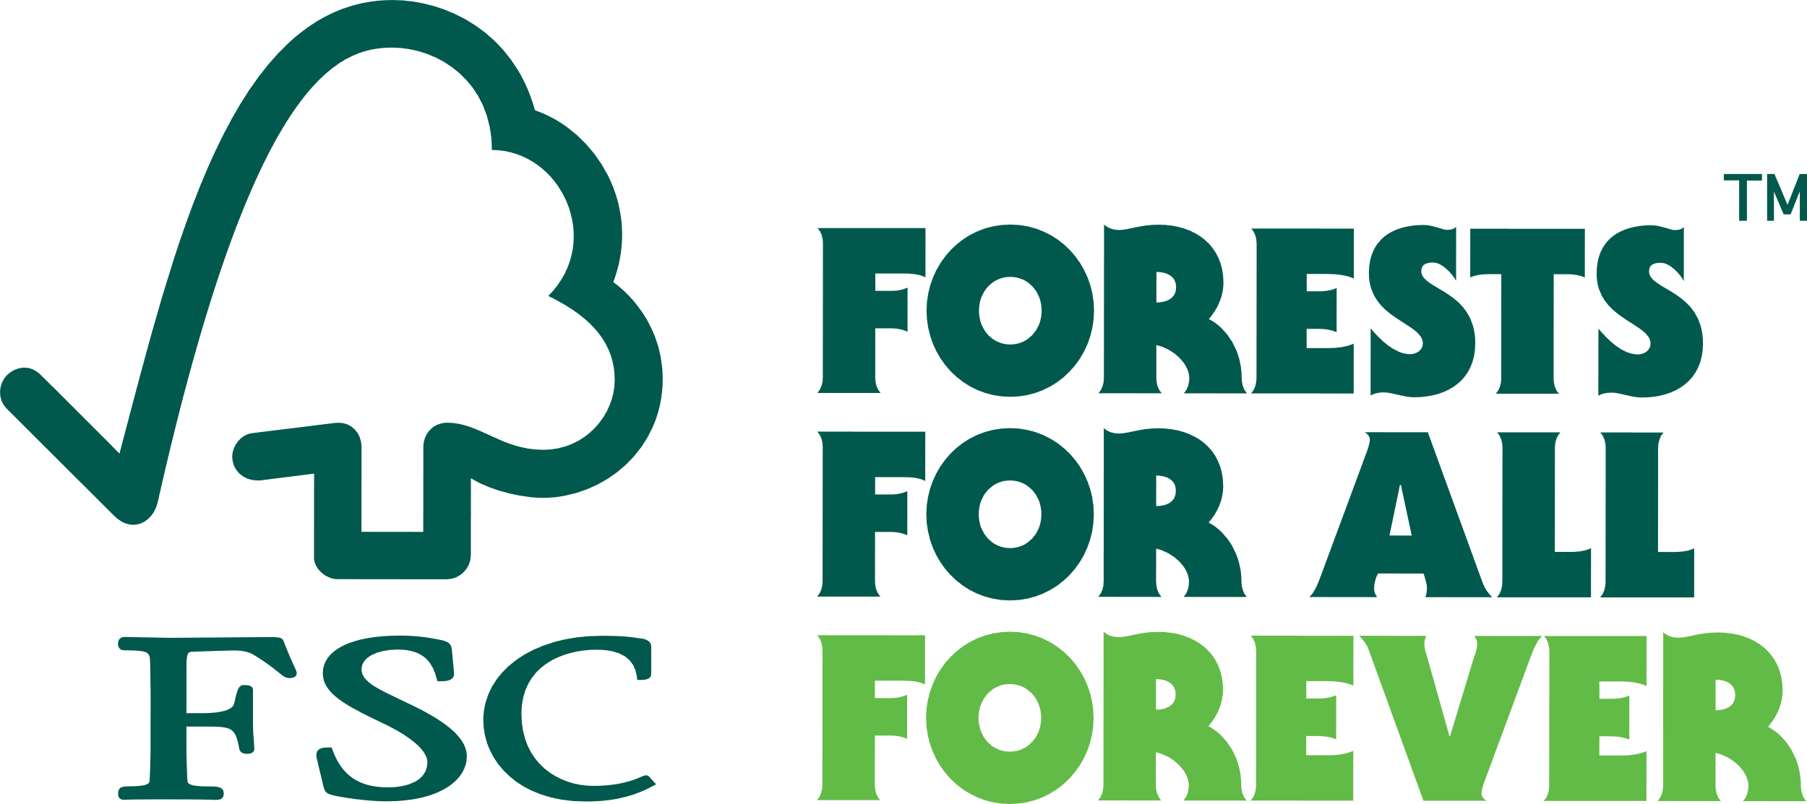

FSC International Center - Performance and Standards Unit
Adenauerallee 134
53113 Bonn
Germany

Phone: +49 -(0)228 -36766 -0
Fax: +49 -(0)228 -36766 -65
Email: psu@fsc.org

