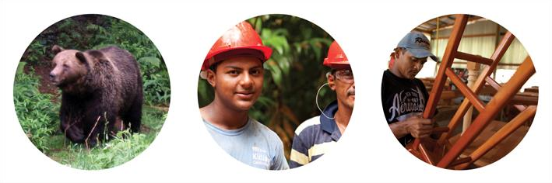


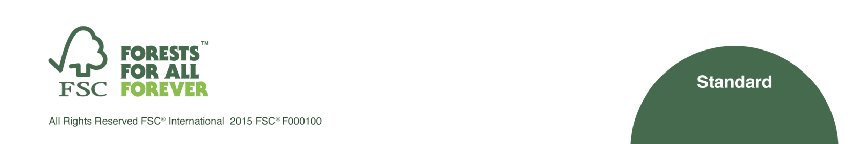
SLIMF ELIGIBILITY CRITERIA - ADDENDUM

FSC-STD-01-003a EN

Title: SLIMF Eligibility Criteria- Addendum

Document reference code: FSC-STD-01-003a EN
Last updated April, 2016
Contact for comments: FSC International Center
- Policy and Standards Unit -
Charles-de-Gaulle-Str. 5
53113 Bonn, Germany

+49-(0)228-36766-0

 +49-(0)228-36766-30  policy.standards@fsc.org

© 2015 Forest Stewardship Council, A.C. All rights reserved.
FSC® F000100
No part of this work covered by the publisher’s copyright may be reproduced or copied in any form or by any means (graphic, electronic or mechanical, including photocopying, recording, recording taping, or information retrieval systems) without the written permission of the publisher.
Printed copies of this document are for reference only. Please refer to the electronic copy on the FSC website (www.fsc.org) to ensure you are referring to the latest version.

SLIMF Eligibility Criteria- Addendum

FSC-STD- 01-004a- EN

The Forest Stewardship Council® (FSC) is an independent, not for profit, nongovernment organization established to support environmentally appropriate, socially beneficial, and economically viable management of the world's forests.
FSC’s vision is that the world’s forests meet the social, ecological, and economic rights and needs of the present generation without compromising those of future generations.

Foreword
This document provides an up to date list of countries for which the SLIMF eligibility criteria differ from those specified for international use in “FSC-STD-01-003 V1-0 EN:
SLIMF Eligibility Criteria”.

- List of countries for which definition of “small” is greater than 100 hectares (ha)
Country | Threshold | Proposed by |  | Approval date
Brazil (Amazon Basin) | 1000 ha | FSC Brazil |  | February, 2006
Brazil(Plantations) | 480  (Productive area)  1000 ha (Total area) | FSC Brazil |  | July, 2013
Canada | 1000 ha | FSC Canada |  | June, 2004
Chile | 1000 ha | FSC Chile |  | December, 2005
Colombia (Natural Forest) | 250 ha | FSC Colombia |  | February, 2006
Czech Republic | 500 ha | FSC Czech Republic |  | February, 2008
Denmark | 1000 ha | FSC Denmark |  | October, 2005
Ecuador | 1000 ha | FSC Ecuador |  | September, 2007
Estonia | 500 ha | FSC Estonia |  | November, 2005
Finland | 200 ha | FSC Finland |  | May, 2009
Ghana | 1000 ha | Ghana National  Working Group |  | May, 2012
Honduras | 1000 ha | FSC Honduras |  | August, 2009
Ireland | 200 ha | FSC Ireland |  | May, 2012
Latvia | 1000 ha | Standards  Development  Latvia | Group | October, 2012
Mexico | 1000 ha | FSC Mexico |  | September, 2007
New Zealand | 1000 ha | Standards  Development  New Zealand | Group | September, 2013
Papua New Guinea | 1000 ha | Standards  Development  Papua New Guin | Group ea | February, 2005
Portuguese Republic | 500ha | Standards  Development Group  Portugal |  | February, 2016

Country | Threshold | Proposed by | Approval date
South Africa | 1000 ha | National Working Group | September,2013
Sweden | 1000 ha | FSC Sweden | February, 2010
United Kingdom | 500 ha | FSC United Kingdom | April, 2012
USA | 1000 ha | FSC United States | February, 2004

- List of countries for which definition of “low intensity” differs from that defined in paragraph 3.1 of “FSC-STD-01-003-EN: SLIMF Eligibility Criteria”

Country | Definition of “low intensity” | Approval date
Brazil | For Brazilian Amazon: Forest harvesting rate proportional to the average annual increment (AAI) for the total production area of the forest management unit (FMU).  The rate of harvesting is less than 20% of the mean annual increment (MAI) within the total production forest area of the unit  Forest harvest limit of a maximum of 5,000 m3/year.  NOTE: In cases where the calculations of average annual increment (AAI) are not available, other measures of growth are accepted at the regional level to a certain type of forest may be used. | February, 2006

ic.fsc.org


FSC International Center GmbH
Charles-de-Gaulle-Straße 5 · 53113 Bonn · Germany
