
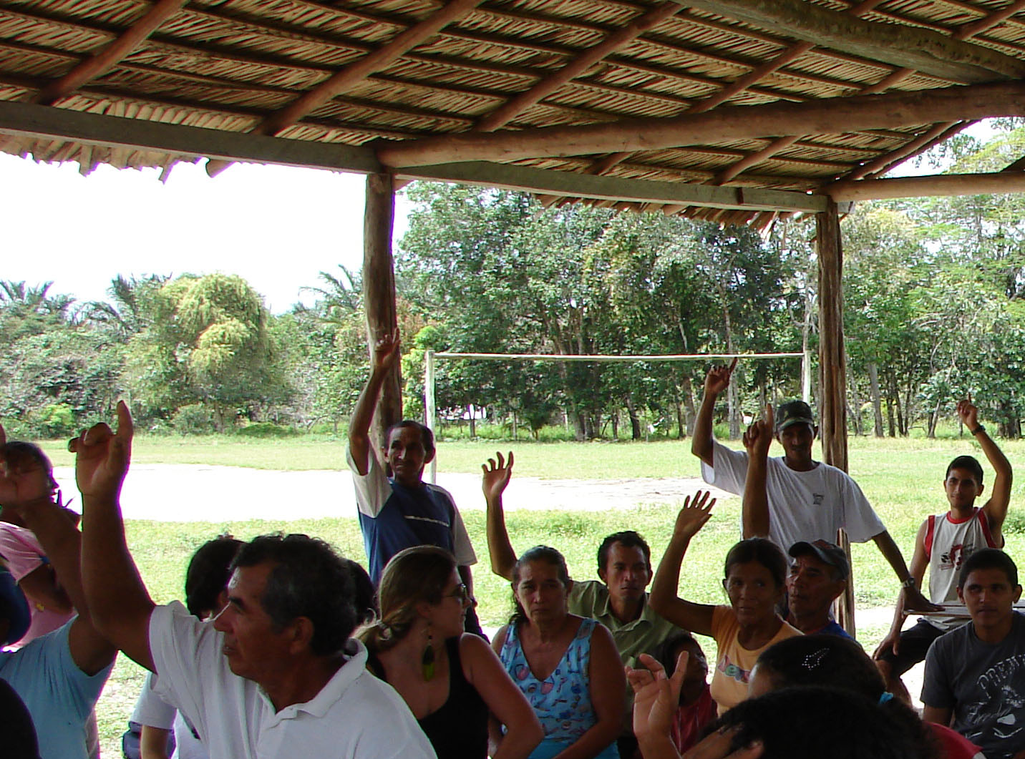
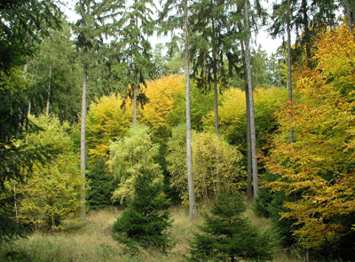

Stakeholder consultation for forest evaluations
FSC-STD-20-006 (V3-0) EN

ACCREDITATION
FSC INTERNATIONAL STANDARD

Title: | Stakeholder consultation for forest evaluations
Document reference code: | FSC-STD-20-006 (V3-0) EN
Scope: | International
Approval date: | 31 August 2009
Contact: | FSC Policy and Standards Unit
E-mail for comments: | policy.standards@fsc.org
© 2009 Forest Stewardship Council, A.C. All rights reserved.

No part of this work covered by the publisher’s copyright may be reproduced or copied in any form or by any means (graphic, electronic or mechanical, including photocopying, recording, recording taping, or information retrieval systems) without the written permission of the publisher.

Stakeholder consultation for forest evaluations
FSC-STD-20-006 (V3-0) EN
FINAL VERSION

The Forest Stewardship Council (FSC) is an independent, not for profit, non-government organization established to support environmentally appropriate, socially beneficial, and economically viable management of the world's forests.

FSC’s vision is where the world’s forests meet the social, ecological, and economic rights and needs of the present generation without compromising those of future generations

Foreword

This standard refers to stakeholder consultation certification body's have to conduct to evaluate a forest manager's conformity with the requirements of the applicable Forest Stewardship Standard.

Stakeholder consultation provides an essential and effective means of verification for many indicators of the applicable Forest Stewardship Standard. National and local stakeholders can provide relevant information as to an applicant's conformity with the environmental, legal, social, or economic requirements of the Forest Stewardship Standard. Such stakeholders include local and national government and non-government organisations (NGOs) involved in forest management, as well as individuals and members of communities directly affected by the forest management.

The objective of this standard is to ensure that the certification body carries out a level of consultation sufficient to provide a credible guarantee that the requirements of the applicable Forest Stewardship Standard are complied with.

This standard is designed to give certification bodies and stakeholders more clarity as to the nature and extent of stakeholder consultation required for evaluation of FSC Forest Stewardship Standards.

Note on use of this standard

All aspects of this standard are considered to be normative, including the scope, standard effective date, references, terms and definitions, notes, tables and annexes, unless otherwise stated (e.g. examples).

Contents

A Scope
B Standard effective date
C References
D Terms and definitions

- General
- Identification of and information for stakeholders
- Consultation during main or re-evaluations
- Evaluating information received from stakeholders
- Records
- Reporting
- Consultation during surveillance

Annex 1 Examples of stakeholder groups

A Scope

This standard applies to all certification bodies carrying out FSC forest management evaluations.

This International Standard shall be used as a normative document for FSC accreditation.

B Standard effective date

This standard becomes effective on 01 January 2010.

New applicant certification bodies that apply for accreditation after the effective date of this standard shall be audited against the requirements of this standard.

Existing applicant certification bodies in the process of accreditation at the effective date shall switch to the requirements of this standard before accreditation is granted.

FSC accredited certification bodies shall be in compliance with the requirements of this standard by 01 January 2011.

C References

The following referenced documents are indispensable for the application of this document. For references without a version number, the latest edition of the referenced document (including any amendments) applies.

FSC-STD-01-002 FSC glossary of terms
FSC-STD-20-001 General Requirements for FSC accredited Certification Bodies: application of ISO/IEC Guide 65:1996 (E)
FSC-STD-20-002 Structure, content and local adaptation of generic forest stewardship standards
FSC-STD-20-007 Forest Management Evaluation

D Terms and definitions

For the purposes of this International Standard, the terms and definitions given in FSC-STD-01-002 FSC Glossary of Terms and the following apply:

Indigenous peoples: "The existing descendants of the peoples who inhabited the present territory of a country wholly or partially at the time when persons of a different culture or ethnic origin arrived there from other parts of the world, overcame them and, by conquest, settlement, or other means reduced them to a non-dominant or colonial situation; who today live more in conformity with their particular social, economic and cultural customs and traditions than with the institutions of the country of which they now form a part, under State structure which incorporates mainly the national, social and cultural characteristics of other segments of the population which are predominant." (Working definition adopted by the UN Working Group on Indigenous Peoples).

Stakeholder: Any individual or group whose interests are affected by the way in which a forest is managed.

Verbal forms for the expression of provisions
[Adapted from ISO/IEC Directives Part 2: Rules for the structure and drafting of International Standards]

“shall”: indicates requirements strictly to be followed in order to conform to the standard.

“should”: indicates that among several possibilities one is recommended as particularly suitable, without mentioning or excluding others, or that a certain course of action is preferred but not necessarily required. A certification body can meet these requirements in an equivalent way provided this can be demonstrated and justified.

“may”: indicates a course of action permissible within the limits of the document.

“can” is used for statements of possibility and capability, whether material, physical or causal.
1 General requirements

1.1 The certification body shall consult with a range of stakeholders who can provide relevant information as to an applicant's conformity with the environmental, legal, social, and economic requirements of the Forest Stewardship Standard.

1.2 Relevant information may include alleged examples of non-conformity, as well as confirmation of conformity with:

- Legal requirements (FSC Principle 1);

- Social requirements (FSC Principles 2, 3, 4 and 9);

- Technical or economic requirements (FSC Principles 5, 7, 8, 10);

- Environmental requirements (FSC Principles 6, 9, 10).

1.3 The certification body shall develop and document its methodology for conducting stakeholder consultations in accordance to the requirements of this Standard.

1.4 The methodology shall ensure that:

1.4.1 a range of stakeholders is consulted, appropriate to the scale and range of impacts of the forest management being assessed;

1.4.2 stakeholders have the opportunity to present their points of view to the auditor(s) in confidence;

1.4.3 information and opinions given by consulted stakeholders are evaluated objectively and meaningfully, and affect the certification decision only in so far as they provide evidence of conformity or non-conformity with the requirements of the applicable Forest Stewardship Standard.

2 Identification of and information for stakeholders

2.1 The certification body shall have effective procedures to identify the range of stakeholders that are likely to have information relevant to the evaluation of the applicant for certification, and/or that may be able to put the certification body in contact with other such stakeholders. The range and number of individuals and organisations to be contacted depends on the scale, intensity and complexity of the forest management operation.

2.2 The certification body should aim to ensure that any stakeholder that has information relevant to conformance of the applicant with the requirements of the Forest Stewardship Standard has the opportunity to bring such information to the attention of the certification body, prior to the decision to grant a certificate.

NOTE: In order to meet this requirement it is necessary that stakeholders are contacted (see Clauses 2.3, 2.5, 2.6) and have the opportunity to respond (see Section 3) in an appropriate local language.

2.3 For all operations except those which meet the eligibility criteria for small forests (see FSC-STD-01-003 SLIMF eligibility criteria) stakeholders to be contacted directly by the certification body shall include:

- Any FSC National Initiative in the country or region;

- The state forest service or equivalent;

- Statutory bodies with some legal mandate over the FMU under evaluation;

- NGOs that are active in respect of social or environmental aspects of forest management at the national level, or at the sub-national level in the environs of the forest to be evaluated, as appropriate;

- Representatives of Indigenous Peoples and forest-dwelling or -using communities that are active at the national level, or at the sub-national level in the environs of the forest to be evaluated, as appropriate;

- Labour organisations or unions of forestry sector workers;

- Contractors who provide services to the forest operation to be assessed;

- International NGOs that have requested to be contacted in respect of evaluations in particular regions or countries.

  - In countries in which there is an FSC National Initiative the certification body shall request that the National Initiative provides the certification body with a list of potential stakeholders that the certification body may contact in the country concerned.

NOTE: Such a list should supplement the certification body’s own efforts to identify stakeholders for consultation.

2.5 The certification body should contact stakeholders at the scale of organisation most likely to have information relevant for the assessment. In the case of large scale enterprises this is likely to include organisations which operate at the national level, and/or at the sub-national level in the environs of the forest to be evaluated. In the case of smaller enterprises it may include only local organisations, interest groups or individuals.

2.6 The certification body shall inform the stakeholders identified in Clause 2.3, above, at least six (6) weeks prior to the start of the main evaluation site visits:

- that an FSC forest evaluation is due to take place;

- the start date of the evaluation;

- the applicant's name and the location of the forest area to be assessed;

- how to acquire a copy of the Forest Stewardship Standard to be used for the evaluation;

- that the certification body is seeking the views and opinions of stakeholders as to whether the applicant's forest management complies with the requirements of the standard;

- how stakeholders may contact the certification body in confidence to let the certification body know of their views and opinions;

- that the team will make arrangements to allow stakeholders to meet with them during the evaluation;

- of the existence of the certification body’s mechanisms for resolution of complaints or disputes;

- that the source of any information is kept confidential on request.

2.7 For main evaluations in a context where no FSC approved national, regional or sub-national Forest Stewardship Standard exists, the stakeholder notification (see Clause 2.6) shall include:

a) that the standard to be used for the evaluation is available on the certification body’s website or on request;

b) that the standard may be modified to take account of stakeholder comments, and that comments and suggested modifications to the standard are welcome (see FSC-STD-20-002 Part 2).

2.8 The certification body may employ a variety of means to inform stakeholders of the information specified in Clause 2.6, above, appropriate to the group being contacted. Techniques may include:

a) direct e-mail contacts in the language of the recipients;

b) personal contacts by phone or letter;

c) notice published in the national and/or local press in the country in which the evaluation is due to take place;

d) local radio announcements;

e) signage posted around the forest management unit in the language of the local people;

f) announcement in village shop/ church hall or local customary notice board for issues of public interest;

g) announcement by the applicant using existing, ongoing mechanisms for consultation between managers and local stakeholders;

h) face to face meetings with stakeholders.

2.9 The certification body should work with the applicant in the case of forest management units which meet the eligibility criteria for small or low intensity FMUs (see FSC-STD-01-003 SLIMF eligibility criteria) to identify local, and where appropriate national stakeholders, and to agree the method of communication. Methods of communication may include those identified in Clause 2.7 above. The certification body may delegate some or all of the implementation of this communication to the applicant, but shall ensure that stakeholders have access to the information listed in Clause 2.6, above, prior to the main evaluation taking place. The certification body shall ensure that there is adequate opportunity for stakeholders to comment directly to the certification body. In areas where tensions with stakeholders are known to exist certification bodies shall carry out direct consultation with local and, where appropriate, national stakeholders.

3 Consultation during main or re-evaluations

3.1 Consultation shall be designed to solicit direct, factual observations with regard to conformity with the requirements of the applicable Forest Stewardship Standard. The certification body shall carry out such consultation as part of the main evaluation. The consultation shall include a sufficient variety and number of people affected by or involved in the applicant's forest management, to evaluate the range of situations relevant to the applicable Forest Stewardship Standard (see FSC-STD-20-007).

NOTE: The stakeholder groups that need to be consulted are determined by the specific indicators and associated means of verification of the applicable standard.

3.2 Consultation and interviews with stakeholders (including workers, staff or subcontractors) shall be carried out in confidence if requested. Consultation and interviews shall therefore, necessarily, be carried out without the presence of the forest manager(s) and/or their representatives or any supervisors.

3.3 The consultation techniques employed shall be culturally appropriate to the stakeholders with whom consultation takes place. Examples of such techniques include:

a) direct arrangements for individual or group meetings at the time of the evaluation;

b) individual or group meetings arranged through the help of a local interlocutor;

c) ad hoc interviews with managers, employees, contractors during site audits;

d) structured interview by telephone at the time of the evaluation;

e) contact by mail or e-mail with a request for written comments to a predetermined set of specific questions.

4 Evaluating information received from stakeholders

4.1 Information provided by stakeholders shall wherever possible be independently corroborated from a second source or be confirmed by the certification body's auditors in the field.

4.2 In all cases information provided by stakeholders shall be evaluated objectively and meaningfully to determine whether it constitutes evidence of a non-conformity with any FSC certification requirement.

5 Records

5.1 The certification body shall keep the following records for each evaluation:

- names and contact details of individuals and organisations consulted on the applicant's conformity with the requirements of the applicable Forest Stewardship Standard;

- notes about all information received orally;

- copies of all correspondence and/or written comments received;

- notes or other information showing how information received was tested or corroborated;

- an explanation of the way in which the certification body interpreted or took account of these comments in coming to a decision as to the applicant ‘s conformity or non-conformity with the applicable Forest Stewardship Standard.

6 Reporting

6.1 The public summary reports prepared or updated after evaluations (main and surveillance) shall include a systematic presentation of stakeholder comments received together with the conclusions and a description of the follow-up action from the certification body (see FSC-STD-20-007b).

NOTE: similar stakeholder comments may be grouped by issues.

6.2 The certification body shall not identify individual stakeholders or stakeholder groups in the report without their prior informed consent.

6.3 Within three (3) months of the certification decision, the certification body shall actively inform the consulted stakeholders who provided written comments or who requested an update on how their concerns were addressed.

7 Consultation during surveillance

7.1 The certification body shall conduct stakeholder consultation during surveillance evaluations as necessary to collect audit evidence in order to verify continued conformity of the certificate holder with relevant certification requirements (see FSC-STD-20-007).

7.2 Consultation techniques and confidentiality of information shall follow the same requirements as in the main evaluation (see Clauses 3.2 and 3.3).

7.3 Comments received from stakeholders after the main evaluation shall be recorded, and evaluated and documented at the following surveillance evaluation, unless provided as part of a formal complaint or indicating a major non-conformity requiring immediate action.
Annex 1: Examples of stakeholder groups

The following list provides examples of some of the stakeholders that may need to be consulted to assess conformity with specific aspects of the applicable Forest Stewardship Standard. This is not a complete list, nor is the certification body required to consult with all the stakeholders listed here if this is not required to verify the applicable indicators.

FSC Principle | Stakeholder groups typically consulted to evaluate conformity
Principle 1 | State forest service, statutory bodies with some legal mandate over the FMU under evaluation, e.g. tax or legal departments
Principle 2 | Representatives and members of communities directly affected by the forest management enterprise  Representatives and members of Indigenous Peoples directly affected by the forest management enterprise
Principle 3 | Representatives and members of Indigenous Peoples directly affected by the forest management enterprise
Principle 4 | Employees, contractors and subcontractors and their representatives, Labour organisations or unions of forestry sector workers; forest recreation organisations.
Principle 5 | Employees  Representatives and members of communities directly affected by the forest management enterprise  Representatives and members of Indigenous Peoples directly affected by the forest management enterprise
Principle 6 | National NGOs that are involved or have an interest in respect of environmental aspects of forest management, either at the national level, or at the sub-national level in the environs of the forest to be evaluated;
Principle 7 | Employees
Principle 8 | Employees
Principle 9 | National NGOs that are involved or have an interest in respect of social or environmental aspects of forest management, either at the national level, or at the sub-national level in the environs of the forest to be evaluated;  Stakeholders relevant to the identified attributes of HCV.  Representatives and members of communities directly affected by the forest management enterprise  Representatives and members of Indigenous Peoples directly affected by the forest management enterprise
Principle 10 | Various

