




Forest management groups
FSC-STD-30-005 V2-0

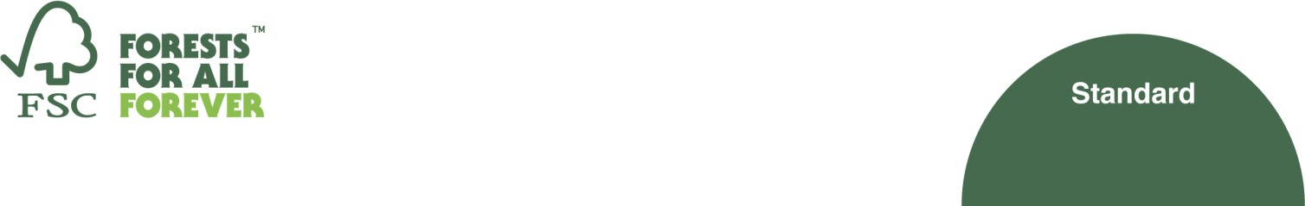

All Rights Reserved FSC® International 2020 FSC®F000100

Title: | Forest management groups
Document code: | FSC-STD-30-005 V2-0 EN
Approval: | 19 November 2020
Contact: | FSC International Center Performance and Standards Unit Adenauerallee 134,  53113 Bonn, Germany
 |    | +49-(0)228-36766-0  +49-(0)228-36766-65  psu@fsc.org
© 2020 Forest Stewardship Council, A.C. All rights reserved.
FSC® F000100

No part of this work covered by the publisher’s copyright may be reproduced or copied in any form or by any means (graphic, electronic or mechanical, including photocopying, recording, recording taping, or information retrieval systems) without the written permission of the publisher.

Printed copies are uncontrolled and for reference only. Please refer to the electronic copy on the FSC website (ic.fsc.org) to ensure you are referring to the latest version.

The Forest Stewardship Council (FSC) is an independent, not for profit, non-government organization established to promote environmentally appropriate, socially beneficial, and economically viable management of the world's forests.

FSC’s vision is where the world’s forests meet the social, ecological, and economic rights and needs of the present generation without compromising those of future generations.

Introduction
In some cases, accessing FSC certification can be challenging from the administrative and economic point of view. These challenges become particularly relevant in the case of small scale forestry, who often don´t have the resources to conform with FSC requirements. To facilitate accessing and maintaining FSC certification, it is possible to create groups: several management units (from several forest owners) grouped together and managed by a Group Entity, which holds the FSC certificate for the whole group.
The benefits of group certification can be economic, by reducing costs related to certification, and achieving economies of scale in getting services and accessing markets. Groups also reduce the administrative tasks for each of the members, who get support in implementing responsible forest management. Within the group, the Group Entity has flexibility to allocate the responsibility for various requirements to the different actors in the group. The intention is to allow for enough flexibility so that each group can find its optimal structure and division of responsibilities to conform with the FSC requirements. For instance, evaluations like the environmental impact assessment or the High Conservation Value (HCV) assessment can be developed by the Group Entity for the whole group area, as long as each management unit in the group conforms with the results of such assessments, together with the rest of the applicable FSC requirements.
It is also possible to create Resource Management Units within the group, where a Resource Manager is granted responsibility over some or all of the management units of the group. This structure allows for more centralized and homogeneous management to be implemented by the Resource Manager, reducing the risk associated with forest management activities.
This revised version of the standard includes the optional possibility of incorporating forestry contractors in the group certificate to implement forestry services in the management units in its group. These forestry contractors are trained and evaluated by the Group Entity. This will provide additional safeguard and reduce the risk associated with management activities even further.
Group certification is commonly used by smallholders but is available to any type of management unit and ownership worldwide.

Version history

V 1-0 | The FSC General Assembly in 1996 approved the development of new approaches to certification of small landholdings. In 1998, FSC approved the FSC Policy “Group Certification: FSC Guidelines for certification bodies” (July 31st, 1998). In 2005 FSC identified the need to incorporate requirements for both forest managers and certification bodies. On August 31st, 2009, the FSC International Board of Directors approved the first version of “FSC Standard for Group Entities in Forest Management Groups” (FSC-STD-30- 005 V1-0).
V 1-1 | A minor standard revision clarified the Resource Manager responsibilities, and the monitoring requirements during the period of validity of the certificate. This version was approved by the FSC Director General, Kim Carstensen, on December 21st, 2017.
V 2-0 | This revision of the standard was a consequence of Motion 46 from the FSC General Assembly 2017. The revision started at the end of 2018 to help improve smallholders´ access to the FSC system, and to address concerns raised by stakeholders since the approval of the first version of the standard. It also incorporated controlled wood in the scope of the standard, the possibility of including forestry contractors in the scope of the group certificate, and a revised internal monitoring sampling methodology with a risk-based  approach. This document version was approved by the FSC Board of Directors at their 86 meeting, on 16 November 2020.

Contents
A Objective 5
B Scope 5
C Effective and validity date 5
D References 5
E Terms and definitions 5
PART I Establishment of forest management groups 8
- Requirements for Group Entities 8
- Requirements for group members 8
- Division of responsibilities 8
- Conformance across management units 10
- Group size 11
- Multinational groups 11
PART II Group management system 11
- Adding new members to the group 11
- Provision of information to members 12
- Group Rules 12
- Group records 13
- Internal monitoring 13
- Chain of Custody 15
PART III Optional Inclusion of Forestry Contractors in Groups 16
- Requirements for forestry contractors 16
- Group Rules for contractors 16
- Evaluation of new forestry contractors 16
- Records regarding contractors 16
- Internal monitoring with contractors in the group 17
- Internal monitoring of contractors 17
- Contractors´ Chain of Custody 17

A Objective
The objective of this standard is to provide the requirements for the establishment and management of FSC Forest Management (FM), Forest Management / Chain of Custody (FM/CoC) or Controlled Wood / Forest Management (CW/FM) group certificates.

B Scope
This standard is for use by Group Entities in order to apply for or to maintain FSC FM, FM/CoC or CW/FM group certification.
NOTE: Any reference to FSC FM/CoC groups in this standard includes FSC FM groups as well.
All aspects of this standard are considered normative, including the scope, effective and validity dates, references, terms and definitions, notes, footnotes, tables and annexes, unless otherwise stated (e.g. as examples). The content of the information boxes is NOT normative.

C Effective and validity date
Approval date: 19 November 2020
Publication date: 16 December 2020
Effective date: 16 March 2021
Transition period: 16 March 2021 – 15 March 2022 Period of validity: Until replaced or withdrawn

D References
The following referenced documents are relevant for the application of this document. For undated references, the latest edition of the referenced document (including any amendments) applies.
FSC-STD-01-001 FSC Principles and Criteria for Forest Stewardship FSC-STD-60-004 International Generic Indicators
FSC-STD-01-002 FSC Glossary of Terms FSC-STD-01-003 SLIMF Eligibility Criteria
FSC-STD-20-007 Forest Management Evaluations
FSC-STD-30-010 FSC Controlled Wood Standard for Forest Management Enterprises

E Terms and definitions
For the purposes of this standard, the terms and definitions provided in FSC-STD-01-002 FSC Glossary of Terms, and the following apply:
Active management unit: A management unit where site-disturbing activities have taken place since the last evaluation implemented by certification bodies, or in the previous 12 months if there was no previous evaluation.
Box 1. Examples of Active management unit Examples of active management:
Timber, energy wood and non-timber forest products harvesting (all commercial logging/extraction methods); soil preparation; planting or seeding; seedling stand management; fertilization; thinning; ditching; post-harvest remediation activities; infrastructure development (e.g. forestry road construction); road decommission (closure); fuel management (e.g. manual clearing); quarrying; chemical pesticides use; prescribed burning; pruning; harvest layout activities (e.g. tree marking, riparian buffer demarcation, identification of environmentally sensitive areas and cultural values).

Examples of inactive management:
Forest protection monitoring activities (e.g. fire patrols, surveillance for unauthorized activities); permanent sample plots establishment and/or monitoring; fire break maintenance; road side mowing; road grading (shaping); boundary line demarcation and maintenance; forest resource surveys/inventory; non-chemical invasive species management; developing/updating forest management plan; passive operational planning of a forest management activity (e.g. GIS activities, boundary demarcation, stand level reconnaissance).
Applicable Forest Stewardship Standard: In the context of this standard, this term is used to refer to:
- The approved national standard(s) of a country or region. These can be Interim National Standard(s), Interim Regional Standard(s), or National Forest Stewardship Standard(s)¹; OR
- The controlled wood standard FSC-STD-30-010 FSC Controlled Wood Standard for Forest Management Enterprises.
Communities: In the context of this standard, this generic term is used to refer to Local communities, Traditional peoples and Indigenous Peoples, which are defined in FSC-STD-01-001 FSC Principles & Criteria.
Forest gate: The first point of sale outside of the group.
NOTE: The FM/CoC group certificate covers sales among the different actors of the group (e.g. members, contractors, Group Entity), and stops when the FSC-certified material is first sold outside of the group.
Forestry contractor: A person or group of persons legally registered (e.g. consultant, company) that takes responsibility for providing forest logging, silvicultural or other management activities on the ground on the basis of a contractual agreement with a Group Entity, Resource Manager(s) or group member(s). The forestry contractor may provide these services directly or through sub- contractors (outsourcing).
NOTE: In the context of this standard, the term ‘forestry contractor’ refers to a forestry contractor that has joined a group and is covered by the scope of the FSC FM/CoC group certificate to operate in the management units of the group.
Group Entity: A person or group of persons (e.g. cooperative, owners association, company) registered as a legal entity and representing the management units and forestry contractors that constitute a group for FSC FM/CoC or CW/FM group certification. The Group Entity applies for or holds group certification through a certification body and represents the group for the initial FSC certification process and during the period of validity of the certificate. The Group Entity is responsible for the internal organization of the group (the group management system) and conformance with this standard.
Group member: A forest owner or leaseholder participating with their management unit(s) in a group for FSC FM/CoC or CW/FM group certification. Group members do not hold individual FSC certificates, but their management units are covered by the group certificate issued to the Group Entity.
NOTE: Any type of management unit (e.g. plantation, natural forest, small, large, etc.) may become part of a group, although some groups may have their own specific rules about the management units that can join.
Group Rules: Procedures established by the Group Entity to meet the requirements of the applicable Forest Stewardship Standard and to administer the group.

1 See FSC-PRO-60-007 for the definition of “Interim National Standard”, “Interim Regional Standard” and “National Forest Stewardship Standard”. References to the Criteria in the applicable Forest Stewardship Standard refer to the Version 5 of the FSC Principles and Criteria (P&C). For standards developed according to Version 4 of the P&C please check which is the corresponding criterion.

Resource Manager: A person or legal entity to which some or all group members have given the responsibility to ensure conformance with the applicable Forest Stewardship Standard. In a group, the Resource Manager and the Group Entity may be the same person / legal entity. The Resource Manager oversees the operational forest management activities but does not assume ownership of the forest resources.
Resource Management Unit (RMU): The management units, belonging to one or more members of a group, that are managed by the same Resource Manager.
Site-disturbing activities: forest management activities with a risk of adversely impacting any value of the forest, including economic, environmental and/or social values.
Sub-certificate code: An identification number issued to a group member by the Group Entity for the purpose of distinguishing the members of the group. Issuing sub-certificate codes is optional and at the discretion of the Group Entity.
NOTE: Sub-certificate codes can be issued by the Group Entity to differentiate and distinguish the members of its group. They are issued for internal use only, and they cannot be confused with the certificate code of the group, nor be used in invoices or sales documents.
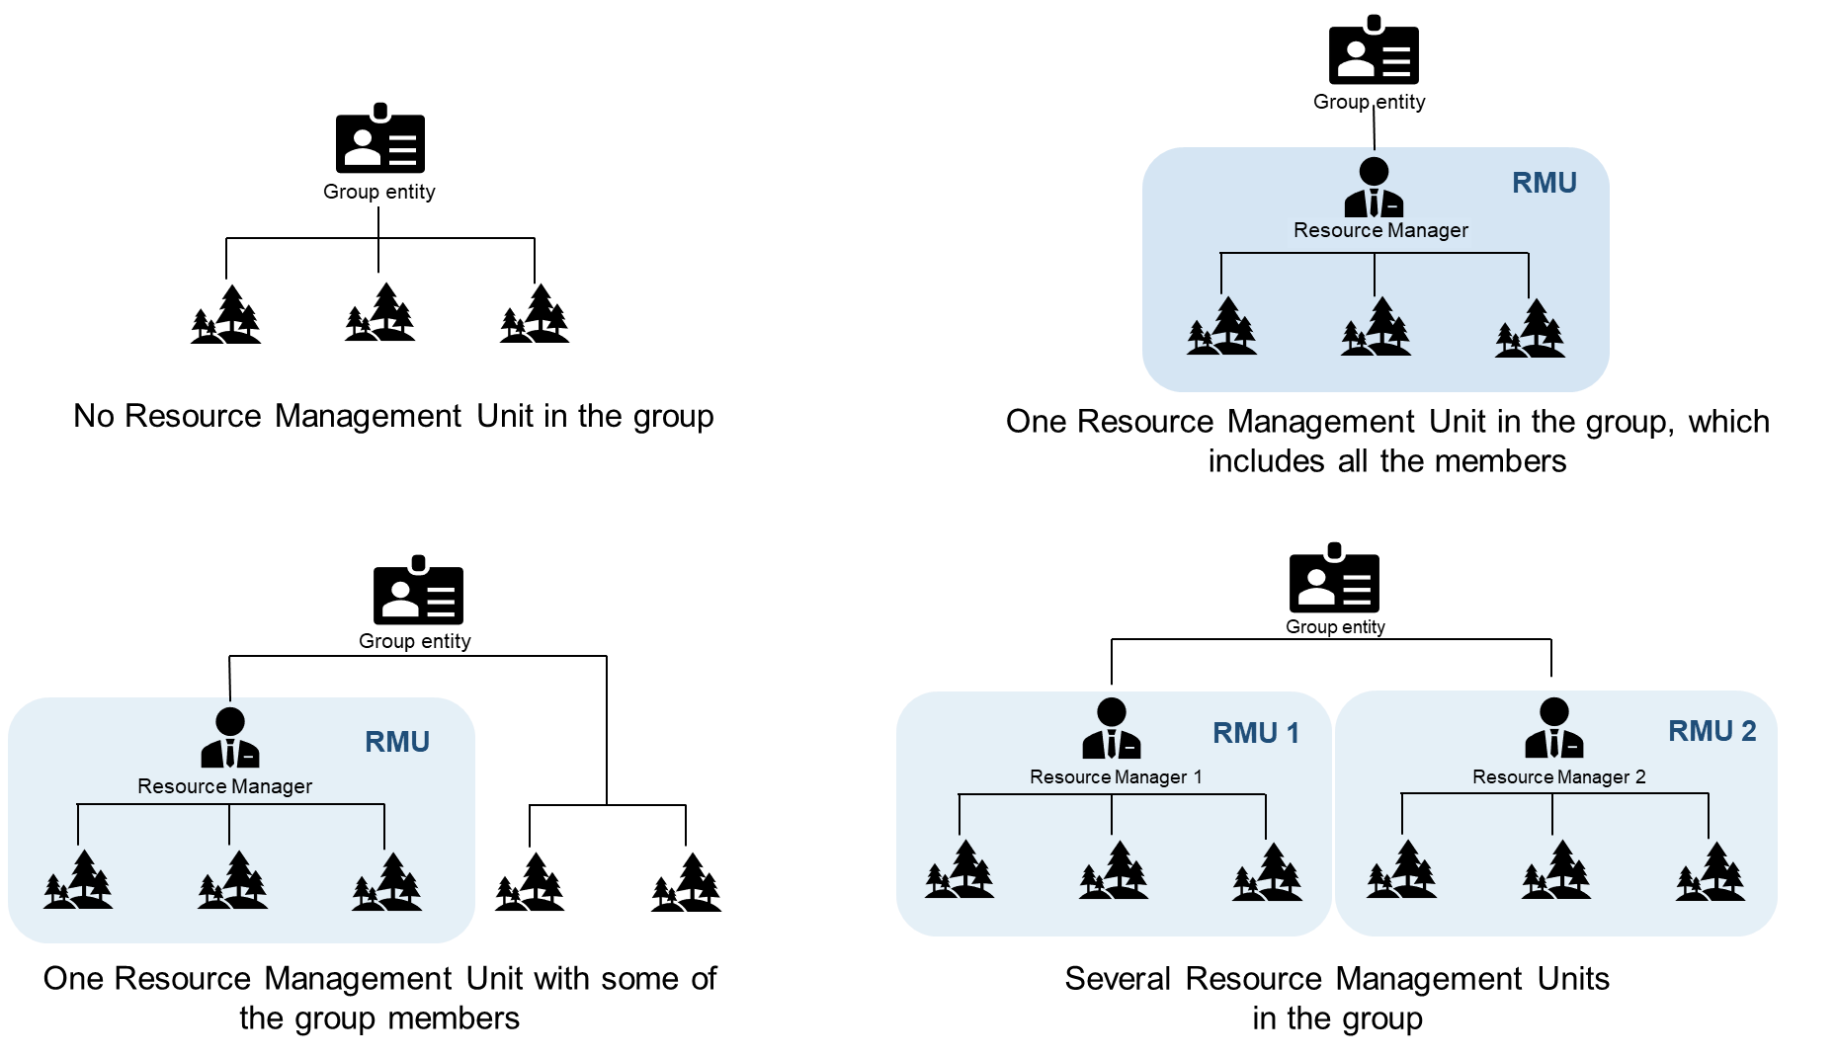

Box 2. Examples of group internal organization
Below please find some examples of how a group can be internally organized. It is optional to have Resource Management Unit(s) in the group, and members can decide to join them, or stay out of them. These are just some examples; other internal organizations are possible.

The number of management units in an RMU will be based on the human and technical capacities of the Resource Manager, at maximum including all the management units of the group.
The Group Entity and the Resource Manager can be the same entity.
The advantage of establishing Resource Management Units is that members can benefit from the knowledge and support in managing their forests from the Resource Manager. The homogeneous management that takes place in Resource Management Units means that the internal monitoring can be established at the discretion of the Group Entity (who can delegate this decision to the Resource Manager).

PART I Establishment of forest management groups
- Requirements for Group Entities
  - The Group Entity shall be a person or group of persons registered as one independent legal entity.
  - The Group Entity shall comply with the applicable legal obligations, such as registration and payment of relevant fees and taxes.
  - When a Group Entity manages more than one group, it shall have enough capacity and resources to manage more than one certificate.
NOTE: Each group will result in one certificate. In any one group, either all members are FSC FM/CoC, or all members are CW/FM; if some members are certified according to FM standards and others according to CW standards, then these would be two different groups.
  - The Group Entity shall be responsible for conformance with this standard.
  - The Group Entity shall make sure that all actors in the group demonstrate sufficient knowledge to fulfil their corresponding responsibilities within the group.
- Requirements for group members
  - A declaration of consent shall be signed by each member wishing to join a group. In the declaration, the member shall:
    - commit to follow the applicable Forest Stewardship Standard and the Group Rules;
    - declare that the management units they are bringing into the group are not included in another FSC certificate;
    - agree to allow the Group Entity, the certification body, FSC and ASI to fulfill their responsibilities;
    - agree that the Group Entity will be the main contact for certification.
NOTE: The declaration of consent does not have to be an individual document. It can be part of a contract or any other document (e.g. meeting minutes) that specifies the relationship agreed between the member and the Group Entity.
NOTE 2: For Communities, the declaration may also be some other form of agreement such as assembly minutes, forest management contracts, tribal agreements for Indigenous communities, recordings of interviews in case of oral agreements, etc.
    - The declaration shall be signed either by the group member or by their representative (e.g. Resource Manager or consultant).
    - When the member is represented by another party (e.g. Resource Manager or consultant), the declaration shall also include a verifiable agreement (legal or otherwise) between the member and their representative.
NOTE: The requirement for the agreement to be verifiable means that the representatives must be able to prove that they have been authorised by the member to act on their behalf.
- Division of responsibilities
  - The Group Entity can divide the responsibilities among the different actors in the group (e.g. Group Entity, members, contractors, etc.).
NOTE: The Group Entity is free to determine at what level implementation of requirements is carried out as long as conformance is demonstrated for each management unit (as per Clause 4.1).

  - The Group Entity shall define and document the division of key responsibilities within the group, as described in Clause 3.1.
Box 3. Applicable Forest Stewardship Standard.
The applicable Forest Stewardship Standard for FM/CoC certification is developed based on the FSC Principles and Criteria, and the International Generic Indicators. In all these documents, the party responsible for conforming with all requirements is referred to as ‘The Organization’.
In groups, ‘The Organization’ is the Group Entity, who can then delegate responsibility to other actors in the group. Because of this, in the context of group certification, ‘The Organization’ would be the actor in the group that is responsible for conformance with a specific requirement from the applicable Forest Stewardship Standard. This can be the Group Entity, but also a member, a contractor, a consultant, a Resource Manager, etc.
For example, the Group Entity can delegate the responsibility to conform with Criterion 10.12 about disposal of waste material to the members of the group. The members would be ‘The Organization’ in charge of conforming with this Criterion, although the Group Entity would be the ultimate responsible for this conformance.
If a non-conformity is identified regarding the implementation of this Criterion, the Group Entity will analyze whether the failure comes from the members level (the members didn´t dispose of the waste material according to the information provided and the responsibility accepted), or if the Group Entity did not provide enough information to the members (if this non-conformity appears in more than one member, this might be an indication of a failure at the Group Entity level).
Controlled Wood:
In the case of CW/FM, the party responsible for conforming with the requirements of FSC-STD-30-010 FSC Controlled Wood Standard for Forest Management Enterprises is the ‘Forest Management Enterprise’. As above, the Group Entity would act by default as the ‘Forest Management Enterprise’, who can delegate its responsibility to conform with standard FSC-STD-30-010 to other actors in the group.
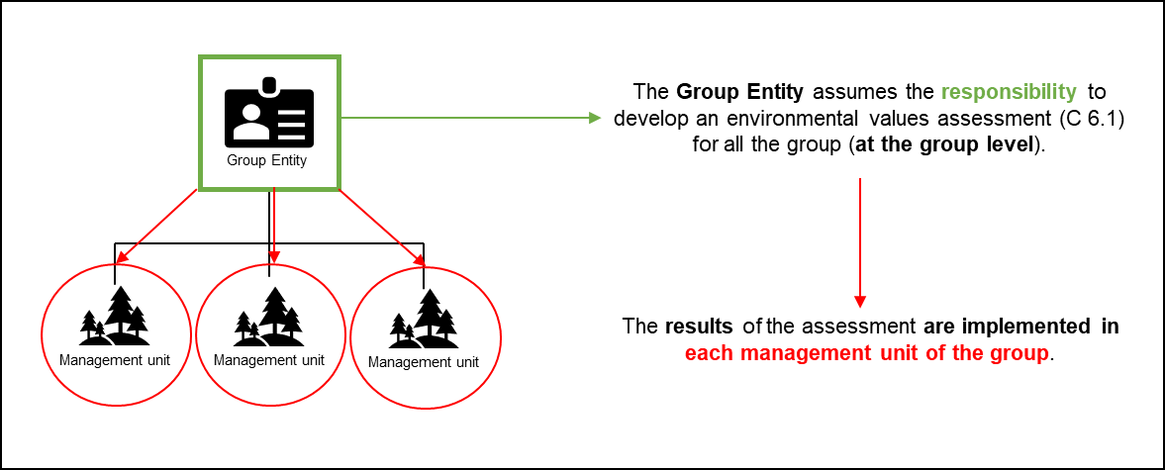
Box 4. Implementation or conformance at group level.
Each group can decide how to internally organize itself, and the Group Entity can decide how to divide the different responsibilities to conform with the applicable Forest Stewardship Standard.
When the Group Entity, or another actor in the group (as explained in Box 3), is responsible for conformance with a requirement from the applicable Forest Stewardship Standard, and this conformance is implemented for all the group, and all the management units of the group, this is commonly referred to as ‘implementation or conformance at group level’. This is possible, and is mostly used for administrative or document-based requirements. It´s important to highlight that the results of any analysis implemented at the group level, and any forest management activities associated with these requirements, must be implemented/conformed with in each management unit of the group.
Here is an example of conformance at group level with Criterion 6.1 about environmental values assessment:

Another example, to conform with Criterion 2.3 about health and safety practices, could be a risk assessment template prepared by the Group Entity for harvesting operations with an associated checklist, including health and safety requirements. This assessment template would be developed by the Group Entity, but used on each management unit to identify the risks associated to each harvesting operation.
Resource Manager and Resource Management Unit
  - Some or all members of a group may choose to transfer the responsibility to ensure conformance with the applicable Forest Stewardship Standard in their management unit(s) to one Resource Manager, and may be grouped into one Resource Management Unit (RMU).
3.3.1. The Resource Manager of an RMU shall assume the responsibility to conform with the applicable Forest Stewardship Standard and to follow the Group Rules on behalf of all members within their RMU.
NOTE: An RMU can include all members of a group or a sub-set of members within a group. There may be more than one RMU within one group.
NOTE 2: Members of an RMU may implement some management activities in their management units, as long as the responsibility to ensure that there is conformance with the applicable Forest Stewardship Standard remains with the Resource Manager.
- Conformance across management units
  - Conformance with all requirements of the applicable Forest Stewardship Standard shall be demonstrated for each management unit within the scope of the FSC FM/CoC or CW/FM group certificate, except as provided for in Clause 4.2.
  - Conformance with area thresholds in the applicable Forest Stewardship Standard with regards to Criterion 6.5, can be demonstrated across management units rather than at the level of the individual management unit for FM/CoC SLIMF management units.
4.2.1. In groups with SLIMF and non-SLIMF management units, the non-SLIMF management units may support SLIMF management units to conform with such requirement, partially or fully.
NOTE: Non-SLIMF management units always need to conform with Criterion 6.5 in each management unit.


Box 5. Conformance with Criterion 6.5 (conservation areas network) across SLIMF management units:
By default, each management unit should conform with Criterion 6.5 on its own (Figure 1). However, if this is not possible for the SLIMF management units individually, they can conform with the requirement across all the SLIMF management units of the group (Figure 2). This means that, for example, there can be two SLIMF management units with a higher percentage of area devoted for conservation, conforming with this requirement on behalf of all the SLIMF management units in the group, provided that the area devoted to conservation meets or exceeds the cumulative area required for all SLIMF management units of the group.
Figure 1. All management units conform with Criterion
6.5 and contain 10% devoted to the conservation areas network.
Figure 2. Some SLIMF management units conform with Criterion 6.5 on behalf of all SLIMF management units. of the group.
The non-SLIMF management units of the group must individually conform with Criterion 6.5. However, they can increase the conservation area to account for the conservation areas of the SLIMF management units of the group. This can be done together with some conservation areas in the SLIMF management units of the


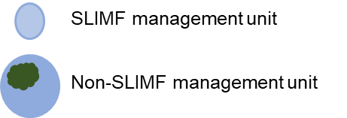




group (Figure 3), or non-SLIMF management units can also be the only ones with conservation areas (Figure 4), conforming with the requirement on behalf of all the SLIMF management units of the group.

Figure 3. Some SLIMF and some non-SLIMF management units of the group conform with Criterion 6.5 on behalf of all SLIMF management units of the group.

Figure 4. The non-SLIMF management units of the group conform with Criterion 6.5 on behalf of all SLIMF management units of the group.

The exception explained here implies that the SLIMF management units that do not have representative sample areas of native ecosystems, or in which these are insufficient, can delegate conformance with Criterion
6.5 to other SLIMF or non-SLIMF management units of the group.
This exception should not be taken as a justification to harvest areas of native ecosystems, which should be protected as per the remaining Criteria under Principle 6.
- Group size
  - The Group Entity shall determine, based on its human and technical capacities, the maximum group size that it can manage, in terms of:
    - number of group members;
    - individual management unit size; and/or
    - total forest area and distribution.
  - The Group Entity shall develop a group management system (as per Part II of this standard) that allows the continuous and effective management of all members of the group.
- Multinational groups
  - FM/CoC and CW/FM groups shall only be established at a national level, except in the cases described in clause 6.2.
  - In cases where homogeneous conditions between countries allow for an effective and credible multinational implementation of the group management system, the Group Entity shall request formal approval from FSC International through their certification body to allow certification of such a group.

PART II Group management system
- Adding new members to the group
  - The Group Entity shall evaluate every applicant who wishes to join the group and ensure that there are no major non-conformities with the applicable Forest Stewardship Standard, nor with membership requirements, before adding the new member to the group.
    - The Group Entity shall conduct a field evaluation to conform with Clause 7.1, except for applicants meeting the SLIMF eligibility criteria or the definition of Communities in this standard, whose evaluation may be done through a desk audit.

    - When a member wants to move from one group to another group managed by the same Group Entity, the Group Entity shall implement this evaluation to allow for the move.
- Provision of information to members
  - The Group Entity shall provide each member with information, or access to information, about how the group works. The information shall include:
    - The Group Rules and the applicable Forest Stewardship Standard, and an explanation of how to conform with them. The Group Entity shall provide access to other applicable normative documents upon request;
    - An explanation of the certification body’s evaluation process;
    - An explanation that the certification body, FSC and ASI have the right to access the members' management unit(s) and documentation;
    - An explanation that the certification body will publish a public summary of their evaluation report; ASI may publish a public summary of their evaluation; and FSC will include information about the group in its database;
    - Explanation of any costs associated with joining the group.
    - When the Group Entity provides members with a summary of these items, it shall make available the full documentation upon request from the members.
    - The information shall be presented in a way that is understandable for members.
- Group Rules
  - The Group shall develop, implement and keep updated written rules to manage the group covering all applicable requirements of this standard, according to the scale and complexity of the group, including:
    - Rules setting out who can become a member of the group;
    - Rules setting out how new members are included in the group;
    - Rules setting out when members can be suspended or removed from the group;
    - An internal monitoring system for the group;
    - A process to resolve corrective action requests issued internally and by the certification body, including timelines and implications if any of the corrective actions are not solved;
    - A procedure to solve complaints from stakeholders to group members;
    - A system for tracking and tracing the FSC-certified forest products produced by the group members up to the defined ‘forest gate’, in conformance with Criterion 8.5 of the applicable Forest Stewardship Standard;
    - Requirements related to marketing or sales of products;
    - Rules setting out how to use the FSC trademarks and the trademark license code.
NOTE: The reference to the scale and complexity of the group refers to the fact that larger and more complex groups, with higher associated risk, might require more comprehensive procedures to ensure the protection of environmental and social values, such as High Conservation Values, Indigenous Peoples, Rare and Threatened Species, etc. Smaller groups, with less associated risk, may develop simpler procedures, but still need to develop all the mentioned Group Rules.

- Group records
  - The Group Entity shall maintain up-to-date records covering all applicable requirements of this standard and the applicable Forest Stewardship Standard. These shall include:
    - A list of the members of the group, including for each member:
      - name and contact details;
      - the date of entering the group and, where relevant, the date of leaving the group, and the reason for leaving;
      - number and area of management units included in the group;
      - geographical location (e.g. coordinates) of each management unit included in the group, supported by a map or documentation;
      - type of forest ownership per member (e.g. privately owned; state managed; communal management; etc.);
      - main products;
      - the sub-certificate codes where these have been issued.
NOTE: The Group Entity must fulfil data protection responsibilities when gathering this information.
    - Any records of training provided to staff and/or group members;
    - Declaration of consent from all group members, as per Clause 2.2;
    - Documentation and records regarding recommended practices for forest management (e.g. silvicultural systems);
    - Records demonstrating the implementation of the group management system. These shall include records of internal monitoring, non-conformities identified in such monitoring, actions taken to correct any identified non-conformity, etc.;
    - Records of the actual or estimated annual harvesting volume of the group and actual annual FSC sales volume of the group.
NOTE: The amount of records maintained centrally by the Group Entity may vary from case to case. In order to reduce costs and increase the efficiency of evaluations by the certification body, and subsequent monitoring by FSC and/or ASI, records should be stored centrally or be accessible digitally whenever possible.
  - The Group Entity shall retain group records for at least five (5) years.
  - In countries where FSC International has determined that there is a high risk of false claims involving material harvested from groups, the Group Entity shall maintain up-to- date records of the harvesting and FSC sales volumes of each management unit in the group.
NOTE: For management units in the group where the harvesting and sales are carried out by a contractor, the Group Entity should verify that the volumes sold by the contractor correspond to the estimated volumes bought from its group. For this purpose, the contract between the forest owner and the contractor should include a requirement for the contractor to communicate to the forest owner and the Group Entity the actual (measured) volume harvested and sold.
- Internal monitoring
  - The Group Entity shall implement a documented internal monitoring system that includes at least the following:
    - A description of the internal monitoring system, sufficient to:

      - make sure there is continued conformance with the applicable Forest Stewardship Standard in the management units in the group;
      - check the adequacy of the group management system and the Group Entity´s overall performance.
    - Regular (at least annual) monitoring visits to a sample of management units within the group;
    - Regular (at least annual) analysis of the results of the internal monitoring to improve the group management system.
  - The Group Entity shall select the requirements from the applicable Forest Stewardship Standard to be monitored at each internal evaluation according to the scale, intensity and risk.
NOTE: The Group Entity may focus their monitoring during a particular internal evaluation on specific elements of the applicable Forest Stewardship Standard, with the provision that all aspects of the Forest Stewardship Standard are evaluated for the group, through the sampled management units, during the period of validity of the certificate.
  - The Group Entity shall specify what constitutes an active management unit for the group and justify the classification of activities as active or inactive management.
  - The minimum sample of management units to be visited annually for internal monitoring shall be calculated according to this table:

Size class | Internal monitoring
Active management units > 1,000 ha | X= √y
Active management units ≤ 1,000 ha; SLIMF management units and Communities | X= 0.6 * √y
Inactive management units | X= 0.1 * √y
Management units in Resource Management Units | At the discretion of the Group Entity
Table 1. Internal monitoring sampling calculation.

Where: X = number of management units to be sampled;
y = number of active or inactive management units within each category.
  - The number of units calculated (X) using Table 1 shall be rounded up to the nearest whole number.
  - Inactive management units may be monitored remotely if the necessary information is available (e.g. remote sensing, digital imagery, phone interviews, documents proving payments/sales/provision of material and training).
  - The Group Entity may lower the minimum sample defined in Clause 11.4 based on the regular analysis of the results of the monitoring as per Clause 11.1 c).
  - The Group Entity shall increase the calculated minimum sample when high risks are identified (e.g. unresolved substantiated land tenure or use rights disputes, High Conservation Values (HCVs) are threatened, substantiated stakeholder complaints, etc.).
  - The Group Entity should visit different management units during the internal monitoring from the ones previously visited by the certification body, unless there are pending corrective actions, complaints or risk factors that require a revisit of the same units.

  - The Group Entity shall issue corrective action requests to address non-conformities identified during the internal monitoring and follow up their implementation.
NOTE: Non-conformities identified at the level of a group member may result in non- conformities at the Group Entity level when the non-conformities are determined to be the result of the Group Entity’s performance.
Box 6. Internal monitoring
The internal monitoring of the group includes annual field visits to a sample of management units of the group. The minimum number of management units to be visited annually is calculated by using the table in Clause 11.4.
The Group Entity can also justify applying a lower monitoring intensity as per Clause 11.5. For this, the Group Entity needs to analyze the results of their internal monitoring. Based on this analysis, the Group Entity can improve their group management system, and adapt their internal monitoring intensity to fit their circumstances.
The Group Entity must be able to demonstrate to the certification body that the internal monitoring methodology defined for their group will allow them to verify that the group management units are in conformance with the applicable Forest Stewardship Standard, and that non-conformities will be identified.
As a result of the analysis of the internal monitoring results, it could also be that the Group Entity needs to sample more than the baseline or minimum sample established in Clause 11.4. This is of course possible, and is actually a requirement when there are high risks situations in the group, as explained in Clause 11.6.
- Chain of Custody
  - The Group Entity shall implement a tracking and tracing system for FSC-certified products, to ensure that they are not mixed with non-certified material.
  - The Group Entity shall ensure that all invoices for sales of FSC-certified material include the required information (as per the applicable Forest Stewardship Standard).
  - The Group Entity shall ensure that all uses of the FSC trademarks are approved by their certification body in advance.
  - The Group Entity shall not issue any kind of certificates to their members that could be confused with FSC certificates.
NOTE: To prove that certain management units are covered by the group certificate, the member can use the list of the members of the group or a member certificate issued by the certification body. It is important that none of these documents are confused with the FSC certificate of the group held by the Group Entity.

Box 7. Ecosystem Services
The Group Entity or all/some of the members can choose to implement the FSC-PRO-30-006 Ecosystem Services Procedure: Impact Demonstration and Market Tools on their management unit(s) when the group has FM or FM/CoC certification.
Additional technical guidance for using the Ecosystem Services Procedure to improve access to ecosystem services markets can be found in the FSC-GUI-30-006 Guidance for Demonstrating Ecosystem Services Impacts.

PART III Optional Inclusion of Forestry Contractors in Groups
- Requirements for forestry contractors
  - Forestry contractors may only join an FSC FM/CoC group.
NOTE: Forestry contractors can join more than one group, and operate under the FSC group certificate(s) but only in the management units of the group(s) that they have joined.
NOTE 2: Forestry contractors can have a separate CoC certificate to operate in management units outside the group.
NOTE 3: Upon completion of the ongoing revision of standard FSC-STD-30-010 V2-0 FSC Controlled Wood Standard for Forest Management Enterprises, this clause will be reviewed to consider the possibility for forestry contractors to also join CW/FM groups.
  - The Group Entity may allocate responsibilities to conform with the applicable Forest Stewardship Standard to forestry contractors in the group, as per Clause 3.1.
  - A contract, including a declaration of consent, shall be signed by each forestry contractor wishing to join a group. In the contract, the forestry contractor shall:
    - commit to follow the applicable Forest Stewardship Standard and the Group Rules, and to ensure that any sub-contractors will follow them as well;
    - agree to allow the Group Entity, the certification body, FSC and ASI to fulfil their responsibilities;
    - agree that the Group Entity will be the main contact for certification;
    - include the agreed terms between the forestry contractor and the Group Entity.
- Group Rules for contractors
  - The Group Entity shall adapt the Group Rules to include forestry contractors.
  - The Group Entity shall define the process for forestry contractors to report to the Group Entity the type (e.g. harvesting, planting, management plan development), location (management units of the group) and outcomes (e.g. volume harvested, number of plants planted, documents developed) of their operations.
- Evaluation of new forestry contractors
  - The Group Entity shall evaluate each forestry contractor applying to join the group, prior to approving the application, through:
    - An on-site evaluation of an operation in a sample management unit; and/or
    - A verification that the contractor has sufficient qualifications or knowledge to operate according to the applicable Forest Stewardship Standard and fulfil their responsibilities within the group.
  - When a forestry contractor wants to move from one group to another group managed by the same Group Entity, the Group Entity shall implement this evaluation to allow for the move.
- Records regarding contractors
  - When forestry contractors are included in the group, the Group Entity shall maintain up- to-date records, including:
    - Name and contact details;
    - The date of entering the group and, where relevant, the date of leaving the group, and the reason for leaving;

    - Any records of training provided by the Group Entity;
    - The results of the forestry contractors´ monitoring through the sampled management units (Clause 17.1) and the targeted internal evaluation (Clause 18.1);
    - Records of the harvesting and sales volumes, at least annually, if applicable, resulting from operations carried out by contractors within the group certificate.
- Internal monitoring with contractors in the group
  - In management units where outsourced services are carried out only by forestry contractors in the group, the Group Entity shall follow Section 11 of this standard, but instead of using Table 1 in clause 11.4, the minimum sample of management units to be visited annually for internal monitoring shall be calculated according to Table 2:

Activity in the management unit | Internal monitoring
Active management units | X= 0.6 * √y
Inactive management units | X= 0.1 * √y
Table 2: Internal monitoring sampling calculation with forestry contractors in the group.

Where: X = number of management units to be sampled;
y = number of active or inactive management units within each category.
- Internal monitoring of contractors
  - The Group Entity shall implement a targeted internal evaluation of all forestry contractors included in the group at least once during the validity of the certificate.
NOTE: This targeted internal evaluation is additional to the internal monitoring of the contractors´ performance through the management units sampled annually (as per Clause 17.1). The objective of this evaluation is to ensure that contractors are adequately fulfilling the responsibilities that the Group Entity has allocated to them (e.g. planning, evaluation of new members, internal monitoring, development of documents).
18.1.1 The Group Entity shall increase this internal evaluation intensity when high risks are identified (e.g. recurrent non-conformities by the contractor, substantiated stakeholder complaints about the contractor´s performance).
18.2 The Group Entity shall issue corrective action requests to address non-conformities identified during the monitoring of the forestry contractors and follow up their implementation.
- Contractors´ Chain of Custody
  - Forestry contractors shall have records of the annual harvesting volume and annual FSC sales volume of their harvesting and sales activities covered by the certificate of the group.
  - Such volume records shall be provided to the Group Entity.
  - Forestry contractors shall ensure that all invoices for sales of FSC-certified material include the required information (as per the applicable Forest Stewardship Standard) and provide a copy of these invoices to the Group Entity.
  - When selling FSC-certified material, the contractor shall use in the invoices the certificate code of the group from which the material comes from.

Box 8. Forestry contractors in the group
Forestry contractors can be included in the scope of the group certificate by following the requirements of Part III of this standard. This inclusion is optional and voluntary, and allows for some benefits:
- reducing the internal monitoring intensity in the management units where the outsourced services are carried out only by forestry contractors of the group;
- potentially reducing the risk associated with management activities, by using contractors that are trained and monitored by the Group Entity;
- providing access for forestry contractors to the Chain of Custody system of the FM/CoC groups, for example:
- A forestry contractor included in the group can purchase FSC-certified material from a number of members of the group and aggregate the material (load/unload and accumulate it at a log yard) before selling it to the Group Entity of the group. The Group Entity can then sell the material at a point ‘beyond the forest gate’ (outside of the actors in the group). All these transactions would be under the scope of the group certificate and the contractor would not need a separate CoC certificate. Volumes of the sold FSC-certified material must be recorded.
- A forestry contractor of the group buys standing timber (or NTFPs) from one member of the group and sells it within or outside of the group. This activity would also be covered by the group certificate (and the contractor would not need a separate CoC certificate).
- A contractor X that belongs to group Y sells FSC-certified material to a contractor A that belongs to group
B. Contractor X can sell the material being covered by its group certificate, because the material comes from their group Y. Contractor A, in order to pass on the FSC claim from contractor X, would need a separate CoC certificate, since the material they are purchasing does not come from their group.
If a forestry contractor that belongs to a group would like to work in other management units outside of their group, they would need their own separate Chain of Custody certificate in order to be able to pass on the FSC claim for the certified material from the management units outside of their group.
When a forestry contractor belongs to more than one group, regarding the selling of FSC-certified material and the certificate code to use on invoices, the contractor can:
- have their own separate CoC certificate, so that they take ownership of the purchased material and they can mix the material purchased from the multiple groups; or
- if they want to operate under the group certificates, they would need to segregate and track the material using the groups CoC control system.

Forestry contractors can continue to work in groups without having to be included in the scope of the group certificate(s). In this case, these contractors do not need to follow the requirements of Part III of this standard, and they would not be covered by the group certificate(s), so they would require a separate Chain of Custody certificate.

The diagrams below show some examples of how forestry contractors can be included in groups:

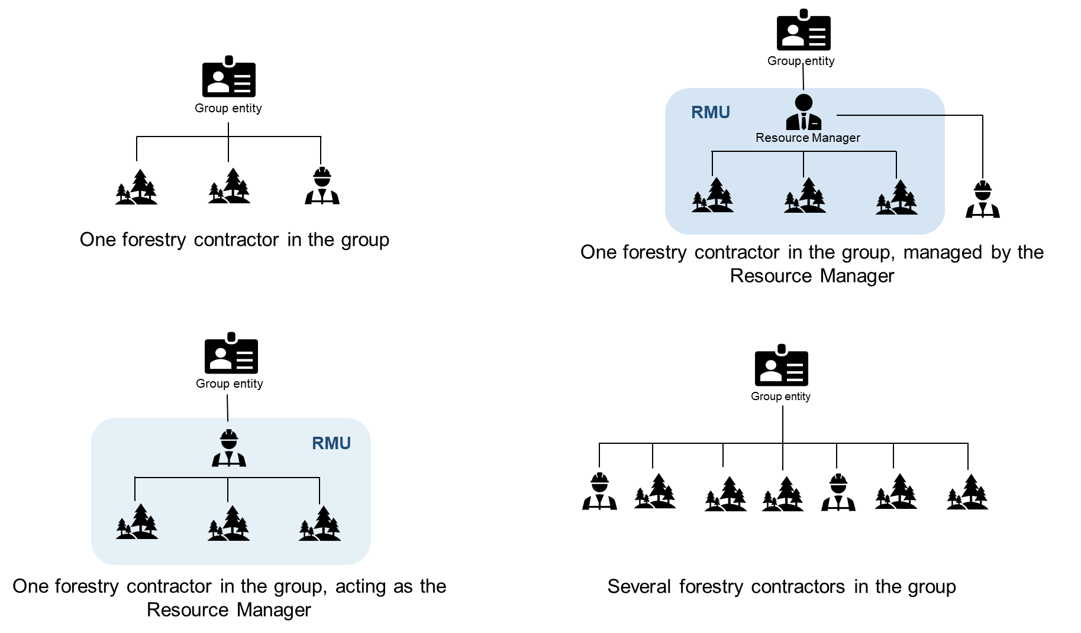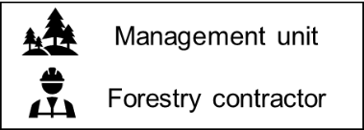



www.fsc.org
FSC International Center GmbH Adenauerallee 134 · 53113 Bonn · Germany

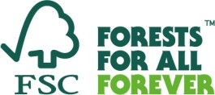

All Rights Reserved FSC® International 2020 FSC®F000100

