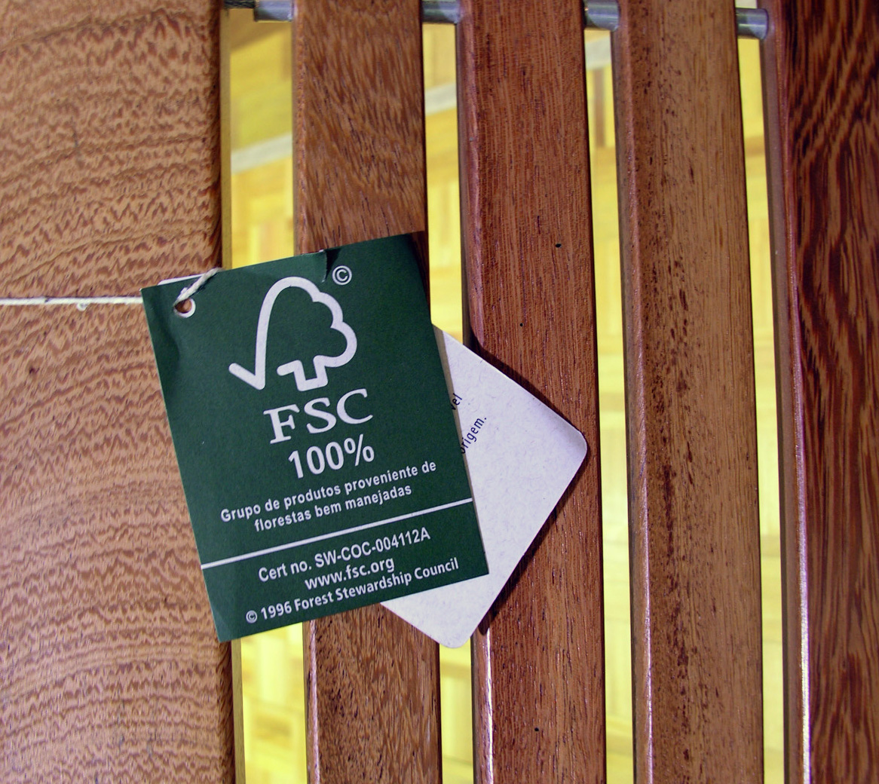
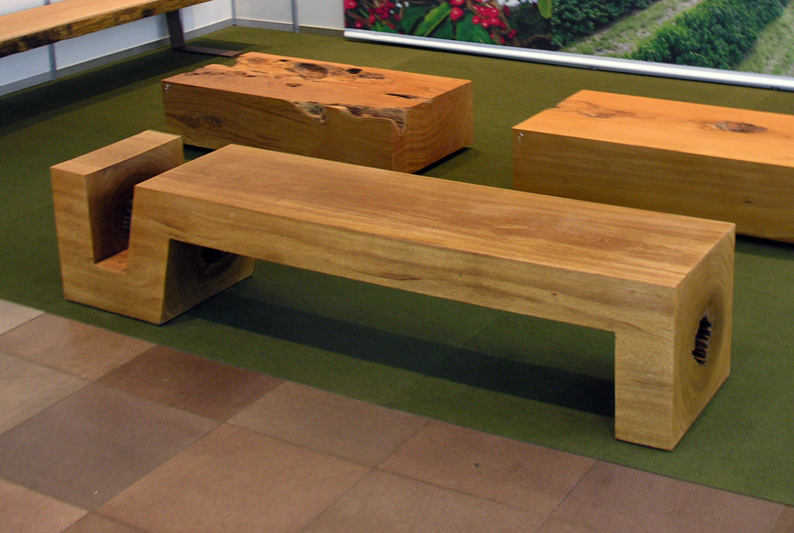
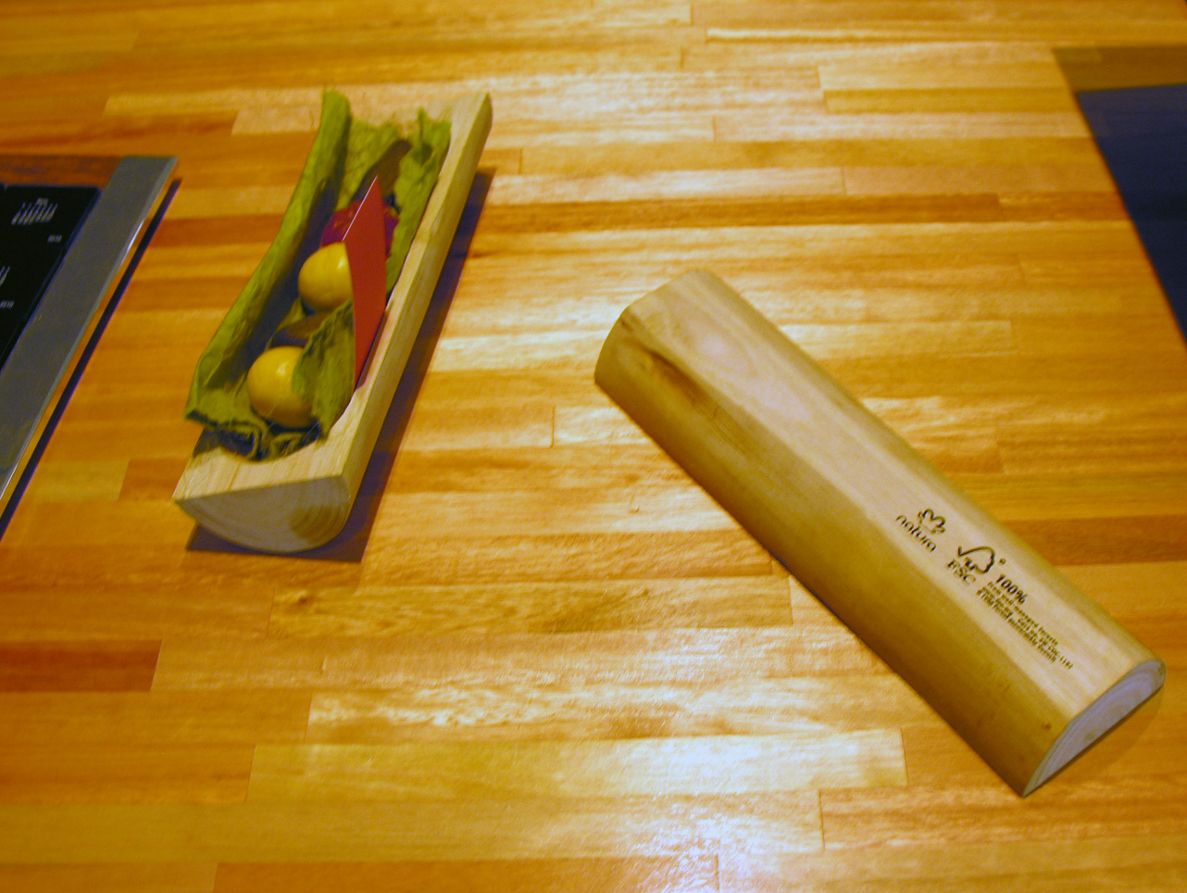

FSC® STANDARD ADDENDUM

FSC Product Classification

FSC-STD-40-004a V2-1 EN

CHAIN OF CUSTODY
Title: | FSC Product Classification
Document reference code: | FSC-STD-40-004a V2-1 EN
Scope: | International
Approval: | 16 December 2013
Contact: | FSC International Center  Policy and Standards Unit  Charles-de-Gaulle Str. 5  53113 Bonn, Germany  Phone: +49-228 / 367-66-0  Fax: +49-228 / 367-6630  E-mail: policy.standards@fsc.org
© 2013 Forest Stewardship Council, A.C. All rights reserved.

No part of this work covered by the publisher’s copyright may be reproduced or copied in any form or by any means (graphic, electronic or mechanical, including photocopying, recording, recording taping, or information retrieval systems) without the written permission of the publisher.

Printed copies are uncontrolled and for reference only. Please refer to the electronic copy on the FSC website (www.fsc.org) to ensure you are referring to the latest version.

The Forest Stewardship Council® (FSC) is an independent, not for profit, non-government organization established to promote environmentally appropriate, socially beneficial, and economically viable management of the world's forests.

FSC’s vision is that the world’s forests meet the social, ecological, and economic rights and needs of the present generation without compromising those of future generations.

Foreword

This document shall be used as an addendum to “FSC-STD-40-004: FSC Standard for Chain of Custody Certification” for the purpose of classifying FSC product groups.
The organization’s product groups covered by FSC Chain of Custody certification will be publicly listed on the FSC certificate database (www.info.fsc.org).
This document will be updated at regularly intervals in order to reflect the increasing range of certified products covered by FSC Chain of Custody certificates.

Note on use of this standard addendum

All aspects of this standard are considered to be normative, including the scope, standard effective date, references, terms and definitions, tables and annexes, unless otherwise stated.

Contents

A Scope
B Effective date
C References
D Terms and definitions
FSC Product Classification
- Wood Products
- Pulp and Paper Products
- Non-timber Forest Products (NTFPs)

A Scope
This standard addendum stipulates the product type nomenclatures that shall be used by Certificate Holders for the purpose of classifying FSC Product Groups.

B Effective date
This standard addendum becomes effective on 01 January 2014 and all certificate holders shall be in compliance with this document by 01 January 2014.

C References
The following referenced documents are indispensable for the application of this document. For references without a version number, the latest edition of the referenced document (including any amendments) applies.

FSC-STD-40-004 FSC Standard for Chain of Custody Certification

D Terms and definitions
For the purposes of this international standard, the terms and definitions given in FSC-STD-01-002 FSC Glossary of Terms and the following apply:

Agglomerated cork stoppers: Stoppers formed of granulated corks which are constituents derived from the manufacture of natural cork closures.
Banner: Displayed using a stand or placeholder, typically larger than posters.
Bartop cork stopper: is a cork composed by a cork body and a capsule in another material.
Blockboard: Engineered wood product characterised by an intermediate ply consisting of sawn bars.
Boards, finished: Refers to wood used in construction that is finished (moulded, planed, or sanded) and cut to standardized width and depth (≤1” or 2.54 cm thick)
Boule: Rectangular, unedged block of wood.
Brochure: Type of leaflet, also referred to as a pamphlet.
Catalogue: Publication containing a list of general merchandise from a company.
Coated paper*: All paper suitable for printing or other graphic purposes and coated on one or both sides with minerals such as china clay (kaolin), calcium carbonate, etc. Coating may be by a variety of methods, both on-machine and off-machine, and may be supplemented by
super-calendering. Coated Mechanical papers are made of fibres produced mainly (90%) by a mechanical pulping process and are also known as coated groundwood. Coated Woodfree papers are made of fibres produced mainly (90%) by a chemical pulping process and are also known as coated freesheet.
Colmated corks: Natural cork stoppers with their pores (lenticels) sealed exclusively with cork dust, which results from rectifying natural cork stoppers. For the cork dust to adhere to the pores (lenticels), FDA grade natural resin, rubber glue and occasionally water-based glue are used.
Compressed wood: Wood that has been densified by pressure.
Corrugated fibreboard: Sometimes known as corrugated board or corrugated cardboard, is a combined paper-based material consisting of a fluted corrugated medium and one or two flat linerboards.
Crepe: Paper that has been coated with sizing and then creped to create gathers.
Decking: Floor decking normally used for terraces (a low or high raised flat platform).
Deinked pulp*: Pulp made from recovered paper from which inks and other contaminants have been removed.
Dimensional timber/lumber, finished: Wood used in construction that is finished (moulded, planed and/or sanded) and cut to standardized width and depth (e.g. 2x4 inches, 5x10 cm).
Dissolving pulp: Pulp consisting of nearly pure cellulose. It is also called high purity cellulose.
Edging: Rough edged, often conical pinnacled trimmings, also called splinter.
Ethanol: Alcohol fermented from natural wood sugars that are extracted from the waste sulfite liquor produced from the specialty cellulose pulp process.
Flitch: Unedged block of wood.
Fluting: Corrugating medium between the linerboard of corrugated board.
Flyer: Single printed page with no folds, sometimes called leaflet.
Fuelwood: Roundwood or other parts of a (felled) tree used for energy production. e.g. splitwood, split billets, chips, forest pellets, faggot and firestarters, also called firewood.
Glued laminated timber (GLULAM): Type of structural product composed of several layers of dimensioned timber glued together, also called glulam or manufactured trusses.
Greaseproof paper: Paper that is impermeable to oil or grease and is normally used in cooking or food packaging.
Gum resin: Solid form of resin, produced by heating fresh liquid resin to vaporize the volatile liquid terpene components.
Hammock: Sling suspended between two points, used for swinging, sleeping or resting.
I-joist: An I-Joist comprises a web and two flanges. The web (typically OSB or plywood) is sandwiched between a top and bottom flange (typically LVL or sawn lumber).
Institutional casework: Furniture of a kind used in educational and health care environments, such as schools, medical facilities, laboratories.
Laminate flooring: Multi-layer synthetic flooring product fused together with a lamination process. Laminate flooring simulates wood (or stone, in some cases) with a photographic appliqué layer under a clear protective layer. The inner core layer is usually composed of melamine resin and fibre board materials.
Laminated compressed wood: Consists of laminated veneer sheets that are densified under pressure. It is also called densified wood.
Laminated Veneer Lumber (LVL): Laminated veneer lumber consists of veneers (typically 1/7”-1/10” thickness) all running parallel to the length of product (exception that some lay-ups may require 1-2 cross plies for improved dimensional stability). LVL is commonly bonded together using exterior structural-grade adhesives that are cured under high temperature and pressure.
Laminboard: Engineered wood product that has an intermediate ply consisting of upright standing strips of peeled veneer.
Magazine: Publication generally published on a regular schedule, at least four times a year.
Moulded plywood: Formed plywood under heat and moisture for special purposes, e.g. chair seats.
Moulding: A strip of material used to cover transitions between surfaces or for decoration.
Newsprint*: Paper mainly used for printing newspapers. It is made largely from mechanical pulp and/or recovered paper, with or without a small amount of filler. Weights usually range from 40 to 52g/m² but can be as high as 65g/m². Newsprint is machine-finished or slightly calendered, white or slightly coloured and is used in reels for letterpress, offset or flexo-printing.
Non-timber forest product: All forest products except timber, including other materials obtained from trees such as resins and leaves, as well as any other plant and animal products. Examples include, but are not limited to, seeds, fruits, nuts, honey, ornamental plants and other forest products whether they were originated inside a forest system.
Notebook: Book or binder composed of pages of notes, often ruled, used for various purposes including recording notes, drawing or something like this. They are of varying sizes. Notebooks are also called notepads, writing pads, drawing pads, etc.
Paper: A material manufactured in thin, lightweight, flexible sheets from the pulp of wood or other fibrous substances, typically used for writing, drawing, or printed on, or as wrapping material.
Paperboard: A material manufactured in thick, heavy, rigid sheets from the pulp of wood or other fibrous substances, typically used for construction of corrugated or cartons. Sometimes referred to as cardboard, containerboard or boxboard.
Parallel Strand Lumber (PSL): PSL consists of long veneer strands laid in parallel formation and bonded together with an adhesive to form the finished structural section. Like LVL and glulams, this product is used for beam and header applications where high bending strength is needed. PSL is also frequently used as load-bearing columns.
Parquet flooring: Geometric mosaic of solid wood pieces used for flooring.
Particleboard: Engineered wood product manufactured from wood particles (mainly shavings), also called chipboards.
Poster: Printed paper designed to be attached to a wall or vertical surface.
Pressboard: Board made by compressing layers of paper together.
Railway sleeper/tie: A railroad tie/railway tie (North America), or railway sleeper (Europe) is a rectangular piece of wood used as a base for railroad tracks.
Rolled thermal paper: Thermographic paper in roll (e.g. paper roll used for cash register).
Roundwood: Felled, limbed, if applicable cross-cutted and if applicable debarked wood as raw material for the subsequent manufacturing. E.g. sawmill wood, veneering wood, sleeper timber, pole timber and industrial timber.
Shaving: Fine particle of wood produced as a by-product of sawing, also called sawdust or sawings.
Slab: The outer part with rough edge of a log, produced during sawing.
Smooth-surface panels: The surface layer of the particleboard consists of fibres.
Soil conditioner: Material used to improve the physic-chemical and biological qualities of soil.
Stool: A kind of chair without back or arm rests.
Substrates for plants: Growing medium for plants.
Technical cork stopper: Stoppers that consist of a very dense agglomerate cork body with natural cork disks glued on one or both ends.
Thermographic paper: Paper that changes its colour on heating.
Timber: Wood in any of its stages from felling through readiness for use as structural material for construction or wood pulp for paper production. In this classification timber is a term also used for sawn wood products.
Translucent paper: Paper that allows light to pass through diffusely.
Uncoated paper: Paper that does not have any kind of coating such as clay or latex applied to it. Uncoated paper is typically used for copy or printing paper.
Veneer: Thin slices of wood, thinner than 6 mm.
Veneer plywood: Plywood that consists of only parallel veneer layers.
Veneer strip: The breadth of veneer strips is up to 80 mm.
Wrapping papers*: Papers whose main use is wrapping or packaging made from any combination of virgin or recovered fibres, bleached or unbleached. They may be subject to various finishing and/or marking processes. Included are sack kraft, other wrapping krafts, sulfite and grease-proof papers.
Wood flour: Wood flour is pulverized wood. The consistency is fairly equal to sand or sawdust, but can vary ranging in size from a fine powder to roughly the size of a grain of rice.
Wood wool: A thin but elastic wood fibre produced during planning, also called excelsior.

* Definitions from CEPI - Confederation of European Paper Industries.

FSC Product Classification
The table below provides the Product Type nomenclatures that shall be used by Certificate Holders for the classification of FSC Product Groups, in accordance with the requirements of FSC-STD-40-004 FSC Standard for Chain of Custody Certification.

WOOD PRODUCTS

Level 1 | Level 2 | Level 3 | Examples
W1  Rough wood | W1.1  Roundwood (logs)
W1.2
Fuel wood
W1.3
Twigs
W2  Wood charcoal |  |  | E.g. Barbecue charcoal
W3  Wood in chips or particles | W3.1  Wood chips
W3.2
Sawdust
W3.3
Wood shavings
W3.4
Wood wool
W3.5
Wood flour
W3.6
Wood pellets
W3.7
Sawdust briquettes
W4  Impregnated/treated wood | W4.1  Impregnated roundwood
W4.2
Impregnated railway sleepers/ties
 | W4.3  Treated dimensional lumber, timber or plywood | W4.3.1  Treated glued laminated timber
W4.3.2
Treated finger jointed lumber
W5  Solid wood (sawn, chipped, sliced or peeled) | W5.1  Flitches and boules
 | W5.2  Solid wood boards |  | E.g. Lumber core, rough-cut lumber, blockboard, stave core board
W5.3
Beams
W5.4
Planks
W5.5
Poles and piles
 | W5.6  Railway sleepers/ties, not impregnated |  | E.g. Railroad tie
 | W5.7  Raw wood for parquet flooring |  | E.g. Wood blocks, friezes, strips.
W5.8
Slabs and edgings
W5.9
Pencil slats
W6  Products from planing mill | W6.1  Dimensional timber and lumber, finished
W6.2
Non-dimensional timber and lumber
W6.3
Boards, finished
W7  Veneer | W7.1  Peeled veneer
W7.2
Sliced veneer
W7.3
Sawn veneer
W7.4
Veneer strips
W8  Wood panels | W8.1  Plywood | W8.1.1  Laminboard
W8.1.2
Veneer plywood
 | W8.2  Particleboard | W8.2.1  Melamine particleboard
W8.2.2
Veneered particleboard
W8.2.3
Oriented Strand Board (OSB)
W8.2.4
Smooth-surface panel
W8.2.5
Wood cement particleboard
W8.2.6
Plasterboard
W8.2.7
Strawboard
W8.2.8
Graded particleboard
 | W8.3  Fibreboard | W8.3.1  High-density fibreboard (HDF)
W8.3.2
Medium-density fibreboard (MDF)
 |  | W8.3.3  Softboard | E.g. (noise-)insulating boards
W8.3.4
Medium-hard-fibreboard
W9  Engineered wood products | W9.1  Finger jointed wood
W9.2
Laminated veneer lumber (LVL)
W9.3
Parallel strand lumber (PSL)
W9.4
Wood-wool board
W9.5
Solid-wood board
W9.6
Glued laminated timber (GLULAM)
W9.7
I-joists, I-beams
 | W9.8  Laminated compressed wood |  | E.g. Laminated wood, densified wood
 | W9.9  Composite board |  | E.g. Cellular boards
 | W9.10  Compressed wood |  | E.g. Resin-treated compressed wood, heat-stabilized compressed wood
W9.11
Wood-plastic composites
W10  Wood package and similar | W10.1  Solid wood packaging |  | E.g. Cases, boxes, crates, cases for jewellery or cutlery.
W10.2
Cable-drums
W10.3
Pallets and skids
 | W10.4  Cooper's products |  | E.g. Staves, barrels, casks, vats, tubs
W10.5
Container flooring
W11  Wood for construction | W11.1  Doors and door frames |  | E.g. Flush doors, fire doors
W11.2
Windows and window frames
W11.3
Stairs
W11.4
Dividers
 | W11.5  Flooring | W11.5.1  Laminate flooring
 |  | W11.5.2  Parquet flooring | E.g. Assembled parquet panels, block parquets
W11.5.3
Plank flooring
W11.5.4
Wood-block flooring
W11.5.5
Engineered flooring
W11.6
Gates and garage doors
W11.7
Wall cladding
 | W11.8  Mouldings |  | E.g. MDF mouldings, softwood mouldings
W11.9
Hot tubs and sauna
W11.10
Wooden insulation
W11.11
Window blinds, shutters and similar
 | W11.12  Houses and building elements |  | E.g. Prefabricated facade construction elements
W11.13
Marine constructions, except boats
W11.14
Trusses and roofs
 | W11.15  Roofing tiles |  | E.g. Shingles, shakes.
W12  Indoor furniture | W12.1  Cabinet
 | W12.2  Custom furniture |  | E.g. Custom cabinetry, built-in desks, counters, etc.
W12.3
Tables
W12.4
Beds
W12.5
Couches and armchairs
W12.6
Chairs and stools
W12.7
Office furniture
 | W12.8  Institutional casework |  | E.g. Furniture for laboratories, schools, hospitals.
W12.9
Wardrobes
W12.10
Cupboards and chests
W12.11
Kitchen countertops
W12.12
Parts of furniture
W12.13
Shelves

W13  Outdoor furniture and gardening | W13.1  Garden furniture | W13.1.1  Garden tables
W13.1.2
Garden benches
W13.1.3
Garden chairs and stools
W13.1.4
Hammocks and hammock frames
W13.2
Trellis and plant support
 | W13.3  Shelters and parasols |  | E.g. Gazebo
W13.4
Fences, fence stakes, pales
W13.5
Decking and garden sleepers
W13.6
Garden sheds
 | W13.7  Other outdoor furniture and gardening products |  | E.g. Flower boxes, palisades, wooden boxes for storing outdoor equipment
W14  Musical instruments | W14.1  String musical instruments |  | E.g. Violin, guitars, harps
 | W14.2  Keyboard musical instruments |  | E.g. Piano, organs
 | W14.3  Wind or mouth-blown musical instruments |  | E.g. Clarinet, oboe, bassoon
 | W14.4  Percussion instruments |  | E.g. Drums, bongos
 | W14.5  Parts of musical instruments |  | E.g. Guitar necks
W15  Recreational goods | W15.1  Playground equipment |  | E.g. Roundabouts, swings, slides, cable railway, sheds and similar
W15.2
Toys and games made with wood
 | W15.3  Sporting goods | W15.3.1  Bicycles
W15.3.2
Bats, sticks, poles and paddles
W15.3.3
Boards and skis
 |  | W15.3.4  Other sporting goods | E.g. Yoga blocks, wooden balls
W16  Household articles | W16.1  Wooden frames |  | E.g. Frames for paintings, photographs, mirrors
 | W16.2  Brooms, brushes and brush handles |  | E.g. Brush bodies and handles, combs
 | W16.3  Tableware, kitchenware and similar |  | E.g. Wooden spoons, chopsticks, toothpicks, pepper mills, bbq sets
W16.4
Clothes hangers and pegs
W16.5
Toilet seats
W16.6
Matches
W16.7
Mousetraps
W16.8
Fans
W16.9
Ladders
 | W16.10  Bath items or accessories |  | E.g. Stool, bath chair, bath tub
W17  Stationery of wood | W17.1  Pens
W17.2
Pencils
W17.3
Rulers
W17.4
Stamps
W18  Other manufactured wood products | W18.1  Dowels and turnery parts of wood
W18.2
Coffins
 | W18.3  Medical supplies made of wood |  | E.g. Orthopaedic products, prosthetic limbs, tongue depressors
 | W18.4  Tools, tool bodies and tool handles |  | E.g. Hammer, axes
W18.5
Ice pop/lolly sticks
W18.6
Jewellery
 | W18.7  Works of art |  | E.g. Wood marquetry, inlaid wood, statuettes and similar
W18.8
Ornamental & decorative objects
W18.9
Wheels
 | W18.10  Boats |  | E.g. Sailboats, kayaks, canoes
W18.11
Wooden lighters
 | W18.12  Wildlife and pet products |  | E.g. Nestboxes, birdhouses
W19
Other wood products n.e.c.*
* The n.e.c. abbreviation means that the category includes those products “not elsewhere classified”.

PULP AND PAPER PRODUCTS

Level 1 | Level 2 | Level 3 | Examples
P1  Pulp | P1.1  Mechanical pulp, bleached | P1.1.1  Groundwood
 |  | P1.1.2  Refiner pulp | E.g. RMP, TMP, CTMP
 | P1.2  Mechanical pulp, unbleached | P1.2.1  Groundwood
 |  | P1.2.2  Refiner pulp | E.g. RMP, TMP, CTMP
P1.3
Chemical pulp, bleached
P1.4
Chemical pulp, unbleached
P1.5
Semi-chemical pulp, bleached
P1.6
Semi-chemical pulp, unbleached
 | P1.7  Dissolving pulp | P1.7.1  Specialty cellulose | E.g. Microcrystalline cellulose
 |  | P1.7.2  Cellulose derivatives | E.g. Cellulose ethers, cellulose esters, cellulose acetate, nitrocellulose
P1.7.3
Regenerated cellulose film
 |  | P1.7.4  Rayon and other synthetic fibres | E.g. Artificial silk, textile fibres, yarn, viscose
 | P1.8  Pulp from recovered paper | P1.8.1  Recovered pulp, deinked
P1.8.2
Recovered pulp, not deinked
P2  Paper | P2.1  Copying, printing, communication paper | P2.1.1  Coated paper
P2.1.2
Uncoated paper
P2.2
Newsprint
 | P2.3  Wrapping and packaging paper |  | E.g. Sack kraft, grease-proof paper, wrapping krafts, coated kraft papers
 | P2.4  Specialty paper | P2.4.1  Impregnated papers
P2.4.2
Photographic base papers
 |  | P2.4.3  Thermographic papers | E.g. Thermal transfer papers
P2.4.4
Translucent papers
 |  | P2.4.5  Self-copying and carbon papers | E.g. Carbon papers, transfer papers, spirit duplicator copy papers
P2.4.6
Cigarette papers
 |  | P2.4.7  Filter papers | E.g. Tea-bag tissues
P2.4.8
Crepe papers
P2.4.9
Embossed paper and perforated paper
P2.4.10
Composite papers
 |  | P2.4.11  Wallpaper base | E.g. Non-printed wallpaper
 |  | P2.4.12  Security paper | E.g. Money paper, vouchers, coupons
 | P2.5  Hand-made papers |  | E.g. Japanese papers / washi
P2.6
Tissue paper
P3  Paperboard | P3.1  Uncoated paperboard
 | P3.2  Coated paperboard |  | E.g. Solid bleached board, solid unbleached board, white lined chipboard
P3.3
Pressboard
 | P3.4  Paperboard laminates | P3.4.1  High-pressure laminates (HPDL, HPL)
P3.4.2
Low-pressure laminates (LPL)
P3.4.3
Continuous pressure laminates (CPL)
 | P3.5  Metalized paperboard |  | E.g. Transferred metalized paperboard, direct metalized paperboard, metalized film laminated paperboard, foil laminated paperboard
P3.6
Crepe paperboard

P4  Corrugated paper and paperboard | P4.1  Linerboard or testliner
P4.2
Fluting
P4.3
Corrugated fibreboard
P5  Packaging and wrappings of paper | P5.1  Cardboard packaging |  | E.g. Colour boxes, gift boxes
 | P5.2  Corrugated paper packaging |  | E.g. Corrugated paper boxes
 | P5.3  Sacks and bags of paper |  | E.g. Carrier bags
P5.4
Food wrapping paper
P5.5
Carton pack for beverages and liquid food
P5.6
Egg boxes and similar
 | P5.7  Optical disc packaging and covers |  | E.g. CD and DVD covers
P6  Household and sanitary pulp and paper products | P6.1  Cleaning tissues and paper towels |  | E.g. Towelling paper, cleansing cloth
P6.2
Facial tissues and refreshing tissues
P6.3
Napkins / serviettes
P6.4
Toilet paper / bathroom tissue
P6.5
Sanitary towels, tampons, diapers and similar
P6.6
Tablecloths
 | P6.7  Dinnerware |  | E.g. Cups, plates, trays
 | P6.8  Medical supplies made of pulp/paper |  | E.g. Ear buds/swabs, hospital gowns
P7  Stationery of paper (printed and unprinted) | P7.1  Notebooks |  | E.g. Exercise books
 | P7.2  Pads |  | E.g. Letter pads
 | P7.3  File folders |  | E.g. Manila folders, corporate folders
 | P7.4  Rolled thermal paper |  | E.g. Receipt
P7.5
Post and greeting cards
P7.6
Envelopes
 | P7.7  Gummed papers |  | E.g. Post-it notes
 | P7.8  Adhesive labels |  | E.g. Parcel labels
P7.9
Transfers
P7.10
Postage stamps
P8  Printed materials | P8.1  Books
P8.2
Magazines
P8.3
Newspaper
 | P8.4  Advertising materials |  | E.g. Catalogues, flyers, banners, posters
P8.5
Business cards
P8.6
Calendars, diaries and organisers
 | P8.7  Toys and games made with paper |  | E.g. Puzzles, playing cards
P8.8
Wallpapers
P9
Bobbins, spools, rolls and similar
P10
Other pulp and paper products n.e.c.*
* The n.e.c. abbreviation means that the category includes those products “not elsewhere classified”.

NON-TIMBER FOREST PRODUCTS (NTFPs)

Level 1 | Level 2 | Level 3 | Examples
N1
Barks
N2  Soil conditioner and substrates for plants |  |  | E.g. Bark mulch
N3  Cork and articles of cork | N3.1  Natural cork, raw or boiled
N3.2
Cork powder
N3.3
Cork granules
 | N3.4  Cork stoppers |  | E.g. Natural, technical, colmated, agglomerated, bartop cork and sparkling wine/champagne cork stoppers
N3.5
Rolls and panels of compressed cork
N3.6
Cork disks
N3.7
Articles of cork
N4  Straw, wicker, rattan and similar | N4.1  Rattan cane (rough form) |  | E.g. Osier branches, basketry, roofs
N4.2
Rattan taper (clean, peeled and spitted)
N4.3
Decorative objects and wickerwork
N4.4
Rattan furniture
N4.5
Rattan furniture components
N5  Bamboo and articles of bamboo | N5.1  Natural bamboo
N5.2
Edible bamboo
 | N5.3  Fuel bamboo |  | E.g. Pellets, charcoal
 | N5.4  Bamboo plywood |  | E.g. Plywood and OSB
N5.5
Bamboo flooring
N5.6
Bamboo furniture
 | N5.7  Bamboo household articles and wickerwork |  | E.g. Baskets, containers, curtains, mats, hats, combs, brushes, frames
N5.8
Bamboo textiles
N5.9
Bamboo vinegar
N5.10
Bamboo pulp

N6  Plants and parts of plants | N6.1  Flowers
N6.2
Grasses, ferns, mosses and lichens
 | N6.3  Whole trees or plants | N6.3.1  Christmas trees
N6.4
Pine cones
N7  Natural gums, resins, oils and derivatives | N7.1  Rubber/ Latex | N7.1.1  Natural rubber
N7.1.2
Tyres
N7.1.3
Balls
N7.1.4
Footwear
N7.1.5
Rubber foam pillows and mattresses
N7.1.6
Balata, gutta-percha, guayule, chicle
N7.1.7
Other manufactured articles of rubber
 | N7.2  Gum resin |  | E.g. Gum arabic, gum tragacanth, gamboge, frankincense, myrrh
 | N7.3  Resin and manufactured resin products |  | E.g. Dammar, elemi, sandarac, canada balsam, benjamin, pitch, lacquer, unguents, incense
N7.4
Tannin
 | N7.5  Essential oils |  | E.g. Camphor, Brazil nut oil, Copaiba Oil
N8  Chemical, medicinal and cosmetic products | N8.1  Ethanol
N8.2
Medicinal plants and products
 | N8.3  Pharmaceutical raw materials |  | E.g. Salicylic acid, quinine, paclitaxel, betulinic acid, snakewood extract, neem
N8.4
Cosmetics and health care products
N8.5
Wood vinegar
N8.6
Pyroligneous acid
N9  Food | N9.1  Nuts |  | E.g. Brazil nuts, cashew nuts
 | N9.2  Tea |  | E.g. Erva-mate, mate
N9.3
Palm-hearts
 | N9.4  Mushrooms, truffles |  | E.g. Shiitake mushrooms, pine mushrooms
 | N9.5  Fruits |  | E.g. Berries, açaí
 | N9.6  Sap-based foods | N9.6.1  Maple syrup or sugar
N9.6.2
Birch syrup or sugar
 | N9.7  Game |  | E.g. Deer, rabbit
N9.8
Honey
N10
Other non-timber forest products n.e.c.*
* The n.e.c. abbreviation means that the category includes those products “not elsewhere classified”.

