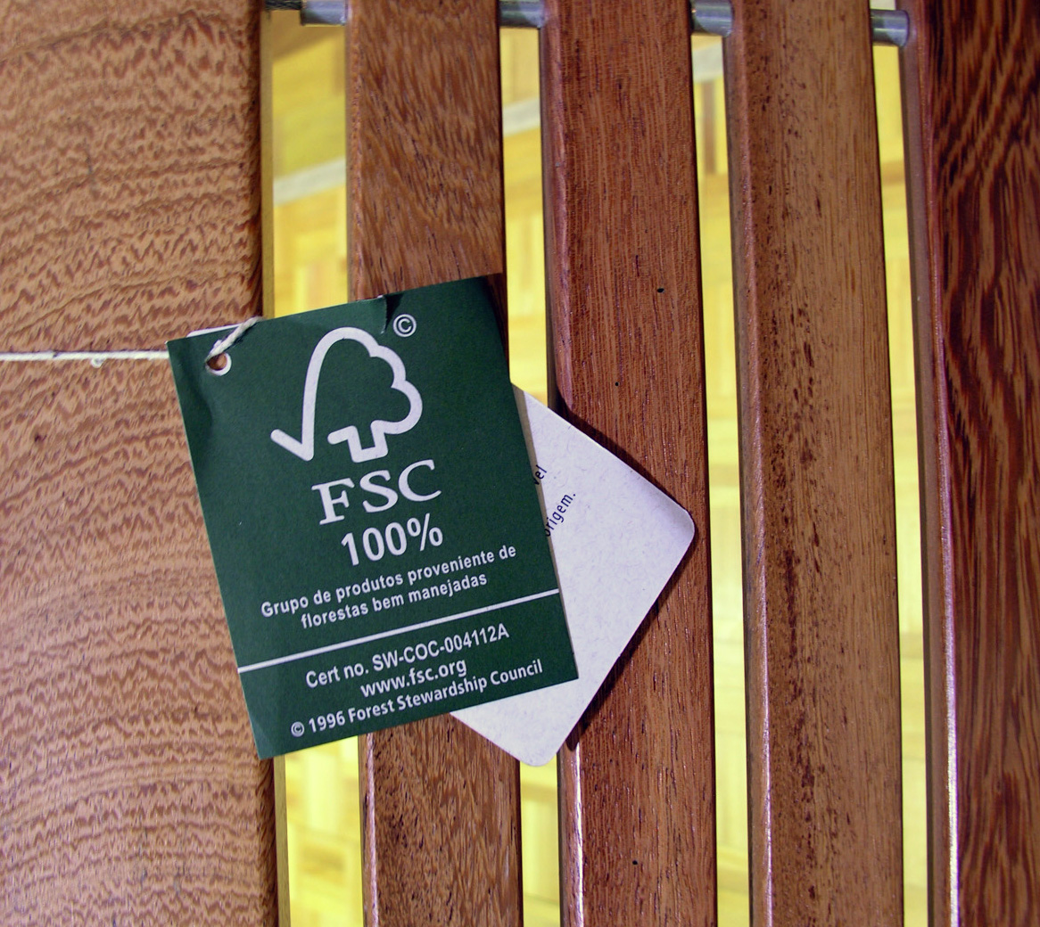



FSC STANDARD

Sourcing reclaimed material for use in FSC Product Groups
or FSC Certified Projects

FSC-STD-40-007 (V2-0) EN

CHAIN OF CUSTODY

CHAIN OF CUSTODY

Title: | Sourcing reclaimed material for use in FSC Product Groups  or FSC Certified Projects
Document reference code: | FSC-STD-40-007 (V2-0) EN
Scope: | International
Approval: | 01 April 2011
Contact: | FSC Policy and Standards Unit
E-mail for comments: | policy.standards@fsc.org
© 2011 Forest Stewardship Council, A.C. All rights reserved.

No part of this work covered by the publisher’s copyright may be reproduced or copied in any form or by any means (graphic, electronic or mechanical, including photocopying, recording, recording taping, or information retrieval systems) without the written permission of the publisher.

The Forest Stewardship Council (FSC) is an independent, not for profit, non-government organisation based in Bonn, Germany.

The mission of the Forest Stewardship Council is to support environmentally appropriate, socially beneficial, and economically viable management of the world's forests.

FSC develops, supports and promotes international, national and regional standards in line with its mission; evaluates, accredits and monitors certification bodies which verify the use of FSC standards; provides training and information; and promotes the use of products that carry the FSC logo.

Foreword

This standard has originally been developed by the FSC Technical Working Group for Chain of Custody in the course of the review of “FSC-STD-40-004 Version 1: FSC Chain of Custody Standard for Companies Supplying and Manufacturing FSC-certified Products” between October 2005 and October 2007.
This standard is intended to complement the set of FSC Chain of Custody standards for those cases where organizations want to source non-certified reclaimed materials for use in an FSC-certified product according to “FSC-STD-40-004: FSC Standard for Chain of Custody Certification” or in an FSC-certified project according to “FSC-STD-40-006: FSC Chain of Custody Standard for Project Certification”.

Version 2-0 of FSC-STD-40-007 has been developed following consideration of the feedback from certificate holders and certification bodies in relation to standard application and interpretation.

Note on use of this standard

All aspects of this standard are considered to be normative, including the scope, standard effective date, references, terms and definitions, tables and annexes, unless otherwise stated.

Please send any comments or suggestions regarding this standard to:

FSC International Center
– Policy and Standards Unit –
Charles-de-Gaulle Str. 5
53113 Bonn, Germany
Phone: +49-228 / 367-66-0
Fax: +49-228 / 367-6630
E-Mail: policy.standards@fsc.org
Contents

A Scope
B Effective date
C References
D Terms and definitions
1 Purchase of reclaimed forest-based materials
2 Suppliers validation and monitoring
3 Material inspection and classification upon receipt
4 Supplier Audit Program
Annex I: Examples of reclaimed wood material
Annex II: Examples of reclaimed paper material

A Scope
This standard stipulates the requirements that shall be followed by organizations certified according to FSC-STD-40-004 or FSC-STD-40-006 for purchasing, verifying and classifying reclaimed forest-based inputs (including materials such as bamboo and cork) for use in FSC Product Groups and FSC Certified Projects.
The document also specifies the provisions for the definition and implementation of an organization’s verification program for reclaimed material inputs aiming at ensuring authenticity of it regarding their quantity, quality and compliance with FSC requirements.

B Effective date
This standard becomes effective on 01 April 2011. New certification applicants shall be assessed against this standard by 01 June 2011 and all certificate holders shall be in compliance with this standard by 01 April 2012.

C References
The following referenced documents are indispensable for the application of this document. For references without a version number, the latest edition of the referenced document (including any amendments) applies.

FSC-STD-40-004 FSC Standard for Chain of Custody Certification
FSC-STD-40-006 FSC Chain of Custody Standard for Project Certification

D Terms and definitions
For the purposes of this international standard, the terms and definitions given in FSC-STD-01-002 FSC Glossary of Terms and the following apply:

FSC Recycled: FSC-certified reclaimed material based on exclusive input from reclaimed sources, and supplied with a percentage claim or credit claim. FSC Recycled material or products are eligible to be used in FSC Mixed or FSC Recycled product groups.

Official reclaimed paper classification and assortment system: Official classification and assortment systems of reclaimed papers are developed by (supra-)national organizations (e.g. state, industry associations) and are based upon defined, verifiable and transparent criteria, offering a benchmark for dispute resolution mechanism. These criteria usually aim at the categorisation of reclaimed paper material according to certain quality aspects, but their application in specific supply chains should allow the characterization of the relevant points of reclamation. Official classification and assortment systems are recognized and used in the market in such a way that the classifications and corresponding claims are basic elements in commercial transaction documents and incorrect claims may lead to legal actions against the one who made the claim.

Point of Reclamation: The location, process or site where material is diverted from the waste stream from industrial, residential or municipal sources and reclaimed thereby constituting the starting point within the supply chain for reclaimed material.

Post-consumer reclaimed material: Material that is reclaimed from a consumer or commercial product that has been used for its intended purpose by individuals, households or by commercial, industrial and institutional facilities in their role as end-users of the product.

Pre-consumer reclaimed material: Material that is reclaimed from a process of secondary manufacture or further downstream industry, in which the material has not been intentionally produced, is unfit for end use and not capable of being re-used on-site in the same manufacturing process that generated it.

Reclaimed material: Material that demonstrably would have otherwise been disposed of as waste or used for energy recovery, but has instead been collected and reclaimed as input material, in lieu of virgin material, for re-use, recycling, re-milling in a manufacturing process or other commercial application. Inputs of the following material categories are classified as reclaimed material:
a) FSC Recycled material;
b) Post-consumer reclaimed material;
c) Pre-consumer reclaimed material.

Verbal forms for the expression of provisions
[Adapted from ISO/IEC Directives Part 2: Rules for the structure and drafting of International Standards]

“shall”: indicates requirements strictly to be followed in order to conform to the standard.

“should”: indicates that among several possibilities one is recommended as particularly suitable, without mentioning or excluding others, or that a certain course of action is preferred but not necessarily required. A certification body can meet these requirements in an equivalent way provided this can be demonstrated and justified.

“may”: indicates a course of action permissible within the limits of the document.

“can”: is used for statements of possibility and capability, whether material, physical or causal.

1 Purchase of reclaimed forest-based materials

1.1 The organization that purchases reclaimed forest-based materials (including materials such as bamboo and cork) without FSC claims shall demonstrate that its reclaimed inputs for use in FSC Product Groups or FSC Projects comply with FSC definitions for pre-consumer and/or post-consumer reclaimed material (see Section D “Terms and Definitions”).

NOTE: In order to support the correct implementation of this standard, examples of pre-consumer and post-consumer wood and paper according to FSC definitions are provided in Annex I and II.
2 Suppliers validation and monitoring

2.1 The organization shall conduct a validation process for its suppliers of reclaimed materials to determine whether the materials supplied are eligible to enter into FSC product groups, constituted by the following elements:
a) For each supplier, the organization shall maintain records and define the necessary documentation evidence and actions to demonstrate that materials supplied from them comply with FSC definitions for pre-consumer and post-consumer reclaimed material, including:
- the name and address of the supplier;
- supplier activity (e.g. purchaser/ collector from point of reclamation, trader);
- the reclaimed material categories to be supplied;
- the level of control required (e.g. visual inspection upon receipt, supplier audits).
b) The organization shall monitor the conformance of suppliers in relation to the FSC definitions and purchase specifications and have a contingency plan to cater for non-conforming material or supply documentation. (e.g. request correction of purchasing documents, temporary or permanent invalidation of the supplier, classify the material as non-eligible input for FSC products).
3 Material inspection and classification upon receipt
3.1 Upon receipt, all reclaimed materials shall be verified through visual inspection and classified into pre-consumer and/or post-consumer reclaimed material.

3.2 The organization shall retain objective evidence for each supply confirming that the reclaimed materials comply with FSC definitions for pre-consumer and post-consumer.
NOTE: Different types of evidence can be retained for the control by the certification body, such as use of Official Reclaimed Paper Classification and Assortment Systems, material samples, pictures, quality analysis report, invoices, delivery notes or shipping documents, etc.
3.3 In cases where the classification of reclaimed materials as pre-consumer and/or post-consumer cannot be demonstrated through objective evidence upon receipt, the organization shall include the supplier in a “Supplier Audit Program” as described in Clause 4 below.

3.4 In case that the material received does not comply with purchase specifications and/or the quantities informed in the invoices are not correct, the organization shall carry out immediate follow-up actions to correct the deviation, as required in Clause 2.1 b) above. The actions shall be recorded and communicated to the organization’s certification body during the annual audits.
3.5 In cases where the material received contains a mix of pre-consumer and post-consumer reclaimed material in its composition, the organization shall apply one of the following measures:
- Classify the full amount of material as pre-consumer reclaimed, or
- Analyse and confirm the quantities of pre-consumer and post-consumer material in the mix received. In this case, the supplier shall:
- declare in writing the quantities of pre-consumer and post-consumer reclaimed material in each material mix supplied, and
- be included in the “Supplier Audit Program”.
4 Supplier Audit Program
4.1 The organization shall perform regular (at least annual) on-site audits of the suppliers included in the Supplier Audit Program (including overseas suppliers) based on a sampling approach. The minimum number of suppliers to be audited per year is as follows: the size of the sample shall be the square root’s number of suppliers (x) with 0.8 as a coefficient (y= 0.8√x, where ‘y’ is the number of suppliers to be audited), rounded to the upper whole number. The organization shall ensure that the selected sample is alternating and representative in terms of their:
a) Geographic distribution;
b) Activities and/or products;
c) Size and/or annual production.
NOTE: Traders or sales offices that do not take physical possession of reclaimed materials, and will not alter, store or re-package the reclaimed materials may be verified through desk audits (remote audits).
4.2 The organization may contract an accredited certification body or other external qualified party to carry out the supplier audits.
4.3 In cases where the supplier selected for sampling sells reclaimed materials that were previously collected, classified and traded by other companies or sites, the complete supply chain of these materials shall be audited back to the point where the classification as pre-consumer and/or post consumer can be demonstrated through objective evidences.
4.4 The organization shall evaluate and verify the documents and other evidence regarding the supplied material quantity, quality and compliance with FSC definitions of pre-consumer and post-consumer material, which includes:
a) Supplier’s instructions or procedures in place to control and classify the reclaimed materials;
b) When applicable, trainings or instructions provided to the supplier’s personnel in relation to classification and control of reclaimed materials;
c) Registers that demonstrates the origin of the materials (e.g. pictures, address of the demolished house, invoices, etc).
NOTE: A declaration from the supplier, even if part of the contractual agreement, is not considered sufficient proof of the origin and material category. However, it can be used as additional evidence to demonstrate the material compliance with FSC definitions.

4.5 The organization shall document the supplier audits, including a record of the audit date, the audit findings in relation to the requirements in Clause 4.4, the names and qualifications of the auditors and examples of any evidence collected to verify the classification of the materials.

ANNEX I: Examples of reclaimed WOOD material

Post-consumer wood sources  Municipal Sources  Commercial (Retail, Office, Small Business);  Construction and Demolition Debris;  Defibrillated and solid wood recovered from landfills, transfer stations, and Material Recovery Facilities (MRFs)2;  Industrial Packaging and Administrative wastes (does not include process wastes);  Institutional (schools);  Residential |  | Post-consumer wood material  Commercial Transport Packaging  including pallets, crates, cases, cable drums at the end of their useful life3;  Construction and Demolition Debris4 including doors, flooring, old cabinets, mouldings, and dimensional lumber, discarded wood packaging e.g. pallets and cable drums. Wood reclaimed through 'Deconstruction" e.g. salvaged dimensional lumber and architectural elements;  Damaged Stock and Rejected Products manufactured from post-consumer wood products, including deconstructed building materials, or wood reclaimed from construction and demolition (C&D) debris;  Used telephone poles, railroad ties, building materials, furnishings, cabinets, shop fittings, shelving etc. that have been used for their intended purpose by residential, commercial, or industrial consumers;  Off-cuts, shavings, sawdust and the like generated during the re-milling of post-consumer wood products, deconstructed building materials, or wood reclaimed from C&D debris. |  | Not accepted as reclaimed wood material  Wood material in the form of off-cuts produced from virgin parent materials that are discarded by a primary or secondary production process but that has properties allowing it to be reused on site by being incorporated back into the same manufacturing process that generated it.  Co-products from virgin parent materials (example: Offcuts, shavings, sawdust, and the like, generated during primary manufacture of logs).  Forestry Waste  Any virgin material considered as forest or urban waste. (e.g. branches, small or rotten pieces of wood, trunks of old trees and palms planted for food production, salvaged urban trees and underwater salvaged trees)
Pre-consumer wood sources  Municipal Sources  Commercial  Institutional  Industrial Sources  Process waste from converters and secondary manufacturing onwards |  | Pre-consumer wood material  Damaged stock, rejected products, overstock, discontinued items not used for their intended purpose;  Offcuts, shavings, sawdust, and the like, generated during secondary manufacture or subsequent steps in manufacturing an end product. |  | NOTES  1 Construction and Demolition Debris is not considered "municipal" waste in the US, but for the purposes of this standard it will not be separated.  2 Wood Waste generated at MRFs, Landfills, and Transfer Stations originated from other municipal sources listed above, but is mentioned separately for clarification. This source may contain pre-consumer reclaimed wood.  3 In the US, 'Durable Goods" are defined as products that have a life-span of three years or longer, but that distinction is not relevant for the purpose of this standard. Wood transport packaging is more logically categorized as a durable good.  4 C&D debris will inevitably contain some pre-consumer wastes, such as end cuts from dimensional lumber, flooring, and moulding, and rejected building materials.

ANNEX II: Examples of reclaimed PAPER material

Post consumer paper sources  Domestic;  Distribution, retail and industrial; |  | Post consumer paper material  Commercial transport packaging  Computer print-outs  Magazines, direct mail, home office materials, and boxes  Old magazines from residential or office collections  Old newspapers from residential or office collections  Reclaimed household scrap paper and packaging, including old newspapers  Reclaimed office waste paper  Used corrugated boxes  Used tabulating cards |  | Not accepted as reclaimed paper material  Materials that are discarded by a manufacture process but that has properties allowing it to be reused on site by being incorporated back into the same manufacturing process that generated it.  Examples:  Dry paper trimmings from production or on-site sheeting and converting operations;  Faulty paper at the mill;  Mill broke, trim and scrap re-used onsite in the same manufacturing process;  Obsolete inventories at the mill;  Wet paper removed from the paper machine
Pre-consumer paper sources  Secondary and subsequent manufacture;  Distributors  Merchants |  | Pre-consumer paper material  All scrap generated during the intermediate steps in producing an end product following primary manufacturing (i.e. post-mill);  Bindery trim and scrap;  Forms conversion scrap;  Merchant return stock;  Obsolete inventories from distributors, printers, converters and others beyond the original manufacturer;  Over-issue publications;  Printers’ scraps, pre-printing, make-ready, overruns, errors, rejections;  Publisher overruns and returns;  Scrap from product manufacturing, including bag, box and carton manufacturing;  Scraps from converters, mail order houses, others in value-added chain;  Sheeting scrap from converters

