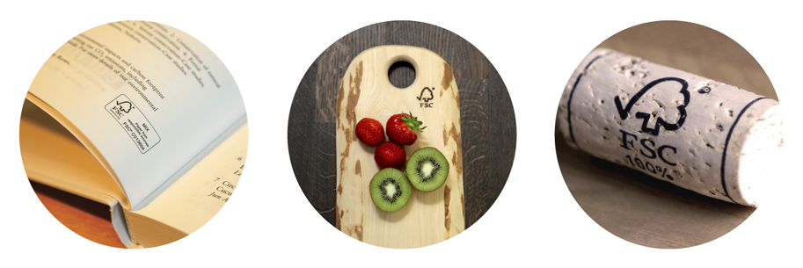

Requirements for use of the FSC® trademarks by certificate holders

FSC-STD-50-001 V2-1

Title: | Requirements for use of the FSC® trademarks by certificate holders
Document code: | FSC-STD-50-001 V2-1 EN
Approval: | 31 May 2021
Contact: | FSC Global Development  Adenauerallee 134  53113 Bonn, Germany
 |      | +49 (0)228 367 660  +49 (0)228 367 6630  trademark@fsc.org
© 2021 Forest Stewardship Council AC. All rights reserved.
FSC® F000100

No part of this work covered by the publisher’s copyright may be reproduced or copied in any form or by any means (graphic, electronic, or mechanical, including photocopying, recording, taping, or information retrieval systems) without the written permission of the publisher.

Printed copies are uncontrolled and for reference only. Please refer to the electronic copy on the FSC website (fsc.org) to ensure you are referring to the latest version.

The Forest Stewardship Council (FSC) is an independent, not-for-profit, nongovernmental organization established to support environmentally appropriate, socially beneficial, and economically viable management of the world’s forests.

The FSC vision is that the world’s forests meet the social, ecological, and economic rights and needs of the present generation without compromising those of future generations.

Contents
Introduction 4
Version history 4
A Objective 6
B Scope 6
C Standard effective date 6
D References 6
Part I: General requirements 7
1. Ground rules for using the FSC trademarks 7
2. Restrictions on using FSC trademarks 8
Part II: Using the FSC labels on products 9
3. Selecting the FSC label 9
4. Labelling requirements 10
Part III: Promoting FSC-certified products and FSC certification 12
5. Promotional elements 12
6. Promotional use requirements……………………………………………………….……13
7. Restrictions on promotional use .14
Part IV: Graphic rules for labelling and promotion 15
8. FSC on-product labels and FSC logo 15
9. ‘Forests For All Forever’ marks 17
10. Misuse of FSC trademarks 19
Annex A. Trademark use management system 20
Annex B. Additional trademark rules for group, multi-site, and project certificate holders…..21
Annex C. How to describe FSC, products with FSC claims and how to describe controlled wood…………………………………………………………………………………………………..23
Annex D. Terms and definitions 25

Introduction
This document contains the requirements and guidelines for the use of Forest Stewardship Council trademarks by FSC certificate holders. It covers labelling and the promotion of products with FSC trademarks, as well as the promotion of an organization’s status as an FSC certificate holder.

Labelling products and promoting them with FSC trademarks helps consumers to make informed decisions about the products and materials they purchase. Therefore, it is essential that FSC trademarks are used correctly, do not mislead customers or the public about certification claims, and are not associated with quality aspects beyond those covered by FSC certification.

The FSC trademarks are the primary communications tool for FSC certificate holders to demonstrate that their products meet the standards set by FSC. As FSC licence holders, certificate holders play an important role in protecting the joint investments that licensees as users, and FSC as the trademark owner, have made to develop the FSC system. These requirements are established to ensure accurate messaging about the meaning of FSC, and to enhance the unified presentation of these messages to increase recognition of the licensee’s accomplishments.

FSC provides further tools to help certificate holders in labelling and promotion, such as:
- a quick guide to FSC trademark use, available on the FSC website, that summarizes the core requirements presented in this document;
- an online trademark portal and marketing toolkit with guidance and ready-to-use examples on how to create promotional materials in line with the FSC brand;
- an online training course on the use of FSC trademarks.

Certificate holders’ access to the online services is arranged through certification bodies.

Version history
V1-0 | The first version of the requirements, approved in January 2010, combined several documents and gathered together all the clauses on trademark use previously presented over a number of standards and guidelines. V1-0 also introduced new on-product labels to the FSC system.
V1-1 & V1-2 | Minor reviews in February and November 2010 clarified the language and terminology used, and made improvements to the graphical requirements based on stakeholder comments, to ease the use of the new labels.
V2-0 | A major review took place to create this current version, which incorporates Motion 29, passed at the 2014 General Assembly. The requirements were simplified and a trademark use management system option introduced for certificate holders. NOTE: The decision on MIX-label text was postponed until the controlled wood strategy is approved. The MIX label presented in this version may be used until this revision happens, which will be at latest within one year after approval of the FSC controlled wood strategy.
V2-1 | The Strategy for FSC Mix Products and Controlled Wood published in April 2019 called for (i) a change of the FSC MIX label text to reinforce truth in labelling and (ii) the introduction of fixed controlled wood statements to enhance the understanding of controlled wood. A technical working group was set up in November 2019 and a public consultation was subsequently carried out. Read more about the relevant process via the FSC website.  In June 2020, the FSC Board of Directors approved the revised text of the MIX label as well as the new controlled wood statements. V2-1 incorporates the two changes and corrects an error in the colour codes in clause 8.2 and clause 9.2.

A Objective
The objective of this standard is to set the minimum requirements and provide recommendations for FSC trademark use in the labelling and promotion of FSC-certified products, and for the promotion of FSC certification by FSC certificate holders.

B Scope
Adherence to this standard is mandatory for all FSC certificate holders that are entitled to use the FSC trademarks, as it sets out how to use the FSC trademarks correctly. The standard covers use of the FSC trademarks on FSC-certified products, use for promotion of FSC-certified products, and use for promotion of the organization’s status as an FSC certificate holder. This standard also forms the basis for evaluation and approval, by FSC-accredited certification bodies, of all certificate holders’ uses of FSC trademarks.

Elements for making FSC claims on invoices and delivery documents are defined in chain of custody standard FSC-STD-40-004 and are not affected by these requirements.

C Standard effective date
Approval date 31 May 2021
Publication date 1 October 2021
Effective date 1 January 2022
Transition period 1 January 2022 – 30 June 2024
Period of validity Until replaced or withdrawn

Please note that existing stocks of labelled products and promotional materials that have been approved as correct according to previous versions of the FSC trademark standards may continue to be used and distributed.

D References
FSC-STD-30-010 Controlled Wood Standard for Forest Management Enterprises
FSC-STD-40-003 Chain of Custody Certification of Multiple Sites
FSC-STD-40-004 Chain of Custody Certification
FSC-STD-40-005 Requirements for Sourcing FSC Controlled Wood
FSC-STD-40-006 FSC Chain of Custody Standard for Project Certification
FSC-STD-40-007 Sourcing Reclaimed Material for Use in FSC Product Groups or FSC Certified Projects
Part I: General requirements
1. Ground rules for using the FSC trademarks
1.1 The Forest Stewardship Council AC (FSC) owns the following registered trademarks:

(a) the name ‘Forest Stewardship Council’

(b) the initials ‘FSC’

(c) the FSC logo | (d) the ‘Forests For All Forever’ – full mark | (e) the ‘Forests For All Forever’ – logo with text mark

1.2 In order to use these FSC trademarks, the organization shall have a valid FSC trademark licence agreement and hold a valid certificate.

Note 1. Consultations for certification
Organizations applying for forest management certification or conducting activities related to the implementation of controlled wood requirements, may refer to FSC by name and initials for stakeholder consultation.

1.3 The FSC trademark licence code assigned by FSC to the organization shall accompany any use of the FSC trademarks. It is sufficient to show the code once per product or promotional material.

1.4 The FSC logo and the ‘Forests For All Forever’ marks shall include the trademark symbol ® in the upper right corner when used on products or materials to be distributed in a country where the relevant trademark is registered. The symbol ® shall also be added to ‘FSC’ and ‘Forest Stewardship Council’ at the first or most prominent use in any text; one use per material is sufficient (e.g. website or brochure). For use in a country where the trademark is not yet registered, use of the symbol TM is recommended. The Trademark Registration List document is available in the FSC trademark portal and marketing toolkit.

1.5 The organization shall either have an approved trademark use management system in place or submit all intended uses of FSC trademarks to its certification body for approval. Please see Annex A for further information on trademark use management system.

1.6 The products which are intended to be labelled with the FSC on-product label or promoted as FSC certified shall be included in the organization’s certificate scope and shall meet the eligibility requirements for labelling, as stipulated by the respective FSC standard.

1.7 Holders of group, multi-site, or project certificates shall refer to Annex B of this standard for additional requirements for the use of the FSC trademarks.

2. Restrictions on using FSC trademarks
2.1 The FSC trademarks shall not be used:
- in a way that could cause confusion, misinterpretation, or loss of credibility to the FSC certification scheme;
- in a way that implies that FSC endorses, participates in, or is responsible for activities performed by the organization, outside the scope of certification;
- to promote product quality aspects not covered by FSC certification;
- in product brand or company names, such as ‘FSC Golden Timber’ or website domain names;

2.2 The name ‘Forest Stewardship Council’ shall not be replaced with a translation. A translation may be included in brackets after the name:

Forest Stewardship Council® (translation)

Note 2. Compliance with the requirements
FSC reserves the right to suspend or terminate permission to use the FSC trademarks if the organization is failing to comply with the FSC trademark requirements, as set out in this standard. The interpretation of these rules is at the sole discretion of FSC.

Part II: Using the FSC labels on products

3. Selecting the FSC label
3.1 In order to make an on-product claim, the organization shall select the correct FSC label on the basis of the FSC claim. A text reference to FSC certification on a product may only be made in addition to an on-product label.

3.2 The labels corresponding to the claims categories shall be:

 | FSC 100% | FSC Mix | FSC Recycled
FSC claims | 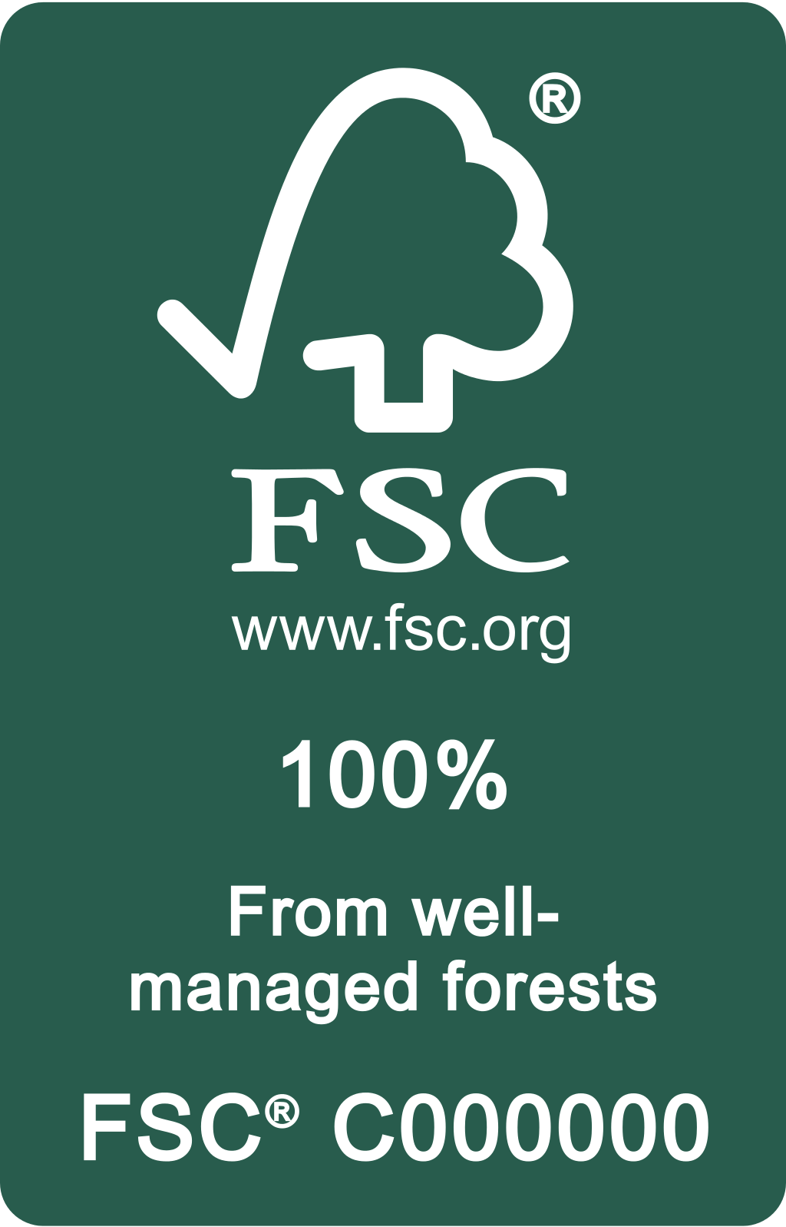 | 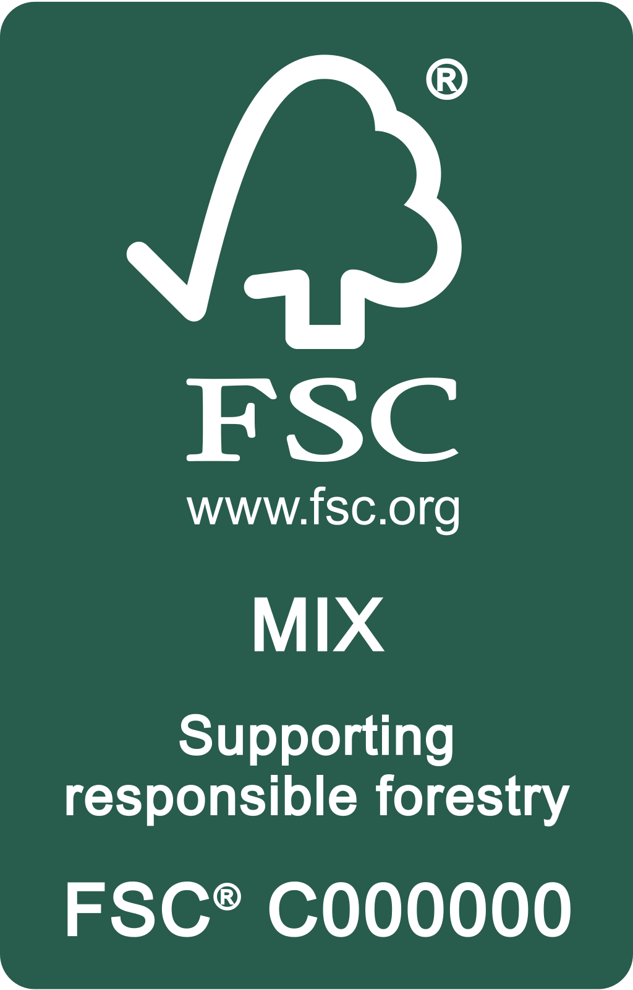 | 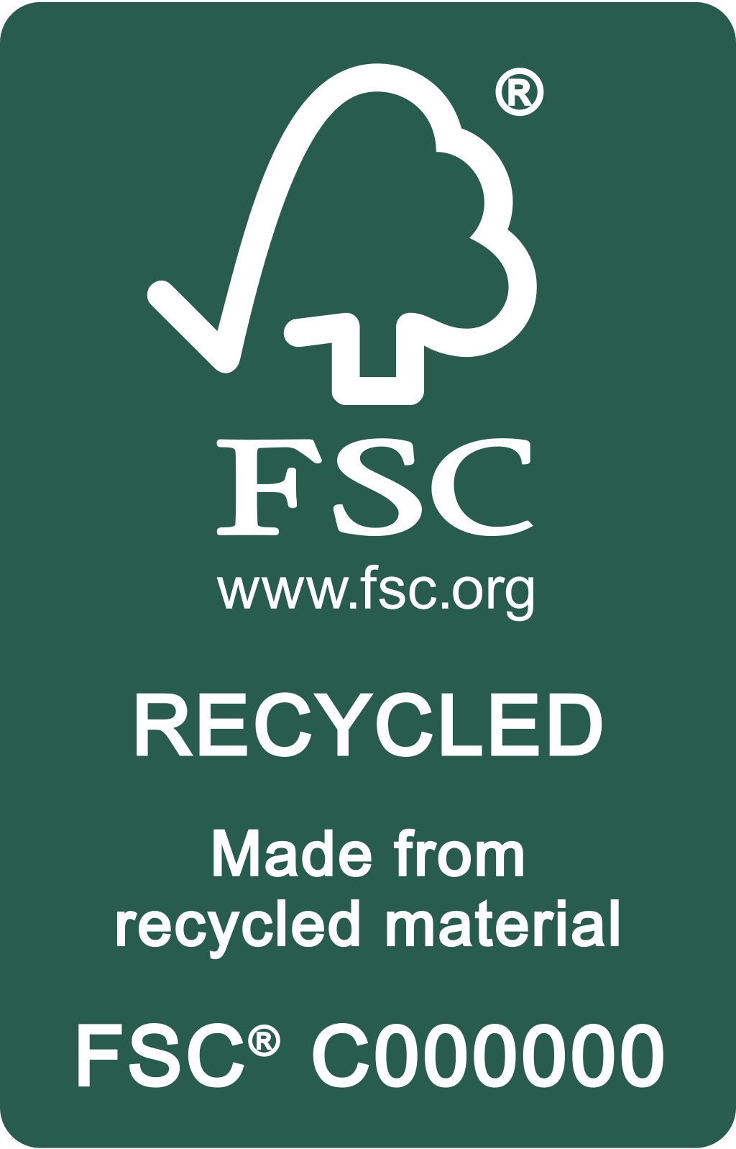
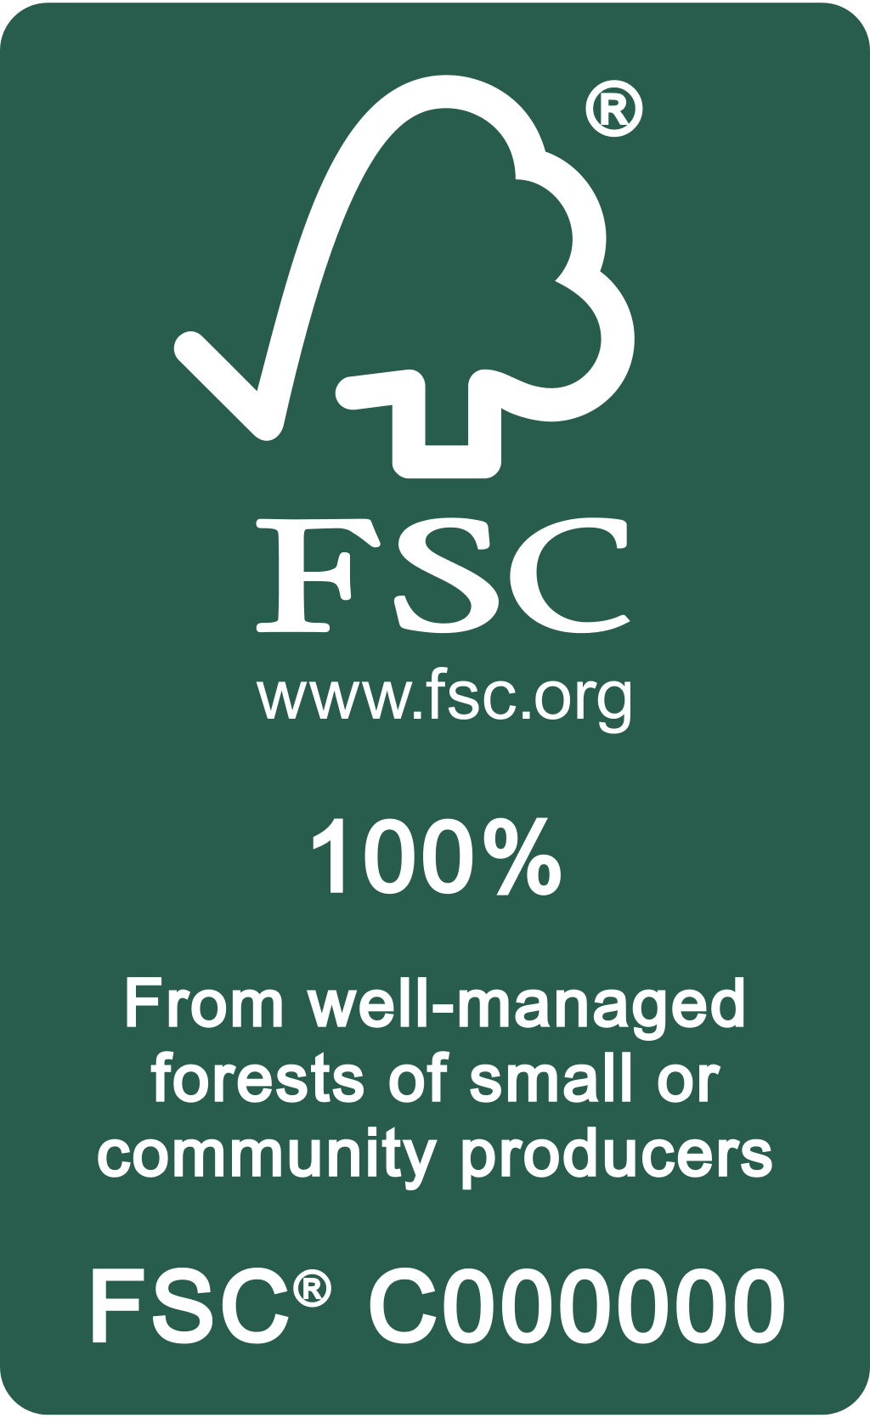
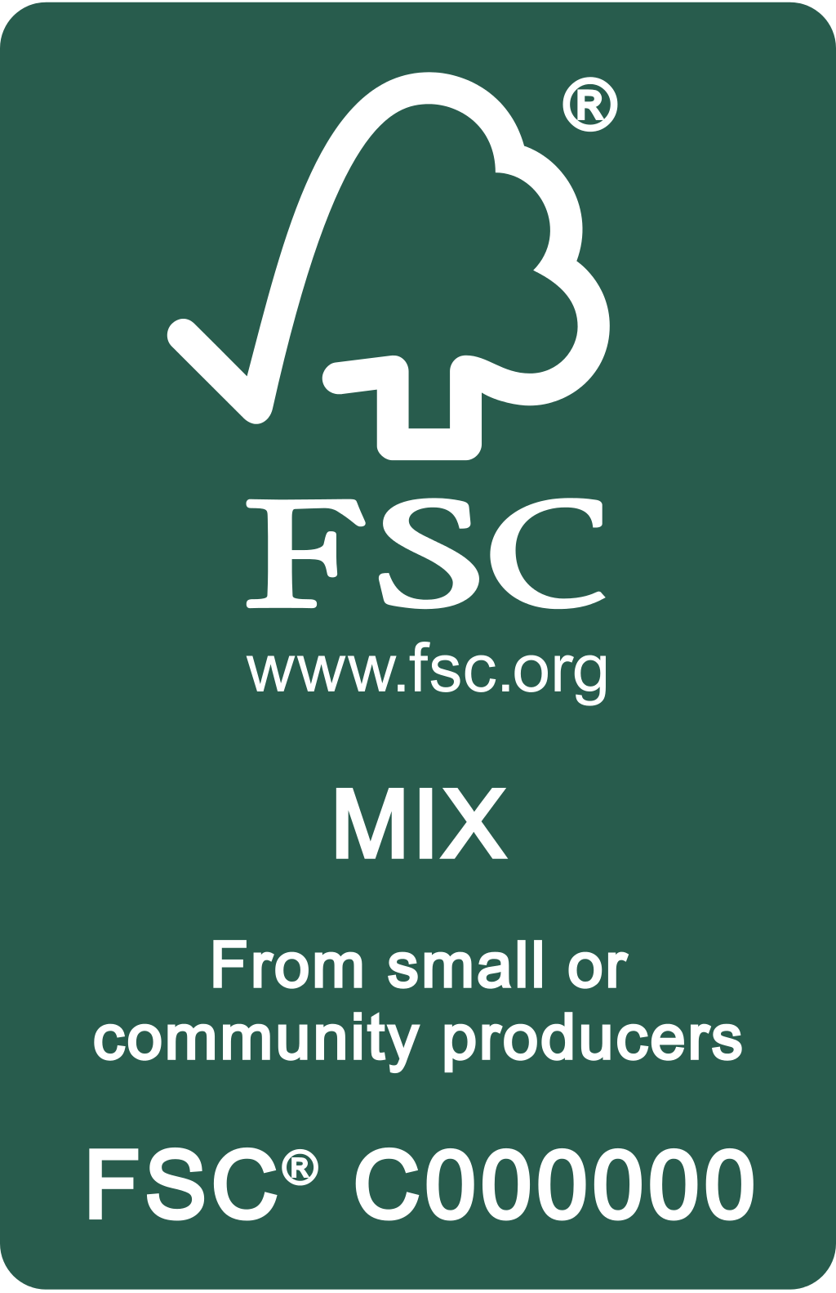
FSC claims specific to small and community producers |  |  | FSC Recycled not applicable

3.3 The FSC on-product label elements shall be:

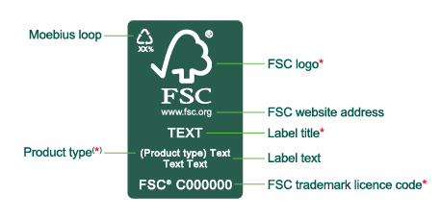

* Compulsory element
⁽*⁾ Compulsory in certain circumstances (see clauses 3.6 and 3.7).

3.4 Only the FSC label artwork provided by the trademark portal, or otherwise issued and approved by the certification body or FSC, shall be used. Access to the trademark portal is arranged by the organization’s certification body.

3.5 Organizations are responsible for compliance with national labelling requirements and consumer protection laws in those countries in which FSC-certified products are promoted, distributed, and sold.

Note 3. National requirements and laws in FSC audits
FSC certification audits do not address compliance with such national requirements and laws.

Specifying product type

3.6 The product type shall be specified unless all the materials of the product and its packaging/content are FSC certified (see clause 4.1). Certified material may be specified either by using product type within the label, or by additional text next to it. Product type shall be always specified:
- on printed publications and on stationery made of paper
- on products containing neutral materials that cannot be distinguished from FSC-certified ingredients (e.g. wood fibre used with uncertified neutral materials such as cotton fibre in paper specified as “wood” instead of “paper”).

3.7 Specific product names shall not be used as product types. A list of product types (e.g. ‘paper’, ‘wood’) is provided in the trademark portal. These are intended as broad categories. The list is not exhaustive and organizations shall contact FSC via the certification body with any request for a new product type (e.g. a non-timber forest product) to be added.

Using the Moebius loop

3.8 The use of the Moebius loop is optional for FSC Mix and FSC Recycled labels.

3.9 The Moebius loop shall not be used without a percentage figure. The figure shall reflect the sum of post- and pre-consumer reclaimed material content, which can be substantiated through FSC chain of custody controls.

- Labelling requirements
4.1 The label shall be used only where all forest-based parts of the product are covered by FSC certification, as specified in FSC-STD-40-004. Packaging made of forest-based materials is considered a separate element. Therefore, the label may refer to the packaging, the product inside, or both, depending on which elements are certified.

4.2 The FSC label should be clearly visible on the product, its packaging, or both.

Note 4. Visible labelling enables promotion
Retailers can promote products as FSC certified only if the label is visible to consumers.

4.3 When a product is FSC labelled, marks of other forest certification schemes shall not be used on the same product. In catalogues, books, and similar FSC-labelled publications, other forest certification scheme marks may be used for promoting other products or for educational purposes.
Using the FSC logo or any reference to FSC in addition to an on-product label

4.4 The FSC logo with the licence code alone may be applied directly to the product (e.g. heat branded) only if an on-product label is used on the packaging, on a hang-tag, or similar.

4.5 Additional FSC logos or reference to FSC may be used only when the on-product label is visible to the consumer (i.e. the label is accessible without damaging the sales packaging). For example, if the on-product label is inside the sales packaging, no additional logos, marks, or references to FSC shall be applied on the outer surface of the packaging.

Segregation marks and labelling semi-finished products

4.6 FSC trademarks may be used to identify FSC-certified materials in the chain of custody before the products are finished. It is not necessary to submit such segregation marks for approval. All segregation marks shall be removed before the products go to the final point of sale, or are delivered to uncertified organizations.

4.7 If an organization wishes to label semi-finished products, the FSC label shall only be applied in such a way that it can be removed before or during further processing.

Labelling arrangements between organizations

4.8 If two FSC-certified organizations enter into an agreement whereby the supplier labels products with the buyer’s FSC trademark licence code, the following conditions shall be met:
- Products to be labelled shall be included in the certificate scope of both organizations.
- Both parties shall inform their certification bodies in writing about the agreement. This information shall include the definition of the certification body or the certificate holder with an approved trademark use management system that shall be responsible for approval of on-product labels.
- The supplier is responsible for ensuring that the buyer’s code is used only on eligible products that are supplied to that buyer.
- If contractors are being used by the supplier, the supplier is responsible for ensuring that contractors only use it for eligible products supplied to the buyer.
- Both organizations shall keep the agreement easily available for auditing by certification bodies.

Using references to controlled wood on product

4.9 Certificate holders may use the controlled wood statements presented in Annex C to explain the meaning of controlled wood when describing the materials of a MIX labelled product. On product, these statements shall only be used in addition to the FSC MIX label and in addition to a description of the MIX label such as those in Annex C.

Part III: Promoting FSC-certified products and FSC certification
- Promotional elements
5.1 Organizations may promote FSC-certified products and their status as an FSC certificate holder with FSC trademarks (1.1).

Note 5. Messaging about FSC and FSC-certified products
In Annex C of this document, examples of describing FSC and FSC-certified products are presented. For more marketing materials, please visit marketingtoolkit.fsc.org

5.2 When promoting with FSC logo, the elements shall be:

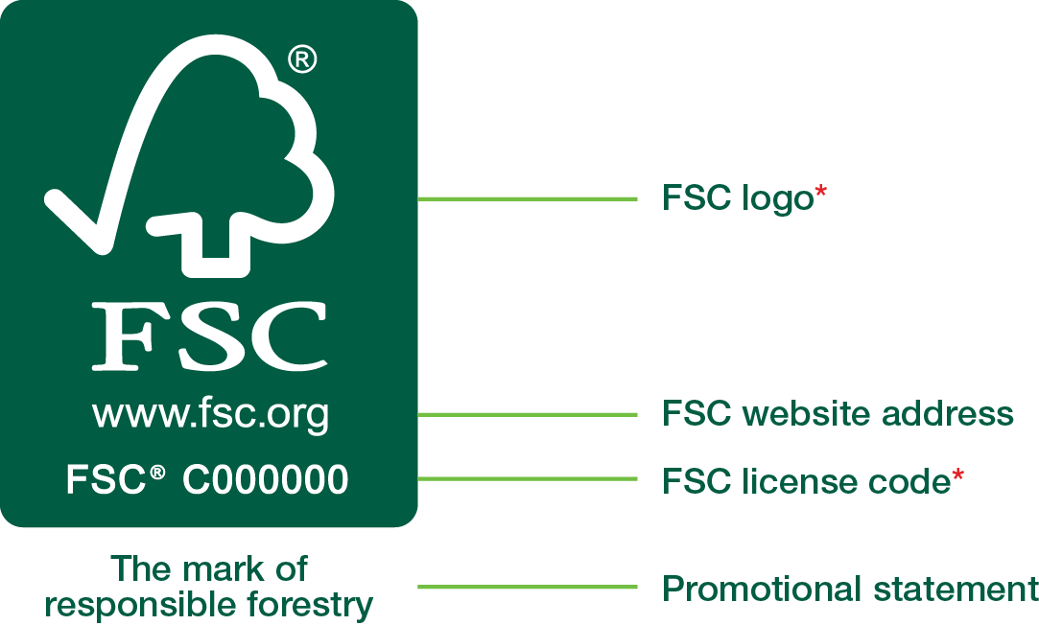

* Compulsory element

The ‘promotional panel’ arrangement shown is available in the trademark portal.

5.3 When promoting with ‘Forests For All Forever’ marks, the elements shall be:

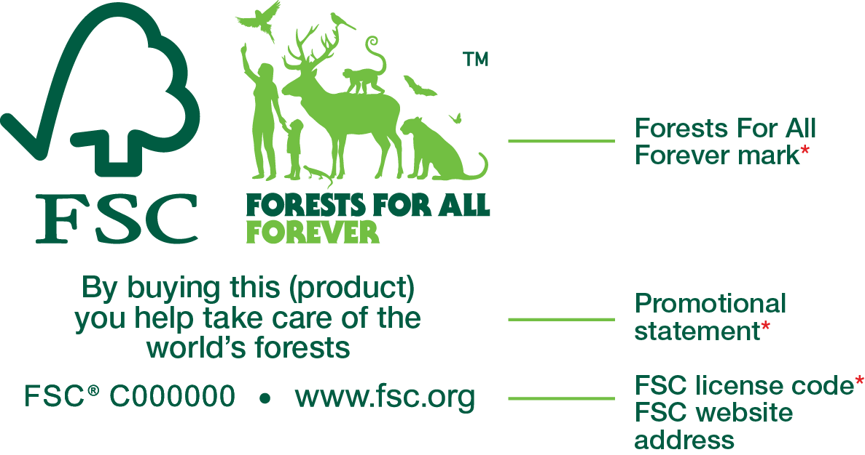

* Compulsory element

The arrangement shown here is for illustrative purposes only.

5.4 The elements may also be presented separately, for example on different parts of a web page. One use of an element (e.g. license code) per material is sufficient.

5.5 When referring to FSC certification without using FSC logo or ‘Forests For All Forever’ marks, the license code shall be included at least once per material.

5.6 Organizations are responsible for their own compliance with national consumer protection laws in those countries in which products are promoted and promotional materials distributed.

Note 6. National consumer protection laws and FSC audits
FSC certification audits do not include compliance with such requirements and laws.

- Promotional use requirements

Promotional materials listing products

6.1 It is sufficient to present the promotional elements (see clauses 5.2 and 5.3) only once in catalogues, brochures, websites, etc. If they list both FSC-certified and uncertified products, a text such as “Look for our FSC®-certified products” shall be used next to the promotional elements and the FSC-certified products shall be clearly identified. If some or all of the products are available as FSC certified on request only, this shall be clearly stated.

6.2 If the FSC trademarks are used for promotion on invoice templates, delivery notes, and similar documents that may be used for FSC and non-FSC products, the following or similar statement shall be included: “Only the products that are identified as such on this document are FSC® certified.”

Promotional items and trade fairs

6.3 The FSC logo (see clause 1.1(c)) with the license code may be used on promotional items not for sale, such as mugs, pens, T-shirts, caps, banners, and company vehicles.

6.4 If promotional items are made wholly or partly of wood (e.g. pencils or memory sticks), they must meet the applicable labelling requirements as specified by FSC-STD-40-004, but do not need to carry an on-product label.

6.5 When FSC trademarks are used for promotion at trade fairs, the organization shall:
- clearly mark which products are FSC certified, or
- add a visible disclaimer stating “Ask for our FSC®-certified products” or similar if no FSC-certified products are displayed.

Text used to describe the FSC certification of the organization does not require a disclaimer.

Investment claims about FSC-certified operations

6.6 Organizations shall take full responsibility for the use of the FSC trademarks by investment companies and others making financial claims based on their FSC-certified operations.

6.7 Any such claims shall be accompanied by a disclaimer: “FSC® is not responsible for and does not endorse any financial claims on returns on investments.”

Promoting controlled wood
6.8. To promote sales or sourcing of controlled material or FSC controlled wood, certificate holders may only use the statements presented in Annex C.

7. Restrictions on promotional use
7.1 The FSC trademarks shall not be used in a way that implies equivalence to other forest certification schemes (e.g. FSC/xxx certification).

7.2 When used on the same promotional material as marks of other certification schemes, the FSC trademarks shall not be used in a way which disadvantages FSC in terms of size or placement.

7.3 The FSC logo or ‘Forests For All Forever’ marks shall not be used on business cards for promotion. A text reference to the organization’s FSC certification, with licence code, is allowed, for example “We are FSC® certified (FSC® C######)” or “We sell FSC®-certified products (FSC® C######)”.

7.4 FSC-certified products shall not be promoted with the certification body logo alone.

7.5 The FSC logo or the ‘Forests For All Forever’ marks shall not be used to promote controlled material or controlled wood.

Part IV: Graphic rules for labelling and promotion
8. FSC on-product labels and FSC logo
Colour

8.1 FSC on-product labels and FSC logo shall be used in following colour variations:

Green  negative | Green  positive | Black-and-white  negative | Black-and-white  positive
 | 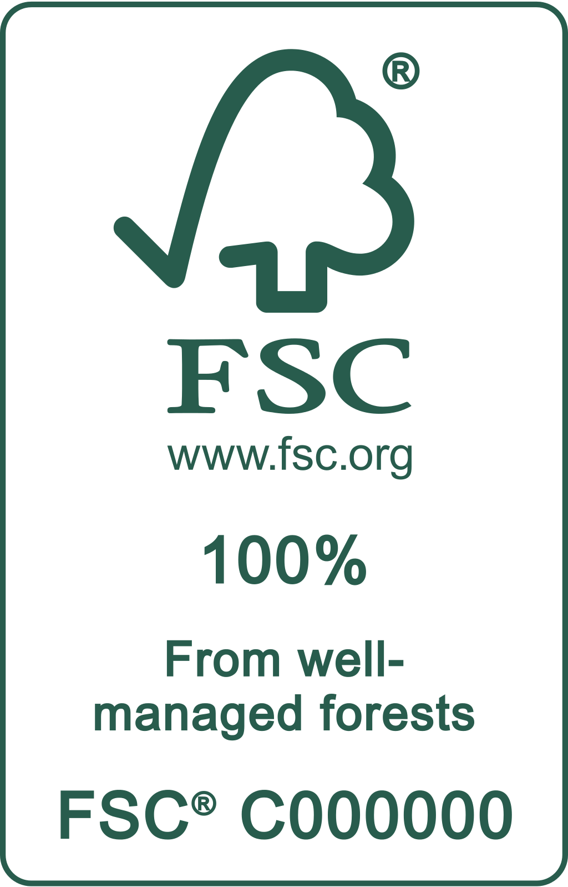

8.2 The green colour for reproduction shall be Pantone™ 626C (or its closest
approximation such as R 40 G 92 B 77 / C 80 M 18 Y 56 K 54).

8.3 If standard colours are not available for the print area, an available colour providing legible contrast on a solid background may be used instead. The label may be produced in positive or negative versions, or as transparent.

Size and format of the on-product labels

8.4 FSC labels may be used in portrait or landscape formats.

8.5 FSC labels shall be printed at a size at which all elements are legible. The minimum size for the label shall be:
- in portrait format: 9 mm in width
- in landscape format: 6 mm in height.

Recommended minimum size for label with all elements | Minimum size for  all labels
8.6 Where adding the product type or translation requires more space, the portrait label may be increased in height and the landscape label in width only.

8.7 The use of a border around the label is recommended. When a border is not used, the label elements shall not be altered or separated.

8.8 When it is not technically possible to print labels with multiple lines, such as for very small products with limited surface for printing (e.g. pens, make-up brushes), a one-line arrangement of label elements may be used. All elements shall be legible with a minimum height of 6mm of the FSC logo. They can be aligned on the bottom or centred.

Size of the logo

8.9 The recommended minimum size of the FSC logo is 10 mm, and it shall be no less than 6 mm in height. This also applies when the logo is used as part of a promotional panel layout (see clause 5.2).

Recommended minimum size | Minimum size for logo

Placement of the on-product label and the logo

8.10 There shall be enough clear space surrounding the label and logo to ensure that they remain uncluttered. The minimum space is calculated by using the height of the ‘FSC’ initials of the logo.

9. ‘Forests For All Forever’ marks
Colour and size

9.1 ‘Forests For All Forever’ trademarks shall be used only in following colour variations:

- Dark and light green
- White and light green
- White and dark green
- White | 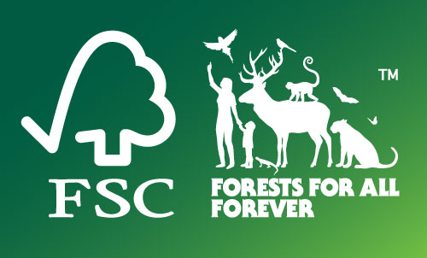 | 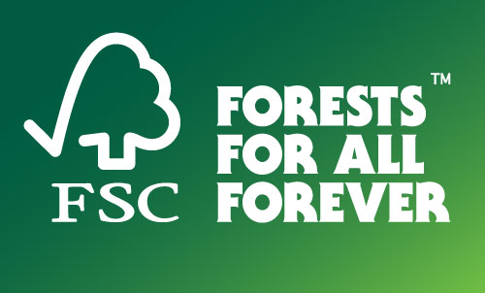
- Black
- Dark green
Please note that the colours only refer to the trademark, not the background colour, which is given here only to display marks with white elements.

9.2 The green colours for reproduction shall be:
- Dark green: Pantone™ 626C (or its closest approximation such as R 40 G 92 B 77 / C 80 M 18 Y 56 K 54)
- Light green: Pantone™ 368C (or its closest approximation such as R 120 G 190 B 32 / C 65 M 0 Y 100 K 0).

9.3 No other colours shall be used; the marks shall not be reproduced if the required colours are not available.

9.4 The minimum size for the ‘Forests For All Forever’ full mark shall be 10 mm in height and 6 mm for the logo with text mark.
Placement of the marks

9.5 There shall be enough clear space around the marks. The minimum space is calculated by using the height of the ‘FSC’ initials on the logo.

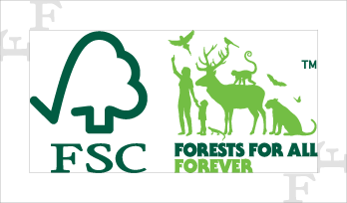 | 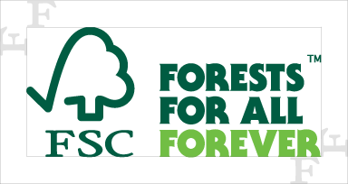

Translations of the marks and strapline

9.6 The official language versions of the ‘Forests For All Forever’ trademarks provided by FSC shall be used only in countries stipulated in the Trademark Registration List available in the trademark portal and marketing online toolkit. Organizations shall not create new translations.

9.7 Translations of the strapline ‘Forests For All Forever’ approved by FSC may be used in text format within the messaging or below the mark, while still respecting the exclusion zones.
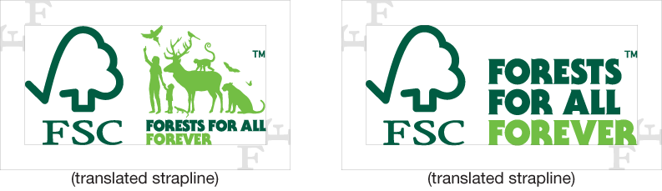


10. Misuse of FSC trademarks
10.1 The following actions are not allowed:
- Changing the proportions of any designs.
- Changing or adding to the contents of any designs beyond the specified elements.
- Making FSC appear to be part of other information, such as environmental claims not relevant to FSC certification.
- Creating new colour variations.
- Changing the shape of the border or background.
- Tilting or rotating the designs in relation to other content.
- Violating the exclusion zone around designs.
- Combining any FSC trademarks or designs with any other branding in a way that implies association.
- Placing the logo, the label, or the marks on a background that interferes with the design.
- Placing any trademarks in way that is misleading about what they refer to.
- Using the shown elements of the ‘Forest For All Forever’ marks on their own.

(a) | (b) | (c) | (d)
(e) | (f) | (g) | (h)
(i)  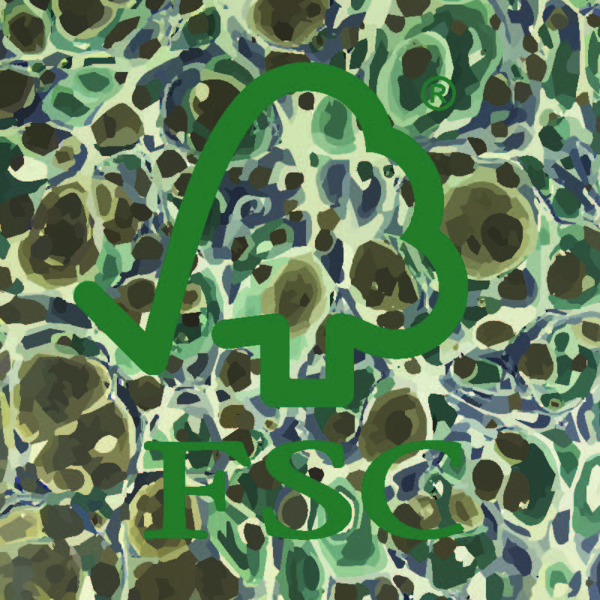 | (j)  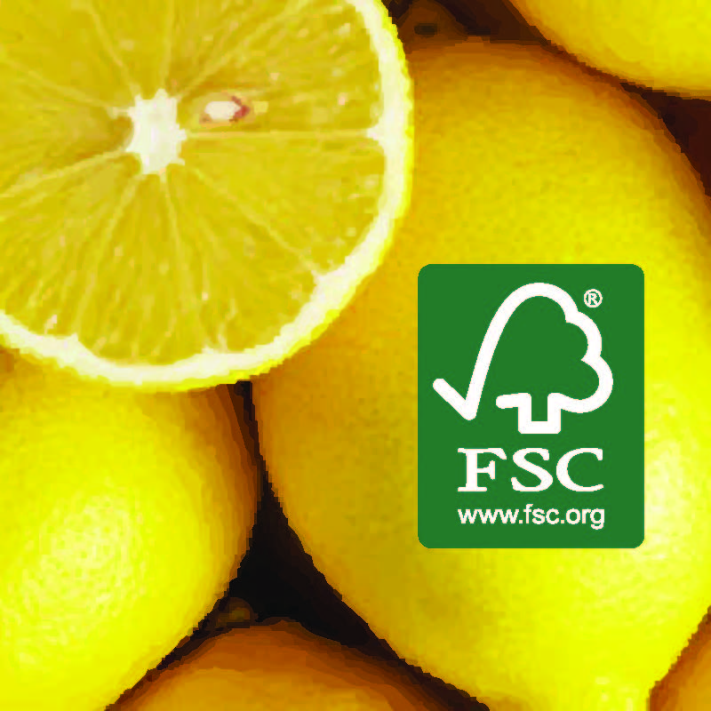 | (k)

Annex A. Trademark use management system
1. General
1.1 Instead of submitting all intended uses of FSC trademarks to its certification body for approval, the organization may implement a trademark use management system with an internal control system. The system, with all the conditions specified in this Annex, shall be approved by the certification body before the organization may start using it.

1.2 Prior to the use of an internal control system, the organization shall demonstrate a good understanding of the requirements in question by submitting a sufficient number of consecutive correct approval requests to the certification body for each type of intended use (e.g. organizations controlling both labelling and promotion shall submit requests for each). It is at the discretion of the certification body to determine when the organization has demonstrated a good record of submissions.

1.3 If an organization demonstrates consistent failure to control its FSC trademark use, the certification body may request that all trademark use be submitted for approval by them prior to use.

2. Trademark use management system
2.1 The organization shall implement and maintain a trademark use management system adequate to its size and complexity, to ensure its continuous conformity with all applicable requirements of this standard (FSC-STD-50-001 V2-1), including the following:
- appoint a management representative who has overall responsibility and authority for the organization’s conformity with all applicable trademark requirements;
- implement and maintain up-to-date documented procedures covering the trademark control within the organization;
- define the personnel responsible for the implementation of each procedure;
- define the scope of the system to include on-product labelling or promotion, or both;
- train defined staff on the up-to-date version of the organization’s procedures to ensure their competence in implementing the trademark use management system;
- maintain complete and up-to-date records of trademark approvals, which shall be retained for a minimum period of five (5) years.

2.2 Prior to each new use of the FSC trademarks, the organization shall ensure trademark use control by implementing an internal trademark approval process or by receiving external approval from its certification body.

2.3 Organizations’ internal control systems shall include designated trademark controllers who act as internal approvers of the trademark use. Trademark controllers shall have been trained on FSC trademark use – the online FSC Trademark Training Course for Certificate Holders is recommended.
Annex B. Additional trademark rules for group, multi-site, and project certificate holders
1. Special requirements for:
a) FSC group forest management certificate holders
b) FSC group and multi-site chain-of-custody certificate holders

1.1 The group entity (or manager, or central office) shall ensure that all uses of the FSC trademarks by the group entity or its individual members are approved by the certification body prior to use, or that the group and its members have an approved trademark use management system in place. When seeking approval by the certification body, group members shall submit all approvals via the group entity or central office, and keep records of approvals. Alternative submission methods may be approved by the certification body.

1.2 The group entity shall not produce any document similar to an FSC certificate for its participants. If individual membership documents are issued, these statements shall be included:
a) “Managing the FSC® certification programme of [name of group]”
b) “Group certification by [name of certification body]”

1.3 No other forest certification schemes’ marks or names shall appear on any membership documents (as per clause 1.2) issued by the group in connection with FSC certification.

1.4 Subcodes of members shall not be added to the licence code.

2. Special requirements for FSC project certification (applicants or certificate holders)
2.1 The project manager shall be responsible for submitting all uses of the FSC trademarks relating to the project to the certification body prior to use.

2.2 Promotional use of FSC trademarks shall only refer to the project itself and not to any parties involved in the project.

2.3 Use of FSC trademarks on stationery templates is not allowed by any parties to the project.

2.4 Once the project is registered with the certification body as an applicant project, either of the following statements may be included in signage and printed materials: “FSC-certified wood specified for [this project]” or “Sourcing responsible forest products”.

2.5 The year that the certificate is issued shall always be included in the materials.

2.6 Once the project is complete and the certificate has been issued, the appropriate FSC product label may be used in a sign on the project, if desired; alternatively, the promotional panel may be used for signs, banners, and other materials. A product type shall always be specified, whether this is for full project certification (e.g. house, arena) or partial project certification (e.g. floors, joinery).

2.7 For full project certification, once the certificate has been issued, the project may be described in promotions as an FSC-certified project. For example, “FSC-certified house”.

2.8 For partial project certification, once the certificate has been issued, the FSC-certified elements shall be named with every use of the FSC trademarks. For example, “The internal joinery in these offices is FSC certified”.

2.9 If the final project owner was not included in the certification, the project manager shall provide a formal signed and dated document giving the licence code and year of issue and the scope of the certificate, verified by the certification body, in order to allow the owner to apply to FSC to use the FSC trademarks in future promotions.

Annex C. How to describe FSC, products with FSC claims, and how to describe controlled wood
Here are some examples of how to describe FSC and FSC-certified products. This list is not intended to be exhaustive; other alternatives are possible as long as they transmit the meaning of FSC correctly. Please also see marketingtoolkit.fsc.org for ideas for messaging and inspiration for creating marketing materials.

How to describe FSC:
- The Forest Stewardship Council® (FSC®) is a global, not-for-profit organization dedicated to the promotion of responsible forest management worldwide. FSC defines standards based on agreed principles for responsible forest stewardship that are supported by environmental, social, and economic stakeholders. To learn more, visit www.fsc.org
- The Forest Stewardship Council® is an international nongovernmental organization that promotes environmentally appropriate, socially beneficial, and economically viable management of the world’s forests. To learn more, visit www.fsc.org
- FSC® is dedicated to the promotion of responsible forest management worldwide.
- FSC® helps take care of forests for future generations.
- FSC® helps take care of forests and the people and wildlife that call them home.

How to describe a product with an FSC label/claim:
- By choosing this product, you help take care of the world’s forests. Learn more: www.fsc.org
- By choosing this product, you are supporting responsible management of the world’s forests.
- The FSC® label means that the materials used for this product come from [see label-specific text]

100% label
- Only [material/fibres] from FSC®-certified forests have been used for this product.
- This product is made of FSC®-certified [material].
- [Material] of this product comes from well-managed, FSC®-certified forests.
- This FSC® label means that wood has been harvested to benefit communities, wildlife, and the environment.

Mix label
- This product is made of FSC®-certified and other controlled material.
- This product is made of material from well-managed, FSC®-certified forests and other controlled sources.
- This product is made of material from well-managed FSC®-certified forests, recycled materials, and other controlled sources.
- This product is made of material from well-managed FSC®-certified forests and from recycled materials.
- This product is made of recycled materials and other controlled sources.

Do not say that products carrying the ‘Mix’ label are made of materials from responsibly or well-managed forests without referring to the other sources used.

Recycled label
- The forest-based material in this product is recycled.
- The FSC® label on this [product] ensures responsible use of the world’s forest resources.

Do not say that a product carrying the ‘Recycled’ label is made of material from responsibly or well-managed forests.

Smallholder label
- The FSC® label means that [material] for this product has been harvested to benefit smallholders and communities.
- This FSC® label means that [material] has been harvested to benefit smallholders, communities, wildlife, and the environment

How to describe controlled wood:

The below are fixed controlled wood statements that can be used by certificate holders. Minor changes of the syntax are allowed if they do not alter the meaning of the statements.

- FSC® controlled wood mitigates the risk of forest products originating from unacceptable sources (fsc.org/en/cw).

- FSC® controlled wood mitigates the risk of forest products originating from unacceptable sources. FSC controlled wood requirements prohibit and are designed to avoid: illegally harvested wood, wood harvested in violation of traditional and human rights, wood from forests with threatened high conservation values, wood from forests with genetically modified trees and wood from forests converted to plantations or non-forest uses. For more information on FSC controlled wood see fsc.org/en/cw.

Annex D. Terms and definitions
For the purposes of this standard, the terms and definitions given in FSC-STD-01-002 FSC Glossary of Terms and the following apply.

Certificate: A document issued under the rules of a certification system, indicating that adequate confidence is provided that a duly identified product, process, or service is in conformity with a specific standard or other normative document (ISO/IEC Guide 2:1991 paragraph 14.8 and ISO/CASCO 193 paragraph 4.5).

Certification body: Body that performs conformity assessment services and that can be the object of accreditation (adapted from ISO/IEC 17011:2004 (E)).

Controlled material: Input material supplied without an FSC claim which has been assessed to be in conformity to the requirements of the standard FSC-STD-40-005 Requirements for Sourcing Controlled Wood.

FSC-certified product: A product that conforms to all applicable certification requirements and is eligible to be sold with FSC claims and to be promoted with the FSC trademarks. FSC controlled wood is not considered an FSC-certified product.

FSC controlled wood: Material or product with the ‘FSC controlled wood’ claim.

FSC trademark licence agreement: The legal document signed by the organization permitting use of the FSC trademarks (the ‘licensed material’).

FSC trademark licence code: Identification code issued to organizations that have signed an FSC trademark licence agreement. For certificate holders, this is in the form FSC® C######. It is used to identify the organization on the FSC licence holder database and must accompany any use of the FSC trademarks.

FSC trademarks: FSC has several registered trademarks: (a) the FSC logo; (b) the initials ‘FSC’; (c) the name ‘Forest Stewardship Council’; (d) the ‘Forests For All Forever – full’ mark; and (e) the ‘Forests For All Forever – logo with text’ mark.

Group entity: The entity that applies for group certification and holds any group certificate that is issued. The group entity may be an individual person, a cooperative body, an association, or other similar legal entity.

Moebius loop: Sign consisting of three arrows forming a loop. The percentage figure indicates the portion of combined post- and pre-consumer reclaimed material used for the product.

Non-timber forest products: Any forest-based product except wood (timber), including other materials obtained from trees such as resins and leaves, as well as any other plant and animal products. Examples include, but are not limited to, bamboo, seeds, fruits, nuts, honey, palm trees, rubber, cork, ornamental plants, and other products originating from a forest matrix.

On-product label: Arrangement of required information to make a public FSC claim about the materials used in a product, to be used attached to the product or its packaging.

Organization: Registered legal entity that has signed an FSC licence agreement and holds a valid FSC chain of custody certificate or a joint FSC forest management and chain of custody certificate, including group entities, members of multi-site, group forest managers, chain of custody certification schemes, and users of project certification.

Post-consumer reclaimed material: Material that is reclaimed from a consumer or commercial product that has been used for its intended purpose by individuals, households, or by commercial, industrial, and institutional facilities in their role as end-users of the product.

Pre-consumer reclaimed material: Material that is reclaimed from a process of secondary manufacture or further downstream industry, in which the material has not been intentionally produced, is unfit for end use, and not capable of being re-used on site in the same manufacturing process that generated it.

Product type: For the purposes of these requirements, a list of descriptions of the certified material or content to be used within the on-product label, such as “wood” or “cork”. The list is available in the trademark portal.

Small and community producer: A forest management unit (FMU) or group of FMUs that meet(s) the small and low-intensity managed forest eligibility criteria (FSC-STD-1-003a) and addenda. An FMU must comply with the tenure and management criteria defined in FSC-STD-40-004.

Trademark portal: The online service for providing the FSC labels and logo to organizations that are entitled to use FSC trademarks.

Trademark use management system: A framework of procedures described in Annex A of this standard, used by a certificate holder to ensure correct use of FSC trademarks.

Verbal forms for the expression of provisions
[Adapted from ISO/IEC Directives Part 2: Rules for the Structure and Drafting of International Standards (2011)]
- shall indicates requirements strictly to be followed to conform with the standard.
- should indicates that, among several possibilities, one is recommended as particularly suitable, without mentioning or excluding others, or that a certain course of action is preferred but not necessarily required.
- may indicates a course of action permissible within the limits of the document.
- can is used for statements of possibility or capability, whether material, physical, or causal.



ic.fsc.org

FSC International Center GmbH
Adenauerallee 134· 53113 Bonn · Germany

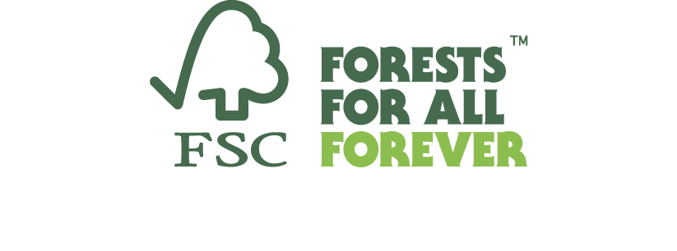

All Rights Reserved FSC® International 2021
FSC® F000100

