**Attention-based Deep Multiple Instance Learning**

**MNIST数据集（平均包长度为10）**

我的结果：

MNIST数据集实验结果(AUC)

|  |  |  |  |  |  |  |  |
| --- | --- | --- | --- | --- | --- | --- | --- |
| **训练包数量** | 50 | 100 | 150 | 200 | 300 | 400 | 500 |
| Attention | 0.865 | 0.964 | 0.975 | 0.976 | 0.981 | 0.991 | 0.992 |
| Gate-Attention | 0.886 | 0.952 | 0.976 | 0.984 | 0.985 | 0.994 | 0.995 |

论文的结果：

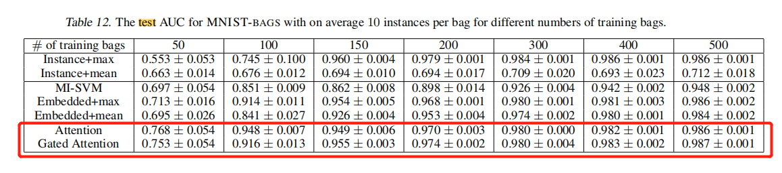

**COLON CANCER数据集（十折交叉验证）**

我的结果：

COLON CANCER数据集实验结果(Accuracy)

|  |  |  |
| --- | --- | --- |
|  | Accuracy | AUC |
| Attention | 90.89% | 0.972 |
| Gated-Attention | 89.78% | 0.975 |

论文的结果：

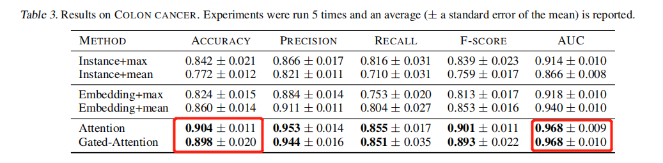s