Section 1: Business objective

1a. Explain the client’s business problem, who will use the predictions, and the practical value the project could provide.
The Cook County Assessor’s Office needs reliable estimates of residential property values, particularly for homes that have not sold recently. Without a recent transaction price, valuers must rely on other evidence to assess a property's likely market value. This project explores whether machine learning can provide a consistent starting point for that assessment.
The purpose of this project is to develop and evaluate a regression model that uses historical transaction data, property characteristics, and location information to estimate residential selling prices in US dollars. The predictions are intended to provide the Assessor’s Office’s residential valuation team with an initial estimate for review, supporting informed and consistent valuation decisions without replacing professional judgement. This could improve the consistency and efficiency of preliminary assessments and help analysts prioritise cases for closer review.
The model will be evaluated using a chronological holdout design, with earlier years used for training and model selection and a later year reserved for final testing. This assesses how well the model predicts prices for later historical transactions. However, because the model is trained exclusively on properties that have sold, its performance on the historical test set may overstate its accuracy for properties that remain unsold or lack recent transactions. The primary objective is to support the valuation of properties that have static archival characteristics (known features) but lack a recent transaction price, rather than predicting properties that are entirely unrecorded in the dataset.

Section 2: Data understanding and representation

2a. What does each row represent? Verify the join, check for duplicate records and repeated sales of the same property, and justify how you handle them.
Our data consists of Properties_2022.csv, which contains one row per unique property (98,899 rows with unique property_id), and sales.csv, which contains one row per completed transaction (109,307 unique transaction_id). A duplicate record would share the same transaction_id, which we confirmed does not exist. Repeated sales of the same property (same property_id, different transaction_id and sale_date) are legitimate and account for the 10,408 extra rows. We set property_id as the index and verified a perfect bi-directional match between the two tables. A left join with validate="many_to_one" confirmed no row inflation. We retained these repeated sales for the time-trend analysis in 2c, and their treatment in modelling is discussed in Section 3c.

2b. Which missing or unusual predictor values matter, and how will you handle them?
We first used the data dictionary to distinguish missing values that could be interpreted from the predictor definitions from those that required imputation. Before the chronological split, we coded missing char_type_resd values as 9.9, the dictionary’s code for “Missing”. For missing ward and community-area values, we used “Non-Chicago” for properties classified as outside Chicago and “Chicago-Unknown” for properties classified as within Chicago. These rules relied on predictor definitions and location classifications, so they could be applied without using sale prices.
After the split, we used training medians or modes to impute predictors with at most 50 missing training values. Predictors with more than 50 missing values and a missingness rate below 1% received both imputation and a missingness indicator. Predictors with at least 1% missingness generally received both as well. Three fields had particularly high training missingness: special service area code (97.15%), unified school district code (96.44%) and tax increment financing district code (91.52%). For these fields, we coded blanks as “Unknown” and added a separate missingness indicator. We compared mean log sale prices by missingness status for these three fields. For predictors with low missingness, we compared median sale prices. For example, the median was $695,000 when the nearby foreclosure-rate value was missing and $324,000 when it was recorded. These comparisons show associations in the training data. In a separate validation check with Ridge D (α = 10), removing the numeric missingness indicators increased WAE (2:1) from $153,123.27 to $153,149.31. We retained the indicators given this small difference.
To decide how to handle unusual values, we inspected training-set histograms and extreme values for predictors initially grouped as continuous (Figures C5–C6). We reviewed the distributions alongside the variable definitions and recorded our decisions in data/featureengineer.csv. We kept acs5_median_household_total_occupied_year_built and char_yrblt outside the continuous transformation sequence because they represent calendar years. Six count or rating predictors with distinct levels were binned separately. For example, the bedroom-count distribution had peaks at distinct integer values, so we represented char_beds using count bands and grouped five or more bedrooms together. We then one-hot encoded the bins using the categories observed in training.
After setting aside the calendar-year predictors and the predictors handled by binning, we processed the remaining predictors using the following continuous transformations. First, we clipped values below the training 1st percentile or above the training 99th percentile to the corresponding boundary. This limited the influence of extreme values while retaining the observations. Second, we applied a Yeo–Johnson transformation to address the pronounced skewness observed in some of the training histograms. For loc_longitude and loc_env_airport_noise_dnl, the transformation raised numerical stability issues, so we used their clipped values for the final step. Finally, we centred and scaled the resulting features using StandardScaler fitted on the training data.
In the shared matrix, categorical predictors with at least 30 training categories used smoothed five-fold out-of-fold target encoding. The mapping for each held-out training fold was fitted on the other four folds. Validation and test values were encoded using mappings fitted on the full training set. Lower-cardinality predictors used rare-category grouping and one-hot encoding based on training categories. We also estimated the imputation values, clipping bounds, Yeo–Johnson parameters and scaling parameters using training data and applied them to validation and test data.

2c. What do summaries and plots show about prices over time and across locations? Identify higher- and lower-price periods and discuss possible explanations.
Sale prices varied across the training period, with higher median prices in early 2024 than in 2023. The median was $315,000 for the full year of 2023 and $340,000 for January–June 2024, a difference of 7.94%. Because these periods are not directly comparable, we also examined the same six months in both years. The January–June median rose from $313,000 in 2023 to $340,000 in 2024 (8.63%). However, part of this difference may reflect changes in the types and locations of homes sold rather than market appreciation alone.
The monthly plots also suggest seasonal variation. Prices were generally higher around May and June, while lower medians appeared in January, February and the observed October–December period. Housing demand, school schedules and weather may help explain these patterns, although differences in transaction volume and property mix could also play a role. The raw-price plot shows a long right tail caused by expensive properties, while the log-scale plot makes the distribution easier to compare.
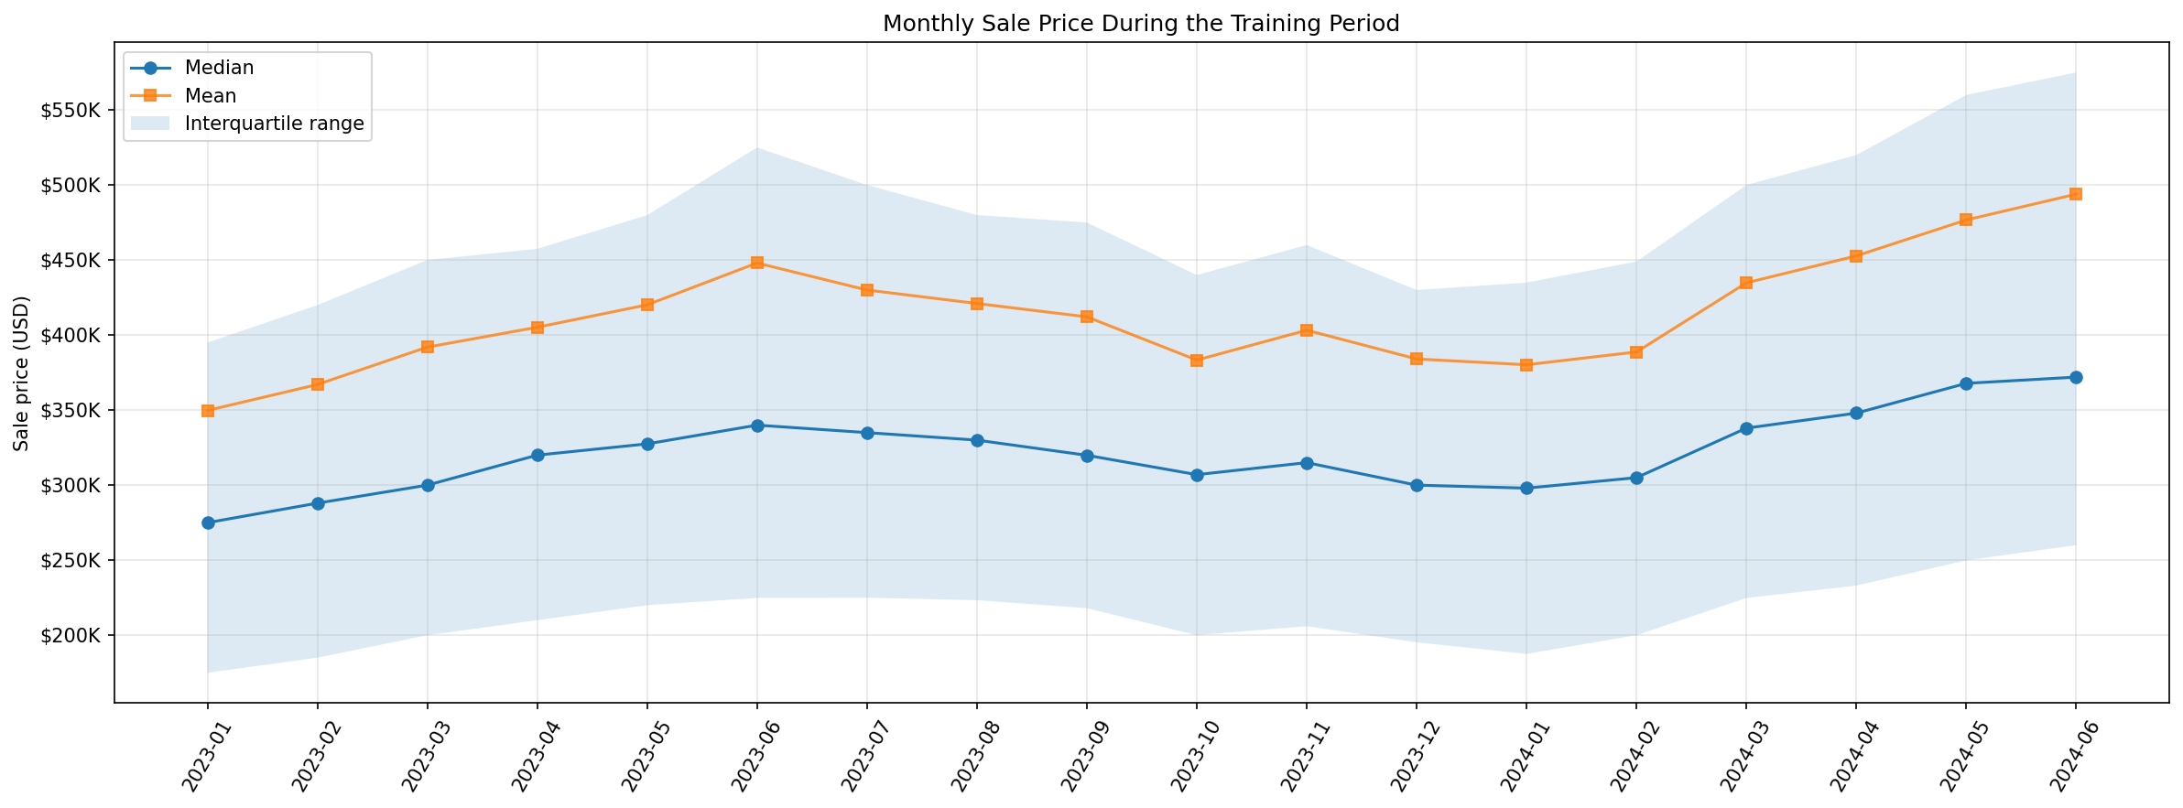
Figure 2.1. Training-only monthly sale prices; shifts may reflect transaction mix as well as market conditions.
The spatial analysis reveals substantial geographic inequality and spatial gradients in property values. Median sale prices were generally higher in the northern latitude deciles. The southernmost and northernmost latitude deciles had median prices of $205,000 and $545,000, respectively (2.66 times). The two easternmost longitude deciles had the lowest medians, $181,488 and $173,000, while the three westernmost deciles had medians of $380,000–$390,000. The highest-to-lowest longitude-decile median ratio was 2.25.
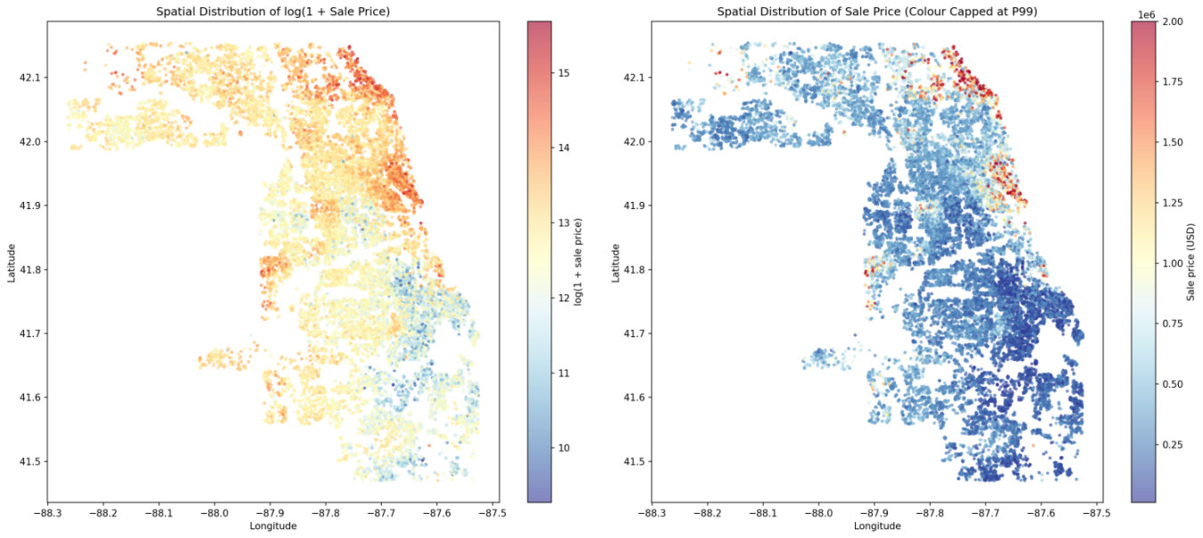
Figure 2.2. Training-only spatial sale-price patterns; geographic gradients are descriptive.
Training-period city medians vary markedly across Cook County, and the city plot shows a wide spread even after restricting displayed locations by sample size. City medians can also reflect differences in the types and sizes of homes sold. Location therefore enters the predictor set, while later 2025 error comparisons use actual township codes and report transaction counts.
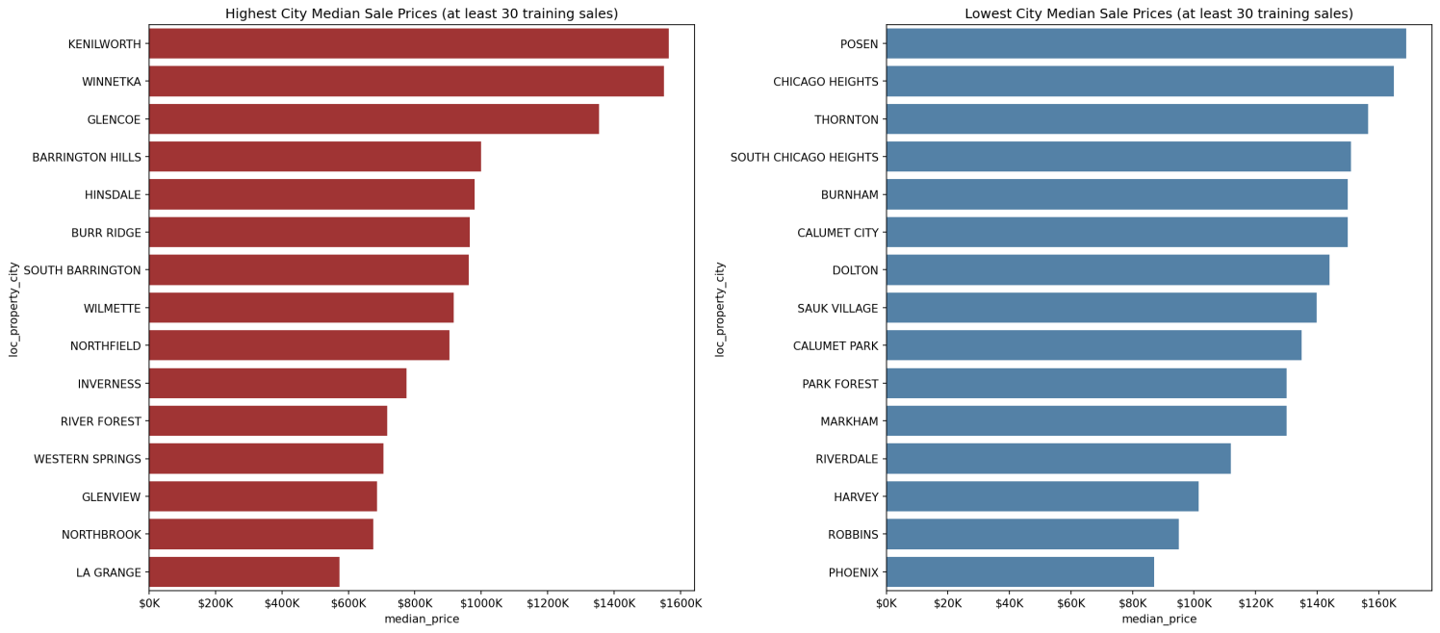
Figure 2.3. Training-only city median sale prices

2d. How will you represent the data? Create and justify at least two new features.
Our data representation followed a dictionary-guided pipeline. We applied strict type casting, ensuring nullable types (Int64, string) preserved missing values as <NA> to support accurate downstream imputation. Categorical variables were encoded cleanly based on cardinality. Building on this foundation, we developed three groups of engineered features to represent property age, quality-dependent building-size relationships, and nonlinear interactions between land and building area.
First, House Age (house_age) was calculated as sale_year − char_yrblt and clipped at zero. It represents the property’s age at the time of sale and serves as a proxy for depreciation and condition.
Second, Built Area × Construction Quality created inter_bldg_sf_quality_deluxe and inter_bldg_sf_quality_poor by multiplying building area by Deluxe and Poor indicators, with Average as the reference category. These interactions represent building-size effects that can differ by construction quality. Their training-only Spearman correlations with log sale price were 0.1214 and 0.0057, compared with 0.5664 for the original building-area variable.
Third, Land Area × Building Area (inter_log1p_land_bldg_product) used log1p(char_land_sf × char_bldg_sf) to compress the product’s extreme right tail. Its training-only Spearman correlation with log sale price was 0.4314, compared with 0.1586 for land area alone. These correlations describe training-set associations; predictive improvements are assessed through validation comparisons.
For the original linear-model comparisons, Feature Set D combined 97 location and property predictors with a Building Size × Archived Building Age interaction. This interaction used pre-sale property information and tested whether the association between floor area and price differed across older and newer buildings. Separately, a continuous valuation month index, measured relative to January 2023, and building age at valuation were explored as candidate temporal features in the E-series experiments. Their purpose was to assess whether explicitly representing transaction timing could capture information beyond the archived property characteristics.
Because the E-series changed multiple feature components, an additional controlled comparison examined the month index alone by adding it to Lasso Feature Set D while holding the regularisation strength at α = 20. This distinguished the incremental contribution of the month index from the combined effects of other engineered features. The final inclusion decision was based on the chronological validation results and the primary WAE (2:1) criterion, rather than assuming that additional temporal information would necessarily improve business-weighted prediction performance. The detailed experimental evidence and resulting feature-selection decision are presented in Section 3d.

2e. What could cause leakage or biased conclusions? How does using only sold properties limit claims about homes that have not sold?
To prevent data leakage, we strictly separated global, rule-based structural handling from data-driven statistical learning. Structural imputations (e.g., filling loc_chicago_ward_num as 'Non-Chicago' based on the is_Chicago indicator) were performed globally before the chronological split. Because these rely purely on feature definitions and are entirely independent of the target variable (sale_price), they do not introduce label leakage. In contrast, any global application of data-driven transformations (e.g., calculating medians or target encoding) would leak future information. Therefore, after the chronological split, all such statistics—including imputation medians, clipping bounds, scaling parameters, and Target Encoding—were fitted exclusively on the training set and applied to the validation/test sets.
The supplied data cover 98,899 properties, each with at least one recorded sale during 2023–2025. The 2025 test measures prediction error for homes that sold that year, including homes with no recorded sale in the model’s fitting period. Homes that remained unsold throughout the study period may differ in condition or marketability, and the model’s accuracy for those homes remains unknown. Estimates for properties with characteristics poorly represented in the training data should receive closer review by a valuer.

Section 3: Model development

3a. Establish a simple price-prediction baseline and explain its purpose.
We used the training-set mean sale price of approximately $418,490 as a simple baseline, assigning the same predicted price to every validation transaction regardless of its location or property characteristics. This simple benchmark uses only information available during training and provides a reference for determining whether more sophisticated models offer meaningful improvements in predictive performance.
Table 3.1. Baseline performance on the 2024 H2 validation set (n = 18,132)
Baseline | WAE 2:1 ($) | MAE ($) | MSE ($², billions) | R²
Global Mean | 342,381.82 | 238,599.62 | 191.693 | −0.0050
Neighbourhood Median | 177,265.28 | 135,959.86 | 85.563 | 0.5514
The slightly negative R² indicates that the training-mean prediction performed marginally worse than predicting the validation-set mean retrospectively. The baseline also produced a WAE (2:1) of $342,381.82, reflecting the greater penalty assigned to overvaluation under the project's primary business-weighted metric. Although the baseline does not account for differences between properties, it establishes a transparent benchmark against which the additional predictive value of property characteristics, location information and more complex regression models can be assessed.
A second, stronger validation reference uses the median sale price of each neighbourhood calculated only from the training period, with township and global fallbacks for unseen areas. It achieved WAE 2:1 of $177,265.28 and MAE $135,959.86 on the same 18,132 validation sales. This shows that location alone explains substantial variation and provides a more demanding benchmark than the Global Mean; the 2025 final comparison uses the specified development-mean baseline.
The final CatBoost K002 reduced validation WAE (2:1) by 28.9% relative to this neighbourhood-median benchmark, and the best linear model, Lasso D, by 13.9%, providing evidence of predictive value beyond a simple location-based pricing rule.

3b. Compare multiple regression approaches taught in the course. Explain your choices and what you learned. You may also investigate separate models for different locations.
We compared linear regression, regression trees, random forests and gradient boosting to assess whether flexibility, averaging and regularisation improve residential price prediction. OLS provides an interpretable benchmark; Ridge and Lasso shrink coefficients, with Lasso also setting some to zero. A regression tree captures non-linear effects and interactions through recursive splits, but has high variance. Random forest averages trees grown on bootstrap samples and considers a random subset of predictors at each split, which reduces the correlation between trees and therefore the variance of their average. Gradient boosting adds trees sequentially, each improving the current fit, with a learning rate shrinking each tree’s contribution. We evaluated four boosting implementations: LightGBM, XGBoost, CatBoost and HistGradientBoosting.
These approaches suit a tabular dataset containing many property and location predictors. We did not prioritise k-nearest neighbours because the curse of dimensionality increases the amount of data needed for reliable local prediction. A standard additive GAM would require explicit interaction terms to represent building-size effects that vary by location. Neural networks were a lower priority because boosting tends to perform better on tabular data. We fitted county-wide models with geographic predictors rather than separate township models, allowing observations to contribute to a shared fit while retaining geographic information.
All models used 54,853 training sales from January 2023 to June 2024 and the same 18,132 validation sales from July to December 2024. Validation WAE (2:1), which weights overvaluation twice as heavily as undervaluation, governed model selection; the 2025 test outcomes were reserved for final evaluation. Table 3.2 compares the selected procedures. The main linear models used Feature Set D, with 3,817 encoded columns, while all tree and boosting models used the same 209-column shared matrix. Feature Set D uses one-hot location encoding, whereas the shared matrix uses target encoding for high-cardinality categories. These results therefore compare complete modelling procedures. Appendix Table B1 reports OLS, Ridge and Lasso results on the same 209-predictor matrix used by the tree and ensemble models in Table 3.2, allowing a comparison on a common feature representation.
Table 3.2. Selected procedures on 2024 H2 validation sales (n = 18,132)
Model and configuration | Representation | WAE 2:1 ($) | MAE ($) | R²
Global Mean baseline | Training mean | 342,381.82 | 238,599.62 | -0.0050
OLS | D 3,817 columns | 157,254.42 | 113,051.17 | 0.7162
Ridge alpha = 12 | D 3,817 columns | 153,109.49 | 110,441.40 | 0.7258
Lasso alpha = 20 | D 3,817 columns | 152,566.39 | 110,000.68 | 0.7286
Tree T018 | 209 shared | 160,998.12 | 115,601.41 | 0.6896
Random Forest R011 | 209 shared | 139,315.50 | 101,041.09 | 0.7448
LightGBM C022 | 209 shared | 126,915.23 | 101,218.90 | 0.7491
HistGradientBoosting H023 | 209 shared | 126,914.57 | 100,952.81 | 0.7554
XGBoost X021 | 209 shared | 126,510.95 | 100,686.67 | 0.7658
CatBoost K002 | 209 shared | 126,068.74 | 100,541.87 | 0.7745

Note: D combines location and property predictors with a building-size by archived-age interaction. Tree T018 uses depth 10 and leaf 10; R011 uses 100 trees, max_features 0.5 and leaf 10. All boosting rows use log1p targets; their iteration counts are in Table 3.6.
First, both model form and feature representation mattered. On the identical shared matrix, random forest reduced WAE (2:1) by 26.4% relative to the best tested linear comparator, Lasso ($139,315.50 versus $189,367.77). Lasso performed much better with Feature Set D ($152,566.39); because the two Lasso procedures differ in encoding, preprocessing and penalty grid, this gap reflects the complete procedure rather than encoding alone. Even against this stronger linear procedure, random forest reduced WAE by 8.7%. On the shared matrix, even the single tree reduced WAE by 15.0% relative to Lasso, but it remained worse than the Lasso D procedure. A single tree did not beat the stronger Lasso D procedure; the selected random forest did.
Second, averaging trees improved on a single tree. Random forest reduced WAE (2:1) by 13.5% and MAE by 12.6% relative to the selected regression tree. This supports the variance-reduction rationale for bagging and predictor randomisation. Section 3e shows how leaf size and the number of candidate predictors controlled the forest's complexity.
Third, boosting's main advantage was lower overvaluation loss. CatBoost had the lowest validation WAE (2:1), $126,068.74, followed by XGBoost at $126,510.95. CatBoost's MAE was only $499.22 lower than random forest's, but its WAE was $13,246.76 lower. Writing e as prediction minus actual price, WAE (2:1) = MAE + mean[max(e, 0)]. This average overvaluation component was $25,526.87 for CatBoost and $38,274.41 for random forest, explaining 96% of the WAE improvement. All four selected boosting models used log1p targets and had median estimate-to-price ratios near 0.90, compared with 0.95 for random forest. These models fit squared error on log price, and back-transforming their predictions with expm1 without a bias correction tends to understate the conditional mean in dollars. The two CatBoost reference trials held the other hyperparameters fixed and selected tree counts separately using the same validation WAE rule. Compared with the raw-price specification, the log1p specification had a lower median estimate-to-price ratio (0.9023 versus 0.9312), a more negative mean signed error (−$49,488 versus −$30,408), slightly higher MAE and 5.1% lower WAE (2:1). CatBoost's $442.21 lead over XGBoost resolves the declared selection rule, but is a small margin of 0.35%.
Fourth, reducing prediction bias did not necessarily improve the chosen business loss. In the controlled CatBoost experiment, adding a continuous month index while holding hyperparameters and tree count fixed improved MAE from $100,541.87 to $95,291.86 and moved mean signed error from -$49,488.14 to -$14,735.09. Yet WAE (2:1) increased to $135,570.25, a deterioration of 7.54%. We therefore retained the shared matrix without that additional index. This matrix already contains calendar-month indicators, construction year and house age at sale; omitting the extra index does not mean omitting all time information. Section 3d reports the linear-model feature experiments. Together, the comparisons show why model selection must follow the stated valuation priority rather than MAE or average bias alone.

3c. How will you split the data and compare models? Justify your validation strategy, considering sale dates and repeated properties.
A chronological validation strategy was adopted because the forecasting task is to predict future residential sale prices using information available from earlier transactions. A random split could place later sales in the training set and earlier sales in the validation set, creating an unrealistic evaluation setting in which models learn from future market conditions. To preserve the temporal order, the 109,307 transactions were divided into training data from January 2023 to June 2024 (18 months; 54,853 transactions), validation data from July to December 2024 (6 months; 18,132 transactions), and test data from January to December 2025 (12 months; 36,322 transactions).
We chose these dates to reflect how the model would be used in practice: learning from earlier sales and predicting prices for later transactions. The training period includes the full 2023 calendar year and the first half of 2024, providing a substantial sample and at least one complete annual seasonal cycle. The immediately following six months provide an out-of-time validation period that approximates predicting near-term transactions under second-half market conditions. Reserving the entire 2025 calendar year for testing allows the final model to be assessed over a longer future period covering all four seasons. The monthly transaction timeline was also checked across the 36-month dataset, with no months lacking transactions. Together, these choices provide a clear chronological separation while retaining sufficient observations for model development and evaluation.
Repeated property sales were considered because the same property can appear in more than one time period. We identified 1,677 validation transactions (9.25%), involving 1,666 distinct properties, whose properties had also appeared in the training period. This overlap does not automatically constitute information leakage: in practice, a future transaction may involve a property that has previously been sold, and earlier transactions can legitimately precede later ones. A property-level split would provide a stricter evaluation of predictions for previously unseen homes, but it would address a different question from forecasting future transactions across the housing market. We therefore used a chronological split to evaluate future sales of both previously seen and unseen properties. On the 2024 validation set, WAE (2:1) was higher for properties seen in training than for unseen properties, both for Random Forest R011 ($160,028 versus $137,205) and for CatBoost K002 ($165,951 versus $122,004).
To minimise leakage, learned preprocessing operations, including imputation, scaling and encoding, were fitted using training data only, and property and transaction identifiers were excluded from model predictors. Models and hyperparameters were selected on the July–December 2024 validation set using WAE (2:1), which gives overvaluation errors twice the weight of equally sized undervaluation errors. MAE, MSE and R² were reported as supplementary measures. All model families were evaluated on the same validation transactions and using the same loss definition, although their feature representations and training-fitted preprocessing pipelines could differ. The 2025 test set was kept separate from feature selection, tuning and model comparison, and was reserved for final evaluation after model selection. Although repeated experimentation on a single validation period may introduce selection bias, this separation provides an independent assessment of the chosen approach on later transactions.

3d. Show how experiments informed your decisions. Include a comparison of feature sets.
Feature-set experiments were conducted to examine whether location and property characteristics provide complementary predictive information and whether engineered features improve performance beyond the original specification. Candidate interactions were motivated by plausible valuation relationships, but inclusion decisions were based on the 2024 H2 validation results, using weighted absolute error (WAE, 2:1) as the primary criterion.
Four initial feature sets were evaluated using ordinary Linear Regression with the same chronological training and validation transactions and training-fitted preprocessing. Set A contained 67 location predictors, while Set B contained 30 property characteristics. Set C combined both groups into 97 original predictors. Set D added a Building Size × Archived Building Age interaction to Set C, testing whether the association between building size and sale price differs by building age. The interaction uses building size and archived building age available before each sale, making it suitable for the study's chronological prediction setting.
Table 3.3. Linear Regression feature-set comparison on the 2024 H2 validation set
Feature Set | Original Predictors | WAE 2:1 ($) | MAE ($) | MSE ($², bn) | R²
A. Location | 67 | 192,465.60 | 136,668.23 | 79.617 | 0.5826
B. Property | 30 | 246,660.93 | 173,941.63 | 98.797 | 0.4820
C. Combined | 97 | 157,672.52 | 113,327.41 | 54.782 | 0.7128
D. C + Size × Archived Age | 98 | 157,254.42 | 113,051.17 | 54.137 | 0.7162
Combining location and property information reduced WAE by approximately 18.1% relative to the location-only set and 36.1% relative to the property-only set, demonstrating the complementary predictive value of the two groups. Adding the Size × Archived Building Age interaction produced a further 0.27% reduction in WAE. Although this improvement was modest, Feature Set D provided a reasonable basis for the subsequent regularised linear-model comparison.
A second series of experiments explored transformations and interactions involving building size, age, property class, township, land area, basement characteristics and flood exposure. The E-series used a common time-aware base configuration (E0), which included a continuous valuation month index and building age at valuation. Ridge Regression was used throughout, with α selected separately for each feature configuration according to validation WAE (2:1). Each E-series result represents a complete Ridge specification combining engineered features with its separately tuned regularization strength, allowing the configurations to be compared on their overall validation performance.
Table 3.4. Selected Ridge configurations E0–E6 on 2024 H2 validation
Feature Set | Selected α | WAE 2:1 ($) | MAE ($) | R²
E0. Time-Aware Base | 10 | 169,542.23 | 110,000.75 | 0.7248
E1. Size × Age | 8 | 168,913.15 | 109,585.75 | 0.7291
E2. Size × Class | 8 | 166,933.85 | 108,223.02 | 0.7431
E3. Size × Township | 12 | 165,529.66 | 106,627.09 | 0.7514
E4. Log Land × Township | 5 | 166,747.57 | 107,781.76 | 0.7482
E5. Basement × Flood | 10 | 169,566.55 | 110,014.31 | 0.7248
E6. Combined Interactions | 5 | 161,801.48 | 104,068.83 | 0.7799
The E-series showed that some tuned E-series configurations achieved lower validation WAE than E0, while others offered little benefit. Size × Township (E3) improved validation WAE relative to E0, whereas Basement × Flood (E5) slightly worsened it. The combined E6 configuration (α = 5) achieved the lowest WAE within this series, reducing it from $169,542.23 to $161,801.48 (approximately 4.6%), alongside lower MAE and higher R². E6 therefore provided the strongest overall validation performance among the tested E-series configurations.
Further targeted experiments compared three additional feature specifications with Feature Set D using Ridge Regression with α fixed at 8. Adding Size × Construction Quality (F1) marginally reduced WAE from $153,163.83 to $153,141.95, while F2 and F3 increased it to $153,463.84 and $153,440.45, respectively (Table B2). A separate exploratory Ridge F1 run at α = 12 achieved WAE of $153,089.21, only $20.28 below Ridge D at the same α ($153,109.49). These marginal gains offered little justification for additional interaction complexity, particularly as Lasso D (α = 20) achieved a lower WAE of $152,566.39.
On the validation set, Ridge E6 (α = 5) achieved a lower MAE than Lasso D (α = 20), at $104,068.83 versus $110,000.68. Under WAE (2:1), E6’s larger overvaluation penalty ($57,733 versus $42,566 per sale) outweighed its MAE advantage. Lasso D therefore had the lower WAE ($152,566.39 versus $161,801.48) and was retained as the preferred linear-family candidate.
To examine temporal information more directly, an additional controlled experiment compared the original Lasso Feature Set D (Model A) with the same specification augmented only by a continuous valuation month index (Model B). Both models used α = 20, the same chronological data split and the same training-fitted preprocessing approach. Unlike the E-series comparisons, this experiment held the original feature specification and regularisation strength fixed while changing only the inclusion of the month index.
Table 3.5. Controlled temporal feature experiment: Lasso D versus D + Month Index
Validation Metric | Model A: Lasso D | Model B: D + Month Index | B − A
WAE 2:1 ($) ↓ | 152,566.39 | 168,505.31 | +15,938.92
MAE ($) ↓ | 110,000.68 | 109,197.96 | −802.72
RMSE ($) ↓ | 227,500.99 | 226,534.94 | −966.05
Mean Signed Error ($) | −24,869.25 | +9,416.75 | +34,286.00
Median Prediction / Actual | 0.9418 | 1.0388 | +0.0970
R² ↑ | 0.7286 | 0.7309 | +0.0023
Note: Both models used Lasso α = 20. Mean Signed Error is defined as prediction minus actual sale price; negative values indicate average underprediction. The only added predictor in Model B was the continuous valuation month index.
Adding the month index slightly reduced MAE and RMSE and improved R², while shifting Mean Signed Error from −$24,869.25 to +$9,416.75. The reported median prediction-to-actual ratio also increased from 0.9418 to 1.0388. These results indicate that the additional temporal feature substantially shifted predictions upward, reducing the original average underestimation but moving the model towards average overestimation. Under the 2:1 WAE definition, overvaluations receive twice the penalty of equally sized undervaluations. As a result, the modest improvement in absolute accuracy was outweighed by the increase in positively signed errors: WAE rose by $15,938.92, or approximately 10.45%.
The controlled experiment added only the month index to Lasso D, giving a clearer indication of its contribution than the E-series, where several features changed together. The validation month indices (18–23) lay beyond the training range (0–17). The augmented model produced higher validation predictions on average (Table 3.5). Both specifications used the same regularisation strength (α = 20). Under the predefined WAE (2:1) decision rule, Lasso D without the explicit month index remained the preferred linear-family candidate.
Overall, the experiments showed that combining location and property characteristics substantially improved prediction performance, while additional engineered features produced smaller, configuration-dependent gains. The controlled month-index experiment further supported retaining Lasso D (α = 20) as the preferred linear-family candidate for the group-wide validation comparison. The ranking of these specifications may vary across validation periods.

3e. How did you tune the models and control complexity?
We fitted the models on sales from January 2023 to June 2024 and tuned them using the July–December 2024 validation set. The 2025 test data were reserved for final evaluation and were not used during tuning. Model selection relied on the chronological July–December 2024 validation period rather than random K-fold cross-validation, so evaluation reflected prediction of later transactions. This is distinct from the five-fold out-of-fold target encoding applied within the training data to construct features without using each held-out fold's target values. WAE (2:1) was the primary criterion for the final configuration. Random-forest size was first set by a diminishing-returns rule based on validation MAE, then its leaf and feature settings were selected by WAE. Table 3.6 records the searches and retained configurations.
Table 3.6. Complexity controls, searches and retained configurations
Family | Complexity controls and search | Selected configuration
Ridge and Lasso D | Penalty alpha; coarse then refined grids, plus convergence confirmation | Ridge alpha 12; Lasso alpha 20
Regression tree | 9 depths (2-20 and unlimited) × 4 minimum leaf sizes (1, 10, 50, 200) | T018 depth 10; leaf 10
Random forest | 25-300 trees, then 4 feature shares × 4 minimum leaf sizes | R011 100 trees; share 0.5; leaf 10
LightGBM | 24 Optuna trials; target scale, depth, leaves, learning rate, row/feature sampling, L1/L2 and leaf constraint | C022 log1p; depth 6; 40 leaves; rate 0.03245; 1,077 trees
XGBoost | 24 Optuna trials; target scale, depth, learning rate, row/feature sampling, L1/L2 and child weight | X021 log1p; depth 6; rate 0.02864; child weight 82; 1,377 trees
CatBoost | 24 Optuna trials; target scale, depth, learning rate, row/feature sampling and L2 | K002 log1p; depth 6; rate 0.05; L2 1; 1,376 trees
HistGradientBoosting | 24 Optuna trials; target scale, depth, leaves, learning rate, feature sampling, L2 and leaf size | H023 log1p; depth 6; 45 leaves; rate 0.02585; 1,370 iterations
Linear models. Ridge and Lasso controlled complexity through their penalty strength. On Feature Set D, Lasso reduced WAE from OLS's $157,254.42 to $152,566.39 and retained 1,074 of 3,817 coefficients, setting 2,743 to zero. Ridge's WAE varied by only $54.34 across alpha values 8-15, indicating a flat region around the selected alpha of 12. Solver checks were separate from model selection: the final Lasso alpha-20 fit used tolerance 1e-5, converged in 3,112 iterations and had a dual gap below its stopping threshold. The feature and preprocessing experiments are discussed in Section 3d rather than repeated here.
Regression tree. Figure 3.1 shows the bias-variance trade-off directly. With a minimum leaf size of 1, training MAE fell from $155,312.98 at depth 2 to $56.14 for an unlimited tree, while validation MAE reached its minimum of $117,571.33 at depth 8 and then rose to $145,333.80. The deeper tree fitted the training observations increasingly closely while predicting later sales less accurately. Minimum leaf size restrained this behaviour: with a minimum leaf size of 50, validation MAE stayed between $115,538.39 and $116,085.52 from depth 10 to unlimited. The selected tree was T018, depth 10 and minimum leaf 10, with the lowest WAE of $160,998.12. It was selected on WAE even though the depth-10, leaf-50 tree had a slightly lower MAE.
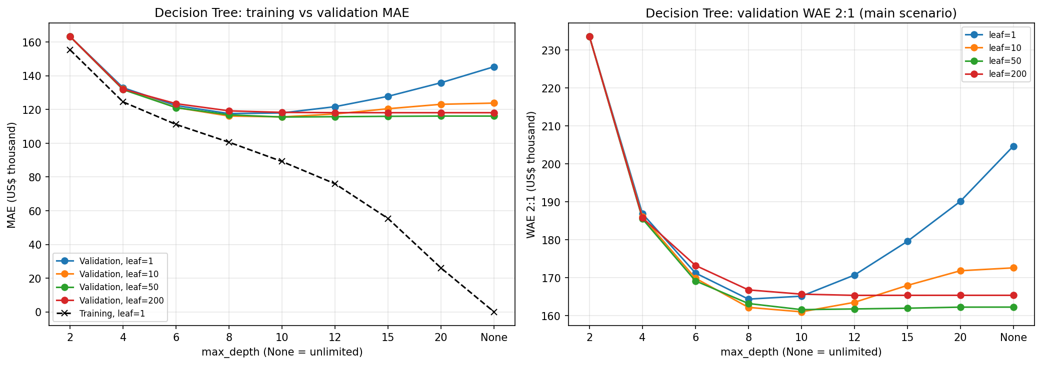
Figure 3.1. Regression-tree complexity: training and validation MAE (left), and validation WAE (2:1) (right), by maximum depth and minimum leaf size. Source: final tree notebook output.
Random forest. The tree-count path used max_features = 0.33 and minimum leaf 3. Validation MAE declined from $102,873.94 with 25 trees to $101,374.87 with 100, but improved by only another $403.24 at 300 trees. We selected the smallest forest within 0.5% of the lowest path MAE: 100 trees, only 0.40% above the 300-tree result. This reduced computation while preserving nearly all of the observed averaging benefit. Tree count was then held fixed for the 16-configuration complexity grid in Figure 3.2.
The selected R011 used 50% of predictors per split and minimum leaf 10, achieving WAE $139,315.50 and MAE $101,041.09. Tiny leaves fitted the training data much more closely without improving validation: at 50% of predictors, leaf 1 gave training MAE $35,591.65 and validation MAE $102,921.41, whereas leaf 10 gave $72,147.85 and $101,041.09. Increasing the leaf size to 30 worsened validation MAE to $103,138.56. Across all 16 settings, validation MAE varied by 2.8%; using 80% of predictors was worst at every tested leaf size. The chosen setting balances tree flexibility and the diversity created by predictor randomisation.
Validation MAE exceeded out-of-bag MAE by $6,042-$7,125 across the grid, and no tested setting closed this gap. The gap combines the later sale period with a different evaluation procedure, so it does not measure market drift alone; selection therefore relied on the later validation window.
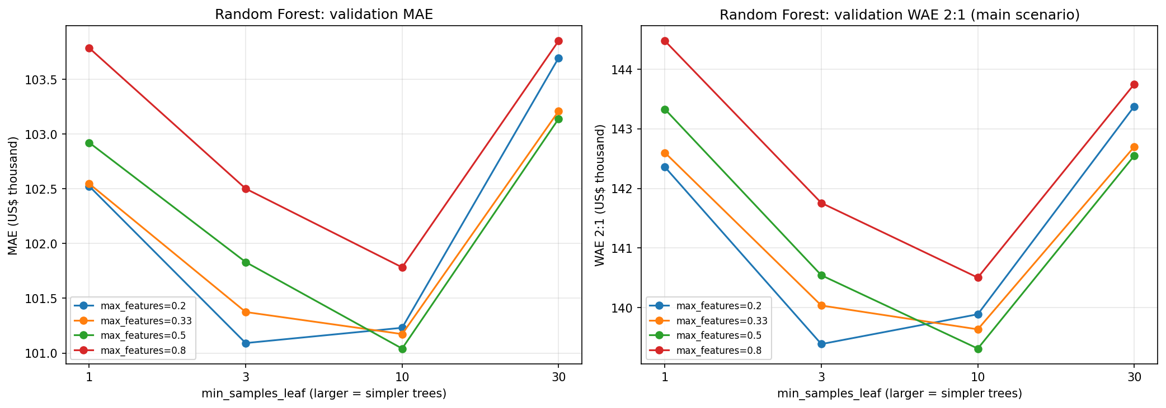Figure 3.2. Random-forest complexity at 100 trees: validation MAE (left) and WAE (2:1) (right), by minimum leaf size and candidate predictor share. Source: final tree notebook output.
Boosting. Each of the four implementations received 24 Optuna trials (seed 6810), comprising two pre-specified reference configurations (raw-price and log1p targets) and 22 additional trials managed by the TPE sampler. The searches varied depth, learning rate, feature sampling, L2 regularisation and target scale, with leaf constraints, row sampling and L1 penalties where supported. This gave the boosting families the same trial budget while respecting their different tree structures. All candidates used squared-error fitting objectives on their chosen target scale; WAE (2:1) governed hyperparameter and iteration selection rather than serving as the fitting loss.
For every trial, dollar WAE (2:1) was evaluated after each tree, up to 1,400 rounds, with patience 100. LightGBM and XGBoost used custom dollar-WAE metrics for library early stopping, and the code checked the selected iteration against the same explicit patience rule. CatBoost and HistGradientBoosting were fitted for 1,400 rounds, after which the rule was applied to staged validation predictions to retain the selected number of trees. Thus iteration selection used the same criterion, although the latter two implementations did not stop computation early. Log predictions were converted back with expm1 before scoring.
In the 96-trial main search, all 79 log-target candidates had lower WAE than all 17 raw-target candidates ($126,068.74-$128,479.70 versus $132,799.36-$136,806.00). The lowest raw-target MAE was nevertheless $98,508.87, below the selected CatBoost's $100,541.87. This reinforced the distinction between symmetric accuracy and the chosen valuation priority. CatBoost K002 combined depth 6, learning rate 0.05, L2 leaf penalty 1, 90% row and feature sampling, and 1,376 trees. Figure 3.3 shows the selected CatBoost's learning curve: training WAE kept falling, while validation WAE improved by only $153 over the last 176 trees ($126,222 at 1,200 trees; $126,069 at 1,376). For the selected CatBoost, XGBoost and HistGradientBoosting configurations, the 1,400-round cap was reached before the 100-round patience condition was met, so each retained tree count is the lowest-WAE round within the cap rather than a confirmed stopping point. Hyperparameters, target scale and tree count were frozen before the final estimator was refitted on training plus validation.
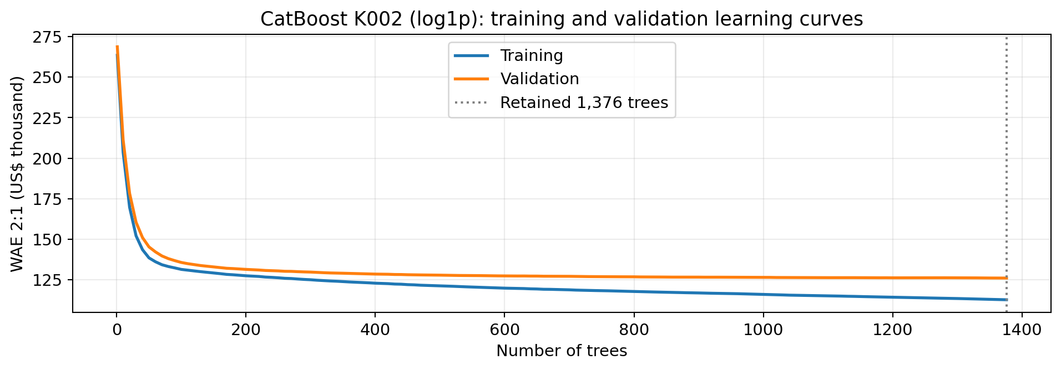
Figure 3.3. Training and validation WAE (2:1) for selected CatBoost K002 as tree count increases. The dotted line marks the retained 1,376 trees. Source: final boosting notebook diagnostics.

3f. Which final model and prediction procedure did you select, and why?
The final model was selected using the pre-specified WAE (2:1) criterion on the 18,132 validation sales from July–December 2024. Table 3.7 compares the four boosting-family winners, all using the same 209-column representation; Table 3.2 provides the full comparison across modelling procedures. The 2025 test set was not used for selection.
Table 3.7. Leading boosting configurations on 2024 H2 validation (n = 18,132)
Model and configuration | WAE 2:1 ($) | MAE ($) | MSE ($², billions) | R²
CatBoost K002; log1p, 1,376 trees | 126,068.74 | 100,541.87 | 43.002 | 0.7745
XGBoost X021; log1p, 1,377 trees | 126,510.95 | 100,686.67 | 44.664 | 0.7658
HistGradientBoosting H023; log1p, 1,370 iterations | 126,914.57 | 100,952.81 | 46.649 | 0.7554
LightGBM C022; log1p, 1,077 trees | 126,915.23 | 101,218.90 | 47.849 | 0.7491
K002 improved validation WAE (2:1) by $442.21 relative to XGBoost X021, $845.83 relative to HistGradientBoosting H023 and $846.49 relative to LightGBM C022, and by $13,246.76 relative to Random Forest R011 (Table 3.2). Its validation MSE was 43.00 billion squared dollars and R² was 0.7745, also the best among the four. The narrow gap to the other boosting families supports criterion-based selection, not a claim of universal CatBoost superiority. Lasso D (α = 20; WAE $152,566.39) was the strongest linear candidate (Table 3.2).
CatBoost K002 uses the frozen 209-column representation without identifiers or target columns. It fits log1p(sale_price), converts predictions back to non-negative US dollars and uses depth 6, learning rate 0.05 and 1,376 trees; other parameters are recorded in the final-model export. After validation it was refitted without further tuning on 72,985 development sales, then scored once on 36,322 held-out 2025 sales. Sale-month indicators and house_age were retained; the additional continuous month index was not adopted because it worsened primary validation WAE.

Section 4: Final evaluation

4a. How do your price predictions perform on the test set compared with the baseline? Justify your regression metrics and interpret a residual plot.
The frozen CatBoost K002 procedure substantially outperformed the Global Mean baseline on the 36,322 held-out 2025 sales. After validation selection, the estimator was refitted on all 72,985 training-plus-validation sales using the frozen 209-column representation, log1p target and 1,376 trees. The baseline predicted $426,200.21 for every test transaction, the mean price of the same development window. Table 4.1 reports both procedures on identical test rows.
Table 4.1. Final 2025 test performance (n = 36,322)
Metric | CatBoost K002 | Global Mean baseline
WAE 2:1 ($) | 133,983.35 | 360,699.00
MAE ($) | 105,380.58 | 256,774.35
MSE ($², billions) | 65.034 | 245.129
RMSE ($) | 255,017.63 | 495,104.71
R² | 0.7321 | -0.0099
Median absolute percentage error | 17.90% | 42.79%
WAE (2:1) fell by 62.85% relative to the baseline, while MAE fell by 58.96% and RMSE by 48.49%. After refitting on training plus validation, test WAE (2:1) was 6.3% above validation WAE ($133,983.35 versus $126,068.74). WAE reflects the stated higher priority on avoiding overvaluation; it is a weighted error per sale, not a measured financial cost. MAE expresses the average absolute miss in dollars. MSE and RMSE give greater emphasis to large errors, with RMSE retaining dollar units. R-squared measures improvement in squared error relative to the test-set mean predictor: 0.7321 means a 73.21% reduction in that squared-error benchmark, rather than 73.21% pricing accuracy. The baseline's slightly negative R-squared reflects the difference between its development-period mean and the later test mean. Median absolute percentage error was 17.90%, providing a scale-relative description alongside dollar errors.
Figure 4.1 defines residuals as predicted minus actual sale price, so negative values indicate undervaluation. Mean signed error was -$48,175.04, the median estimate-to-price ratio was 0.9235, and 36.97% of sales were overvalued. The scatter shows a wider range of dollar errors at higher predicted prices, with many substantial negative residuals. Errors are therefore neither evenly spread around zero nor constant in dollar size. RMSE of $255,017.63, more than twice MAE, confirms that large misses remain important.
The price-decile panel explains why the overall downward bias is not uniform. In the cheapest decile (3,641 sales; median price $92,500), 89.34% of predictions exceeded the sale price and the median ratio was 1.6311. In the most expensive decile (3,603 sales; median price $1,295,000), the median ratio was 0.8455 and MAE was $373,389.43. Predictions are compressed toward the middle of the price distribution: inexpensive sales are often overvalued, while expensive sales are generally undervalued. The baseline improvement establishes useful predictive information, while these remaining errors identify where professional review is especially important.
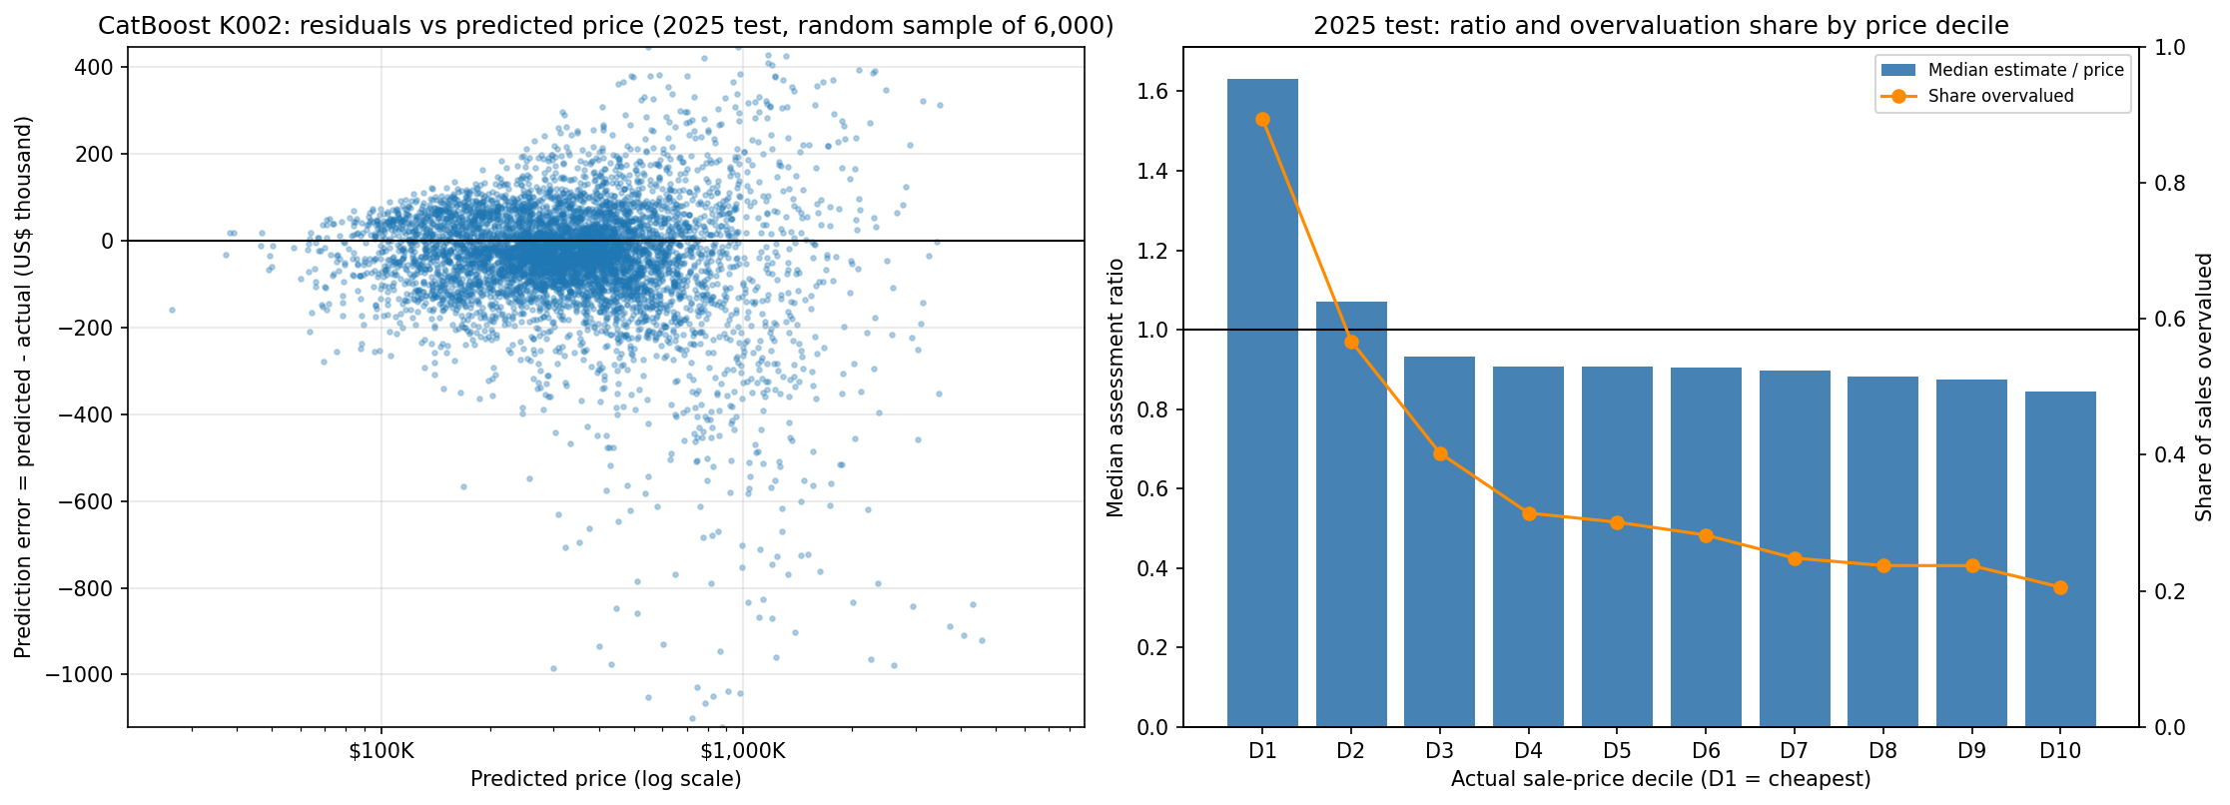Figure 4.1. CatBoost K002 on 2025 test sales: residuals against predicted price (left; logarithmic horizontal scale) and median estimate-to-price ratio with overvaluation share by actual-price decile (right). The left panel shows a random sample of 6,000 sales, with the vertical axis limited to the sample's 0.5th-99.5th residual percentiles; all test sales enter the reported metrics. Source: frozen model test predictions.

4b. Compare performance across time periods and at least three townships (local geographical areas in Cook County). How might price levels and the mix of homes sold explain differences? Support your explanations with evidence from the data.
On 2025 held-out sales, quarterly WAE (2:1) rose from $130,382.13 in Q1 (n=7,074) to $139,194.92 in Q4 (n=8,591). Mean signed error (prediction minus actual) changed from −$39,792.64 to −$55,206.01, suggesting greater underestimation late in the year. Table B3 provides quarterly values; Figure 4.2 provides monthly diagnostics.
Mean signed error was negative in all 12 months of 2025. November had the highest monthly WAE (2:1) at $143,872.78, and monthly median estimate-to-price ratios ranged from approximately 0.90 to 0.97. Median sale prices peaked in Q2 at $375,000, compared with $340,000 in Q1, $365,000 in Q3 and $357,000 in Q4. Median building area ranged from 1,450 to 1,464 square feet, and the median year built was 1954 in every quarter. Mean signed error became more negative in each successive quarter, a pattern that differed from those of all three quarterly medians.
Three Cook County townships show geographic variation. Thornton (code 37; 1,844 sales) had median price $170,000.00, MAE $50,715.99 and WAE (2:1) $69,908.24. Jefferson (code 71; 3,378 sales) had median price $480,000.00, MAE $119,323.06 and WAE $151,297.83. New Trier (code 23; 725 sales) had median price $1,405,000.00, MAE $416,792.65 and WAE $502,087.97. Table B4 reports the characteristics of homes sold in each township.
Median building area was 1,171 square feet in Thornton, 1,533.5 in Jefferson and 2,640 in New Trier. Larger absolute errors accompany larger and more expensive homes. Relative errors point the other way: median absolute percentage error was 26.46% in Thornton, 16.77% in Jefferson and 14.64% in New Trier. We assess dollar and relative errors rather than attributing gaps causally to township. New Trier also has fewer observed sales.
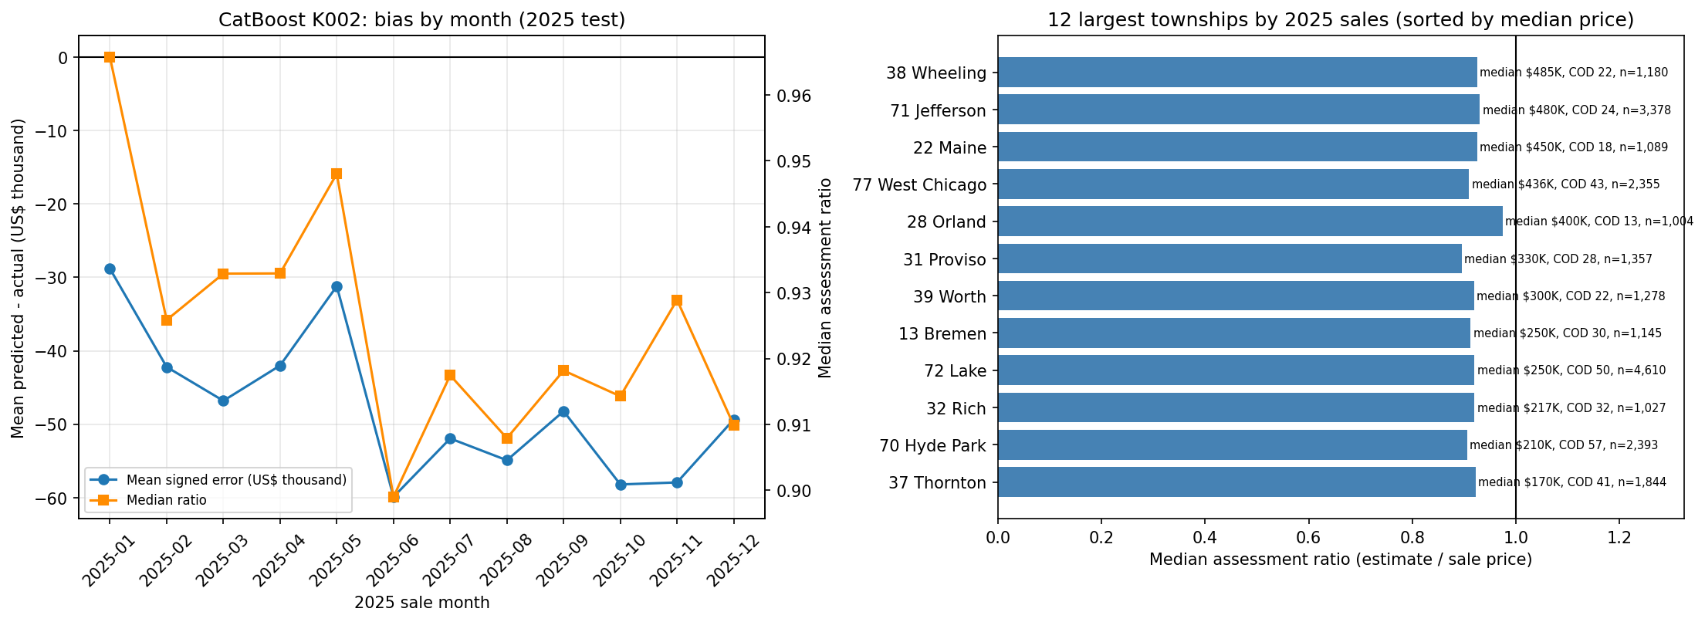
Figure 4.2. Held-out 2025 monthly signed error and township ratios; counts and price levels qualify subgroup comparisons.

4c. Choose and justify weights for overvaluation and undervaluation. Compare weighted absolute error for your model and the baseline under your main scenario and two alternatives. Keep predictions fixed across scenarios. Does your conclusion change?
We prioritised avoiding overvaluation because the model is intended to support residential assessments. If an inflated estimate passes through review, it could disadvantage the homeowner and lead to an assessment challenge. We therefore pre-specified WAE with a 2:1 overvaluation-to-undervaluation weighting as the primary validation metric for model selection, placing greater emphasis on this risk while still penalising undervaluation. The ratio reflects our judgement about the intended use, rather than an empirically estimated difference in the costs of the two errors.
The 2025 Global Mean baseline predicts $426,200.21, the mean sale price of the 72,985 development sales. This differs from the $418,490 training-only mean used in validation because the final development window includes validation sales. CatBoost K002 and the baseline each produced one fixed prediction vector for the same 36,322 test sales. Table 4.2 recomputes WAE under each weighting from these fixed predictions.
Table 4.2. Weighted errors from fixed 2025 test predictions.
Scenario | Model WAE ($) | Baseline WAE ($) | Reduction
Overvaluation Priority (2:1) | $133,983.35 | $360,699.00 | 62.85%
Equal Priority (1:1) | $105,380.58 | $256,774.35 | 58.96%
Undervaluation Priority (1:2) | $182,158.38 | $409,624.05 | 55.53%
The conclusion does not change: K002 outperformed the development-mean baseline under all three weightings, reducing WAE by 62.85%, 58.96% and 55.53%, respectively. The weighting would, however, have changed model selection: within the validation candidate pools summarised in Appendix Table B6, CatBoost K003 ranks first under 1:1 and Ridge E6 under 1:2.

4d. Do the results justify a pilot of your model to support property valuers? Explain your recommendation using the errors, practical value and limitations.
The results support a limited pilot with valuer review. CatBoost K002 reduced primary WAE (2:1) by 62.85% against the development-mean baseline, but test MAE was $105,380.58 and RMSE $255,017.63. Mean signed error was −$48,175.04, and 36.97% of estimates exceeded the sale price. Errors of this size are material for tax-related valuations. The model should therefore supply an initial estimate for professional review, never an automatic final assessment.
Property valuers should receive the estimate with source attributes, a review flag for unusual or damaged homes, and a record of any override. The pilot should check errors by township, price range and month before wider use, monitor WAE (2:1) and signed bias as later sales arrive, and investigate drift or disproportionate subgroup errors. The test covers homes that sold, while the intended users also value unsold homes; recent condition changes and other unrecorded facts therefore require independent evidence and professional judgement.

Section 5: Deployment and operations

5a. How would the office generate, review and use estimates for homes without recent sales? Identify the information and checks needed before an estimate is adopted.
For a home without a recent sale, the office would verify the property identifier, current dwelling attributes, location and valuation date. The scoring process would reproduce the training-fitted preprocessing and frozen 209-column feature schema before applying CatBoost K002. Calendar-month indicators and house_age require a valuation date, even though the additional continuous month index is omitted. The current notebooks record model settings and test predictions, but do not yet provide a packaged model-plus-preprocessing artifact or calibrated prediction intervals for individual properties. Packaging the pipeline and checking that it reproduces the saved test predictions must precede the pilot; calibrated intervals can be developed and assessed during it.
The proposed point estimate would provide a starting point for an analyst. A pilot review screen should show the verified input snapshot, valuation date, model version, nearby comparable sales and flags for missing, stale or implausible attributes. Homes with unusual size, condition or few comparables would receive closer review. The valuer would document any override and its evidence. Review thresholds should be specified and assessed during the pilot.
The final valuation remains with a qualified valuer. Because the model learns only from homes that sold, as discussed in Section 2e, long-unsold properties are flagged as low confidence and prioritised for manual inspection, and every adopted estimate is stored with its model version and prediction date so that the assessment can be reproduced and defended later.
Before adoption, the office should verify feature completeness, category handling, split-schema order, non-finite values and numerical variation, since six numeric predictors lost all variation in an earlier export. It should also inspect current property condition and renovation evidence, which the 2022 archive may miss. Logged predictions, later sale outcomes and reviewer actions would allow reproducible monitoring; they would not by themselves reveal the true value of homes that do not sell.

5b. What would you monitor after introducing the model? Explain what findings would trigger investigation, retraining or increased human review.
Following deployment, model performance should be reviewed quarterly as new transaction prices become available. Weighted absolute error (WAE, 2:1) would remain the primary monitoring metric, consistent with the greater concern about overvaluation in residential assessments. MAE, MSE and R² would provide complementary measures of predictive accuracy, while mean signed error (predicted minus actual sale price) would help detect systematic overvaluation or undervaluation. Monitoring should also be conducted across townships, price ranges and time periods, with transaction counts and changes in the composition of sold properties considered to avoid interpreting small or unrepresentative samples as evidence of model deterioration.
A sustained increase in WAE (2:1) relative to historical performance would trigger an investigation into data quality, changing market conditions and potential model drift. During the pilot, materially worse WAE across two consecutive quarterly reviews, persistent directional bias within a township or price segment, or repeated feature-schema failures would be proposed triggers for investigation and increased human review. CatBoost K002 exhibited a mean signed error of −$48,175.04 on the held-out 2025 test set, highlighting the need to monitor systematic underestimation as well as overestimation. If deterioration persisted after data-quality problems were addressed, a replacement model would require improved performance on a later chronological validation period before deployment.
Input data and preprocessing outputs should also be monitored for missing or implausible values, unseen categories, distribution shifts and unexpected constant features. This is particularly important because earlier pipeline checks identified numerical predictors that had lost meaningful variation during transformation. The revised export introduced stability safeguards, with the current run triggering fallbacks for loc_longitude and loc_env_airport_noise_dnl. Automated checks of feature variation, schema consistency and non-finite values would help detect similar information loss before predictions reach valuers. Since prediction errors can only be measured for properties that subsequently sell, monitoring results cannot establish accuracy for unsold homes. Analyst adjustments and unusual valuation cases should therefore be recorded as additional warning signals, while remaining subject to professional review rather than being treated as verified prediction errors.

5c. Identify two important risks or constraints when using your model in practice. Explain how the organisation should manage them.
Risk 1: the evidence comes from sold homes and archived characteristics. The model learns from completed transactions, while its proposed users must estimate homes without recent sales. A home that remains unsold may differ in condition or marketability, and a 2022 archive can miss later renovation, damage or changes in use. The test set does not resolve this transfer problem: even the 32,335 test transactions involving properties with no sale in the fitting window ultimately have observed sales. Their MAE of $96,109.97 measures performance on later sellers, not on homes that remain unsold.
The office should verify current size, use and condition, identify stale or unsupported inputs, and require inspection or additional comparable sales for properties outside the training range. Initial use should remain subject to a valuer's documented review. A pilot should deliberately include homes without recent transactions and record input corrections, independent appraisal evidence and subsequent sales when available. This builds evidence for the intended population instead of assuming that the transaction test establishes it.
Risk 2: aggregate accuracy conceals price-related valuation errors. Although K002 was selected to minimise WAE (2:1), which penalises overvaluation twice as heavily, it still overvalued the cheapest sales: their median estimate-to-price ratio was 1.6311. At the expensive end, the median ratio was 0.8455. If estimates were adopted without review, these patterns could place disproportionate valuation burdens on cheaper properties and miss value at the upper end. The overall median ratio of 0.9235 therefore cannot justify increasing every prediction by the same percentage; doing so would aggravate overvaluation in the low-price segment.
The office should review ratio levels, signed errors and absolute errors by price group and township, with transaction counts, as later sales become available. Before a sale, review flags should use observable characteristics, predicted price and independently selected local comparables, rather than an unknown actual-price decile. Large departures from comparable valuations should receive extra human review and a recorded reason for any adjustment. Any segment-specific recalibration should be tested on a later validation period against both the main WAE and subgroup errors before adoption.

5d. For the case below, should the valuer simply subtract the repair quote from the model estimate? Explain your decision and the further evidence needed in at most 150 words.
Hypothetical case for 5d. Your model estimates a home’s value at US$400,000 using archived property information. The owner supplies a recent inspection showing major damage and a repair quote of US$30,000. The damage is not recorded in the model inputs.
No. The $400,000 estimate uses archived attributes and does not account for the newly documented damage, so it is a starting point rather than an as-is valuation. A $30,000 repair quote measures proposed work, not necessarily the change in market value: buyers may discount for uncertainty, delay, hidden defects or less than the full repair cost. The valuer should confirm the inspection date, damage scope, quote validity, likely remaining defects and whether the model inputs already reflect any condition issue. They should compare recent sales of similarly damaged homes, consider repaired-home comparables and local market evidence, then document a reasoned adjustment and uncertainty range. The estimate should not be mechanically reset to $370,000.
Sources and contribution statement.
Data and definitions came from course-supplied sales.csv, properties_2022.csv, variable_dictionary.csv and the QBUS6810 data dictionary. The modelling extension was informed by the course Gradient Boosting practical. The two submitted notebooks and their saved results provide numerical evidence. Sicheng Wang (SID: 550756484) led data preparation and exploration; Chongchen Jiang (SID: 550397520), linear models; Wenhao Jiang (SID: 540614936), Decision Tree and Random Forest; and Yifeng Ye (SID: 550495941), boosting and integration.

Appendix A AI use and reflection

7a. Data or features.
I initially asked DeepSeek (November 2026) whether Yeo–Johnson plus scaling was generally suitable for continuous variables. It advised checking distribution shape and fitting on training data. I checked the notebook’s rule file, transformations and saved output. The current export clips selected columns at training quantiles, applies PowerTransformer with standardize=False, falls back to clipped values if numerical collapse occurs, then fits StandardScaler on training values. The tree models consume this transformed shared CSV. I accepted training-only fitting and numerical-health checks, but did not implement an unscaled tree pathway. I learned to distinguish proposed transformations from implemented code. An equal-budget ablation of transformed versus untransformed trees remains untested.
The executed export reports two numerical-stability fallbacks: loc_longitude and loc_env_airport_noise_dnl.

7b. Validation or leakage.
In October 2026, I used ChatGPT to investigate whether repeated property sales affected chronological validation (prompt summary: “Check property overlap between training and validation”). Its initial code treated DataFrame row indices as property identifiers and incorrectly reported 0% overlap.
I then used Codex (verification conducted on 25–26 October 2026) to examine the original sales.csv, merge logic and split membership. The audit confirmed that property features had been matched correctly using property_id, but subsequent index handling made the original overlap calculation unreliable. Recalculating overlap using the original property identifiers showed that 1,677 of 18,132 validation transactions (9.25%) involved 1,666 properties previously observed in training.
I rejected the initial 0% result and retained the chronological split because repeated sales are legitimate observations and do not automatically constitute leakage. This experience demonstrated the importance of checking AI-generated code against original identifiers rather than trusting plausible outputs. Section 3c compares validation errors across the two groups. The effect of including earlier sales of the same property in training remains untested.

7c. Modelling or debugging.
I initially accepted a suggestion from Claude (27 October 2026; prompt summary: “Add the time-variable A/B comparison to my tree notebook”) to let my tree notebook also build the group’s combined time-variable table by reading the other members’ saved result files. Checking the output showed that the combined table contained only the tree rows: the Boosting table had been saved in a time_trend_comparison/inputs/ subfolder, so the code skipped it without an error. The table would also have been complete only if the Boosting notebook had run first, an order that was not documented anywhere. I rejected building the combined table in my notebook: the tree-modelling section now exports only its own results with the same 15 required columns, and each family’s comparison is reported from its own saved table. I learned that a silent skip can look like a complete result, so I now check row counts by model family. Combining tables still relies on every member following the same column schema.

7d. Business interpretation.
On 1 November 2026, I asked Codex to review Question 5d (prompt summary: “Should a valuer subtract a $30,000 repair quote from a $400,000 model estimate?”). I initially considered $370,000 as a simple adjustment. Codex explained that repair cost and lost market value differ. I checked that recent damage was absent from archived model inputs and that average test error was not a property-specific damage discount. I accepted the need for a dated inspection, verified repair scope, as-is comparables and documented valuer judgement, rejecting automatic subtraction. This shifted our recommendation toward a supervised pilot. Actual market discounts and hidden defects remain unknown.
Other AI assistance: Codex and Claude assisted with code and output cross-checks, debugging discussions and report editing. Numerical statements were reconciled with saved files produced by the two submitted notebooks.

Appendix B Supplementary model results
Table B1. Shared-matrix linear-model comparison (2024 H2 validation)
Model | Best Tested α | WAE 2:1 ($) | MAE ($) | MSE ($², bn) | R²
Linear Regression | — | 192,979.19 | 127,426.80 | 65.859 | 0.6547
Ridge | 100 | 190,929.16 | 126,875.71 | 66.286 | 0.6525
Lasso | 100 | 189,367.77 | 126,647.48 | 66.155 | 0.6531
Note: These models used the same 209-predictor exported feature matrix and validation rows. Their representation differs from the feature-engineered D-series models. For Ridge and Lasso, α = 100 was the best tested penalty and the upper boundary of the search grid.
Table B2. Additional feature configurations versus Feature Set D (Ridge α=8)
Feature Configuration | WAE 2:1 ($)
F0. Reference Feature Set D | 153,163.83
F1. D + Size × Construction Quality | 153,141.95
F2. D + Centered Log Land × Log Building | 153,463.84
F3. D + Combined Repaired Features | 153,440.45
Note: Ridge α = 8 was held constant across these comparisons. F1 improved WAE by only approximately $22 relative to the reference, while F2 and F3 worsened it.
Table B3. Quarter-level CatBoost K002 test results (2025)
Period | n | Median price ($) | MAE ($) | WAE 2:1 ($) | Signed error ($)
2025-Q1 | 7,074 | 340,000 | 100,186 | 130,382 | -39,793
2025-Q2 | 10,563 | 375,000 | 103,931 | 133,601 | -44,590
2025-Q3 | 10,094 | 365,000 | 105,587 | 132,472 | -51,817
2025-Q4 | 8,591 | 357,000 | 111,199 | 139,195 | -55,206
Table B4. Three-township CatBoost K002 test comparison (2025)
Township | n | Median price ($) | Median area (sq ft) | MAE ($) | WAE 2:1 ($) | Median APE
37 Thornton | 1,844 | 170,000 | 1,171.0 | 50,716 | 69,908 | 26.46%
71 Jefferson | 3,378 | 480,000 | 1,533.5 | 119,323 | 151,298 | 16.77%
23 New Trier | 725 | 1,405,000 | 2,640.0 | 416,793 | 502,088 | 14.64%
Table B5. Equal-budget boosting search summary (2024 H2 validation; each family optimised dollar WAE 2:1)
Family | Optuna trials | Target / best trees | Validation WAE 2:1 ($) | Validation MAE ($) | Search (min)
Histogram GB | 24 | log1p / 1,370 | 126,914.57 | 100,952.81 | 9.43
LightGBM | 24 | log1p / 1,077 | 126,915.23 | 101,218.90 | 3.20
XGBoost | 24 | log1p / 1,377 | 126,510.95 | 100,686.67 | 6.54
CatBoost | 24 | log1p / 1,376 | 126,068.74 | 100,541.87 | 16.76

Table B6. Retrospective ranking of validation candidates under alternative WAE weightings
Model family | Overvaluation 2:1 | Equal 1:1 | Undervaluation 1:2
Global Mean | fixed; $342,381.82 | fixed; $238,599.62 | fixed; $373,417.03
Linear Regression | D; $157,254.42 | D; $113,051.17 | D; $181,899.10
Ridge | F1 α12; $153,089.21 | E6 α8; $104,068.43 | E6 α8; $150,381.70
Lasso | D α20; $152,566.39 | D α20; $110,000.68 | D α20; $177,435.64
Decision Tree | T018; $160,998.12 | T019; $115,538.39 | T019; $185,036.45
Random Forest | R011; $139,315.50 | R011; $101,041.09 | R003; $163,802.43
Hist. Gradient Boosting | H023; $126,914.57 | H001; $99,854.54 | H003; $164,875.32
LightGBM | C022; $126,915.23 | C006; $99,812.70 | C006; $166,271.24
CatBoost | K002; $126,068.74 | K003; $98,508.87 | K003; $162,521.90
XGBoost | X021; $126,510.95 | X001; $99,701.84 | X001; $166,038.36
Existing validation candidates were retrospectively ranked under each weighting without changing the pre-specified 2:1 selection rule. For Ridge, F1 (α = 12; WAE $153,089.21) had the lowest tested 2:1 WAE; Table 3.2 retains the simpler D (α = 12; $153,109.49), only $20.28 higher. CatBoost K002 ranks first under 2:1 at $126,068.74, CatBoost K003 with a raw-dollar target ranks first under 1:1 at $98,508.87, and Ridge E6 (α = 8) ranks first under 1:2 at $150,381.70. These rankings are validation sensitivity checks; the 2025 test comparison uses only the frozen K002 and baseline predictions. The tree and boosting entries come from searches without the additional continuous month index; Ridge E6 includes it.

Appendix C Supporting diagnostic figures
Appendix C presents exploratory price and feature distributions, tree and random-forest diagnostics, and boosting diagnostics. These figures support the data analysis and model-development results discussed in Sections 2 and 3.
Figure C1. Sale-price boxplots by training year.
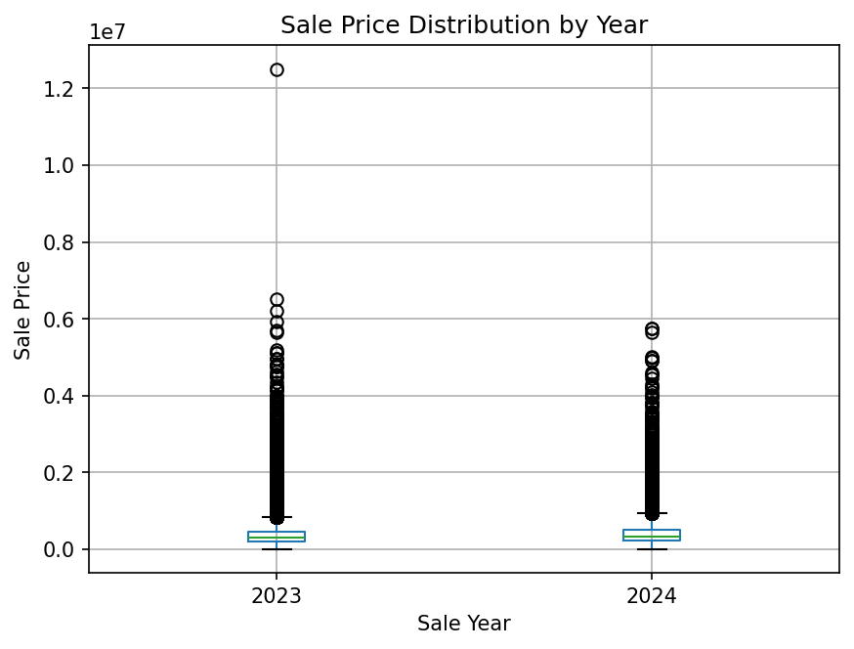
Figure C2. Sale-price histogram and its long right tail.
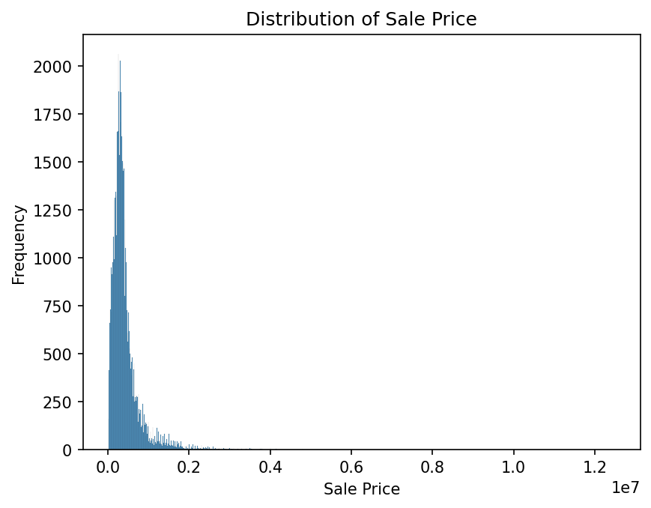
Figure C3. Log-transformed sale-price boxplots by training year.
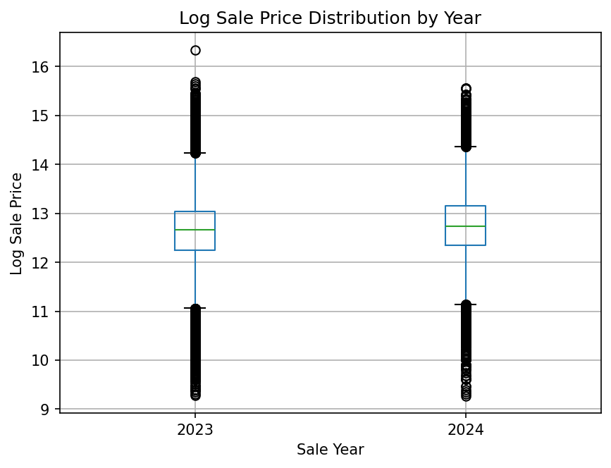
Figure C4. Log-transformed sale-price histogram.
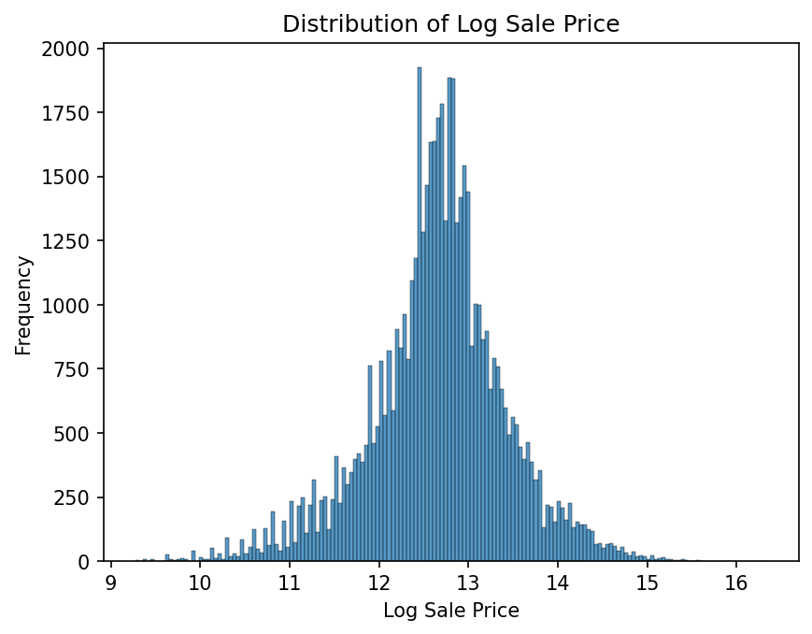
Figure C5. Continuous feature distributions, part one.
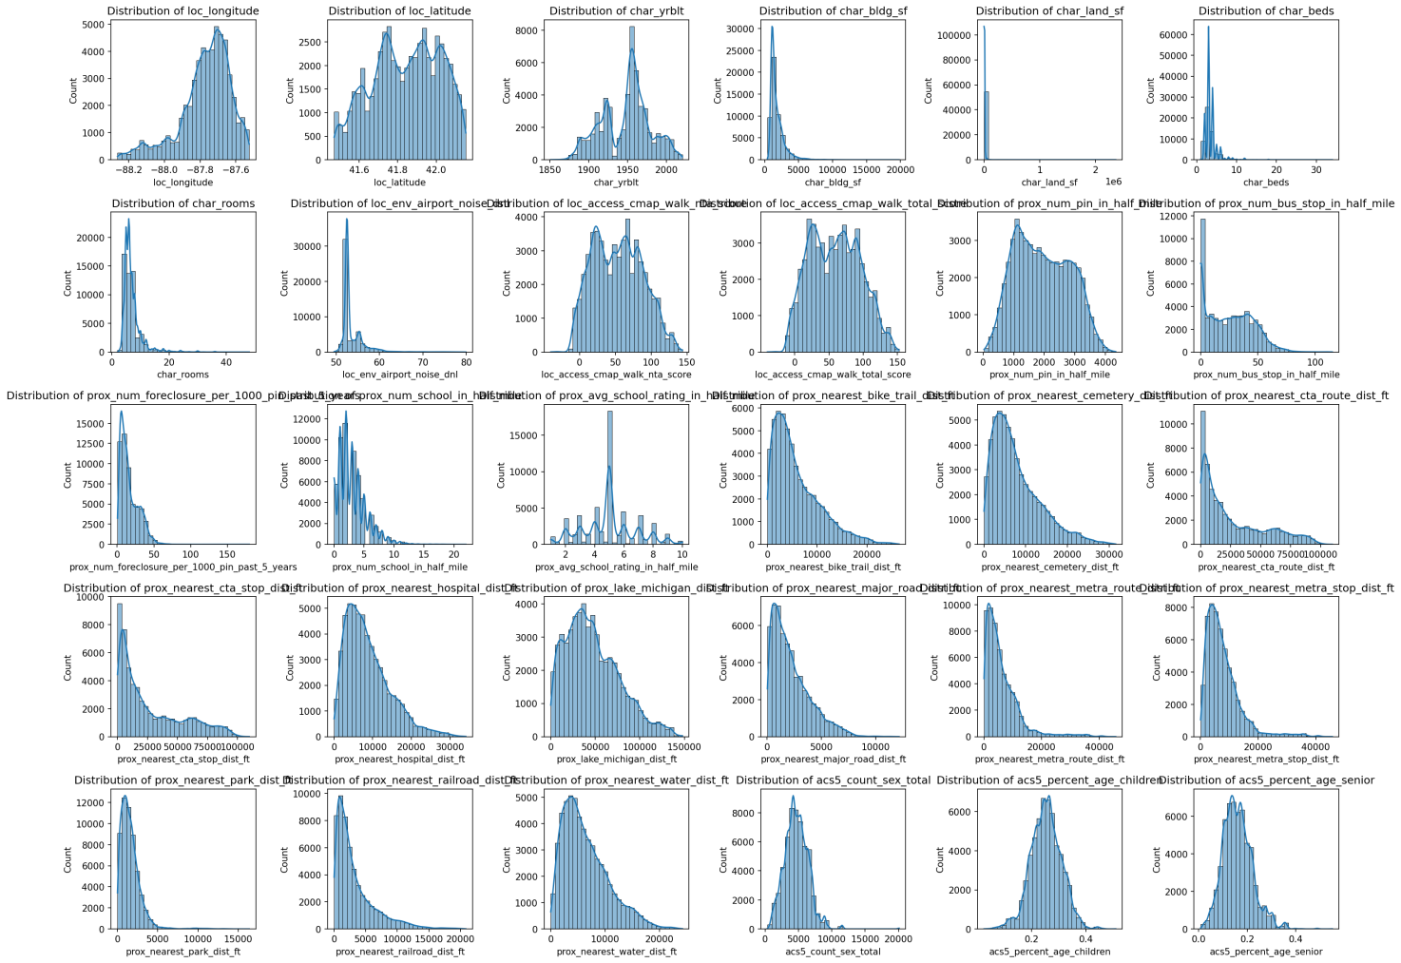
Figure C6. Continuous feature distributions, part two.
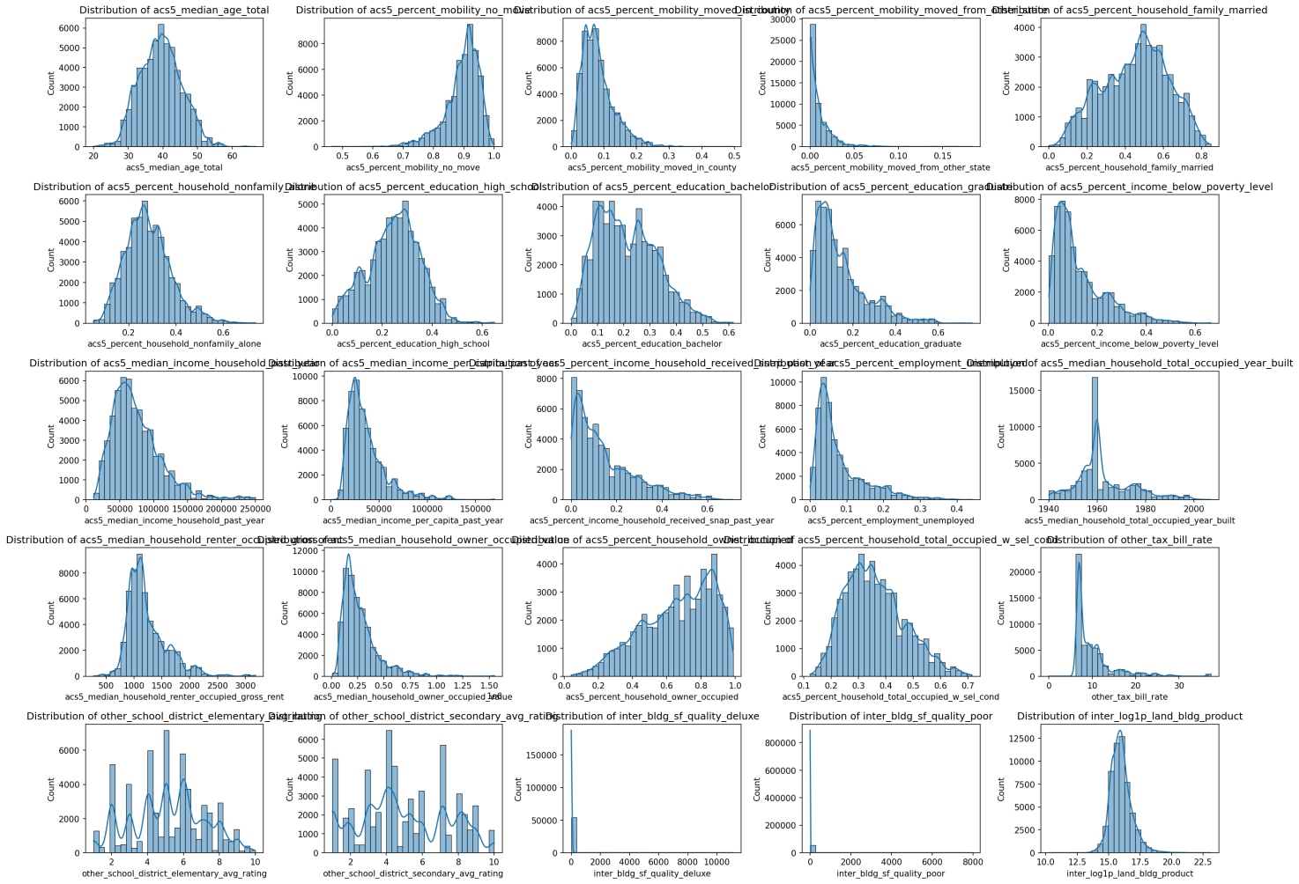
Figure C7. Discrete predictor relationships with log sale price.
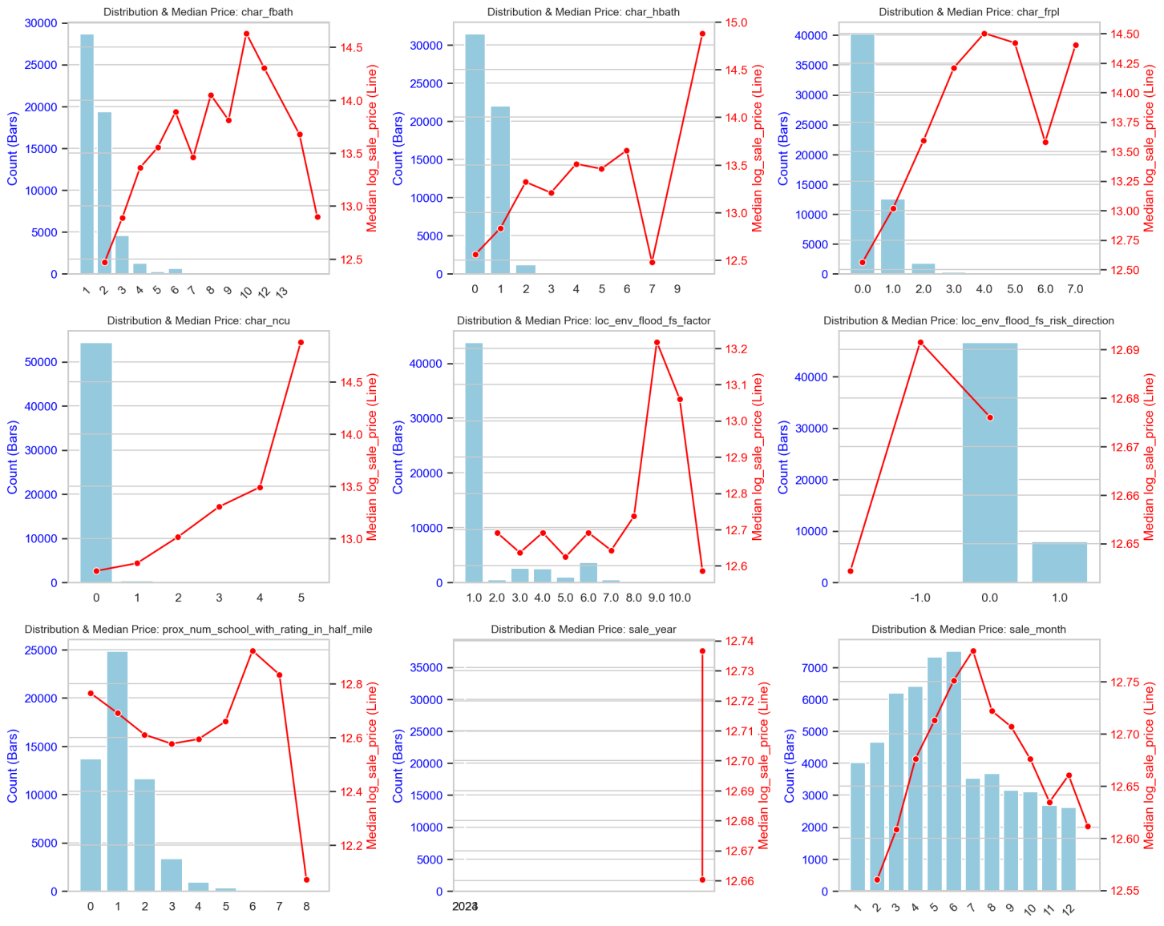
Figure C8. Construction quality categories against log sale price.
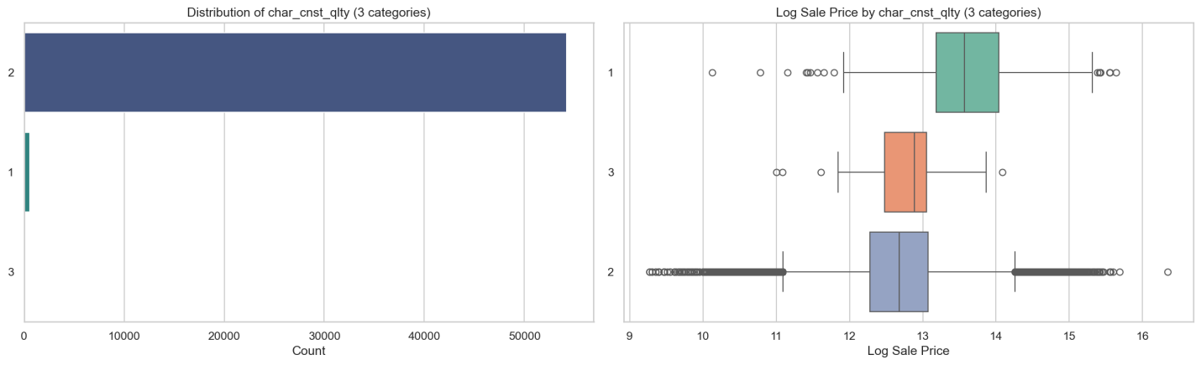
Figure C9. Township-code categories against log sale price.
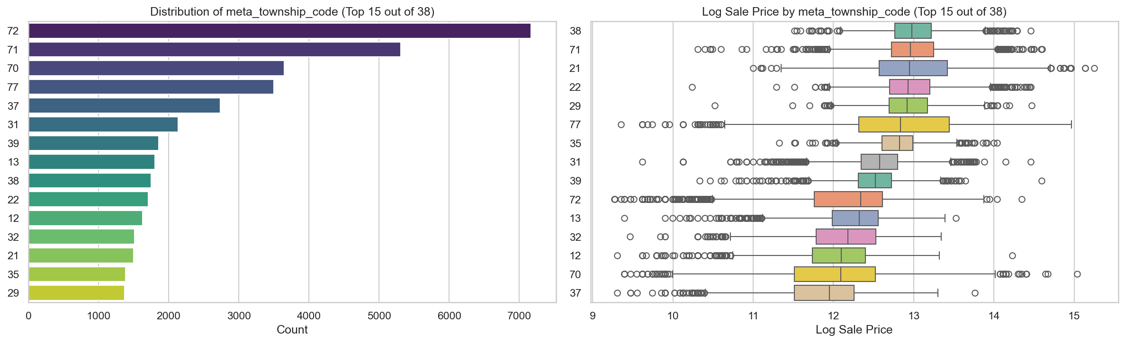
Figure C10. Single-tree depth and leaf-size diagnostic.
Figure C11. Random Forest estimator-count path.
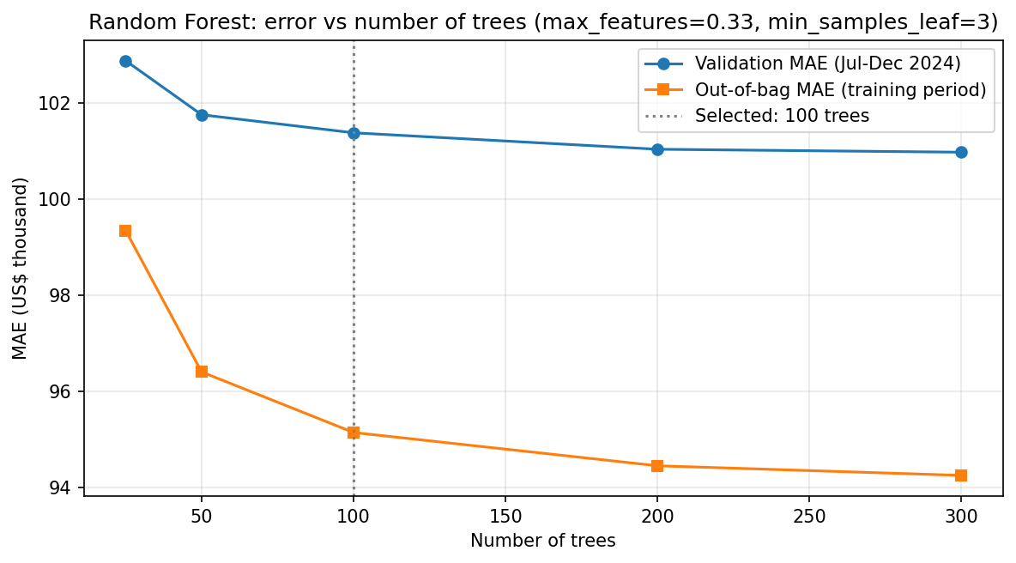
Figure C12. Random Forest feature importance.
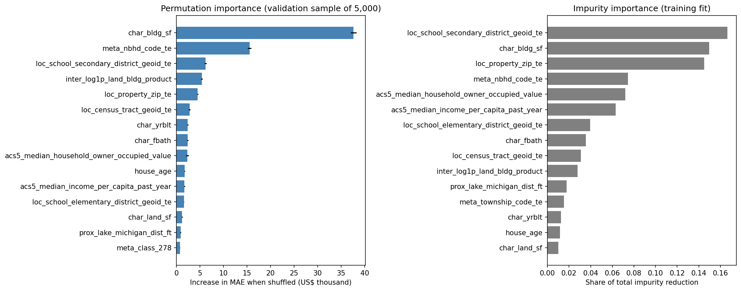
Figure C13. Random Forest validation residuals.
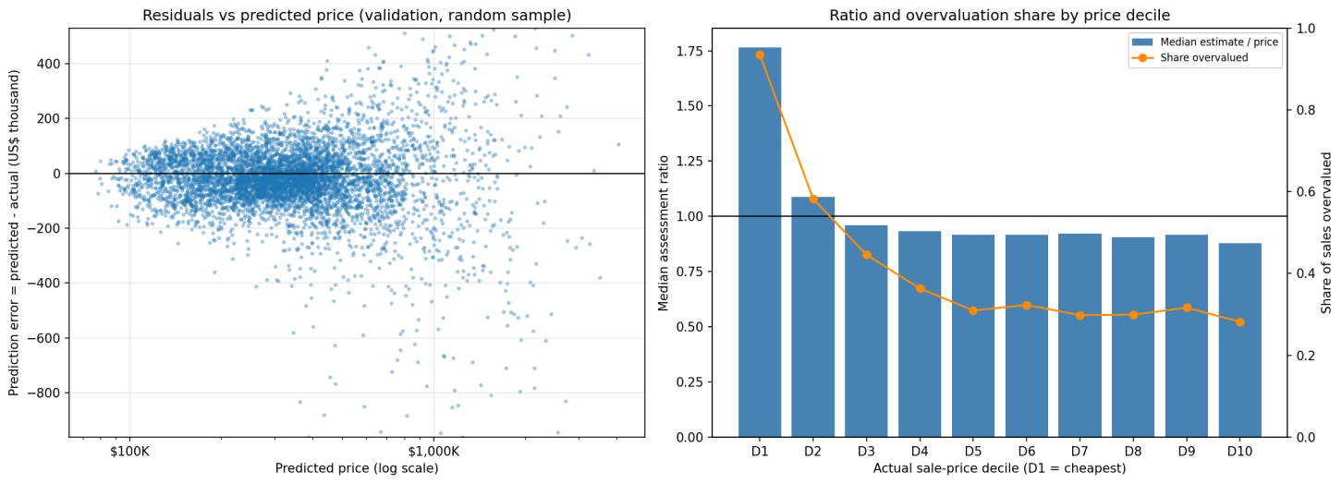
Figure C14. Tree time-index comparison by validation month.
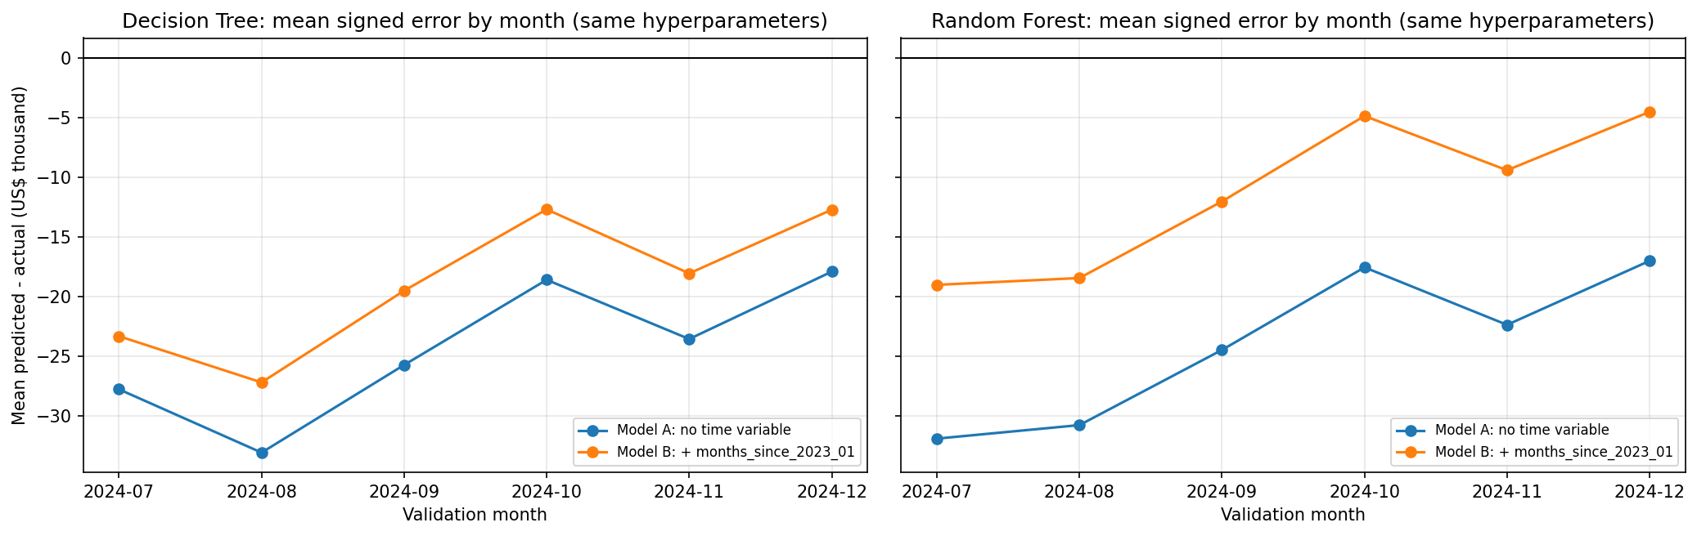
Figure C15. Gain-based feature importance for LightGBM C022 fitted on the training data.
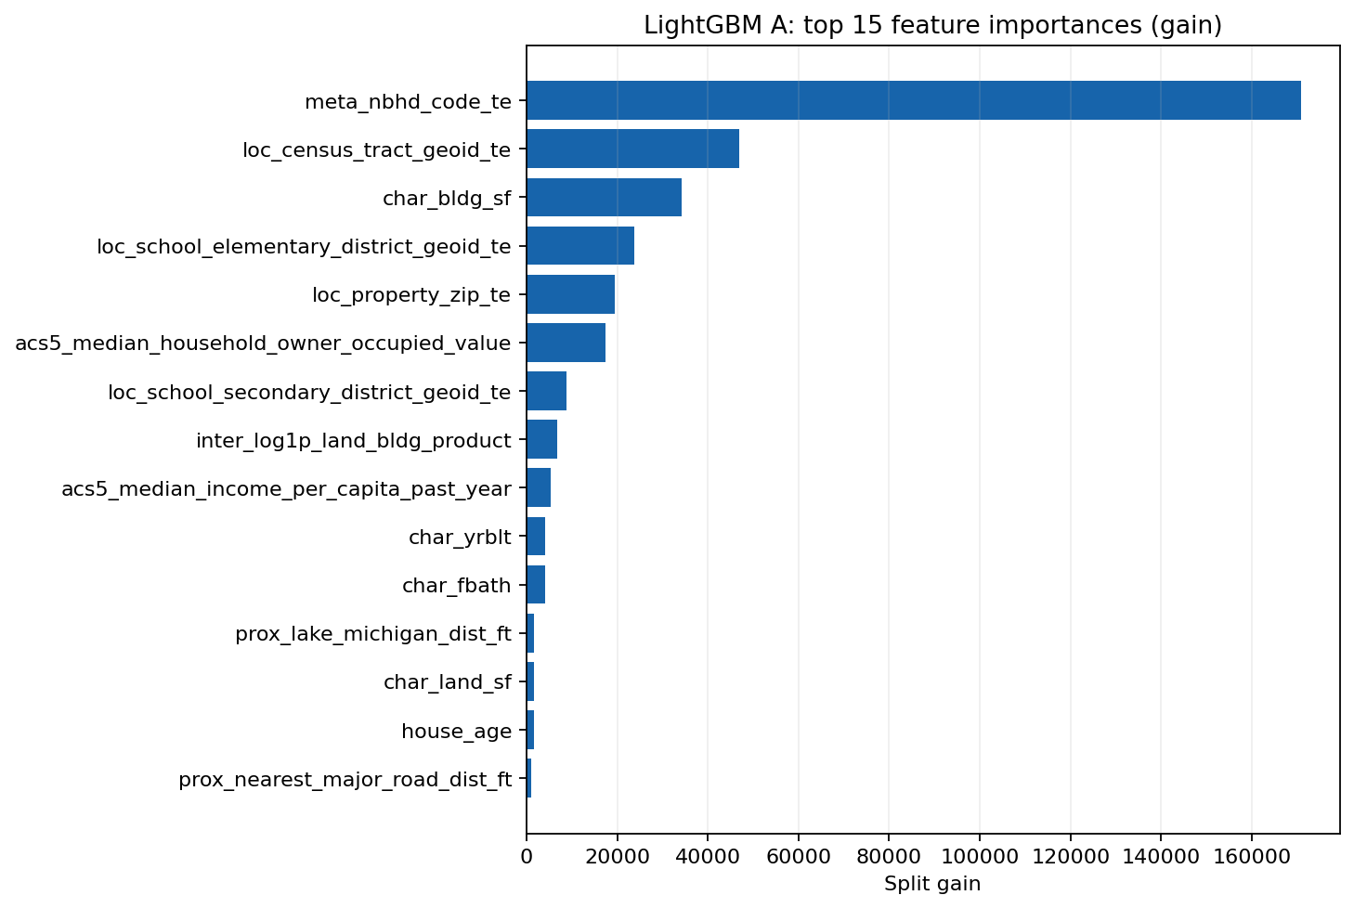
Figure C16. Monthly sale-price patterns in the training-period exploratory output.
Figure C17. Spatial sale-price patterns in the training-period exploratory output.
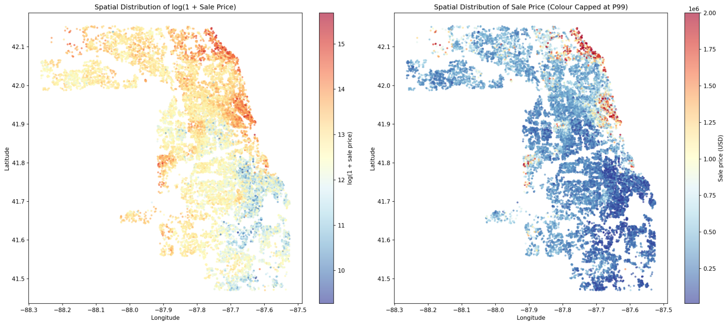
Figure C18. Optuna optimisation histories for the four boosting families (24 trials per family; validation WAE 2:1).
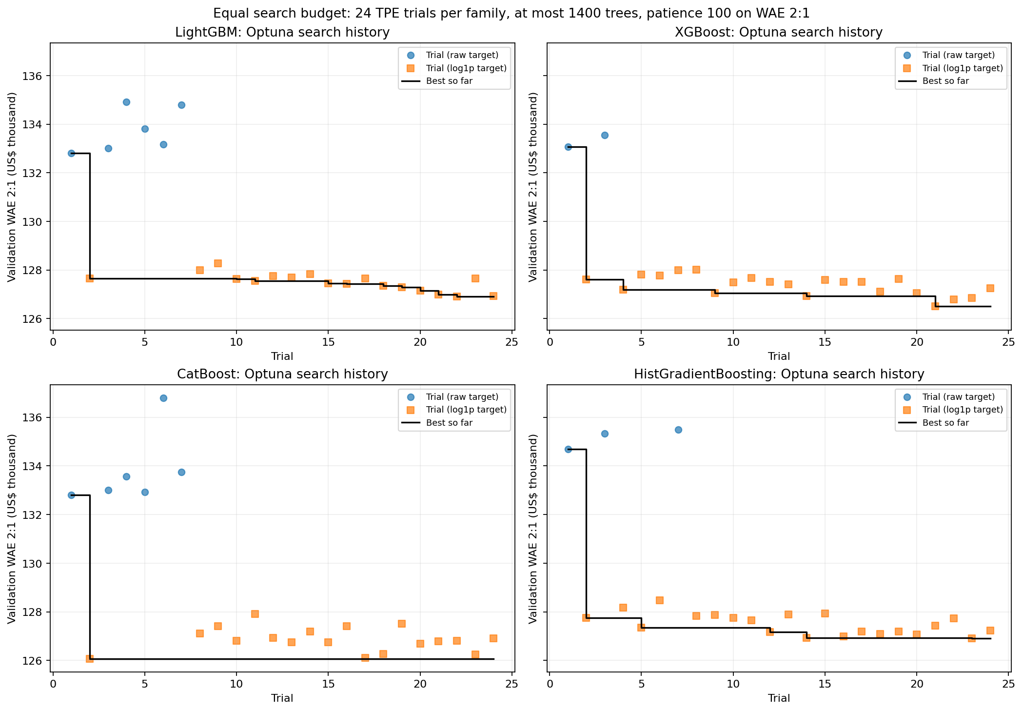
Figure C19. Validation WAE 2:1 learning curves of the four boosting-family winning configurations.


