Cook County Sale Price Modelling Reference Edition
Machine Learning for Business (QBUS6810)
Editorial reference edition, 2 November 2026. Blue text and blue table values identify additions or corrections checked against the two executed notebooks and saved prediction files. This version deliberately includes many figures for selection and shortening before the 18-page submission limit.

Section 1: Business objective
1a. Explain the client’s business problem, who will use the predictions, and the practical value the project could provide.
The Cook County Assessor’s Office needs to estimate the potential selling prices of residential properties for taxation purposes. For properties without recent sale records, the absence of a recent transaction price makes it difficult to estimate their potential market values. The office therefore needs a consistent approach to support property valuation when recent sales information is unavailable.

The purpose of this project is to develop and evaluate a regression model that uses historical transaction data, property characteristics, and location information to estimate residential selling prices in US dollars. The predictions are intended to provide the Assessor’s Office’s residential valuation team with an initial estimate for review, supporting informed and consistent valuation decisions without replacing professional judgement. This could improve the consistency and efficiency of preliminary assessments and help analysts prioritise cases for closer review

The model will be evaluated using a chronological holdout design, with earlier years used for training and model selection and a later year reserved for final testing. This assesses how well the model predicts prices for later historical transactions. However, because the model is trained exclusively on properties that have sold, its performance on the historical test set may overstate its accuracy for properties that remain unsold or lack recent transactions. The primary objective is to support the valuation of properties that have static archival characteristics (known features) but lack a recent transaction price, rather than predicting properties that are entirely unrecorded in the dataset. These sample-selection limitations will be considered when assessing the model's suitability for tax assessment purposes. These limitations will be considered when assessing whether the model is suitable for supporting property valuation.

Section 2: Data understanding and representation
2a. What does each row represent? Verify the join, check for duplicate records and repeated sales of the same property, and justify how you handle them.
Our data consists of Properties_2022.csv, which contains one row per unique property (98,899 rows with unique property_id), and sales.csv, which contains one row per completed transaction (109,307 unique transaction_id). A duplicate record would share the same transaction_id, which we confirmed does not exist. Repeated sales of the same property (same property_id, different transaction_id and sale_date) are legitimate and account for the 10,408 extra rows. We set property_id as the index and verified a perfect bi-directional match between the two tables. A left join with validate="many_to_one" confirmed no row inflation. We retained these repeated sales for the time-trend analysis in 2c, and their treatment in modelling is discussed in Section 3c.
2b. Which missing or unusual predictor values matter, and how will you handle them?
We identified and addressed predictor-quality issues using a context-dependent, evidence-based approach. Guided by the data dictionary, we imputed structural missing values before splitting the data. For instance, missing char_type_resd was filled with '9.9' (defined as "Missing"). For Chicago-specific location features, missing values indicated properties outside Chicago; we filled these globally based on an is_Chicago indicator. Because these are rule-based transformations independent of the target variable, they pose no label leakage.

After the chronological split, missing values in the training set were handled using a differentiated strategy based on missingness fraction and feature type. Features with minimal missingness (< 1%) were imputed with the median or mode. For general substantial-missing features (> 1%), we imputed the median/mode and created a corresponding binary indicator (e.g., feature_missing). For three specific fields with extreme missing rates (> 90%, such as loc_tax_tif_district_num), we created an _is_missing indicator and explicitly replaced the missing categories with the string "Unknown". To justify these indicators, we evaluated whether missingness correlated with the target by comparing median prices between missing and non-missing groups. This descriptive evidence serves as a data-driven heuristic suggesting potential MNAR patterns, rather than a definitive statistical proof.

To handle unusual values, continuous features were clipped at the 1st and 99th percentiles to prevent distortion, and heavy-skewed variables (e.g., char_land_sf) underwent Yeo-Johnson transformations to approximate Gaussian distributions. For categorical features, we applied a dynamic encoding strategy: high-cardinality features (≥ 30 categories) used smoothed Out-of-Fold Target Encoding to prevent leakage and dimensionality explosion; lower-cardinality features were dynamically inspected, merging low-frequency rare categories into an 'Other' group before applying One-Hot Encoding. Redundant boolean missing indicators were removed if they lacked significant correlation with the target. All data-driven statistics, clipping bounds, and transformation parameters were strictly fitted on the training set and applied to validation and test sets.

Pipeline verification also included numerical-stability checks for continuous-variable transformations. Where a transformation produced non-finite values or removed meaningful variation, the pipeline used clipped values followed by training-fitted standardisation instead. In the executed export, this fallback was triggered for loc_longitude and loc_env_airport_noise_dnl. These checks reduced the risk of losing predictive information during preprocessing.
2c. What do summaries and plots show about prices over time and across locations? Identify higher- and lower-price periods and discuss possible explanations.
The summary statistics and time-series plots reveal two distinct temporal dynamics: a clear year-over-year appreciation and strong seasonality. Regarding annual price differences, the reported median sale price was $315,000 for 2023 and $340,000 in early 2024, approximately 7.94% higher. However, because these figures represent different time windows, this difference should not be interpreted as a like-for-like year-over-year growth rate; changes in the characteristics and locations of homes sold may also contribute to the observed variation.

A distinct seasonal peak occurs in May and June, reaching a median price of $355,000. A possible explanation is the seasonal surge in housing demand, as families may prefer to move during the summer to align with school district schedules, and favorable weather could facilitate viewings and moving logistics. Conversely, price troughs are consistently observed in January, February, and October–December, with medians dropping to around $285,000–$300,000. This reflects typical winter market cooling. During these periods, lower transaction volumes and holiday distractions may reduce buyer urgency, potentially giving buyers stronger negotiating power. Furthermore, comparing the raw and log-scale plots shows that the raw mean is heavily skewed by high-end luxury properties (long-tail extremes), whereas the log transformation stabilizes the variance, providing a clearer view of true central tendencies. (Note: While these market mechanisms are plausible, they cannot be definitively proven by the descriptive price statistics alone.)

Figure 2.1. Training-only monthly sale prices; shifts may reflect transaction mix as well as market conditions.
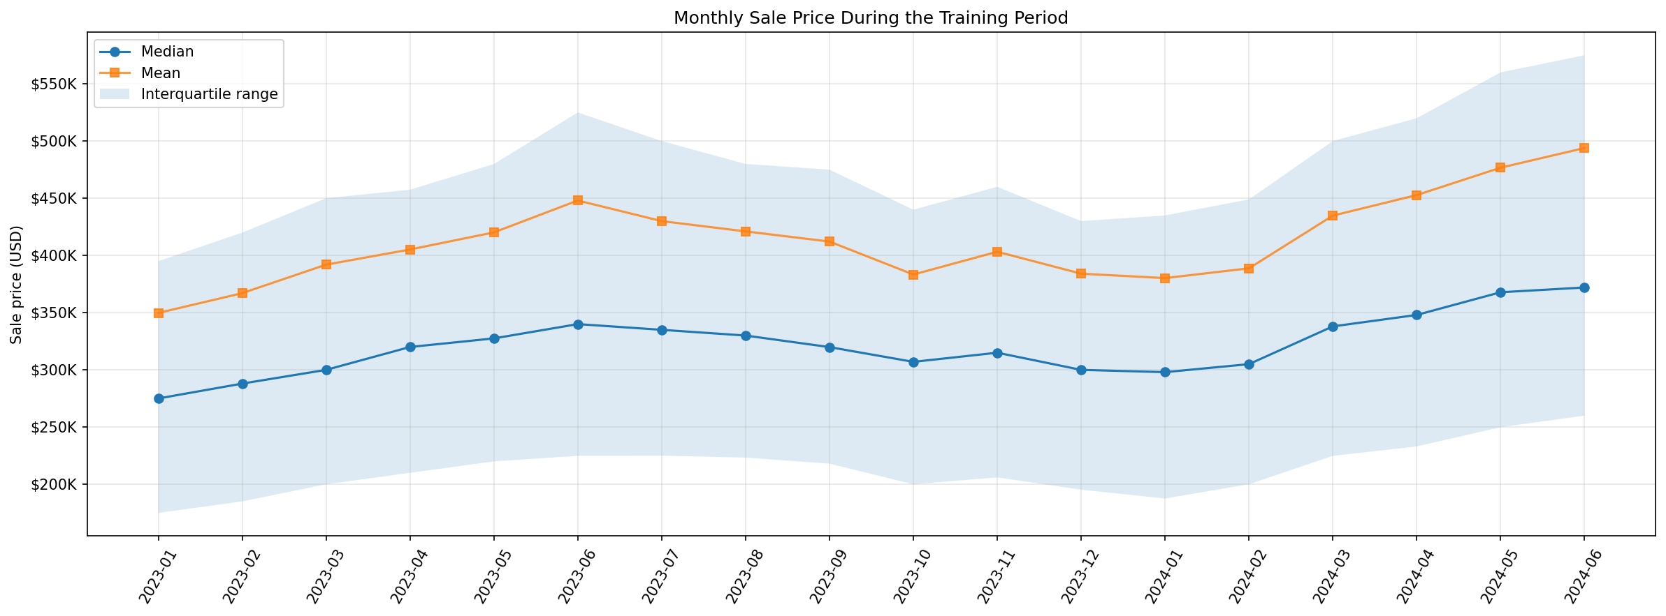

The spatial analysis reveals substantial geographic inequality and spatial gradients in property values. Scatter plots of coordinates and latitude/longitude decile charts show a clear "Northeast high, South low" gradient. Prices rise steadily as one moves north (higher latitude) and east toward the Lake Michigan shoreline (higher longitude). The inter-decile price difference across latitudes and longitudes represents a 2.66x and 2.25x multiplier, respectively. This aligns with the presence of premium waterfront resources and higher socioeconomic status in the northern suburbs.

Figure 2.2. Training-only spatial sale-price patterns; geographic gradients are descriptive.
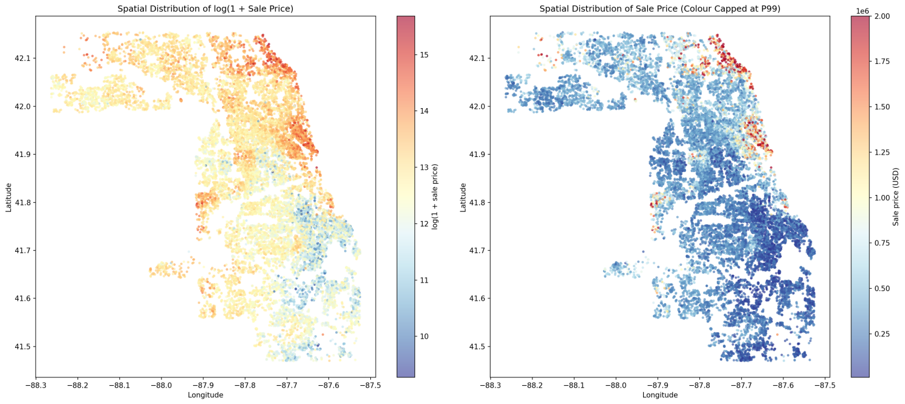

Training-period city medians vary markedly across Cook County, and the city plot shows a wide spread even after restricting displayed locations by sample size. This is descriptive evidence about homes sold in each city, not an isolated location effect: home type, size and transaction mix also differ. Location therefore enters the predictor set, while later 2025 error comparisons use actual township codes and report transaction counts.
Figure 2.3. Training-only city median sale prices
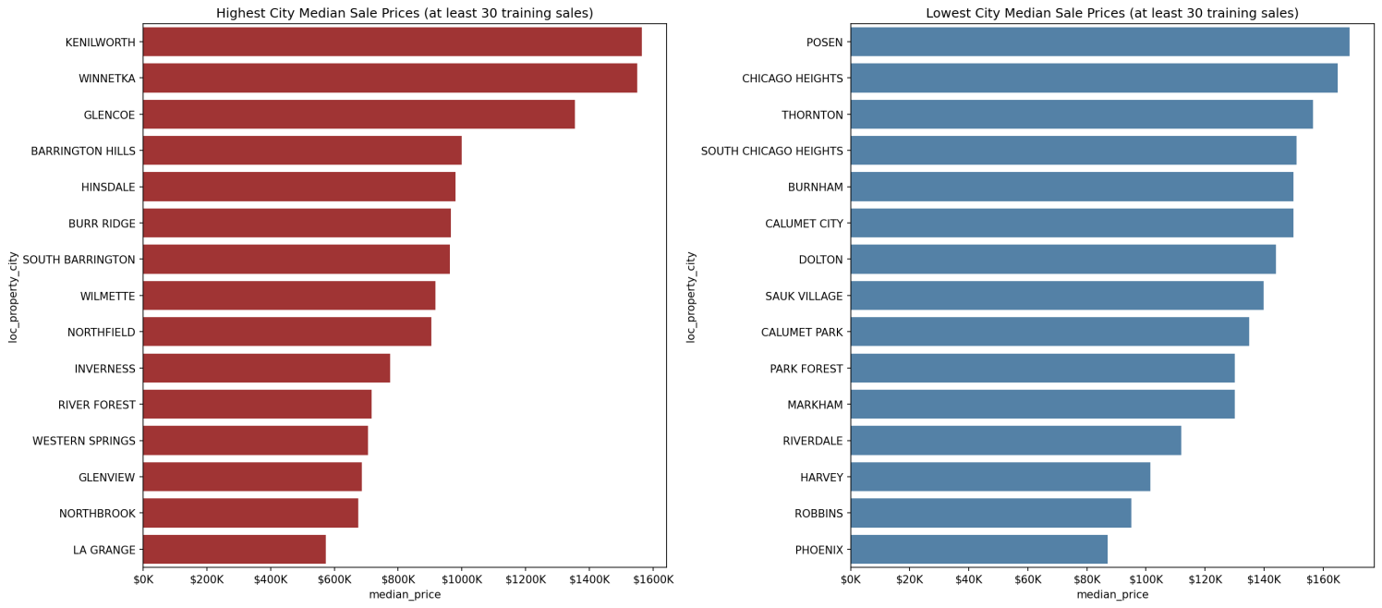
2d. How will you represent the data? Create and justify at least two new features.
Our data representation followed a dictionary-guided pipeline. We applied strict type casting, ensuring nullable types (Int64, string) preserved missing values as <NA> to support accurate downstream imputation. Categorical variables were encoded cleanly based on cardinality. Building upon this foundation, we constructed new features focusing on non-linear relationships, real-time valuation signals, and distributional stability:

House Age (house_age): Calculated as sale_year − char_yrblt and clipped at zero. This represents the property's age at the time of sale and serves as a proxy for age-related differences in condition, depreciation and market value. Age alone does not fully measure physical deterioration or recent renovations.

Built Area × Construction Quality (inter_bldg_sf_quality_deluxe and inter_bldg_sf_quality_poor): building area was multiplied by Deluxe and Poor indicators, with Average as the reference category. The training-only Spearman correlations with log sale price were 0.1214 and 0.0057 for these two interaction columns; the original building-area correlation was 0.5664. The interactions test different size slopes by construction quality, but these univariate correlations do not establish incremental predictive value.

Land Area × Building Area (inter_log1p_land_bldg_product): log1p(char_land_sf × char_bldg_sf) limits the product’s extreme right tail. Training-only Spearman correlation with log sale price was 0.4314, versus 0.1586 for land area alone. This is a descriptive association; validation experiments determine whether the engineered feature improves prediction.

For the original linear-model comparisons, Feature Set D combined 97 location and property predictors with a Building Size × Archived Building Age interaction. This interaction used pre-sale property information and tested whether the association between floor area and price differed across older and newer buildings. Separately, a continuous valuation month index, measured relative to January 2023, and building age at valuation were explored as candidate temporal features in the E-series experiments. Their purpose was to assess whether explicitly representing transaction timing could capture information beyond the archived property characteristics.

Because the E-series changed multiple feature components, an additional controlled comparison examined the month index alone by adding it to Lasso Feature Set D while holding the regularisation strength at α = 20. This distinguished the incremental contribution of the month index from the combined effects of other engineered features. The final inclusion decision was based on the chronological validation results and the primary WAE (2:1) criterion, rather than assuming that additional temporal information would necessarily improve business-weighted prediction performance. The detailed experimental evidence and resulting feature-selection decision are presented in Section 3d.
2e. What could cause leakage or biased conclusions? How does using only sold properties limit claims about homes that have not sold?
To prevent data leakage, we strictly separated global, rule-based structural handling from data-driven statistical learning. Structural imputations (e.g., filling loc_chicago_ward_num as 'Non-Chicago' based on the is_Chicago indicator) were performed globally before the chronological split. Because these rely purely on feature definitions and are entirely independent of the target variable (sale_price), they do not introduce label leakage. In contrast, any global application of data-driven transformations (e.g., calculating medians or target encoding) would leak future information. Therefore, after the chronological split, all such statistics—including imputation medians, clipping bounds, scaling parameters, and Target Encoding—were fitted exclusively on the training set and applied to the validation/test sets.

A critical limitation lies in the provided data structure: only transactions that have already occurred are included in the dataset. There are no records of homes that remained unsold during the observed period (i.e., properties in the supplied archive without matching sales). This sample-selection bias carries two implications. First, our model cannot learn the characteristics of unsold homes; it may systematically misestimate their true market value due to unobserved characteristics (e.g., extreme property staleness or hidden defects). Second, because the model is trained on a bounded pool of 98,899 sold properties rather than the full population of housing stock, its predictive capability may fail to generalize to entirely novel, out-of-sample homes that exhibit architectural styles or neighborhood dynamics not captured in this historical archive. This inherent limitation necessitates expert human review for any property outside the known historical distribution.

Section 3: Model development
3a. Establish a simple price-prediction baseline and explain its purpose.
A Global Mean baseline was established by predicting the training-set mean sale price of $418,490 for every validation transaction, regardless of property characteristics or location. This simple benchmark uses only information available during training and provides a reference for determining whether more sophisticated models offer meaningful improvements in predictive performance.
Table 3.1. Global Mean baseline performance on the 2024 validation set
2024 Validation | WAE 2:1 ($)
Global Mean Baseline | 342,381.82
Neighbourhood Median Baseline | 177,265.28
The slightly negative R² indicates that the training-mean prediction performed marginally worse than predicting the validation-set mean retrospectively. The baseline also produced a WAE (2:1) of $342,381.82, reflecting the greater penalty assigned to overvaluation under the project's primary business-weighted metric. Although the baseline does not account for differences between properties, it establishes a transparent benchmark against which the additional predictive value of property characteristics, location information and more complex regression models can be assessed.

A second, stronger validation reference uses the median sale price of each neighbourhood calculated only from the training period, with township and global fallbacks for unseen areas. It achieved WAE 2:1 of $177,265.28 and MAE $135,959.86 on the same 18,132 validation sales. This shows that location alone explains substantial variation and provides a more demanding benchmark than the Global Mean; the 2025 final comparison uses the specified development-mean baseline.

The selected Lasso D also reduced validation WAE (2:1) by approximately 13.9% relative to this stronger neighbourhood-median benchmark, providing evidence of predictive value beyond a simple location-based pricing rule.
3b. Compare multiple regression approaches taught in the course. Explain your choices and what you learned. You may also investigate separate models for different locations.
Linear Regression, Ridge and Lasso were compared to investigate whether coefficient regularisation improves house-price prediction. Linear Regression provides an unregularised reference. Ridge uses L2 regularisation to shrink coefficients and potentially reduce instability, particularly when predictors are correlated or expanded through categorical encoding. Lasso uses L1 regularisation, which can additionally set some coefficients to zero. Comparing these approaches allows us to assess whether regularisation provides predictive benefits beyond an ordinary linear model.

To make the comparison consistent, all three models were evaluated using Feature Set D, consisting of combined location and property characteristics plus the Building Size × Archived Building Age interaction. They were trained using the same chronological training and validation samples, with an independently reconstructed preprocessing pipeline fitted on training data only. Ridge and Lasso were fitted using their standard penalised squared-error objectives, with regularisation strengths selected according to the pre-specified validation WAE (2:1). MAE, MSE and R² provided supporting performance measures.
Table 3.2. Comparison of linear regression approaches using the same Feature Set D on the 2024 H2 validation set
Model | Feature Set | α | WAE 2:1 ($) | MAE ($) | MSE ($², billions) | R²
Linear Regression | D | — | 157,254.42 | 113,051.17 | 54.137 | 0.7162
Ridge | D | 12 | 153,109.49 | 110,441.40 | 52.30 | 0.7258
Lasso | D | 20 | 152,566.39 | 110,000.68 | 51.76 | 0.7286
Note: Feature Set D contains the Combined location and property predictors plus the Size × Archived Building Age interaction. All three models use the same original predictors.
Both regularised models outperformed ordinary Linear Regression across all reported validation metrics. Lasso reduced WAE (2:1) by approximately 2.98% relative to Linear Regression, suggesting that regularisation improved predictive performance for this feature representation. However, Lasso's advantage over Ridge was only $543.10 (0.35%), indicating that L1 regularisation provided a relatively modest additional benefit over L2 regularisation.

To assess sensitivity to feature representation, a supplementary comparison fitted Linear Regression, Ridge and Lasso on the same 209-predictor exported matrix used by the tree families. Their current saved validation WAE 2:1 values are $192,979.19, $190,929.16 and $189,367.77, respectively. Ridge and Lasso selected α=100 at the upper edge of the tested range, so the search does not establish a global optimum. These results are worse than the original-pipeline linear runs, but the feature specifications and tuning also differ, so the gap cannot be attributed to preprocessing alone. Appendix Table A1 records the current saved run.

Overall, the results support regularisation and demonstrate the importance of evaluating preprocessing choices alongside model algorithms. Lasso with Feature Set D and α = 20 was retained as the preferred linear-family candidate under the primary WAE (2:1) criterion. Nevertheless, its advantage over Ridge was modest, and validation performance does not guarantee superiority across future periods or alternative feature representations. In the subsequent group-wide validation comparison, XGBoost X006 achieved a lower WAE (2:1) of $127,037.32 and was selected as the final model. Lasso D remained the preferred linear-family candidate rather than the overall group winner.

Decision Tree and Random Forest — Member 3
Decision Tree was an interpretable single-tree reference; Random Forest reduced sensitivity to individual splits by averaging trees. On the 209-predictor shared matrix, T018 (depth 10, leaf 10) had validation WAE 2:1 of $160,998.12 and MAE $115,601.41. R011 (100 trees, max_features 0.5, leaf 10) reduced WAE to $139,315.50 and MAE to $101,041.09. These are same-row predictive comparisons, not causal effects of individual property attributes.
Boosting — Member 4
Boosting models were evaluated because sequential trees can capture nonlinear relationships in the 209-predictor shared matrix. The current notebook compared 24 seeded LightGBM Optuna trials, six fixed Histogram Gradient Boosting candidates, and six fixed configurations each for XGBoost and CatBoost. Raw-price and log1p targets were scored in US dollars on the same 2024 H2 validation transactions. LightGBM used dollar-scale WAE 2:1 for both early stopping and search; its family winner C020 (912 trees) achieved $127,137.84. The other family winners were H005 at $129,256.11, X006 at $127,037.32 and K006 at $127,094.44.
XGBoost X006 had the lowest tested validation WAE 2:1, only $57.12 below CatBoost K006 and $100.52 below LightGBM C020. Those gaps are below 0.1%, so the ranking should not be presented as universal algorithm superiority. Search effort also differed by family. The controlled LightGBM time-index comparison raised WAE from $127,137.84 to $135,841.84 with C020 hyperparameters and 912 trees fixed, despite lowering MAE; the no-index variant was retained under the prespecified 2:1 objective. XGBoost itself was not given an equivalent month-index experiment.
Overall Comparison — Group Synthesis
Across the main-scenario validation candidates, XGBoost X006 was first on WAE 2:1 ($127,037.32), followed closely by CatBoost K006 ($127,094.44), LightGBM C020 ($127,137.84), Histogram Gradient Boosting H005 ($129,256.11), Random Forest R011 ($139,315.50), Lasso D α=20 ($152,566.39) and Decision Tree T018 ($160,998.12). All improved on the Global Mean baseline ($342,381.82). The near tie among the first three and unequal tuning budgets limit the precision of the ranking; the declared WAE rule selected X006 for the final test. The linear pipeline used a different representation, so these compare complete procedures.

3c. How will you split the data and compare models? Justify your validation strategy, considering sale dates and repeated properties.
A chronological validation strategy was adopted because the forecasting task is to predict future residential sale prices using information available from earlier transactions. A random split could place later sales in the training set and earlier sales in the validation set, creating an unrealistic evaluation setting in which models learn from future market conditions. To preserve the temporal order, the 109,307 transactions were divided into training data from January 2023 to June 2024 (18 months; 54,853 transactions), validation data from July to December 2024 (6 months; 18,132 transactions), and test data from January to December 2025 (12 months; 36,322 transactions).

These boundaries were selected to reflect the forecasting horizon rather than the observed distribution of sale prices. The training period includes the full 2023 calendar year and the first half of 2024, providing a substantial sample and at least one complete annual seasonal cycle. The immediately following six months provide an out-of-time validation period that approximates predicting near-term transactions under second-half market conditions. Reserving the entire 2025 calendar year for testing allows the final model to be assessed over a longer future period covering all four seasons. The monthly transaction timeline was also checked across the 36-month dataset, with no months lacking transactions. Together, these choices provide a clear chronological separation while retaining sufficient observations for model development and evaluation.

Repeated property sales were considered because the same property can appear in more than one time period. We identified 1,677 validation transactions (9.25%), involving 1,666 distinct properties, whose properties had also appeared in the training period. This overlap does not automatically constitute information leakage: in practice, a future transaction may involve a property that has previously been sold, and earlier transactions can legitimately precede later ones. A property-level split would provide a stricter evaluation of predictions for previously unseen homes, but it would address a different question from forecasting future transactions across the housing market. We therefore prioritised chronological separation while recognising that repeated properties may make validation performance more optimistic than performance on entirely unseen homes.

To minimise leakage, learned preprocessing operations, including imputation, scaling and encoding, were fitted using training data only, and property and transaction identifiers were excluded from model predictors. Models and hyperparameters were selected using the July–December 2024 validation set, with weighted absolute error (WAE, 2:1) as the primary criterion because overvaluations incur twice the loss of equally sized undervaluations. MAE, MSE and R² were reported as supplementary measures. All model families were evaluated on the same validation transactions and using the same loss definition, although their feature representations and training-fitted preprocessing pipelines could differ. The 2025 test set was kept separate from feature selection, tuning and model comparison, and was reserved for final evaluation after model selection. Although repeated experimentation on a single validation period may introduce selection bias, this separation provides an independent assessment of the chosen approach on later transactions.
3d. Show how experiments informed your decisions. Include a comparison of feature sets.
Feature-set experiments were conducted to examine whether location and property characteristics provide complementary predictive information and whether engineered features improve performance beyond the original specification. Candidate interactions were motivated by plausible valuation relationships, but inclusion decisions were based on the 2024 H2 validation results, using weighted absolute error (WAE, 2:1) as the primary criterion.

Four initial feature sets were evaluated using ordinary Linear Regression with the same chronological training and validation transactions and training-fitted preprocessing. Set A contained 67 location predictors, while Set B contained 30 property characteristics. Set C combined both groups into 97 original predictors. Set D added a Building Size × Archived Building Age interaction to Set C, testing whether the association between building size and sale price differs by building age. The building characteristics were drawn from pre-sale property records rather than future transaction outcomes.
Table 3.3. Linear Regression feature-set comparison on the 2024 H2 validation set
Feature Set | Original Predictors | WAE 2:1 ($) | MAE ($) | MSE ($², bn) | R²
A. Location | 67 | 192,465.60 | 136,668.23 | 79.617 | 0.5826
B. Property | 30 | 246,660.93 | 173,941.63 | 98.797 | 0.4820
C. Combined | 97 | 157,672.52 | 113,327.41 | 54.782 | 0.7128
D. C + Size × Archived Age | 98 | 157,254.42 | 113,051.17 | 54.137 | 0.7162
Combining location and property information reduced WAE by approximately 18.1% relative to the location-only set and 36.1% relative to the property-only set, demonstrating the complementary predictive value of the two groups. Adding the Size × Archived Building Age interaction produced a further 0.27% reduction in WAE. Although this improvement was modest, Feature Set D provided a reasonable basis for the subsequent regularised linear-model comparison.

A second series of experiments explored transformations and interactions involving building size, age, property class, township, land area, basement characteristics and flood exposure. The E-series used a common time-aware base configuration (E0), which included a continuous valuation month index and building age at valuation. Ridge Regression was used throughout, with α selected separately for each feature configuration according to validation WAE (2:1). Since both the engineered features and regularisation strengths varied, these experiments compare complete tuned configurations rather than isolating individual feature effects.
Table 3.4. Selected Ridge configurations across E0–E6 on the 2024 H2 validation set
Feature Set | Selected α | WAE 2:1 ($) | MAE ($) | R²
E0. Time-Aware Base | 10 | 169,542.23 | 110,000.75 | 0.7248
E1. Size × Age | 8 | 168,913.15 | 109,585.75 | 0.7291
E2. Size × Class | 8 | 166,933.85 | 108,223.02 | 0.7431
E3. Size × Township | 12 | 165,529.66 | 106,627.09 | 0.7514
E4. Log Land × Township | 5 | 166,747.57 | 107,781.76 | 0.7482
E5. Basement × Flood | 10 | 169,566.55 | 110,014.31 | 0.7248
E6. Combined Interactions | 5 | 161,801.48 | 104,068.83 | 0.7799
The results varied across feature configurations. Size × Township (E3) substantially improved WAE relative to E0, whereas Basement × Flood (E5) slightly worsened it. The combined E6 configuration (α = 5) achieved the lowest WAE within this series, reducing it from $169,542.23 to $161,801.48 (approximately 4.6%), alongside lower MAE and higher R². These results suggest that selected engineered features can improve predictive performance, although the observed gains cannot be attributed solely to individual interactions because regularisation strengths also differed.

Further targeted experiments compared three additional feature specifications against Feature Set D using Ridge Regression with α fixed at 8. Adding Size × Construction Quality (F1) reduced WAE only marginally, from $153,163.83 to $153,141.95, whereas F2 and F3 increased WAE to $153,463.84 and $153,440.45, respectively (Appendix Table A2). A separate exploratory Ridge F1 run at α = 12 achieved WAE of $153,089.21, slightly below Ridge D at the same α ($153,109.49). However, the $20.28 improvement (approximately 0.013%) was negligible relative to the additional feature complexity, and both configurations were outperformed by Lasso D (α = 20; WAE $152,566.39). The evidence therefore did not justify adopting F1 as the preferred linear-family specification.

The distinction between conventional predictive accuracy and business-weighted loss was particularly important. After tuning, Ridge E6 (α = 5) achieved a lower MAE than Lasso D (α = 20), at $104,068.83 compared with $110,000.68. However, E6 had a higher WAE (2:1), at $161,801.48 compared with $152,566.39. Consequently, better performance under MAE did not imply a preferable model under the asymmetric loss criterion.

To examine temporal information more directly, an additional controlled experiment compared the original Lasso Feature Set D (Model A) with the same specification augmented only by a continuous valuation month index (Model B). Both models used α = 20, the same chronological data split and the same training-fitted preprocessing approach. Unlike the E-series comparisons, this experiment held the original feature specification and regularisation strength fixed while changing only the inclusion of the month index.
Table 3.4a. Controlled temporal feature experiment: Lasso D versus D + Month Index (2024 H2 validation)
Validation Metric | Model A: Lasso D | Model B: D + Month Index | B − A
WAE 2:1 ($) ↓ | 152,566.39 | 168,505.31 | +15,938.92
MAE ($) ↓ | 110,000.68 | 109,197.96 | −802.72
RMSE ($) ↓ | 227,500.99 | 226,534.94 | −966.05
Mean Signed Error ($) | −24,869.25 | +9,416.75 | +34,286.00
Median Prediction / Actual | 0.9418 | 1.0388 | +0.0970
R² ↑ | 0.7286 | 0.7309 | +0.0023
Note: Both models used Lasso α = 20. Mean Signed Error is defined as prediction minus actual sale price; negative values indicate average underprediction. The only added predictor in Model B was the continuous valuation month index.
Adding the month index slightly reduced MAE and RMSE and improved R², while shifting Mean Signed Error from −$24,869.25 to +$9,416.75. The reported median prediction-to-actual ratio also increased from 0.9418 to 1.0388. These results indicate that the additional temporal feature substantially shifted predictions upward, reducing the original average underestimation but moving the model towards average overestimation. Under the 2:1 WAE definition, overvaluations receive twice the penalty of equally sized undervaluations. As a result, the modest improvement in absolute accuracy was outweighed by the increase in positively signed errors: WAE rose by $15,938.92, or approximately 10.45%.

This controlled result provides stronger evidence about the incremental effect of the month index than the earlier E-series configurations, which changed several features simultaneously. It does not establish that temporal information is universally unhelpful: the validation period lies beyond the training-period month-index range, and the experiment holds Lasso's regularisation strength fixed rather than retuning it for the augmented specification. Nevertheless, under the predefined WAE (2:1) decision rule, the original Lasso D without the explicit month index remained the preferred linear-family candidate.

Overall, the experiments supported combining location and property characteristics, introducing engineered features selectively, and evaluating trade-offs using the business-weighted loss rather than MAE alone. The preferred linear-family specification, Lasso D (α = 20), was supported by both broad feature exploration and the controlled temporal-feature comparison. It was subsequently included in the completed group-wide validation comparison, while the single validation period remains a limitation when assessing future generalisation.
3e. How did you tune the models and control complexity?
Linear Models — Linear Regression, Ridge and Lasso
Model complexity was controlled through selective feature engineering and regularisation. As shown in Section 3d, additional features were retained only when supported by validation evidence rather than economic intuition alone. Feature Set D was held constant when comparing Linear Regression, Ridge and Lasso, allowing the effects of different regularisation approaches to be assessed using a consistent original predictor specification.
Ridge applies L2 regularisation to shrink coefficients and reduce sensitivity to correlated predictors, whereas Lasso applies L1 regularisation and can additionally eliminate coefficients. Both models were fitted using penalised squared-error objectives. Their regularisation strengths (α) were selected by minimising validation WAE (2:1), rather than directly optimising this asymmetric metric during fitting. All tuning used the same 2024 H2 validation transactions, with preprocessing fitted on training data only.
Table 3.5. Selected regularisation tuning results using Feature Set D on the 2024 H2 validation set
Model | α | Validation WAE 2:1 ($)
Ridge | 5 | 153,335.99
Ridge | 10 | 153,123.27
Ridge | 12 | 153,109.49
Ridge | 20 | 153,170.43
Lasso | 10 | 153,035.86
Lasso | 20 | 152,566.39
Lasso | 30 | 152,847.45
Ridge achieved its lowest tested WAE at α = 12, while Lasso performed best at α = 20. The relatively small differences among nearby Ridge configurations suggest that predictive performance was not highly sensitive to moderate changes in its regularisation strength. Conversely, the deterioration at stronger settings demonstrates that additional coefficient shrinkage does not necessarily improve prediction. Lasso α = 20 achieved a WAE of $152,566.39, approximately $543.10 lower than the selected Ridge configuration, indicating a modest advantage under the primary business-weighted criterion.
The controlled month-index A/B experiment in Section 3d held Lasso α = 20 and the other modelling settings constant, changing only the inclusion of the continuous valuation month index. This was designed to isolate the incremental feature effect rather than conduct an additional round of hyperparameter tuning.
Preprocessing choices were also evaluated through controlled ablation experiments using Ridge at a fixed α = 10. The reference configuration, which retained numerical missing-value indicators, achieved WAE (2:1) of $153,123.27. Removing these indicators increased WAE to $153,149.31, whereas adding an is_Chicago indicator produced $153,124.19. These marginal differences provided limited support for retaining the existing missing-value indicators but insufficient evidence that the additional Chicago indicator justified greater complexity. The findings were specific to this Ridge configuration and were not assumed to generalise to other models.
Numerical convergence was checked separately to ensure that model comparisons were not driven by solver stopping errors. Earlier Ridge runs showed sensitivity to a relatively loose convergence tolerance, so the solver tolerance was tightened to 1e-10 and its results were checked against an independent direct solution. Earlier Lasso screening runs also raised convergence concerns. The selected Lasso α = 20 configuration was subsequently refitted with a tolerance of 1e-5, converging after 3,112 iterations with its dual gap below the stopping threshold and retaining 1,074 non-zero coefficients. These checks strengthened confidence in the numerical solutions, although convergence alone does not establish protection against overfitting.
Overall, Lasso with Feature Set D and α = 20 achieved the lowest validation WAE (2:1) among the evaluated linear-family configurations. However, its advantage over Ridge was modest, and repeated tuning against a single validation period may favour period-specific patterns. Lasso D (α = 20) was therefore retained as the preferred linear-family candidate and included in the completed group-wide validation comparison. Although it achieved the lowest WAE among the evaluated linear configurations, the final group decision was based on comparing all model families using the same primary validation criterion.

Decision Tree and Random Forest — Member 3
Figure 3.1. Forest complexity grid on the 2024 H2 validation set; the chosen R011 balances WAE and tree size.
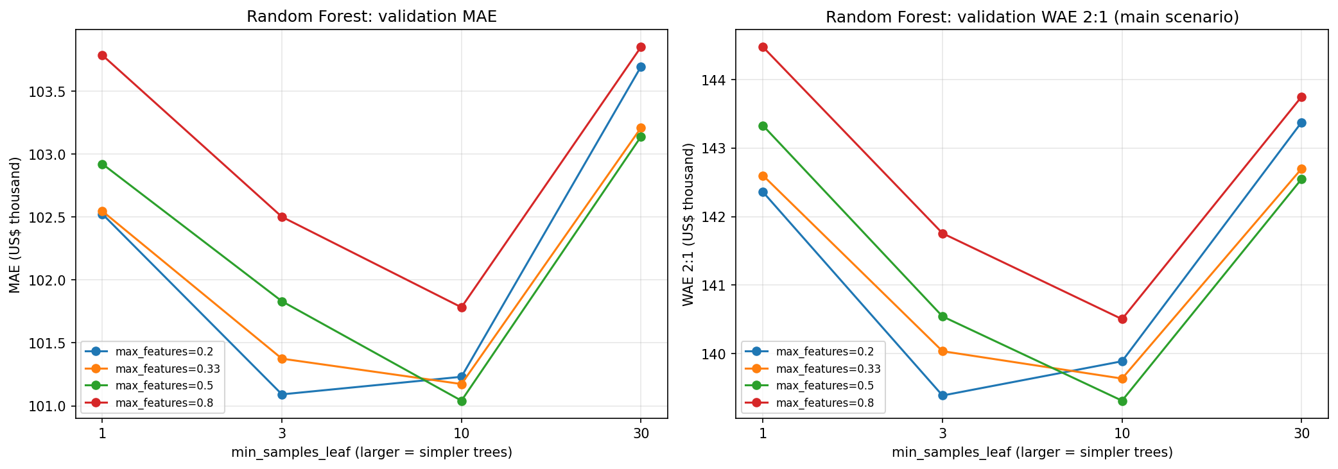
The Decision Tree grid varied depth over nine settings and minimum leaf size over four. T018 (depth 10, leaf 10) minimised validation WAE 2:1. The forest tree-count path tested 25–300 trees; the complexity grid varied max_features and minimum leaf size. R011 used 100 trees, max_features 0.5 and leaf size 10. Training and out-of-bag scores were diagnostics; the later validation window governed selection. Smaller leaves and deeper trees increased flexibility but were kept only when they improved the primary validation loss.
Boosting — Member 4
LightGBM used 24 Optuna trials with seed 6810. Its search varied target scale, depth, leaf count, learning rate, minimum child size, row and feature sampling, and L1/L2 penalties; early stopping monitored dollar WAE 2:1 for at most 1,400 rounds with patience 100. C020 selected 912 trees. H005 used 400 trees; X006 and K006 each used 800 trees in fixed six-candidate grids without a matched Optuna budget. Training-versus-validation WAE learning curves show the benefit and eventual flattening of extra trees. X006 was selected by the group’s primary validation loss, not by its lower MSE alone.
Figure 3.2. Training and validation WAE 2:1 as boosting rounds increase; the curves are diagnostics, not a second selection rule.
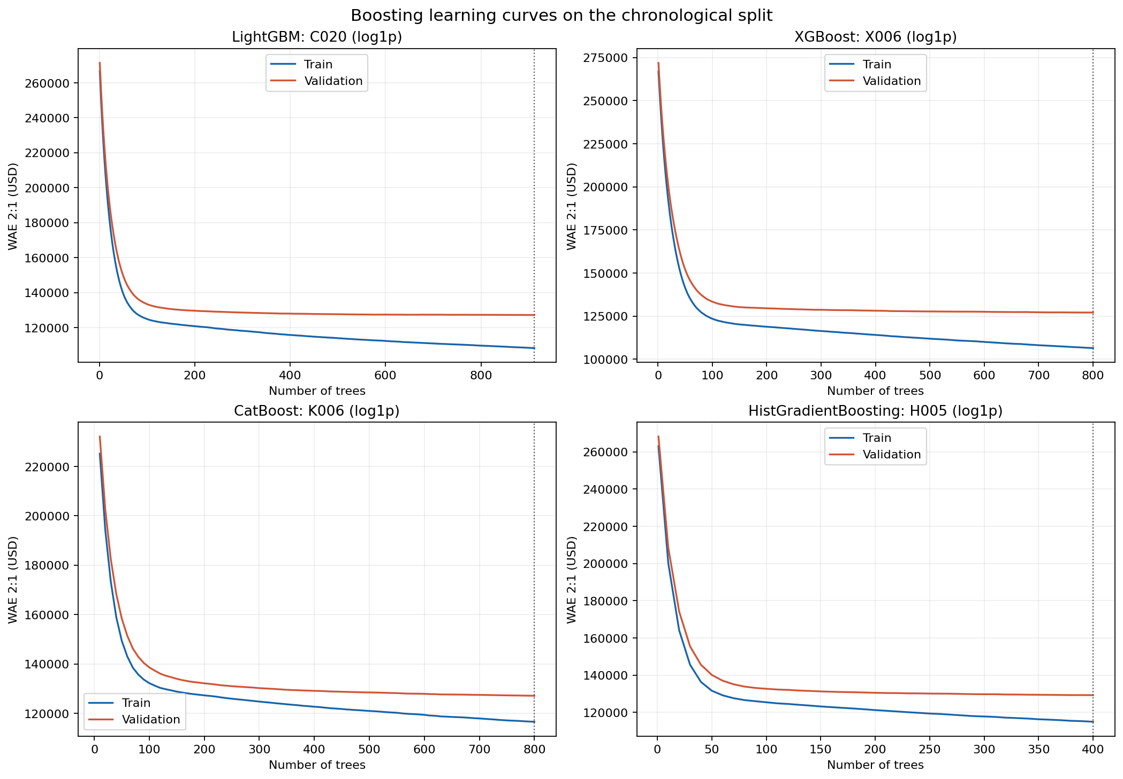
Overall Model Tuning — Group Synthesis
X006, K006 and C020 differed by at most $100.52 in validation WAE 2:1, while their model classes and tuning budgets differed. H005 used 400 trees but had WAE $2,218.79 above X006. The predeclared WAE rule resolves selection among tested candidates, yet the small leading gaps do not demonstrate a durable ranking in a new period. A simpler operational model could be reconsidered during a pilot if implementation or maintenance costs are material; the 2025 test was reserved for evaluation, not post-hoc selection.

3f. Which final model and prediction procedure did you select, and why?
Table 3.6 compares main-scenario configurations from the model families on the same 18,132 validation transactions. The chosen model is XGBoost X006 (log1p target, 800 trees), with the lowest tested WAE 2:1 of $127,037.32. The table also retains the three linear approaches for transparency; their feature representation differs from the shared matrix used by tree and boosting models.
Model family | Retained 2:1 configuration | WAE 2:1 ($) | MAE ($) | MSE ($bn) | R²
Global Mean | Training mean | $342,381.82 | $238,599.62 | 191.693 | −0.0050
Linear Regression | D | $157,254.42 | $113,051.17 | 54.137 | 0.7162
Ridge | D, α=12 | $153,109.49 | $110,441.40 | 52.304 | 0.7258
Lasso | D, α=20 | $152,566.39 | $110,000.68 | 51.757 | 0.7286
Decision Tree | T018; depth 10, leaf 10 | $160,998.12 | $115,601.41 | 59.195 | 0.6896
Random Forest | R011; 100 trees, leaf 10 | $139,315.50 | $101,041.09 | 48.680 | 0.7448
Hist. Gradient Boosting | H005; log1p, 400 trees | $129,256.11 | $102,471.84 | 47.880 | 0.7490
LightGBM | C020; log1p, 912 trees | $127,137.84 | $101,201.80 | 47.198 | 0.7525
CatBoost | K006; log1p, 800 trees | $127,094.44 | $101,783.64 | 47.572 | 0.7506
XGBoost | X006; log1p, 800 trees | $127,037.32 | $101,086.26 | 44.506 | 0.7667
X006 improved WAE 2:1 by $57.12 versus K006, $100.52 versus C020, $2,218.79 versus H005 and $12,278.18 versus R011. Its validation MSE was $44.51 billion and R² was 0.7667. The first two WAE margins are very small, so the result supports a rule-based choice among tested configurations rather than a claim that XGBoost is inherently superior. Lasso D α=20 remained the strongest main-scenario linear candidate at $152,566.39.
X006 uses the 209 predictors in the official split CSV, excluding sale_price and log_sale_price. It fits log1p(sale_price), transforms predictions back to non-negative US dollars, and uses 800 trees with frozen hyperparameters. After validation selection, the final estimator was refitted on all 72,985 training-plus-validation sales with no test-informed tuning. Its predictions were evaluated on the 36,322 held-out 2025 sales. Membership IDs preserve transaction alignment, and property_id and transaction_id are never predictors. The 209 columns already include calendar-month indicators and house_age; “no time index” means that the additional continuous month index was omitted.
Reconciliation note: the older Linear Regression D values in Tables 3.2 and 3.3 were updated to the current saved run ($157,254.42 WAE 2:1). The current shared-CSV linear comparison is also materially different from the earlier appendix values, so Table A1 below uses the executed notebook’s saved outputs. No model result was forced to agree with the earlier report.

Section 4: Final evaluation
4a. How do your price predictions perform on the test set compared with the baseline? Justify your regression metrics and interpret a residual plot.
On 36,322 held-out 2025 sales, frozen XGBoost X006 reached WAE 2:1 of $134,003.25 versus $360,699.00 for the development-mean baseline. MAE was $105,304.33 versus $256,774.35; RMSE was $251,497.04 versus $495,104.71; and R² was 0.7394 versus −0.0099. WAE reflects the chosen higher penalty for overvaluation, MAE expresses typical dollar error, RMSE highlights large misses, and R² gives a variance-based check without encoding the asymmetric business priority.
The residual is predicted minus actual sale price. Its mean was −$47,906.50, so average predictions were below recorded sale prices. The residual chart and price-decile panel show that error direction changes across the price distribution, and individual misses remain large despite the baseline improvement. Price deciles use observed test outcomes solely for evaluation and cannot define a deployable rule.
Figure 4.1. Frozen XGBoost X006 residuals and assessment ratios on held-out 2025 transactions.
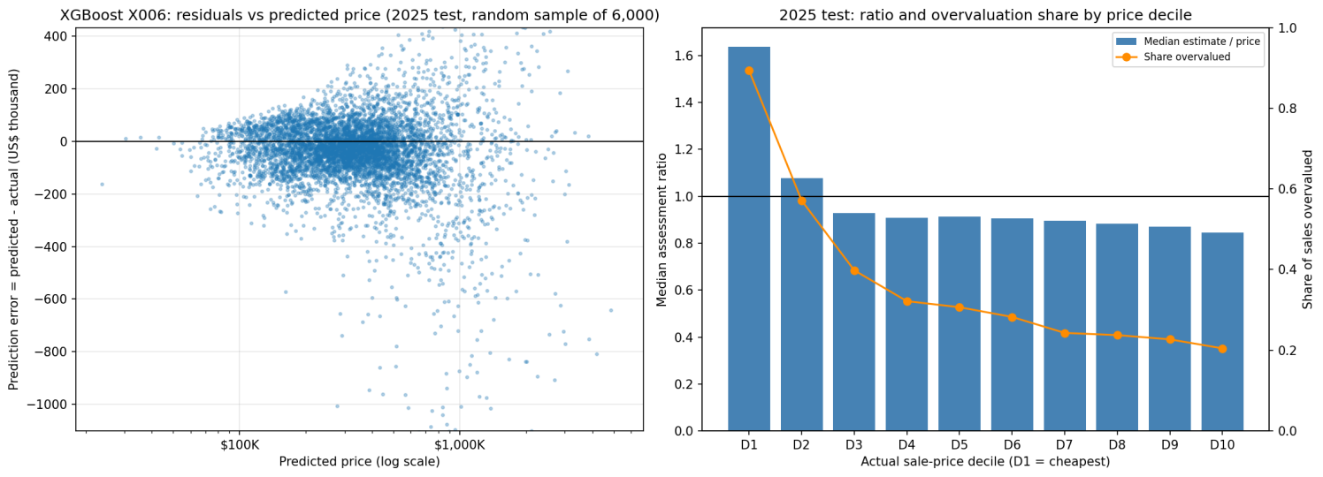
4b. Compare performance across time periods and at least three townships (local geographical areas in Cook County). How might price levels and the mix of homes sold explain differences? Support your explanations with evidence from the data.
The held-out 2025 results vary by quarter and township. Quarterly WAE 2:1 rose from $130,472.39 in Q1 to $138,844.51 in Q4, while mean signed error moved from −$39,017.85 to −$53,946.53. Counts, prices and property mix differ across quarters, so this descriptive pattern does not isolate time drift. The monthly diagnostics and the 2025 township table provide the finer evidence for monitoring.

The 2025 monthly table covers all 12 months, rather than the 2024 validation period. Test errors remain negatively signed in every quarter and become more negative later in the year. The median test sale price was $340,000 in Q1, $375,000 in Q2, $365,000 in Q3 and $357,000 in Q4. Changes in home mix and price level could contribute to the error pattern; the table alone cannot identify a causal market trend.

Three actual township codes illustrate the geographic variation. Thornton (code 37; 1,844 test sales) had median price $170,000, MAE $50,799 and WAE 2:1 $70,085. Jefferson (code 71; 3,378 sales) had median price $480,000, MAE $120,197 and WAE $151,242. New Trier (code 23; 725 sales) had median price $1,405,000, MAE $413,598 and WAE $506,714. These are townships, unlike city names such as Winnetka or Chicago.
The township differences partly track price level and observable home mix. Median building area in these three examples was 1,171, 1,533.5 and 2,640 square feet. Dollar errors naturally tend to be larger where sale prices are higher, while relative errors can tell a different story: median absolute percentage error was 25.8% in Thornton, 16.8% in Jefferson and 15.3% in New Trier. This evidence supports monitoring absolute and relative errors together; it does not establish that township itself caused the gap. Smaller township samples and unrecorded property condition remain limitations.
Figure 4.2. Held-out 2025 monthly signed error and township ratios; counts and price levels qualify subgroup comparisons.
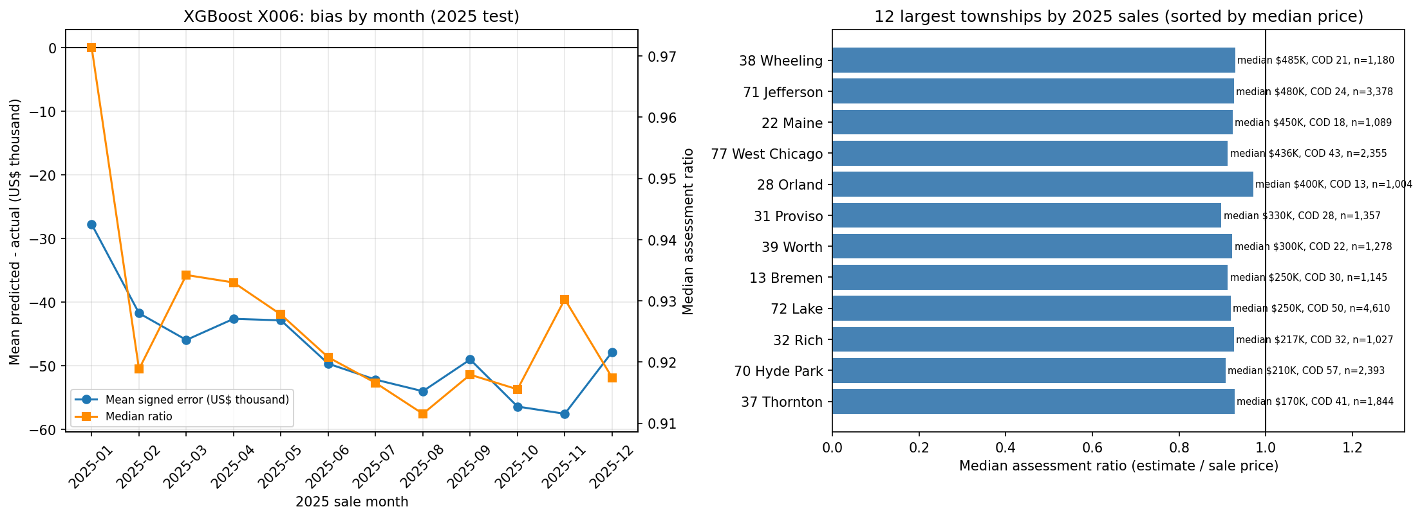
4c. Choose and justify weights for overvaluation and undervaluation. Compare weighted absolute error for your model and the baseline under your main scenario and two alternatives. Keep predictions fixed across scenarios. Does your conclusion change?
We prioritised avoiding overvaluation because the model is intended to support residential assessments. If an inflated estimate passes through review, it could disadvantage the homeowner and lead to an assessment challenge. We therefore pre-specified WAE with a 2:1 overvaluation-to-undervaluation weighting as the primary validation metric for model selection, placing greater emphasis on this risk while still penalising undervaluation. The ratio reflects our judgement about the intended use, rather than an empirically estimated difference in the costs of the two errors.
Table 4c.1. Reported family configurations selected under each WAE scenario on 2024 H2 validation (US$)
Model family | Overvaluation 2:1 | Equal 1:1 | Undervaluation 1:2
Global Mean | fixed; $342,381.82 | fixed; $238,599.62 | fixed; $373,417.03
Linear Regression | D; $157,254.42 | D; $113,051.17 | D; $181,899.10
Ridge | D α12; $153,109.49 | E6 α8; $104,068.43 | E6 α8; $150,381.70
Lasso | D α20; $152,566.39 | D α20; $110,000.68 | D α20; $177,435.64
Decision Tree | T018; $160,998.12 | depth10 leaf50; $115,538.39 | depth10 leaf50; $185,036.45
Random Forest | R011; $139,315.50 | R011; $101,041.09 | R003; $163,802.43
Hist. Gradient Boosting | H005; $129,256.11 | H002; $99,840.00 | H002; $164,271.77
LightGBM | C020; $127,137.84 | C013; $99,625.13 | C013; $166,020.68
CatBoost | K006; $127,094.44 | K003; $99,239.36 | K003; $163,044.22
XGBoost | X006; $127,037.32 | X003; $99,413.37 | X003; $164,612.43
The validation table re-selects configurations under each WAE weighting and therefore shows sensitivity of model choice. X006 wins 2:1 overall at $127,037.32; CatBoost K003 wins 1:1 at $99,239.36; Ridge E6 α=8 wins 1:2 at $150,381.70. These alternatives are separate from the required fixed-prediction 2025 test: Table 4c.2 holds X006 and the baseline predictions fixed, changing only the directional weights.
For Ridge 2:1, the table retains D α=12 configuration ($153,109.49). The complete experiment register also contains an exploratory F1 α=12 result of $153,089.21, only $20.28 lower; F1 was not adopted because the gain did not justify the added interaction. The existing group report and the final-model decision are unchanged.
For the held-out 2025 test, the baseline predicts the mean of the 72,985 development sales ($426,200.21) for every transaction. This differs from the $418,490 training-only mean used for the 2024 validation baseline because the final fit includes validation. The frozen XGBoost X006 predictions and this same baseline vector are scored on all 36,322 2025 sales under each of the three pre-specified weightings:
Table 4c.2. Fixed 2025 test predictions for XGBoost X006 and the development-mean baseline
Scenario | Model WAE ($) | Baseline WAE ($) | Reduction
Overvaluation 2:1 | 134,003.25 | 360,699.00 | 62.85%
Equal 1:1 | 105,304.33 | 256,774.35 | 58.99%
Undervaluation 1:2 | 181,909.74 | 409,624.05 | 55.59%
Only the weights change across the three 2025 scenarios. X006 reduced WAE versus the development-mean baseline by 62.85% under 2:1, 58.99% under 1:1 and 55.59% under 1:2. The conclusion that it beats this baseline does not change. The alternative validation winners above should not be substituted into this fixed-prediction test after observing test outcomes.
These findings establish performance relative to the specified mean-price baseline, not superiority over every possible baseline or professional valuation. They also do not demonstrate that the selected model is optimal under each alternative weighting scheme, or that performance will transfer unchanged to homes without recent sales.

4d. Do the results justify a pilot of your model to support property valuers? Explain your recommendation using the errors, practical value and limitations.
The 2025 results support a limited pilot with valuer review. X006 reduced primary WAE 2:1 by 62.85% against the development-mean baseline, but its test MAE was still $105,304.33 and RMSE $251,497.04. Mean signed error was −$47,906.50 (predicted minus actual), and 36.93% of test estimates exceeded the recorded price. These individual errors remain material for tax-related valuations despite the aggregate gain.
Property valuers should receive the estimate with source attributes, a review flag for unusual or damaged homes, and a record of any override. The pilot should check errors by township, price range and month before wider use, monitor WAE (2:1) and signed bias as later sales arrive, and investigate drift or disproportionate subgroup errors. The test covers homes that sold, while the intended users also value unsold homes; recent condition changes and other unrecorded facts therefore require independent evidence and professional judgement.
For Question 4c, the following error weights are options. You may instead propose weights supported by relevant research. These weights express priorities, not actual financial costs.
Scenario | Overvaluation | Undervaluation
Equal priority | 1 | 1
Greater concern about overvaluation | 2 | 1
Greater concern about undervaluation | 1 | 2
For weighted absolute error, multiply each absolute price error by the weight for its direction, then average over sales. Choose your main scenario before model selection and evaluate two alternatives in Question 4c. Cite any research used.

Section 5: Deployment and operations
5a. How would the office generate, review and use estimates for homes without recent sales? Identify the information and checks needed before an estimate is adopted.
For a home without a recent sale, the office would first verify the property identifier, current dwelling characteristics, location and valuation date. A production service would then need to reproduce the 209-column training-fitted export schema and score the frozen XGBoost X006 estimator. The current notebooks save predictions and model settings, but do not yet save a deployable model-plus-preprocessing artifact or calibrated prediction interval; those are pilot implementation tasks, not completed outputs. Calendar-month indicators and house_age require an explicit valuation date for an unsold home, even though the additional continuous month index was not selected.

The proposed point estimate is a starting point for an analyst, not an automatic assessment. A pilot review screen should show the verified input snapshot, valuation date, model version, nearby comparable sales and flags for missing, stale or implausible attributes. Homes with unusual size, condition or few comparables would receive closer review. The valuer would document any override and its evidence. Review thresholds and an uncertainty interval must be specified and validated before deployment; the notebooks do not establish them.

The final valuation remains with a qualified valuer. Because the model learns only from homes that sold, as discussed in Section 2e, long-unsold properties are flagged as low confidence and prioritised for manual inspection, and every adopted estimate is stored with its model version and prediction date so that the assessment can be reproduced and defended later.
Before adoption, the office should verify feature completeness, category handling, split-schema order, non-finite values and numerical variation, since six informative columns previously collapsed during export. It should also inspect current property condition and renovation evidence, which the 2022 archive may miss. Logged predictions, later sale outcomes and reviewer actions would allow reproducible monitoring; they would not by themselves reveal the true value of homes that do not sell.

5b. What would you monitor after introducing the model? Explain what findings would trigger investigation, retraining or increased human review.
Following deployment, model performance should be reviewed quarterly as new transaction prices become available. Weighted absolute error (WAE, 2:1) would remain the primary monitoring metric, consistent with the greater concern about overvaluation in residential assessments. MAE, MSE and R² would provide complementary measures of predictive accuracy, while mean signed error (predicted minus actual sale price) would help detect systematic overvaluation or undervaluation. Monitoring should also be conducted across townships, price ranges and time periods, with transaction counts and changes in the composition of sold properties considered to avoid interpreting small or unrepresentative samples as evidence of model deterioration.

A sustained increase in WAE relative to historical performance would trigger an investigation into changes in housing-market conditions, input data quality and model drift. The selected XGBoost model exhibited a mean signed error of −$47,906.50 on the held-out 2025 test set, highlighting the importance of monitoring systematic underestimation as well as overestimation. Persistent directional bias or unusually high WAE within particular townships or price groups would warrant investigation and increased human review, even if aggregate performance remained acceptable. If deterioration continued after potential data-quality problems were addressed, retraining using more recent transactions would be considered. Any replacement model should first demonstrate improved performance through chronological validation rather than being deployed solely because it was trained on newer observations.

Input data and preprocessing outputs should also be monitored for missing or implausible values, unseen categories, distribution shifts and unexpected constant features. This is particularly important because pipeline verification identified six informative numerical predictors that had previously collapsed to zero during transformation. Automated checks of feature variation, schema consistency and non-finite values would help detect similar information loss before predictions reach valuers. Since prediction errors can only be measured for properties that subsequently sell, monitoring results cannot establish accuracy for unsold homes. Analyst adjustments and unusual valuation cases should therefore be recorded as additional warning signals, while remaining subject to professional review rather than being treated as verified prediction errors.
5c. Identify two important risks or constraints when using your model in practice. Explain how the organisation should manage them.
First, models trained on recorded transactions may not generalise to long-unsold homes or homes whose condition changed after the 2022 archive. The office should verify current characteristics, compare recent local sales, flag unusual cases for inspection and retain human sign-off. A pilot should record how often archived inputs require correction and whether review changes the adopted valuation.
Second, error patterns vary by price level, period and township. X006 still has substantial 2025 dollar errors and a negative average signed error. Aggregate WAE can conceal subgroup problems. The office should monitor WAE, MAE, signed error, ratio measures and counts by township and price band; worsening or concentrated errors should trigger investigation and greater manual review before any retraining decision.
5d. For the case below, should the valuer simply subtract the repair quote from the model estimate? Explain your decision and the further evidence needed in at most 150 words.
Hypothetical case for 5d. Your model estimates a home’s value at US$400,000 using archived property information. The owner supplies a recent inspection showing major damage and a repair quote of US$30,000. The damage is not recorded in the model inputs.
No. The $400,000 estimate uses archived attributes and does not account for the newly documented damage, so it is a starting point rather than an as-is valuation. A $30,000 repair quote measures proposed work, not necessarily the change in market value: buyers may discount for uncertainty, delay, hidden defects or less than the full repair cost. The valuer should confirm the inspection date, damage scope, quote validity, likely remaining defects and whether the model inputs already reflect any condition issue. They should compare recent sales of similarly damaged homes, consider repaired-home comparables and local market evidence, then document a reasoned adjustment and uncertainty range. The estimate should not be mechanically reset to $370,000.
Sources and contribution statement. Data and variable definitions came from the course-supplied sales.csv, properties_2022.csv, variable_dictionary.csv and QBUS6810 data dictionary. The modelling extension used the course “10 Gradient Boosting” notebook. The two submitted notebooks and their saved predictions provide the reported numerical evidence. Member 1 led data preparation and exploration, Member 2 linear models, Member 3 Decision Tree and Random Forest, and Member 4 boosting. The group should verify this contribution summary before submission.

AI use and reflection
Include four short cases in an appendix, using the following labels:
7a. Data or features.
I initially asked DeepSeek (November 2025) whether Yeo–Johnson plus scaling was generally suitable for continuous variables. It advised checking distribution shape and fitting on training data. I checked the notebook’s rule file, transformations and saved output. The current export clips selected columns at training quantiles, applies PowerTransformer with standardize=False, falls back to clipped values if numerical collapse occurs, then fits StandardScaler on training values. The tree models consume this transformed shared CSV. I accepted training-only fitting and numerical-health checks, but did not implement an unscaled tree pathway. I learned to distinguish proposed transformations from implemented code. An equal-budget ablation of transformed versus untransformed trees remains untested.

The executed export reports two numerical-stability fallbacks: loc_longitude and loc_env_airport_noise_dnl.
7b. Validation or leakage.
In October 2026, I used ChatGPT to investigate whether repeated property sales affected chronological validation (prompt summary: “Check property overlap between training and validation”). Its initial code treated DataFrame row indices as property identifiers and incorrectly reported 0% overlap.

I then used Codex (verification conducted on 25–26 October 2026) to examine the original sales.csv, merge logic and split membership. The audit confirmed that property features had been matched correctly using property_id, but subsequent index handling made the original overlap calculation unreliable. Recalculating overlap using the original property identifiers showed that 1,677 of 18,132 validation transactions (9.25%) involved 1,666 properties previously observed in training.

I rejected the initial 0% result and retained the chronological split because repeated sales are legitimate observations and do not automatically constitute leakage. This experience demonstrated the importance of checking AI-generated code against original identifiers rather than trusting plausible outputs. However, repeated-property overlap may still overstate generalisation to unfamiliar properties, while temporal feature availability and training-only preprocessing require separate verification.
7c. Modelling or debugging. I initially thought LightGBM C007 would remain the final choice after adding XGBoost and CatBoost. On 1 November 2026, I asked Codex to check the model-selection rule against the group’s 2:1 validation WAE objective. I checked the executed candidate table and frozen selection file: XGBoost X006 scored $127,037.32, CatBoost K006 $127,094.44 and LightGBM C020 $127,137.84. I accepted X006 under the declared rule and rejected the older C007 statement, then recalculated 2025 WAE from the saved transaction-level predictions. I learned that small search or library changes can reorder near-tied models. The $57.12 lead over K006 may not persist in another period, and search budgets were unequal.
7d. Business interpretation.
On 1 November 2026, I asked Codex to review the Question 5d case (prompt summary: “Should a valuer subtract a $30,000 repair quote from a $400,000 model estimate?”). I initially considered $370,000 as a simple adjustment. Codex advised that repair cost and market-value loss differ. I checked that recent damage is absent from the predictors and that the current XGBoost 2025 test MAE of $105,304.33 is an average transaction error, not a property-specific discount. I accepted the need for a dated inspection, repair scope, as-is comparables and documented valuer judgement, and rejected automatic subtraction. This changed the recommendation to an analyst-supervised pilot. The actual market discount and hidden damage remain unknown.
Other AI assistance: Codex helped audit the notebooks, compare saved results with this reference edition, and draft blue revisions. Reported 2025 WAE values were independently recalculated from saved transaction-level predictions. Group members should verify the account of their own work before submission.
For each case, answer all four points:
- What did you initially think? Give the AI tool, date, prompt or relevant excerpt, and abrief summary of its advice.
- How did you check the advice, and what did the check show? Refer to your code, resultsor a reliable source. At least two cases must use your data or code.
- What did you accept, change or reject, and why? Explain the effect on your work.
- What did you learn, and what remains uncertain?
Use at most 180 words per case and two appendix pages in total. Do not paste full conversations. Add a short declaration of other AI assistance.

Formatting and submission
- Page limit: 18 pages, excluding appendices. Keep explanations relevant and concise.
- Use the five report headings above. Label and discuss all figures and tables.
- Put additional experiment logs and supporting figures in an appendix. Keep the evidence for your main conclusions in the report.
- Acknowledge data and other sources. Include a short group contribution statement.
- Deadline: 06 Nov, 23:59 (Week 13). Follow Canvas for group size and submission details.

Assessment and reproducibility
The accompanying rubric gives the marks and marking criteria. Support your decisions with evidence from this dataset.
Your code must run in a clear order using relative file paths, fixed random seeds where relevant and no hidden manual steps. List required packages and brief running instructions at the start of the notebook or script. Remove unused code and irrelevant output.

Appendix
Table A1. Shared-CSV Linear Model Sensitivity Analysis (2024 H2 validation)
Model | Best Tested α | WAE 2:1 ($) | MAE ($) | MSE ($², bn) | R²
Linear Regression | — | 192,979.19 | 127,426.80 | 65.859 | 0.6547
Ridge | 100 | 190,929.16 | 126,875.71 | 66.286 | 0.6525
Lasso | 100 | 189,367.77 | 126,647.48 | 66.155 | 0.6531
Note: All models used the same 209-predictor exported feature matrix and 2024 H2 validation transactions. The reported results reflect the corrected month encoding. For Ridge and Lasso, α = 100 was the best setting within the tested range and also its upper boundary; global optimality is not claimed. Because the original and shared-CSV experiments differ in feature representation and tuning configurations, the performance gap cannot be attributed to a single factor.
Table A2. Additional Feature Configurations Compared with Feature Set D (Ridge α = 8)
Feature Configuration | WAE 2:1 ($)
F0. Reference Feature Set D | 153,163.83
F1. D + Size × Construction Quality | 153,141.95
F2. D + Centered Log Land × Log Building | 153,463.84
F3. D + Combined Repaired Features | 153,440.45
Note: Ridge α = 8 was held constant across these comparisons. F1 improved WAE by only approximately $22 relative to the reference, while F2 and F3 worsened it. These are comparisons of complete feature configurations rather than isolated causal effects of individual interactions.

Additional figures for editorial review
These figures are optional supporting evidence. Keep only those discussed in the final report and move detailed diagnostics to the appendix or remove them to meet the page limit.
Figure A1. Sale-price boxplots by training year.
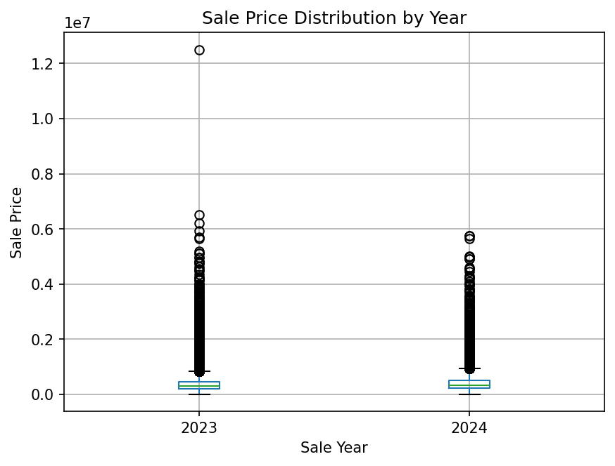
Figure A2. Sale-price histogram and long tail.
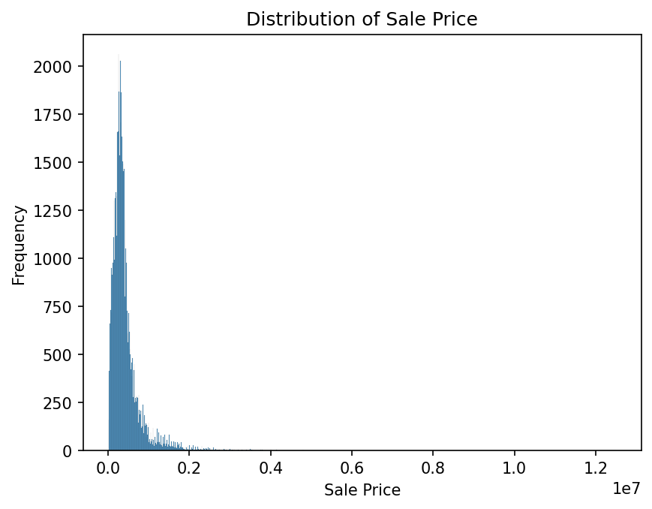
Figure A3. Log-price boxplots by training year.
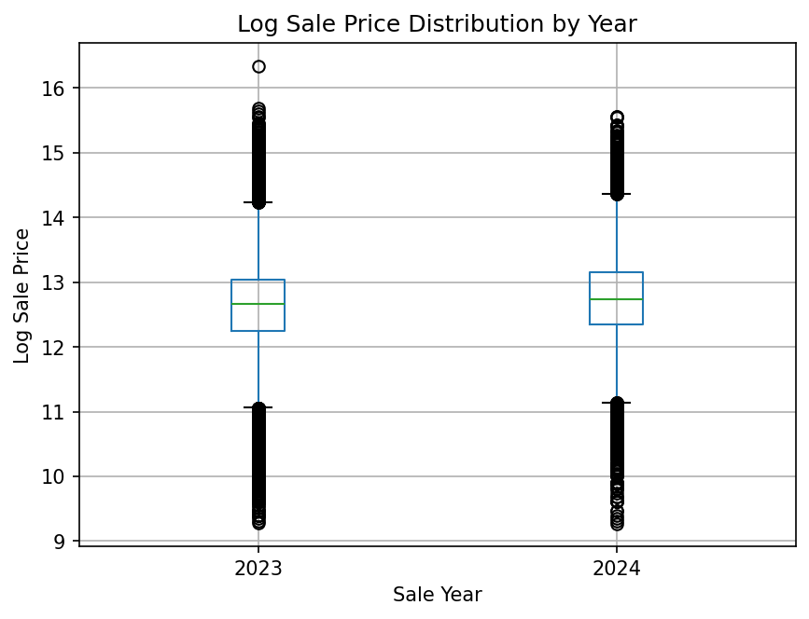
Figure A4. Log-price histogram.
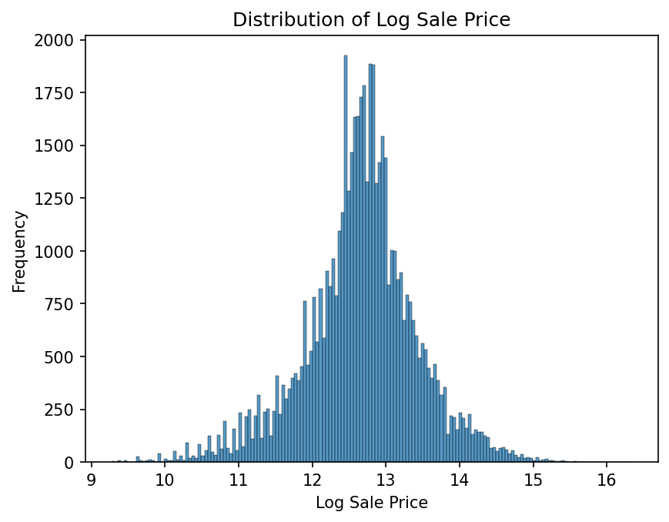
Figure A5. Continuous predictor distributions, part one.
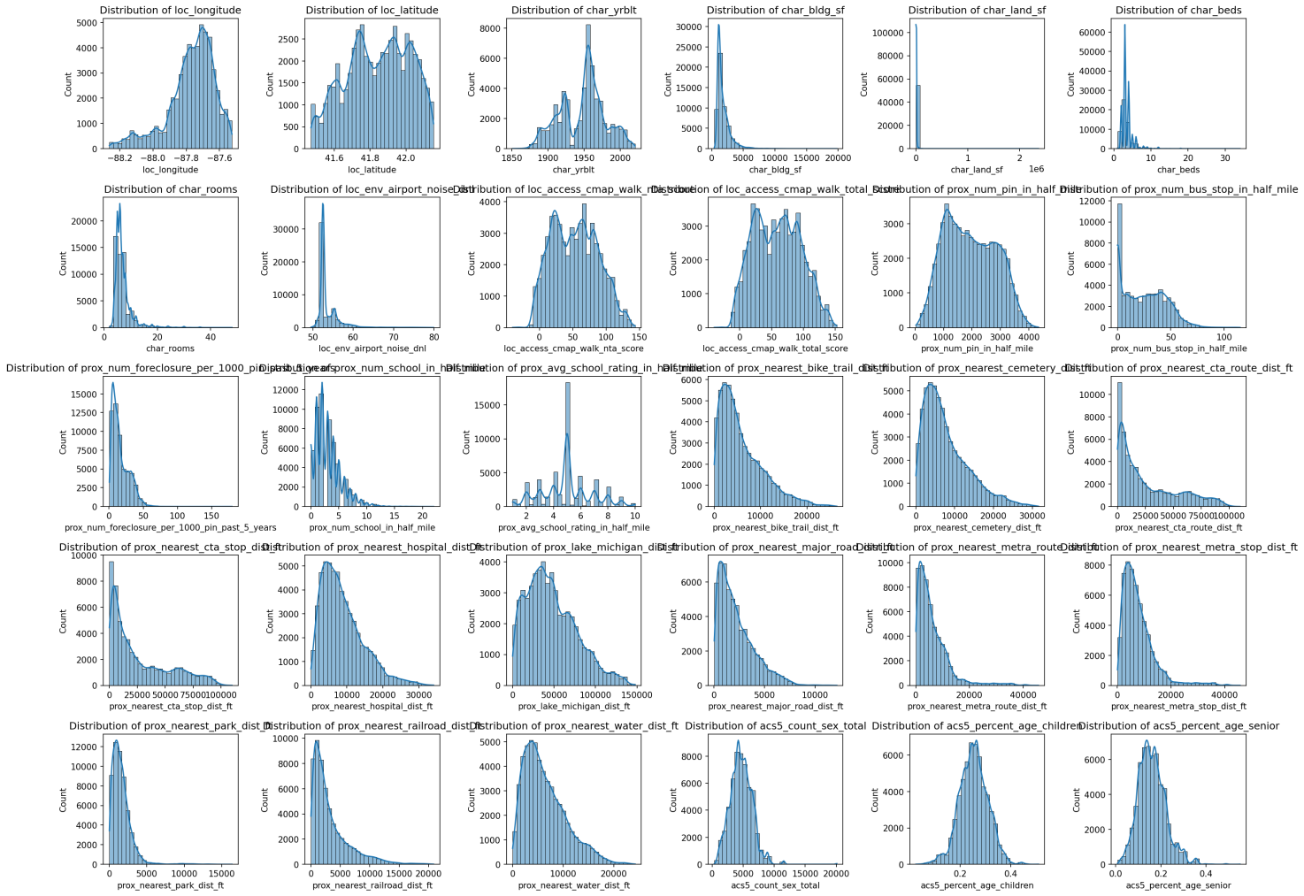
Figure A6. Continuous predictor distributions, part two.
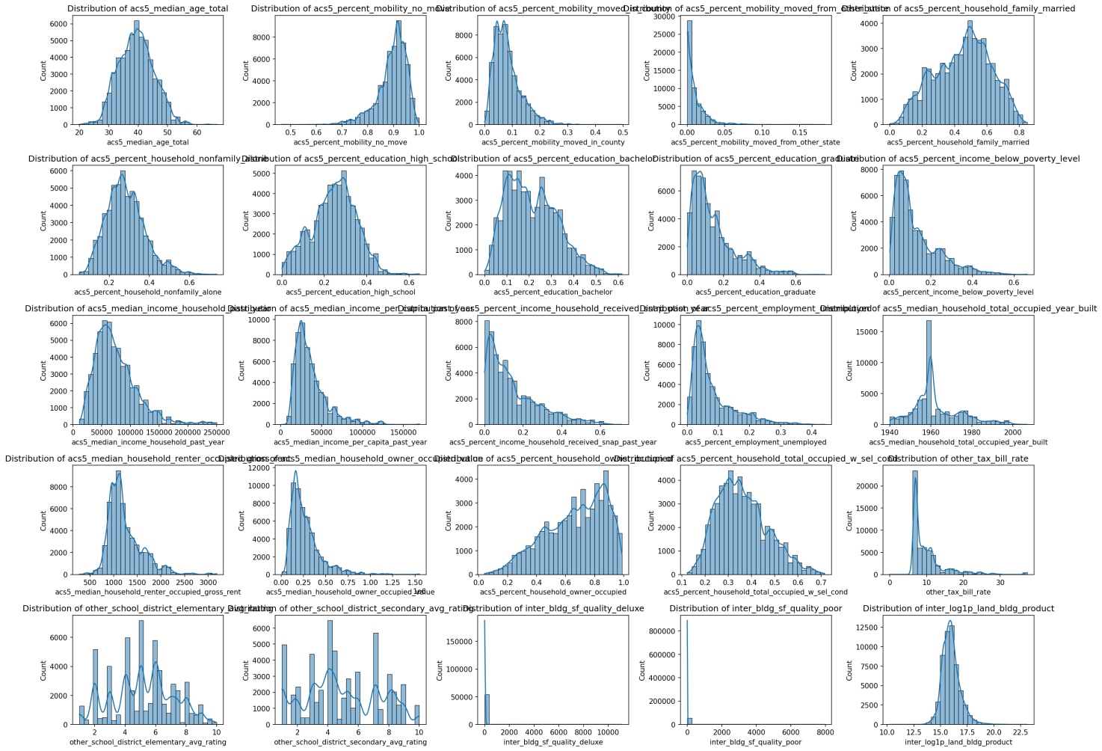
Figure A7. Discrete predictors and log price.
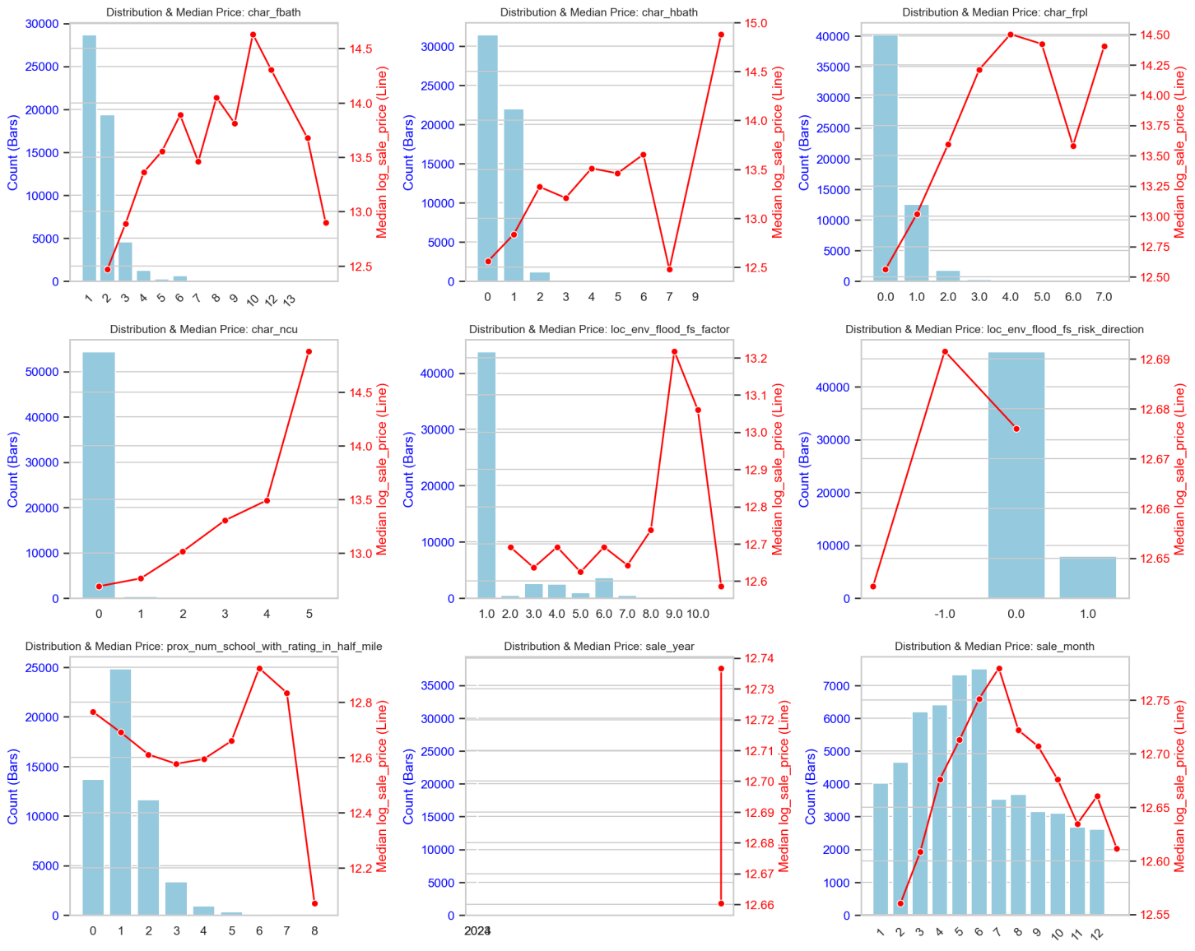
Figure A8. Construction quality categories and log price.
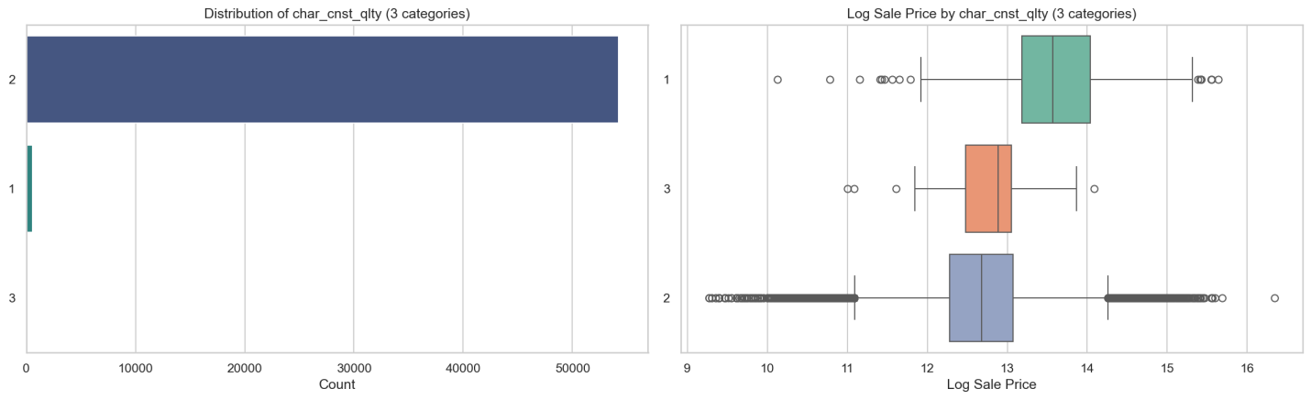
Figure A9. Township code categories and log price.
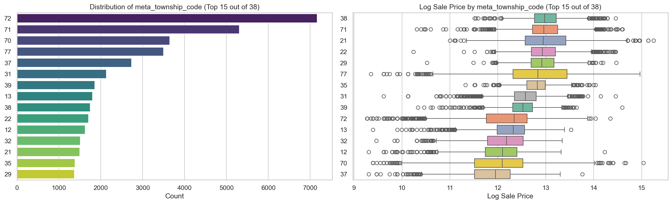
Figure A10. Single-tree depth and leaf-size diagnostics.
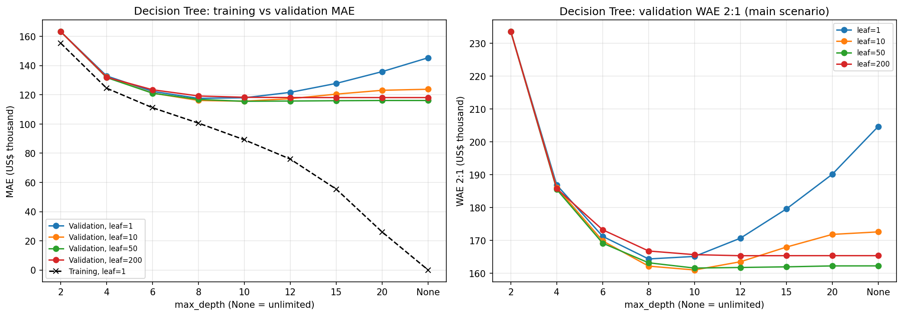
Figure A11. Random Forest estimator-count path.
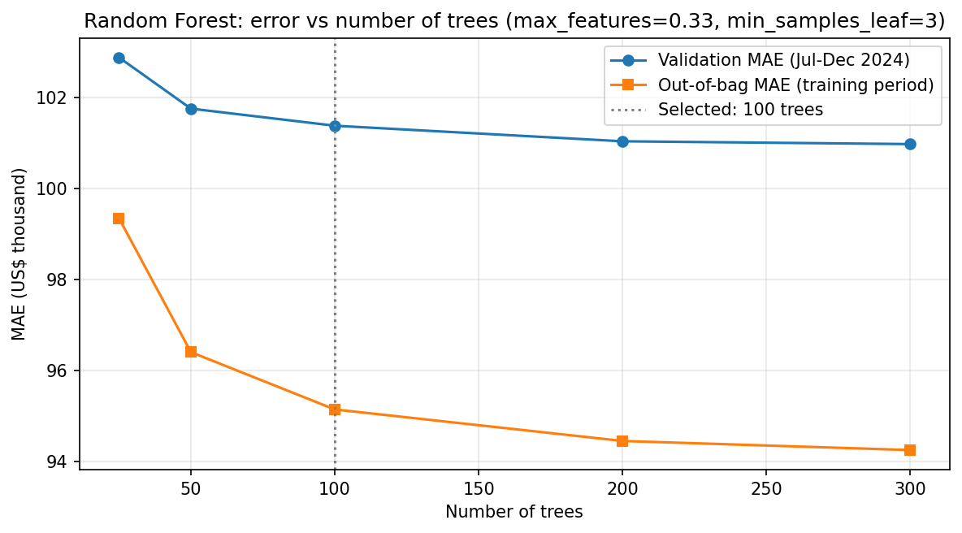
Figure A12. Random Forest feature importance.
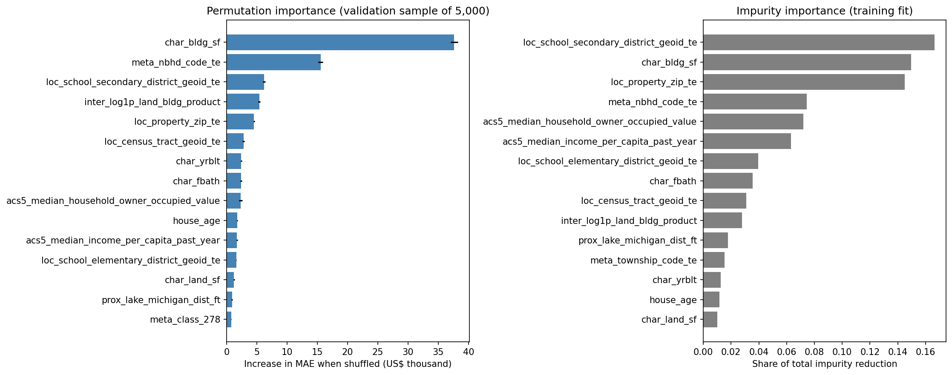
Figure A13. Random Forest validation residual diagnostics.
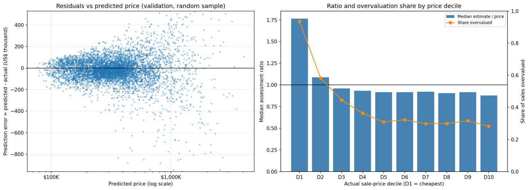
Figure A14. Tree time-index comparison by validation month.
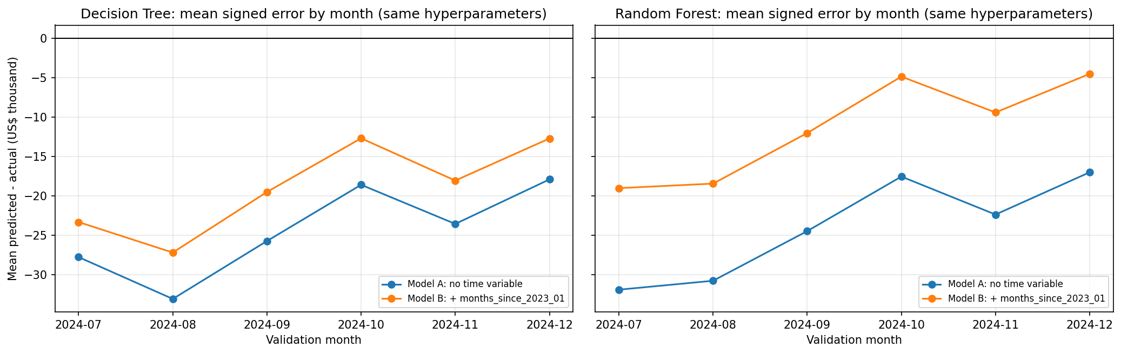
Figure A15. LightGBM gain-based feature importance; this describes the fitted LightGBM comparator, not the final XGBoost model.


