1.



2.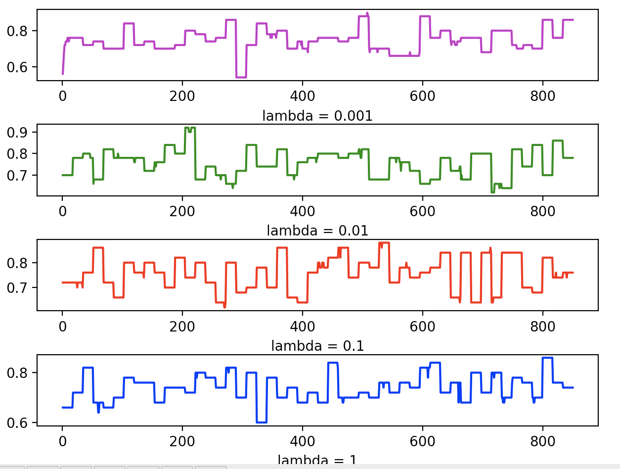

3.

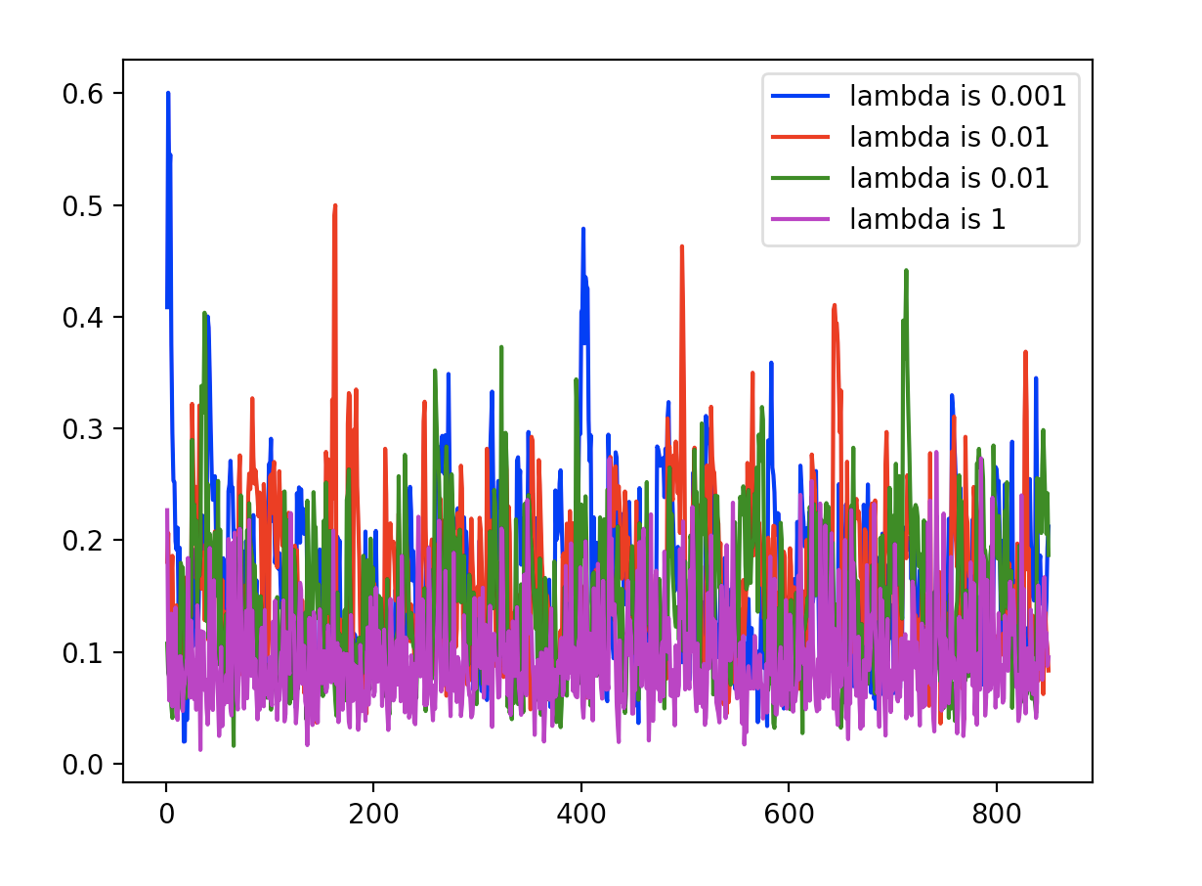

4.

Lambda : 0.001

After running, we can see that compared with other values, 0.001 shows a more stable

result after several epochs and shows a relatively higher accuracy and more stable curve.

Therefore, I choose lambda = 0.001

m = 1

n = 50

learning rate = m / ( 0.01 \* epoch + n)

I my choice, the learning rate will have a stable decrease each time as the epoch increases but after multiplication with 0.01 the learning rate will not decrease too sharply.

5.

