Inkclusive
Project README and algorithm guide
Researchers
Ely Rose Panganiban-Briones
Jovelyn Ocampo
Edan Belgica
Alvin Catalo

Table of Contents
Part 1. Project README 3
How the pieces fit together 3
Run locally 3
Checks 4
Part 2. System design diagrams 5
2.1 System architecture 6
2.2 Deployment diagram 7
2.3 Use case diagram 8
2.4 Data flow diagram: Level 0 (context) 9
2.5 Data flow diagram: Level 1 10
2.6 Sequence diagram: check and apply a suggestion 11
2.7 Sequence diagram: admin sign-in and term management 12
2.8 Gender-fair algorithm flowchart 13
2.9 Data and storage model 14
Part 3. Frontend README 15
How the system works 15
Main routes and services 15
Local data and privacy 16
Setup 16
Commands 16
Configuration 16
Setup 17
Commands 17
Configuration 17
Part 4. Backend README (API server) 18
API v1 18
Request flow and storage 19
Local setup 19
Docker 20
Important deployment note 20
Part 5. Algorithm and function guide 22
1. Main analysis flow 22
2. Gender-fair checker (main_gfl.py) 22
3. Grammar analysis and HTTP API (main.py) 24
4. Term library and count storage 25
5. Admin authentication (admin_auth.py) 26
6. Frontend request, offsets, and edits 26
7. Other document workflows and utilities 27
8. Important implementation notes for documentation accuracy 28

Part 1. Project README
Inkclusive is a writing assistant for grammar review and gender-fair language. The project is split into two independently runnable applications:
Application | Folder | Responsibility
Web client | inkclusive-frontend/ | SvelteKit interface, editor, document import/export, browser history, and admin UI
API server | inkclusive-backend/ | FastAPI endpoints for grammar, gender-fair suggestions, term data, and request counts

Architecture overview
Writer → SvelteKit client
SvelteKit client → FastAPI backend (grammar and GFL requests)
FastAPI backend → LanguageTool (grammar)
FastAPI backend → spaCy and term rules (GFL)
FastAPI backend → CSV data files
SvelteKit client → SvelteKit API routes (import and export) → PDF.js, Mammoth, Tesseract.js, jsPDF
SvelteKit client → Browser IndexedDB (writing history)

How the pieces fit together
- The browser opens the SvelteKit client. /dashboard redirects to /dashboard/editor; the dashboard also has Scan and History pages.
- The editor uses ProseMirror. The suggestion panel sends text to the backend's /grammar and /gfl endpoints, then displays the returned suggestions so the writer can apply or ignore them.
- The backend checks grammar with LanguageTool. Its gender-fair language logic uses spaCy, the en_core_web_sm model, the preferred pronouns sent by the client, and replacement rules in gendered_terms.csv.
- Scan accepts PDFs, DOCX files, and JPEG/PNG images. The frontend's SvelteKit API routes extract PDF text with PDF.js, DOCX text with Mammoth, and image text with Tesseract.js. PDF and DOCX exports are handled by the frontend's export utilities and API route.
- History is stored in the browser's IndexedDB. The backend's request count and term library are stored in local CSV files.
- /admin provides a sign-in and UI for managing terms. The backend verifies the password, issues an expiring bearer token, and requires it for all term-library endpoints. The SvelteKit server stores the token in an HttpOnly cookie and proxies admin requests. Admin sign-in is rate-limited, and password changes invalidate existing tokens.

Run locally
Start the backend first. It needs Python 3.10 or newer, the spaCy English model, and Java 17 or newer for LanguageTool's local server.
cd inkclusive-backend
python -m venv .venv
.venv\Scripts\Activate.ps1
pip install -r requirements.txt
python -m spacy download en_core_web_sm
uvicorn main:app --reload --host 0.0.0.0 --port 8000

In a second terminal, configure and start the client:
cd inkclusive-frontend
Copy-Item .env.example .env
npm ci
npm run dev

The client is served by Vite (normally http://localhost:5173), and the API by FastAPI at http://localhost:8000. See the frontend guide (inkclusive-frontend/README.md) and backend guide (inkclusive-backend/README.md) for configuration and commands.

Checks
From inkclusive-frontend/:
npm run check
npm run build
npm test

The frontend deploy configuration uses SvelteKit's Netlify adapter. The backend includes a Dockerfile and a Docker Compose setup.

Part 2. System design diagrams
This part documents how Inkclusive is structured and how data moves through it. The diagrams are derived from the READMEs and the algorithm guide in this document. Each one answers a different question, so together they give a new developer, a reviewer, or a panelist the full picture without reading the code.
Diagram | Question it answers | Main audience
System architecture | What are the parts of the system and how are they layered? | Developers, reviewers
Deployment diagram | Where does each part run, and over which connections? | Developers, DevOps
Use case diagram | Who uses the system and what can each user do? | Stakeholders, panel
DFD Level 0 (context) | What data enters and leaves the system as a whole? | Everyone
DFD Level 1 | Which processes transform the data, and where is it stored? | Analysts, developers
Sequence: check and apply | In what order do the components talk during a writing check? | Developers
Sequence: admin sign-in | How are admin sessions and term changes authenticated? | Developers, security
Algorithm flowchart | How does the gender-fair checker turn text into corrections? | Developers, researchers
Data and storage model | What records exist and where is each kept? | Developers

2.1 System architecture
The system has four layers. The SvelteKit client runs in the browser and keeps drafts and history locally. A thin SvelteKit server handles DOCX extraction and proxies admin requests. The FastAPI backend does the language analysis and manages the term library. Server-side state lives in three small files.
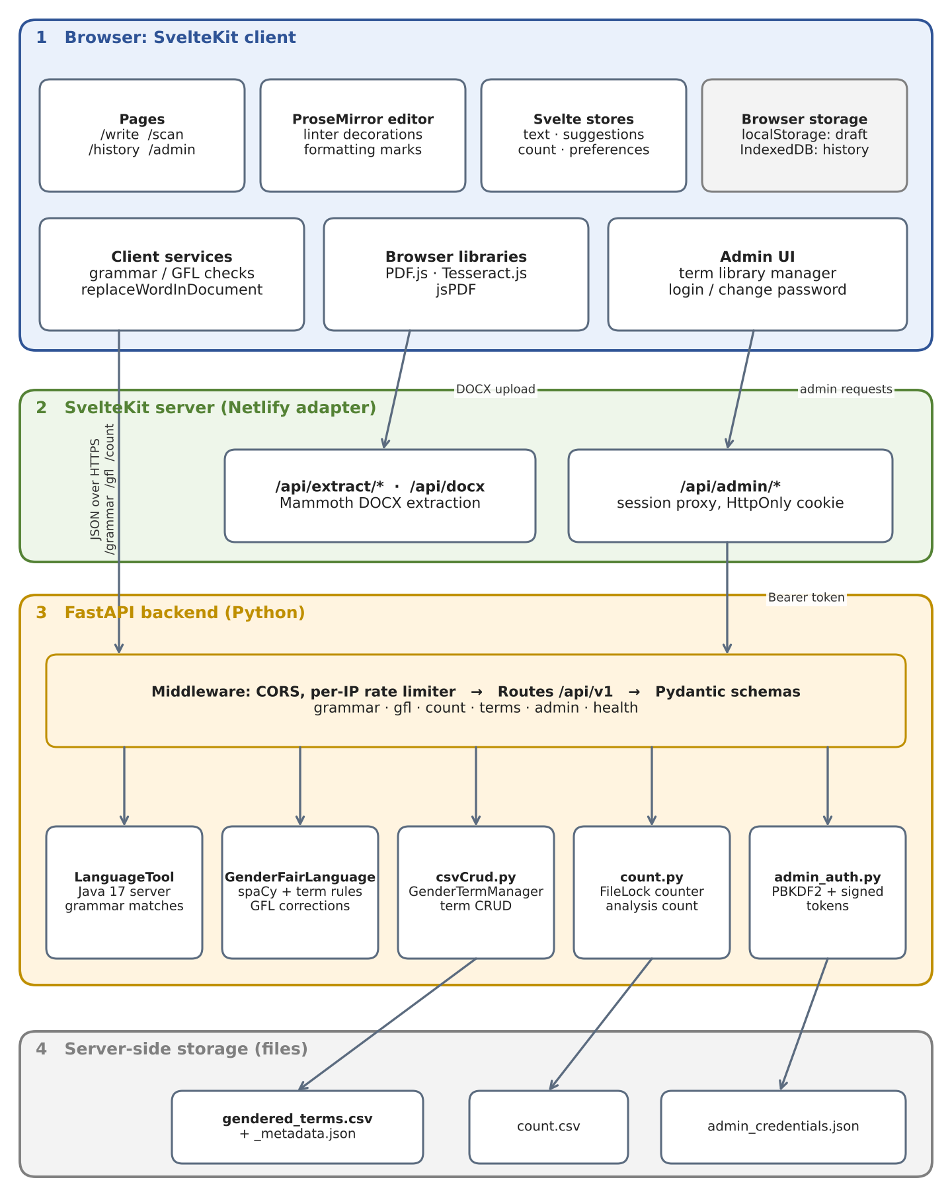
Figure 1. System architecture of Inkclusive.

2.2 Deployment diagram
The client and its SvelteKit server routes are deployed to Netlify. The backend runs in a Docker container that bundles uvicorn, the LanguageTool Java server, and spaCy. A mounted volume holds the CSV, JSON, and counter files so they survive container replacement. Secrets come from a private .env file.
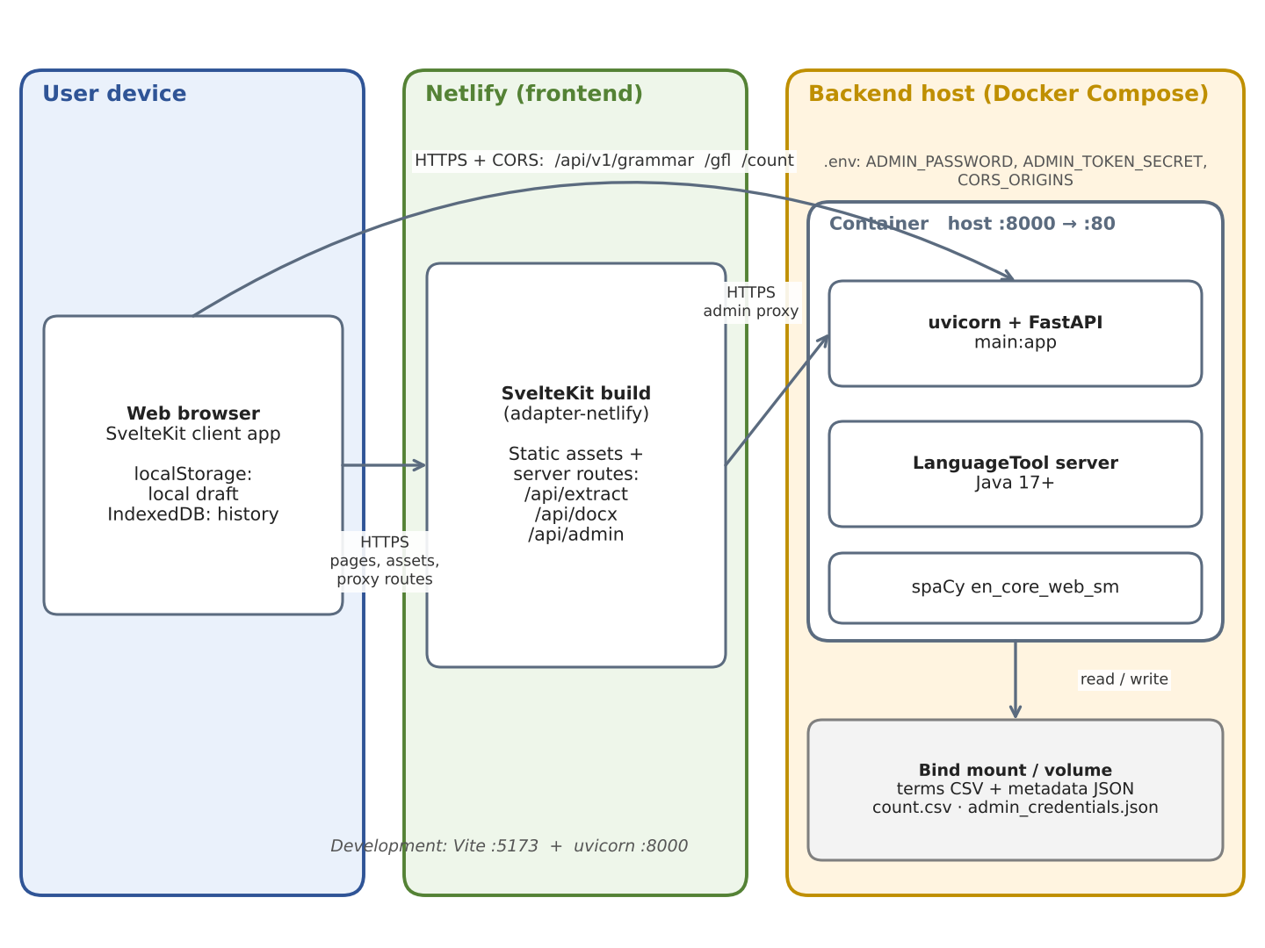
Figure 2. Deployment view: user device, Netlify, and the backend host.

2.3 Use case diagram
There are two actors. Writers use the editor, scan, check, and export features without an account. The administrator signs in to manage the term library and change the admin password.
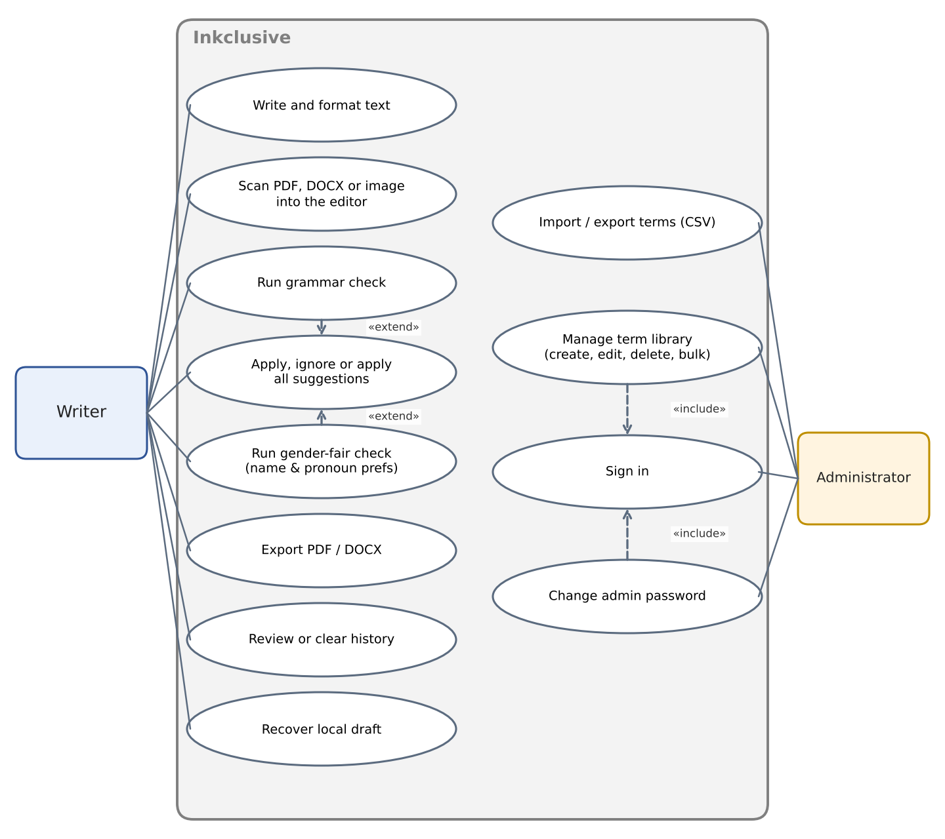
Figure 3. Use cases for the Writer and the Administrator.

2.4 Data flow diagram: Level 0 (context)
The context diagram treats Inkclusive as a single process. It shows only what crosses the system boundary: the writer supplies text, files, and preferences and receives suggestions and exports; the administrator supplies credentials and term changes and receives a token and term records.
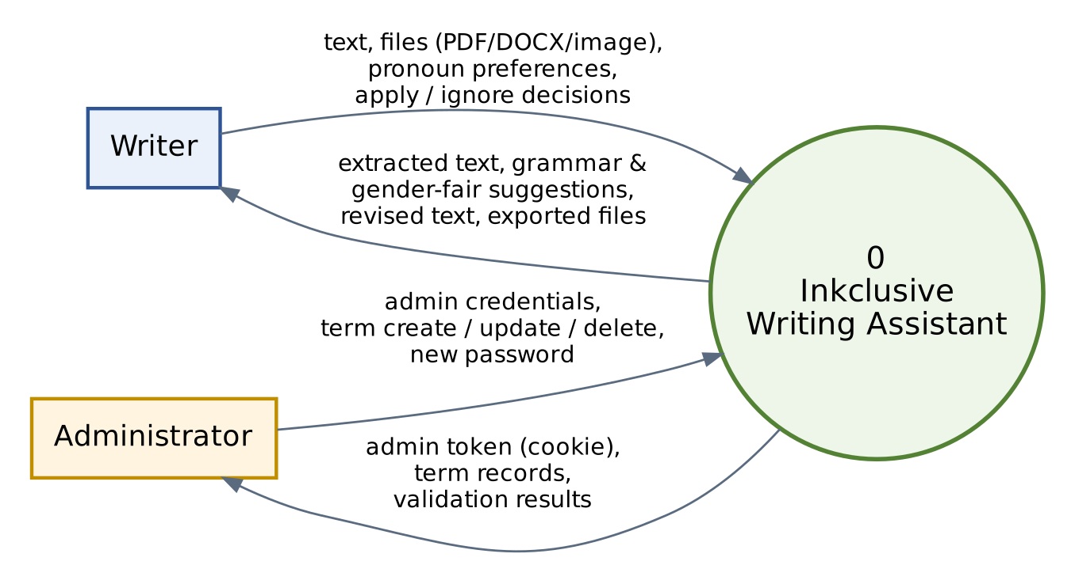
Figure 4. Data flow diagram, Level 0 (context diagram).

2.5 Data flow diagram: Level 1
Level 1 breaks the system into seven processes and five data stores (D1 to D5). Grammar and gender-fair analysis both feed the review process, which returns the writer's apply or ignore decisions to the editor. Only gender-fair analysis reads the term library and increments the analysis counter.
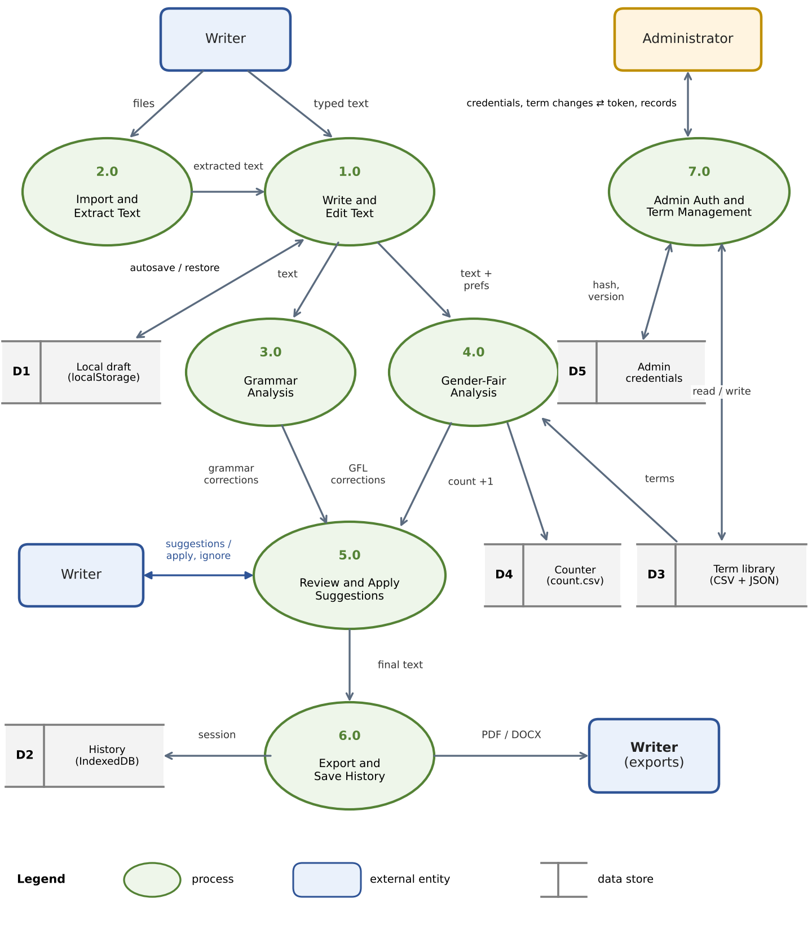
Figure 5. Data flow diagram, Level 1.

2.6 Sequence diagram: check and apply a suggestion
This is the main user flow. The client calls the grammar endpoint first, then the gender-fair endpoint. Each response carries character offsets, which the editor later maps to ProseMirror positions when the writer applies a suggestion.
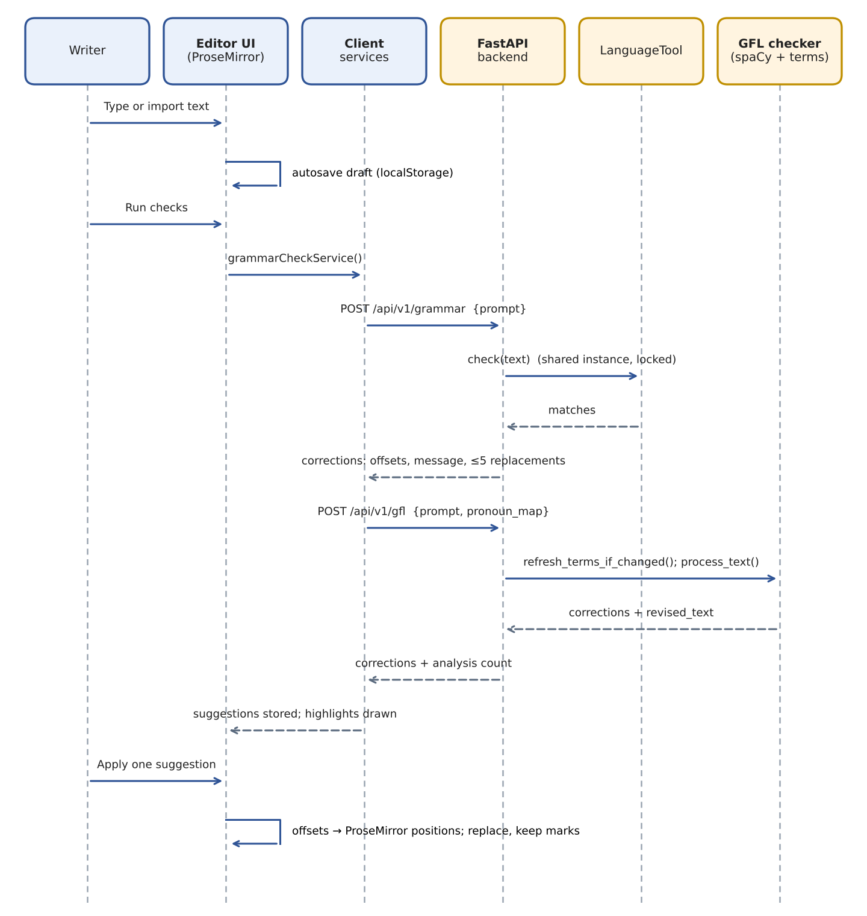
Figure 6. Sequence of a writing check and an applied suggestion.

2.7 Sequence diagram: admin sign-in and term management
The backend verifies the password and issues an expiring token. The SvelteKit server keeps that token in an HttpOnly cookie and attaches it as a bearer token on every term request, so browser scripts never see it. Changing the password invalidates earlier tokens.
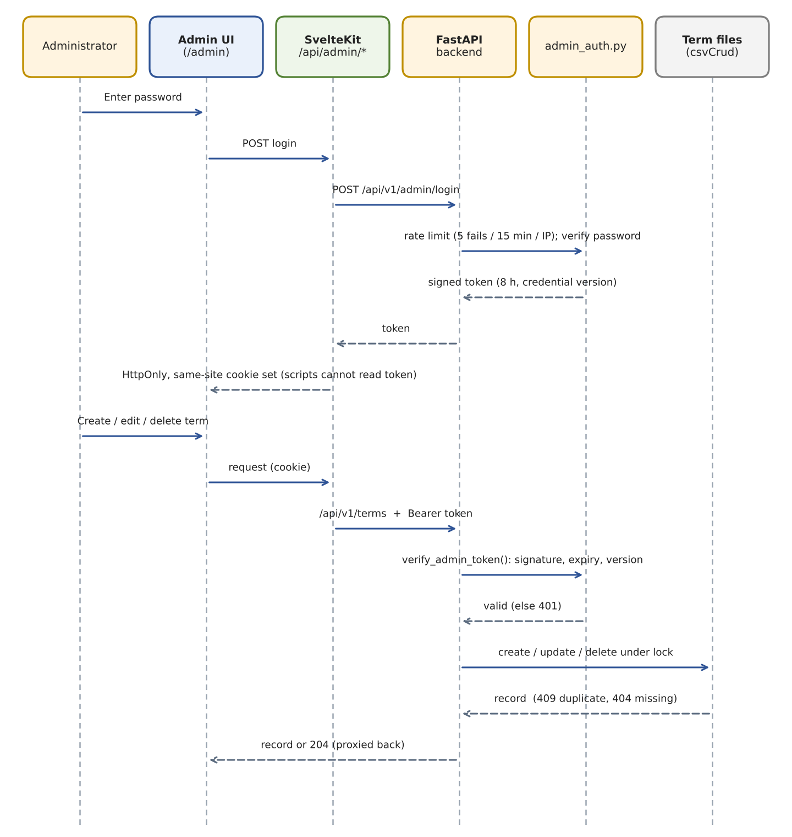
Figure 7. Sequence of admin sign-in and a term change.

2.8 Gender-fair algorithm flowchart
This flowchart summarizes GenderFairLanguage.process_text(). All five detectors run on the same spaCy parse. Overlapping candidates are then resolved greedily before metadata is attached and the preview text is built.
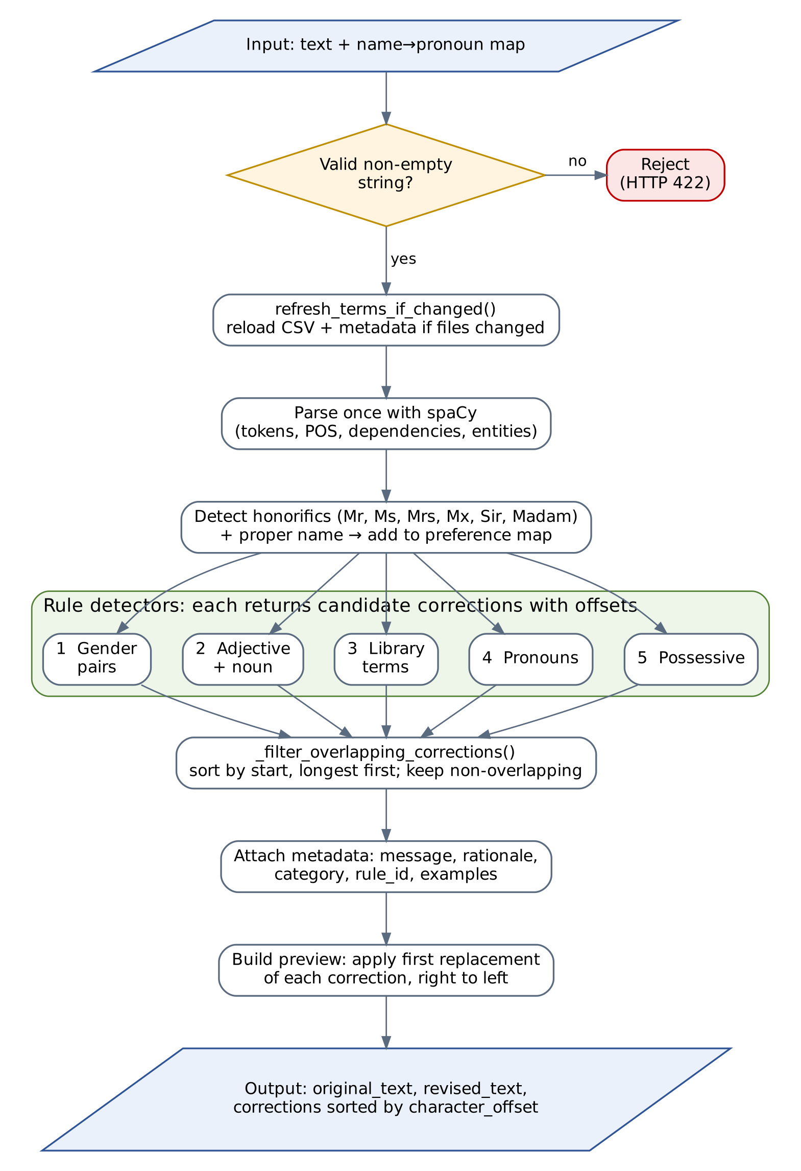
Figure 8. Flowchart of the gender-fair language checker.

2.9 Data and storage model
Inkclusive has no relational database. Persistent state is split between server-side files (terms, counter, admin credentials) and browser storage (draft, history). Corrections and tokens are transient objects created per request.
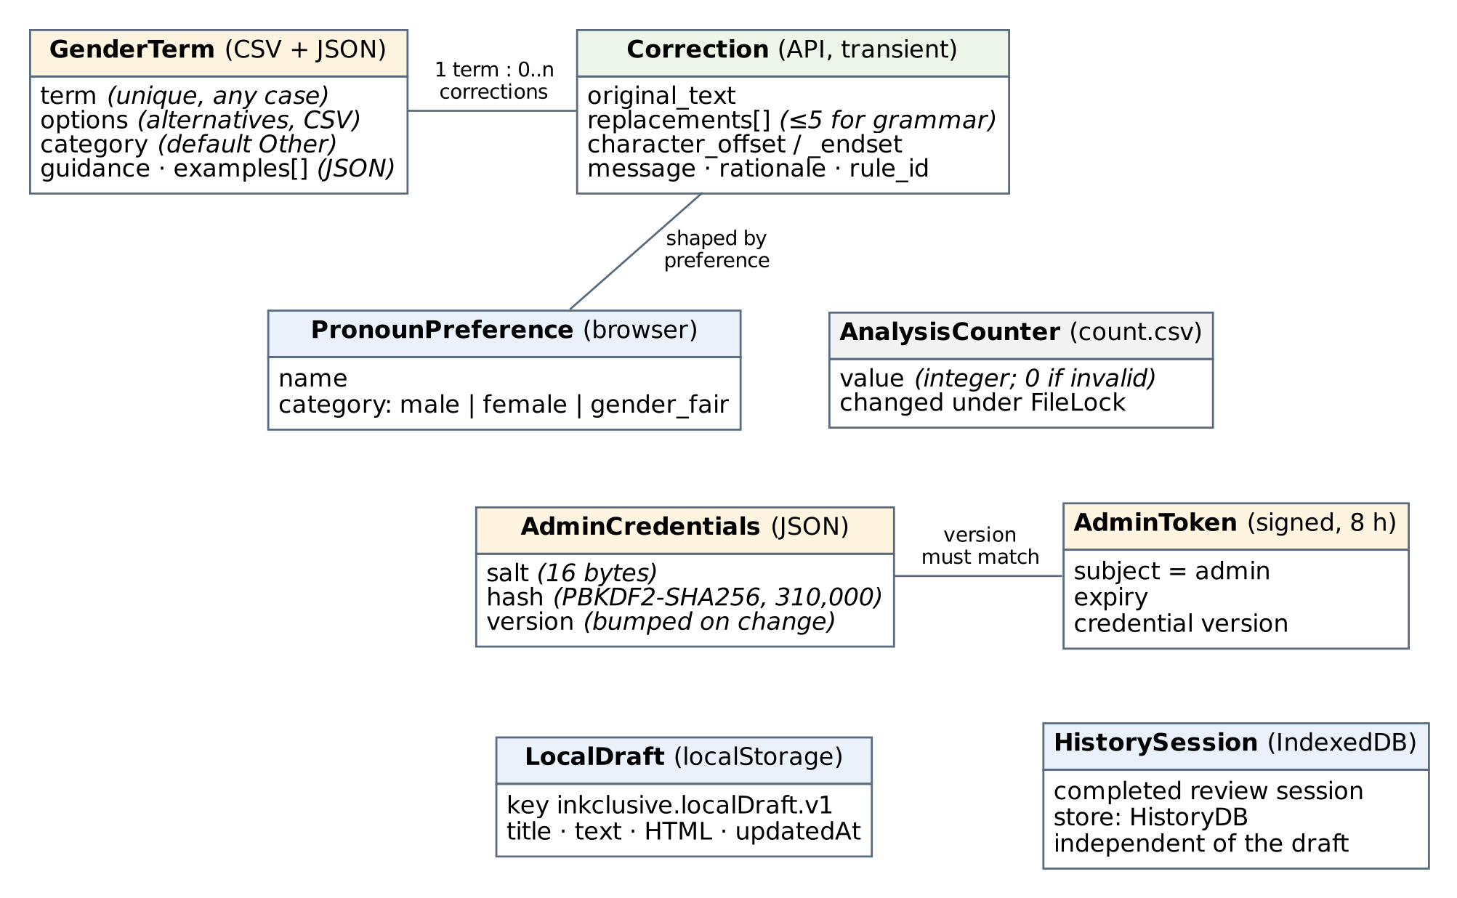
Figure 9. Records and where each is stored.

Part 3. Frontend README
Inkclusive is an inclusive-writing assistant built with SvelteKit, TypeScript, and a separate FastAPI service. Writers can edit text, scan a document into the editor, review grammar and gender-fair language suggestions, apply changes selectively, and export their work.

How the system works
- Write or import text. The ProseMirror editor stores the current title and text in Svelte stores. On the Scan page, the browser extracts text from PDFs with PDF.js and images with Tesseract.js; DOCX files are sent to a SvelteKit endpoint that extracts plain text with Mammoth.
- Autosave a local draft. The editor saves the current title, text, and formatted HTML to browser localStorage after a short pause in typing. If the editor opens with no current text, it restores the last non-empty draft. No account or login is required. Drafts are local to the current browser and device; clearing browser storage removes them. This autosave is separate from the session History page, which stores completed review sessions in IndexedDB.
- Run the checks. The client sends the text to the FastAPI /api/v1/grammar endpoint and then /api/v1/gfl. LanguageTool supplies grammar messages and replacement options; internal rule identifiers remain available to the API for diagnostics but are hidden from writers. The gender-fair checker uses its term list, pronoun preferences, and optional admin guidance to produce alternatives and explanations.
- Review suggestions. Each finding is attached to a source range and includes its explanation when available. A writer can apply one replacement, ignore a finding, or apply all suggestions. The editor updates its text and formatted HTML as changes are made.
- Save or export. Review sessions can be revisited from browser history. The editor can export supported document formats using the client-side document utilities.

Main routes and services
- /write - write, format, autosave, and review suggestions.
- /scan - extract text from PDF, DOCX, JPG, JPEG, and PNG files, with status, error, and cancel feedback.
- /history - view or clear review sessions saved in browser IndexedDB.
- /admin - manage term alternatives, categories, guidance, and examples; import or export the library as CSV.
- SvelteKit /api/extract/*, /api/docx, and /api/admin/* - server endpoints for extraction/export helpers and protected admin sessions.
- FastAPI /api/v1/grammar, /api/v1/gfl, /api/v1/count, and /api/v1/terms/* - versioned language analysis and term library API.
Admin sign-in is verified by the FastAPI backend. Term-management requests are proxied through same-origin SvelteKit endpoints, which keep the expiring backend token in an HttpOnly cookie. Configure ADMIN_PASSWORD and a random ADMIN_TOKEN_SECRET of at least 32 bytes on the backend, plus PUBLIC_BACKEND_URL for the frontend. Admins can change their password from the admin header; the backend stores a salted hash in ADMIN_CREDENTIALS_FILE (default ./admin_credentials.json), so point it at persistent storage when deploying.
The former /dashboard/editor, /dashboard/scan, and /dashboard/history URLs redirect to /write, /scan, and /history respectively.

Local data and privacy
- Draft recovery: one current draft is stored in localStorage under inkclusive.localDraft.v1. It is not uploaded automatically, synchronized between devices, or backed up by an account.
- History: writing sessions are stored in browser IndexedDB (HistoryDB). Clearing this history is independent of the current autosaved draft.
- Analysis: grammar and gender-fair checks send text to the configured FastAPI backend. Imported DOCX text is processed by the SvelteKit server endpoint. Configure deployments and privacy notices accordingly.
- Term metadata: the backend keeps the existing gendered_terms.csv format for compatibility with its checker and saves categories, usage guidance, and examples in gendered_terms_metadata.json.

Setup
Use Node.js 20 or newer. Set PUBLIC_BACKEND_URL to the FastAPI base URL; a trailing slash is optional.
npm ci
npm run dev

The dev server normally runs at http://localhost:5173. For backend setup and API details, see the backend README (../inkclusive-backend/README.md).

Commands
npm run check # Svelte and TypeScript diagnostics
npm run build # production build
npm run preview # serve the production build locally
npm test # Vitest unit tests
npm run lint # ESLint and Prettier checks

The client uses Tailwind CSS 4 through its Vite plugin, the SvelteKit Netlify adapter, ProseMirror, TanStack Table, Zod, PDF.js, Tesseract.js, Mammoth, and jsPDF. Tailwind setup is in vite.config.ts, src/app.css, and tailwind.config.ts.

Configuration
Variable | Purpose
PUBLIC_BACKEND_URL | Browser-visible base URL of the FastAPI service; a trailing slash is optional.
ADMIN_PASSWORD | Set on the backend; used by the API to authenticate admin sign-in.
ADMIN_TOKEN_SECRET | Set on the backend; random secret of at least 32 bytes used to sign expiring admin tokens.

Netlify uses npm run build; its adapter output is configured in netlify.toml.

Setup
Use Node.js 20 or newer. Set PUBLIC_BACKEND_URL to the backend base URL; a trailing slash is optional. Configure admin credentials on the backend as described in its README.
npm ci
npm run dev

The dev server normally runs at http://localhost:5173. For local backend setup, see the backend README (../inkclusive-backend/README.md).

Commands
npm run check # Svelte and TypeScript diagnostics
npm run build # production build
npm run preview # serve the production build locally
npm test # Vitest unit tests
npm run lint # ESLint and Prettier checks

The app uses Tailwind CSS 4 through its Vite plugin, SvelteKit's Netlify adapter, ProseMirror, TanStack Table, Zod, PDF.js, Tesseract.js, Mammoth, and jsPDF. Tailwind's project setup is in vite.config.ts, src/app.css, and tailwind.config.ts, following the Tailwind SvelteKit guide (https://tailwindcss.com/docs/installation/framework-guides/sveltekit).

Configuration
Variable | Purpose
PUBLIC_BACKEND_URL | Base URL of the FastAPI server; a trailing slash is optional. The browser uses same-origin SvelteKit proxy routes for admin requests.
ADMIN_PASSWORD | Configure on the backend only; it is checked by the backend admin login endpoint.
ADMIN_TOKEN_SECRET | Configure on the backend only; random secret of at least 32 bytes used to sign admin session tokens.

The Netlify build uses npm run build and publishes the adapter output as configured in netlify.toml.

Part 4. Backend README (API server)
This FastAPI service processes writing checks and stores the gender-fair term rules used by Inkclusive. The SvelteKit web client lives in ../inkclusive-frontend/.

API v1
New clients should use the versioned /api/v1 routes. Interactive docs are available at /docs and the OpenAPI schema at /openapi.json.
Method | Route | Purpose
GET | /api/v1/health | Basic service health response.
POST | /api/v1/grammar | Grammar suggestions and corrected text.
POST | /api/v1/gfl | Gender-fair suggestions, taking an optional pronoun_map.
GET | /api/v1/count | Read the analysis counter.
POST | /api/v1/admin/login | Verify the admin password and issue an expiring bearer token.
POST | /api/v1/admin/change-password | Change the password for the authenticated admin.
GET | /api/v1/terms | List full term records.
GET | /api/v1/terms/{term} | Read a term, case-insensitively.
POST | /api/v1/terms | Create a term; returns the created record.
PATCH | /api/v1/terms/{term} | Update the supplied alternatives and/or metadata fields.
DELETE | /api/v1/terms/{term} | Delete one term; returns 204.
POST | /api/v1/terms/bulk | Create 1–500 terms in one validated operation.
DELETE | /api/v1/terms | Delete a list of terms in one operation.

Analysis bodies accept up to 20,000 characters. Grammar responses include the original and revised text plus correction offsets, explanatory messages, rule identifiers, and replacements. Offsets refer to the submitted text exactly; leading and trailing whitespace is preserved. Term mutations return validation errors as 422, duplicate terms as 409, and missing terms as 404. Analysis routes return 429 with a Retry-After header when the per-process limit of 10 analysis requests per 30 seconds is reached; unavailable analyzers return 503.
Example request bodies:
{"prompt":"The chairman shared his report."}

{"prompt":"The chairman shared his report.","pronoun_map":{"Alex":"gender_fair"}}

{"term":"chairman","options":["chairperson","chair"],"category":"Job title",
"guidance":"Use a role name when gender is not relevant.",
"examples":["The chair opened the meeting."]}

The previous unversioned routes remain as compatibility aliases but are omitted from OpenAPI. The unversioned GET /terms keeps its older term-to-options response. The old count mutation route has been removed; the analysis counter is read-only over HTTP.

Request flow and storage
The web client posts the current document text to /api/v1/grammar, reviews those corrections, and then posts it to /api/v1/gfl with any name and pronoun preferences. The client uses each correction's character range to apply a chosen replacement to the editor. LanguageTool performs grammar analysis; main_gfl.py uses spaCy and the configured term CSV for gender-fair pattern detection.
main.py defines the HTTP endpoints and per-client rate limiter. schemas.py validates request bodies. csvCrud.py reads and writes gendered_terms.csv, with one term and its alternatives per row. Additional term category, guidance, and example metadata is stored in gendered_terms_metadata.json so the CSV remains readable by the checker. count.py manages count.csv.
The term CSV and metadata JSON must be backed up together. The frontend's local draft is stored in the user's browser and is not sent to this service unless the user runs a language check.

Local setup
Use Python 3.10 or newer and Java 17 or newer for the local LanguageTool server (see the language_tool_python requirements: https://pypi.org/project/language_tool_python/). From the project root, open PowerShell and run these commands the first time you set up the backend:
cd inkclusive-backend
python -m venv .venv
.venv\Scripts\Activate.ps1
pip install -r requirements.txt
python -m spacy download en_core_web_sm

Create a private .env file in inkclusive-backend with these values. The backend loads this file when it starts, and .env is excluded from Git:
ADMIN_PASSWORD=choose-a-long-unique-password
ADMIN_TOKEN_SECRET=paste-a-generated-secret-here
# Optional: store password changes in persistent storage (defaults to ./admin_credentials.json)
ADMIN_CREDENTIALS_FILE=./admin_credentials.json

Generate a secret once with python -c "import secrets; print(secrets.token_urlsafe(48))" and paste the output as ADMIN_TOKEN_SECRET. Keep reusing the same secret across restarts; changing it immediately expires existing admin sessions.
ADMIN_PASSWORD is the initial admin password. After signing in, use Change password in the admin header to save a new password as a salted PBKDF2 hash in ADMIN_CREDENTIALS_FILE. The file takes precedence over ADMIN_PASSWORD for later sign-ins, and changing the password expires existing admin sessions. The default file is in the backend working directory; configure this path to a persistent volume when deploying to a host with temporary container storage, or the changed password will be lost when that storage is replaced. Keep the credentials file private and back it up securely.
You only need to create the virtual environment, install dependencies, and download the spaCy model once per environment. To run the backend on later occasions, open PowerShell in the inkclusive-backend folder and run:
.venv\Scripts\Activate.ps1
uvicorn main:app --reload --host 0.0.0.0 --port 8000

Keep that terminal open while using the app. Activate the environment again in each new terminal. Repeat the setup commands only if you delete or recreate .venv, or when project dependencies change.
On macOS or Linux, activate the environment with source .venv/bin/activate instead.
The API is available at http://localhost:8000; FastAPI's interactive documentation is at /docs.

Docker
From this directory, create the .env file described above, then run:
docker compose up --build

Compose passes these values to the container and maps host port 8000 to port 80. Keep the .env file private and out of version control.

Important deployment note
All term-library endpoints, including legacy aliases, require a valid admin bearer token. The admin login is rate-limited to five failed attempts per client IP every 15 minutes. Tokens expire after eight hours. The frontend keeps the token in an HttpOnly, same-site cookie and proxies admin requests to the backend, so browser scripts cannot read the token.
Configure these backend environment variables before enabling admin management:
ADMIN_PASSWORD=<a long, unique admin password>
ADMIN_TOKEN_SECRET=<a random secret of at least 32 bytes>

Generate a token secret locally with python -c "import secrets; print(secrets.token_urlsafe(48))". Set the same backend URL in the frontend's PUBLIC_BACKEND_URL. In production, serve the frontend and backend over HTTPS and set CORS_ORIGINS to trusted frontend origins. CORS is not a replacement for authentication.
Set CORS_ORIGINS to a comma-separated list of trusted web origins in production. It defaults to * for local development and does not enable credentialed requests. CORS allows the ngrok-skip-browser-warning header used by the frontend for tunneled API requests. The in-memory analysis rate limit is per worker process; use a shared rate limiter when deploying multiple workers.
The term CSV, term metadata JSON, and count CSV files are the current storage layer. Back them up together if their contents need to survive container replacement; the Compose bind mount keeps the backend directory available to the container.

Part 5. Algorithm and function guide
This guide follows a document from editor input through analysis and back to an applied edit. It also describes the backend support functions and the key frontend conversion functions. Generated UI primitives, Svelte lifecycle callbacks, and declarative store definitions are not algorithms; their roles are summarized at the end.

1. Main analysis flow
The application has two independent analysis passes. The grammar pass delegates to LanguageTool. The gender-fair language (GFL) pass combines fixed phrase rules, a configurable term list, and pronoun rules. Neither pass automatically edits the document: each returns candidate corrections with character offsets. The writer chooses which correction to apply.
Analysis flow
Editor text → choose analysis pass
Grammar: LanguageTool matches → correction objects
GFL: spaCy parse and title preferences → pair, term, adjective+noun, pronoun, and possessive rules → keep non-overlapping candidates → correction objects
Correction objects → suggestion panel → writer chooses replacement
Map text offsets to ProseMirror positions → replace document text and preserve formatting

The GFL result's revised_text is a preview formed by taking the first alternative for every surviving correction. The editor still uses the separate correction list for interactive edits. Applying a correction uses its original-text offsets, so offsets must match the text sent for analysis.

2. Gender-fair checker (main_gfl.py)

Data and setup
- DEFAULT_PRONOUNS maps each category (male, female, gender_fair) to subject, object, possessive, and reflexive forms.
- GENDER_ADJECTIVES contains gendered modifiers used by the adjective+noun rule.
- GENDER_PAIRS maps paired gendered nouns or pronouns to candidate neutral expressions.
- nlp = spacy.load('en_core_web_sm') loads the English pipeline once when the module starts. spaCy supplies token boundaries, parts of speech, dependency roles, and named entities; it does not decide whether a phrase is socially appropriate.

GenderFairLanguage methods
Function | Purpose and algorithm
__init__(terms_csv) | Stores the CSV path; loads term alternatives and JSON guidance metadata; records file modification times so later requests can detect admin edits.
_get_source_signature() | Returns modification times (or None) for the term CSV and companion metadata JSON.
refresh_terms_if_changed() | Compares current file times with the saved signature. If either changed, reloads alternatives and metadata, then updates the signature.
_load_and_prioritize_terms(csv_filename) | Reads each CSV row as a term plus alternatives, lowercases terms, drops empty terms/options, and orders terms by descending word count. Longer phrases have priority during detection.
_adjust_capitalization(original, replacement) | Keeps a replacement's explicit capitalization if it has uppercase characters; otherwise mirrors all-uppercase, title case, or lowercase from the original.
_is_within_quotes(doc, start_idx, end_idx) | Counts unescaped double quotes on both sides of a span. Treats it as quoted only when both boundaries are inside a paired quote. Several detectors skip such text.
_process_text_replacements(text, name_pronoun_map) | Parses text once with spaCy. Detects honorifics (Mr, Ms, Mrs, Mx, Sir, Madam) followed by proper-name tokens and adds inferred categories to the preference map. Runs each rule detector, resolves overlaps, attaches metadata, then applies the first replacement of each correction from right to left so earlier offsets stay valid. Returns preview text and correction records.
_normalize_hyphenated_name(name) | Removes spaces around hyphens and trims a name, allowing variants such as Ada-Lovelace to match consistently.
_get_pronoun_role(token) | Uses spaCy dependency tags / PRP$ to choose subject, object, possessive, or reflexive form. Defaults to subject when the parse has no recognized role.
_find_gender_pairs(text, doc) | Searches case-insensitively for each configured pair in either order, allowing simple s/es endings and and/or. For or, attempts to singularize plural alternatives. Skips quoted matches, preserves capitalization, and returns span-based suggestions.
_find_adjective_noun_pairs(text, doc) | Scans adjacent spaCy tokens. If a token is in GENDER_ADJECTIVES and the next token is a noun, proposes alternatives for the noun from the term library (or the noun itself if no term exists). The full adjective+noun span is highlighted; quoted spans are skipped.
_find_individual_terms(text, doc) | For each prioritized library term, performs a case-insensitive whole-word/whole-phrase regex search. Removes alternatives identical to the matched text, skips quoted matches, adjusts case, and emits offsets and alternatives.
_find_pronoun_replacements(text, doc, name_pronoun_map) | For a gender-marked pronoun token (PRP/PRP$), skips neutral pronouns and quoted spans. Searches up to 10 preceding tokens for a mapped proper name, then falls back to prior PERSON/ORG entities. Uses that category's pronouns when found; otherwise uses singular-they forms. Keeps case and emits a one-word correction.
_find_possessive_constructions(text, doc) | For a token in GENDER_ADJECTIVES, checks for a possessive 's dependency child. If found, suggests deleting the possessive phrase and following space, unless quoted.
_filter_overlapping_corrections(corrections) | Sorts by start offset ascending and, for equal starts, longest end first. Greedily keeps a candidate only if its start is at or after the end of the last kept span. This ensures the same characters are not replaced twice.
process_text(text, name_pronoun_map=None) | Rejects empty/non-string input, runs _process_text_replacements, and returns original text, first-option preview, and valid corrections sorted by character offset.

load_gfl(csv_path) is the factory that constructs a GenderFairLanguage instance.

Correction object
Each correction records original_text, replacements, character_offset, and character_endset (exclusive end offset). Some rules also include word_index. The API adds message, rationale, category, rule_id, and examples from the metadata JSON. A term metadata match uses GFL_TERM_LIBRARY; otherwise the rule ID is GFL_LANGUAGE_PATTERN.

3. Grammar analysis and HTTP API (main.py)
Function | Purpose
AnalysisRateLimitMiddleware.dispatch(request, call_next) | For grammar/GFL POST paths, retains timestamps less than 30 seconds old per client IP. Rejects a request when there are already 10 in the window and returns a Retry-After; otherwise records it and forwards the request.
require_admin(credentials) | Validates a bearer token with verify_admin_token; raises HTTP 401 when absent or invalid. Used as a dependency on term mutations/reads.
admin_login(payload, request) | Requires password and token-secret configuration; checks failed attempts per IP within 15 minutes (limit 5), verifies the password, clears failures on success, and issues an expiring token.
admin_change_password(payload, _admin) | Requires the bearer dependency, changes credentials, maps invalid current password to HTTP 400 and save failures to 503.
health_check() | Returns a static service health/version object.
_grammar_revision(body) | Locks the shared LanguageTool instance, checks the submitted text and makes LanguageTool's corrected preview. Converts each match into bounded start/end offsets, original snippet, message/category/rule ID, and at most five replacement options. Service errors become HTTP 503.
grammar_revision(body) | Versioned and legacy HTTP wrapper returning _grammar_revision.
gender_fair_revision(body) | Locks term refresh and GFL processing, increments the persistent analysis counter, and returns the counter with checker results. Invalid text maps to 422; analyzer failures map to 503.
list_all_terms_legacy() / list_all_terms() | Under the terms lock, returns the term library in the legacy dictionary shape or current record-list shape.
list_term_records_legacy() | Compatibility route returning the record-list shape.
get_term_legacy(term) / get_term(term) | Case-insensitive lookup; returns the legacy term/options object or full record, or HTTP 404.
_create_term(term_data) | Creates one term under lock and reads back its record. Duplicate terms become HTTP 409. create_term_legacy and create_term are route wrappers with legacy/current response shapes.
_update_term(term, update_data) | Finds a term, retains old alternatives if options were omitted, updates supplied metadata fields, and returns the refreshed record. Missing terms map to HTTP 404. update_term_legacy, update_term, and patch_term are PUT/PATCH wrappers.
_delete_term(term) | Deletes one term under lock; maps missing terms to HTTP 404. delete_term_legacy and delete_term are route wrappers.
_create_terms_bulk(payload) | Converts validated request records into GenderTerm objects, creates them atomically at the manager level under lock, and returns the created count; duplicates map to 409. Legacy/current route wrappers delegate to it.
delete_terms_bulk(payload) | Deletes validated terms under lock and returns the count; if any requested term is missing it returns HTTP 404.
get_count_request() | Reads and returns the current count.

Pydantic models in schemas.py validate request and response structure before route functions run. GrammarBody.reject_blank_prompt rejects all-whitespace prompts. GenderTermCreate.clean_term, clean_options, and clean_examples trim and discard blank values; update validators do likewise and require_an_update requires at least one supplied field. GenderTermBulkDelete.clean_terms trims and deduplicates case-insensitively only as exact cleaned strings (the current implementation uses insertion-order string deduplication). Other model fields enforce lengths, counts, and allowed pronoun categories.

4. Term library and count storage

csvCrud.py
GenderTerm is the in-memory record: term, alternatives, category, guidance, examples. GenderTermManager.__init__ stores the CSV and derives a sibling _metadata.json path. _metadata reads that JSON and returns an empty object if missing or malformed; _save_metadata writes formatted UTF-8 JSON. load combines CSV alternatives with optional metadata, defaulting category to Other. save rewrites CSV rows.
create strips and checks a case-insensitive duplicate before appending and writing the CSV and metadata. create_many checks duplicates against existing and incoming terms before saving all rows and metadata. find_term returns the legacy term-to-options mapping; find_record returns one full record case-insensitively. update replaces alternatives and only the metadata fields explicitly supplied. delete removes a single case-insensitive match from both files. delete_many verifies every requested term exists before writing, removes them from both files, and returns the count. get_all_term returns the legacy mapping; get_all_records returns full records.

count.py
FileLock.acquire repeatedly creates a lock directory until successful or timeout; release removes it. __enter__ / __exit__ make that lock usable with with. read_counter reads an integer and uses zero for missing, empty, or invalid data. update_counter locks, reads, adds a delta, writes a process-specific temporary file, and atomically replaces the counter file; cleanup removes a leftover temporary file. increment_counter and decrement_counter call it with +1 and -1. FileLockTimeout represents lock acquisition timeout.

5. Admin authentication (admin_auth.py)
_credentials_path selects the configured JSON file. _read_credentials safely loads it or returns an empty record. _write_credentials writes a temporary file in the same directory, flushes it, atomically replaces the target, attempts restrictive permissions, and cleans leftovers. _password_hash uses a random 16-byte salt and PBKDF2-HMAC-SHA256 (310,000 iterations). _encode / _decode convert URL-safe base64 without/with restored padding. verify_admin_password prefers the stored salted hash and uses constant-time comparison; otherwise it checks ADMIN_PASSWORD. has_admin_password checks whether either source is configured. _credential_version returns the stored integer version or zero. change_admin_password verifies the current password, stores a new salt/hash, and increments the credential version. create_admin_token creates a signed payload with admin subject, 8-hour expiry, and credential version. verify_admin_token checks signature, subject, expiry, and current version; changing the password invalidates old tokens.

6. Frontend request, offsets, and edits
- getSavedPronounPreferenceMap() reads saved name/pronoun preferences and builds the map sent to GFL analysis.
- grammarCheckService(nextSlide) posts editor text to /grammar, stores the preview, converts returned corrections to TSuggestion records, filters ignored grammar snippets, updates the suggestions store, advances progress, and shows a toast on failure.
- glfCheckService(nextSlide) posts editor text and pronoun preferences to /gfl, maps corrections to suggestions, advances progress, and refreshes the displayed count.
- getCount() reads /count, validates the response is JSON, and updates countStore.
- replaceWordInDocument(editorState, dispatch, suggestion) converts analysis offsets into ProseMirror positions, checks bounds, collects text formatting marks over the selection, deletes the old span, and inserts the chosen replacement. If the selection crosses multiple formatting segments, it distributes replacement characters proportionally and preserves each segment's marks. It dispatches only when the document changed and synchronizes plain text in the store.
- convertTextOffsetsToDocPositions(doc, start, end) walks ProseMirror text nodes while accumulating plain-text lengths and translates both offsets into document positions; returns null if either offset cannot be mapped.
- computeHighlightDecorations (in LinterPlugin.ts) maps suggestions onto editor ranges and creates decorations for highlighted text; createLinterPlugin installs those decorations in ProseMirror.

7. Other document workflows and utilities
These functions support importing, exporting, and the UI rather than deciding GFL matches.
- filterTokenizedText(items) removes selected emoji/artifact characters, normalizes spacing, groups PDF text items whose vertical coordinates are within two units, orders lines top-to-bottom, and joins them with newlines.
- getPageText(pdf, pageNo) gets one PDF page's text content and passes its items through that filter.
- getTextFromPDF(file, signal) validates file presence/type, reads bytes, loads PDF.js, extracts all page texts concurrently, checks cancellation between stages, and joins pages. It destroys the PDF loading task on cancellation/finalization.
- ocrToText(file, language, signal) runs Tesseract OCR with the chosen language and cancellation signal; returns recognized text (see implementation for worker cleanup/error behavior).
- convertDragToFile / convertInputToFile obtain the first file from a drop/input event. getSuffix extracts and validates the supported document suffix. dragOverHandler prevents the browser's default drag-over behavior.
- buildInputRules(schema) creates ProseMirror input rules from the editor schema. createDocFromText(text) turns plain text into a ProseMirror document using the app's schema.
- highlightWords(words, view) creates/dispatches editor decorations for the supplied word ranges.
- exportStateAsPDF(state) serializes editor content for PDF output. API route handlers under routes/api validate multipart/request data and invoke PDF, image, DOCX extraction/export libraries.
- readLocalDraft, writeLocalDraft, and clearLocalDraft load, save, and remove the versioned browser-local draft; writes include an update timestamp and report storage failure.
- Admin frontend service functions (toPayload, getTermRecords, postBulkList, putList, deleteListItem, bulkDeleteListItem) translate form data to API payloads and call the corresponding term endpoints. Server handlers proxy admin calls and manage the HttpOnly session cookie; page load functions mostly redirect or initialize route data.
- cn joins/merges CSS class values; getWordIndices locates word occurrences in a string. Carousel/data-table helpers (setEmblaContext, getEmblaContext, renderComponent, renderSnippet, createSvelteTable, mergeObjects) adapt library state/components and are UI infrastructure.
Svelte stores (textContent, aiSuggestions, revisedTextStore, countStore, progress/preferences and related stores) are observable state containers, not standalone algorithms. UI component event handlers render views and call the services above. There are also test-local helper functions that only build fixtures or reproduce a small behavior for tests.

8. Important implementation notes for documentation accuracy
- main_gfl.py currently defines _find_pronoun_replacements twice. Python keeps the later definition (the one near the end of the file); the earlier definition is overwritten and never called. The later implementation's neutral-pronoun set also includes "'s".
- Title-derived preferences are inserted into the provided name map in lower case. Explicit client preferences and inferred titles therefore feed the same pronoun resolution path; a later occurrence of an unrecognized pronoun referent falls back to singular they.
- Pronoun replacement is heuristic: it associates pronouns with a mapped proper name within ten prior tokens, then tries prior PERSON/ORG entities. It is not full coreference resolution and may miss or misattribute references.
- The overlap resolver is greedy by source order and longest span at a shared start. If one candidate begins inside a previously accepted candidate, it is dropped. This is the conflict policy, not a semantic ranking of suggestions.
- The current term matching uses \b around the configured phrase. This works for ordinary words and many phrases but can behave unexpectedly for terms beginning/ending with punctuation. CSV and metadata JSON should be backed up together.

Documentation addendum: libraries and language tools
This addendum maps the main project libraries to their roles and shows representative analysis requests. It supplements the frontend and backend README material above.

Frontend libraries
Svelte 5, SvelteKit, Vite, TypeScript, and the Netlify adapter build and serve the interface and its server routes. ProseMirror packages provide the rich-text editor, schema, formatting commands, undo/redo, decorations, and range-based text edits.
PDF.js (pdfjs-dist) extracts selectable text from PDFs; image-only PDF pages need OCR and are not OCRed by PDF.js. Tesseract.js recognizes text in supported image uploads. Mammoth extracts DOCX text. jsPDF and html-to-docx create PDF and DOCX exports.
TanStack Table powers the admin term table. Zod and SvelteKit Superforms validate term-entry forms. Bits UI and Formsnap provide UI/form primitives; Tailwind CSS and its plugins style the app. Lucide supplies icons, Sonner supplies toast notifications, Embla powers carousels, Driver.js provides the guided tour, mode-watcher manages theme preference, and date-fns formats history dates.
Vitest and jsdom support unit tests; ESLint, Prettier, and svelte-check support linting, formatting, and Svelte/TypeScript diagnostics. These development tools do not analyze user writing.

Grammar example: LanguageTool
The backend uses language-tool-python to call a local LanguageTool service. LanguageTool returns grammar matches and candidate replacements; main.py maps them to Inkclusive correction records with character ranges, messages, categories, rule identifiers, and replacements. The exact message and candidates depend on the installed LanguageTool version.
Request: POST /api/v1/grammar with JSON body {"prompt":"She go to school."}.
Representative response: {"original_text":"She go to school.","revised_text":"She goes to school.","corrections":[{"character_offset":4,"character_endset":6,"original_text":"go","message":"Grammar explanation from LanguageTool","rationale":"Grammar explanation from LanguageTool","category":"GRAMMAR","rule_id":"RULE_ID_FROM_LANGUAGETOOL","replacements":["goes"]}]}.

Gender-fair example: spaCy and Inkclusive rules
The backend loads spaCy with en_core_web_sm. Its tokenization, part-of-speech tags, dependency labels, and named entities support Inkclusive detectors; spaCy does not generate the suggestions. Inkclusive applies its own configured term phrases, gendered word-pair rules, adjective+noun patterns, pronoun substitutions, and possessive-construction rules.
Request: POST /api/v1/gfl with JSON body {"prompt":"Alex said he would bring his notes.","pronoun_map":{"Alex":"gender_fair"}}.
Representative result: ?Alex said they would bring their notes.? Corrections identify ?he? (characters 10?12) and ?his? (characters 25?28), and include alternatives plus rationale/category metadata. The response also includes the current GFL analysis count.
The checker uses the first replacement to build revised_text; the editor lets the writer review and apply suggestions by character range. Pronoun association is heuristic, and phrase/pair rules do not fully understand context, so suggestions should be reviewed.

Backend supporting libraries
FastAPI defines the HTTP API, Uvicorn serves it, Pydantic validates request and response bodies, and python-dotenv loads local environment configuration. language-tool-python provides grammar matches; spaCy and en_core_web_sm support the gender-fair rules. Java 17 or newer is required by the local LanguageTool server.

