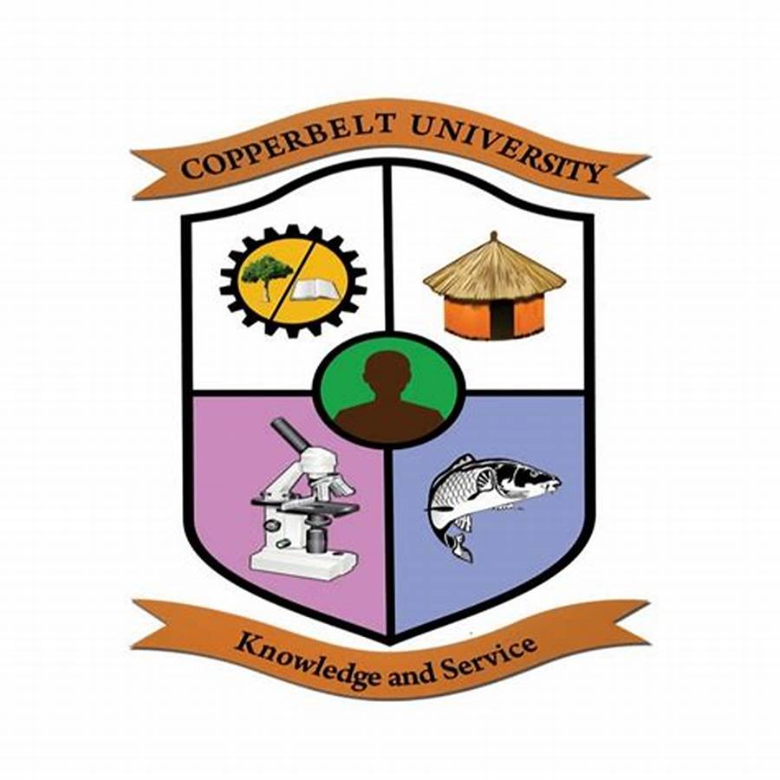

THE COPPERBELT UNIVERSITY
SCHOOL OF HUMANITIES AND SOCIAL SCIENCES
DEPARTMENT OF DEVELOPMENT STUDIES

SIN NO: 24158418
COURSE: SOCIAL SCIENCE
COURSE CODE: DS 130
LECTURER: MR NHERERA
YEAR: 1
DUE DATE: 08/04/25

QUESTION

DISCUSS THE IMPLICATION OF GLOBALIZATION FOR NATIONAL SOVEREINGTY AND ECONOMIC DEVELOPMENT?
Introduction
it is one of the most vital phenomena in the world today and that is globalization. It refers to the manner in which states, businesses, and cultures tend to become interdependent and connected. Globalization has reached each and every corner of human life, from the political to culture to money matters. Though it has created multiple opportunities, it has also raised very critical issues concerning national sovereignty and economic advancement. These two concepts national sovereignty and economic development form the core in achieving the complexities and challenges that globalization exposes countries all over the world to. In this essay, we shall discuss the implications of globalization to national sovereignty and economic development, such as how it affects the ability of countries to make independent choices and improve the quality of life of their citizens.
What is Globalization?
Globalization is the increased movement of goods, services, information, technology, ideas, and people across borders. It has been made possible by advances in communication, transport, and trade liberalization. As a result, countries that were once isolated are now linked in a global network. The economy of a country is now interdependent with the economies of other countries, and what happens in one corner of the globe can have significant impacts on other parts.
Globalization addresses several facets of life including trade, culture, politics, and social norms. For instance, companies can now conduct business in numerous countries, customers are able to access a variety of imported products, and ideas can spread very fast through the internet. Despite how these changes have triggered economic growth and accelerated cultural exchange, they threaten economic development and national sovereignty.
National Sovereignty in the Age of Globalization
National sovereignty is the authority of a nation to govern itself independently without interference from the outside. It is the belief that all nations possess the right to determine the way in which they will govern themselves, enact their own legislation, and apply their own policies. Globalization dissolves this belief on several fronts.
One of the main ways that globalization destroys national sovereignty is by way of multinational companies. Multinational companies with large operations in numerous countries have the ability to affect governments significantly. For example, multinational corporations can influence governments to pass laws that cater to their business interests. The corporations are wealthier and better endowed than the respective nations, which is something that governments cannot handle. Sometimes, governments may be forced to concession-making to the multinationals in order to attract investment or to maintain economic growth and thus have their ability for decision-making in the best interest of their people curtailed.
Moreover, international institutions like the United Nations, the International Monetary Fund (IMF), and the World Trade Organization (WTO) have an increasing role in shaping national policy. Global rules and regulations set by international institutions bind nations to adhere to them, at times inhibiting the ability of a nation to act unilaterally. For example, trade agreements entered into by a nation through the WTO obligate countries to open their markets to international products, which at times might conflict with the needs of local industries or protecting the environment.
Second, countries that are reliant on foreign aid or global loans may find themselves under pressure from donor countries or multilateral institutions to adopt specific economic or political strategies, which will not necessarily align with the preferences of the country. This is particularly prevalent in developing nations, where international investment and loans are crucial to the growth of the economy but come with strings that limit national sovereignty.
Globalization and Economic Development
Economic development is the process of improving the standard of living and quality of life in a country. It entails increasing income, poverty alleviation, improved health and education, and economic stability. Globalization can boost economic development but presents challenges as well.
Positive Impacts on Economic Development
Increased access to markets is one of the greatest strengths of globalization. With the fall in trade barriers and the cost of transportation, countries are now exporting their goods and services to the global market. This has also created new opportunities for business and allowed countries to specialize in those areas where they have a competitive advantage. For example, countries with plenty of natural resources can export these resources to countries that are short of resources, and countries with advanced technology or manufacturing capability can export their goods to an expanded market. Greater access to global markets has witnessed greater trade, and in most cases, economic growth.
Additionally, globalization has led to technology and knowledge transfers between countries. Companies and countries can now share innovations in science, medicine, engineering, and other fields that can improve productivity and well-being. For instance, the majority of developing countries have benefited from exposure to sophisticated methods of farming, which have led to increased food production and reduction of hunger. Globalization has also made it possible for countries to learn from each other's experiences in health, education, and infrastructure development.
In addition, globalization has enabled countries to attract foreign investment. Multinational corporations will invest in countries with lower labor costs or emerging economies, and this can create employment as well as increase economic growth. The investments can lead to the development of new industries, infrastructure, and services that boost the economy as a whole.
Negative Impacts on Economic Development
However, globalization also has its downsides when it comes to economic development. While some nations benefit from increased trade and investment, others may struggle to compete in a global market. Third-world countries, particularly, may struggle to compete with wealthier nations or multinational corporations that have more resources and advanced technology. As a result, some sectors in these countries may lag behind, leading to increasing inequality and economic imbalance.
Another issue is over-reliance on global markets. Countries too reliant on exporting or foreign investment can be vulnerable to economic setbacks in other parts of the world. For example, if the leading trading partner country experiences economic crisis, then it can have a negative impact on the economy of countries whose economy relies on exporting to such a country. This vulnerability can hamper long-term economic development and stability.
In addition, while jobs have been created through globalization, it has also led to the loss of employment in other sectors. For example, companies can relocate production to cheaper nations, leaving workers in higher-cost nations unemployed. This is referred to as "offshoring," and it has been an economic worry in most developed countries, particularly in manufacturing sectors.
Environmental and Social Impacts
Globalization also has strong environmental and social impacts that can affect economic growth. The rapid increase in global trade has resulted in environmental degradation, where industries may prioritize profit over the conservation of the environment. Deforestation, pollution, and climate change are all global issues that have been exacerbated by the heightened industrial activity and transportation associated with globalization.
Socially, globalization has the potential to bring about cultural homogenization, where global influences overshadow local customs, traditions, and identities. This erodes cultural diversity and can lead to tensions between global and local values.
Striking a Balance: Sovereignty, Development, and Globalization
In order to respond to the challenges of globalization, countries must weigh national sovereignty against the prospect and risk of international economic integration. As such, most countries have a tricky endeavor of balancing the equilibrium between local need and international forces.
Developing nations, particularly, need to move to ensure that globalization leads to sustainable and equitable development. This entails the establishment of policies that promote equitable trade, protect local industries, and ensure that benefits of globalization are distributed evenly. At the same time, these countries need to protect their sovereignty by ensuring that they retain the ability to make independent choices about their development patterns.
For developed countries, the challenge is how to avoid allowing too much dependence on global markets or weakening domestic industries. Governments can offset the undesirable effects of globalization by investing in education, technology, and infrastructure, and by ensuring that workers have the skills needed to compete in a global economy.

Multinational Corporation's (MNC) impact
MNCs sometimes have more influence than those of smaller states' governments. They can use their leverage on legislation, labor law, and environmental protection to serve their interests as commercial enterprises at the expense of democratic decision-making and local agenda.
Countries which become members of international or regional blocs (e.g., the European Union) willingly cede some sovereignty in order to participate in collective decision-making. While this may have benefits such as access to trade or peacekeeping, it also has the effect of having some domestic policy shaped or determined from outside.

Conclusion
Globalization is a strong force that has reshaped the world in many different ways with both positive and negative consequences. While it has the potential to trigger economic growth and development, it also has some risks to national sovereignty and economic stability. The greatest challenge for countries today is to find how to harness the positives of globalization and maintain their sovereignty while ensuring that economic development is sustainable and fair. That requires responsible policies, international coordination, and commitment to fairness and justice. In the end, how countries are able to navigate through globalization will determine whether or not they can thrive in an increasingly interconnected world.

References
1. Bhagwati, J. (2004). In Defense of Globalization. Oxford University Press.
2. Friedman, T. L. (2005). The World Is Flat: A Brief History of the Twenty-First Century. Farrar, Straus, and Giroux.
3. Giddens, A. (2009). The Politics of Climate Change. Polity Press.
4. Held, D., & McGrew, A. (2007). Globalization Theory: Approaches and Controversies. Polity Press.
5. International Monetary Fund (IMF) (2001). Globalization: Threat or Opportunity? International Monetary Fund.
6. Keohane, R. O., & Nye, J. S. (2000). Globalization: What's New? What's Not? (And So What?). Foreign Policy, 118, 104-119.
7. Piketty, T. (2014). Capital in the Twenty-First Century. Harvard University Press.
8. Rodrik, D. (2011). The Globalization Paradox: Democracy and the Future of the

