Date: - 28-02-2026

TO,
CUBE Highways Technologies Private Limited,
3rd Floor, GMR Aero Towers – 2,
Mamidipally Village, Saroor Nagar Mandal,
Ranga Reddy, Hyderabad, Telangana - 500108

GST No- 36AAKCC7533R1ZW
PAN No- AAKCC7533R

Sir,

Subject: Consultant fee for Feb- 2026 data processing & Analysis Rs.12,964/- per month. The commercials are mentioned below.

Particulars | No. of working  days in Feb'26 | WBS Elements | Payable Amount  (Rs.)
Consultant fee – Data Processing | 22 | DATL-SSA-TAR-ATA-HIRATE-MC-198 | 12,964
 | 22 | Total Pay | Rs. 12,964/-

Thanking you and always assuring you of our best services.

Yours faithfully

Authorised Signature
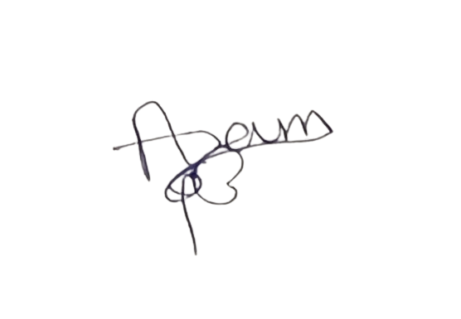

Service Provider: Ahmed Azam
Address: H.NO.17-2-1198/11/A,YAKUTPURA,HYDERABAD,TELANGANA,500023
Email- ahmedazam8341@gmail.com
Contact No. 8341808647
PAN No- DUWPA4934E

Bank details below:

Account-Name | Bank Name | Bank Account Number | IFSC Code
Ahmed Azam | Kotak Mahindra Bank | 2945621135 | KKBK0007474

Date: - 28-02-2026

TO,
CUBE Highways Technologies Private Limited,
3rd Floor, GMR Aero Towers – 2,
Mamidipally Village, Saroor Nagar Mandal,
Ranga Reddy, Hyderabad, Telangana - 500108

GST No- 36AAKCC7533R1ZW
PAN No- AAKCC7533R

Sir,

Subject: Consultant fee for Feb- 2026 data processing & Analysis Rs.16,500/- per month. The commercials are mentioned below.

Particulars | No. of working  days in Feb'26 | WBS Elements | Payable Amount  (Rs.)
Consultant fee – Data Processing | 28 | FRHL-SSA-TAR-ASA-E. NSV ANALYSIS-MC-147 | 16,500
 | 28 | Total Pay | Rs. 16,500/-

Thanking you and always assuring you of our best services.

Yours faithfully

Authorised Signature


Service Provider: Anand Ganesh Chopade
Address: Shraddha Nagar, Isarwadi, DIST: Aurangabad, Maharashtra - 431148.
Email- chopadeanand268@gmail.com
Contact No. 8010503913
PAN No- CTZPC5331C

Bank details below:

Account-Name | Bank Name | Bank Account Number | IFSC Code
Anand Ganesh Chopade | India Post Payments Bank | 31610122842 | IPOS0000001

Date: - 28-02-2026

TO,
CUBE Highways Technologies Private Limited,
3rd Floor, GMR Aero Towers – 2,
Mamidipally Village, Saroor Nagar Mandal,
Ranga Reddy, Hyderabad, Telangana - 500108

GST No- 36AAKCC7533R1ZW
PAN No- AAKCC7533R

Sir,

Subject: Consultant fee for Feb- 2026 data processing & Analysis Rs.15,911/- per month. The commercials are mentioned below.

Particulars | No. of working  days in Feb'26 | WBS Elements | Payable Amount  (Rs.)
Consultant fee – Data Processing | 14 | MSHPL-SSA-TAR-ATA-HIRATE-MC-343 | 8,250
 | 13 | BWHPL-SSA-TAR-ATA-HIRATE-MC-340 | 7,661
 | 27 | Total Pay | Rs. 15,911/-

Thanking you and always assuring you of our best services.

Yours faithfully

Authorised Signature


Service Provider: Arundathi Jalagam
Address: H.NO.4-56,PEDDAVANGARA,WARANGAL,TELANGANA,506317
Email- arundhathijalagam@gmail.com
Contact No. 9100150574
PAN No- DUQPA7064F

Bank details below:

Account-Name | Bank Name | Bank Account Number | IFSC Code
Jalagam Arundathi | SBI | 43626231188 | SBIN0020683

Date: - 28-02-2026

TO,
CUBE Highways Technologies Private Limited,
3rd Floor, GMR Aero Towers – 2,
Mamidipally Village, Saroor Nagar Mandal,
Ranga Reddy, Hyderabad, Telangana - 500108

GST No- 36AAKCC7533R1ZW
PAN No- AAKCC7533R

Sir,

Subject: Consultant fee for Feb- 2026 data processing & Analysis Rs.15,911/- per month. The commercials are mentioned below.

Particulars | No. of working  days in Feb'26 | WBS Elements | Payable Amount  (Rs.)
Consultant fee – Data Processing | 27 | NAMEL-SSA-TAR-ATA-HIRATE-MC-400 | 15,911
 | 27 | Total Pay | Rs. 15,911/-

Thanking you and always assuring you of our best services.

Yours faithfully

Authorised Signature
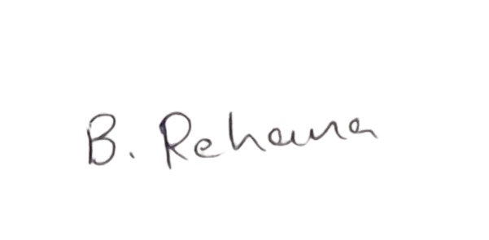

Service Provider: Bonagiri Rehana
Address: H.NO.3-52,DEVARVPPALA,WARANGAL,TELANGANA,506302
Email- rehanabonagiri@gmail.com
Contact No. 8639518077
PAN No- GEBPR8711A

Bank details below:

Account-Name | Bank Name | Bank Account Number | IFSC Code
Bonagiri Rehana | union bank | 12010100193495 | UBIN0801208

Date: - 28-02-2026

TO,
CUBE Highways Technologies Private Limited,
3rd Floor, GMR Aero Towers – 2,
Mamidipally Village, Saroor Nagar Mandal,
Ranga Reddy, Hyderabad, Telangana - 500108

GST No- 36AAKCC7533R1ZW
PAN No- AAKCC7533R

Sir,

Subject: Consultant fee for Feb- 2026 data processing & Analysis Rs.13,554/- per month. The commercials are mentioned below.

Particulars | No. of working  days in Feb'26 | WBS Elements | Payable Amount  (Rs.)
Consultant fee – Data Processing | 23 | DATL-SSA-TAR-ATA-HIRATE-MC-198 | 13,554
 | 23 | Total Pay | Rs. 13,554/-

Thanking you and always assuring you of our best services.

Yours faithfully

Authorised Signature


Service Provider: Chouta Keerthana
Address: H.NO.8-2-676/1/B/30/7/34,BanjaraHills,HYDERABAD,TELANGANA,500034
Email- kr089715@gmail.com
Contact No. 9059094535
PAN No- CHOPC1314A

Bank details below:

Account-Name | Bank Name | Bank Account Number | IFSC Code
Chouta Keerthana | IDBI | 1274104000131728 | IBKL0001274

Date: - 28-02-2026

TO,
CUBE Highways Technologies Private Limited,
3rd Floor, GMR Aero Towers – 2,
Mamidipally Village, Saroor Nagar Mandal,
Ranga Reddy, Hyderabad, Telangana - 500108

GST No- 36AAKCC7533R1ZW
PAN No- AAKCC7533R

Sir,

Subject: Consultant fee for Feb- 2026 data processing & Analysis Rs.15,321/- per month. The commercials are mentioned below.

Particulars | No. of working  days in Feb'26 | WBS Elements | Payable Amount  (Rs.)
Consultant fee – Data Processing | 26 | NAMEL-SSA-TAR-ATA-HIRATE-MC-400 | 15,321
 | 26 | Total Pay | Rs. 15,321/-

Thanking you and always assuring you of our best services.

Yours faithfully

Authorised Signature


Service Provider: Deshapaga Raghavendar
Address: H No. 1-82/1 Peddagolkonda,shamshabad,golkonda kalan,K.V Rangareddy,Telangana-501218
Email- raghavendardeshapaga8@gmail.com
Contact No. 9603899456
PAN No- EQSPR2228P

Bank details below:

Account-Name | Bank Name | Bank Account Number | IFSC Code
Deshapaga Raghavendar | INDIAN BANK | 6864847698 | IDIB000S169

Date: - 28-02-2026

TO,
CUBE Highways Technologies Private Limited,
3rd Floor, GMR Aero Towers – 2,
Mamidipally Village, Saroor Nagar Mandal,
Ranga Reddy, Hyderabad, Telangana - 500108

GST No- 36AAKCC7533R1ZW
PAN No- AAKCC7533R

Sir,

Subject: Consultant fee for Feb- 2026 data processing & Analysis Rs.16,500/- per month. The commercials are mentioned below.

Particulars | No. of working  days in Feb'26 | WBS Elements | Payable Amount  (Rs.)
Consultant fee – Data Processing | 28 | FRHL-SSA-TAR-ASA-E. NSV ANALYSIS-MC-147 | 16,500
 | 28 | Total Pay | Rs. 16,500/-

Thanking you and always assuring you of our best services.

Yours faithfully

Authorised Signature


Service Provider: Dhenumakonda Lavanya
Address: H No.2-83 S Rayavaram penugollu,Visakhapatnam,Andhra Pradesh-531055
Email- laoneyavarma@gmail.com
Contact No. 8978693988
PAN No- DDLPD4947Q

Bank details below:

Account-Name | Bank Name | Bank Account Number | IFSC Code
Dhenumakonda Lavanya | SBI | 31527922267 | SBIN0001955

Date: - 28-02-2026

TO,
CUBE Highways Technologies Private Limited,
3rd Floor, GMR Aero Towers – 2,
Mamidipally Village, Saroor Nagar Mandal,
Ranga Reddy, Hyderabad, Telangana - 500108

GST No- 36AAKCC7533R1ZW
PAN No- AAKCC7533R

Sir,

Subject: Consultant fee for Feb- 2026 data processing & Analysis Rs.13,554/- per month. The commercials are mentioned below.

Particulars | No. of working  days in Feb'26 | WBS Elements | Payable Amount  (Rs.)
Consultant fee – Data Processing | 23 | KTIPL-SSA-TAR-ATA-HIRATE-MC-348 | 13,554
 | 23 | Total Pay | Rs. 13,554/-

Thanking you and always assuring you of our best services.

Yours faithfully

Authorised Signature


Service Provider: Diravath Mounika
Address: H.NO.6-93 ,THIMMAPUR,KARIMNAGAR,TELANGANA,505527.
Email- mounikdiravath2110@gmail.com
Contact No. 9652682002
PAN No- IIHPM0467E

Bank details below:

Account-Name | Bank Name | Bank Account Number | IFSC Code
Diravath Mounika | SBI | 62254247607 | SBIN0020569

Date: - 28-02-2026

TO,
CUBE Highways Technologies Private Limited,
3rd Floor, GMR Aero Towers – 2,
Mamidipally Village, Saroor Nagar Mandal,
Ranga Reddy, Hyderabad, Telangana - 500108

GST No- 36AAKCC7533R1ZW
PAN No- AAKCC7533R

Sir,

Subject: Consultant fee for Feb- 2026 data processing & Analysis Rs.15,321/- per month. The commercials are mentioned below.

Particulars | No. of working  days in Feb'26 | WBS Elements | Payable Amount  (Rs.)
Consultant fee – Data Processing | 26 | FRHL-SSA-TAR-ASA-E. NSV ANALYSIS-MC-147 | 15,321
 | 26 | Total Pay | Rs. 15,321/-

Thanking you and always assuring you of our best services.

Yours faithfully

Authorised Signature


Service Provider: Gaja Bala Narayana
Address: H No. 3-23, Chandrakal,Nagakurnool,Telangana-509412.
Email- balanarayana0@gmail.com
Contact No. 9666662981
PAN No- BTLPB1602E

Bank details below:

Account-Name | Bank Name | Bank Account Number | IFSC Code
Gaja Bala Narayana | Karur Vysya Bank | 4875166000000916 | KVBL0004875

Date: - 28-02-2026

TO,
CUBE Highways Technologies Private Limited,
3rd Floor, GMR Aero Towers – 2,
Mamidipally Village, Saroor Nagar Mandal,
Ranga Reddy, Hyderabad, Telangana - 500108

GST No- 36AAKCC7533R1ZW
PAN No- AAKCC7533R

Sir,

Subject: Consultant fee for Feb- 2026 data processing & Analysis Rs.14,732/- per month. The commercials are mentioned below.

Particulars | No. of working  days in Feb'26 | WBS Elements | Payable Amount  (Rs.)
Consultant fee – Data Processing | 25 | FRHL-SSA-TAR-ASA-E. NSV ANALYSIS-MC-147 | 14,732
 | 25 | Total Pay | Rs. 14,732/-

Thanking you and always assuring you of our best services.

Yours faithfully

Authorised Signature


Service Provider: Gopala Saritha
Address: H No. 3-23, Chandrakal,Nagakurnool,Telangana-509412.
Email- saritha13061992@gmail.com
Contact No. 9666908661
PAN No- BRMPG3562M

Bank details below:

Account-Name | Bank Name | Bank Account Number | IFSC Code
Gopala Saritha | SBI | 62497215340 | SBIN0022046

Date: - 28-02-2026

TO,
CUBE Highways Technologies Private Limited,
3rd Floor, GMR Aero Towers – 2,
Mamidipally Village, Saroor Nagar Mandal,
Ranga Reddy, Hyderabad, Telangana - 500108

GST No- 36AAKCC7533R1ZW
PAN No- AAKCC7533R

Sir,

Subject: Consultant fee for Feb- 2026 data processing & Analysis Rs.11,196/- per month. The commercials are mentioned below.

Particulars | No. of working  days in Feb'26 | WBS Elements | Payable Amount  (Rs.)
Consultant fee – Data Processing | 19 | WUPTL-SSA-TAR-ATA-HIRATE-MC-187 | 11,196
 | 19 | Total Pay | Rs. 11,196/-

Thanking you and always assuring you of our best services.

Yours faithfully

Authorised Signature


Service Provider: Gudise Hemanth Kumar
Address: H No.2-43 Mamidimada,Ghanpur,Mahabubnagar-Telangana-509380
Email- hemanthKumar65945@gmail.com
Contact No. 9492378496
PAN No- KUTPK9254D

Bank details below:

Account-Name | Bank Name | Bank Account Number | IFSC Code
Gudise Hemanth Kumar | Union bank | 39910100036659 | UBIN0803995

Date: - 28-02-2026

TO,
CUBE Highways Technologies Private Limited,
3rd Floor, GMR Aero Towers – 2,
Mamidipally Village, Saroor Nagar Mandal,
Ranga Reddy, Hyderabad, Telangana - 500108

GST No- 36AAKCC7533R1ZW
PAN No- AAKCC7533R

Sir,

Subject: Consultant fee for Feb- 2026 data processing & Analysis Rs.14,143/- per month. The commercials are mentioned below.

Particulars | No. of working  days in Feb'26 | WBS Elements | Payable Amount  (Rs.)
Consultant fee – Data Processing | 12 | MHPL-SSA-TAR-ATA-HIRATE-MC-346 | 7,071
 | 12 | SPPL-SSA-TAR-ATA-HIRATE-MC-352 | 7,071
 | 24 | Total Pay | Rs. 14,143/-

Thanking you and always assuring you of our best services.

Yours faithfully

Authorised Signature
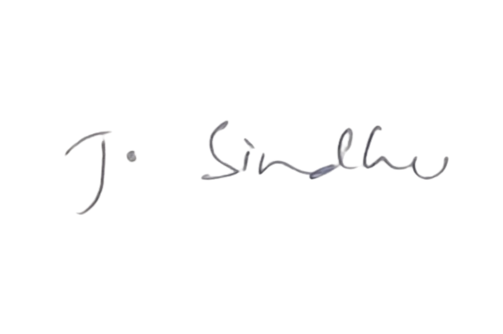

Service Provider: Jetti Hima Sindhu
Address: H.NO.11-3-1087, GOKUL NAGAR,NAMPALLY,HYDERABAD,TELANGANA,500001.
Email- lisnaagarwal3@gmail.com
Contact No. 7893229694
PAN No- JQUPS5460M

Bank details below:

Account-Name | Bank Name | Bank Account Number | IFSC Code
Jetti Hima Sindhu | SBI | 62472874174 | SBIN0020309

Date: - 28-02-2026

TO,
CUBE Highways Technologies Private Limited,
3rd Floor, GMR Aero Towers – 2,
Mamidipally Village, Saroor Nagar Mandal,
Ranga Reddy, Hyderabad, Telangana - 500108

GST No- 36AAKCC7533R1ZW
PAN No- AAKCC7533R

Sir,

Subject: Consultant fee for Feb- 2026 data processing & Analysis Rs.16,500/- per month. The commercials are mentioned below.

Particulars | No. of working  days in Feb'26 | WBS Elements | Payable Amount  (Rs.)
Consultant fee – Data Processing | 28 | FRHL-SSA-TAR-ASA-E. NSV ANALYSIS-MC-147 | 16,500
 | 28 | Total Pay | Rs. 16,500/-

Thanking you and always assuring you of our best services.

Yours faithfully

Authorised Signature
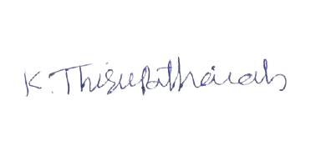

Service Provider: K THIRUPATHAIAH
Address: H NO.3-47 Veeraipalle,Peddamandadi,Wanaparthy,Telangana-509380
Email- tk0615781@gmail.com
Contact No. 7416847735
PAN No- CJFPT3716C

Bank details below:

Account-Name | Bank Name | Bank Account Number | IFSC Code
K THIRUPATHAIAH | SBI | 41732898722 | SBIN0021740

Date: - 28-02-2026

TO,
CUBE Highways Technologies Private Limited,
3rd Floor, GMR Aero Towers – 2,
Mamidipally Village, Saroor Nagar Mandal,
Ranga Reddy, Hyderabad, Telangana - 500108

GST No- 36AAKCC7533R1ZW
PAN No- AAKCC7533R

Sir,

Subject: Consultant fee for Feb- 2026 data processing & Analysis Rs.16,500/- per month. The commercials are mentioned below.

Particulars | No. of working  days in Feb'26 | WBS Elements | Payable Amount  (Rs.)
Consultant fee – Data Processing | 28 | FRHL-SSA-TAR-ASA-E. NSV ANALYSIS-MC-147 | 16,500
 | 28 | Total Pay | Rs. 16,500/-

Thanking you and always assuring you of our best services.

Yours faithfully

Authorised Signature
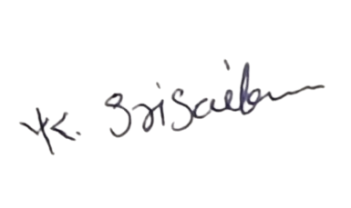

Service Provider: Kanche Srisailam
Address: H.NO.1-21,DASARLAPALLE,MANABUB NAGAR,TELANGANA,509385.
Email- srisailamkanche@gmail.com
Contact No. 9010586905
PAN No- HSBPK8265H

Bank details below:

Account-Name | Bank Name | Bank Account Number | IFSC Code
Kanche Srisailam | Indusind bank | 189010586905 | INDB0000004

Date: - 28-02-2026

TO,
CUBE Highways Technologies Private Limited,
3rd Floor, GMR Aero Towers – 2,
Mamidipally Village, Saroor Nagar Mandal,
Ranga Reddy, Hyderabad, Telangana - 500108

GST No- 36AAKCC7533R1ZW
PAN No- AAKCC7533R

Sir,

Subject: Consultant fee for Feb- 2026 data processing & Analysis Rs.16,500/- per month. The commercials are mentioned below.

Particulars | No. of working  days in Feb'26 | WBS Elements | Payable Amount  (Rs.)
Consultant fee – Data Processing | 28 | FRHL-SSA-TAR-ASA-E. NSV ANALYSIS-MC-147 | 16,500
 | 28 | Total Pay | Rs. 16,500/-

Thanking you and always assuring you of our best services.

Yours faithfully

Authorised Signature
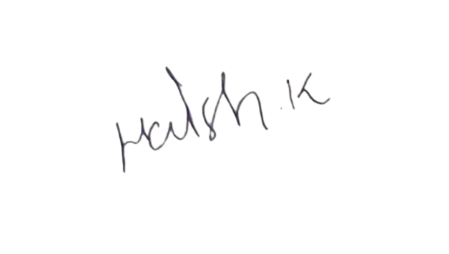

Service Provider: Kasireddy Harish
Address: H.NO.10-68/1,PEDDAMUPPARAM,MAHABUBAD,TELANGANA,506324.
Email- kasireddyharish20@gmail.com
Contact No. 8500881174
PAN No- EKVPK1472H

Bank details below:

Account-Name | Bank Name | Bank Account Number | IFSC Code
Kasireddy Harish | Axis Bank | 917010024214988 | UTIB0000370

Date: - 28-02-2026

TO,
CUBE Highways Technologies Private Limited,
3rd Floor, GMR Aero Towers – 2,
Mamidipally Village, Saroor Nagar Mandal,
Ranga Reddy, Hyderabad, Telangana - 500108

GST No- 36AAKCC7533R1ZW
PAN No- AAKCC7533R

Sir,

Subject: Consultant fee for Feb- 2026 data processing & Analysis Rs.16,500/- per month. The commercials are mentioned below.

Particulars | No. of working  days in Feb'26 | WBS Elements | Payable Amount  (Rs.)
Consultant fee – Data Processing | 28 | FRHL-SSA-TAR-ASA-E. NSV ANALYSIS-MC-147 | 16,500
 | 28 | Total Pay | Rs. 16,500/-

Thanking you and always assuring you of our best services.

Yours faithfully

Authorised Signature


Service Provider: Kasturi Sathish
Address: H.NO1-74,Chandanapur Village,Ramagiri Mandal,pparlakesaram, Jallaram Peddapalli,Telangana-505184
Email- satti.knr@gmail.com
Contact No. 8639980592
PAN No- ICQPK13146R

Bank details below:

Account-Name | Bank Name | Bank Account Number | IFSC Code
Sathish Kasthuri | Kotak Mahindra Bank | 7147479003 | KKBK0007492

Date: - 28-02-2026

TO,
CUBE Highways Technologies Private Limited,
3rd Floor, GMR Aero Towers – 2,
Mamidipally Village, Saroor Nagar Mandal,
Ranga Reddy, Hyderabad, Telangana - 500108

GST No- 36AAKCC7533R1ZW
PAN No- AAKCC7533R

Sir,

Subject: Consultant fee for Feb- 2026 data processing & Analysis Rs.16,500/- per month. The commercials are mentioned below.

Particulars | No. of working  days in Feb'26 | WBS Elements | Payable Amount  (Rs.)
Consultant fee – Data Processing | 28 | LIGHTSTORM-SSA-ATMS-INST-LGS-01-MC-472 | 16,500
 | 28 | Total Pay | Rs. 16,500/-

Thanking you and always assuring you of our best services.

Yours faithfully

Authorised Signature
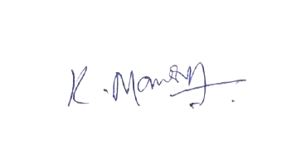

Service Provider: KATRAVATH MANGESH
Address: H NO. 1-33 Anareddypally Thanda,Mukarlabad,gandeed,Rangareddy, Telangana-509337
Email- mangeshrathod9@gmail.com
Contact No. 8309885034
PAN No- EYLPK8528L

Bank details below:

Account-Name | Bank Name | Bank Account Number | IFSC Code
MANGESH KATRAVATH | INDIAN O BANK | 157001000003990 | IOBA0001570

Date: - 28-02-2026

TO,
CUBE Highways Technologies Private Limited,
3rd Floor, GMR Aero Towers – 2,
Mamidipally Village, Saroor Nagar Mandal,
Ranga Reddy, Hyderabad, Telangana - 500108

GST No- 36AAKCC7533R1ZW
PAN No- AAKCC7533R

Sir,

Subject: Consultant fee for Feb- 2026 data processing & Analysis Rs.15,911/- per month. The commercials are mentioned below.

Particulars | No. of working  days in Feb'26 | WBS Elements | Payable Amount  (Rs.)
Consultant fee – Data Processing | 27 | JMTL-SSA-TAR-ATA-HIRATE-MC-194 | 15,911
 | 27 | Total Pay | Rs. 15,911/-

Thanking you and always assuring you of our best services.

Yours faithfully

Authorised Signature


Service Provider: Katravath Mohan Rathod
Address: H.NO.1-65 Annareddypally,mohammadabad,mahabubnagar,Telangana,509337
Email- mohanrathod1319@gmail.com
Contact No. 9948932200
PAN No- CVCPK9680H

Bank details below:

Account-Name | Bank Name | Bank Account Number | IFSC Code
Katravath Mohan Rathod | SBI | 62165502183 | SBIN0020468

Date: - 28-02-2026

TO,
CUBE Highways Technologies Private Limited,
3rd Floor, GMR Aero Towers – 2,
Mamidipally Village, Saroor Nagar Mandal,
Ranga Reddy, Hyderabad, Telangana - 500108

GST No- 36AAKCC7533R1ZW
PAN No- AAKCC7533R

Sir,

Subject: Consultant fee for Feb- 2026 data processing & Analysis Rs.13,554/- per month. The commercials are mentioned below.

Particulars | No. of working  days in Feb'26 | WBS Elements | Payable Amount  (Rs.)
Consultant fee – Data Processing | 20 | KMTL-SSA-TAR-ATA-HIRATE-MC-195 | 11,786
 | 3 | LIGHTSTORM-SSA-ATMS-INST-LGS-01-MC-472 | 1,768
 | 23 | Total Pay | Rs. 13,554/-

Thanking you and always assuring you of our best services.

Yours faithfully

Authorised Signature


Service Provider: Katravath Radhika
Address: H.NO.1-65 Annareddypally,mohammadabad,mahabubnagar,Telangana,509337
Email- radhikakatravath9@gmail.com
Contact No. 9370061997
PAN No- GGKPR5896F

Bank details below:

Account-Name | Bank Name | Bank Account Number | IFSC Code
Katravath Radhika | SBI | 62416578569 | SBIN0020468

Date: - 28-02-2026

TO,
CUBE Highways Technologies Private Limited,
3rd Floor, GMR Aero Towers – 2,
Mamidipally Village, Saroor Nagar Mandal,
Ranga Reddy, Hyderabad, Telangana - 500108

GST No- 36AAKCC7533R1ZW
PAN No- AAKCC7533R

Sir,

Subject: Consultant fee for Feb- 2026 data processing & Analysis Rs.16,500/- per month. The commercials are mentioned below.

Particulars | No. of working  days in Feb'26 | WBS Elements | Payable Amount  (Rs.)
Consultant fee – Data Processing | 28 | LIGHTSTORM-SSA-ATMS-INST-LGS-01-MC-472 | 16,500
 | 28 | Total Pay | Rs. 16,500/-

Thanking you and always assuring you of our best services.

Yours faithfully

Authorised Signature


Service Provider: Kodavath Swamy
Address: H no.1-3 Lacha Nayak Thanda,Yellur,Mahabubnagar,Telangana-509102
Email- kodavath636677@gmail.com
Contact No. 7670820654
PAN No- LXNPS7221L

Bank details below:

Account-Name | Bank Name | Bank Account Number | IFSC Code
Kodavath Swamy | SBI | 62269385368 | SBIN0020195

Date: - 28-02-2026

TO,
CUBE Highways Technologies Private Limited,
3rd Floor, GMR Aero Towers – 2,
Mamidipally Village, Saroor Nagar Mandal,
Ranga Reddy, Hyderabad, Telangana - 500108

GST No- 36AAKCC7533R1ZW
PAN No- AAKCC7533R

Sir,

Subject: Consultant fee for Feb- 2026 data processing & Analysis Rs.4,125/- per month. The commercials are mentioned below.

Particulars | No. of working  days in Feb'26 | WBS Elements | Payable Amount  (Rs.)
Consultant fee – Data Processing | 7 | FRHL-SSA-TAR-ASA-E. NSV ANALYSIS-MC-147 | 4,125
 | 7 | Total Pay | Rs. 4,125/-

Thanking you and always assuring you of our best services.

Yours faithfully

Authorised Signature
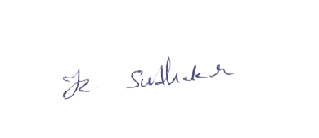

Service Provider: KOLLA SUDHAKAR
Address: H NO.6-48 Vennacherla,Mahabubnagar,Telangana-509235
Email- kolla.sudhakar1996@gmail.com
Contact No. 7330879720
PAN No- OSLPS3845C

Bank details below:

Account-Name | Bank Name | Bank Account Number | IFSC Code
KOLLA SUDHAKAR | HDFC | 50100442145170 | HDFC0004216

Date: - 28-02-2026

TO,
CUBE Highways Technologies Private Limited,
3rd Floor, GMR Aero Towers – 2,
Mamidipally Village, Saroor Nagar Mandal,
Ranga Reddy, Hyderabad, Telangana - 500108

GST No- 36AAKCC7533R1ZW
PAN No- AAKCC7533R

Sir,

Subject: Consultant fee for Feb- 2026 data processing & Analysis Rs.12,375/- per month. The commercials are mentioned below.

Particulars | No. of working  days in Feb'26 | WBS Elements | Payable Amount  (Rs.)
Consultant fee – Data Processing | 21 | LIGHTSTORM-SSA-ATMS-INST-LGS-01-MC-472 | 12,375
 | 21 | Total Pay | Rs. 12,375/-

Thanking you and always assuring you of our best services.

Yours faithfully

Authorised Signature
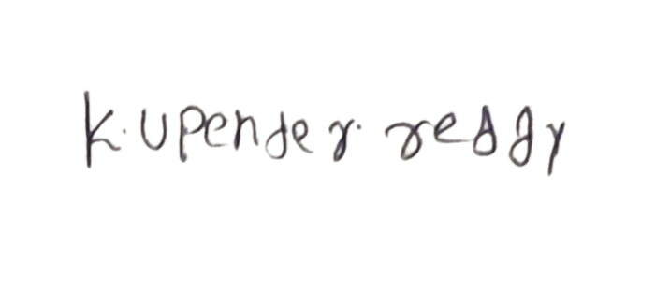

Service Provider: Kunduru Upender Reddy
Address: H.NO.5-126, CHEEDELLA,NALGONDA,TELANGANA,508233.
Email- upenderreddykunduru@gmail.com
Contact No. 9640245955
PAN No- ERXPK5692C

Bank details below:

Account-Name | Bank Name | Bank Account Number | IFSC Code
Kunduru Upender Reddy | Axis Bank | 916010055686890 | UTIB0000370

Date: - 28-02-2026

TO,
CUBE Highways Technologies Private Limited,
3rd Floor, GMR Aero Towers – 2,
Mamidipally Village, Saroor Nagar Mandal,
Ranga Reddy, Hyderabad, Telangana - 500108

GST No- 36AAKCC7533R1ZW
PAN No- AAKCC7533R

Sir,

Subject: Consultant fee for Feb- 2026 data processing & Analysis Rs.16,500/- per month. The commercials are mentioned below.

Particulars | No. of working  days in Feb'26 | WBS Elements | Payable Amount  (Rs.)
Consultant fee – Data Processing | 28 | LIGHTSTORM-SSA-ATMS-INST-LGS-01-MC-472 | 16,500
 | 28 | Total Pay | Rs. 16,500/-

Thanking you and always assuring you of our best services.

Yours faithfully

Authorised Signature
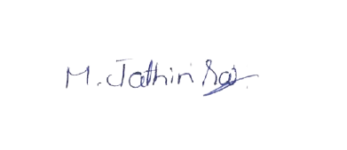

Service Provider: M JATHIN SAI
Address: H NO.1-12A Housing Board Colony,Adoni,Kurnool,Andhra Pradesh-518301
Email- jathinsai1607@gmail.com
Contact No. 9059050754
PAN No- CNSPJ0555J

Bank details below:

Account-Name | Bank Name | Bank Account Number | IFSC Code
M JATHIN SAI | CANARA BANK | 601101033059 | CNRB0000601

Date: - 28-02-2026

TO,
CUBE Highways Technologies Private Limited,
3rd Floor, GMR Aero Towers – 2,
Mamidipally Village, Saroor Nagar Mandal,
Ranga Reddy, Hyderabad, Telangana - 500108

GST No- 36AAKCC7533R1ZW
PAN No- AAKCC7533R

Sir,

Subject: Consultant fee for Feb- 2026 data processing & Analysis Rs.16,500/- per month. The commercials are mentioned below.

Particulars | No. of working  days in Feb'26 | WBS Elements | Payable Amount  (Rs.)
Consultant fee – Data Processing | 28 | LIGHTSTORM-SSA-ATMS-INST-LGS-01-MC-472 | 16,500
 | 28 | Total Pay | Rs. 16,500/-

Thanking you and always assuring you of our best services.

Yours faithfully

Authorised Signature
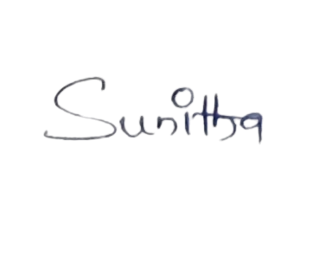

Service Provider: M Sunitha
Address: H.NO.2-70 ,MARRIPALLY,MAHABUBNAGAR,TELANGANA,509385.
Email- m.sunitha410@gmail.com
Contact No. 9014140557
PAN No- NWJPS3380H

Bank details below:

Account-Name | Bank Name | Bank Account Number | IFSC Code
M Sunitha | Kotak Mahindra Bank | 7446263983 | KKBK0007463

Date: - 28-02-2026

TO,
CUBE Highways Technologies Private Limited,
3rd Floor, GMR Aero Towers – 2,
Mamidipally Village, Saroor Nagar Mandal,
Ranga Reddy, Hyderabad, Telangana - 500108

GST No- 36AAKCC7533R1ZW
PAN No- AAKCC7533R

Sir,

Subject: Consultant fee for Feb- 2026 data processing & Analysis Rs.14,143/- per month. The commercials are mentioned below.

Particulars | No. of working  days in Feb'26 | WBS Elements | Payable Amount  (Rs.)
Consultant fee – Data Processing | 10 | SIPL-SSA-TAR-ATA-HIRATE-MC-350 | 5,893
 | 14 | WVEPL-SSA-TAR-ATA-HIRATE-MC-193 | 8,250
 | 24 | Total Pay | Rs. 14,143/-

Thanking you and always assuring you of our best services.

Yours faithfully

Authorised Signature


Service Provider: M Swarupa
Address: H No. 2-28 Ambedkar Colony,Palem,Mahabubnagar,Telangana-509381
Email- mswapna9705@gmail.com
Contact No. 9704958673
PAN No- HHEPS7287D

Bank details below:

Account-Name | Bank Name | Bank Account Number | IFSC Code
M Swarupa | SBI | 62082018885 | SBIN0015884

Date: - 28-02-2026

TO,
CUBE Highways Technologies Private Limited,
3rd Floor, GMR Aero Towers – 2,
Mamidipally Village, Saroor Nagar Mandal,
Ranga Reddy, Hyderabad, Telangana - 500108

GST No- 36AAKCC7533R1ZW
PAN No- AAKCC7533R

Sir,

Subject: Consultant fee for Feb- 2026 data processing & Analysis Rs.15,321/- per month. The commercials are mentioned below.

Particulars | No. of working  days in Feb'26 | WBS Elements | Payable Amount  (Rs.)
Consultant fee – Data Processing | 26 | BFHL-SSA-TAR-ATA-HIRATE-MC-210 | 15,321
 | 26 | Total Pay | Rs. 15,321/-

Thanking you and always assuring you of our best services.

Yours faithfully

Authorised Signature


Service Provider: Meka Esthar Rani
Address: H.No.2-52/3 Venkatapur,Moinabad,VTC: Venkatapur,PO: Venkatapur, Sub District:Moinabad, K.V.Rangareddy-Telangana-501504
Email- estharerani2007@gmail.com
Contact No. 9550267098
PAN No- HWJPR8666B

Bank details below:

Account-Name | Bank Name | Bank Account Number | IFSC Code
Meka Esthar Rani | Central Bank of India | 5442742115 | CBIN0283538

Date: - 28-02-2026

TO,
CUBE Highways Technologies Private Limited,
3rd Floor, GMR Aero Towers – 2,
Mamidipally Village, Saroor Nagar Mandal,
Ranga Reddy, Hyderabad, Telangana - 500108

GST No- 36AAKCC7533R1ZW
PAN No- AAKCC7533R

Sir,

Subject: Consultant fee for Feb- 2026 data processing & Analysis Rs.15,321/- per month. The commercials are mentioned below.

Particulars | No. of working  days in Feb'26 | WBS Elements | Payable Amount  (Rs.)
Consultant fee – Data Processing | 26 | LIGHTSTORM-SSA-ATMS-INST-LGS-01-MC-472 | 15,321
 | 26 | Total Pay | Rs. 15,321/-

Thanking you and always assuring you of our best services.

Yours faithfully

Authorised Signature


Service Provider: Mamidi Raj kumar
Address: H .NO 4-42,Kokapet,C BIT,Rajender Nagar,HYDERABAD,TELANGANA,500075
Email- rajkumarmamidi709@gmail.com
Contact No. 7093755434
PAN No- KPMPK7832F

Bank details below:

Account-Name | Bank Name | Bank Account Number | IFSC Code
Mamidi Raj kumar | SBI | 41459036508 | SBIN0063949

Date: - 28-02-2026

TO,
CUBE Highways Technologies Private Limited,
3rd Floor, GMR Aero Towers – 2,
Mamidipally Village, Saroor Nagar Mandal,
Ranga Reddy, Hyderabad, Telangana - 500108

GST No- 36AAKCC7533R1ZW
PAN No- AAKCC7533R

Sir,

Subject: Consultant fee for Feb- 2026 data processing & Analysis Rs.16,500/- per month. The commercials are mentioned below.

Particulars | No. of working  days in Feb'26 | WBS Elements | Payable Amount  (Rs.)
Consultant fee – Data Processing | 28 | LIGHTSTORM-SSA-ATMS-INST-LGS-01-MC-472 | 16,500
 | 28 | Total Pay | Rs. 16,500/-

Thanking you and always assuring you of our best services.

Yours faithfully

Authorised Signature
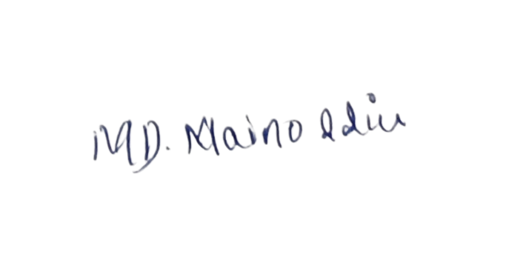

Service Provider: Md Mainoddin
Address: H.NO. 1-128, DASARLAPALLY,MahaboobNagar,TELANGANA.509385.
Email- mynumahamad@gmail.com
Contact No. 8074007481
PAN No- EZZPM8565E

Bank details below:

Account-Name | Bank Name | Bank Account Number | IFSC Code
Md Mainoddin | Axis Bank | 915010021020869 | UTIB0000370

Date: - 28-02-2026

TO,
CUBE Highways Technologies Private Limited,
3rd Floor, GMR Aero Towers – 2,
Mamidipally Village, Saroor Nagar Mandal,
Ranga Reddy, Hyderabad, Telangana - 500108

GST No- 36AAKCC7533R1ZW
PAN No- AAKCC7533R

Sir,

Subject: Consultant fee for Feb- 2026 data processing & Analysis Rs.16,500/- per month. The commercials are mentioned below.

Particulars | No. of working  days in Feb'26 | WBS Elements | Payable Amount  (Rs.)
Consultant fee – Data Processing | 28 | LIGHTSTORM-SSA-ATMS-INST-LGS-01-MC-472 | 16,500
 | 28 | Total Pay | Rs. 16,500/-

Thanking you and always assuring you of our best services.

Yours faithfully

Authorised Signature


Service Provider: Mekala Anusha
Address: H No. 1-96,Sarvaram,Suryapet,Telangana-508212
Email- mekalaanusha1122@gmail.com
Contact No. 6301872371
PAN No- EWRPA3594L

Bank details below:

Account-Name | Bank Name | Bank Account Number | IFSC Code
Mekala Anusha | SBI | 37170369569 | SBIN0006316

Date: - 28-02-2026

TO,
CUBE Highways Technologies Private Limited,
3rd Floor, GMR Aero Towers – 2,
Mamidipally Village, Saroor Nagar Mandal,
Ranga Reddy, Hyderabad, Telangana - 500108

GST No- 36AAKCC7533R1ZW
PAN No- AAKCC7533R

Sir,

Subject: Consultant fee for Feb- 2026 data processing & Analysis Rs.16,500/- per month. The commercials are mentioned below.

Particulars | No. of working  days in Feb'26 | WBS Elements | Payable Amount  (Rs.)
Consultant fee – Data Processing | 28 | LIGHTSTORM-SSA-ATMS-INST-LGS-01-MC-472 | 16,500
 | 28 | Total Pay | Rs. 16,500/-

Thanking you and always assuring you of our best services.

Yours faithfully

Authorised Signature
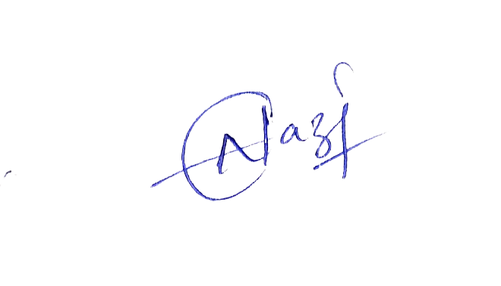

Service Provider: MOHAMMAD NAZIYA
Address: H NO.4-186,Mothkur,Nalgonda,Telagana-508277
Email- mohammadnaziya48@gmail.com
Contact No. 8555074984
PAN No- GCNPM9203E

Bank details below:

Account-Name | Bank Name | Bank Account Number | IFSC Code
NAZIYA MOHAMMAD | SBI | 62305277319 | SBIN0020296

Date: - 28-02-2026

TO,
CUBE Highways Technologies Private Limited,
3rd Floor, GMR Aero Towers – 2,
Mamidipally Village, Saroor Nagar Mandal,
Ranga Reddy, Hyderabad, Telangana - 500108

GST No- 36AAKCC7533R1ZW
PAN No- AAKCC7533R

Sir,

Subject: Consultant fee for Feb- 2026 data processing & Analysis Rs.12,964/- per month. The commercials are mentioned below.

Particulars | No. of working  days in Feb'26 | WBS Elements | Payable Amount  (Rs.)
Consultant fee – Data Processing | 22 | DATL-SSA-TAR-ATA-HIRATE-MC-198 | 12,964
 | 22 | Total Pay | Rs. 12,964/-

Thanking you and always assuring you of our best services.

Yours faithfully

Authorised Signature


Service Provider: Mohammad Shaheen Begum
Address: H No. 2-79/3 Adarshnagar Colony, Amangal,K,V Rangareddy,Telangana-509321
Email- shaheenshannu1234@gmail.com
Contact No. 9347132809
PAN No- LCQPS1203J

Bank details below:

Account-Name | Bank Name | Bank Account Number | IFSC Code
Shaheen Begum | TELANGANA GRAMEENA BANK | 73222345612 | TGRB0007143

Date: - 28-02-2026

TO,
CUBE Highways Technologies Private Limited,
3rd Floor, GMR Aero Towers – 2,
Mamidipally Village, Saroor Nagar Mandal,
Ranga Reddy, Hyderabad, Telangana - 500108

GST No- 36AAKCC7533R1ZW
PAN No- AAKCC7533R

Sir,

Subject: Consultant fee for Feb- 2026 data processing & Analysis Rs.14,732/- per month. The commercials are mentioned below.

Particulars | No. of working  days in Feb'26 | WBS Elements | Payable Amount  (Rs.)
Consultant fee – Data Processing | 25 | LIGHTSTORM-SSA-ATMS-INST-LGS-01-MC-472 | 14,732
 | 25 | Total Pay | Rs. 14,732/-

Thanking you and always assuring you of our best services.

Yours faithfully

Authorised Signature


Service Provider: Mohammed Yaqoob khan
Address: H.NO.7-106/102,VENKATESWARA COLONY ,A R C I ROAD,BALAPUR,TELANGANA,500005.
Email- mohammedyaqoob8790@gmail.com
Contact No. 8790552127
PAN No- DGUPM2215Q

Bank details below:

Account-Name | Bank Name | Bank Account Number | IFSC Code
Mohammed Yaqoob khan | Axis Bank | 916010055681552 | UTIB0000370

Date: - 28-02-2026

TO,
CUBE Highways Technologies Private Limited,
3rd Floor, GMR Aero Towers – 2,
Mamidipally Village, Saroor Nagar Mandal,
Ranga Reddy, Hyderabad, Telangana - 500108

GST No- 36AAKCC7533R1ZW
PAN No- AAKCC7533R

Sir,

Subject: Consultant fee for Feb- 2026 data processing & Analysis Rs.14,143/- per month. The commercials are mentioned below.

Particulars | No. of working  days in Feb'26 | WBS Elements | Payable Amount  (Rs.)
Consultant fee – Data Processing | 24 | LIGHTSTORM-SSA-ATMS-INST-LGS-01-MC-472 | 14,143
 | 24 | Total Pay | Rs. 14,143/-

Thanking you and always assuring you of our best services.

Yours faithfully

Authorised Signature


Service Provider: Mudavath Balakoti
Address: H no. 2-1 Gemya Naik Thanda,Mukkidigundam,Yellur,Mahabubnaga,Telangana-509102
Email- kotimudavatha@gmail.com
Contact No. 9052450309
PAN No- CVSPB7185A

Bank details below:

Account-Name | Bank Name | Bank Account Number | IFSC Code
Mudavath Balakoti | SBI | 36962149815 | SBIN0017895

Date: - 28-02-2026

TO,
CUBE Highways Technologies Private Limited,
3rd Floor, GMR Aero Towers – 2,
Mamidipally Village, Saroor Nagar Mandal,
Ranga Reddy, Hyderabad, Telangana - 500108

GST No- 36AAKCC7533R1ZW
PAN No- AAKCC7533R

Sir,

Subject: Consultant fee for Feb- 2026 data processing & Analysis Rs.15,911/- per month. The commercials are mentioned below.

Particulars | No. of working  days in Feb'26 | WBS Elements | Payable Amount  (Rs.)
Consultant fee – Data Processing | 13 | MKTL-SSA-TAR-ATA-HIRATE-MC-191 | 7,661
 | 14 | MBEL-SSA-TAR-ATA-HIRATE-MC-192 | 8,250
 | 27 | Total Pay | Rs. 15,911/-

Thanking you and always assuring you of our best services.

Yours faithfully

Authorised Signature
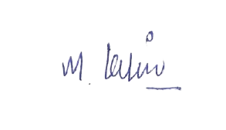

Service Provider: MUDAVATH KIRAN
Address: H NO.4-95,Bodagutta,peddarevelly,Mahabubnagar,Telangana-509408
Email- mudavathkiran2323@gmail.com
Contact No. 9346793175
PAN No- EOIPM7777G

Bank details below:

Account-Name | Bank Name | Bank Account Number | IFSC Code
MUDAVATH KIRAN | Kotak Mahindra Bank | 7747859311 | KKBK0007452

Date: - 28-02-2026

TO,
CUBE Highways Technologies Private Limited,
3rd Floor, GMR Aero Towers – 2,
Mamidipally Village, Saroor Nagar Mandal,
Ranga Reddy, Hyderabad, Telangana - 500108

GST No- 36AAKCC7533R1ZW
PAN No- AAKCC7533R

Sir,

Subject: Consultant fee for Feb- 2026 data processing & Analysis Rs.14,732/- per month. The commercials are mentioned below.

Particulars | No. of working  days in Feb'26 | WBS Elements | Payable Amount  (Rs.)
Consultant fee – Data Processing | 25 | LIGHTSTORM-SSA-ATMS-INST-LGS-01-MC-472 | 14,732
 | 25 | Total Pay | Rs. 14,732/-

Thanking you and always assuring you of our best services.

Yours faithfully

Authorised Signature


Service Provider: Mudavath Ramesh
Address: H No.6-36 Bodabonda Thanda,Yellur,Mahabubnagar,Telangana-509102
Email- rameshmudavath2016@gmail.com
Contact No. 9948545619
PAN No- DEFPR5473L

Bank details below:

Account-Name | Bank Name | Bank Account Number | IFSC Code
Mudavath Ramesh | Union bank | 201510100051658 | UBIN0820156

Date: - 28-02-2026

TO,
CUBE Highways Technologies Private Limited,
3rd Floor, GMR Aero Towers – 2,
Mamidipally Village, Saroor Nagar Mandal,
Ranga Reddy, Hyderabad, Telangana - 500108

GST No- 36AAKCC7533R1ZW
PAN No- AAKCC7533R

Sir,

Subject: Consultant fee for Feb- 2026 data processing & Analysis Rs.15,321/- per month. The commercials are mentioned below.

Particulars | No. of working  days in Feb'26 | WBS Elements | Payable Amount  (Rs.)
Consultant fee – Data Processing | 26 | LIGHTSTORM-SSA-ATMS-INST-LGS-01-MC-472 | 15,321
 | 26 | Total Pay | Rs. 15,321/-

Thanking you and always assuring you of our best services.

Yours faithfully

Authorised Signature


Service Provider: Neeli Sreevani
Address: H NO.6-68,Mallial,Karimnagar,Telangana-505307
Email- neeli.srivani@gmail.com
Contact No. 9133240404
PAN No- BLZPN1093D

Bank details below:

Account-Name | Bank Name | Bank Account Number | IFSC Code
Neeli Sreevani | SBI | 62256724577 | SBIN0020147

Date: - 28-02-2026

TO,
CUBE Highways Technologies Private Limited,
3rd Floor, GMR Aero Towers – 2,
Mamidipally Village, Saroor Nagar Mandal,
Ranga Reddy, Hyderabad, Telangana - 500108

GST No- 36AAKCC7533R1ZW
PAN No- AAKCC7533R

Sir,

Subject: Consultant fee for Feb- 2026 data processing & Analysis Rs.16,500/- per month. The commercials are mentioned below.

Particulars | No. of working  days in Feb'26 | WBS Elements | Payable Amount  (Rs.)
Consultant fee – Data Processing | 28 | LIGHTSTORM-SSA-ATMS-INST-LGS-01-MC-472 | 16,500
 | 28 | Total Pay | Rs. 16,500/-

Thanking you and always assuring you of our best services.

Yours faithfully

Authorised Signature


Service Provider: Padira Radhika
Address: H.NO.11-21-1389-1 N T R Nagar,VTC:Chintalakunta,PO:L B Nagar,District:K.v.Rangareddy-Telangana-500074
Email- radhikapadira8@gmail.com
Contact No. 8897516245
PAN No- GZRPR4153K

Bank details below:

Account-Name | Bank Name | Bank Account Number | IFSC Code
Padira Radhika | Kotak Mahindra Bank | 5550666386 | KKBK0007508

Date: - 28-02-2026

TO,
CUBE Highways Technologies Private Limited,
3rd Floor, GMR Aero Towers – 2,
Mamidipally Village, Saroor Nagar Mandal,
Ranga Reddy, Hyderabad, Telangana - 500108

GST No- 36AAKCC7533R1ZW
PAN No- AAKCC7533R

Sir,

Subject: Consultant fee for Feb- 2026 data processing & Analysis Rs.16,500/- per month. The commercials are mentioned below.

Particulars | No. of working  days in Feb'26 | WBS Elements | Payable Amount  (Rs.)
Consultant fee – Data Processing | 28 | LIGHTSTORM-SSA-ATMS-INST-LGS-01-MC-472 | 16,500
 | 28 | Total Pay | Rs. 16,500/-

Thanking you and always assuring you of our best services.

Yours faithfully

Authorised Signature


Service Provider: Pandiri Punith kumar
Address: H no. 12-1-489 Bandlaguda, Hayathnagar,Telangana-500068
Email- punithpandiri121@gmail.com
Contact No. 9319735245
PAN No- JDQPK8803M

Bank details below:

Account-Name | Bank Name | Bank Account Number | IFSC Code
Pandiri Punith kumar | HDFC | 50100629039482 | HDFC0000512

Date: - 28-02-2026

TO,
CUBE Highways Technologies Private Limited,
3rd Floor, GMR Aero Towers – 2,
Mamidipally Village, Saroor Nagar Mandal,
Ranga Reddy, Hyderabad, Telangana - 500108

GST No- 36AAKCC7533R1ZW
PAN No- AAKCC7533R

Sir,

Subject: Consultant fee for Feb- 2026 data processing & Analysis Rs.14,143/- per month. The commercials are mentioned below.

Particulars | No. of working  days in Feb'26 | WBS Elements | Payable Amount  (Rs.)
Consultant fee – Data Processing | 24 | LIGHTSTORM-SSA-ATMS-INST-LGS-01-MC-472 | 14,143
 | 24 | Total Pay | Rs. 14,143/-

Thanking you and always assuring you of our best services.

Yours faithfully

Authorised Signature
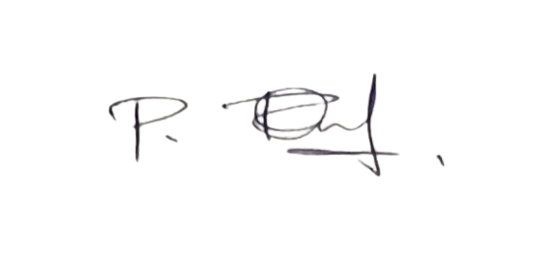

Service Provider: Poojari Ramu
Address: H.NO.1-60 PALAKURTHY,RAGHAVAPURAM,WARANGAL,TELANGANA,506252.
Email- poojariramu1998@gmail.com
Contact No. 7997742062
PAN No- DUNPR8858D

Bank details below:

Account-Name | Bank Name | Bank Account Number | IFSC Code
Poojari Ramu | SBI | 35975315015 | SBIN0014240

Date: - 28-02-2026

TO,
CUBE Highways Technologies Private Limited,
3rd Floor, GMR Aero Towers – 2,
Mamidipally Village, Saroor Nagar Mandal,
Ranga Reddy, Hyderabad, Telangana - 500108

GST No- 36AAKCC7533R1ZW
PAN No- AAKCC7533R

Sir,

Subject: Consultant fee for Feb- 2026 data processing & Analysis Rs.15,911/- per month. The commercials are mentioned below.

Particulars | No. of working  days in Feb'26 | WBS Elements | Payable Amount  (Rs.)
Consultant fee – Data Processing | 27 | LIGHTSTORM-SSA-ATMS-INST-LGS-01-MC-472 | 15,911
 | 27 | Total Pay | Rs. 15,911/-

Thanking you and always assuring you of our best services.

Yours faithfully

Authorised Signature


Service Provider: Porandla Chandar
Address: H No.3-114/A Beerappa Nagar,Thorrur,Mahabubabad-506163
Email- p.chandu105@gmail.com
Contact No. 8374756961
PAN No- BVQPP9673N

Bank details below:

Account-Name | Bank Name | Bank Account Number | IFSC Code
Porandla Chandar | SBI | 33518091215 | SBIN0006961

Date: - 28-02-2026

TO,
CUBE Highways Technologies Private Limited,
3rd Floor, GMR Aero Towers – 2,
Mamidipally Village, Saroor Nagar Mandal,
Ranga Reddy, Hyderabad, Telangana - 500108

GST No- 36AAKCC7533R1ZW
PAN No- AAKCC7533R

Sir,

Subject: Consultant fee for Feb- 2026 data processing & Analysis Rs.15,911/- per month. The commercials are mentioned below.

Particulars | No. of working  days in Feb'26 | WBS Elements | Payable Amount  (Rs.)
Consultant fee – Data Processing | 27 | LIGHTSTORM-SSA-ATMS-INST-LGS-01-MC-472 | 15,911
 | 27 | Total Pay | Rs. 15,911/-

Thanking you and always assuring you of our best services.

Yours faithfully

Authorised Signature


Service Provider: Ramavath Saimahesh Nayak
Address: H No. 3-35/b Thkkalapally,Kothapalle,K.V Rangareddy,TELANGANA-501509
Email- maheshsai1551@gmail.com
Contact No. 9603172036
PAN No- EWIPR5735M

Bank details below:

Account-Name | Bank Name | Bank Account Number | IFSC Code
Ramavath Saimahesh Nayak | HDFC | 50100410269561 | HDFC0009095

Date: - 28-02-2026

TO,
CUBE Highways Technologies Private Limited,
3rd Floor, GMR Aero Towers – 2,
Mamidipally Village, Saroor Nagar Mandal,
Ranga Reddy, Hyderabad, Telangana - 500108

GST No- 36AAKCC7533R1ZW
PAN No- AAKCC7533R

Sir,

Subject: Consultant fee for Feb- 2026 data processing & Analysis Rs.16,500/- per month. The commercials are mentioned below.

Particulars | No. of working  days in Feb'26 | WBS Elements | Payable Amount  (Rs.)
Consultant fee – Data Processing | 28 | LIGHTSTORM-SSA-ATMS-INST-LGS-01-MC-472 | 16,500
 | 28 | Total Pay | Rs. 16,500/-

Thanking you and always assuring you of our best services.

Yours faithfully

Authorised Signature


Service Provider: Ramavath Uma Mahesh
Address: H No. 3-35/b Thkkalapally,Kothapalle,K.V Rangareddy,TELANGANA-501509
Email- maheshramavath1551@gmail.com
Contact No. 7799103929
PAN No- GDXPM6332R

Bank details below:

Account-Name | Bank Name | Bank Account Number | IFSC Code
Ramavath Uma Mahesh | SBI | 62206849096 | SBIN0020382

Date: - 28-02-2026

TO,
CUBE Highways Technologies Private Limited,
3rd Floor, GMR Aero Towers – 2,
Mamidipally Village, Saroor Nagar Mandal,
Ranga Reddy, Hyderabad, Telangana - 500108

GST No- 36AAKCC7533R1ZW
PAN No- AAKCC7533R

Sir,

Subject: Consultant fee for Feb- 2026 data processing & Analysis Rs.14,143/- per month. The commercials are mentioned below.

Particulars | No. of working  days in Feb'26 | WBS Elements | Payable Amount  (Rs.)
Consultant fee – Data Processing | 19 | APEL-SSA-TAR-ATA-HIRATE-MC-199 | 11,196
 | 5 | LIGHTSTORM-SSA-ATMS-INST-LGS-01-MC-472 | 2,946
 | 24 | Total Pay | Rs. 14,143/-

Thanking you and always assuring you of our best services.

Yours faithfully

Authorised Signature


Service Provider: Ranabotu Saidi Reddy
Address: H No 5-166,Cheedella,VTC: Cheedella,PO: Cheedella,District: Suryapet,State: Telangana,PIN Code: 508233
Email- saidireddyranabothu4@gmail.com
Contact No. 7569236580
PAN No- GDEPR4345Q

Bank details below:

Account-Name | Bank Name | Bank Account Number | IFSC Code
Ranabotu Saidi Reddy | PUMJAB NATIONAL BANK | 9702000100021909 | PUNB0970200

Date: - 28-02-2026

TO,
CUBE Highways Technologies Private Limited,
3rd Floor, GMR Aero Towers – 2,
Mamidipally Village, Saroor Nagar Mandal,
Ranga Reddy, Hyderabad, Telangana - 500108

GST No- 36AAKCC7533R1ZW
PAN No- AAKCC7533R

Sir,

Subject: Consultant fee for Feb- 2026 data processing & Analysis Rs.15,321/- per month. The commercials are mentioned below.

Particulars | No. of working  days in Feb'26 | WBS Elements | Payable Amount  (Rs.)
Consultant fee – Data Processing | 26 | LIGHTSTORM-SSA-ATMS-INST-LGS-01-MC-472 | 15,321
 | 26 | Total Pay | Rs. 15,321/-

Thanking you and always assuring you of our best services.

Yours faithfully

Authorised Signature


Service Provider: Sadde Sindhura
Address: H.NO.3-12-94/2 Veerannapat,Mahbubnagar,Telangana-509001
Email- saddesindhura@gmail.com
Contact No. 8328386867
PAN No- QKGPS0608A

Bank details below:

Account-Name | Bank Name | Bank Account Number | IFSC Code
Sadde Sindhura | SBI | 44099240598 | SBIN0011990

Date: - 28-02-2026

TO,
CUBE Highways Technologies Private Limited,
3rd Floor, GMR Aero Towers – 2,
Mamidipally Village, Saroor Nagar Mandal,
Ranga Reddy, Hyderabad, Telangana - 500108

GST No- 36AAKCC7533R1ZW
PAN No- AAKCC7533R

Sir,

Subject: Consultant fee for Feb- 2026 data processing & Analysis Rs.16,500/- per month. The commercials are mentioned below.

Particulars | No. of working  days in Feb'26 | WBS Elements | Payable Amount  (Rs.)
Consultant fee – Data Processing | 28 | LIGHTSTORM-SSA-ATMS-INST-LGS-01-MC-472 | 16,500
 | 28 | Total Pay | Rs. 16,500/-

Thanking you and always assuring you of our best services.

Yours faithfully

Authorised Signature


Service Provider: Shaikh abdul Avesh
Address: H No. 6-51 Maldakal,Mahabubnagar,Telangana-509132
Email- shaikavezs578@gmail.com
Contact No. 9959492676
PAN No- LZIPS2159G

Bank details below:

Account-Name | Bank Name | Bank Account Number | IFSC Code
Shaikh abdul Avesh | Union bank | 152410100076860 | UBIN0815241

Date: - 28-02-2026

TO,
CUBE Highways Technologies Private Limited,
3rd Floor, GMR Aero Towers – 2,
Mamidipally Village, Saroor Nagar Mandal,
Ranga Reddy, Hyderabad, Telangana - 500108

GST No- 36AAKCC7533R1ZW
PAN No- AAKCC7533R

Sir,

Subject: Consultant fee for Feb- 2026 data processing & Analysis Rs.15,321/- per month. The commercials are mentioned below.

Particulars | No. of working  days in Feb'26 | WBS Elements | Payable Amount  (Rs.)
Consultant fee – Data Processing | 26 | LIGHTSTORM-SSA-ATMS-INST-LGS-01-MC-472 | 15,321
 | 26 | Total Pay | Rs. 15,321/-

Thanking you and always assuring you of our best services.

Yours faithfully

Authorised Signature
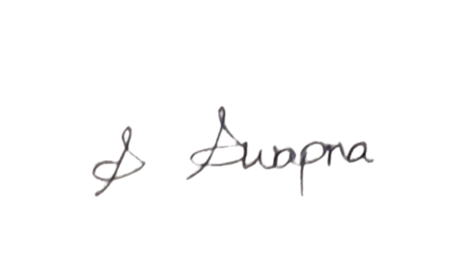

Service Provider: Shivarathri Swapna
Address: H.NO. 4-17,PALADUGU,YADADRI,TELANGANA,508111.
Email- ShivarathriSwapna708@GMAIL.COM
Contact No. 9391074547
PAN No- OGBPS6403Q

Bank details below:

Account-Name | Bank Name | Bank Account Number | IFSC Code
Shivarathri Swapna | Kotak Mahindra Bank | 9645267939 | KKBK0007463

Date: - 28-02-2026

TO,
CUBE Highways Technologies Private Limited,
3rd Floor, GMR Aero Towers – 2,
Mamidipally Village, Saroor Nagar Mandal,
Ranga Reddy, Hyderabad, Telangana - 500108

GST No- 36AAKCC7533R1ZW
PAN No- AAKCC7533R

Sir,

Subject: Consultant fee for Feb- 2026 data processing & Analysis Rs.15,911/- per month. The commercials are mentioned below.

Particulars | No. of working  days in Feb'26 | WBS Elements | Payable Amount  (Rs.)
Consultant fee – Data Processing | 27 | LIGHTSTORM-SSA-ATMS-INST-LGS-01-MC-472 | 15,911
 | 27 | Total Pay | Rs. 15,911/-

Thanking you and always assuring you of our best services.

Yours faithfully

Authorised Signature


Service Provider: Tandra Sabastin
Address: H.NO.10-2-249/A, A C GUARDS,SHANTI NAGAR,HYDERABAD,TELANGANA,500004.
Email- pinkysudheer49@gmail.com
Contact No. 7995221835
PAN No- LYSPS66468K

Bank details below:

Account-Name | Bank Name | Bank Account Number | IFSC Code
Tandra Sabastin | Kotak Mahindra Bank | 9714151992 | KKBK0000563

Date: - 28-02-2026

TO,
CUBE Highways Technologies Private Limited,
3rd Floor, GMR Aero Towers – 2,
Mamidipally Village, Saroor Nagar Mandal,
Ranga Reddy, Hyderabad, Telangana - 500108

GST No- 36AAKCC7533R1ZW
PAN No- AAKCC7533R

Sir,

Subject: Consultant fee for Feb- 2026 data processing & Analysis Rs.15,911/- per month. The commercials are mentioned below.

Particulars | No. of working  days in Feb'26 | WBS Elements | Payable Amount  (Rs.)
Consultant fee – Data Processing | 27 | LIGHTSTORM-SSA-ATMS-INST-LGS-01-MC-472 | 15,911
 | 27 | Total Pay | Rs. 15,911/-

Thanking you and always assuring you of our best services.

Yours faithfully

Authorised Signature


Service Provider: Tabassum Afreen
Address: H No. 3-39 Kanalpalle,Wanapathy,Telangana-509381
Email- afreentabassum891@gmail.com
Contact No. 7702980763
PAN No- BISPA3108F

Bank details below:

Account-Name | Bank Name | Bank Account Number | IFSC Code
Tabassum Afreen | union bank | 33410100164864 | UBIN0803341

Date: - 28-02-2026

TO,
CUBE Highways Technologies Private Limited,
3rd Floor, GMR Aero Towers – 2,
Mamidipally Village, Saroor Nagar Mandal,
Ranga Reddy, Hyderabad, Telangana - 500108

GST No- 36AAKCC7533R1ZW
PAN No- AAKCC7533R

Sir,

Subject: Consultant fee for Feb- 2026 data processing & Analysis Rs.16,500/- per month. The commercials are mentioned below.

Particulars | No. of working  days in Feb'26 | WBS Elements | Payable Amount  (Rs.)
Consultant fee – Data Processing | 28 | LIGHTSTORM-SSA-ATMS-INST-LGS-01-MC-472 | 16,500
 | 28 | Total Pay | Rs. 16,500/-

Thanking you and always assuring you of our best services.

Yours faithfully

Authorised Signature


Service Provider: Thatipally Manoj Kumar
Address: H No. 5-20 Parlapalle,Karimnagar-Telangana-505469
Email- thatipallymanojKumar3@gmail.com
Contact No. 9515590369
PAN No- BCTPT8662B

Bank details below:

Account-Name | Bank Name | Bank Account Number | IFSC Code
Thatipally Manoj Kumar | SBI | 62275405956 | SBIN0020569

Date: - 28-02-2026

TO,
CUBE Highways Technologies Private Limited,
3rd Floor, GMR Aero Towers – 2,
Mamidipally Village, Saroor Nagar Mandal,
Ranga Reddy, Hyderabad, Telangana - 500108

GST No- 36AAKCC7533R1ZW
PAN No- AAKCC7533R

Sir,

Subject: Consultant fee for Feb- 2026 data processing & Analysis Rs.13,554/- per month. The commercials are mentioned below.

Particulars | No. of working  days in Feb'26 | WBS Elements | Payable Amount  (Rs.)
Consultant fee – Data Processing | 21 | NDEPL-SSA-TAR-ATA-HIRATE-MC-190 | 12,375
 | 2 | LIGHTSTORM-SSA-ATMS-INST-LGS-01-MC-472 | 1,179
 | 23 | Total Pay | Rs. 13,554/-

Thanking you and always assuring you of our best services.

Yours faithfully

Authorised Signature


Service Provider: Thurpati vijay Baskar
Address: H.NO.10-12/1 Anthireddy guda,Mahabubnagar,TELANGANA,509228
Email- thurpativijay8096@gmail.com
Contact No. 8096772259
PAN No- BVVPV1235P

Bank details below:

Account-Name | Bank Name | Bank Account Number | IFSC Code
Thurpati vijay Bhaskar | PUMJAB NATIONAL BANK | 2715001500003899 | PUNB0271500

Date: - 28-02-2026

TO,
CUBE Highways Technologies Private Limited,
3rd Floor, GMR Aero Towers – 2,
Mamidipally Village, Saroor Nagar Mandal,
Ranga Reddy, Hyderabad, Telangana - 500108

GST No- 36AAKCC7533R1ZW
PAN No- AAKCC7533R

Sir,

Subject: Consultant fee for Feb- 2026 data processing & Analysis Rs.15,911/- per month. The commercials are mentioned below.

Particulars | No. of working  days in Feb'26 | WBS Elements | Payable Amount  (Rs.)
Consultant fee – Data Processing | 16 | KETL-SSA-TAR-ATA-HIRATE-MC-196 | 9,429
 | 11 | LIGHTSTORM-SSA-ATMS-INST-LGS-01-MC-472 | 6,482
 | 27 | Total Pay | Rs. 15,911/-

Thanking you and always assuring you of our best services.

Yours faithfully

Authorised Signature


Service Provider: Ushanolla Ravali
Address: H.NO 3-95 Mamidipally,Balapur ,Mamidipalli, Saroornagar, K.V.Rangareddy-Telangana-500005
Email- ushanollaravali@gmail.com
Contact No. 7396387072
PAN No- HXVPR0536M

Bank details below:

Account-Name | Bank Name | Bank Account Number | IFSC Code
Ushanolla Ravali | union bank | 145612010001965 | UBIN0814563

Date: - 28-02-2026

TO,
CUBE Highways Technologies Private Limited,
3rd Floor, GMR Aero Towers – 2,
Mamidipally Village, Saroor Nagar Mandal,
Ranga Reddy, Hyderabad, Telangana - 500108

GST No- 36AAKCC7533R1ZW
PAN No- AAKCC7533R

Sir,

Subject: Consultant fee for Feb- 2026 data processing & Analysis Rs.15,911/- per month. The commercials are mentioned below.

Particulars | No. of working  days in Feb'26 | WBS Elements | Payable Amount  (Rs.)
Consultant fee – Data Processing | 16 | SMTL-SSA-TAR-ATA-HIRATE-MC-188 | 9,429
 | 11 | LIGHTSTORM-SSA-ATMS-INST-LGS-01-MC-472 | 6,482
 | 27 | Total Pay | Rs. 15,911/-

Thanking you and always assuring you of our best services.

Yours faithfully

Authorised Signature


Service Provider: Ushanula Ramya
Address: H.NO.3-95Mamidipally,HYDERABAD,TELANGANA,500005.
Email- sairamya1193@gmail.com
Contact No. 9182099529
PAN No- FWFPR0806B

Bank details below:

Account-Name | Bank Name | Bank Account Number | IFSC Code
Ushanula Ramya | FINO PAYMENTS BANK | 20287368958 | FINO0009001

Date: - 28-02-2026

TO,
CUBE Highways Technologies Private Limited,
3rd Floor, GMR Aero Towers – 2,
Mamidipally Village, Saroor Nagar Mandal,
Ranga Reddy, Hyderabad, Telangana - 500108

GST No- 36AAKCC7533R1ZW
PAN No- AAKCC7533R

Sir,

Subject: Consultant fee for Feb- 2026 data processing & Analysis Rs.15,911/- per month. The commercials are mentioned below.

Particulars | No. of working  days in Feb'26 | WBS Elements | Payable Amount  (Rs.)
Consultant fee – Data Processing | 16 | NKTL-SSA-TAR-ATA-HIRATE-MC-189 | 9,429
 | 11 | LIGHTSTORM-SSA-ATMS-INST-LGS-01-MC-472 | 6,482
 | 27 | Total Pay | Rs. 15,911/-

Thanking you and always assuring you of our best services.

Yours faithfully

Authorised Signature


Service Provider: Chejerla Nagavamsidhar Reddy
Address: H No 1/576,ssathavathi Nagar,Chinnapadugupadu,kovur,Nellore,Andhra Pradesh-524137
Email- cknvreddy@gmail.com
Contact No. 8688267006
PAN No- CGXPN5992B

Bank details below:

Account-Name | Bank Name | Bank Account Number | IFSC Code
Chejerla Nagavamsidhar Reddy | ICICI BANK | 004701636131 | ICIC0000047

