创建bash文件并且修改权限使其能够被执行
vi menu.sh # 创建bash文件
./menu.sh # 尝试运行文件并且发现没有权限
man chmod # 查看chmod使用方法
ls -l # 确认文件权限
chmod +x menu.sh # 修改文件权限，增加可执行权限
ls -l # 确认文件权限
./menu.sh # 执行menu.sh
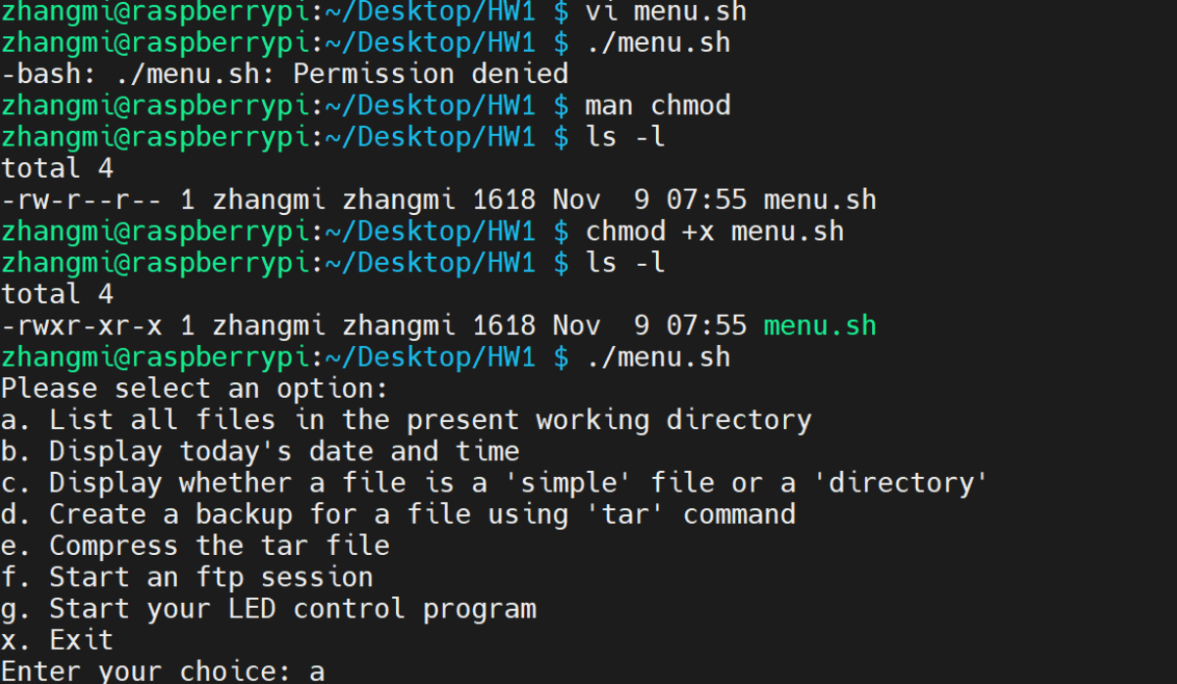

menu.sh代码
#!/bin/bash

while true; do
echo "Please select an option:"
echo "a. List all files in the present working directory"
echo "b. Display today's date and time"
echo "c. Display whether a file is a 'simple' file or a 'directory'"
echo "d. Create a backup for a file using 'tar' command"
echo "e. Compress the tar file"
echo "f. Start an ftp session"
echo "g. Start your LED control program"
echo "x. Exit"
read -p "Enter your choice: " option

case $option in
a)
ls -l
;;
b)
date
;;
c)
read -p "Enter the file name: " filename
if [ -f "$filename" ]; then
echo "It's a file."
elif [ -d "$filename" ]; then
echo "It's a directory."
else
echo "File not found."
fi
;;
d)
read -p "Enter the file name to backup: " filename
read -p "Enter the backup file name: " backupname
tar -cvf $backupname $filename
;;
e)
read -p "Enter the tar file name to compress: " tarfilename
gzip $tarfilename
;;
f)
read -p "Enter the domain name (or IP address): " domain
ftp $domain
;;
g)
if [ -x "/home/zhangmi/Desktop/gpio-led.py" ]; then
python /home/zhangmi/Desktop/gpio-led.py
else
echo "LED control program not found."
fi
;;
x)
echo "Exiting..."
exit 0
;;
*)
echo "Invalid option, please try again."
;;
esac
done

在树莓派上安装ftp
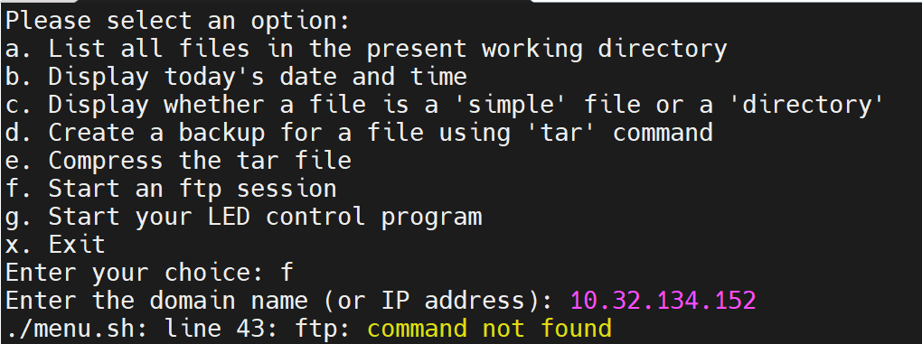
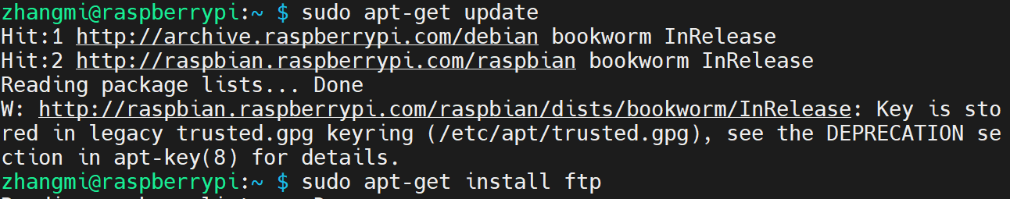
在一段等待之后进入了ftp服务
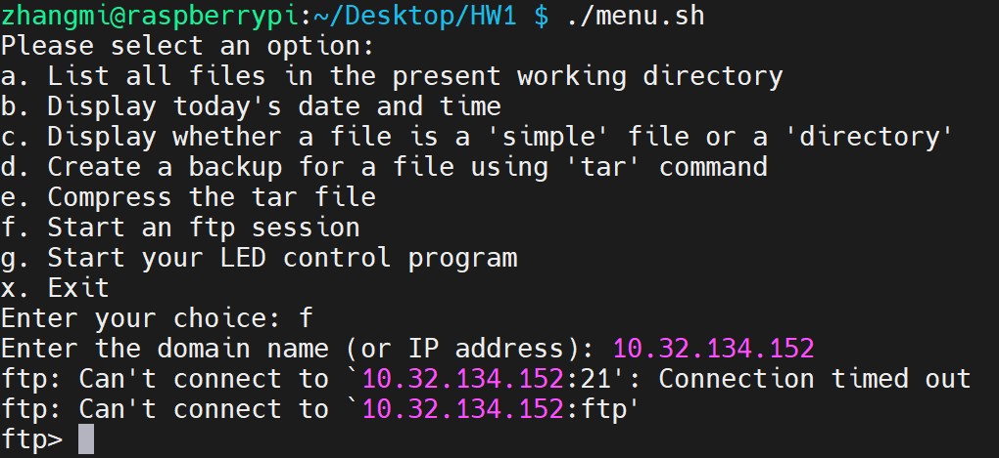

解决g.Start your LED control program一直显示LED control program not found 的问题
期望执行的文件为/home/zhangmi/Desktop/gpio-led.py，一开始发现一直显示LED control program not found，检查文件权限之后发现问题：gpio-led.py没有执行权限。
运行chmod +x gpio-led.py之后解决问题。
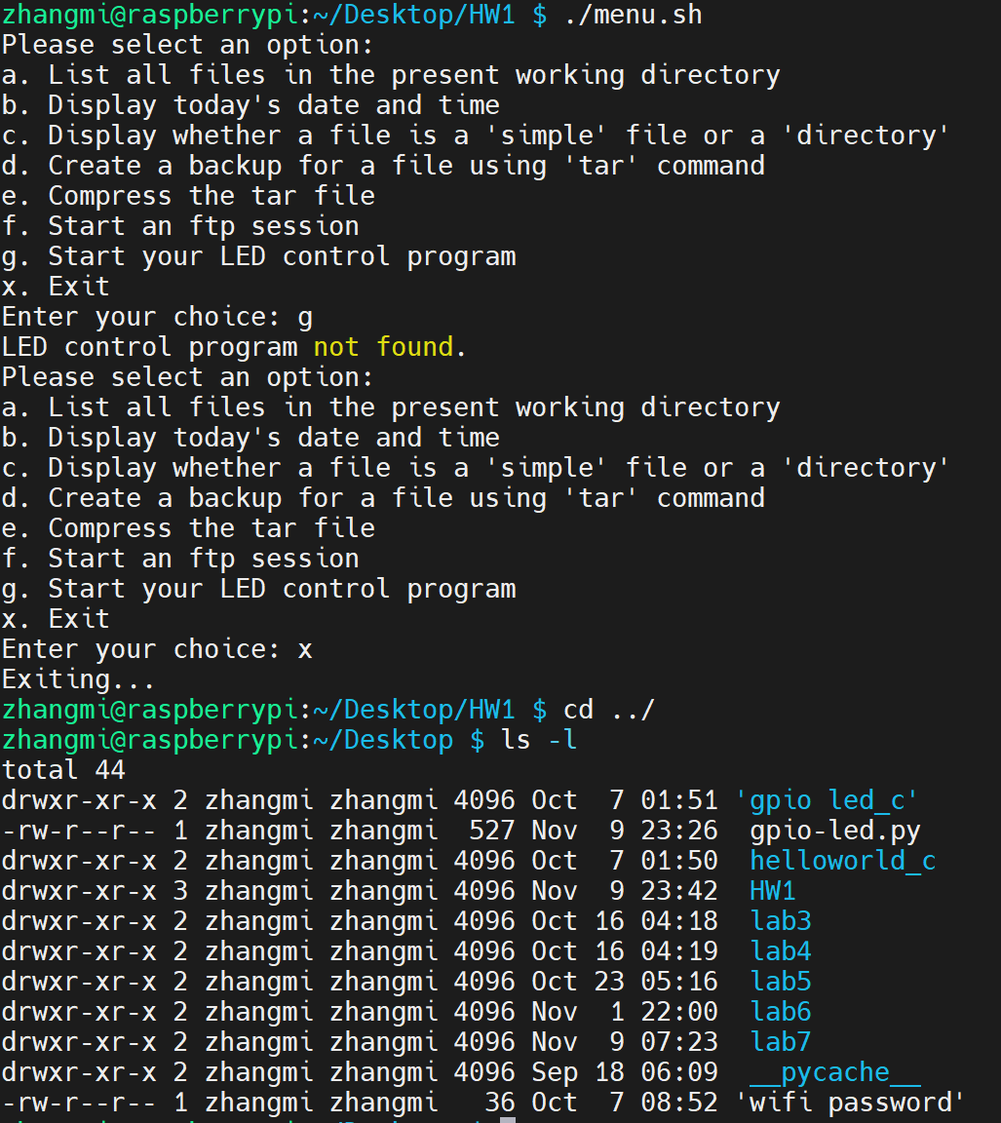
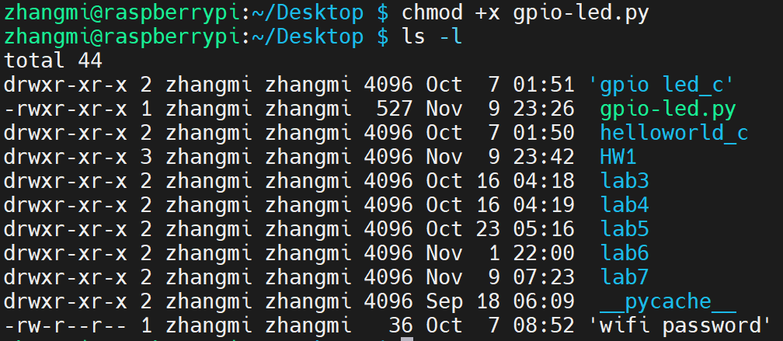

拓展：增加新功能CPU and Memory Usage以及Network Speed Test
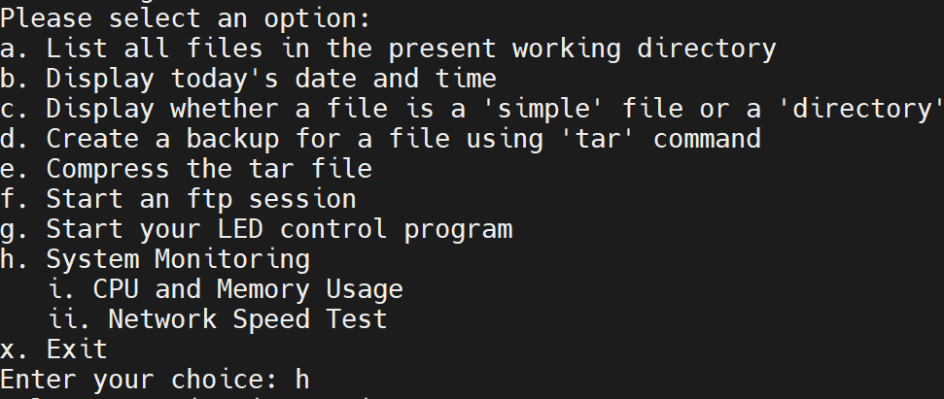menu-upgraded.sh代码
#!/bin/bash

while true; do
echo "Please select an option:"
echo "a. List all files in the present working directory"
echo "b. Display today's date and time"
echo "c. Display whether a file is a 'simple' file or a 'directory'"
echo "d. Create a backup for a file using 'tar' command"
echo "e. Compress the tar file"
echo "f. Start an ftp session"
echo "g. Start your LED control program"
echo "h. System Monitoring"
echo " i. CPU and Memory Usage"
echo " ii. Network Speed Test"
echo "x. Exit"
read -p "Enter your choice: " option

case $option in
a)
ls -l
;;
b)
date
;;
c)
read -p "Enter the file name: " filename
if [ -f "$filename" ]; then
echo "It's a file."
elif [ -d "$filename" ]; then
echo "It's a directory."
else
echo "File not found."
fi
;;
d)
read -p "Enter the file name to backup: " filename
read -p "Enter the backup file name: " backupname
tar -cvf $backupname $filename
;;
e)
read -p "Enter the tar file name to compress: " tarfilename
gzip $tarfilename
;;
f)
read -p "Enter the domain name (or IP address): " domain
ftp $domain
;;
g)
if [ -x "/home/zhangmi/Desktop/gpio-led.py" ]; then
python /home/zhangmi/Desktop/gpio-led.py
else
echo "LED control program not found."
fi
;;
h)
echo "Select a monitoring option:"
echo "i. CPU and Memory Usage"
echo "ii. Network Speed Test"
read -p "Enter your choice: " monitor_option
case $monitor_option in
i)
# CPU and Memory Usage
if command -v htop &> /dev/null; then
htop
else
top
fi
;;
ii)
# Network Speed Test
speedtest-cli
;;
*)
echo "Invalid option, please try again."
;;
esac
;;
x)
echo "Exiting..."
exit 0
;;
*)
echo "Invalid option, please try again."
;;
esac
done

Install speedtest-cli以实现网络测速功能
