Lab6：超声波传感器实验
姓名：何衍宁 学号：12311512
基础部分
实现超声波测距，代码：
import RPi.GPIO as GPIO
import time
import threading
from collections import deque

TRIG = 2 #trig gpio2

ECHO = 3 #echo gpio3

GPIO.setmode(GPIO.BCM)
GPIO.setup(TRIG, GPIO.OUT)
GPIO.setup(ECHO, GPIO.IN, pull_up_down=GPIO.PUD_DOWN)

# 常量定义
SPEED_OF_SOUND = 343.0 # m/s
distances = deque(maxlen=50)
_lock = threading.Lock()
latest_distance_m = None
_start_ns = None

def trig_once():
"""触发一次超声波发射"""
GPIO.output(TRIG, GPIO.HIGH)
time.sleep(0.000015) # 15us 脉冲
GPIO.output(TRIG, GPIO.LOW)

def echo_edge(channel):
"""处理ECHO引脚的上升沿与下降沿"""
global _start_ns, latest_distance_m
level = GPIO.input(channel)

if level == GPIO.HIGH:
_start_ns = time.monotonic_ns()
else:
if _start_ns is None:
return
dur_ns = time.monotonic_ns() - _start_ns
_start_ns = None

dur_s = dur_ns / 1e9
distance_m = (SPEED_OF_SOUND * dur_s) / 2.0

# 过滤异常值（比如超出或太小）
if 0.01 <= distance_m <= 4.0: # 有效测距区间约1cm-4m
with _lock:
latest_distance_m = distance_m
distances.append(distance_m)

GPIO.output(TRIG, GPIO.LOW)
time.sleep(0.05)
GPIO.add_event_detect(ECHO, GPIO.BOTH, callback=echo_edge)
try:
print("Start measuring...")
while True:
trig_once()
time.sleep(0.06) # 每次测量间隔约60ms（防止回波干扰）

with _lock:
if distances:
d = latest_distance_m
avg = sum(distances) / len(distances)
else:
d = None
avg = None

if d is not None:
print(f"Distance: {d*100:.1f} cm, Avg(50): {avg*100:.1f} cm")
else:
print("No valid echo detected")

except KeyboardInterrupt:
print("Stop")

finally:
GPIO.remove_event_detect(ECHO)
GPIO.cleanup()
print("Out")
测试部分：Vcc改成3.3V无法正常工作
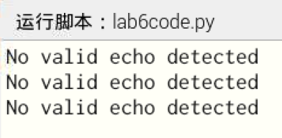
要求：将输出5V降压为3.3V电压
Echo模块输出5V，树莓派gpio口不适合长期接受5V。
为保护gpio口，最简单的方法就是串联电阻分压，将5V降为3.3V，如图所示：
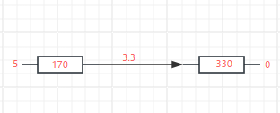
由于手头没有电阻，无法实际测试。

实验数据记录：
序号 | 实际距离 (cm) | 检测距离 (cm) | 测量误差 (%)
1 | 29 | 27.6 | 4.8
2 | 27 | 26.0 | 3.7
3 | 25 | 24.1 | 3.6
4 | 23 | 22.2 | 3.5
5 | 21 | 20.1 | 4.3
6 | 19 | 18.3 | 3.7
7 | 17 | 16.0 | 5.9
8 | 15 | 14.0 | 6.7
9 | 13 | 12.3 | 5.4
10 | 11 | 9.8 | 10.9
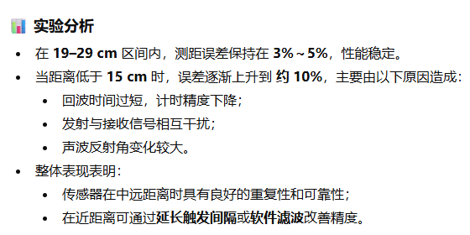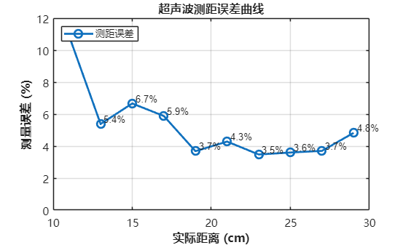
% 实际距离（cm）
actual = [29 27 25 23 21 19 17 15 13 11];
% 检测距离（cm）
measured = [27.6 26.0 24.1 22.2 20.1 18.3 16.0 14.0 12.3 9.8];

% 计算测量误差百分比
error_percent = abs(measured - actual) ./ actual * 100;

% 绘制误差曲线
figure;
plot(actual, error_percent, '-o', 'LineWidth', 2, 'MarkerSize', 8);
grid on;
xlabel('实际距离 (cm)', 'FontSize', 12, 'FontWeight', 'bold');
ylabel('测量误差 (%)', 'FontSize', 12, 'FontWeight', 'bold');
title('超声波测距误差曲线', 'FontSize', 14, 'FontWeight', 'bold');
xlim([10 30]);
ylim([0 12]);

% 显示每个点的误差值标签
for i = 1:length(actual)
text(actual(i)+0.2, error_percent(i)+0.3, ...
sprintf('%.1f%%', error_percent(i)), 'FontSize', 10);
end

% 美化外观
set(gca, 'FontName', 'Microsoft YaHei', 'FontSize', 11);
legend('测距误差', 'Location', 'northwest');

