Homework for Chap 2
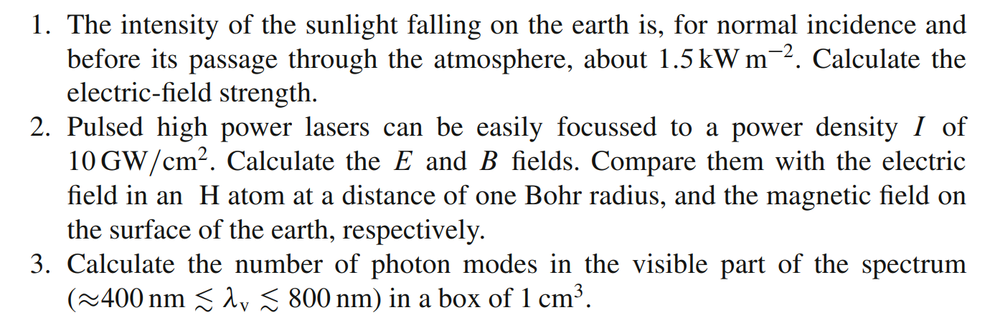
4. Derive the density of states for electrons in a 3-dimensional semiconductor

Homework for Chap 3

- What are the definition and meaning of Einstein’s coefficients?
- Consider the following figure (Fig 3.9 (c) in the textbook), explain why the three curves intersect, i.e., why zero absorption gives both the highest maxima and the lowest minima in reflectance

