EE336 Fundamental of Photovoltaics
Lab I
Sun Position Calculation

Name: HE Yanning （何衍宁）
Student Number: 12311512
2026/03/06

Quiz1
A solar panel is installed parallel to the ground in Shenzhen as illustrated in Figure 1a. Assuming that there is no effect of the atmosphere and weather on the sun light intensity,
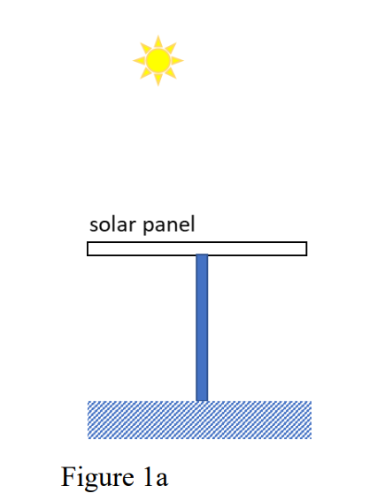
(a) Plot the sun position throughout the day on the polar plot for today.
Shenzhen is located at 22.52°N, 114°E.
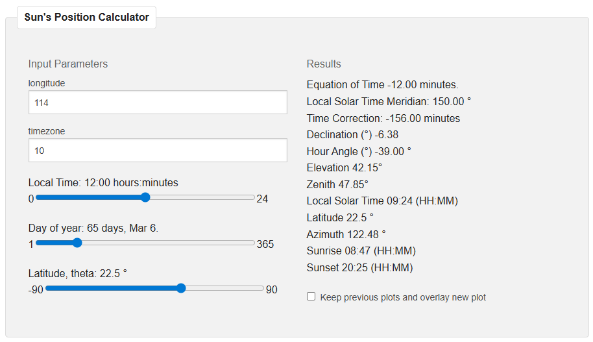
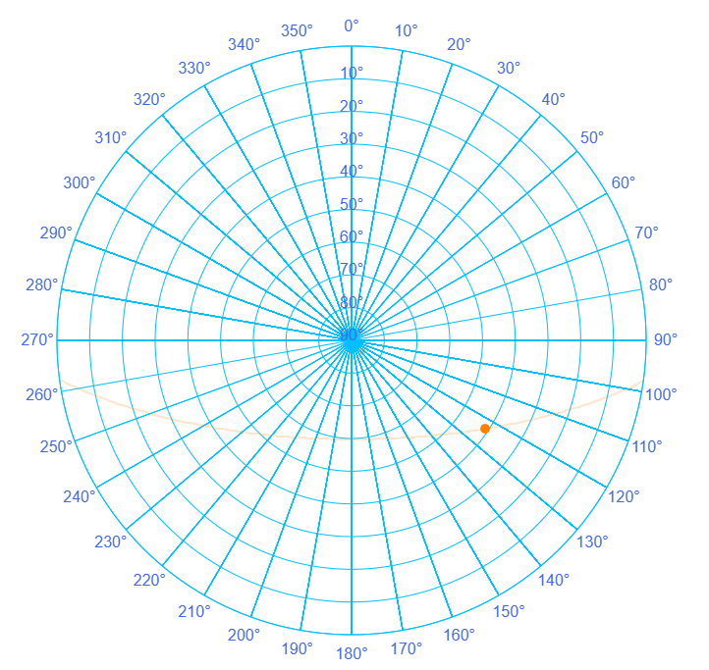
(b) On what day and month of the year and what time does the solar panel receive the highest power from the sun?
The solar panel receives the highest power from the sun on June 6th at 12:00 PM.
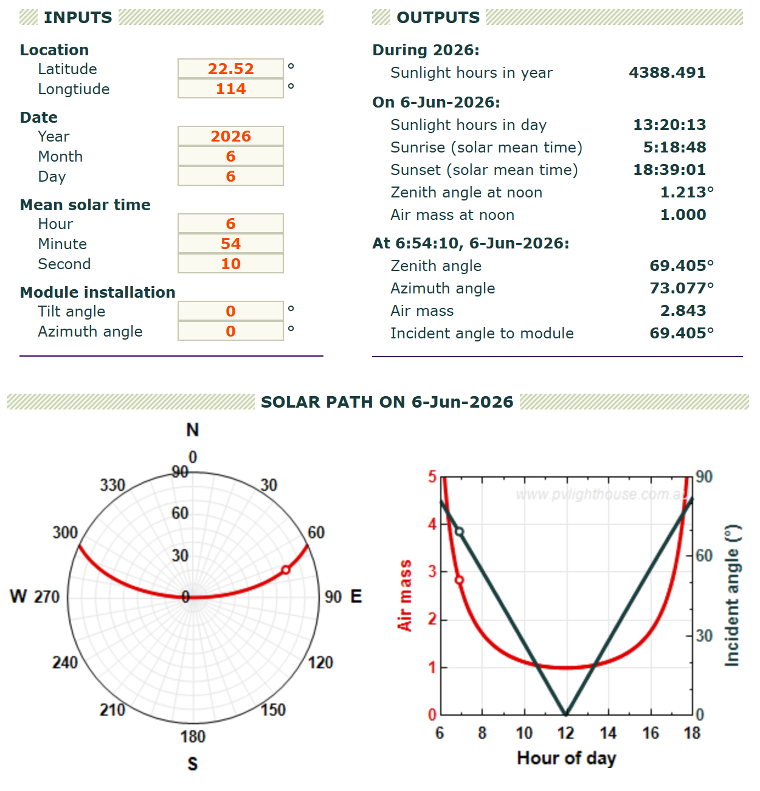

(c) If the solar panel is titled 30 ̊from horizontal (Figure 1b) at that time, what is the relative change in the power received by the solar panel?
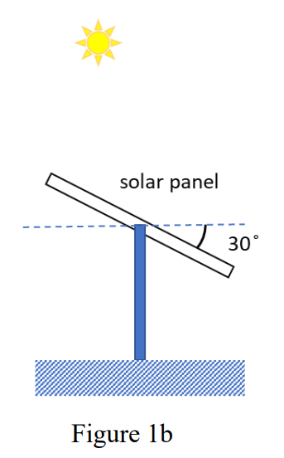
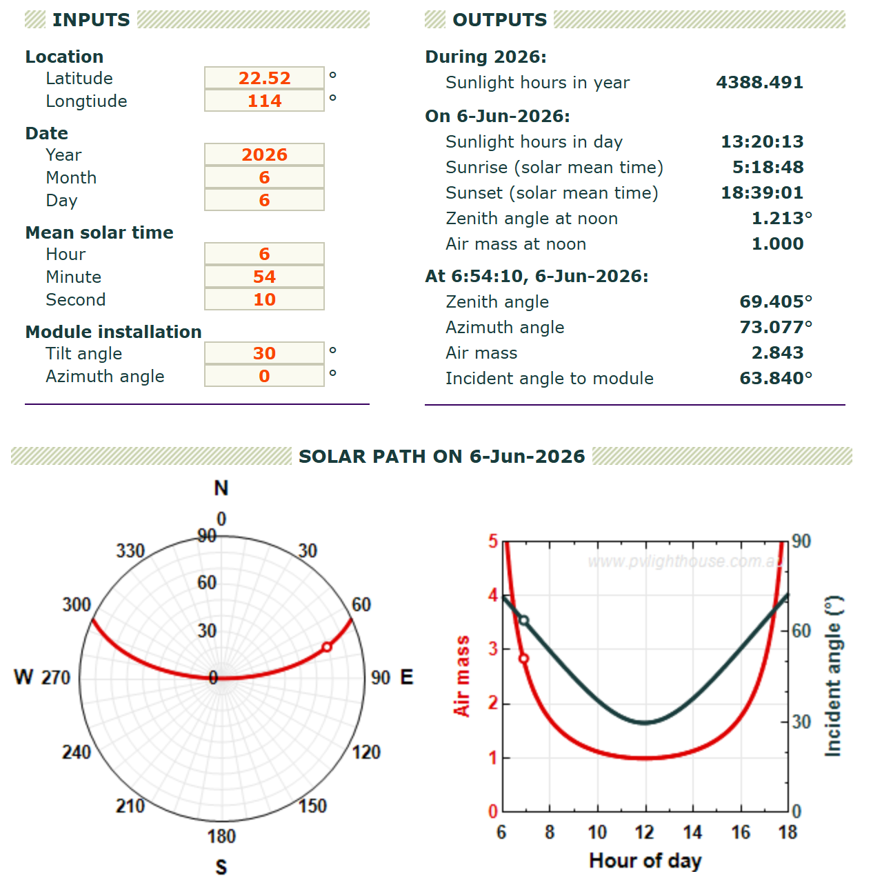
Relative change$=\frac{cos(0°)-cos(30°)}{cos(0°)}=\frac{1-\frac{\sqrt{3}}{2}}{1}=$13.4%
(d) Plot the sun’s position throughout the day on the polar plot on that day.
As shown in the image, the yellow line represents the position of the sun.、
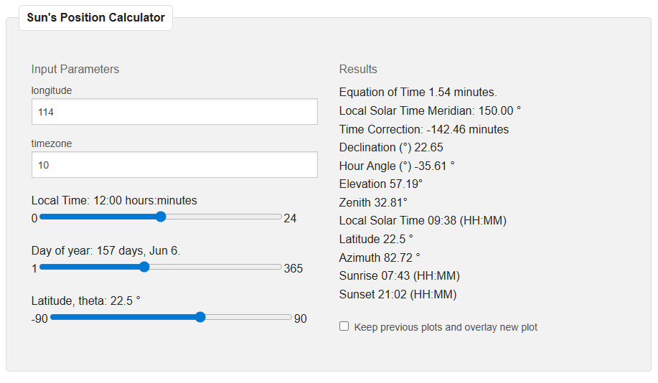
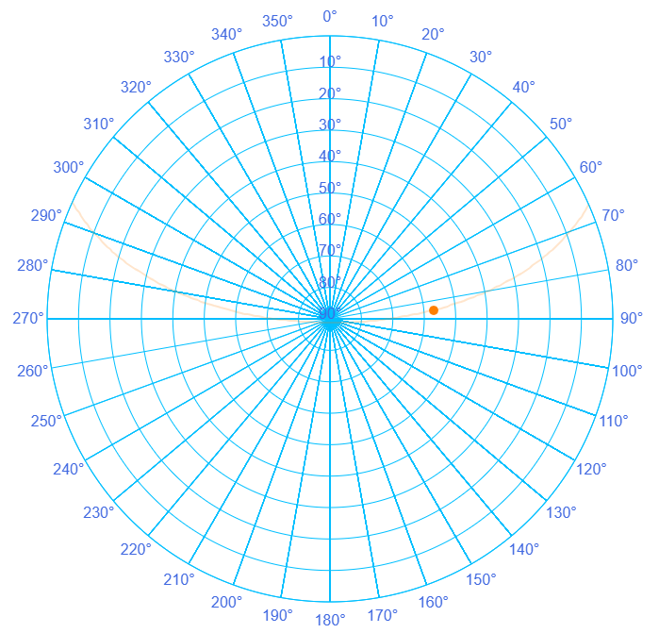
(e) How should position of the solar panel be adjusted (in terms of tilt angle and azimuth angle) at 9am, 12am, 3pm and 5pm of that day to receive the maximum power from the sun?
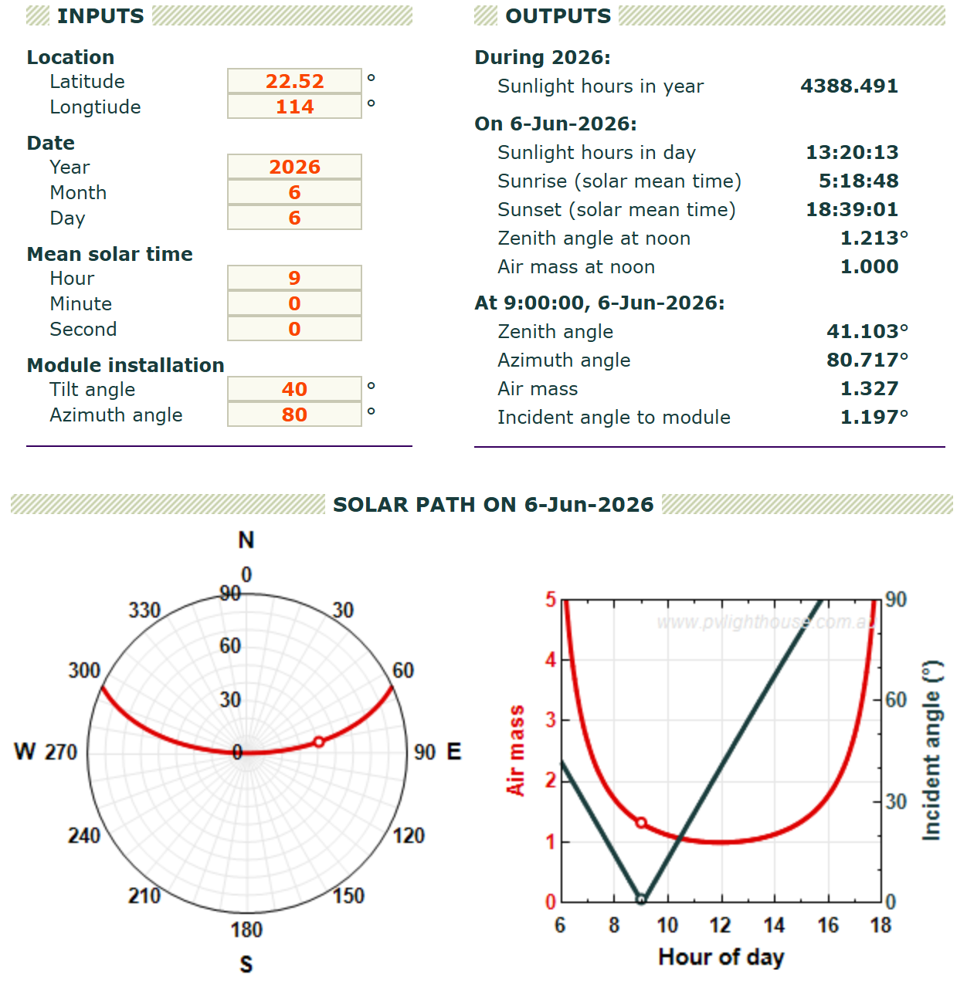
9:00
Tilt Angle: 41.10°
Azimuth Angle: 80.717°

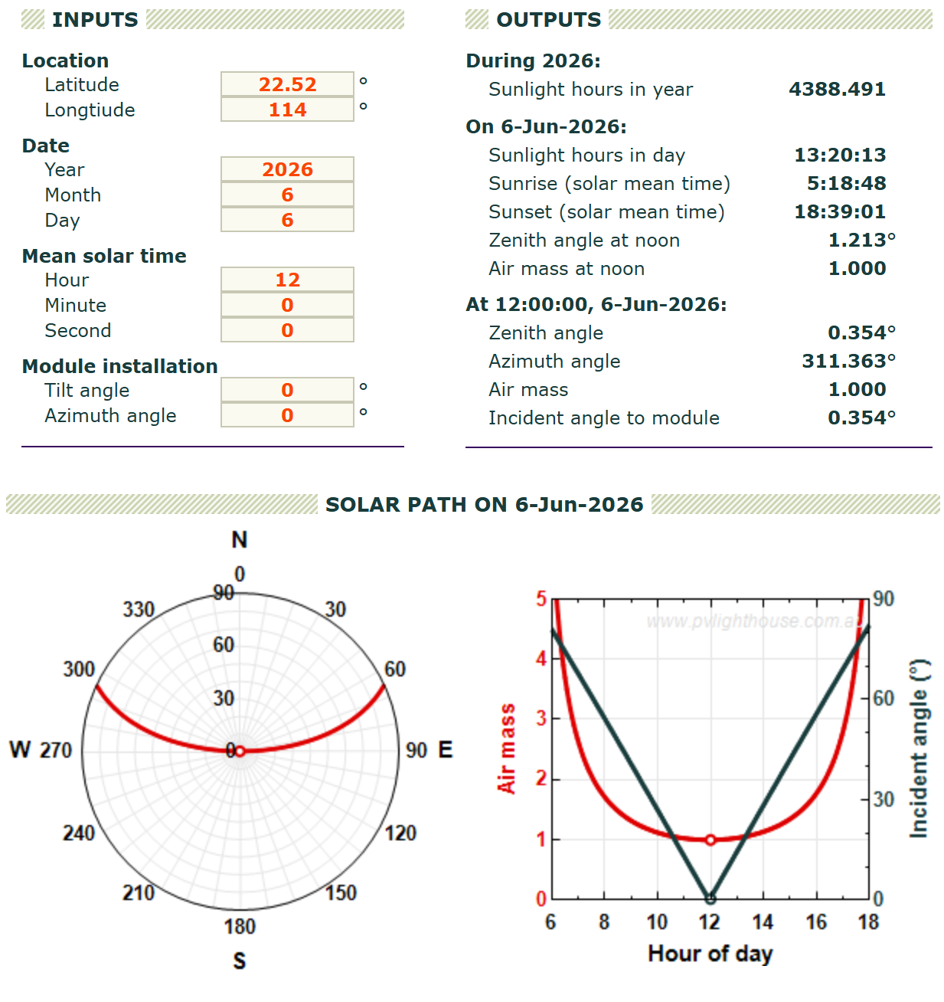
12:00
Tilt Angle: 0.354°
Azimuth Angle: 311.363°

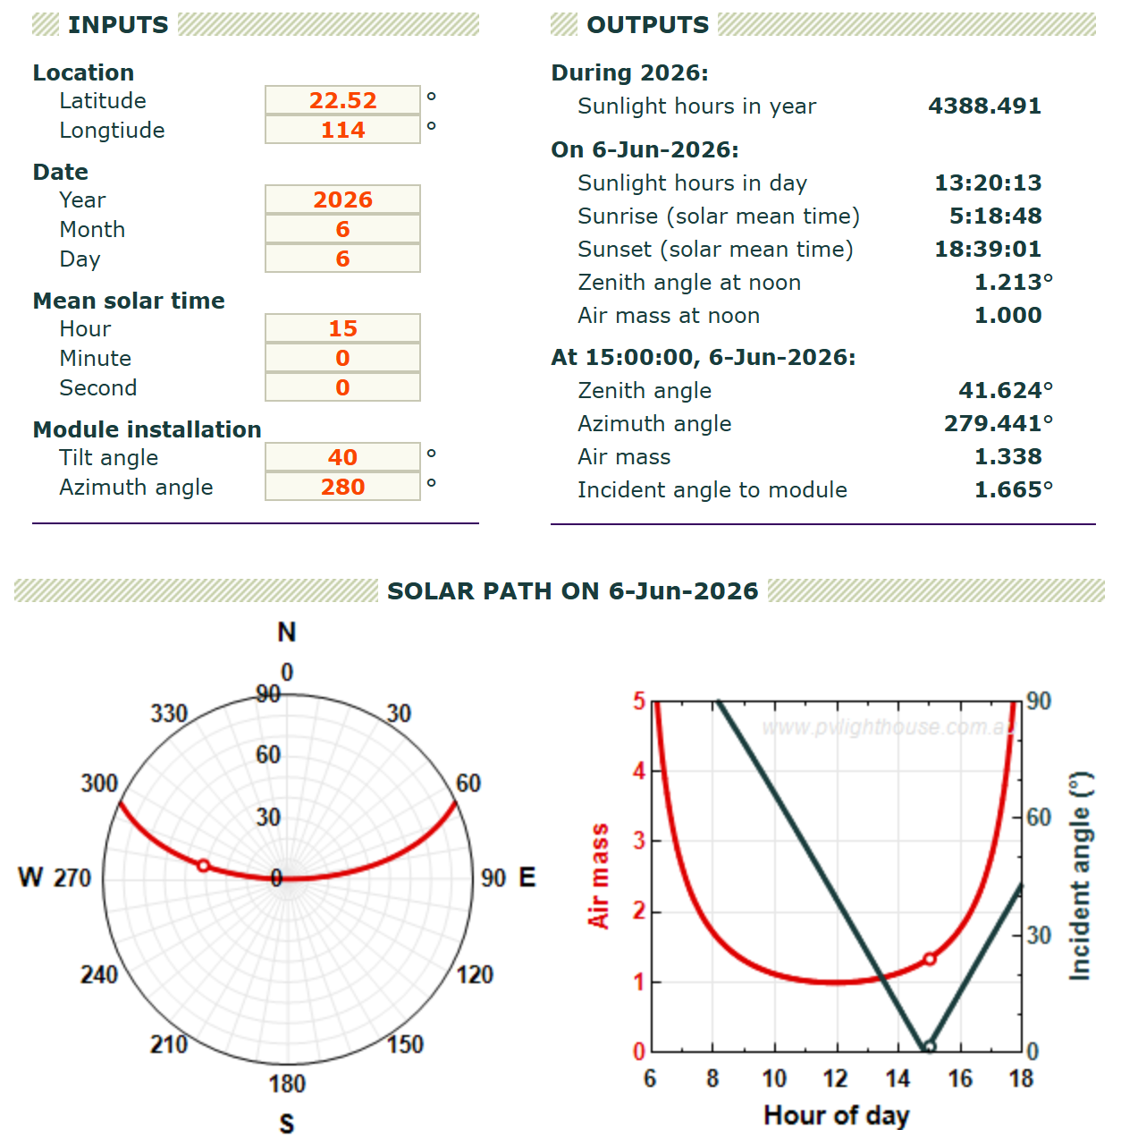
15:00
Tilt Angle: 41.624°
Azimuth Angle: 279.441°

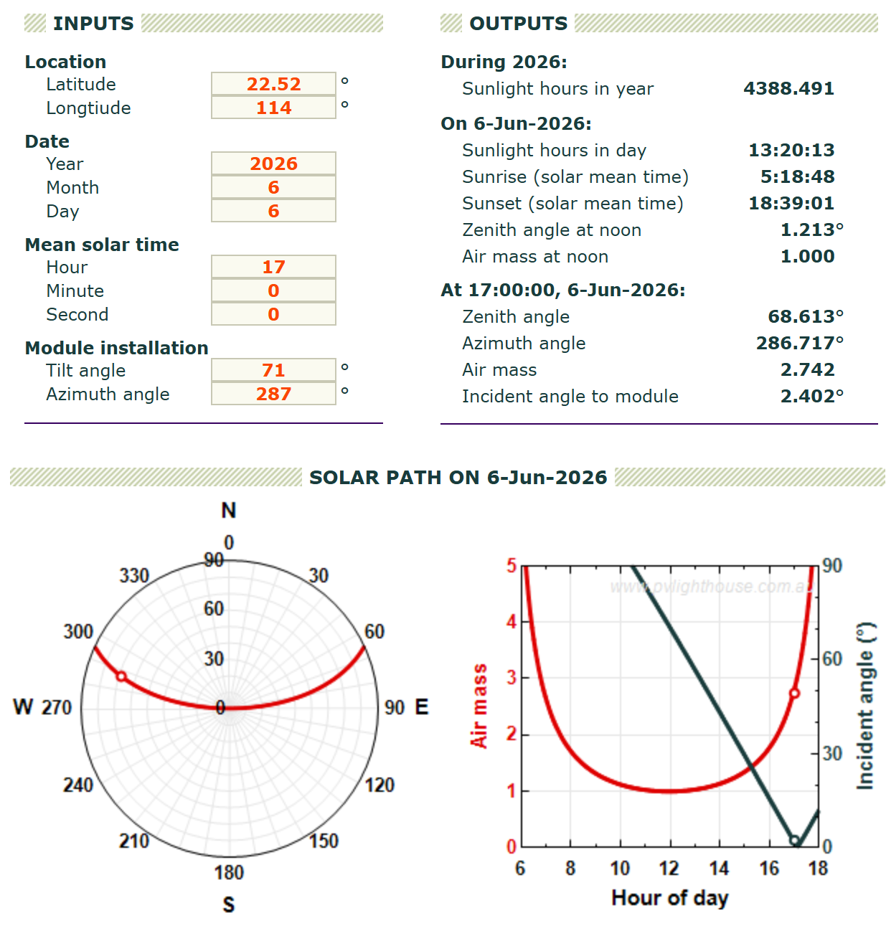
17:00
Tilt Angle: 68.613°
Azimuth Angle: 286.717°

Quiz2
A solar panel is installed with tilt angle 30̊(as in Figure 1b) at Sydney (Australia).
(a) Plot the sun position throughout the day on the polar plot for today.
Sydney is situated at 33.9°S, 151.2°E.
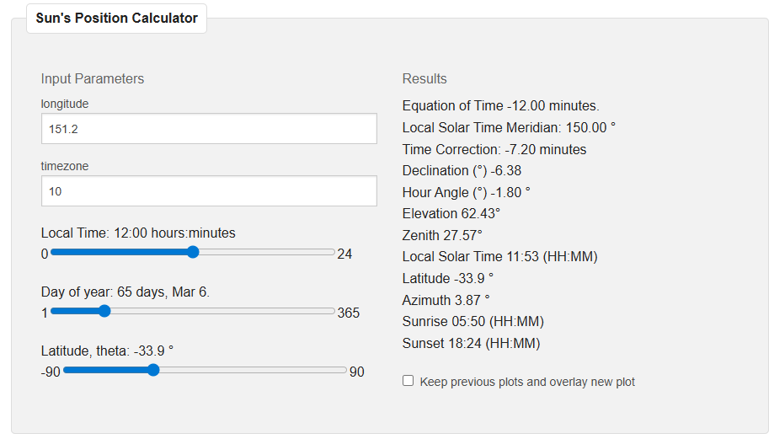
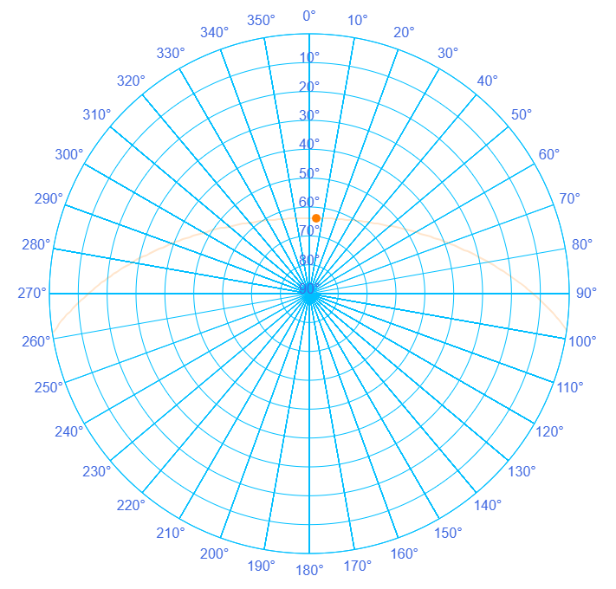
b）If the azimuth angle is set to 0̊, plot the air mass and incident angle to the panel versus hour of the day.
Air mass and incident angle to the panel versus hour of the day.
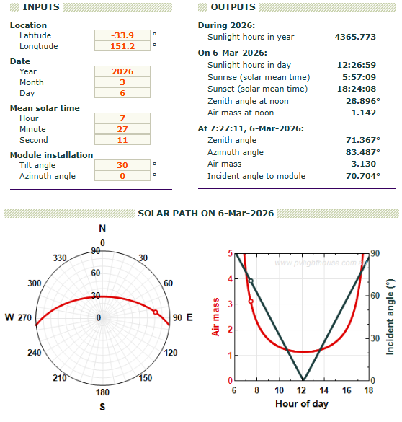
(c) Compare with the sun position plot that you observed in Shenzhen and comment on the observation.
Compare Sydney and Shenzhen
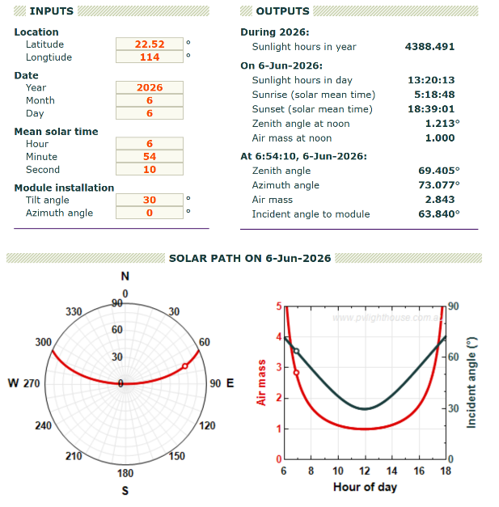
As depicted in the figure, with Sydney on the left and Shenzhen on the right, their respective locations in the Southern (33.9°S) and Northern (22.52°N) Hemispheres lead to completely different solar trajectories. This hemispheric contrast manifests as a clear north-south mirror symmetry in their solar polar diagrams.

(d) What should be the azimuth angle range of the solar panel for today? 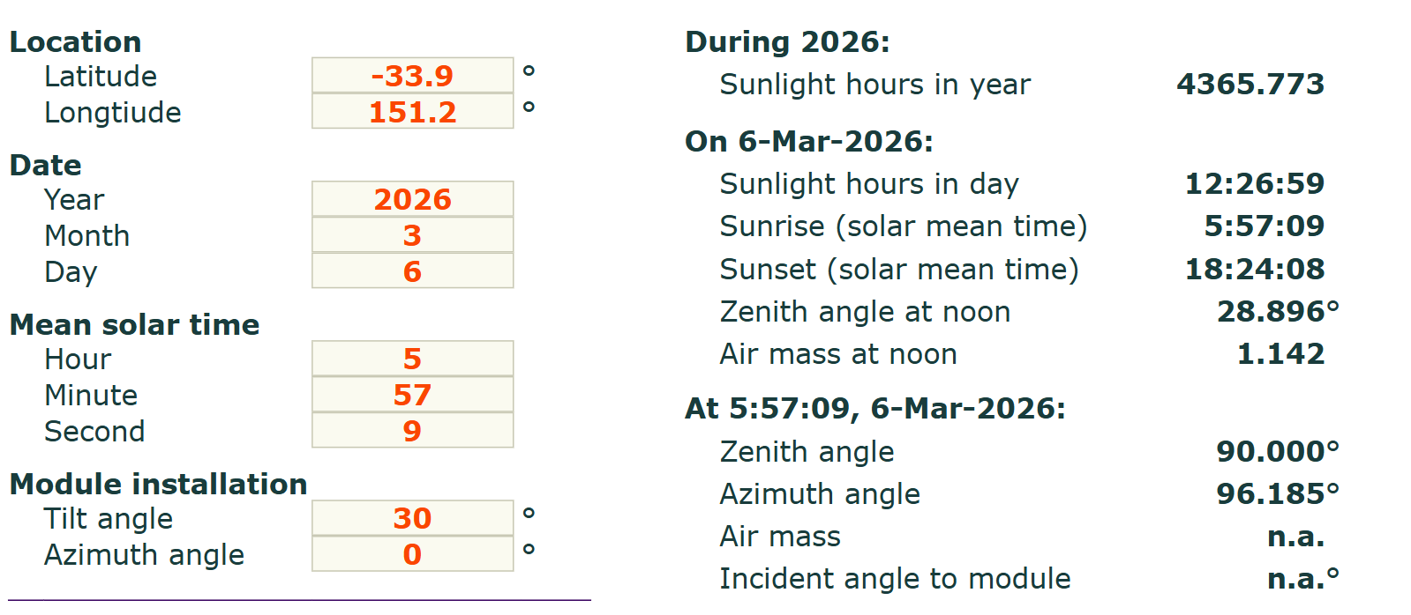
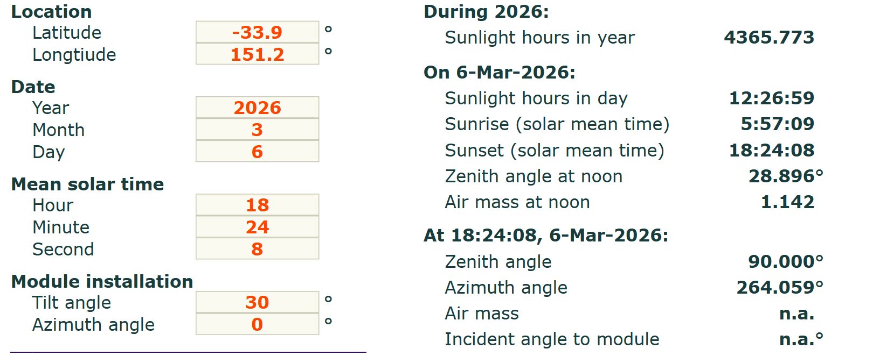
The input is derived from the sunrise and sunset times given in the image, with the two extreme cases of azimuth angle being 96.185° and 264° respectively. The range of variation is 96.185°-360°-264°.

(e) What is the optimized tilt angle and azimuth angle of the solar panel to receive the highest power from sun at today noon?
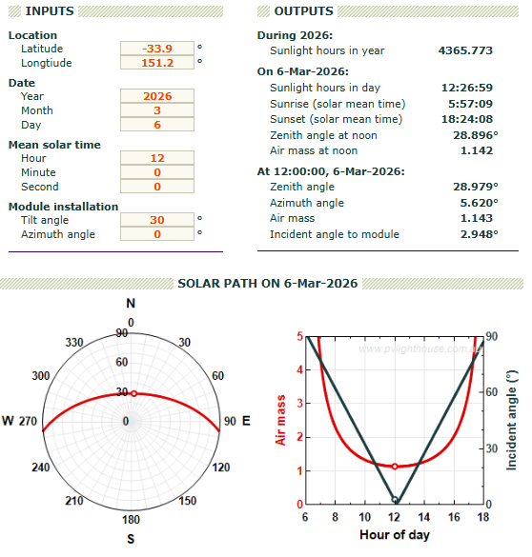
Tilt 28.979°
Azimuth 5.620°

Quiz3
Two solar panels (A and B) are installed in New York City. The solar panel A is installed at tilt angle 0 ̊and the solar panel B is installed at tilt angle 65 ̊. Ignoring the local weather effects,
(a) Compare the solar insolation at New York City on 1st Jan and 30 June and calculate the solar intensity ratio between the two dates.
New York: 40.7°N, 74°W
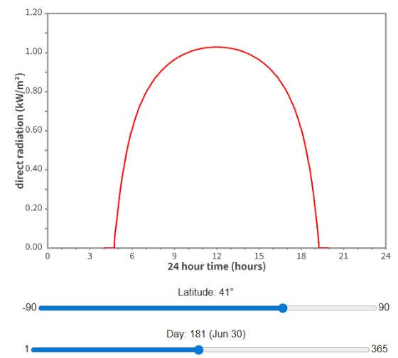
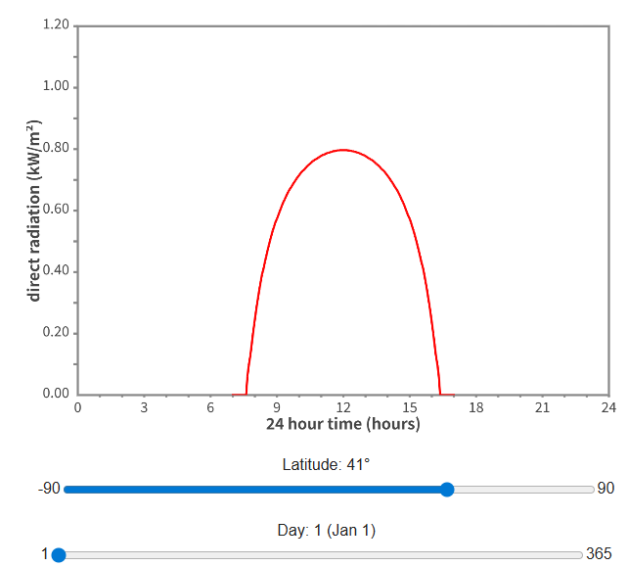

Intensity estimated at the highest point:
1st Jan: 0.797 kW/m²
30th Jun: 1.029 kW/m²
Ratio: 0.797/1.029 = 78%
(b) On which day(s) does the solar panel A receive the highest power from the sun?
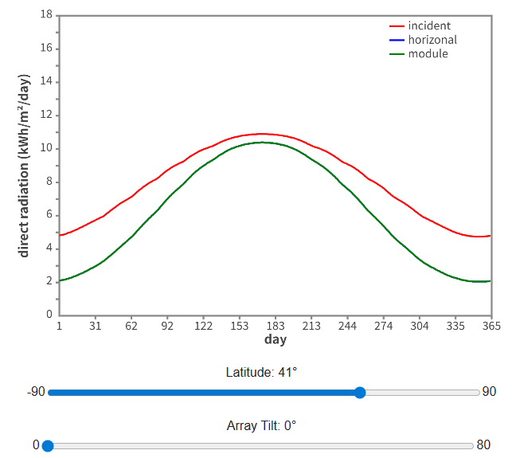
The curve peaked around day 176, on June 25th.

(c) On which day(s) does the solar panel B receive the highest power from the sun?
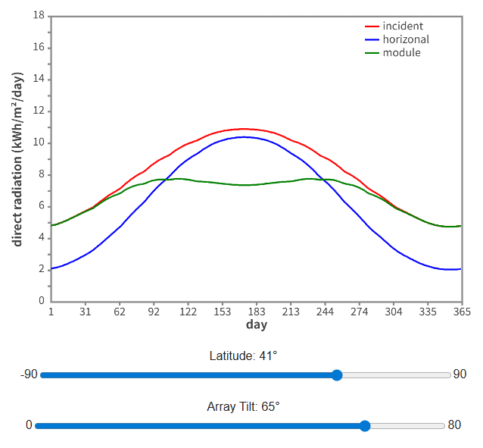
By observing the peak of the green curve and comparing it to the horizontal axis (Day), the two exact dates are approximately:
Around day 115, April 25th
Around day 230, August 16th.
(d) Plot the solar power received by each solar panel through out the year. In which period of the year, the solar panel A outperform the solar panel B? In which period of the year, the solar panel B outperform the solar panel A?
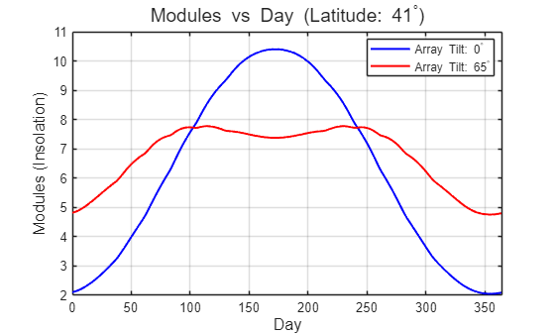

From the spring/autumn equinox to summer (about April to September):
The sun’s path in the sky is relatively high. The horizontally installed solar panel A performs better than panel B. At this time, the 65° tilt angle of panel B is too large, so the sunlight hits the surface at a very shallow angle, resulting in low receiving efficiency.
From the autumn/spring equinox to winter (about October to March):
The sun’s path in the sky is very low. The steep solar panel B performs better than panel A. At this time, it can better face the low-angle winter sunlight, so it receives more solar energy.

(e) Should the tilt angle of the solar panel B be adjusted more than 65 ̊?
No
As calculated in question (c), the zenith angle of the sun at its lowest point of the year (noon on the winter solstice) in New York City is about 64.15°. A tilt angle of 65° already closely matches this extremely low solar angle. If the tilt angle is increased beyond 65° (for example, 75° or even vertical at 90°), the sunlight would strike the panel from slightly above even on the day when the sun is lowest in the year, which would reduce the received power. In addition, the performance loss would become even more significant during the rest of the year.
Quiz4
Suppose that you install a solar panel at the north pole and south pole.
(a) Plot the sun position throughout the day on the polar plot for today.
North Pole, 90° North latitude; South Pole, -90° North latitude
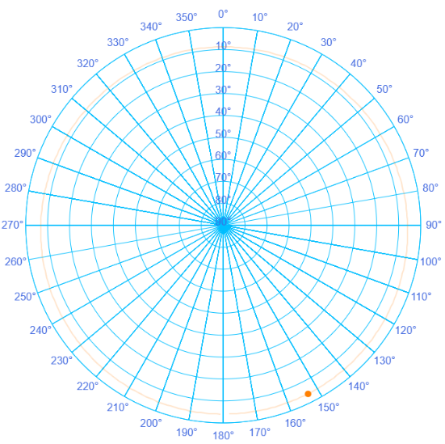
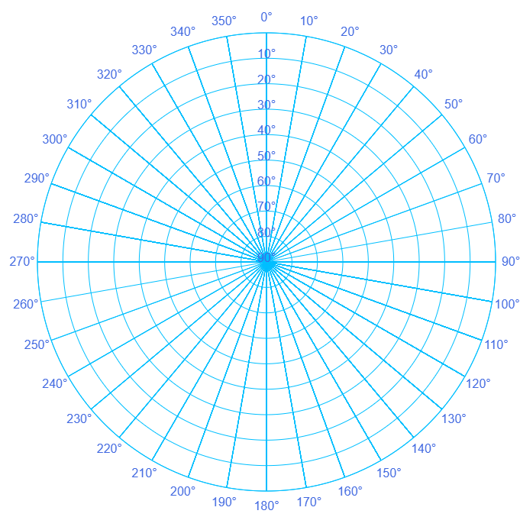
North South

(b) Where is the sun position at mid night and noon?
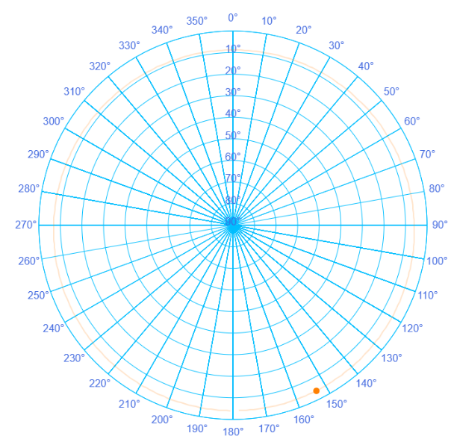
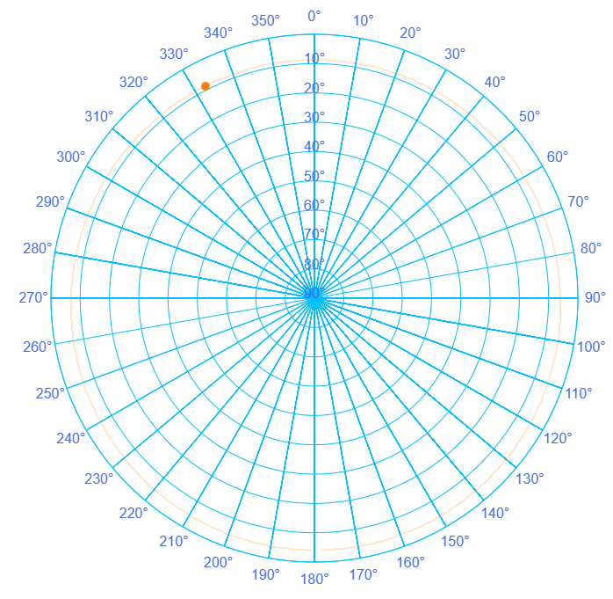
At the poles, the sun's altitude is almost constant throughout the day and it orbits along the horizon, so the sun at noon and midnight is at the same altitude, but in completely opposite positions.

(c) Will you install the solar panel in horizontal position or vertical position?
Vertical installation.
At the pole, even in midsummer (the summer solstice), the maximum solar elevation angle is only about 23.45°. This means that throughout the year, sunlight reaches the surface at a very low angle near the horizon. A vertical installation can better face these low-angle incoming rays and therefore capture more solar energy.

(d) At which tilt angle does the solar panel receive the lowest solar power?
The received power is lowest when the panel is installed horizontally (tilt angle 0°).
At the pole, the solar elevation angle is very low, so sunlight travels almost parallel to the surface of a horizontally placed panel. This very large incident angle leads to a high reflection rate, which greatly reduces the amount of effective radiation absorbed by the solar panel.

(e) How should the tilt angle of the solar panel be adjusted to receive the highest total solar power over the whole year?
To obtain the highest total power throughout the year, a simple fixed tilt angle is not sufficient.
Azimuth tracking: At the pole, the sun rotates 360° horizontally in the sky every day. Therefore, the solar panel should be equipped with a vertical-axis tracking system, so that its front surface follows the sun and rotates once in the horizontal direction every 24 hours.
Seasonal tilt adjustment: The tilt angle of the panel should be adjusted with the seasons so that it always matches the solar zenith angle. At the spring and autumn equinoxes, when the sun just appears above the horizon (solar elevation angle 0°), the panel should remain fully vertical (90°). As the polar day progresses toward the summer solstice, when the solar elevation reaches its maximum of 23.45°, the tilt angle should gradually decrease to about 66.55° (90° − 23.45°).

