Date: 2026/3/6
Quiz1
1）深圳经纬度：北纬22.52°，东经114°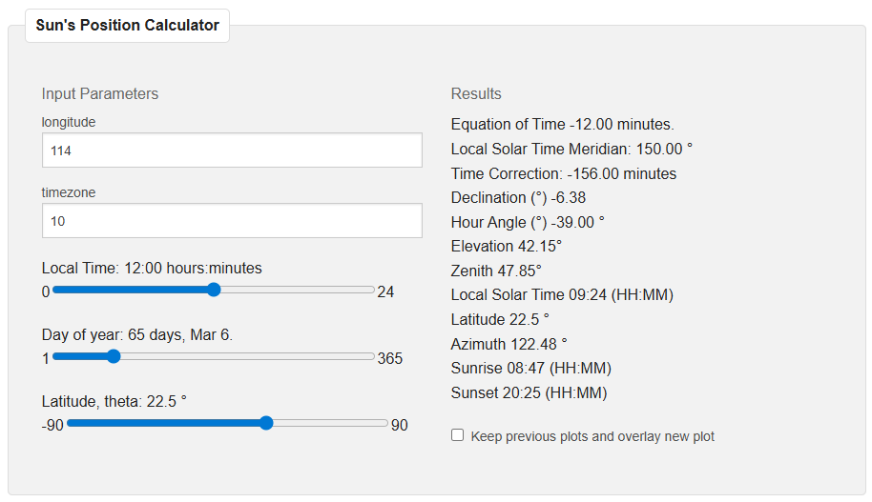
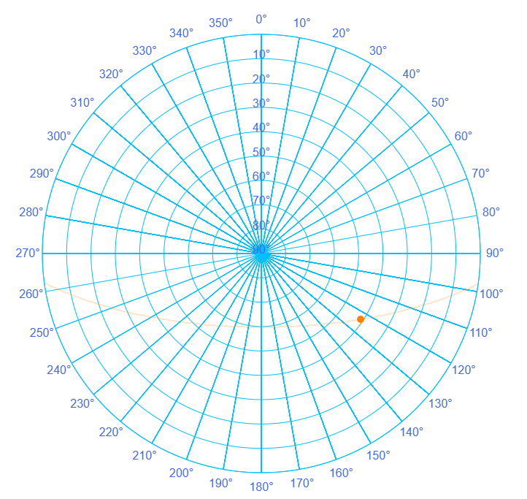
2）
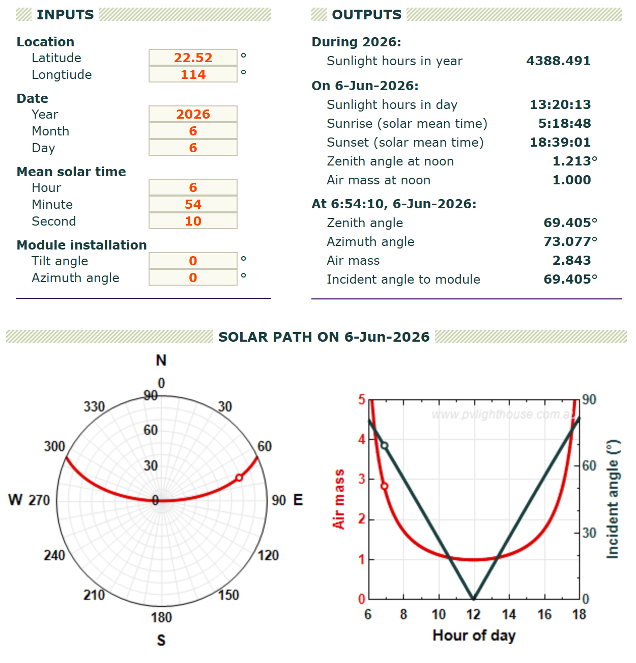

3）
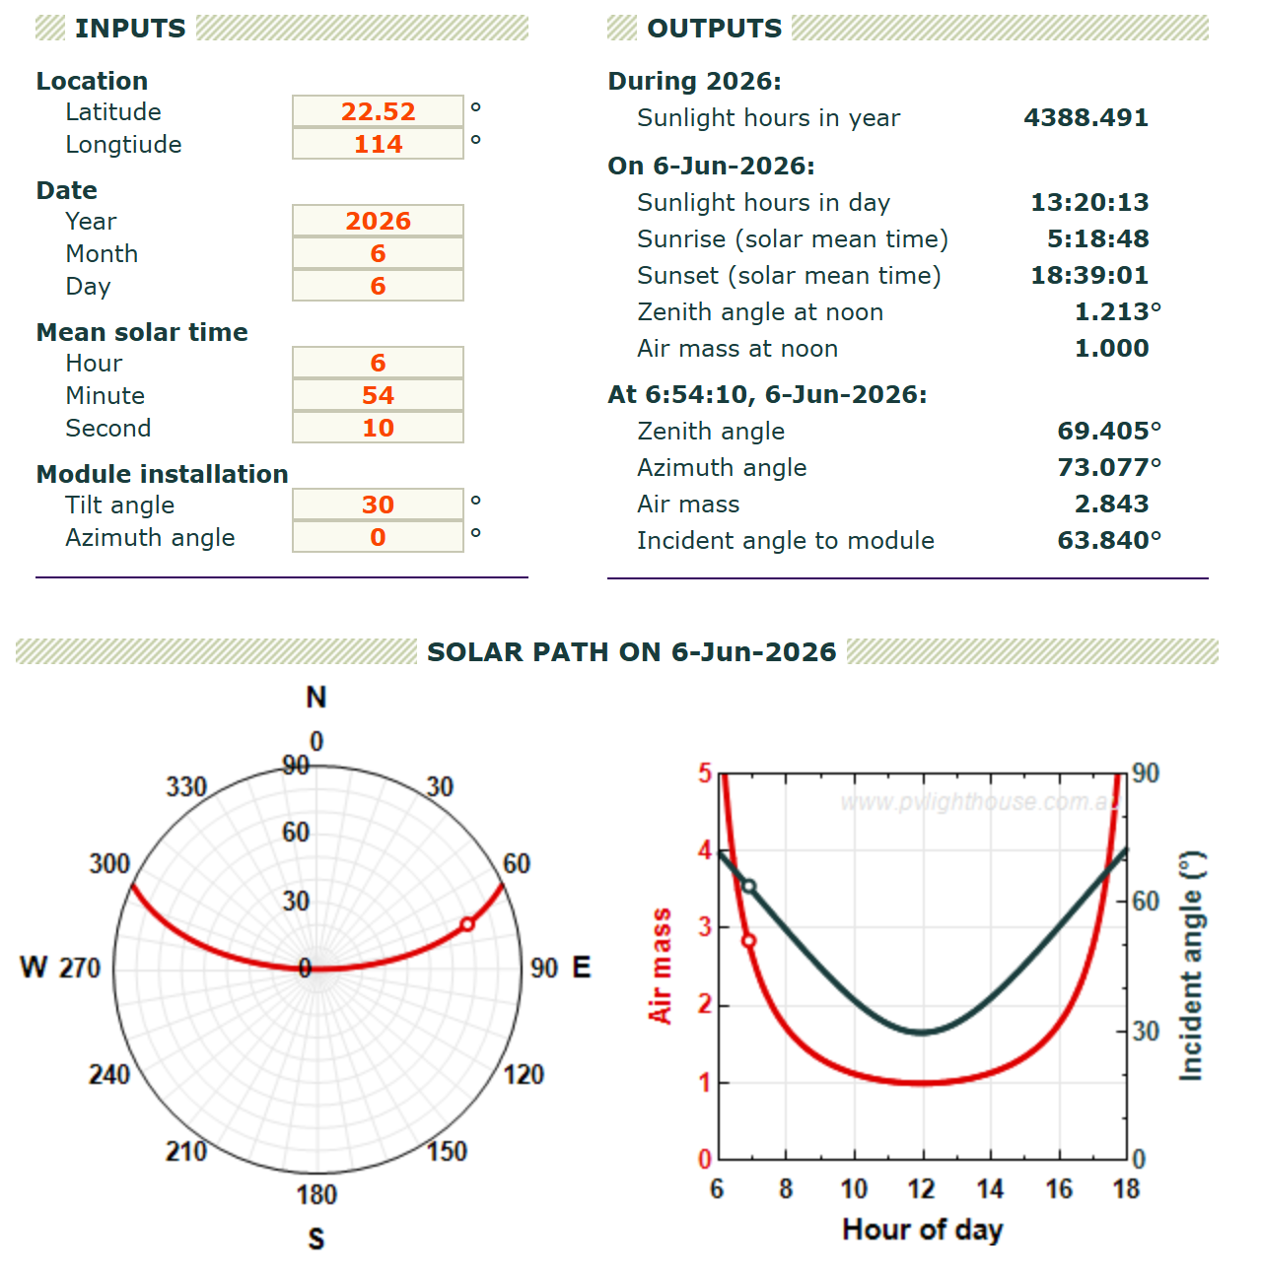

4）
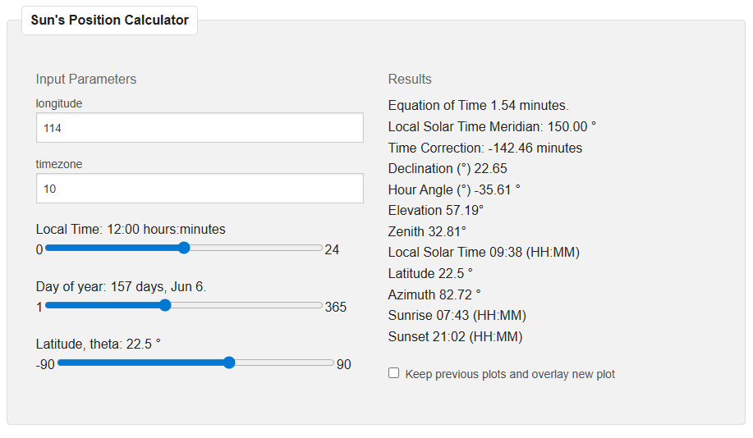
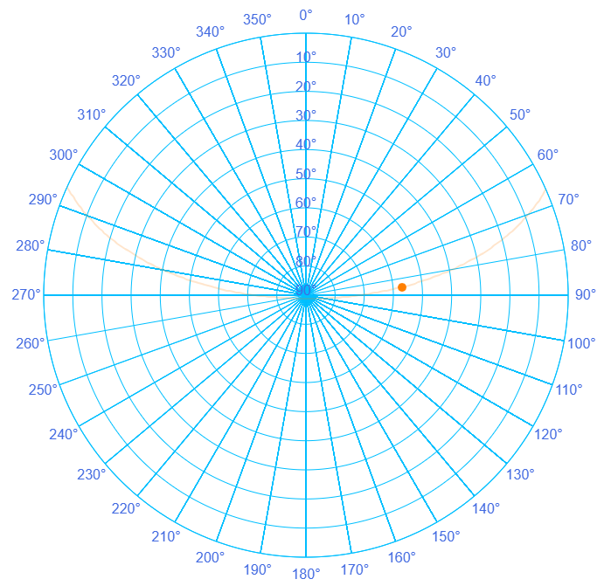
5）
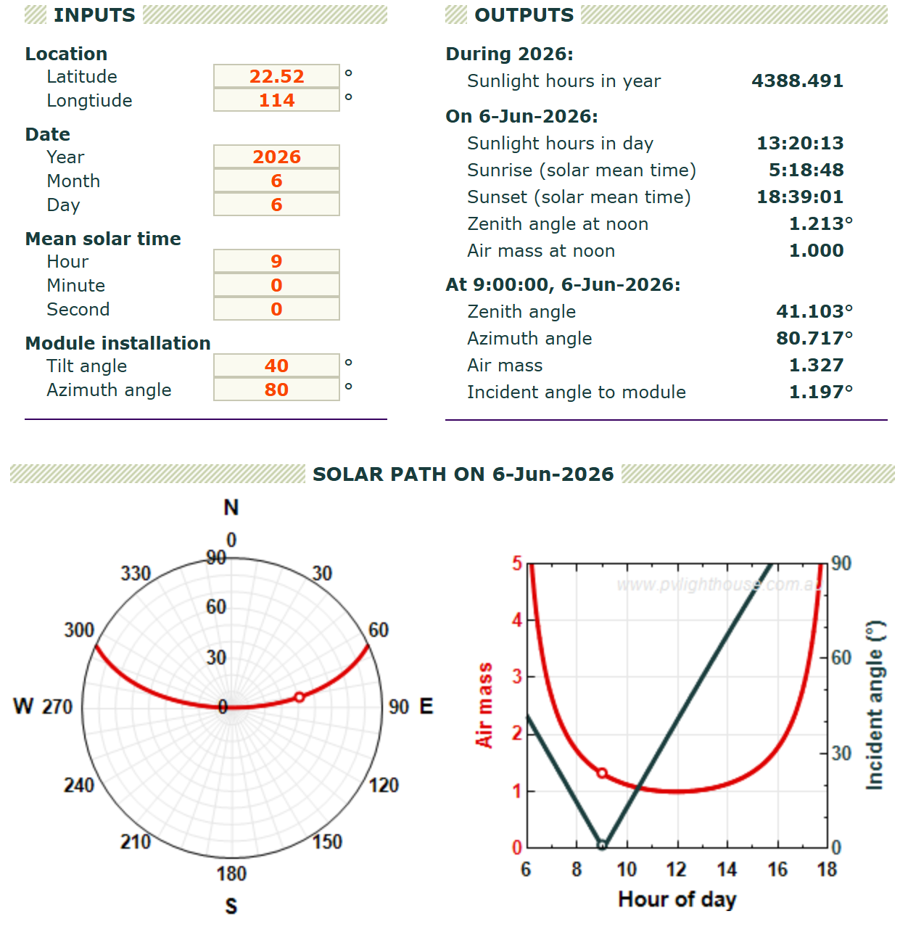
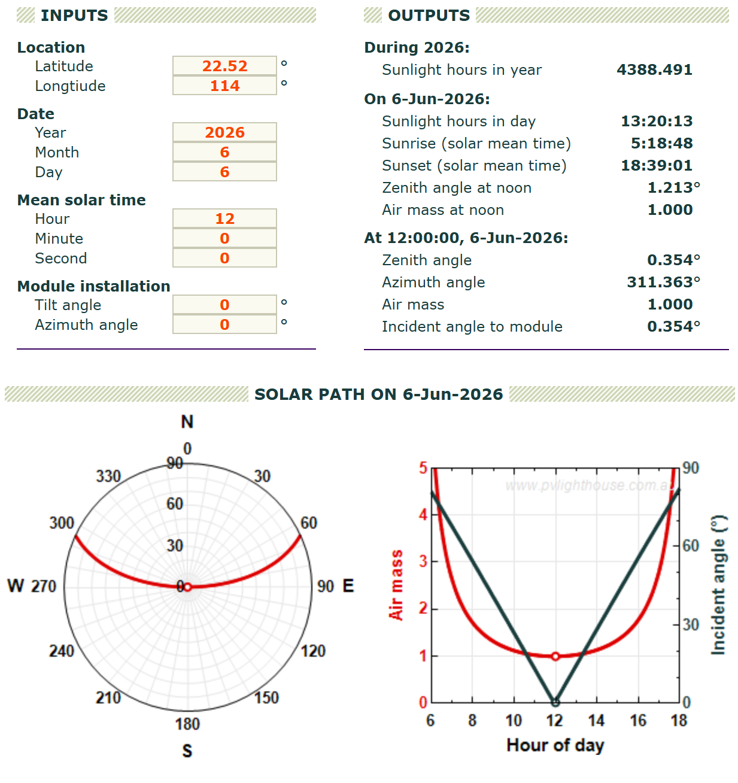
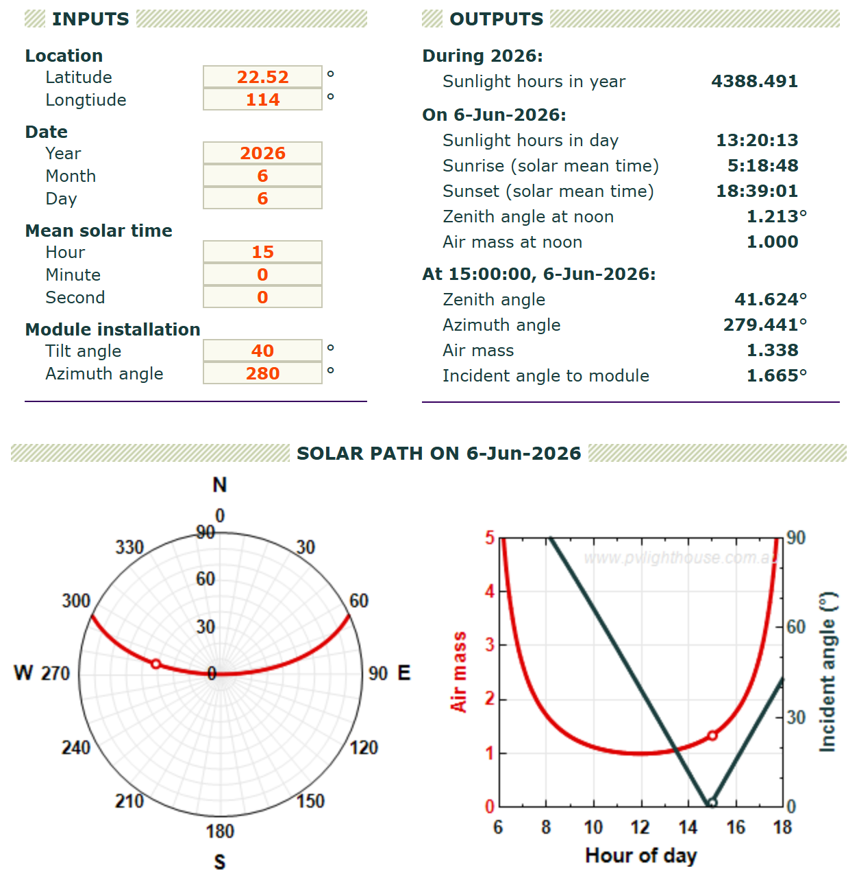
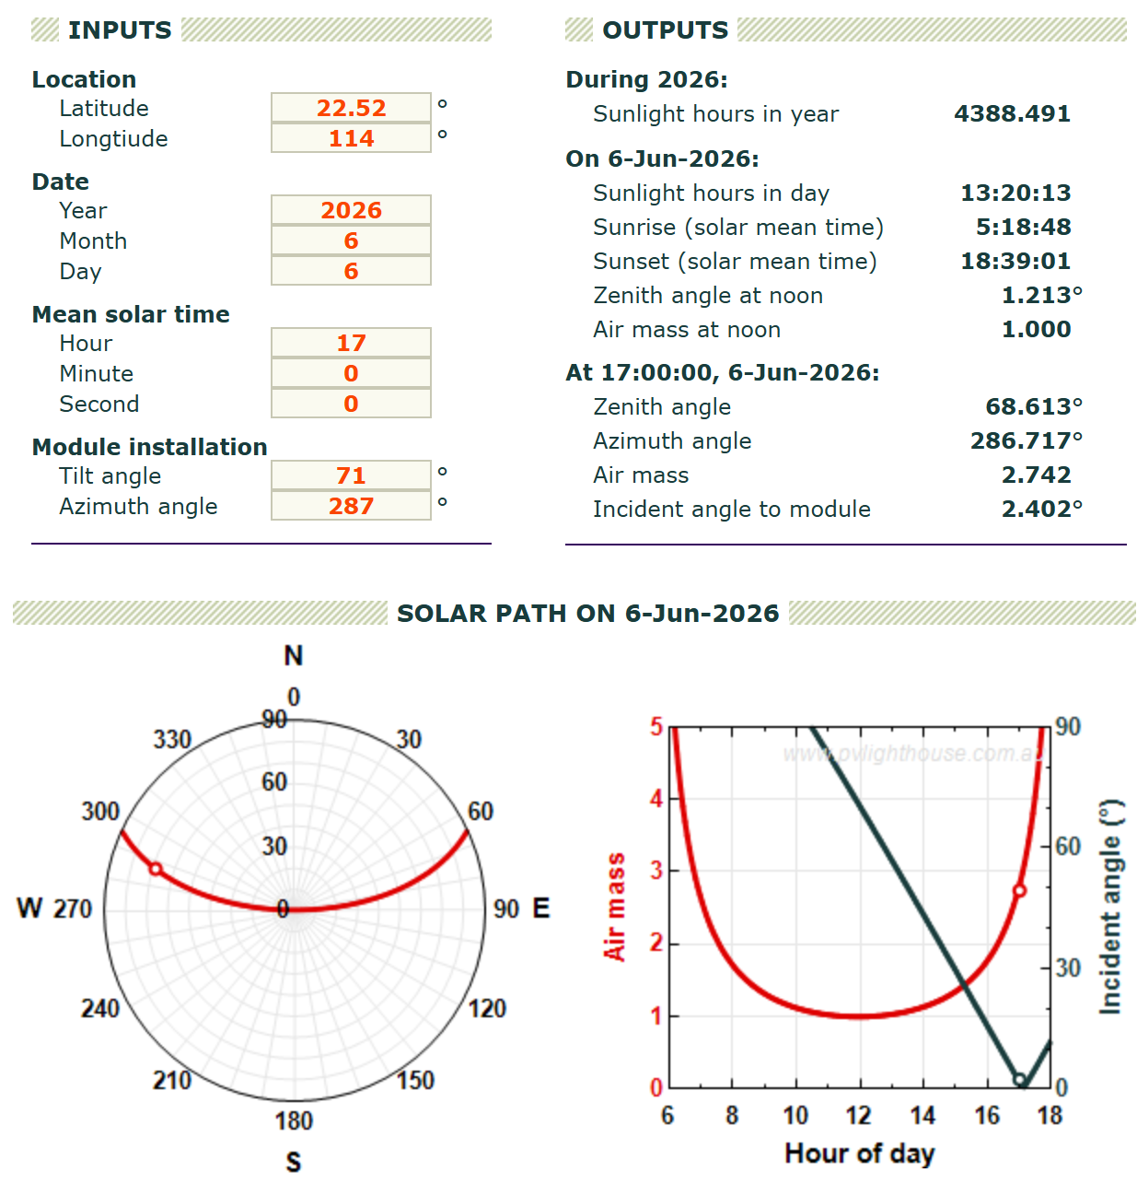

Quiz2
1）悉尼：南纬-33.9°，东经151.2°
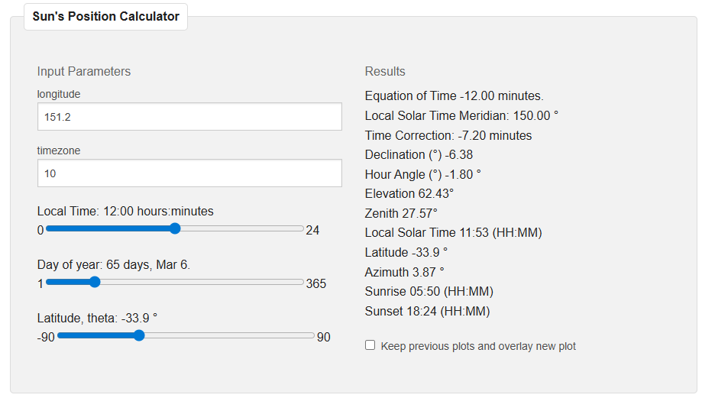
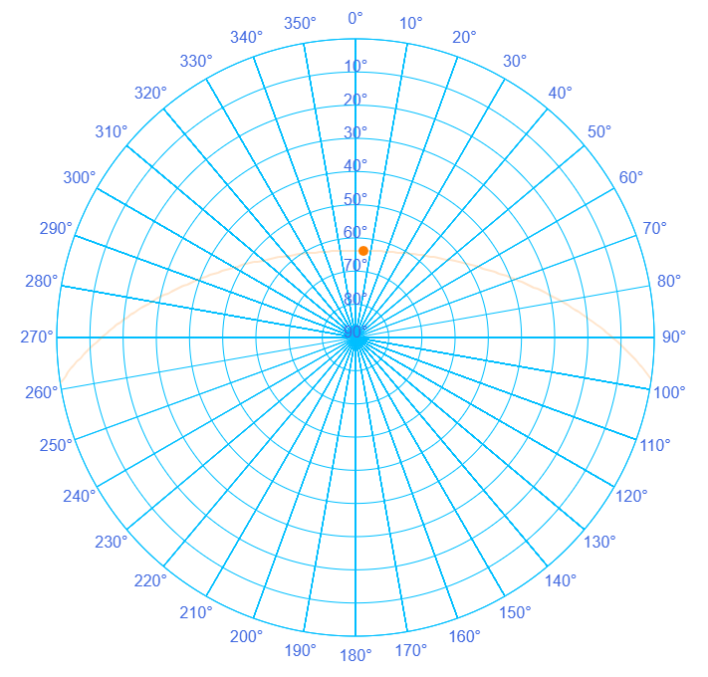
2）
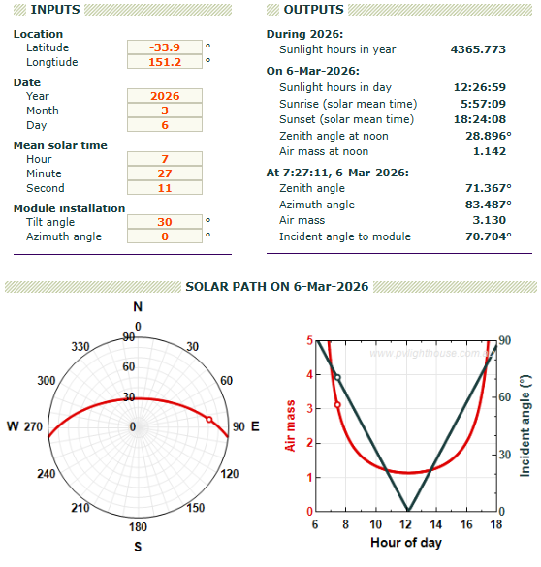

3）Compare Sydney and Shenzhen
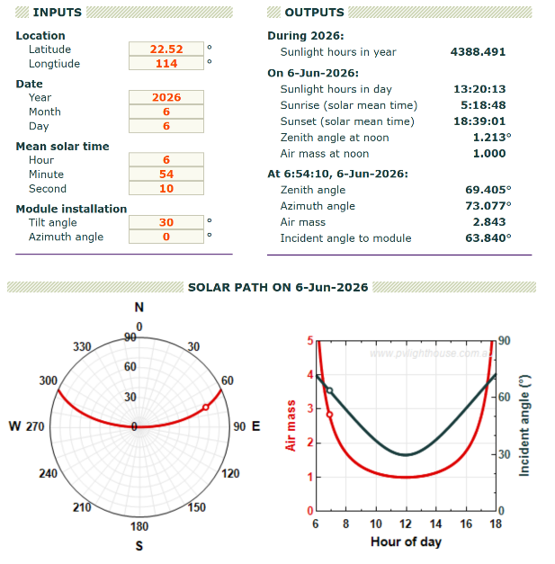
In figure, left is Sydney, right is Shenzhen.
Since Shenzhen is located in the Northern Hemisphere (about 22.52°N), while Sydney is in the Southern Hemisphere(about 33.9°S). The main difference is the sun direction in the sky. Therefore, the polar plots of the sun’s path in the two cities show a clear mirror symmetry in the north-south direction.

4)
89-0-269(-71)
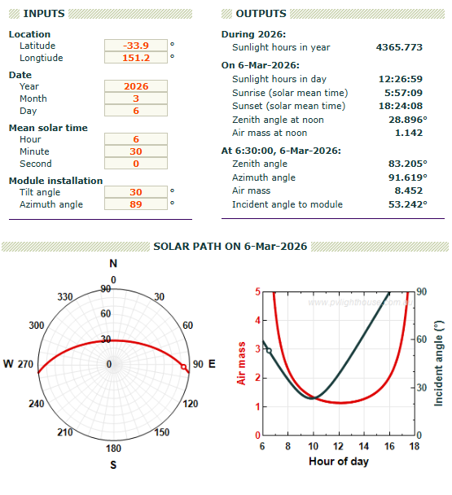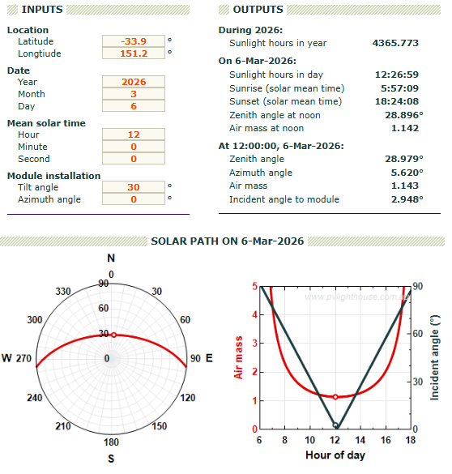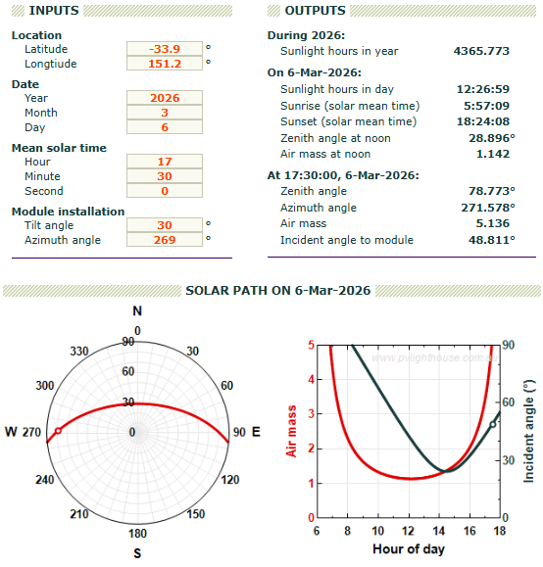

5)

Tilt 30°
Azimuth 0°

Quiz3
1)纽约：北纬40.7°，西经-74°
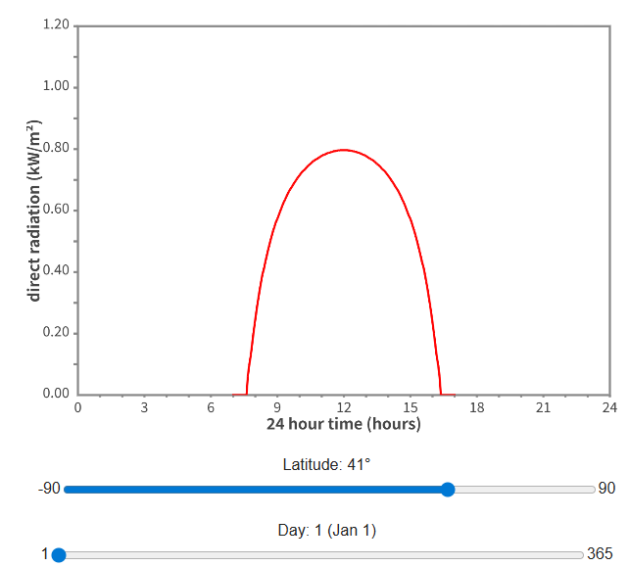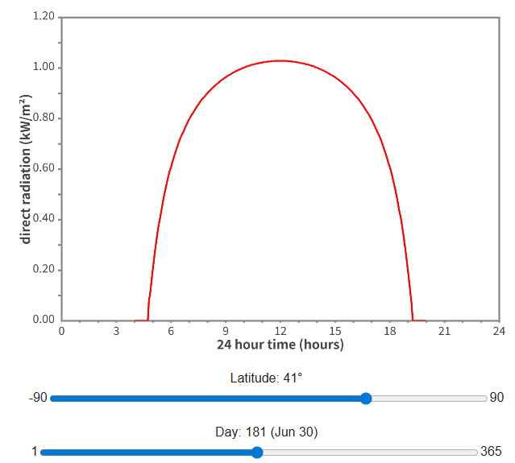
1st Jan max 0.7973 kW/m²
30th Jun max 1.0290 kW/m²
Ratio: 0.7973/1.0290 = 77.5%

2)A tile 0
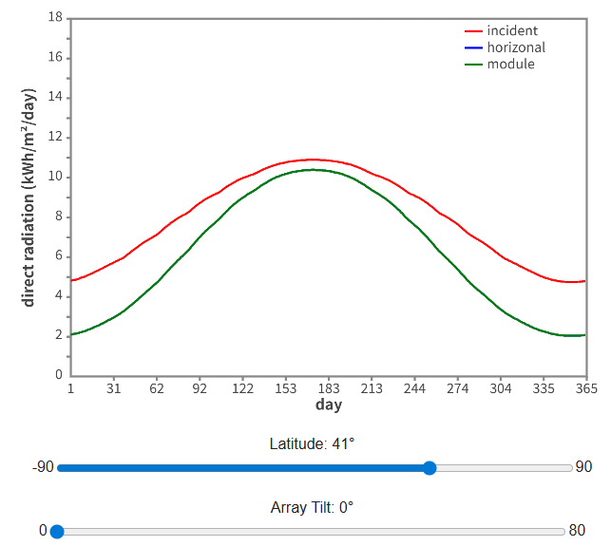
176 10.91 10.4 10.4
June 25th

3）B tilt 65°
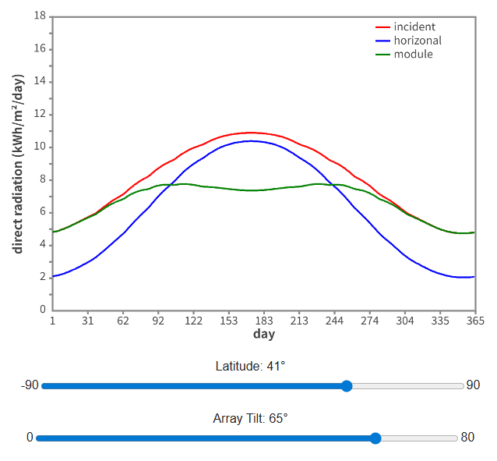
230 9.709 8.556 7.776
Aug 16th

4）画图
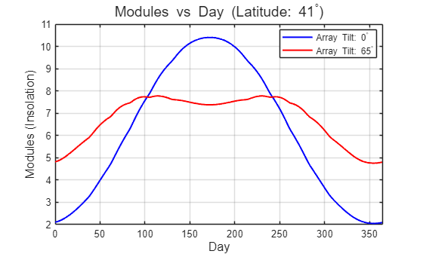
From the spring/autumn equinox to summer (about April to September):
The sun’s path in the sky is relatively high. The horizontally installed solar panel A performs better than panel B. At this time, the 65° tilt angle of panel B is too large, so the sunlight hits the surface at a very shallow angle, resulting in low receiving efficiency.
From the autumn/spring equinox to winter (about October to March):
The sun’s path in the sky is very low. The steep solar panel B performs better than panel A. At this time, it can better face the low-angle winter sunlight, so it receives more solar energy.

5）
Answer: No, it should not.
Reason: As calculated in question (c), the zenith angle of the sun at its lowest point of the year (noon on the winter solstice) in New York City is about 64.15°. A tilt angle of 65° already closely matches this extremely low solar angle. If the tilt angle is increased beyond 65° (for example, 75° or even vertical at 90°), the sunlight would strike the panel from slightly above even on the day when the sun is lowest in the year, which would reduce the received power. In addition, the performance loss would become even more significant during the rest of the year.

Quiz4
- 北极，北纬90°；南极，北纬-90°
North
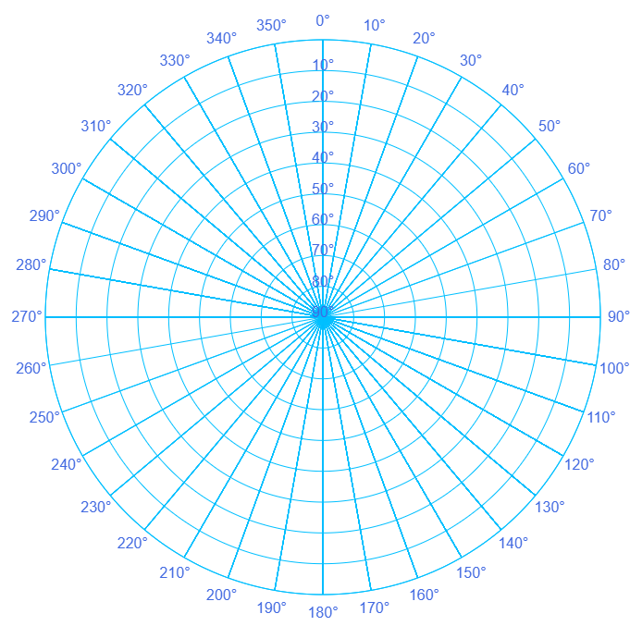
South
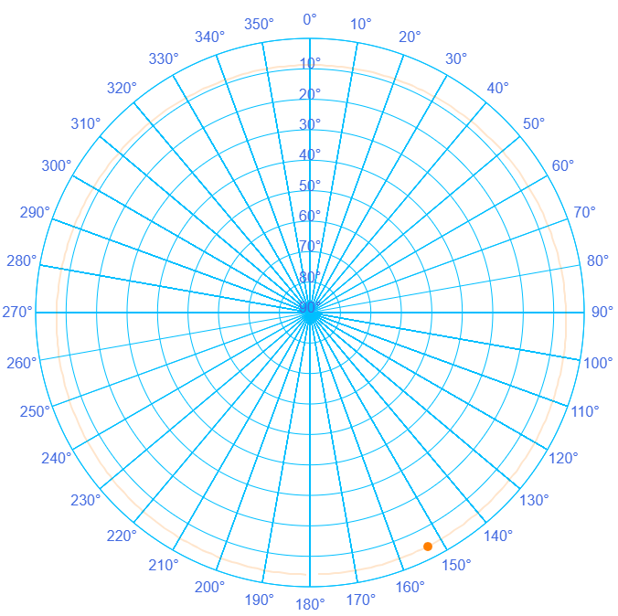
2)
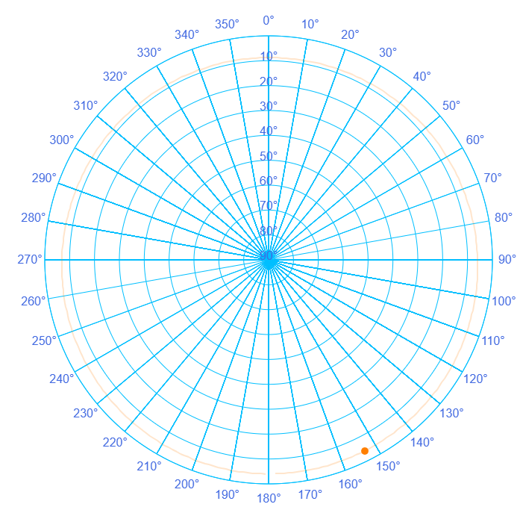
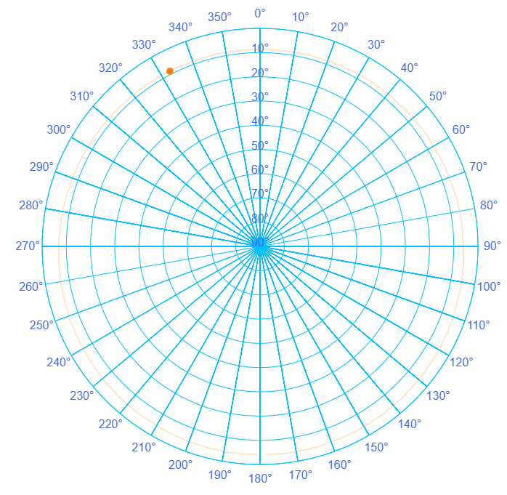

3)
Answer: I would choose a vertical installation (tilt angle 90°).
Reason: At the pole, even in midsummer (the summer solstice), the maximum solar elevation angle is only about 23.45°. This means that throughout the year, sunlight reaches the surface at a very low angle near the horizon. A vertical installation can better face these low-angle incoming rays and therefore capture more solar energy.

4）
Answer: The received power is lowest when the panel is installed horizontally (tilt angle 0°).
Reason: At the pole, the solar elevation angle is very low, so sunlight travels almost parallel to the surface of a horizontally placed panel. This very large incident angle leads to a high reflection rate, which greatly reduces the amount of effective radiation absorbed by the solar panel.

5）
Answer:
To obtain the highest total power throughout the year, a simple fixed tilt angle is not sufficient.
Azimuth tracking: At the pole, the sun rotates 360° horizontally in the sky every day. Therefore, the solar panel should be equipped with a vertical-axis tracking system, so that its front surface follows the sun and rotates once in the horizontal direction every 24 hours.
Seasonal tilt adjustment: The tilt angle of the panel should be adjusted with the seasons so that it always matches the solar zenith angle. At the spring and autumn equinoxes, when the sun just appears above the horizon (solar elevation angle 0°), the panel should remain fully vertical (90°). As the polar day progresses toward the summer solstice, when the solar elevation reaches its maximum of 23.45°, the tilt angle should gradually decrease to about 66.55° (90° − 23.45°).

