Lab 2: Fabrication and Characterization of Perovskite Solar Cells

实验二：钙钛矿太阳能电池的制备与表征

Abstract / 摘要
English. This experiment focuses on the fabrication and characterization of inverted p-i-n perovskite solar cells. The lab includes normal-bandgap perovskite, Cs0.05FA0.902MA0.048PbI2.7Br0.3, and wide-bandgap perovskite, Cs0.25FA0.75Pb(Br0.5I0.5)3. Based on the provided J-V and EQE data, the normal-bandgap devices show higher short-circuit current density and higher power conversion efficiency, while the wide-bandgap devices show higher open-circuit voltage. From the Origin-style J-V curves, the average estimated performance is JSC = 25.03 mA cm-2, VOC = 1.167 V, FF = 0.777, and PCE = 22.70% for the normal-bandgap cells, and JSC = 14.17 mA cm-2, VOC = 1.345 V, FF = 0.797, and PCE = 15.22% for the wide-bandgap cells. From the EQE absorption edges, the estimated bandgaps are approximately 1.56 eV for the normal-bandgap perovskite and approximately 1.83 eV for the wide-bandgap perovskite.
中文。 本实验研究倒置 p-i-n 结构钙钛矿太阳能电池的制备与表征。实验涉及正常带隙钙钛矿 Cs0.05FA0.902MA0.048PbI2.7Br0.3 和宽带隙钙钛矿 Cs0.25FA0.75Pb(Br0.5I0.5)3。根据提供的 J-V 与 EQE 数据，正常带隙器件具有更高的短路电流密度和更高的光电转换效率，而宽带隙器件具有更高的开路电压。由 Origin 风格 J-V 曲线估算，正常带隙电池的平均性能约为 JSC = 25.03 mA cm-2、VOC = 1.167 V、FF = 0.777、PCE = 22.70%；宽带隙电池的平均性能约为 JSC = 14.17 mA cm-2、VOC = 1.345 V、FF = 0.797、PCE = 15.22%。由 EQE 吸收边估算，正常带隙钙钛矿的带隙约为 1.56 eV，宽带隙钙钛矿的带隙约为 1.83 eV。

1. Introduction / 引言
English. Metal-halide perovskite solar cells have attracted great attention because they combine strong optical absorption, tunable bandgap, long carrier diffusion length, and low-temperature solution processing. By changing the halide composition, especially the I/Br ratio, the bandgap can be tuned from a normal-bandgap value suitable for high-current single-junction devices to a wide-bandgap value suitable for tandem solar cells.
中文。 金属卤化物钙钛矿太阳能电池因其强光吸收、可调带隙、较长载流子扩散长度以及低温溶液加工等优点而受到广泛关注。通过调节卤素组成，尤其是 I/Br 比例，可以将带隙从适合高电流单结器件的正常带隙调节到适合叠层太阳能电池的宽带隙。
English. In this lab, the device structure is an inverted p-i-n configuration: ITO/glass / hole transport layer / perovskite absorber / electron transport layer / hole blocking layer / metal electrode. The main characterization methods are J-V measurement under AM1.5G illumination and external quantum efficiency measurement.
中文。 本实验器件采用倒置 p-i-n 结构：ITO 玻璃 / 空穴传输层 / 钙钛矿吸收层 / 电子传输层 / 空穴阻挡层 / 金属电极。主要表征方法包括 AM1.5G 光照下的 J-V 测试和外量子效率 EQE 测试。

2. Experimental Method / 实验方法
English. ITO/glass substrates were sequentially cleaned in diluted detergent, deionized water, isopropanol, and ethanol for 15 min each. Before depositing the hole transport layer, the cleaned substrates were treated by UV-ozone for 25 min. The 4PADCB self-assembled monolayer was spin-coated at 4000 rpm for 30 s and annealed at 120 degC for 10 min.
中文。 ITO 玻璃基底依次在稀释洗涤剂、去离子水、异丙醇和乙醇中超声清洗，每步 15 min。沉积空穴传输层之前，清洗后的基底经过 25 min 紫外臭氧处理。4PADCB 自组装单分子层以 4000 rpm 旋涂 30 s，并在 120 degC 退火 10 min。
English. The perovskite precursor was deposited by a two-step spin-coating process: 1000 rpm for 5 s and then 4000 rpm for 30 s. During the second stage, 160 uL chlorobenzene was dropped as the anti-solvent at 11 s. The film was then annealed at 100 degC for 30 min. PC61BM was spin-coated as the electron transport layer, BCP was spin-coated as the hole blocking layer, and a metal electrode was thermally evaporated through a shadow mask.
中文。 钙钛矿前驱体采用两步旋涂工艺沉积：1000 rpm 旋涂 5 s，随后 4000 rpm 旋涂 30 s。在第二阶段第 11 s 滴加 160 uL 氯苯作为反溶剂，随后薄膜在 100 degC 退火 30 min。PC61BM 作为电子传输层旋涂，BCP 作为空穴阻挡层旋涂，最后通过掩膜热蒸发金属电极。

3. Results / 结果

3.1 J-V Characteristics / J-V 特性
English. The J-V curves show the typical diode behavior of photovoltaic devices. The normal-bandgap cells provide higher photocurrent, while the wide-bandgap cells provide higher voltage. This trend agrees with the expected bandgap-current-voltage tradeoff.
中文。 J-V 曲线表现出典型光伏二极管行为。正常带隙电池具有更高的光电流，而宽带隙电池具有更高的电压。这一趋势符合带隙、电流和电压之间的基本权衡关系。
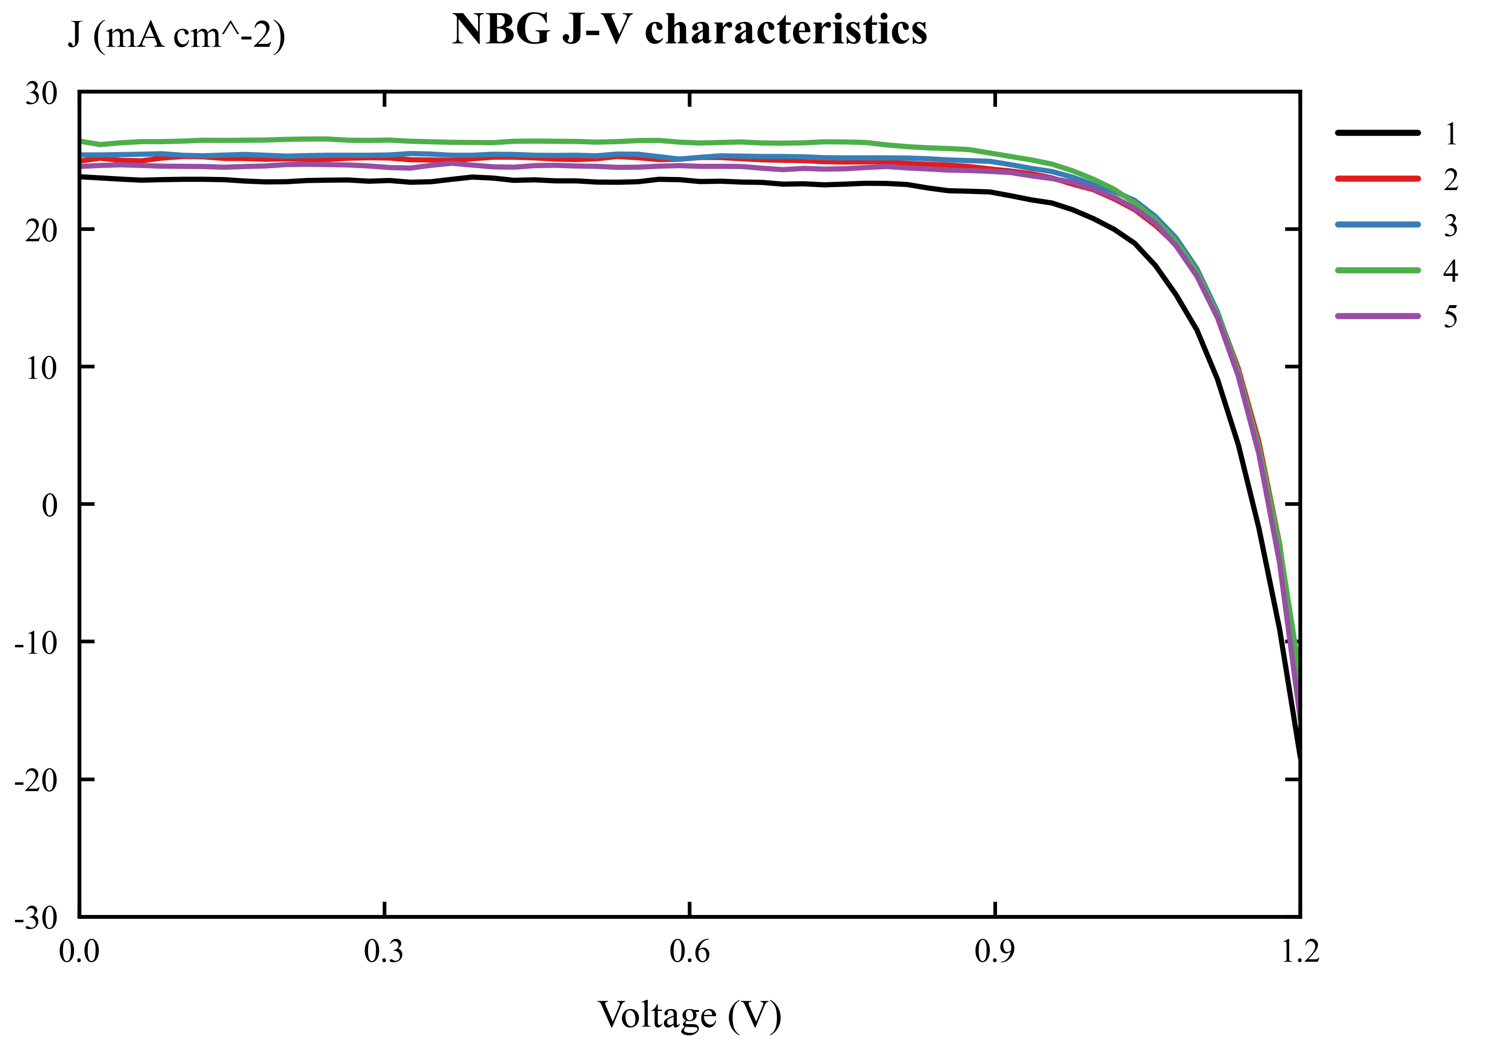
NBG J-V characteristics
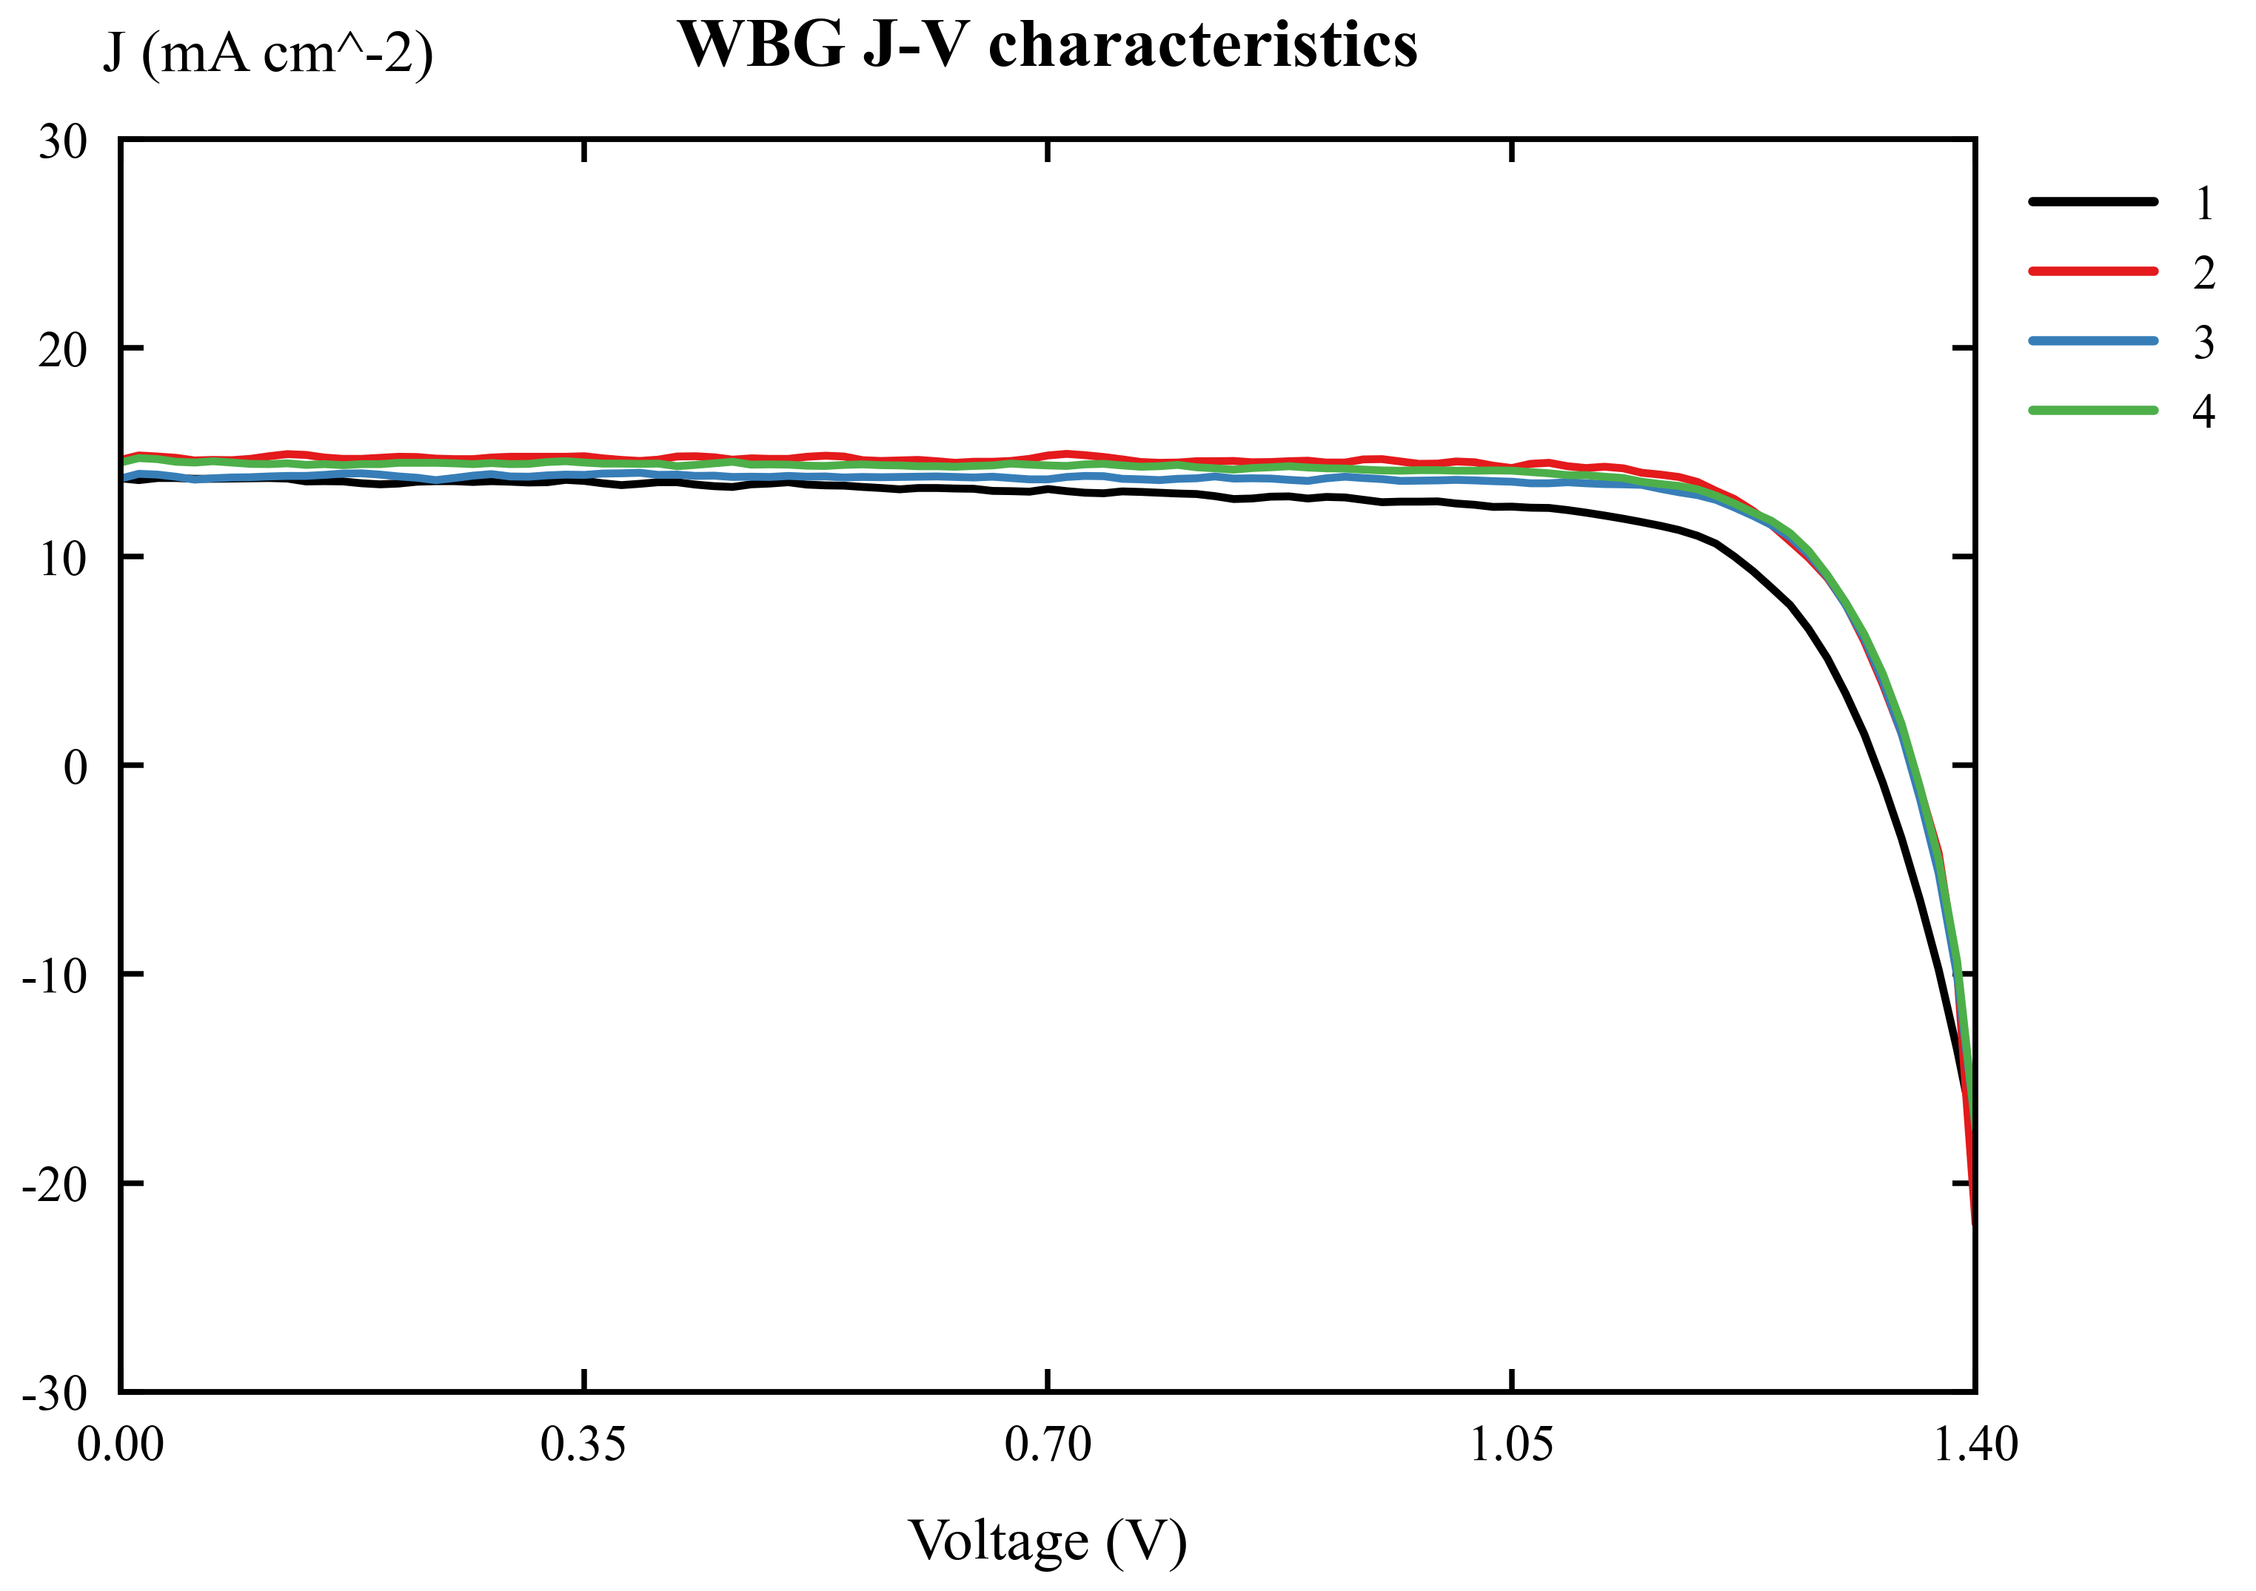
WBG J-V characteristics
Device | JSC (mA cm-2) | VOC (V) | FF | PCE (%)
Normal-bandgap, average | 25.03 | 1.167 | 0.777 | 22.70
Normal-bandgap, standard deviation | 0.97 | 0.008 | 0.014 | 1.04
Wide-bandgap, average | 14.17 | 1.345 | 0.797 | 15.22
Wide-bandgap, standard deviation | 0.48 | 0.014 | 0.043 | 1.25

English. These values were estimated from the provided Origin-style J-V curves. Under 100 mW cm-2 illumination, the maximum output power density in mW cm-2 is numerically equal to PCE in percent.
中文。 表中数值由提供的 Origin 风格 J-V 曲线估算得到。在 100 mW cm-2 光照条件下，最大输出功率密度的数值 mW cm-2 与 PCE 的百分数数值相等。

3.2 EQE Spectra and Bandgap / EQE 光谱与带隙
English. The EQE spectra show that the normal-bandgap perovskite absorbs to longer wavelengths, while the wide-bandgap perovskite has an earlier absorption cutoff. Therefore, the normal-bandgap device can collect more red photons and generates a larger JSC.
中文。 EQE 光谱显示，正常带隙钙钛矿可以吸收到更长波长，而宽带隙钙钛矿的吸收截止波长更短。因此，正常带隙器件能够收集更多红光光子，从而产生更高的 JSC。
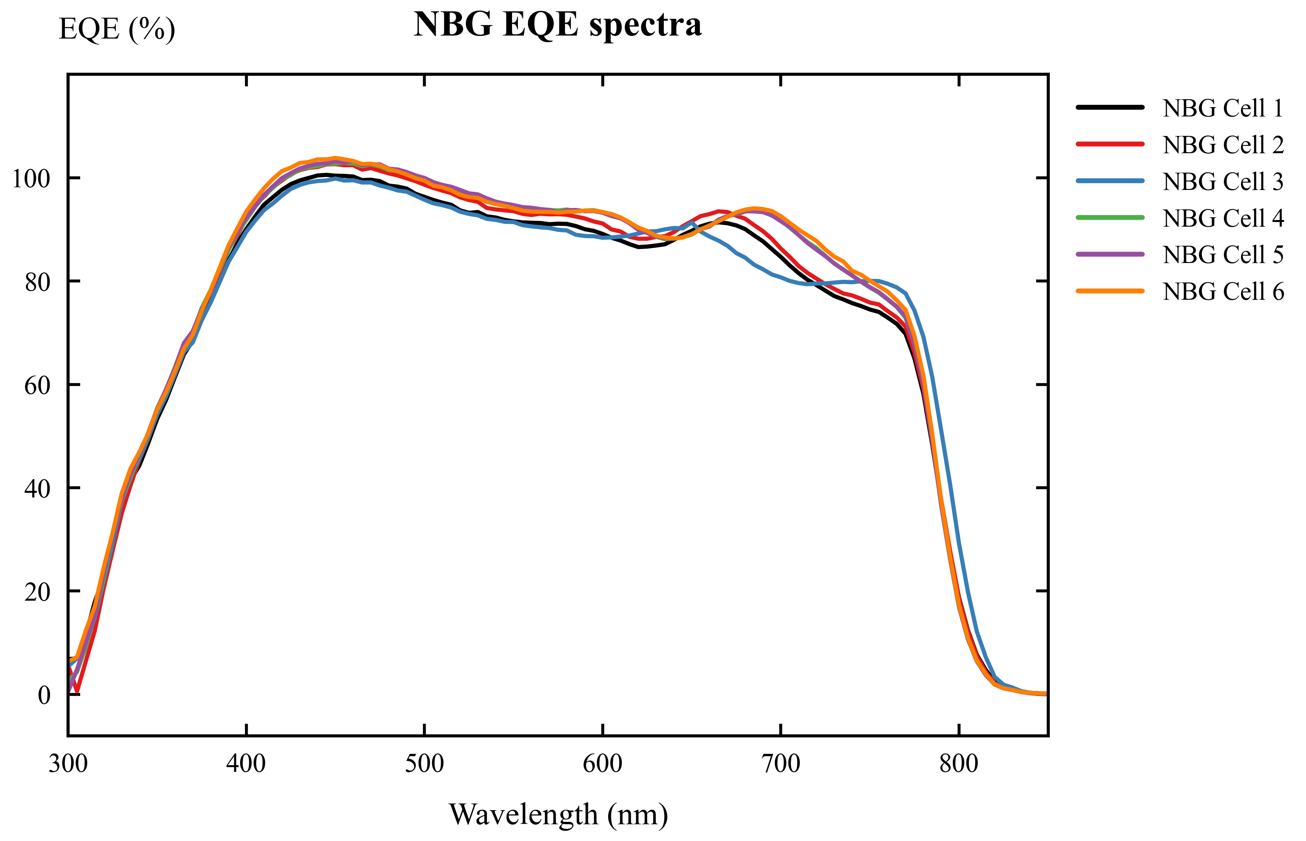
NBG EQE spectra
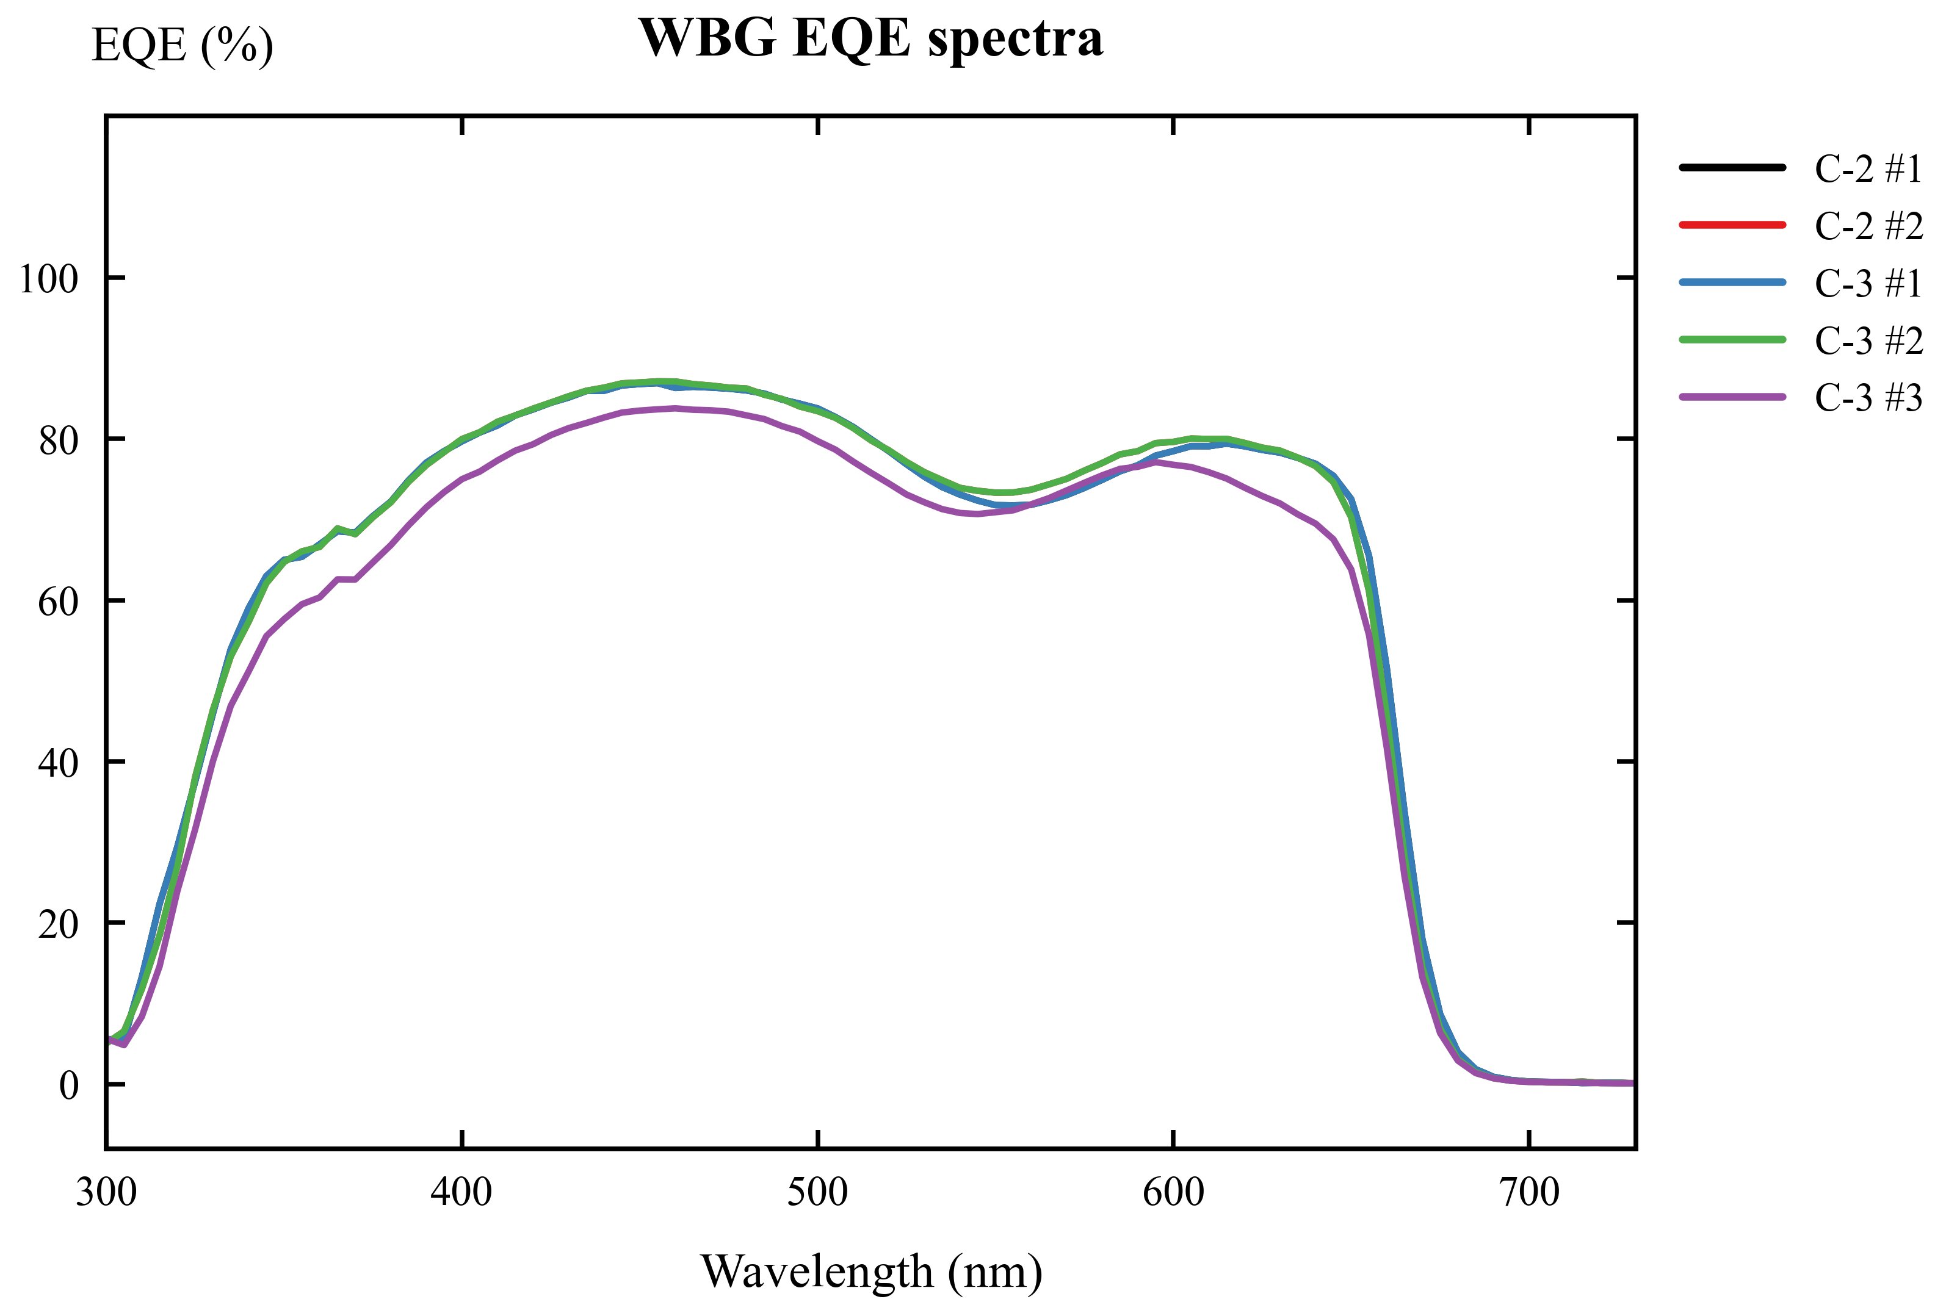
WBG EQE spectra
Device | Linear absorption edge (nm) | Bandgap from linear edge (eV) | 50% EQE edge (nm) | Bandgap from 50% edge (eV) | Final reported bandgap
Normal-bandgap | 812.35 | 1.526 | 785.58 | 1.578 | about 1.56 eV
Wide-bandgap | 676.95 | 1.832 | 659.02 | 1.882 | about 1.83 eV

English. The bandgap was estimated using Eg = 1240 / lambda_edge, where Eg is in eV and lambda_edge is in nm. For the wide-bandgap raw EQE export in the WBG-EQE folder, linear extrapolation gives an absorption edge of 678.79 nm and Eg = 1.827 eV, which is very close to the Origin-figure estimate of about 1.83 eV.
中文。 带隙采用 Eg = 1240 / lambda_edge 估算，其中 Eg 单位为 eV，lambda_edge 单位为 nm。对于 WBG-EQE 文件夹中的宽带隙原始 EQE 导出数据，线性外推得到吸收边约为 678.79 nm，对应 Eg = 1.827 eV，与 Origin 图估算的约 1.83 eV 非常接近。

4. Explicit Answers to Discussion Topics / 讨论题逐条回答

Question 1. What are the functions of each layer in the perovskite solar cell?

问题 1：钙钛矿太阳能电池中各层的功能是什么？
English. ITO/glass is the transparent conducting substrate. It allows light to enter the device and collects carriers at the front contact. The HTL, 4PADCB, selectively extracts holes and blocks electrons, reducing interfacial recombination at the ITO side. The perovskite layer is the light absorber; it generates electron-hole pairs and transports carriers. The ETL, PC61BM, selectively extracts electrons and blocks holes. BCP works as a hole blocking layer and improves electron-selective contact with the metal electrode. The metal electrode collects electrons and closes the external circuit.
中文。 ITO 玻璃是透明导电基底，既允许光进入器件，又作为前电极收集载流子。空穴传输层 4PADCB 选择性提取空穴并阻挡电子，从而降低 ITO 界面的复合。钙钛矿层是主要吸光层，负责吸收光子、产生电子-空穴对并传输载流子。电子传输层 PC61BM 选择性提取电子并阻挡空穴。BCP 作为空穴阻挡层，可以改善金属电极侧的电子选择性接触。金属电极负责收集电子并构成外电路。

Question 2. What is the purpose of anti-solvent during the perovskite film deposition?

问题 2：钙钛矿薄膜沉积过程中反溶剂的作用是什么？
English. The anti-solvent, chlorobenzene, rapidly extracts the host solvent from the wet precursor film during spin coating. This causes fast supersaturation and nucleation, helps form a compact and uniform intermediate film, and reduces pinholes after annealing. A good anti-solvent step improves film morphology, carrier transport, shunt resistance, and device reproducibility.
中文。 反溶剂氯苯在旋涂过程中可以快速抽提出湿膜中的主溶剂，使前驱体溶液迅速过饱和并成核，从而形成致密、均匀的中间薄膜，并在退火后减少针孔。良好的反溶剂工艺可以改善薄膜形貌、载流子传输、并联电阻和器件重复性。

Question 3. Why does the normal-bandgap perovskite give higher PCE and JSC, but lower VOC than the wide-bandgap perovskite?

问题 3：为什么正常带隙钙钛矿的 PCE 和 JSC 更高，但 VOC 低于宽带隙钙钛矿？
English. The normal-bandgap perovskite has a smaller bandgap, so it absorbs longer-wavelength photons and uses a larger part of the solar spectrum. Therefore, it gives a higher JSC. In the measured curves, the normal-bandgap cells have an average JSC of about 25.03 mA cm-2, much higher than the wide-bandgap average of about 14.17 mA cm-2. This larger current also leads to a higher PCE for the normal-bandgap cells. However, VOC is limited by the absorber bandgap. A wide-bandgap absorber can provide a larger quasi-Fermi-level splitting, so the wide-bandgap cells show a higher VOC of about 1.345 V, compared with about 1.167 V for the normal-bandgap cells.
中文。 正常带隙钙钛矿的带隙较小，可以吸收更长波长的光子，因此能够利用更大范围的太阳光谱，产生更高的 JSC。在实测曲线估算中，正常带隙电池的平均 JSC 约为 25.03 mA cm-2，明显高于宽带隙电池的约 14.17 mA cm-2。更高的电流也使正常带隙电池具有更高的 PCE。然而，VOC 受吸收层带隙限制。宽带隙材料能够提供更大的准费米能级分裂，因此宽带隙电池的 VOC 更高，约为 1.345 V，而正常带隙电池约为 1.167 V。

Question 4. What is the application of wide-bandgap perovskite solar cell?

问题 4：宽带隙钙钛矿太阳能电池的应用是什么？
English. Wide-bandgap perovskite solar cells are mainly used as top cells in tandem photovoltaics. In a perovskite/silicon tandem or all-perovskite tandem cell, the wide-bandgap top cell absorbs high-energy visible photons and transmits lower-energy photons to the bottom cell. This spectral splitting reduces thermalization loss and can increase efficiency beyond the single-junction limit. Wide-bandgap perovskites can also be used in semi-transparent and building-integrated photovoltaic devices.
中文。 宽带隙钙钛矿太阳能电池最主要的应用是作为叠层光伏器件中的顶电池。在钙钛矿/硅叠层或全钙钛矿叠层电池中，宽带隙顶电池吸收高能可见光光子，并让较低能量的光子透过到底电池。这种光谱分配可以降低热化损失，使效率超过单结电池极限。宽带隙钙钛矿还可用于半透明光伏和建筑集成光伏器件。

Question 5. What are the estimated bandgaps of the perovskites based on the measured EQE spectra?

问题 5：根据测得的 EQE 光谱，钙钛矿的估算带隙是多少？
English. The bandgap was estimated from the EQE absorption edge using Eg = 1240 / lambda_edge. For the normal-bandgap perovskite, the EQE edge gives a bandgap around 1.53 eV by linear extrapolation and around 1.58 eV by the 50% EQE method. Therefore, the normal-bandgap perovskite is reported as approximately 1.56 eV. For the wide-bandgap perovskite, the linear edge gives approximately 1.83 eV. The raw WBG-EQE data give Eg = 1.827 eV, so the wide-bandgap perovskite is reported as approximately 1.83 eV, close to the nominal 1.84 eV.
中文。 带隙通过 EQE 吸收边公式 Eg = 1240 / lambda_edge 估算。对于正常带隙钙钛矿，线性外推得到的带隙约为 1.53 eV，50% EQE 截止法得到的带隙约为 1.58 eV，因此可报告为约 1.56 eV。对于宽带隙钙钛矿，线性吸收边得到的带隙约为 1.83 eV；WBG-EQE 原始数据计算得到 Eg = 1.827 eV，因此可报告为约 1.83 eV，接近讲义中的标称值 1.84 eV。

5. Conclusion / 结论
English. The inverted p-i-n perovskite solar cells were analyzed using J-V and EQE data. The normal-bandgap device shows higher JSC and PCE because it absorbs a wider spectral range, especially longer-wavelength photons. The wide-bandgap device shows higher VOC because its larger bandgap allows a larger photovoltage. Based on the measured EQE spectra, the estimated bandgaps are approximately 1.56 eV for the normal-bandgap perovskite and approximately 1.83 eV for the wide-bandgap perovskite. These values are consistent with the compositions given in the lab manual.
中文。 本实验利用 J-V 和 EQE 数据分析了倒置 p-i-n 钙钛矿太阳能电池。正常带隙器件能够吸收更宽的光谱范围，特别是更长波长光子，因此具有更高的 JSC 和 PCE。宽带隙器件由于带隙更大，可以产生更高的 VOC。根据测得的 EQE 光谱，正常带隙钙钛矿的估算带隙约为 1.56 eV，宽带隙钙钛矿的估算带隙约为 1.83 eV。这些结果与实验讲义中给出的材料组成和标称带隙一致。

References / 参考文献
1. EE336 Fundamentals of Photovoltaics, Lab 2: Fabrication and Characterization of Perovskite Solar Cells. 2. WBG-EQE measurement files: C-3_Save_All Data.txt and C-2_Save_All Data_Save_All Data.txt. 3. Origin-style figures in the report_artifacts folder: NBG/WBG J-V and EQE curves.

