Lab 2: Fabrication and Characterization of Perovskite Solar Cells
Name: He Yanning
Student ID: 12311512
2026/4/29

Abstract
This experiment focuses on the fabrication and characterization of inverted p-i-n perovskite solar cells. The lab includes normal-bandgap perovskite, Cs0.05FA0.902MA0.048PbI2.7Br0.3, and wide-bandgap perovskite, Cs0.25FA0.75Pb(Br0.5I0.5)3. Based on the provided J-V and EQE data, the normal-bandgap devices show higher short-circuit current density and higher power conversion efficiency, while the wide-bandgap devices show higher open-circuit voltage. From the Origin-style J-V curves, the average estimated performance is JSC = 25.03 mA cm-2, VOC = 1.167 V, FF = 0.777, and PCE = 22.70% for the normal-bandgap cells, and JSC = 14.17 mA cm-2, VOC = 1.345 V, FF = 0.797, and PCE = 15.22% for the wide-bandgap cells. From the EQE absorption edges, the estimated bandgaps are approximately 1.56 eV for the normal-bandgap perovskite and approximately 1.83 eV for the wide-bandgap perovskite.
Introduction
Metal-halide perovskite solar cells have attracted great attention because they combine strong optical absorption, tunable bandgap, long carrier diffusion length, and low-temperature solution processing. By changing the halide composition, especially the I/Br ratio, the bandgap can be tuned from a normal-bandgap value suitable for high-current single-junction devices to a wide-bandgap value suitable for tandem solar cells.
In this lab, the device structure is an inverted p-i-n configuration: ITO/glass / hole transport layer / perovskite absorber / electron transport layer / hole blocking layer / metal electrode. The main characterization methods are J-V measurement under AM1.5G illumination and external quantum efficiency measurement.
Working Principle
A perovskite solar cell converts light into electrical energy through photon absorption, charge generation, charge separation, and charge collection. When incident photons with energy higher than the perovskite bandgap enter the device, they are absorbed by the perovskite layer and generate electron-hole pairs. Because metal-halide perovskites have relatively low exciton binding energy, these photogenerated carriers can be separated efficiently at room temperature.
In the inverted p-i-n device, selective transport layers drive the photogenerated carriers toward different electrodes. Holes are extracted by the hole transport layer and collected by the ITO front electrode, while electrons are extracted by PC61BM and collected by the top metal electrode. The selective contacts suppress carrier recombination and help maintain a high quasi-Fermi-level splitting, which determines the open-circuit voltage. The photocurrent under short-circuit conditions is mainly determined by the absorption range, EQE, and charge-collection efficiency.
The main photovoltaic parameters are JSC, VOC, FF, and PCE. JSC represents the collected current density at zero voltage. VOC is the voltage at zero net current and is strongly related to the absorber bandgap and recombination loss. FF reflects the squareness of the J-V curve and is affected by series resistance, shunt resistance, and diode quality. PCE is calculated from PCE = JSC x VOC x FF / Pin, where Pin is the incident light power density.
Device Architecture
Device types: Normal-bandgap (NBG) and wide-bandgap (WBG) perovskite solar cells
The device used in this experiment is an inverted positive-intrinsic-negative, or p-i-n, perovskite solar cell. The layer sequence is ITO/glass / 4PADCB / perovskite / PC61BM / BCP / metal electrode. Light enters from the ITO/glass side, passes through the transparent conducting substrate and the ultrathin hole transport layer, and is absorbed mainly by the perovskite film.
ITO/glass serves as the transparent front electrode and mechanical substrate. 4PADCB is a self-assembled monolayer hole transport layer that improves hole extraction and interfacial selectivity. The perovskite layer is the intrinsic absorber, and its composition determines whether the device is normal-bandgap or wide-bandgap. PC61BM acts as the electron transport layer, BCP acts as a hole blocking layer, and the evaporated metal electrode works as the back contact for electron collection.
This architecture is different from a conventional n-i-p device because the hole-selective contact is placed at the illuminated ITO side and the electron-selective contact is placed near the top metal electrode. This inverted structure is commonly used in perovskite devices because it can be processed at relatively low temperature, is compatible with self-assembled monolayers, and is suitable for tandem solar cell integration.

Layer | Material | Function
Transparent front electrode and substrate | ITO/glass | Provides mechanical support and transparent electrical contact. It allows light to enter from the front side and collects holes in the inverted p-i-n device.
Hole transport layer, HTL | 4PADCB self-assembled monolayer | Selectively extracts holes, blocks electrons, improves ITO/perovskite interface contact, and reduces interfacial recombination.
Perovskite absorber | NBG: Cs0.05FA0.902MA0.048PbI2.7Br0.3; WBG: Cs0.25FA0.75Pb(Br0.5I0.5)3 | Absorbs incident photons, generates electron-hole pairs, and determines the absorption edge, JSC, and VOC potential through its bandgap.
Electron transport layer, ETL | PC61BM | Selectively extracts electrons from the perovskite and blocks holes, improving electron collection and suppressing recombination near the back contact.
Hole blocking layer | BCP | Blocks holes from reaching the metal electrode, improves electron-selective contact, and helps reduce leakage and interfacial recombination.
Back metal electrode | Evaporated Ag or Au | Collects electrons from the ETL side and completes the external circuit.
Table 1. Functions of each layer in the inverted perovskite solar cell.
Experimental Method
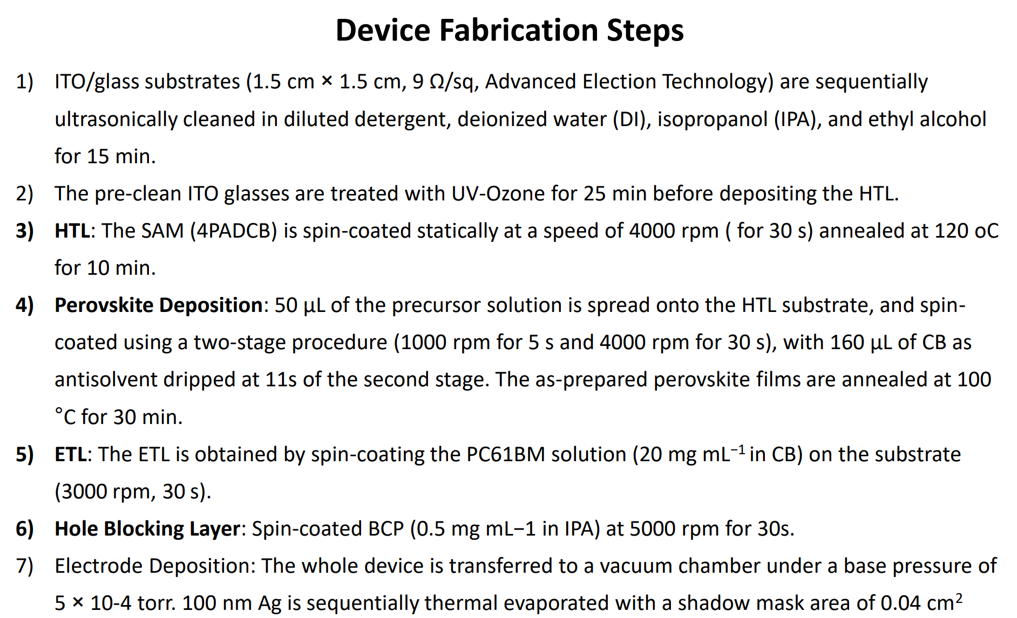
Figure 1. Device Fabrication Steps.
ITO/glass substrates were sequentially cleaned in diluted detergent, deionized water, isopropanol, and ethanol for 15 min each. Before depositing the hole transport layer, the cleaned substrates were treated by UV-ozone for 25 min. The 4PADCB self-assembled monolayer was spin-coated at 4000 rpm for 30 s and annealed at 120 degC for 10 min.
The perovskite precursor was deposited by a two-step spin-coating process: 1000 rpm for 5 s and then 4000 rpm for 30 s. During the second stage, 160 uL chlorobenzene was dropped as the anti-solvent at 11 s. The film was then annealed at 100 degC for 30 min. PC61BM was spin-coated as the electron transport layer, BCP was spin-coated as the hole blocking layer, and a metal electrode was thermally evaporated through a shadow mask.
Step | Process | Purpose
1 | Substrate cleaning in detergent, DI water, IPA, and ethanol | Removes dust, organic residues, ions, and grease from the ITO surface, reducing shunts and improving film uniformity.
2 | UV-ozone treatment | Further removes organic contamination, increases ITO surface energy, improves wettability, and promotes uniform HTL coating.
3 | Spin-coating 4PADCB HTL | Forms a hole-selective interface that extracts holes and blocks electrons at the illuminated electrode side.
4 | Annealing the HTL at 120 degC | Improves molecular ordering, adhesion, and interfacial contact between ITO and the following perovskite layer.
5 | First stage perovskite spin coating at 1000 rpm | Spreads the precursor solution across the substrate and forms an initial wet film.
6 | Second stage spin coating at 4000 rpm | Thins the wet film, removes excess solvent, and helps define the final film thickness and uniformity.
7 | Chlorobenzene anti-solvent dripping | Rapidly extracts solvent, induces supersaturation and nucleation, and promotes a compact perovskite intermediate film with fewer pinholes.
8 | Perovskite annealing at 100 degC | Converts the intermediate film into crystalline perovskite, improves grain formation, and enhances charge transport.
9 | Spin-coating PC61BM ETL | Forms an electron-selective contact, extracts electrons, blocks holes, and passivates the perovskite surface.
10 | Spin-coating BCP hole blocking layer | Suppresses hole leakage to the metal electrode and improves the selectivity of the back contact.
11 | Thermal evaporation of metal electrode through a shadow mask | Deposits the back electrode, defines the active device area, and completes the current-collection pathway.
Table 2. Functions of each step.
Result
J-V Characteristics
The J-V curves show the typical diode behavior of photovoltaic devices. The normal-bandgap cells provide higher photocurrent, while the wide-bandgap cells provide higher voltage. This trend agrees with the expected bandgap-current-voltage tradeoff.
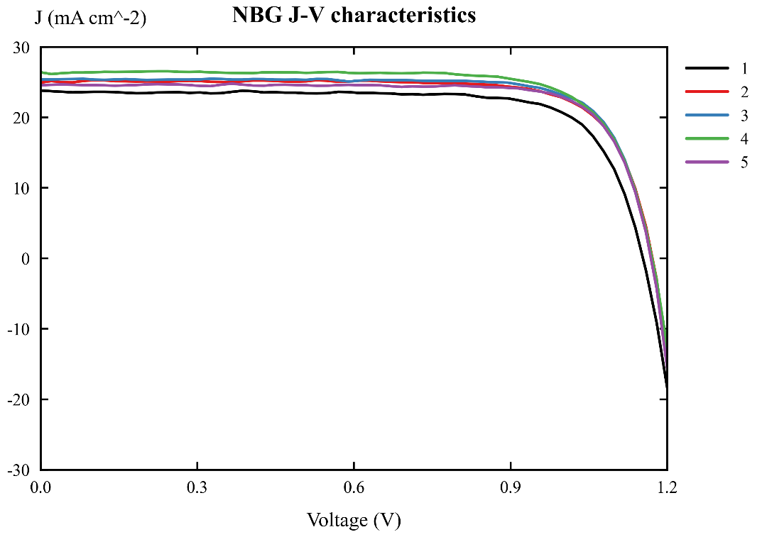
Figure 2. J-V curves of normal-bandgap perovskite devices.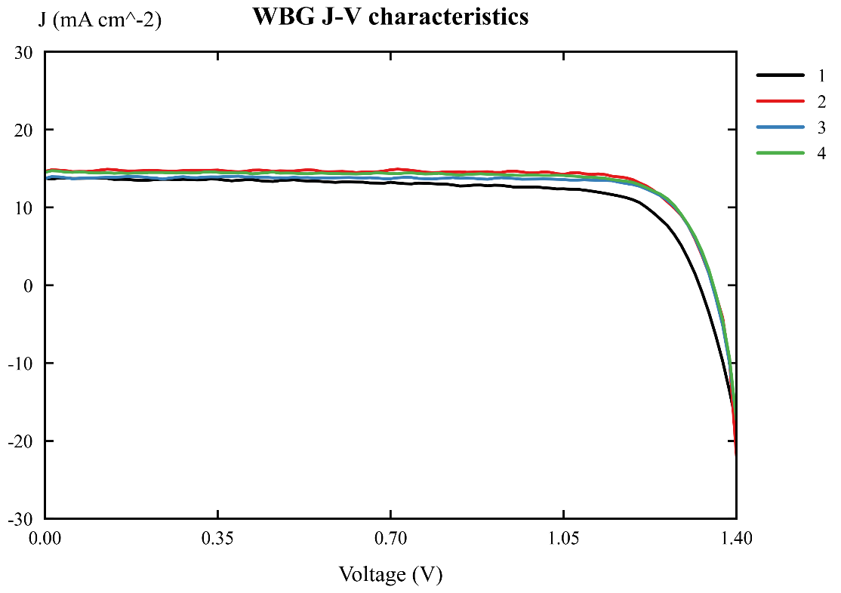
Figure 3. J-V curves of wide-bandgap perovskite devices.
Device | JSC (mA cm-2) | VOC (V) | FF | PCE (%)
Normal-bandgap, average | 25.03 | 1.167 | 0.777 | 22.70
Normal-bandgap, standard deviation | 0.97 | 0.008 | 0.014 | 1.04
Wide-bandgap, average | 14.17 | 1.345 | 0.797 | 15.22
Wide-bandgap, standard deviation | 0.48 | 0.014 | 0.043 | 1.25
Table 3. Photovoltaic parameters extracted from measured J-V curves.
These values were estimated from the provided Origin-style J-V curves. Under 100 mW cm-2 illumination, the maximum output power density in mW cm-2 is numerically equal to PCE in percent.
EQE Spectra and Bandgap
The EQE spectra show that the normal-bandgap perovskite absorbs to longer wavelengths, while the wide-bandgap perovskite has an earlier absorption cutoff. Therefore, the normal-bandgap device can collect more red photons and generates a larger JSC.
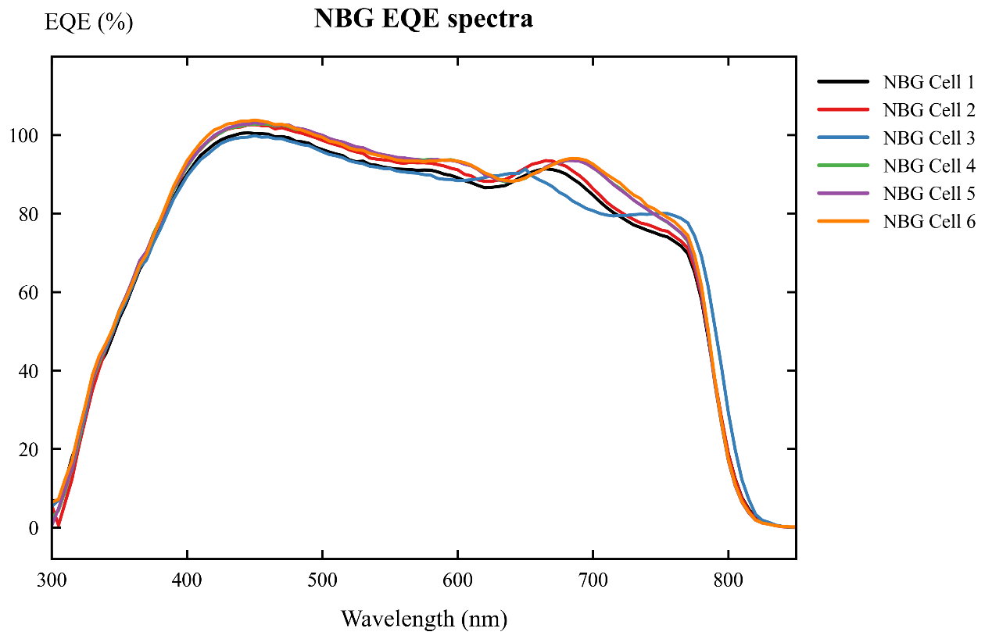
Figure 4. EQE spectra of normal-bandgap perovskite devices.
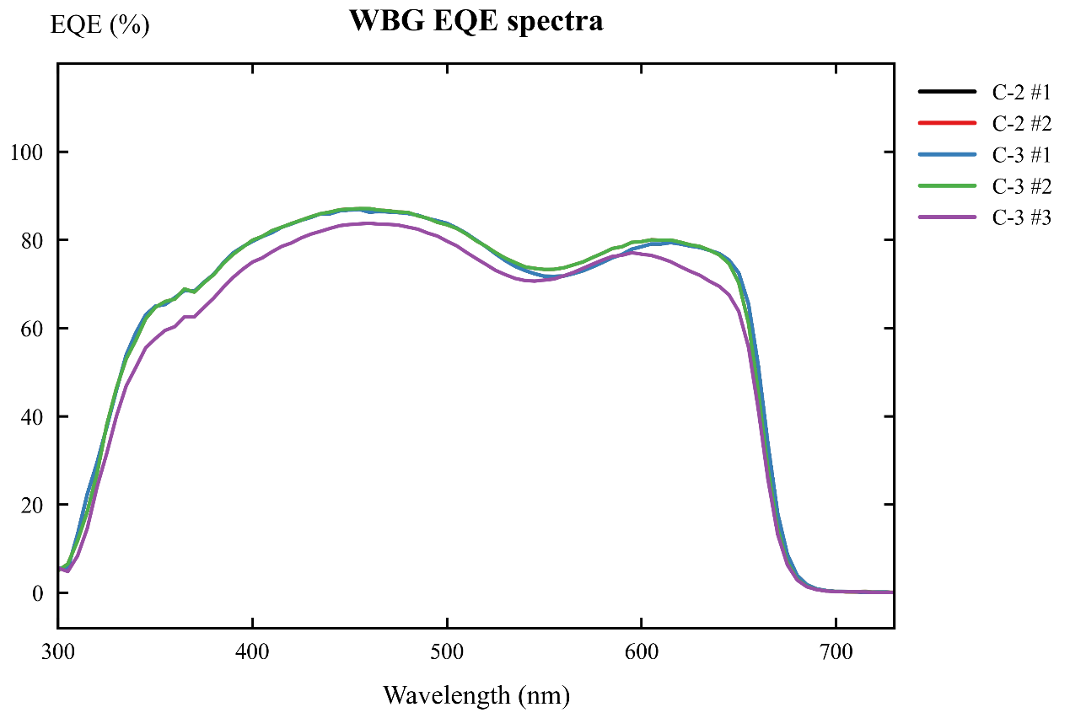
Figure 5. EQE spectra of wide-bandgap perovskite devices.
Device | Linear absorption edge (nm) | Bandgap from linear edge (eV) | 50% EQE edge (nm) | Bandgap from 50% edge (eV) | Final reported bandgap
Normal-bandgap | 812.35 | 1.526 | 785.58 | 1.578 | about 1.56 eV
Wide-bandgap | 676.95 | 1.832 | 659.02 | 1.882 | about 1.83 eV
Table 4. Bandgap estimates from the long-wavelength EQE absorption edge.
The bandgap was estimated using Eg = $1240/λ_{edge}$, where Eg is in eV and $λ_{edge}$ is in nm. For the wide-bandgap raw EQE export in the WBG-EQE folder, linear extrapolation gives an absorption edge of 678.79 nm and Eg = 1.827 eV, which is very close to the Origin-figure estimate of about 1.83 eV.
Discussion
Question 1. What are the functions of each layer in the perovskite solar cell?
ITO/glass is the transparent conducting substrate. It allows light to enter the device and collects carriers at the front contact. The HTL, 4PADCB, selectively extracts holes and blocks electrons, reducing interfacial recombination at the ITO side. The perovskite layer is the light absorber; it generates electron-hole pairs and transports carriers. The ETL, PC61BM, selectively extracts electrons and blocks holes. BCP works as a hole blocking layer and improves electron-selective contact with the metal electrode. The metal electrode collects electrons and closes the external circuit.
Question 2. What is the purpose of anti-solvent during the perovskite film deposition?
The anti-solvent, chlorobenzene, rapidly extracts the host solvent from the wet precursor film during spin coating. This causes fast supersaturation and nucleation, helps form a compact and uniform intermediate film, and reduces pinholes after annealing. A good anti-solvent step improves film morphology, carrier transport, shunt resistance, and device reproducibility.
Question 3. Why does the normal-bandgap perovskite give higher PCE and JSC, but lower VOC than the wide-bandgap perovskite?
The normal-bandgap perovskite has a smaller bandgap, so it absorbs longer-wavelength photons and uses a larger part of the solar spectrum. Therefore, it gives a higher JSC. In the measured curves, the normal-bandgap cells have an average JSC of about 25.03 mA cm-2, much higher than the wide-bandgap average of about 14.17 mA cm-2. This larger current also leads to a higher PCE for the normal-bandgap cells. However, VOC is limited by the absorber bandgap. A wide-bandgap absorber can provide a larger quasi-Fermi-level splitting, so the wide-bandgap cells show a higher VOC of about 1.345 V, compared with about 1.167 V for the normal-bandgap cells.
Question 4. What is the application of wide-bandgap perovskite solar cell?
Wide-bandgap perovskite solar cells are mainly used as top cells in tandem photovoltaics. In a perovskite/silicon tandem or all-perovskite tandem cell, the wide-bandgap top cell absorbs high-energy visible photons and transmits lower-energy photons to the bottom cell. This spectral splitting reduces thermalization loss and can increase efficiency beyond the single-junction limit. Wide-bandgap perovskites can also be used in semi-transparent and building-integrated photovoltaic devices.
Question 5. What are the estimated bandgaps of the perovskites based on the measured EQE spectra?
The bandgap was estimated from the EQE absorption edge using Eg = $1240/λ_{edge}$. For the normal-bandgap perovskite, the EQE edge gives a bandgap around 1.53 eV by linear extrapolation and around 1.58 eV by the 50% EQE method. Therefore, the normal-bandgap perovskite is reported as approximately 1.56 eV. For the wide-bandgap perovskite, the linear edge gives approximately 1.83 eV. The raw WBG-EQE data give Eg = 1.827 eV, so the wide-bandgap perovskite is reported as approximately 1.83 eV, close to the nominal 1.84 eV.

Conclusion
The inverted p-i-n perovskite solar cells were analyzed using J-V and EQE data. The normal-bandgap device shows higher JSC and PCE because it absorbs a wider spectral range, especially longer-wavelength photons. The wide-bandgap device shows higher VOC because its larger bandgap allows a larger photovoltage. Based on the measured EQE spectra, the estimated bandgaps are approximately 1.56 eV for the normal-bandgap perovskite and approximately 1.83 eV for the wide-bandgap perovskite. These values are consistent with the compositions given in the lab manual.
References
1. EE336 Fundamentals of Photovoltaics, Lab 2: Fabrication and Characterization of Perovskite Solar Cells. 2. WBG-EQE measurement files: C-3_Save_All Data.txt and C-2_Save_All Data_Save_All Data.txt. 3. Origin-style figures in the report_artifacts folder: NBG/WBG J-V and EQE curves.

