Lab 3: Fabrication and Characterization of Organic Photovoltaic Devices
He Yanning | 12311512

Abstract
This experiment investigated organic photovoltaic (OPV) devices fabricated on patterned ITO/glass substrates with the structure ITO/PEDOT:PSS/active layer/PDINN/Ag. Three active-layer conditions were compared: D18 only, D18:Y6 without additive, and D18:Y6 with additive. The D18-only control showed almost no photovoltaic response, with an average PCE of 0.0029%. In contrast, the D18:Y6 bulk heterojunction devices reached average PCE values of 15.61% without additive and 16.65% with additive. The additive increased the average short-circuit current density from 25.33 to 26.06 mA cm-2 and improved the fill factor from 69.25% to 71.17%. EQE analysis gave integrated current densities of 20.60 and 21.72 mA cm-2 for the blend devices without and with additive, respectively.

1. Introduction
Organic photovoltaics convert sunlight into electrical energy using conjugated organic semiconductors. Compared with inorganic photovoltaic technologies, OPVs can be processed from solution at low temperature and are attractive for lightweight, flexible, and semi-transparent solar modules. Their performance strongly depends on the electronic structure and nanoscale morphology of the active layer.
In this lab, D18 was used as the polymer donor and Y6 as the non-fullerene acceptor. A D18-only device was fabricated as a control, while D18:Y6 blend devices were prepared with and without additive. The comparison demonstrates why a donor-acceptor bulk heterojunction is needed and how processing additives can improve OPV performance.

2. Working Principle
In an OPV device, photons are absorbed by the active organic semiconductor layer and generate bound excitons rather than immediately free carriers. Efficient photocurrent therefore requires a donor-acceptor interface where the exciton can dissociate: the donor preferentially transports holes, while the acceptor preferentially transports electrons.
The D18:Y6 blend forms a bulk heterojunction, which distributes donor-acceptor interfaces throughout the film. This shortens the distance excitons must diffuse before reaching an interface and creates percolated pathways for holes and electrons.

3. Device Architecture
The device architecture used in this experiment is ITO/glass / PEDOT:PSS / active layer / PDINN / Ag. ITO/glass serves as the transparent conducting substrate. PEDOT:PSS is the hole transport layer. The active layer is either D18 only or a D18:Y6 blend. PDINN works as the electron transport layer and interfacial modifier near the metal electrode. The thermally evaporated Ag layer is the top electrode.

4. Experimental Method
Patterned ITO/glass substrates were cleaned by sequential sonication in detergent water, deionized water, and absolute ethanol for 15 min each. The substrates were dried with an air gun and stored at 60 degC for 1 h before use. Before film deposition, the substrates were treated by UV-ozone for 20 min.
The active-layer solutions were prepared using chloroform as solvent. Three device conditions were fabricated: D18:Y6 with a 1:1.2 donor-to-acceptor ratio without additive, D18:Y6 with additive, and D18 only. PEDOT:PSS was spin-coated at 4000 rpm. The active layers were spin-coated inside the glovebox at 3000 rpm and then thermally annealed. PDINN was spin-coated at 3000 rpm. Finally, 100 nm Ag was thermally evaporated through a shadow mask.

5. Results

5.1 J-V Characteristics
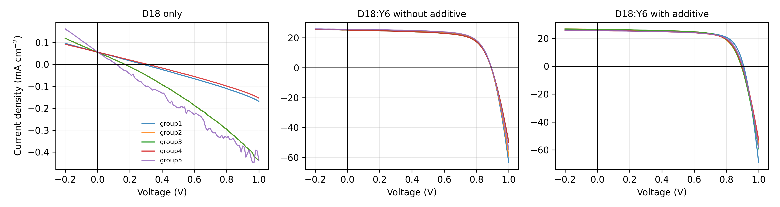
Figure 1. J-V curves of D18-only and D18:Y6 OPV devices.
The D18-only device produced extremely small current density because a single donor material does not provide an efficient acceptor interface for exciton dissociation. The D18:Y6 blend devices showed clear photovoltaic behavior. Adding the processing additive improved both JSC and FF, producing the highest average PCE.
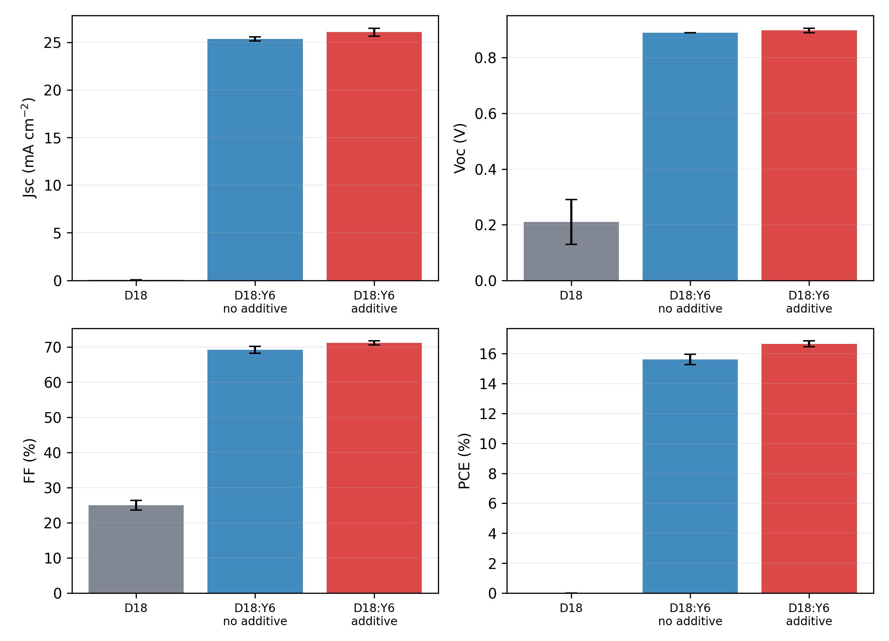
Figure 2. Average photovoltaic parameters from five devices for each condition.
Device | Voc (V) | Jsc (mA cm^-2) | FF (%) | PCE (%)
D18 only | 0.210 +/- 0.081 | 0.056 +/- 0.001 | 24.969 +/- 1.364 | 0.003 +/- 0.001
D18:Y6 without additive | 0.890 +/- 0.000 | 25.330 +/- 0.220 | 69.248 +/- 0.958 | 15.613 +/- 0.349
D18:Y6 with additive | 0.898 +/- 0.008 | 26.061 +/- 0.420 | 71.169 +/- 0.596 | 16.654 +/- 0.197

5.2 EQE Spectra
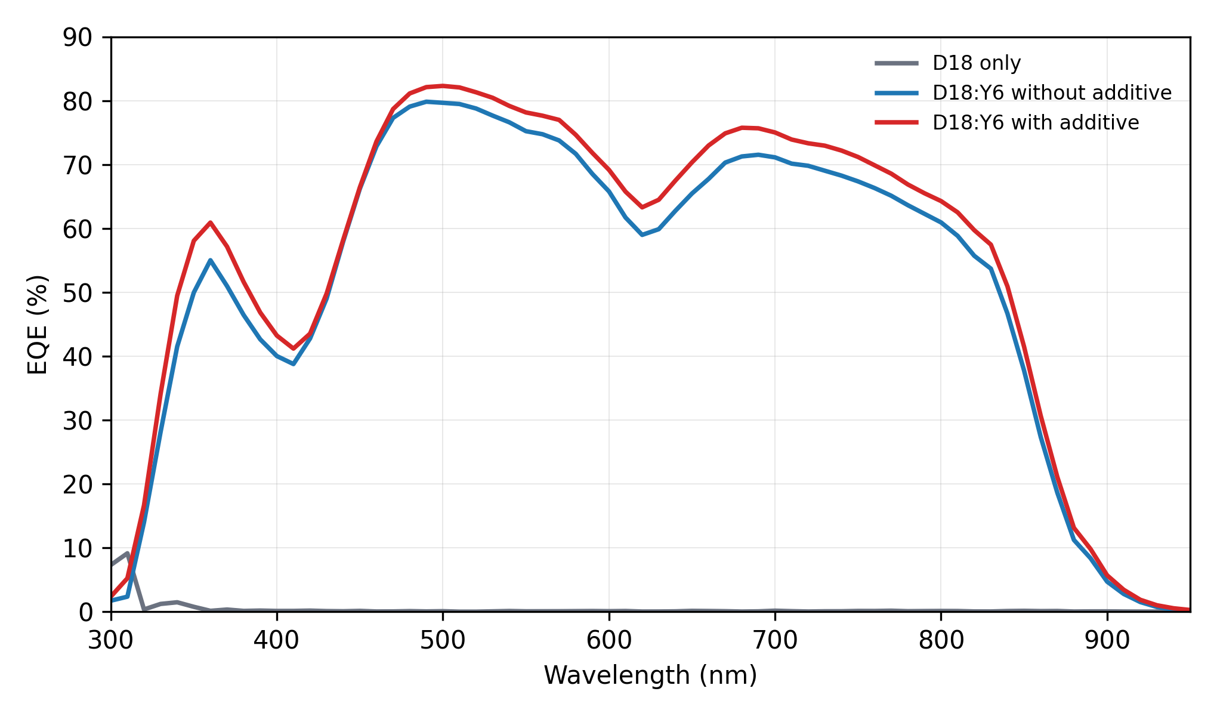
Figure 3. EQE spectra of the three OPV active-layer conditions.
The blend devices show broad EQE response from the visible to near-infrared region, consistent with the complementary absorption and charge generation of the D18:Y6 bulk heterojunction. The additive-treated device has higher EQE over most of the wavelength range, agreeing with its higher JSC in the J-V measurement.
Device | Integrated Jsc from EQE (mA cm^-2) | Mean EQE 400-800 nm (%) | Maximum EQE (%) | Linear absorption edge (nm) | Bandgap from linear edge (eV)
D18 only | 0.034 | 0.082 | 9.141
D18:Y6 without additive | 20.600 | 67.050 | 79.824 | 911.072 | 1.361
D18:Y6 with additive | 21.721 | 70.139 | 82.296 | 911.949 | 1.360

5.3 Absorption Edge and Optical Gap
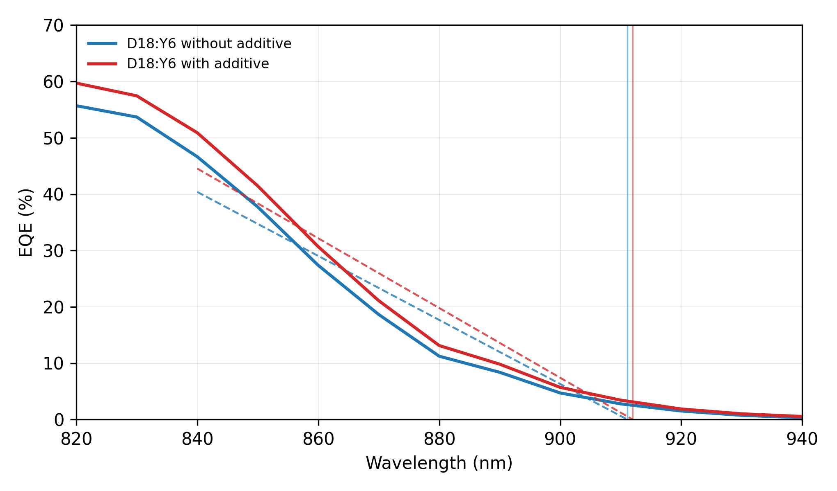
Figure 4. Linear extrapolation of the D18:Y6 long-wavelength EQE edge.
The long-wavelength EQE edge of the D18:Y6 devices was linearly extrapolated using the 840-920 nm region. The resulting optical gaps are about 1.36 eV for both blend devices, consistent with the low-bandgap Y6 acceptor dominating the near-infrared absorption edge. The D18-only EQE signal was very weak and noisy, so its edge-derived bandgap is not considered reliable in this report.

6. Discussion
The large difference between the D18-only control and the D18:Y6 blend devices confirms the central role of the donor-acceptor bulk heterojunction. In D18-only films, excitons have no efficient acceptor phase for charge transfer, so most photogenerated excitons recombine before contributing to current.
Adding Y6 introduces acceptor domains and donor-acceptor interfaces, enabling exciton dissociation and balanced charge transport. The additive further improves performance, most likely by optimizing phase separation, molecular packing, and vertical composition distribution. These morphology improvements can reduce recombination and transport resistance, which is reflected in the higher average FF and PCE.
The EQE-integrated JSC values are lower than the J-V JSC values. This mismatch can arise from spectral mismatch between the solar simulator and AM1.5G reference spectrum, calibration uncertainty, device area definition, light-bias conditions, or degradation/position variation during measurements. However, the trend remains consistent: the additive-treated blend device gives the highest spectral response and the highest J-V performance.

7. Conclusion
Organic photovoltaic devices based on D18, D18:Y6 without additive, and D18:Y6 with additive were fabricated and characterized. The D18-only control showed negligible photovoltaic output, confirming that a donor-only active layer cannot efficiently separate excitons. The D18:Y6 blend formed an effective bulk heterojunction and achieved an average PCE of 15.61% without additive. With additive, the average PCE increased to 16.65%, mainly because JSC and FF improved. EQE spectra further confirmed stronger broadband photocurrent generation in the additive-treated device, with an integrated JSC of 21.72 mA cm-2.

References
EE336 Fundamentals of Photovoltaics, Lab Session for Organic Photovoltaics (OPVs) Device Fabrication.
J-V measurement files in OPV DATA/D18, OPV DATA/D18 Y6无添加剂, and OPV DATA/D18 Y6加添加剂.
EQE measurement files in OPV DATA/EQE.

