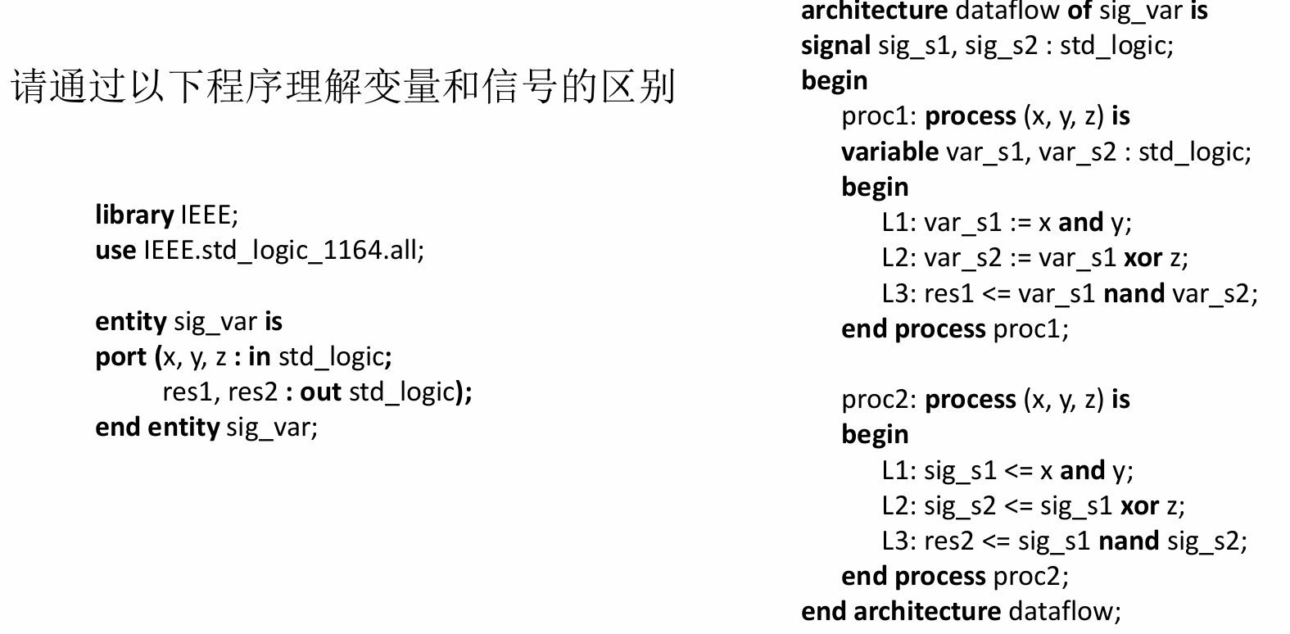
- 假设x、y、z信号为初始值为0、占空比为50%的周期方波，其中x信号的周期为80 ns，y信号的周期为40 ns，z信号的周期为20ns。
- 请自行推导res1和res2的输出波形。
- 请设计testbench文件进行仿真以验证你的结果。

推导res1和res2的输出波形：
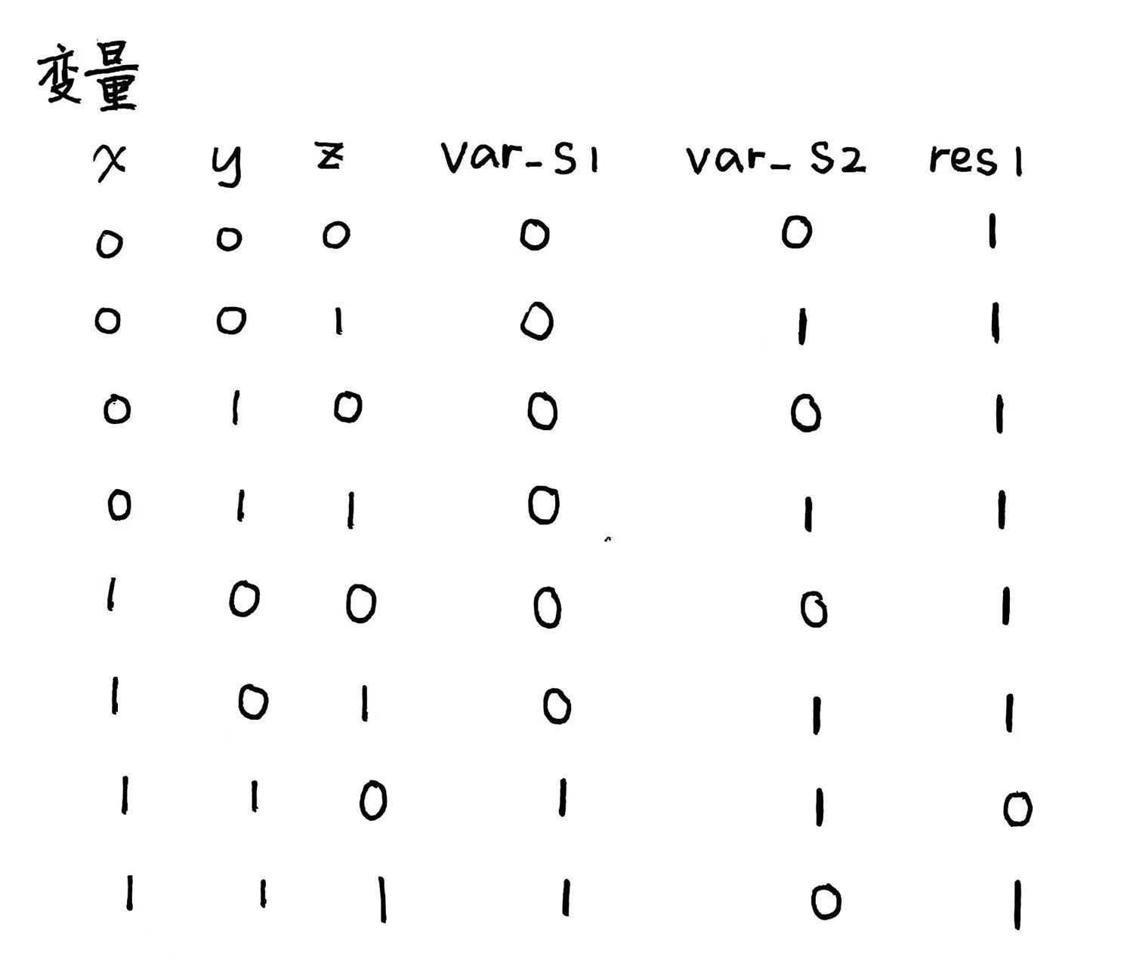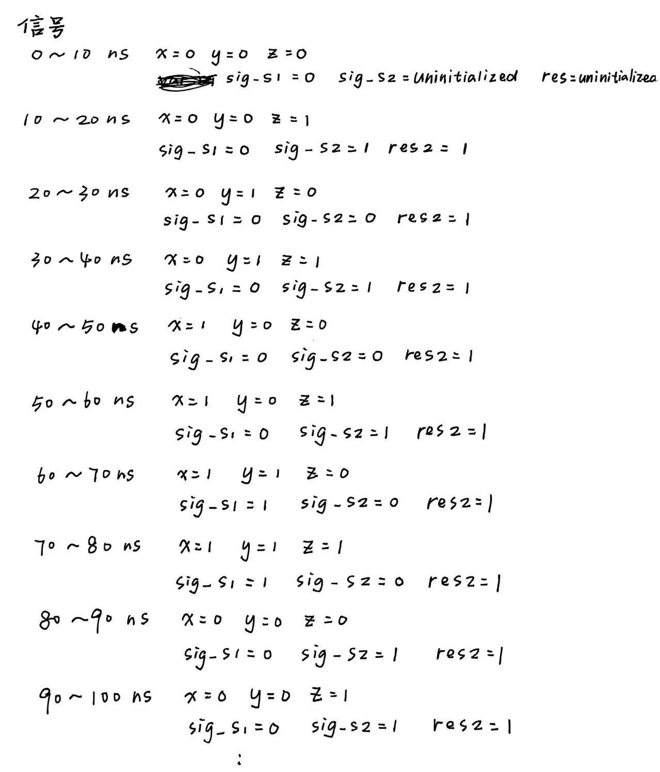
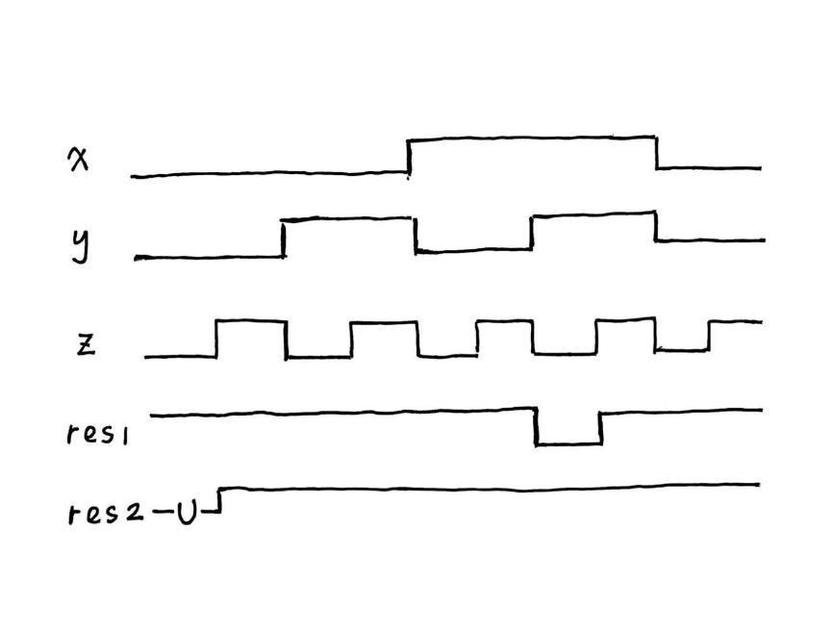

testbench代码：
library IEEE;
use IEEE.STD_LOGIC_1164.ALL;

entity sig_var_tb is
-- Port ( );
end sig_var_tb;

-- 结构体
architecture tb of sig_var_tb is
-- 元件声明
component sig_var is
Port ( x : in STD_LOGIC;
y : in STD_LOGIC;
z : in STD_LOGIC;
res1 : out STD_LOGIC;
res2 : out STD_LOGIC);
end component;
-- 信号声明
signal x_i, y_i, z_i, r1_o, r2_o : std_logic := '0';
-- 常数声明
constant period : time := 10ns;

begin
uut: sig_var port
map ( x => x_i,
y => y_i,
z => z_i,
res1 => r1_o,
res2 => r2_o);

x_i <= not x_i after period*8;
y_i <= not y_i after period*4;
z_i <= not z_i after period*2;

end tb;

仿真结果：
Behavioral simulation
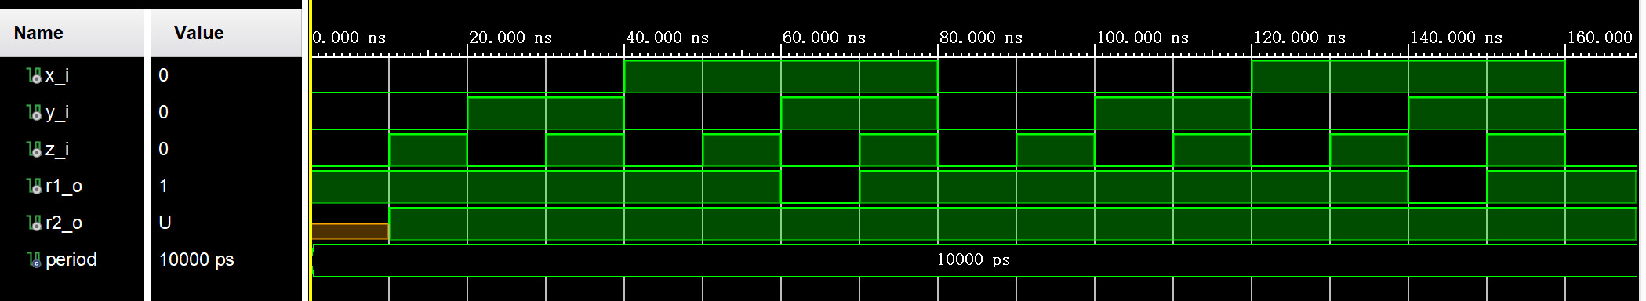

Post-synthesis simulation - functional
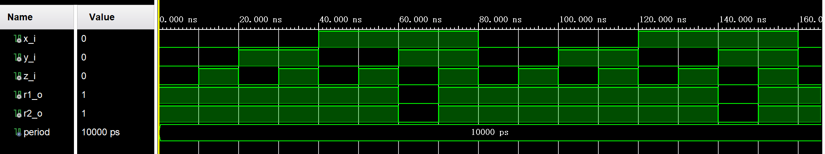

Post-synthesis simulation - timing
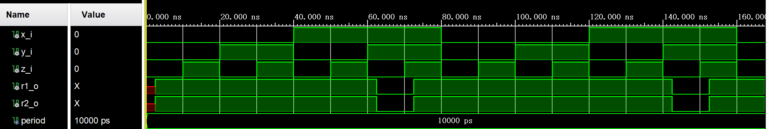

Post-implementation simulation - functional
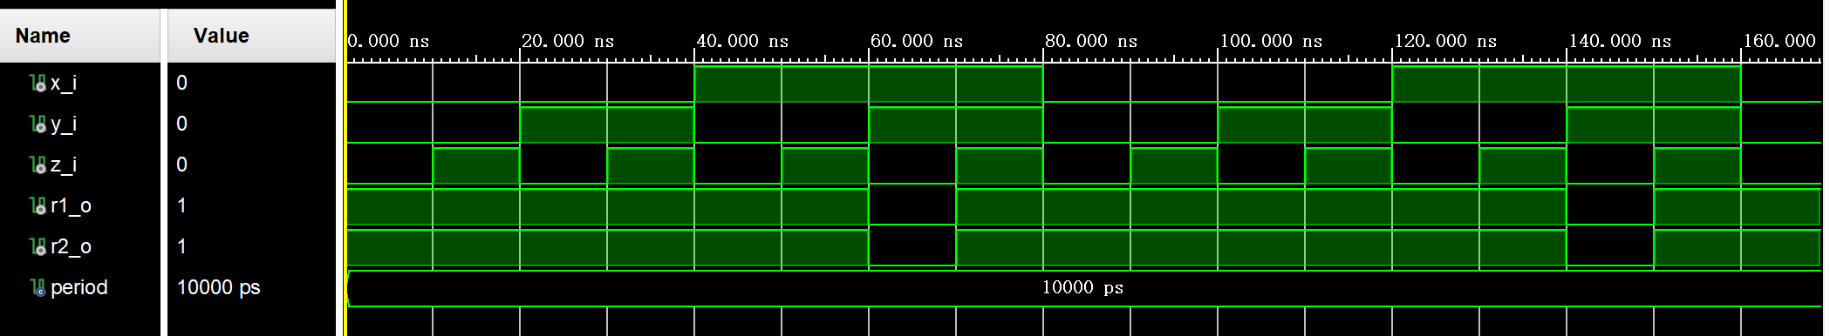

Post-implementation simulation - timing
