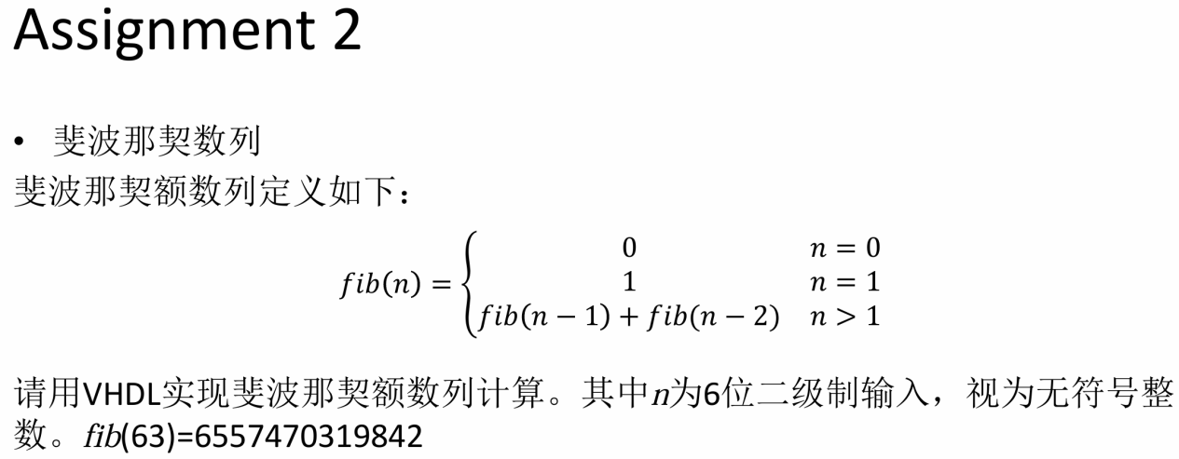

算法状态机图
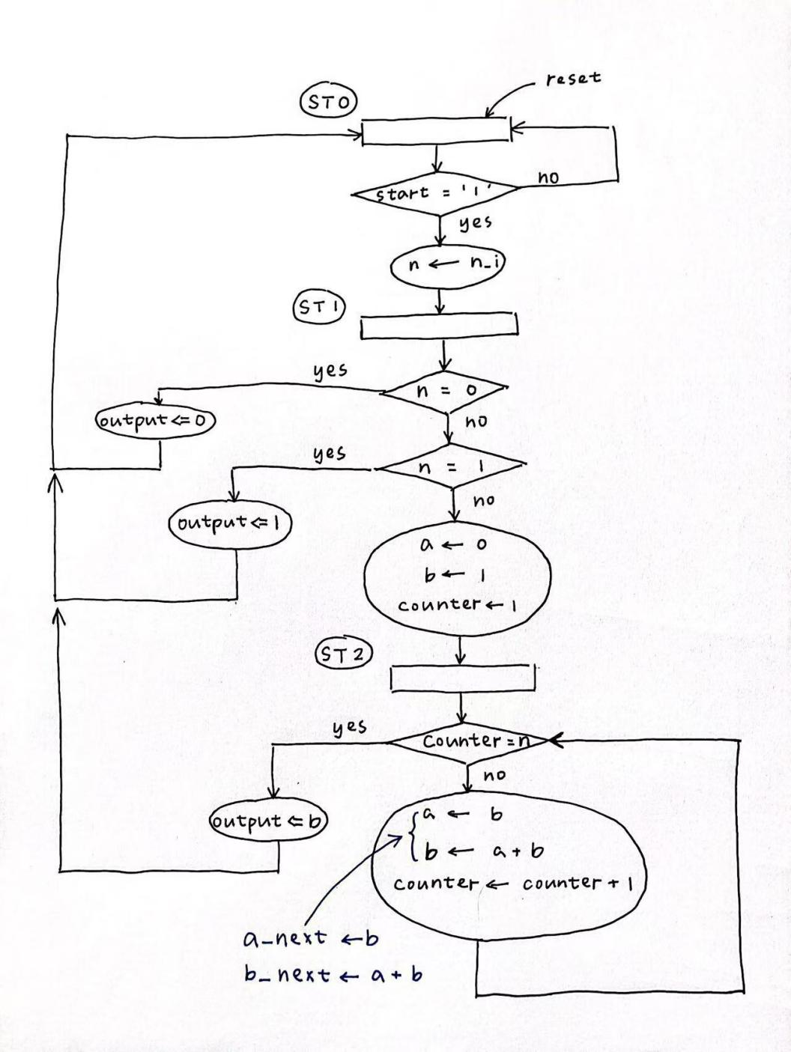

VHDL代码
library IEEE;
use IEEE.STD_LOGIC_1164.ALL;
use IEEE.STD_LOGIC_ARITH.ALL;
use IEEE.STD_LOGIC_UNSIGNED.ALL;

entity Fibonacci_sequence is
Port ( n_i : in std_logic_vector(5 downto 0);
clk : in STD_LOGIC;
reset : in STD_LOGIC;
start : in STD_LOGIC;
output : out std_logic_vector(43 downto 0) );
end Fibonacci_sequence;

architecture FSMD of Fibonacci_sequence is
signal n, counter, counter_next : std_logic_vector(5 downto 0);
signal a, b, a_next, b_next : std_logic_vector(43 downto 0);
type S_Type is (ST0, ST1, ST2);
signal state, next_state : S_Type;
begin
clkproc: process(clk, reset) is
begin
if (reset= '1') then
state <= ST0;
a <= (others => '0');
b <= x"00000000001";
counter <= "000001"; -- counter从1开始计数
elsif (clk'event and clk= '1') then
state <= next_state;
a <= a_next;
b <= b_next;
counter <= counter_next;
end if;
end process clkproc;

operproc: process (state, n_i, a, b, counter, start)is
begin
output <= (others => '0');
a_next <= a;
b_next <= b;
counter_next <= counter;

case state is
when ST0 =>
if (start = '1') then
n <= n_i;
next_state <= ST1;
else
next_state <= ST0;
end if;
when ST1 =>
if (n = "000000") then
output <= (others => '0');
next_state <= ST0;
elsif (n = "000001") then
output <= x"00000000001";
next_state <= ST0;
else
a_next <= (others => '0');
b_next <= x"00000000001";
counter_next <= "000001"; -- counter从1开始计数
next_state <= ST2;
end if;
when ST2 =>
if (counter = n) then
output <= b;
next_state <= ST0;
else
a_next <= b;
b_next <= a + b;
counter_next <= counter + 1;
next_state <= ST2;
end if;
end case;
end process operproc;
end FSMD;

testbench代码
library IEEE;
use IEEE.STD_LOGIC_1164.ALL;
use IEEE.STD_LOGIC_ARITH.ALL;
use IEEE.STD_LOGIC_UNSIGNED.ALL;

entity Fibonacci_sequence_tb is
-- Port ( );
end Fibonacci_sequence_tb;

architecture tb of Fibonacci_sequence_tb is
component Fibonacci_sequence is
Port ( n_i : in std_logic_vector(5 downto 0);
clk : in STD_LOGIC;
reset : in STD_LOGIC;
start : in STD_LOGIC;
output : out std_logic_vector(43 downto 0) );
end component;
signal n : std_logic_vector(5 downto 0);
signal clk_i, res_i, start_i : STD_LOGIC := '0';
signal out_o : std_logic_vector(43 downto 0);
constant halfperiod : time := 5ns;
begin
fs: Fibonacci_sequence
port map ( n_i => n,
clk => clk_i,
reset => res_i,
start => start_i,
output => out_o
);
clk_i <= not clk_i after halfperiod;
res_i <= '1', '0' after halfperiod*4;
start_i <= '1' after halfperiod*6, '0' after halfperiod*8;
n <= "111111" after halfperiod*6;
end tb;

结果（RTL Schematic，仿真波形）
RTL Schematic:
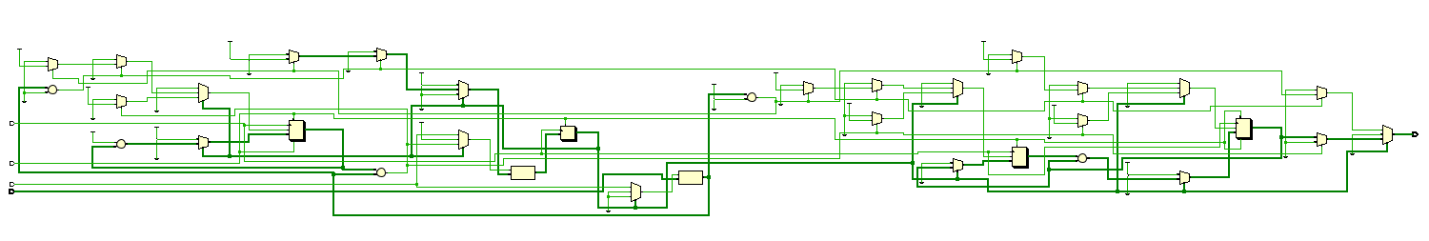
Post-implementation simulation (Functional):
Test 1:
n = 63
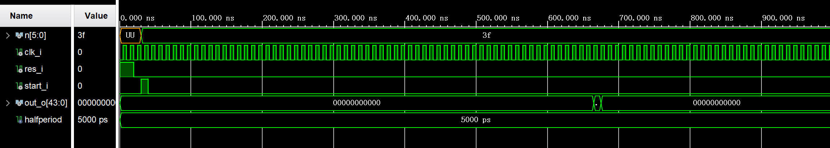
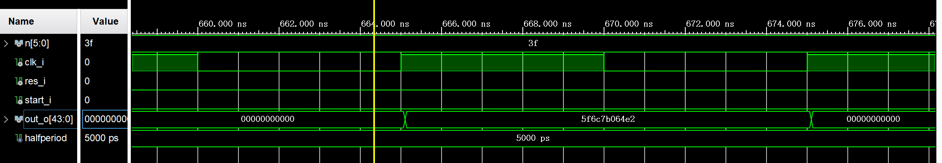
可以看到，当输入的信号n为0x3f（转换到十进制为63）时，计算输出的值为0x5f6c7b064e2（转换到十进制为6557470319842）。
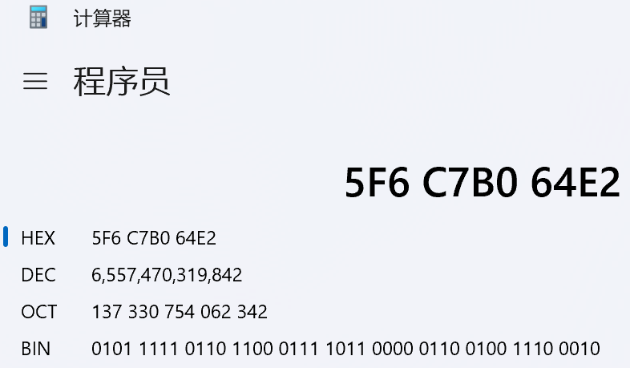

Test 2:
n = 9
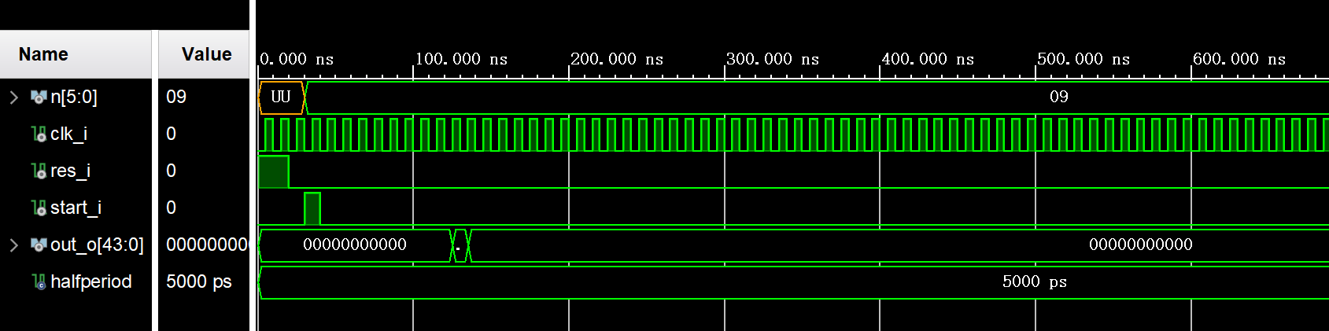
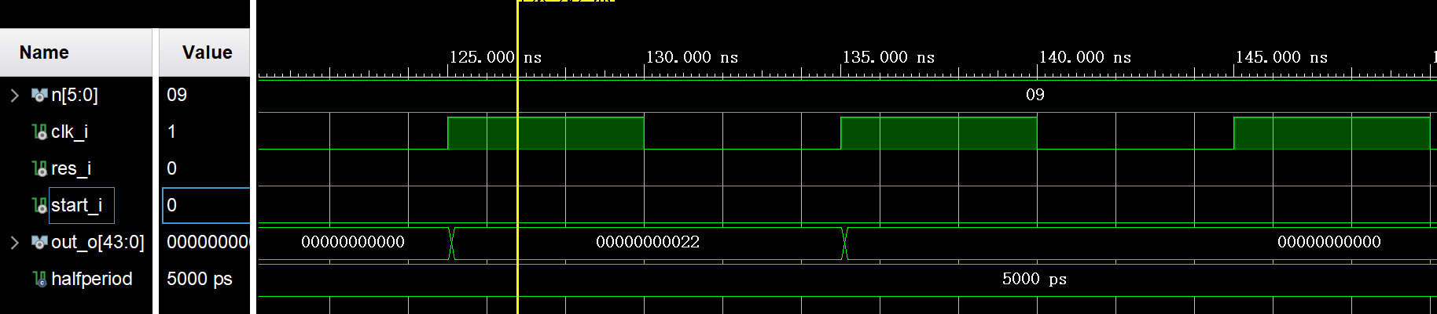
当输入的信号n为0x09（转换到十进制为9）时，计算输出的值为0x22（转换到十进制为34）。
number | 0 | 1 | 1 | 2 | 3 | 5 | 8 | 13 | 21 | 34
n | 0 | 1 | 2 | 3 | 4 | 5 | 6 | 7 | 8 | 9

Test 3:
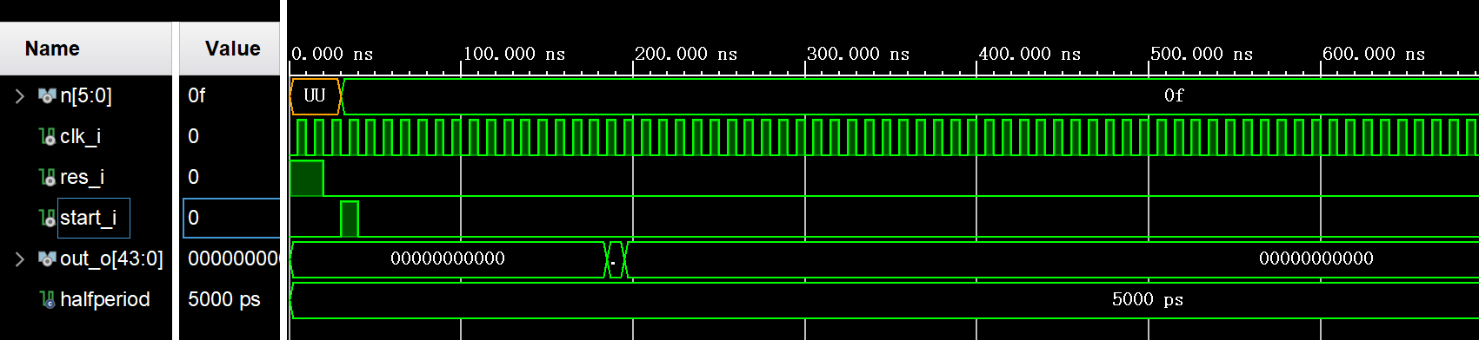
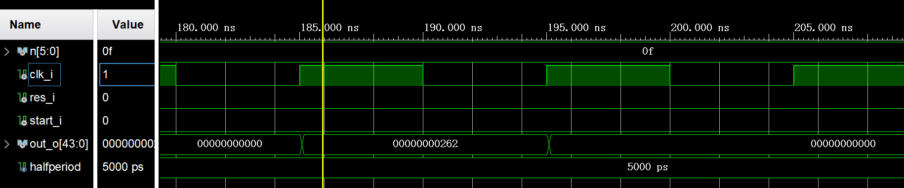
当输入的信号n为0x0f（转换到十进制为15）时，计算输出的值为0x262（转换到十进制为610）。
number | 0 | 1 | 1 | 2 | 3 | 5 | 8 | 13 | 21 | 34 | 55 | 89 | 144 | 233 | 377 | 610
n | 0 | 1 | 2 | 3 | 4 | 5 | 6 | 7 | 8 | 9 | 10 | 11 | 12 | 13 | 14 | 15

在上面的几次测试中，输出的值都符合斐波拉契数列的数字规律，说明电路功能正常。

